**Design and Implementation of a Full Model Hindlimb Model of a Rat**

**Fletcher Young**

# Abstract

The purpose of this work is to develop a hindlimb muscle model driven by synergies in order to better understand the hierarchical control structure of reflex modulation. This model will use information from the literature to estimate parameters for all muscles in the hindlimb. Using optimization techniques and the hindlimb model, known torque profiles will be deconstructed into muscle force profiles.

Contents

Abstract 0

Background 2

Modeling Considerations 4

Rats as a Model 5

Previous Project Developments 6

Synergies 8

Perturbations 10

Completed Work and Remaining Work 10

Aim 1 - Develop a physiologically relevant rat hindlimb model 11

Completed Work 11

Remaining Work 15

Publications 15

Aim 2 – Developing stimulation patterns for muscles during walking 15

Completed Work 15

Remaining Work 24

Publications 25

Aim 3 – Creating a walking rat with large neural network 25

Completed Work 25

Remaining Work 27

Publications 27

References 27

# Background

Animals are capable of traversing complex environments by continuously coordinating sensorimotor signals to address navigation demands. A sophisticated control system is necessary to integrate the feedforward decision making processes with the sensory response feedback signals that regulate locomotion. The high-dimensional parameterization of sophisticated control systems is difficult to implement in existing robots, leading researchers to develop simplified models of that make intelligent robotic navigation tenable. It stands to reason that a control system modeled after biological systems may offer an effective framework for robust control systems.

Robots and animals must encode environmental state variables to regulate downstream reflexes. In vertebrates, these signals are transmitted to processing centers in the brain through the spinal cord, where high level cognitive decisions are made. While understanding how individual levels of the control hierarchy function, a critical aspect that must be addressed is the transmission method that these subunits use to communicate.

Typical robotic control regimes use a top-down approach, with a high level processing unit directing the integration of sensor input and actuator control. This is similar to how animals control their movements, with the brain acting as the central processor and muscles acting as the actuators. Although the state of the art advances every year, there is still a definitive gap in the capabilities of even newborn animals and advanced robots. While robotic systems are effective at completing predetermined tasks, they lack the generality of task performance that animals possess. Robots are better equipped to enter well-understood environments and carry out predetermined tasks rather than modulate their behavior based on varying environmental factors.

Walking robots have been a focus of scientific research for decades, with uses such as rehabilitation, search and rescue, and even commercial products (Lakatos et al. 2016; Stefan O. Schrade et al. 2018; Chang et al. 2017). Roboticists are beginning to appreciate the incorporation of the musculature in designing these robots and even incorporating biological control systems in the robots themselves (Sharbafi et al. 2016; Luo et al. 2018). This integrated design approach is encouraging but is chasing a standard of biological fidelity that is currently computationally impossible. Emulating the complexity of living nervous systems, especially those of a human, is untenable both due to computational constraints and biological uncertainty. For this reason, it is most useful to develop systems which reduce the computational complexity of the system by reducing the parameterization of control variables. By grouping neuromechanical subsystems, it may be possible to simultaneously develop functional robotic systems while also influencing biological experiments aimed at identifying novel control pathways.

Models of neurorobotic systems must integrate the nervous system and associated body systems to understand how neural activation influences biomechanical behaviors. The nervous system coordinates body systems (e.g. muscles and skeleton) to manipulate the environment and processes sensory feedback to plan future actions. Research suggests that the nervous system controls the body using neural “suggestions” rather than “demands”, issuing generalized commands that are contingent on the states of the body and environment (Chiel and Beer 1997). This is likely caused by the simultaneous development of the systems, making the independent analysis of adaptive behavior difficult when attempting to model the nervous system independent of a body (Chiel et al. 2009). Developing models that accurately reflect the neural entrainment exhibited by nervous system and body systems is contingent on simulating environmental factors as realistically as possible.

The difficulty of implementing a generalizable control system lies in providing a robust framework necessary to manipulate the environment while avoiding engrained, predetermined command instructions. Living organisms modulate their behavior based on near constant feedback from complex downstream systems, which monitor the state of the environment using minimal processing power. Some of the systems within these lower hierarchical levels manifest as reflexes that engage rapid responses that protect the organism from environmental abnormalities (e.g. retracting one’s hand from a hot stove, compensating for tripping on the sidewalk). Constant feedback modulation from lower hierarchical levels is critical to capturing nonlinear coordination which could be the key to creating more robust robotic control schemes. Novel techniques based on these principles have been developed, which integrate biologically inspired control schemes into robots (Szczecinski, Hunt, and Quinn 2017b; Szczecinski et al. 2014).

## Modeling Considerations

An effective control system should accommodate environmental uncertainty by coordinating tasks within the environment at appropriate timescales and filtering sensory signals based on the complexity of the necessary response. A complete biological map a living system’s feedforward and feedback systems would demonstrate how its internal structure meets the demands of the task-environment space. Unfortunately, the biological experimentation necessary to create such a map is often impossible to attain. As such, it is necessary to model neuromechanical systems to distill this wealth of biological information into a form that is palatable for existing robots.

Modeling living systems should be an iterative process that oscillates between searching for new structures, testing the response of known structures, and replicating them in simulation. Modeling approaches depend on experimental goals, often assuming a morphological or functional approach (Buschmann et al. 2015). In a morphological approach, the biological components of the control system have direct representation in the model. This is often appropriate for systems that have well documented neural systems with high specificity, capable of representing the system as specific neurons or neuron groups. Functional approaches prioritize output metrics (e.g. joint motion, output torque) rather than direct biological representation. Functional approaches are more common in robotic applications where designs are focused on practicality of manufacturing devices whereas morphological approaches are more common in biological studies. Where available, the proposed model takes a morphological approach while maintaining emphasis on the functional demands of a robotic control system.

## Rats as a Model

The use of a rat for this model is preferable for three primary reasons. First, the rat is a legged vertebrates with a well-documented anatomy. Second, rats use legged locomotion in a land-based environment, an enviable paradigm for robots that must navigate complex environments used by humans. Finally, rats have been modeled using a hierarchical nervous system that allows for the feedback reactions we hope to analyze.

Previous work has developed walking patterns for robots inspired by insects (Szczecinski et al. 2014). The alternating tripod gait of hexapod insects is inherently stable due to the ability to always have three legs on the ground (Beer et al. 1997). Additionally, insects have a low center of gravity and joints that are heavily damped. An elevated center of weight and the necessity for rapid, wide-range actuation makes designing independent, human-scale robots difficult. Rats have a higher center of gravity than insects and must compensate for balance due to the lack of limbs. Rat locomotion has been studied extensively (Andrada et al. 2013; Fischer et al. 2002; Morrison 1970; Witte et al. 2002) and muscle properties have been derived to fit the Hill model (Will L. Johnson et al. 2008; W. L. Johnson et al. 2011; Eng et al. 2008).

## G:\My Drive\Living Machines\Living Machines 2018\SourceArchive\Fig1.pngPrevious Project Developments

Figure 1 The rat model used by Dr. Alex Hunt for modeling locomotion. Note the antagonistic muscle pairs at each joint. The blue bar represents a solid support that raises the static torso above the ground while moving.

The proposed model advances the work completed by Dr. Alexander Hunt in completion of his doctoral thesis (Hunt et al. 2014; 2015). In Hunt's work, a neuromechanical rat model demonstrated locomotor capabilities through the coordinated actuation of hindlimb muscles on an articulated skeleton. Joints act as discrete subunits with isolated central pattern generators (CPGs), a pair of neurons which oscillate in the presence of a constant input. CPGs are increasingly used in models that control locomotion (Ijspeert 2008; S. O. Schrade et al. 2017; Duysens and Forner-Cordero 2019; Dutta et al. 2019; Beer, Chiel, and Gallagher 1999). By including a single set of antagonistic muscles at each joint, a simple one-to-one connection between the muscles and the CPG halves was possible. The model decomposed joint kinematics into the motorneuron signals necessary to generate them.

Hierarchical control of muscles, including feedback from muscles sensors, allows researchers to compare stimulation protocols to optimize locomotion. Hunt’s model incorporated a hierarchical CPG system (McCrea and Rybak 2008) to coordinate joint motion. This control system abstracts the neural control of locomotion into a hierarchy with a high order rhythm generator (RG) layer and a lower level pattern formation (PF) layer, each composed of oscillating CPGs. Oscillations in the RG layer cause the leg to switch between stance and swing phase. Hunt’s model has a different pattern forming CPG at each joint, oscillating between flexion and extension. Muscle feedback is transmitted through type II, Ia, Ib fibers to the CPGs to modulate oscillation phase patterns.

The Hunt rat model applied a novel neural design approach that compartmentalized groups of neurons into algebraic subunits with known input-output relationships, called “functional subnetworks (FSN)” (Szczecinski, Hunt, and Quinn 2017a). The FSN approach reduces the complexity of a neural system, allowing designers to incorporate feedback integration when biological relationships remain unknown. Networks designed using the FSN approach ease the integration of morphological components with functional relationships. This modular approach also allows for expansion and development as new structures are described in the literature. FSN design been used to control locomotion in robots modeled after a dog (Hunt, Szczecinski, and Quinn 2017) and a praying mantis (Szczecinski et al. 2014).

Hunt’s model excludes muscles which span multiple joints, known as biarticular muscles (Cleland 1867). While monoarticular muscles primarily generate forces along the length of a bone segment, biarticular muscles are critical for generating transverse forces (Hof 2001). Utilizing the multi-level CPG hierarchy of McCrae and Rybak, a one-to-one connection between CPG neurons and antagonistic muscles was possible. The inclusion of biarticular muscles introduces a design challenge when considering how a discrete, joint based control system can be generalized to coordinate contractions in biarticular muscles. Work has already begun to address this design challenge through neural control (Deng et al. 2019) but work remains to be done in integrating a complete muscle set.

The neuromechanical model was created in Animatlab, a simulation suite that unites a physics engine with a neural design environment (Cofer et al. 2010). Animatlab is a vital tool to that allows researchers simultaneously design body components and the neurons which innervate them. Other common simulation suites include OpenSim and even Blender, but these alternatives lack the neural design aspect that is fundamental to the design and analysis of FSN systems. Hunt’s model laid the groundwork for a more complex model with more muscles and an expanded neural control system.

## Synergies

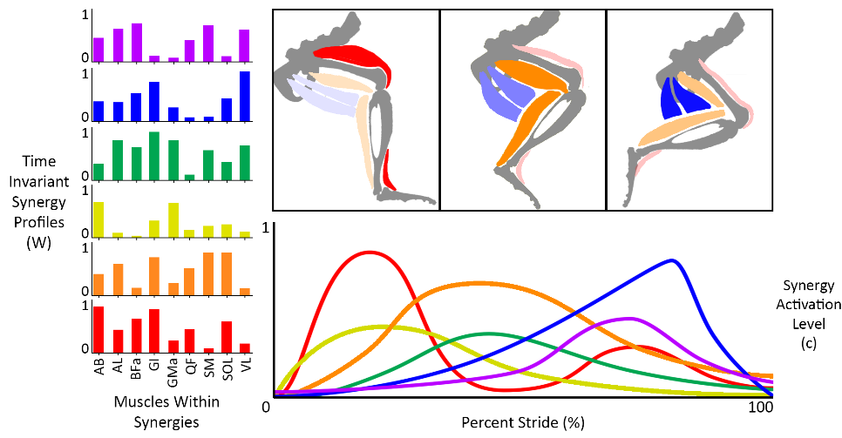As a neural control system grows, calculating parameters representing neurons and synapses becomes computationally impractical. Reducing the dimensionality of the parameter space eases the computational burden and speeds optimization methods used by the FSN method. Organizing muscles into muscle synergies, groups of muscles whose contractions have temporal and spatial correlations, is one method of increasing the computational efficiency of a control system (W. A. Lee 1984; Tresch, Saltiel, and Bizzi 1999). Synergies may physically exist in living systems where they function as a type of lookup table for the central nervous system (CNS) to assemble task responses based on a pre-defined “toolset” (McKay and Ting 2012). Motorneuron clusters have been mapped in the rat spinal cord (Nicolopoulos‐Stournaras and Iles 1983) and can be stimulated to induce synergy-based locomotion (Wenger et al. 2016).

Figure 2 An example of synergy decomposition. Time invariant synergy profiles represent relative muscle activations. Synergy activation levels represent temporal activation of entire synergy groups.

The identification of synergies relies on electromyography (EMG) measurements for all muscles in the limb and statistical methods using a number of matrix factorization techniques (Tresch, Cheung, and d’Avella 2006; Andrea d’Avella, Saltiel, and Bizzi 2003) with the most common being nonnegative matrix factorization (Ting et al. 2012; D. D. Lee and Seung 2001). Rectified, low-pass filtered EMG data is decomposed into a set of spatial vectors, representing time invariant muscle activation profiles, and temporal vectors, representing the timing of synergy coactivation. The appeal of a muscle synergy model is in the reduced parameterization which would ease the computational burden associated with neuromechanical control systems (Alessandro, Carbajal, and d’Avella 2014; Aoi et al. 2013).

The synergy model has recently come under scrutiny, though, as leading researchers have posited that synergies are less likely manifestations of physical neural systems and moreso optimal task-specific responses from the body (Tresch and Jarc 2009; Kutch and Valero-Cuevas 2011; Perreault et al. 2008). The task-specific focus of muscle synergy derivation does not mean that the model is unsuitable for robotic control, though, so long as the natural dynamics of the systems are considered within the task demands (Max Berniker et al. 2009; A. d’Avella and Bizzi 2005). Existing synergy decomposition methods use averaged EMG data which minimizes signal variability that may be important to developing robust synergy profiles across tasks and subjects (Ting et al. 2012; Steele, Tresch, and Perreault 2015). Evidence suggests that the body may simply strive to reduce EMG variability for task-relevant muscles while ignoring signals from other muscles (Cullins et al. 2014; Valero-Cuevas, Venkadesan, and Todorov 2009).

For synergies to be considered a physical hallmark of the nervous system, one would expect relative muscle activation within a synergy to remain consistent over time and across a variety of tasks. It has been theorized that synergies could be encoded in upstream neural connections in the form of torque profiles (T. S. Buchanan et al. 1986). This is supported in primate upper limb work which demonstrates a preferential torque direction for individual muscles (flexors are more sensitive to flexion, etc) (Kurtzer et al. 2006). Recent work has suggested, though, that the nervous system tweaks the weighting of different muscles within synergies at short timescales and for different tasks (Ranganathan et al. 2016; Chia Bejarano et al. 2017). This implies that the nervous system may actually control individual responses to coordinate muscle activation.

There has also been evidence that the CNS may deviate from expected synergistic responses by prioritizing muscle activation that reduces internal stress, even when it has the option to delegate muscle stresses to redundant muscles (Alessandro et al. 2018). Perhaps the infinite solution space offered by muscle redundancy is narrowed by task constraints, which simplify the suggested mapping of neural connections modulating the muscle contractions (Sandercock et al. 2018). The pathway for uniting our generalized muscle model with the traditional neural control regime could stem from the hardcoded implementation of the muscle synergy model.

## Perturbations

Nominal walking patterns are kinematic profiles (joint angles, torque patterns, muscle activation, etc.) that describe limb motion during unimpeded flat ground walking at a self-selected speed. The development of nominal models are useful but ultimately do not reveal much about the interesting aspects of the nervous system. Adding perturbations to kinematic responses, such as obstacles to jump over or holes to fall in to, trigger feedback modulation. Activating feedback systems has the potential to reveal new pathways in the hierarchical structure of walking systems.

# Completed Work and Remaining Work

* A complete hindlimb model with physiological muscle paths and attachments
* Physiological muscle parameters based on force-length and stimulus-tension relationships where available in the literature
* Kinematic model validation through the comparison of muscle moment arm profiles over stride
* Implementation of optimization equations from the literature for decomposing joint torque profiles into individual muscle force profiles

## Aim 1 - Develop a physiologically relevant rat hindlimb model

### Completed Work

*Physiologically relevant muscle attachment points*

A reliable hindlimb model is entirely dependent on the accurate representation of its muscles. Prior work, which simplified the musculature to an antagonistic muscle pair for each joint, was not feasible for a model focuses on muscle group coactivation. Three dimensional kinematic models of four legged animals have been created for rats (Will L. Johnson et al. 2008; Wei, Pai, and Tresch 2018; Thota et al. 2005), mice (Charles et al. 2016), and cats (Ekeberg and Pearson 2005).

At the outset of muscle expansion, efforts were made to apply a 3D point cloud (Will L. Johnson et al. 2008) directly onto hindlimb bone meshes used by Hunt. The application of those attachment points were presented at Living Machines 2018 (Young, Hunt, and Quinn 2018). Johnson’s work was useful from an engineering design standpoint but was unusable for two reasons: the coordinates required hand-tuned scaling in order to map correctly onto the existing bone structures and including only the insertion and origins did not accommodate muscle wrapping via points. The first problem was addressed in Wei et al. 2018 by using a two-step iterative optimization method to apply muscle attachments at different posture configurations.

Wei’s approach would still necessitate hand-tuning attachment locations because Animatlab’s muscle objects are not collision-based, meaning they can pass directly through bones. Muscle attachment points are also stationary relative to bone coordinate frames. For muscles that wrap closely over bones (such as knee 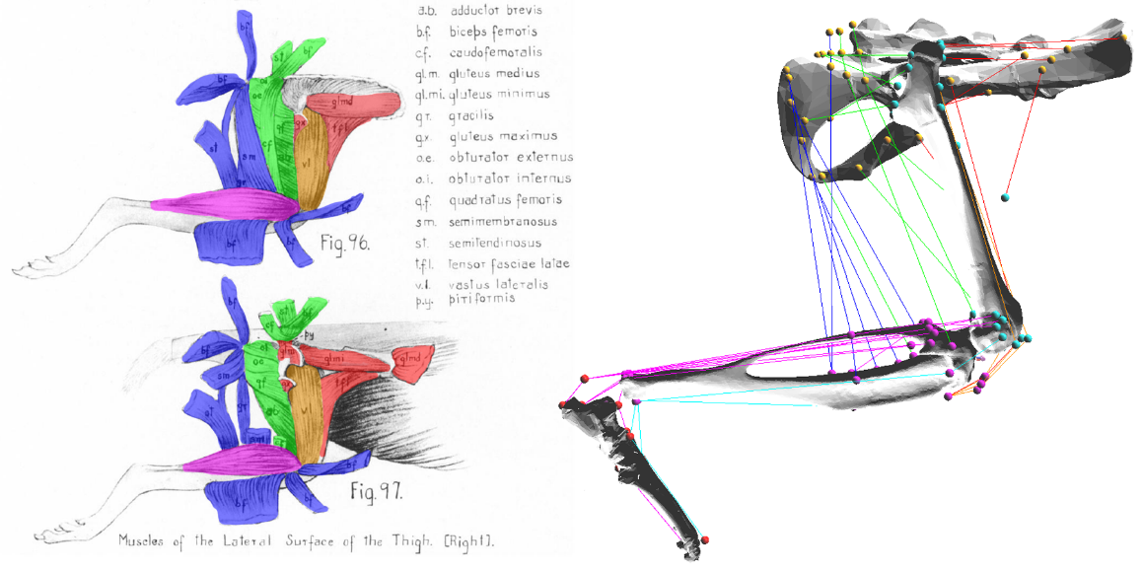extensors like the vastii muscles), muscle paths include via points.

Figure 3 An example of using Greene's anatomical drawings to guide the muscle paths in Animatlab

Instead of using Johnson’s point cloud, muscle paths were hand-guided based on the descriptions found in E.C. Greene’s 1955 publication Anatomy of the Rat (Greene 1955). Muscle paths were developed by integrating anatomical diagrams and descriptions for thirty-eight muscles in the hindlimb. Special care was taken to identify bony landmarks on the bone meshes in order to guide muscles along paths that made anatomical sense. Muscles that insert along a length of bone rather than at a point were reduced to a single line of action that would best approximate the 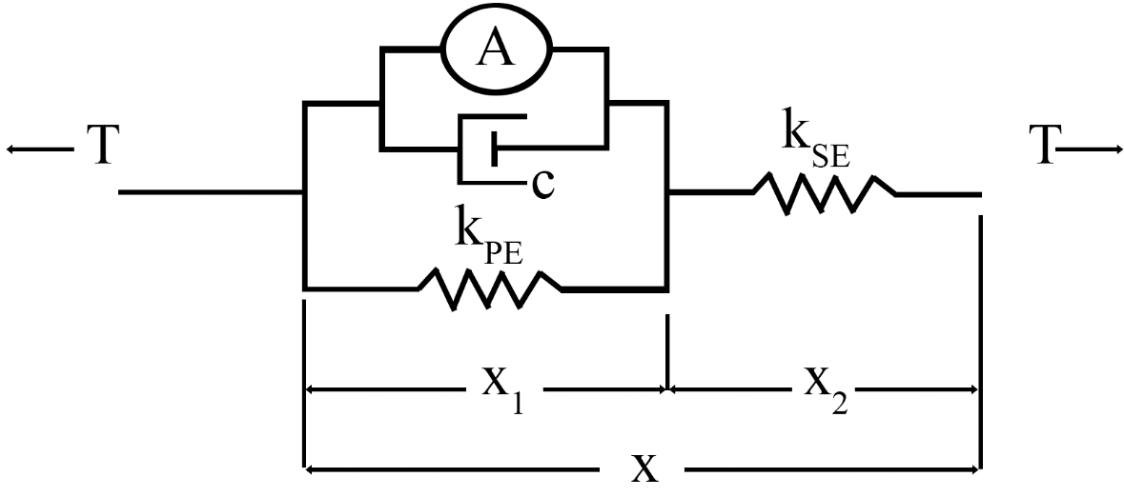directionality of the force it imparts onto the system.

Figure 4 The linear Hill muscle model used by Animatlab.

Once muscle paths were defined for every muscle, muscle parameters were developed. Animatlab uses a linear Hill muscle model for tension,

,

where T is the muscle tension,  is the serial element stiffness,  is the parallel element stiffness, L is the muscle length,  is the muscle activation in Newtons,  is the dimensionless length-tension modifier, and c is the muscle damping factor.

This model demands explicit statements for these different variables, a data set that has not been found in the literature. By using muscle data from Johnson (W. L. Johnson et al. 2011) and Eng (Eng et al. 2008), it is possible to approximate these muscle parameters. Using muscle models from Zajac (Zajac 1989), the physiological parameters were related to Hill parameters. Individual parameter calculation is discussed briefly as follows.

*Dynamic Muscle Moment Arm Profiles*

Muscle moment arms have been analyzed in the literature as a way of understanding the functional effect that muscles have about joints (S. W. Lee et al. 2008; Visser et al. 1990; Yeo et al. 2011; Charles et al. 2016). In small animals, the measurement of muscle moment arms is especially difficult because a small error in measurement accuracy can magnify the torque generating capabilities of muscles. For this reason, using X-Ray imaging or implanting physical markers under the skin can aid in the generation of accurate moment arm profiles during locomotion (An et al. 1984).

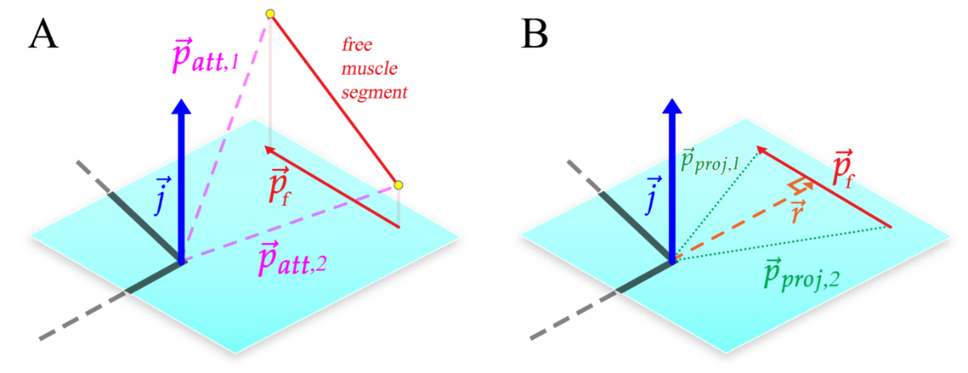As a natural progression of analyzing the biomechanics of the model, moment arm profiles during gait were developed. Calculating moment arms from fundamental principles is a useful tool to analyze the force generating capabilities of specific muscles in the model. Additionally, this is a useful metric whereby the model can be validated against existing hindlimb models. This work led to a publication in the Journal of Biomimetics (Young et al. 2019).

Figure 5 Calculating the muscle moment arm, r. The plane of interest and its coordinate system is defined by the joint center and the joint axis representing flexion/extension (blue). Joint axes are defined using the same convention as Charles and Johnson. Orthogonal joint axes represent abduction/adduction, and inversion/eversion. The free muscle segment that connects the adjacent bone segments (monoarticular muscles) or to the bone segment after the next (biarticular muscles) is projected onto the plane of interest. This projected free segment is called . The muscle moment arm, the signed magnitude of , is calculated from  and  as described in the text.

Muscle moment arms are developed by projecting muscle paths onto a plane on interest and then measuring the shortest distance from the joint center to the free muscle segment. In the case of 2D walking, the plane of interest is the sagittal plane. Since muscles often contain multiple via points and those via points are often stationary relative to one another, the moment arm was calculated based on the segment of muscle that actively undergoes contraction during walking.

### Remaining Work

The Animatlab model must be expanded to include another leg if we want the model to start walking. This will lead to significant processing overhead as the number of attachment points and muscle parameters double. There may be a way to run a single leg version of experiments but that will be less convincing than a full walking rat model.

### Publications

Analyzing Muscle Moment Arms in a Hindlimb Model (Young et al. 2019)

## Aim 2 – Developing stimulation patterns for muscles during walking

### Completed Work

*Physiological Muscle Parameters*

Force calculations in the Hill muscle model need accurate muscle parameters to determine proper results. Muscle information exists in the literature in various animals such as cats (Sacks and Roy 1982). There is no present piece that includes the Hill muscle parameters for every muscle in the rat hindlimb. The closest representation of this dataset lists muscle properties such as mass and optimal resting length for every muscle in the rat hindlimb. A cohesive muscle data set required a literature review and the combination of multiple muscle models to generate a full Hill dataset. Hill parameters were determined by analyzing the response of the length tension and stimulus tension curves and back solving for the parameters.

There is evidence to suggest that the disuse of a musculotendon actuators can lead to a weakening in the maximal stress bearing capabilities (Almeida-Silveira et al. 2000).

* + - * 1. The Length-Tension (LT) Curve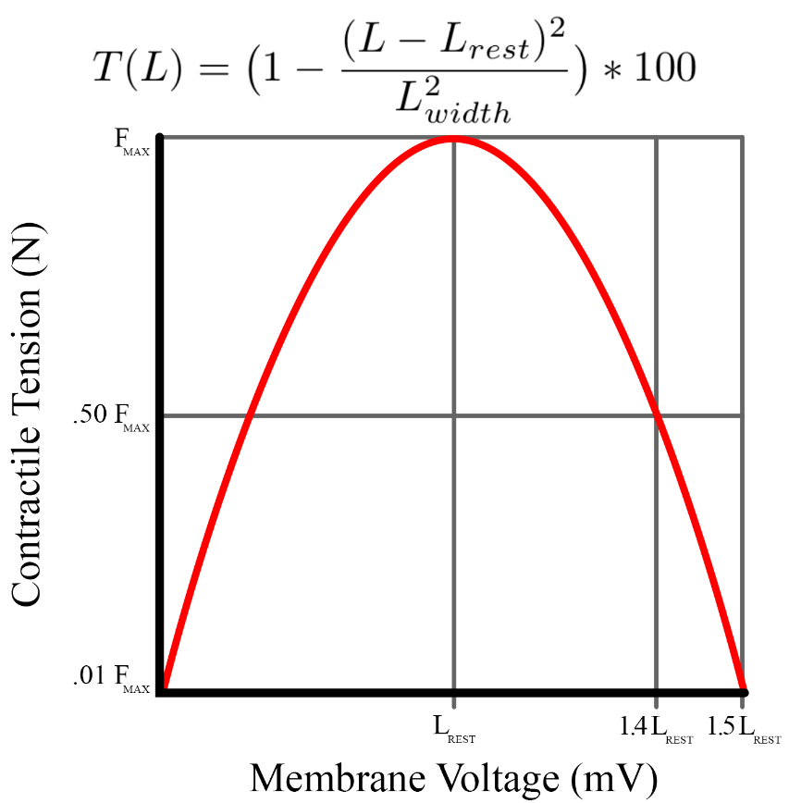

Figure 6 The LT curve as modeled by Animatlab

The length-tension curve relates a muscle’s force-generating capabilities at various isometric lengths. At an optimal resting length, a muscle is able to produce maximal force. This maximal force is different for every muscle and depends on parameters such as its pennation angle, mass, and physiological cross sectional area (PCSA) (Hoy, Zajac, and Gordon 1990). Deviations from the optimal resting length reduce the force that the muscle can exert, although some research suggests that muscles operate at intentionally longer lengths in order to accommodate the shortening effects of the musculo-tendon complex (Ettema and Huijing 1989).

In addition to the active muscle force generated by contracting muscle fibers, muscles have an inherent passive force that is generated when the muscle is extended beyond its optimal resting length. These passive forces tend to be small (Rode et al. 2009) and were not considered in Hunt’s model. They have, however, been introduced in the current model in an effort to make a more physiologically relevant leg model.

Animatlab uses a simplified LT curve equation,

,

where L is the muscle length,  is the tension at a specific length, Lwidth is the muscle width, and Lrest is the resting muscle length. Assuming that the muscle width is half the resting length (due to the symmetry of the Animatlab curve), it is possible to determine the values of the parallel and series spring elements for the muscle at equilibrium. Using the Hill equation and assumption of steady state, the force relationship becomes





.

With optimal force and resting lengths from Johnson (W. L. Johnson et al. 2011), three equations are created to solve for three unknowns: ,, and .







Solutions to these equations were developed from Matlab’s function solver, producing positive-value parameters for each muscle in the system. The solution set with the  value closest to  was chosen for each muscle and injected into an Animatlab project file.

* + - * 1. 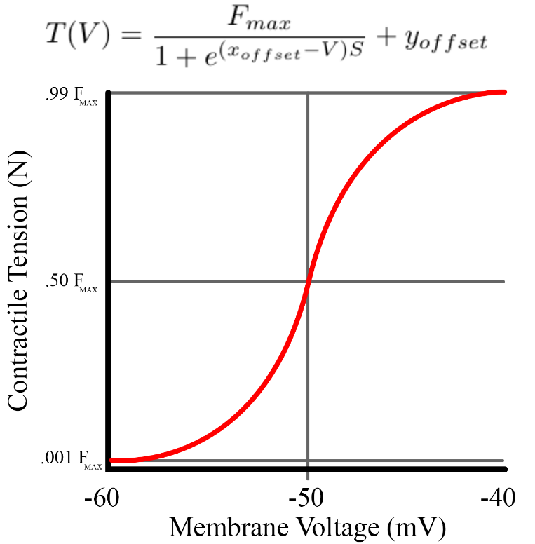The Stimulus-Tension (ST) Curve **(notebook 5-22)**

Figure 7 The ST curve as modeled in Animatlab. Steepness was calculated to meet the boundary conditions shown above.

The stimulus-tension (ST) curve relates muscle membrane potential to muscle force output. ST curves exist in the literature for a number of hindlimb muscles, but not all (Jarc, Berniker, and Tresch 2013). In the Hill equation, this is represented by the parameter Am. This model does not capture many of the nuances associated with the stimulation mechanics of muscles, such as twitch mechanics or the time delay between EMG signal onset and measured force (Thomas S. Buchanan et al. 2004; Corcos et al. 1992).

Animatlab uses a simplified ST equation,

,

where  is the tension at a specific motorneuron voltage in Newtons, Fmax is the maximum muscle force, xoffset is the offset for the sigmoid, yoffset is the force offset for the sigmoid, V is the motorneuron voltage, and S is the steepness of the curve. The model assumes a constant xoffset of -50mV and yoffset of 0 N. From these assumptions, the steepness is calculated such that at -60mV, the muscle exerts .005*Fmax and at -40mV it exerts .99*Fmax.

There is evidence to suggest that there is a linear relationship between integrated EMG signals and the isometric force a muscle generates (Bouisset 1973; Lippold 1952). This is an attractive characteristic because it allows for inverse calculation of the integrated EMG signal. Realistically, though, a robust system would want to account for EMG variability (Steele, Tresch, and Perreault 2015). Additionally, motor stimulation responses can lead to unpredictable force outputs, making it more useful to consider the output forces as a probability space rather than a direct one-to-one activation (M. Berniker et al. 2016).

Previous work has been done to establish functional subnetworks capable of coordinating locomotion (Szczecinski, Hunt, and Quinn 2017a). An applicable ST curve should interface with this functional subnetwork approach if we are to unite the lab’s work of the control and biomechanics. Neurons in these models operate in a set voltage range of -60 to -40mV. For the current model, it is assumed that at -60mV, the muscle generates force equal to .5% Fmax. At -40mV, the muscle generates 99% Fmax. These boundary conditions determine the necessary steepness of the curve and the x offset was set to -50mV.

*Torque*

Stance phase torque profiles have been calculated (Andrada et al. 2013) for rats walking on inclined and flat surfaces. Using kinematic joint data from our German collaborators, Hunt generated swing phase torque profiles using a Simulink simulation (Hunt et al. 2014). Stance and swing torque profiles were combined and smoothed to form a single idealized torque profile for stride. A complete torque profile is an asset to a kinetic model because evidence suggests that there is an approximately linear relationship between normalized EMG and isometric torque generation in muscle about the human elbow (T. S. Buchanan et al. 1986).

*Passive Force*

Passive forces in the leg occur as a result of ground reaction forces and passive forces in muscle. With muscle parameters determined and moment arm profiles well understood, it was possible to generate the passive muscle torques for all joints over stride. To determine torque generating muscle contributions, the passive torque due to body weight must be removed from the overall signal. Using ground reaction forces, it is possible to treat the leg like a multi-segmented arm with a force at the end effector (Murray, Li, and Sastry 1994). Passive joint torques can be calculated by finding the spatial manipulator Jacobian, which acts as an operator that transforms forces at the end effector into torques at the joints. The composition of the spatial manipulator Jacobian is a 6n matrix of the form:



where  represents the joint axis and  represents a joint's global coordinates. End effector forces are calculated using the three dimensional ground reaction force data from the literature (Muir and Whishaw 1999). With the spatial manipulator Jacobian and the ground reaction forces, the sagittal plane load torque in all three joints can be calculated using,

.

Active joint torque is the summation of individual muscle torques about each joint. With a method for calculating muscle moment arms and complete torque profiles, the final challenge is to calculate the muscle forces necessary to generate the complete torque profile. However, an infinite combination of force profiles act as the solution space making the outright distribution of muscle forces difficult.

*Optimizing the force*

Optimizing muscle forces profiles can be accomplished using an inverse or forward dynamics approach in the form of static or dynamic optimization, respectively. Dynamic optimization considers factors such as muscle physiology and physiological variables in the form of nonlinear, time variant equations. Static optimization is highly dependent on accurate kinematic data and is inherently time-independent making is difficult to account for muscle physiology (Anderson and Pandy 2001a). Dynamic optimization can necessitate thousands of hours of CPU processing time (Anderson and Pandy 2001b) and does not offer enough of a tangible benefit over static optimization (Anderson and Pandy 2001a). For this reason, force optimization has been carried out using static optimization methods while making efforts to consider the muscle physiology as much as possible.

A number of different optimization protocols have been used to determine the force profiles for individual muscles. Some processes minimize forces (Pedotti, Krishnan, and Stark 1978; Penrod, Davy, and Singh 1974), some minimize muscle stress (Crowninshield and Brand 1981), some minimize muscle activation (Kaufman et al. 1991), some minimize fatigue (Prilutsky and Zatsiorsky 2002). The optimization method is affected by the number of degrees of freedom the joint must control (Thomas S. Buchanan and Shreeve 1996). An important factor for choosing an optimization criteria is determining which physiological quantity is the most relevant to the dynamics in the system (Hardt 1978). While there has not been a definitive declaration of which method is the most universally effective, the force distribution characteristics of each optimization method have been compared (Herzog and Leonard 1991).

Initially, linear optimization was applied at each time step during a single stride by minimizing the summed forces that, when multiplied by the instantaneous moment arms, equaled the instantaneous torque. Although this is possible since the problem is linear, this optimization method delivers solutions that fall on an “optimization corner” (Crowninshield and Brand 1981), causing jagged force profiles that are not indicative of actual muscle contractions.

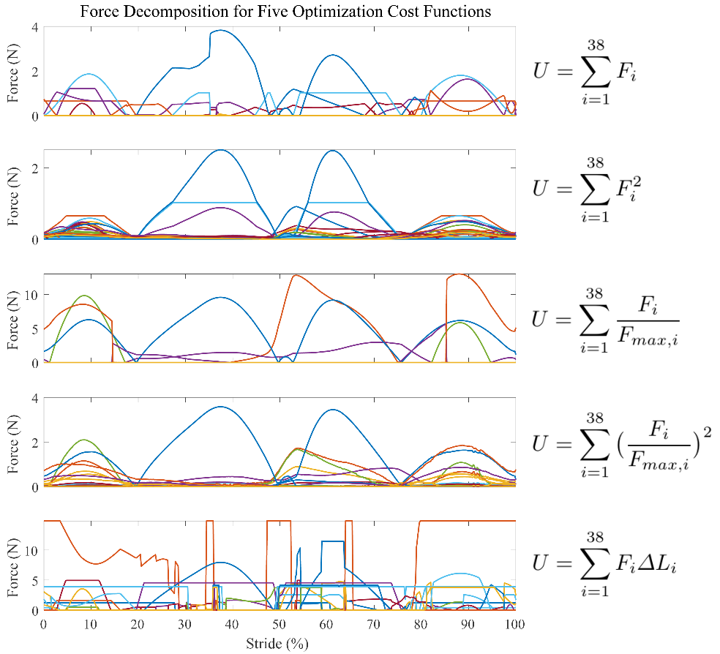

Figure 8 Force profiles as a result of using five different optimization cost functions. In all instances, U is minimized while maintaining the torque demands of the system.

Work has now transitioned to static optimization with an interchangeable cost function. By implementing cost functions from (Pedotti, Krishnan, and Stark 1978) and (Seireg and Arvikar 1973), a suitable cost function has been identified that relates muscle forces to their maximum values squared. This produces continuous force profiles with low function error.

### Remaining Work

Ultimately, work on the muscle model has been a balance of creating an accurate model while still working within the constraints of Animatlab. A number of muscle model equations were studied over the course of model development (Thelen 2003; Brown, Scott, and Loeb 1996; Lloyd and Besier 2003) to better understand how different subsets of the muscle force equations coordinate to induce contractions. The Hill model is reductive because it does not take into account some interesting features of muscle, such as the asymmetrical lengthening/shortening profile of the force velocity curve (Murphy and Beardsley 1974) or the temporal aspects of muscle fiber twitch. This model could be improved through the inclusion of these extra features, but at the cost of the neural interface that Animatlab offers.

Now that muscle force profiles have been developed through optimization, the ST curve equation can be solved to find the neural stimulation necessary to induce those forces. Work by Thelen and Lloyd suggest nonlinear relationships between activation and EMG signals. The underlying EMG signals that elicit these forces can be compared to muscle recordings gathered by research collaborators.

### Publications

There are no existing publications from this aim yet, but there is enough work to collate into a publication with access to experimental data. Possible publications include:

* A publication comparing the modelled EMG results to actual EMG measurements in the rat. This could also feed the EMG signals back into the model and test leg kinematics.
* A publication comparing of different optimization functions on the force profiles, including the impact that passive forces play in force distribution

## Aim 3 – Creating a walking rat with large neural network

### Completed Work

This aim is the least fleshed out, as it would integrate the work already completed in the model. This aim falls under two primary umbrellas: interactive tool design and neural control expansion. As the neural control system becomes more complex, the implementation of sophisticated higher level control systems like MLR cells, which coordinate the RG layer, could be introduced (Grätsch, Büschges, and Dubuc 2019).

So far, completed work has focused entirely on the biomechanics of the model, without the inclusion of the neural connections necessary for locomotion. The first aspect of completed work in this aim is Canvas, Matlab design project that includes an interactive GUI for creating large scale functional subnetworks. This work was fulfilled as part of the EMAE 689 Synthetic Nervous Systems course as a way to ease the creation of large networks in Animatlab. Animatlab is a C based program, meaning that it is compiled. This makes it difficult to understand what is happening “under the hood” of the program and to make quality of life changes. Since the program is no longer actively supported by the developer, it is only a matter of time before the FNS work in our lab will reach a roadblock. For this reason, I have begun exploring avenues for modeling systems that integrate the physics engine and the neural control scheme.

Specifically, Canvas is a GUI project (a self-contained Matlab package) that allows a user to drag-and-drop neurons into various configurations, save them, and reopen them later. The work heavily utilizes the class-based coding structure more commonly found in coding languages such as Python and Java. Substantial work went into implementing a system that not only replicated the neural information of the objects themselves (synapses, neurons, etc.) but also the graphical aspect of network design. As this system matures, it would be possible to create streamlined methods for deploying massive neural networks in a short period of time. Ultimately, though, the simulation of the 3D actuation is not possible in Matlab. For this reason, I plan to conduct work using Python to implement the Bullet physics engine with the neural design we have implemented thus far.

### Remaining Work

To validate these new techniques, I will implement the system I have already described. My metrics for success will be to match the user capabilities of Animatlab while replicating the simulation output in Python. Python is open source, with a widespread community and free resources that would make deployment in the environment preferable. This aligns with my personal goals for an engineering career and meets the needs for aiding the project in the future.

### Publications

# References

Alessandro, Cristiano, Juan Pablo Carbajal, and Andrea d’Avella. 2014. “A Computational Analysis of Motor Synergies by Dynamic Response Decomposition.” *Frontiers in Computational Neuroscience* 7. https://doi.org/10.3389/fncom.2013.00191.

Alessandro, Cristiano, Benjamin A. Rellinger, Filipe O. Barroso, and Matthew C. Tresch. 2018. “Adaptation after Vastus Lateralis Denervation in Rats Suggests Neural Regulation of Joint Stresses and Strains.” *BioRxiv*, January, 1–18. https://doi.org/10.1101/312488.

Almeida-Silveira, Maria Izabel, Daniel Lambertz, Chantal Pérot, and Francis Goubel. 2000. “Changes in Stiffness Induced by Hindlimb Suspension in Rat Achilles Tendon.” *European Journal of Applied Physiology* 81 (3): 252–57. https://doi.org/10.1007/s004210050039.

An, K. N., K. Takahashi, T. P. Harrigan, and E. Y. Chao. 1984. “Determination of Muscle Orientations and Moment Arms.” *Journal of Biomechanical Engineering* 106 (3): 280. https://doi.org/10.1115/1.3138494.

Anderson, Frank C., and Marcus G. Pandy. 2001a. “Static and Dynamic Optimization Solutions for Gait Are Practically Equivalent.” *Journal of Biomechanics* 34 (2): 153–61. https://doi.org/10.1016/S0021-9290(00)00155-X.

———. 2001b. “Dynamic Optimization of Human Walking.” *Journal of Biomechanical Engineering* 123 (5): 381–90. https://doi.org/10.1115/1.1392310.

Andrada, E., J. Mämpel, A. Schmidt, M.S. Fischer, A. Karguth, and H. Witte. 2013. “From Biomechanics of Rats’ Inclined Locomotion to a Climbing Robot.” *International Journal of Design & Nature and Ecodynamics* 8 (3): 192–212. https://doi.org/10.2495/DNE-V8-N3-192-212.

Aoi, Shinya, Takahiro Kondo, Naohiro Hayashi, Dai Yanagihara, Sho Aoki, Hiroshi Yamaura, Naomichi Ogihara, et al. 2013. “Contributions of Phase Resetting and Interlimb Coordination to the Adaptive Control of Hindlimb Obstacle Avoidance during Locomotion in Rats: A Simulation Study.” *Biological Cybernetics* 107 (2): 201–16. https://doi.org/10.1007/s00422-013-0546-6.

Avella, A. d’, and E. Bizzi. 2005. “Shared and Specific Muscle Synergies in Natural Motor Behaviors.” *Proceedings of the National Academy of Sciences* 102 (8): 3076–81. https://doi.org/10.1073/pnas.0500199102.

Avella, Andrea d’, Philippe Saltiel, and Emilio Bizzi. 2003. “Combinations of Muscle Synergies in the Construction of a Natural Motor Behavior.” *Nature Neuroscience* 6 (3): 300–308. https://doi.org/10.1038/nn1010.

Beer, Randall D., Hillel J. Chiel, and John C. Gallagher. 1999. “Evolution and Analysis of Model CPGs for Walking: II. General Principles and Individual Variability.” *Journal of Computational Neuroscience* 7 (2): 119–47. https://doi.org/10.1023/A:1008920021246.

Beer, Randall D., Roger D. Quinn, Hillel J. Chiel, and Roy E. Ritzmann. 1997. “Biologically Inspired Approaches to Robotics: What Can We Learn from Insects?” *Commun. ACM* 40 (3): 30–38. https://doi.org/10.1145/245108.245118.

Berniker, M., A. Jarc, K. Kording, and M. Tresch. 2016. “A Probabilistic Analysis of Muscle Force Uncertainty for Control.” *IEEE Transactions on Biomedical Engineering* 63 (11): 2359–67. https://doi.org/10.1109/TBME.2016.2531083.

Berniker, Max, Anthony Jarc, Emilio Bizzi, and Matthew C. Tresch. 2009. “Simplified and Effective Motor Control Based on Muscle Synergies to Exploit Musculoskeletal Dynamics.” *Proceedings of the National Academy of Sciences*, April, 6. https://doi.org/10.1073/pnas.0901512106.

Bouisset, S. 1973. “EMG and Muscle Force in Normal Motor Activities.” *New Concepts of the Motor Unit, Neuromuscular Disorders, Electromyographic Kinesiology* 1: 547–83. https://doi.org/10.1159/000394059.

Brown, Ian E., Stephen H. Scott, and Gerald E. Loeb. 1996. “Mechanics of Feline Soleus: II Design and Validation of a Mathematical Model.” *Journal of Muscle Research & Cell Motility* 17 (2): 221–33. https://doi.org/10.1007/BF00124244.

Buchanan, T. S., D. P. Almdale, J. L. Lewis, and W. Z. Rymer. 1986. “Characteristics of Synergic Relations during Isometric Contractions of Human Elbow Muscles.” *Journal of Neurophysiology* 56 (5): 1225–41. https://doi.org/10.1152/jn.1986.56.5.1225.

Buchanan, Thomas S., David G. Lloyd, Kurt Manal, and Thor F. Besier. 2004. “Neuromusculoskeletal Modeling: Estimation of Muscle Forces and Joint Moments and Movements From Measurements of Neural Command.” *Journal of Applied Biomechanics* 20 (4): 367–95.

Buchanan, Thomas S., and David A. Shreeve. 1996. “An Evaluation of Optimization Techniques for the Prediction of Muscle Activation Patterns During Isometric Tasks.” *Journal of Biomechanical Engineering* 118 (4): 565–74. https://doi.org/10.1115/1.2796044.

Buschmann, Thomas, Alexander Ewald, Arndt von Twickel, and Ansgar Büschges. 2015. “Controlling Legs for Locomotion—Insights from Robotics and Neurobiology.” *Bioinspiration & Biomimetics* 10 (4): 041001. https://doi.org/10.1088/1748-3190/10/4/041001.

Chang, Sarah R., Mark J. Nandor, Lu Li, Rudi Kobetic, Kevin M. Foglyano, John R. Schnellenberger, Musa L. Audu, Gilles Pinault, Roger D. Quinn, and Ronald J. Triolo. 2017. “A Muscle-Driven Approach to Restore Stepping with an Exoskeleton for Individuals with Paraplegia.” *Journal of NeuroEngineering and Rehabilitation* 14 (1): 48. https://doi.org/10.1186/s12984-017-0258-6.

Charles, James P., Ornella Cappellari, Andrew J. Spence, Dominic J. Wells, and John R. Hutchinson. 2016. “Muscle Moment Arms and Sensitivity Analysis of a Mouse Hindlimb Musculoskeletal Model.” *Journal of Anatomy* 229 (4): 514–35. https://doi.org/10.1111/joa.12461.

Chia Bejarano, Noelia, Alessandra Pedrocchi, Antonio Nardone, Marco Schieppati, Walter Baccinelli, Marco Monticone, Giancarlo Ferrigno, and Simona Ferrante. 2017. “Tuning of Muscle Synergies During Walking Along Rectilinear and Curvilinear Trajectories in Humans.” *Annals of Biomedical Engineering* 45 (5): 1204–18. https://doi.org/10.1007/s10439-017-1802-z.

Chiel, Hillel J., and Randall D. Beer. 1997. “The Brain Has a Body: Adaptive Behavior Emerges from Interactions of Nervous System, Body and Environment.” *Trends in Neurosciences* 20 (12): 553–57. https://doi.org/10.1016/S0166-2236(97)01149-1.

Chiel, Hillel J., Lena H. Ting, Örjan Ekeberg, and Mitra J. Z. Hartmann. 2009. “The Brain in Its Body: Motor Control and Sensing in a Biomechanical Context.” *Journal of Neuroscience* 29 (41): 12807–14. https://doi.org/10.1523/JNEUROSCI.3338-09.2009.

Cleland, John. 1867. “On the Actions of Muscles Passing over More than One Joint.” *Journal of Anatomy and Physiology* 1 (1): 85–93.

Cofer, David, Gennady Cymbalyuk, James Reid, Ying Zhu, William J. Heitler, and Donald H. Edwards. 2010. “AnimatLab: A 3D Graphics Environment for Neuromechanical Simulations.” *Journal of Neuroscience Methods* 187 (2): 280–88. https://doi.org/10.1016/j.jneumeth.2010.01.005.

Corcos, Daniel M., Gerald L. Gottlieb, Mark L. Latash, Gil L. Almeida, and Gyan C. Agarwal. 1992. “Electromechanical Delay: An Experimental Artifact.” *Journal of Electromyography and Kinesiology* 2 (2): 59–68. https://doi.org/10.1016/1050-6411(92)90017-D.

Crowninshield, Roy D., and Richard A. Brand. 1981. “A Physiologically Based Criterion of Muscle Force Prediction in Locomotion.” *Journal of Biomechanics* 14 (11): 793–801. https://doi.org/10.1016/0021-9290(81)90035-X.

Cullins, Miranda J., Kendrick M. Shaw, Jeffrey P. Gill, and Hillel J. Chiel. 2014. “Motor Neuronal Activity Varies Least among Individuals When It Matters Most for Behavior.” *Journal of Neurophysiology* 113 (3): 981–1000. https://doi.org/10.1152/jn.00729.2014.

Deng, Kaiyu, Nicholas S. Szczecinski, Dirk Arnold, Emanuel Andrada, Martin S. Fischer, Roger D. Quinn, and Alexander J. Hunt. 2019. “Neuromechanical Model of Rat Hindlimb Walking with Two-Layer CPGs.” *Biomimetics* 4 (1): 21. https://doi.org/10.3390/biomimetics4010021.

Dutta, Sourav, Abhinav Parihar, Abhishek Khanna, Jorge Gomez, Wriddhi Chakraborty, Matthew Jerry, Benjamin Grisafe, Arijit Raychowdhury, and Suman Datta. 2019. “Programmable Coupled Oscillators for Synchronized Locomotion.” *Nature Communications* 10 (1): 1–10. https://doi.org/10.1038/s41467-019-11198-6.

Duysens, Jacques, and Arturo Forner-Cordero. 2019. “A Controller Perspective on Biological Gait Control: Reflexes and Central Pattern Generators.” *Annual Reviews in Control*, April. https://doi.org/10.1016/j.arcontrol.2019.04.004.

Ekeberg, Örjan, and Keir Pearson. 2005. “Computer Simulation of Stepping in the Hind Legs of the Cat: An Examination of Mechanisms Regulating the Stance-to-Swing Transition.” *Journal of Neurophysiology* 94 (6): 4256–68. https://doi.org/10.1152/jn.00065.2005.

Eng, Carolyn M., Laura H. Smallwood, Maria Pia Rainiero, Michele Lahey, Samuel R. Ward, and Richard L. Lieber. 2008. “Scaling of Muscle Architecture and Fiber Types in the Rat Hindlimb.” *Journal of Experimental Biology* 211 (14): 2336–45. https://doi.org/10.1242/jeb.017640.

Ettema, Gertjan J. C., and Peter A. Huijing. 1989. “Properties of the Tendinous Structures and Series Elastic Component of EDL Muscle-Tendon Complex of the Rat.” *Journal of Biomechanics* 22 (11): 1209–15. https://doi.org/10.1016/0021-9290(89)90223-6.

Fischer, Martin S., Nadja Schilling, Manuela Schmidt, Dieter Haarhaus, and Hartmut Witte. 2002. “Basic Limb Kinematics of Small Therian Mammals.” *Journal of Experimental Biology* 205 (9): 1315–38.

Grätsch, Swantje, Ansgar Büschges, and Réjean Dubuc. 2019. “Descending Control of Locomotor Circuits.” *Current Opinion in Physiology*, Motor Control Systems, 8 (April): 94–98. https://doi.org/10.1016/j.cophys.2019.01.007.

Greene, E. C. 1955. *Anatomy of the Rat.* New York: Hafner Publishing Co. https://www.cabdirect.org/cabdirect/abstract/19561405416.

Hardt, D. E. 1978. “Determining Muscle Forces in the Leg During Normal Human Walking—An Application and Evaluation of Optimization Methods.” *Journal of Biomechanical Engineering* 100 (2): 72–78. https://doi.org/10.1115/1.3426195.

Herzog, W., and T. R. Leonard. 1991. “Validation of Optimization Models That Estimate the Forces Exerted by Synergistic Muscles.” *Journal of Biomechanics*, Proceedings of the NASA Symposium on the Influence of Gravity and Activity on Muscle and Bone, 24 (January): 31–39. https://doi.org/10.1016/0021-9290(91)90375-W.

Hof, A. L. 2001. “The Force Resulting from the Action of Mono- and Biarticular Muscles in a Limb.” *Journal of Biomechanics* 34 (8): 1085–89. https://doi.org/10.1016/S0021-9290(01)00056-2.

Hoy, Melissa G., Felix E. Zajac, and Michael E. Gordon. 1990. “A Musculoskeletal Model of the Human Lower Extremity: The Effect of Muscle, Tendon, and Moment Arm on the Moment-Angle Relationship of Musculotendon Actuators at the Hip, Knee, and Ankle.” *Journal of Biomechanics* 23 (2): 157–69. https://doi.org/10.1016/0021-9290(90)90349-8.

Hunt, Alexander, Manuela Schmidt, Martin Fischer, and Roger D. Quinn. 2014. “Neuromechanical Simulation of an Inter-Leg Controller for Tetrapod Coordination.” In *Biomimetic and Biohybrid Systems*, edited by Armin Duff, Nathan F. Lepora, Anna Mura, Tony J. Prescott, and Paul F. M. J. Verschure, 142–53. Lecture Notes in Computer Science. Springer International Publishing.

Hunt, Alexander, Nicholas Szczecinski, and Roger Quinn. 2017. “Development and Training of a Neural Controller for Hind Leg Walking in a Dog Robot.” *Frontiers in Neurorobotics* 11. https://doi.org/10.3389/fnbot.2017.00018.

Hunt, Alexander, Nicholas S. Szczecinski, Emanuel Andrada, Martin Fischer, and Roger D. Quinn. 2015. “Using Animal Data and Neural Dynamics to Reverse Engineer a Neuromechanical Rat Model.” In *Biomimetic and Biohybrid Systems*, edited by Stuart P. Wilson, Paul F.M.J. Verschure, Anna Mura, and Tony J. Prescott, 211–22. Lecture Notes in Computer Science. Springer International Publishing.

Ijspeert, Auke Jan. 2008. “Central Pattern Generators for Locomotion Control in Animals and Robots: A Review.” *Neural Networks*, Robotics and Neuroscience, 21 (4): 642–53. https://doi.org/10.1016/j.neunet.2008.03.014.

Jarc, A. M., M. Berniker, and M. C. Tresch. 2013. “FES Control of Isometric Forces in the Rat Hindlimb Using Many Muscles.” *IEEE Transactions on Biomedical Engineering* 60 (5): 1422–30. https://doi.org/10.1109/TBME.2013.2237768.

Johnson, W. L., D. L. Jindrich, H. Zhong, R. R. Roy, and V. R. Edgerton. 2011. “Application of a Rat Hindlimb Model: A Prediction of Force Spaces Reachable Through Stimulation of Nerve Fascicles.” *IEEE Transactions on Biomedical Engineering* 58 (12): 3328–38. https://doi.org/10.1109/TBME.2011.2106784.

Johnson, Will L., Devin L. Jindrich, Roland R. Roy, and V. Reggie Edgerton. 2008. “A Three-Dimensional Model of the Rat Hindlimb: Musculoskeletal Geometry and Muscle Moment Arms.” *Journal of Biomechanics* 41 (3): 610–19. https://doi.org/10.1016/j.jbiomech.2007.10.004.

Kaufman, K. R., K. -N. An, W. J. Litchy, and E. Y. S. Chao. 1991. “Physiological Prediction of Muscle Forces—I. Theoretical Formulation.” *Neuroscience* 40 (3): 781–92. https://doi.org/10.1016/0306-4522(91)90012-D.

Kurtzer, Isaac, J. Andrew Pruszynski, Troy M. Herter, and Stephen H. Scott. 2006. “Primate Upper Limb Muscles Exhibit Activity Patterns That Differ From Their Anatomical Action During a Postural Task.” *Journal of Neurophysiology* 95 (1): 493–504. https://doi.org/10.1152/jn.00706.2005.

Kutch, Jason J., and Francisco J. Valero-Cuevas. 2011. “Muscle Redundancy Does Not Imply Robustness to Muscle Dysfunction.” *Journal of Biomechanics* 44 (7): 1264–70. https://doi.org/10.1016/j.jbiomech.2011.02.014.

Lakatos, D., A. Albu-Schäffer, C. Rode, and F. Loeffl. 2016. “Dynamic Bipedal Walking by Controlling Only the Equilibrium of Intrinsic Elasticities.” In *2016 IEEE-RAS 16th International Conference on Humanoid Robots (Humanoids)*, 1282–89. https://doi.org/10.1109/HUMANOIDS.2016.7803435.

Lee, Daniel D., and H. Sebastian Seung. 2001. “Algorithms for Non-Negative Matrix Factorization.” In *Advances in Neural Information Processing Systems 13*, edited by T. K. Leen, T. G. Dietterich, and V. Tresp, 556–562. MIT Press. http://papers.nips.cc/paper/1861-algorithms-for-non-negative-matrix-factorization.pdf.

Lee, Sang Wook, Hua Chen, Joseph D. Towles, and Derek G. Kamper. 2008. “Estimation of the Effective Static Moment Arms of the Tendons in the Index Finger Extensor Mechanism.” *Journal of Biomechanics* 41 (7): 1567–73. https://doi.org/10.1016/j.jbiomech.2008.02.008.

Lee, Wynne A. 1984. “Neuromotor Synergies as a Basis for Coordinated Intentional Action.” *Journal of Motor Behavior* 16 (2): 135–70. https://doi.org/10.1080/00222895.1984.10735316.

Lippold, O. C. J. 1952. “The Relation between Integrated Action Potentials in a Human Muscle and Its Isometric Tension.” *The Journal of Physiology* 117 (4): 492–99. https://doi.org/10.1113/jphysiol.1952.sp004763.

Lloyd, David G, and Thor F Besier. 2003. “An EMG-Driven Musculoskeletal Model to Estimate Muscle Forces and Knee Joint Moments in Vivo.” *Journal of Biomechanics* 36 (6): 765–76. https://doi.org/10.1016/S0021-9290(03)00010-1.

Luo, R., S. Sun, X. Zhao, Y. Zhang, and Y. Tang. 2018. “Adaptive CPG-Based Impedance Control for Assistive Lower Limb Exoskeleton.” In *2018 IEEE International Conference on Robotics and Biomimetics (ROBIO)*, 685–90. https://doi.org/10.1109/ROBIO.2018.8664912.

McCrea, David A., and Ilya A. Rybak. 2008. “Organization of Mammalian Locomotor Rhythm and Pattern Generation.” *Brain Research Reviews*, Networks in Motion, 57 (1): 134–46. https://doi.org/10.1016/j.brainresrev.2007.08.006.

McKay, J. Lucas, and Lena H. Ting. 2012. “Optimization of Muscle Activity for Task-Level Goals Predicts Complex Changes in Limb Forces across Biomechanical Contexts.” *PLOS Computational Biology* 8 (4): e1002465. https://doi.org/10.1371/journal.pcbi.1002465.

Morrison, J.B. 1970. “The Mechanics of the Knee Joint in Relation to Normal Walking.” *Journal of Biomechanics* 3 (1): 51–61. https://doi.org/10.1016/0021-9290(70)90050-3.

Muir, G. D., and Ian Q. Whishaw. 1999. “Ground Reaction Forces in Locomoting Hemi-Parkinsonian Rats: A Definitive Test for Impairments and Compensations.” *Experimental Brain Research* 126 (3): 307–14. https://doi.org/10.1007/s002210050739.

Murphy, Ra, and Ac Beardsley. 1974. “Mechanical Properties of the Cat Soleus Muscle in Situ.” *American Journal of Physiology-Legacy Content* 227 (5): 1008–13. https://doi.org/10.1152/ajplegacy.1974.227.5.1008.

Murray, Richard M., Zexiang Li, and S. Shankar Sastry. 1994. *A Mathematical Introduction to Robotic Manipulation*. CRC Press.

Nicolopoulos‐Stournaras, Stavroula, and John F. Iles. 1983. “Motor Neuron Columns in the Lumbar Spinal Cord of the Rat.” Journal of Comparative Neurology. June 10, 1983. https://doi.org/10.1002/cne.902170107.

Pedotti, A., V. V. Krishnan, and L. Stark. 1978. “Optimization of Muscle-Force Sequencing in Human Locomotion.” *Mathematical Biosciences* 38 (1): 57–76. https://doi.org/10.1016/0025-5564(78)90018-4.

Penrod, D.D., D.T. Davy, and D.P. Singh. 1974. “An Optimization Approach to Tendon Force Analysis.” *Journal of Biomechanics* 7 (2): 123–29. https://doi.org/10.1016/0021-9290(74)90050-5.

Perreault, Eric J., Kuifu Chen, Randy D. Trumbower, and Gwyn Lewis. 2008. “Interactions With Compliant Loads Alter Stretch Reflex Gains But Not Intermuscular Coordination.” *Journal of Neurophysiology* 99 (5): 2101–13. https://doi.org/10.1152/jn.01094.2007.

Prilutsky, Boris I., and Vladimir M. Zatsiorsky. 2002. “Optimization-Based Models of Muscle Coordination.” *Exercise and Sport Sciences Reviews* 30 (1): 32.

Ranganathan, Rajiv, Chandramouli Krishnan, Yasin Y. Dhaher, and William Z. Rymer. 2016. “Learning New Gait Patterns: Exploratory Muscle Activity during Motor Learning Is Not Predicted by Motor Modules.” *Journal of Biomechanics* 49 (5): 718–25. https://doi.org/10.1016/j.jbiomech.2016.02.006.

Rode, Christian, Tobias Siebert, Walter Herzog, and Reinhard Blickhan. 2009. “The Effects of Parallel and Series Elastic Components on the Active Cat Soleus Force-Length Relationship.” *Journal of Mechanics in Medicine and Biology* 09 (01): 105–22. https://doi.org/10.1142/S0219519409002870.

Sacks, Robert D., and Roland R. Roy. 1982. “Architecture of the Hind Limb Muscles of Cats: Functional Significance.” *Journal of Morphology* 173 (2): 185–95. https://doi.org/10.1002/jmor.1051730206.

Sandercock, Thomas G., Qi Wei, Yasin Y. Dhaher, Dinesh K. Pai, and Matthew C. Tresch. 2018. “Vastus Lateralis and Vastus Medialis Produce Distinct Mediolateral Forces on the Patella but Similar Forces on the Tibia in the Rat.” *Journal of Biomechanics* 81 (November): 45–51. https://doi.org/10.1016/j.jbiomech.2018.09.007.

Schrade, S. O., Y. Nager, A. R. Wu, R. Gassert, and A. Ijspeert. 2017. “Bio-Inspired Control of Joint Torque and Knee Stiffness in a Robotic Lower Limb Exoskeleton Using a Central Pattern Generator.” In *2017 International Conference on Rehabilitation Robotics (ICORR)*, 1387–94. https://doi.org/10.1109/ICORR.2017.8009442.

Schrade, Stefan O., Katrin Dätwyler, Marius Stücheli, Kathrin Studer, Daniel-Alexander Türk, Mirko Meboldt, Roger Gassert, and Olivier Lambercy. 2018. “Development of VariLeg, an Exoskeleton with Variable Stiffness Actuation: First Results and User Evaluation from the CYBATHLON 2016.” *Journal of NeuroEngineering and Rehabilitation* 15 (1): 18. https://doi.org/10.1186/s12984-018-0360-4.

Seireg, A., and R.J. Arvikar. 1973. “A Mathematical Model for Evaluation of Forces in Lower Extremeties of the Musculo-Skeletal System.” *Journal of Biomechanics* 6 (3): 313–26. https://doi.org/10.1016/0021-9290(73)90053-5.

Sharbafi, Maziar Ahmad, Christian Rode, Stefan Kurowski, Dorian Scholz, Rico Möckel, Katayon Radkhah, Guoping Zhao, Aida Mohammadinejad Rashty, Oskar von Stryk, and Andre Seyfarth. 2016. “A New Biarticular Actuator Design Facilitates Control of Leg Function in BioBiped3.” *Bioinspiration & Biomimetics* 11 (4): 046003. https://doi.org/10.1088/1748-3190/11/4/046003.

Steele, Katherine M., Matthew C. Tresch, and Eric J. Perreault. 2015. “Consequences of Biomechanically Constrained Tasks in the Design and Interpretation of Synergy Analyses.” *Journal of Neurophysiology* 113 (7): 2102–13. https://doi.org/10.1152/jn.00769.2013.

Szczecinski, Nicholas S., Alexander J. Hunt, and Roger D. Quinn. 2017a. “A Functional Subnetwork Approach to Designing Synthetic Nervous Systems That Control Legged Robot Locomotion.” *Frontiers in Neurorobotics* 11. https://doi.org/10.3389/fnbot.2017.00037.

———. 2017b. “Design Process and Tools for Dynamic Neuromechanical Models and Robot Controllers.” *Biological Cybernetics* 111 (1): 105–27. https://doi.org/10.1007/s00422-017-0711-4.

Szczecinski, Nicholas S., Joshua P. Martin, Roy E. Ritzmann, and Roger D. Quinn. 2014. “Neuromechanical Mantis Model Replicates Animal Postures via Biological Neural Models.” In *Biomimetic and Biohybrid Systems*, edited by Armin Duff, Nathan F. Lepora, Anna Mura, Tony J. Prescott, and Paul F. M. J. Verschure, 296–307. Lecture Notes in Computer Science. Springer International Publishing.

Thelen, Darryl G. 2003. “Adjustment of Muscle Mechanics Model Parameters to Simulate Dynamic Contractions in Older Adults.” *Journal of Biomechanical Engineering* 125 (1): 70–77. https://doi.org/10.1115/1.1531112.

Thota, Anil K., Sonia Carlson Watson, Elizabeth Knapp, Brian Thompson, and Ranu Jung. 2005. “Neuromechanical Control of Locomotion in the Rat.” *Journal of Neurotrauma* 22 (4): 442–65. https://doi.org/10.1089/neu.2005.22.442.

Ting, Lena H., Stacie A. Chvatal, Seyed A. Safavynia, and J. Lucas McKay. 2012. “Review and Perspective: Neuromechanical Considerations for Predicting Muscle Activation Patterns for Movement.” *International Journal for Numerical Methods in Biomedical Engineering* 28 (10): 1003–14. https://doi.org/10.1002/cnm.2485.

Tresch, Matthew C., Vincent C. K. Cheung, and Andrea d’Avella. 2006. “Matrix Factorization Algorithms for the Identification of Muscle Synergies: Evaluation on Simulated and Experimental Data Sets.” *Journal of Neurophysiology* 95 (4): 2199–2212. https://doi.org/10.1152/jn.00222.2005.

Tresch, Matthew C, and Anthony Jarc. 2009. “The Case for and against Muscle Synergies.” *Current Opinion in Neurobiology*, Motor systems • Neurology of behaviour, 19 (6): 601–7. https://doi.org/10.1016/j.conb.2009.09.002.

Tresch, Matthew C., Philippe Saltiel, and Emilio Bizzi. 1999. “The Construction of Movement by the Spinal Cord.” *Nature Neuroscience* 2 (2): 162–67. https://doi.org/10.1038/5721.

Valero-Cuevas, Francisco J., Madhusudhan Venkadesan, and Emanuel Todorov. 2009. “Structured Variability of Muscle Activations Supports the Minimal Intervention Principle of Motor Control.” *Journal of Neurophysiology* 102 (1): 59–68. https://doi.org/10.1152/jn.90324.2008.

Visser, J. J., J. E. Hoogkamer, M. F. Bobbert, and P. A. Huijing. 1990. “Length and Moment Arm of Human Leg Muscles as a Function of Knee and Hip-Joint Angles.” *European Journal of Applied Physiology and Occupational Physiology* 61 (5): 453–60. https://doi.org/10.1007/BF00236067.

Wei, Q., D. K. Pai, and M. C. Tresch. 2018. “Uncertainty in Limb Configuration Makes Minimal Contribution to Errors Between Observed and Predicted Forces in a Musculoskeletal Model of the Rat Hindlimb.” *IEEE Transactions on Biomedical Engineering* 65 (2): 469–76. https://doi.org/10.1109/TBME.2017.2775598.

Wenger, Nikolaus, Eduardo Martin Moraud, Jerome Gandar, Pavel Musienko, Marco Capogrosso, Laetitia Baud, Camille G Le Goff, et al. 2016. “Spatiotemporal Neuromodulation Therapies Engaging Muscle Synergies Improve Motor Control after Spinal Cord Injury.” *Nature Medicine* 22 (2): 138–45. https://doi.org/10.1038/nm.4025.

Witte, Hartmut, Jutta Biltzinger, Rémi Hackert, Nadja Schilling, Manuela Schmidt, Christian Reich, and Martin S. Fischer. 2002. “Torque Patterns of the Limbs of Small Therian Mammals during Locomotion on Flat Ground.” *Journal of Experimental Biology* 205 (9): 1339–53.

Yeo, Sang Hoon, Christopher H. Mullens, Thomas G. Sandercock, Dinesh K. Pai, and Matthew C. Tresch. 2011. “Estimation of Musculoskeletal Models from in Situ Measurements of Muscle Action in the Rat Hindlimb.” *Journal of Experimental Biology* 214 (5): 735–46. https://doi.org/10.1242/jeb.049163.

Young, Fletcher, Alexander J. Hunt, and Roger D. Quinn. 2018. “A Neuromechanical Rat Model with a Complete Set of Hind Limb Muscles.” In *Biomimetic and Biohybrid Systems*, 527–37. Paris, France: Springer.

Young, Fletcher, Christian Rode, Alex Hunt, and Roger Quinn. 2019. “Analyzing Moment Arm Profiles in a Full-Muscle Rat Hindlimb Model.” *Biomimetics* 4 (1): 10. https://doi.org/10.3390/biomimetics4010010.

Zajac, F. E. 1989. “Muscle and Tendon: Properties, Models, Scaling, and Application to Biomechanics and Motor Control.” *Critical Reviews in Biomedical Engineering* 17 (4): 359–411.