The Development of a Model and Simulation Environment for the Investigation of Form and Function in Neuromechanical Models

Fletcher Young

Abstract

Simulated neuromechanical animal models provide a detailed understanding of body systems and their interaction with the world. Sophisticated models incorporate the effects of multiple systems at once, including the nervous, body, and environmental systems. We present here a neuromechanical model of rat locomotion that incorporates all three systems from fundamental principles. Locomotion is examined under perturbed and nominal environmental conditions to provide insight into possible configurations of the neural control system. Finally, the development of an open-source, multi-system simulation tool that can aid in the development future neuromechanical models is discussed.

To better understand the influence of body systems and environment on nervous system structure, I will:

**Aim 1 - Create and validate a kinematic model of a rat hindlimb with a complete musculature.** To investigate the impact of the body on the organization of a nervous system, a neuromechanical model of a rat hindlimb will be developed. Thirty-eight hindlimb muscle paths from the literature will be applied to a three-dimensional model of the rat hindlimb. Model kinematics, in the form of muscle moment arms, will be compared to hindlimb models in the literature to validate muscle paths.

**Aim 2 – Investigate muscle activation strategies that match experimentally observed torque measurements under nominal and perturbed conditions**. To quantify motorneuron activation, muscle model parameters will be developed from physiological measurements in the literature. Experimental measurements for joint motion and torque measurements will be used to calculate muscle forces. Muscle forces will then be converted to muscle activation profiles that will be organized and compared for different locomotion situations.

**Aim 3 – Design a novel simulation package for morphological neural network control of physics-based, muscular neuromechanical models in dynamic environments.** A novel simulation tool will be developed to specifically aid the construction of large-scale neural networks using recently developed design approaches. This work will use open source materials to allow for further development as the field matures. Novel simulation tools will be used to recreate work from past aims and compare output metrics.

Project Motivation

The cyclical nature of form influencing function and vice versa is a basic principle that underlies the development of all living systems. Evolution encourages the development of behavior and physical characteristics necessary for survival in the surrounding environment. As such, environmental constraints have a direct influence on the development of characteristics best suited for the survival of future generations. Body structures, developed to manipulate the environment, determine the capabilities of the animal to manipulate the world. The structure of the nervous system determines how individual parts of the body are controlled. By analyzing the interconnected nature of form and function, it may be possible to develop novel control systems better suited for environmental manipulation.

Though their activity is often analyzed independently, an animal’s nervous and body system develop simultaneously within an ever-present external environment (Chiel and Beer 1997; Chiel et al. 2009). The nervous system compartmentalizes neural processes relevant to local body systems. Passive properties of the body determine the system dynamics, acting as a transfer function from neural activation to environmental manipulation. Finally, the state of the environment dictates how the nervous and body system manipulate the world and, over time, can dramatically alter an animal’s physiology as it carries out adaptive behavior (Chiel, Beer, and Sterling 1988; Pfeifer, Lungarella, and Iida 2007).

Models of animal systems recreate the activity of these interconnected subsystems to better understand the morphology that drives them (Nishikawa et al. 2007). Contemporary models, however, often analyze only one part of a whole animal, reducing the complex systems into computationally manageable parts. While the information gained from these models can be useful for specific applications, they fail to capture the complex interconnections between the different subsystems that are fundamental to understanding the complete pathway from neural activation to environmental manipulation. These models, which serve as the basis for both biological research and robotic design, are most valuable when they provide a holistic interpretation of the animal and the environment it inhabits.

Simulating a system is a useful alternative to biological experimentation that allows researchers to noninvasively test hypotheses regarding unknown neural components. Current simulation tools offer a variety of features for designing neural and physical components of neuromechanical systems. Some environments focus on the creation of neural systems while others focus on kinematic systems in physics environments. Few simulation tools allow for the development of both systems simultaneously, a feature that is critical for the creation of true-to-life neuromechanical systems.

Animals are better suited than robots to address environmental hazards during walking, suggesting that a biologically-inspired control system could be an effective foundation for robotic control (Beer et al. 1997). In recent years, a growing number of robots have incorporate biological principles into their design in an effort to emulate animal behavior (Webster-Wood et al. 2017; Hunt, Szczecinski, and Quinn 2017; Sharbafi et al. 2016; Schrade et al. 2018; Lakatos et al. 2016). In particular, robots have incorporated muscle-like actuators (Chang et al. 2017) and control systems modeled after spinal cord circuits to coordinate locomotion in legged systems (Beer et al. 1997). However, emulating legged locomotion in real-world robotics is difficult with available actuators and traditional robotic control systems. There is an opportunity for the simultaneous advancement of engineering fabrication and biological investigation through the implementation of novel robotic design practices.

This work first presents the creation of a neuromechanical model with a neural and physical system in simulation. Through the development of this model, the interconnected nature of nervous and body systems is analyzed within the context of neuromechanical simulation. This work culminates in the proposal of a novel simulation environment meant to fill a gap in the state of the art: a simulation environment for the simultaneous development of neural and physical systems that takes into account scaling effects and spatial configuration of neural systems.

# Aim 1 - Create and validate a kinematic model of a rat hindlimb with a complete musculature.

## Motivation

Creating a neuromechanical walking model that tests different neural configurations requires a biologically feasible kinematic system. An accurate kinematic system is imperative for accurate kinetic measurements, such as joint torque, muscle forces, and ground reaction forces. To achieve an accurate kinematic model, muscle lines of action have been developed from the literature and adapted to a neuromechanical simulation environment. To validate the muscle paths, muscle moment arm profiles were compared to two existing rodent models in the literature.

This work builds off of a neuromechanical model developed by Dr. Alexander Hunt in completion of a doctoral thesis (Hunt et al. 2014; 2015; Hunt 2016). Hunt's rat model, shown in Figure 1, included a simulated nervous system that coordinated hindlimb muscles to emulate locomotion in a nominal environment using discrete subunits known as central pattern generators (CPGs) (Beer, Chiel, and Gallagher 1999; McCrea and Rybak 2008). This presented a novel method of tuning neural parameters for hypothetical neural feedback systems to induce self-supported walking. In order to analyze the organization of the nervous system that coordinates the over actuated hindlimb, it is necessary to expand the musculature of Hunt’s model.

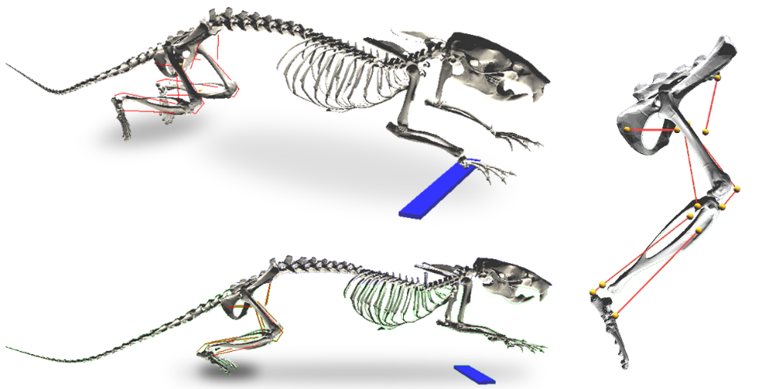

**Figure 1** Hunt's rat model. The torso and upper limbs are held stationary above the ground as the hindlimb muscles coordinate locomotion. Red lines indicate muscle paths and yellow markers represent muscle attachment points.

Muscle Attachment Points

Muscle paths are simulated by affixing muscle attachment points onto a 3D rat skeleton. These attachment points represent restraints on the muscle from ligaments and tendinous sheaths. Muscle contraction generates force between the muscle ends and, guided along the muscle path by intermediate attachment points, moves adjacent bone segments relative to one another.

Initially, muscle attachment point clouds were applied to the skeleton based on xyz-attachment coordinates from the literature (Will L. Johnson et al. 2008). The resulting hindlimb model was presented at Living Machines 2018 (Young, Hunt, and Quinn 2018). However, constraints in the modeling software rendered Johnson’s xyz-coordinates unusable because they lacked coordinates for “via” points, intermediate attachments along the muscle line of action that are necessary to guide the muscle around bones throughout joint motion. Additionally, Johnson’s xyz-coordinates are relative to bone-centric coordinate systems with axes based on poorly defined bony landmarks that were impossible to accurately identify on the simulated bone structures.

Rather than hand-tuning Johnson’s xyz-coordinates, I developed muscle lines of action based on anatomical drawings and descriptions from E.C. Greene’s 1955 publication Anatomy of the Rat (Greene 1955). This work provides detailed descriptions of muscle attachment points relative to bone structures, neighboring muscles, and tendons as well as muscle paths around bones. Due to limitations in the simulation software, it is only possible to represent muscles as lines of action with origin, insertion, and via points. For muscles with lines of attachment (such as the gluteus maximus running along the dorsal border of the ilium), a single attachment point was placed approximately halfway along the line of attachment.

## Kinematic Validation through Dynamic Muscle Moment Arm Profiles

To validate the many-muscle model against existing rodent hindlimb models, I analyzed dynamic moment arm profiles for muscle in the hindlimb. A muscle’s functional effect can be understood by analyzing its moment arm profile about a specific joint axis (Visser et al. 1990; S. W. Lee et al. 2008; Williams et al. 2008; Yeo et al. 2011; Charles et al. 2016). Moment arms are a representation of the mechanical advantage the muscle contractions have about a joint. Accurate muscle moment arm measurements are particularly important in small animals because tiny changes in the placement of muscle attachment points can dramatically impact torque generating calculations. Moment arm profiles are a useful metric whereby a model can be validated against existing hindlimb models.

Muscle moment arm profiles were calculated for an assortment of joint configurations by implementing two different joint motion patterns. The first pattern moved each joint independently through its entire range of motion (Fischer et al. 2002). Moment arms profiles from the first pattern were compared to profiles from two other hindlimb models in the literature (W. L. Johnson et al. 2011; Charles et al. 2016). Second, I implemented a nominal walking pattern (Fischer et al. 2002) to create 3D moment arm profiles for biarticular muscles. The nominal walking protocol illustrated the complex relationship that multi-joint motion has on the mechanical advantage of biarticular muscles, a property that is excluded in traditional single-joint moment arm profiles.

The resulting moment arm profiles showed that the newly developed model was a comparable alternative to existing rodent models and used fundamental principles of kinematic analysis to examine biarticular moment arms. In addition to calculating moment arm profiles, a sensitivity analysis was conducted to examine the impact of muscle attachment point placement on sagittal plane moment arm profiles. The sensitivity analysis showed that moment arm profiles were robust and maintained their shape across limb configurations even when muscle attachments were shifted independently. Moment arm analysis is discussed in detail in a paper published in the Journal of Biomimetics (Young et al. 2019).

## Publications

1. Young, F., Rode, C., Hunt, A. & Quinn, R. Analyzing Moment Arm Profiles in a Full-Muscle Rat Hindlimb Model. Biomimetics 4, 10 (2019).
2. Young, F., Hunt, A. J. & Quinn, R. D. A Neuromechanical Rat Model with a Complete Set of Hind Limb Muscles. in Biomimetic and Biohybrid Systems 527–537 (Springer, 2018).

# Aim 2 – Investigate muscle activation strategies that match experimentally observed torque measurements under nominal and perturbed conditions.

## Motivation

This aim describes methods for calculating muscle parameters for a Hill-type actuator (Hill Archibald Vivian 1938) in order to determine muscle forces and motorneuron activation necessary to induce locomotion. Passive joint torque calculations and optimization strategies for force distribution are presented. Calculation of motorneuron activation signals are discussed as well as the organization of neural structures for locomotion. Finally, the implementation of nervous-system driven locomotion under two environmental conditions is proposed.

To better understand how the nervous system coordinates locomotor activity in the rat, experimental measurements of leg dynamics are converted into motorneuron activation waveforms for each muscle in the hindlimb. Studies of locomotion and postural control have shown that motorneuron activation can be organized into functional groups commonly referred to as muscle synergies or modules (W. A. Lee 1984; d’Avella, Saltiel, and Bizzi 2003; Ting and Macpherson 2005; Tresch, Cheung, and d’Avella 2006). Understanding the role that synergies play in coordinating groups of muscles could provide insight into the spinal circuitry that underlies walking or serve as a novel method of robotic control.

Muscle synergies represent a form of nervous-to-body-system interface where the state of the external environment dictates the functional capabilities of the nervous system through its manifestation in the body. The division of the nervous system into organized groups reduces the complexity of the control system necessary to coordinate locomotion. Recent studies indicate that muscle synergies may not have a physical manifestation in the nervous system and are instead a statistical artifact that arises from the body meeting task-specific demands (Perreault et al. 2008; Tresch and Jarc 2009; Kutch and Valero-Cuevas 2011). Incorporating synergistic components with well-established CPG driven locomotion could suggest novel connections between the nervous system and the body.

By developing a nervous system to control the multi-muscle kinematic model described in Aim 1, it is possible to investigate different structural arrangements best-suited for controlled locomotion under nominal and perturbed conditions.

## Developing Muscle Parameters

Muscles are complex, multi-compartment organs whose force generating capabilities are tied to temporal and spatial properties related to its viscoelastic physiology. Models of kinematic and kinetic muscle relationships often rely on simplifications of the physiology using spring-damper models. Parameter values, representing model subcomponents, are tuned such that force-length-velocity relationships match experimental measurements. In instances where experimental data has not been gathered, parameter values can be determined by combining physiological data and pre-determined functional relationships.

This work uses a two-compartment Hill muscle model that is characterized by an elastic element in series with a contractile-elastic element. In the Hill model, elastic spring elements representing connective tissue are arranged in parallel to a damping element and a contractile element. The nonlinear tension of the Hill model has been formalized (Shadmehr and Arbib 1992),

,

where T is muscle tension,  is serial element stiffness,  is parallel element stiffness, L is muscle length, c is the muscle damping factor,  is muscle activation in Newtons, and  is a dimensionless tension-length percentage.

To the author’s knowledge, a complete formulation of Hill muscle parameters for all rat hindlimb muscles does not exist. Physiological parameters (muscle mass, optimal muscle length, etc.) for rat hindlimb muscles have been described by Johnson et al. (W. L. Johnson et al. 2011) and Eng et al. (Eng et al. 2008). Using functional muscle relationships and physiological parameters in the literature, it is possible to develop explicit parameters for the Hill model.

Two functional muscle relationships form the basis of force generating properties in the Hill model: the length-tension (LT) and the stimulus-tension (ST) relationships. The LT-curve relates a muscle’s force-generating capabilities at various isometric lengths while the ST-curve relates the membrane potential to force output. Key assumptions and simplifications for calculating hindlimb muscle parameters using the LT and ST curves are described below.

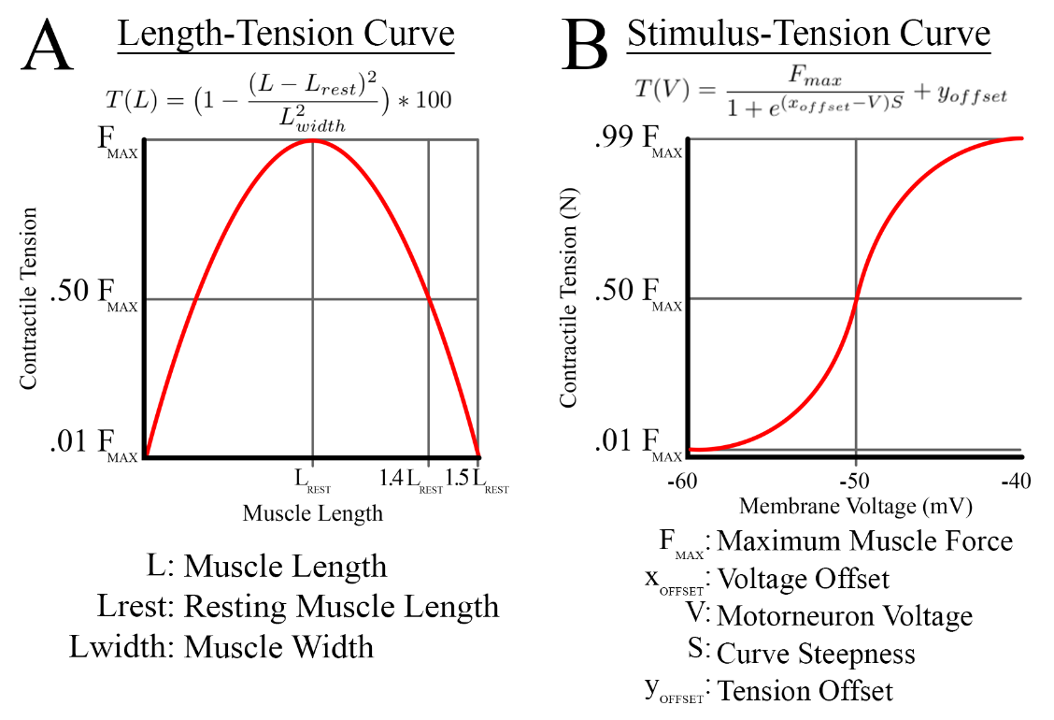

**Figure 2 A)** The length-tension curve relates the maximum attainable tension at an isometric length. **B)** The stimulus-tension curve relates the motorneuron activation to the tension in the muscle.

The simplified LT-curve shown in Figure 2A relates the maximal tension generating capability of muscle at different isometric tensions. Based on assumptions by Zajac (Zajac 1989), the muscle is capable of generating the maximum possible force at its resting potential and its lowest tension when the muscle was at 50% longer or shorter than the resting length. Using the curve shown in Figure 2A, I calculated,, and  values for each muscle by solving Equation 1 at steady state with optimal length and tensions values from Johnson (W. L. Johnson et al. 2011).

The ST-curve in Figure 2B relates the motorneuron activation to the tension in the contractile element of the muscle. No tension is generated at a resting potential of -60mV while at full activation (-40mV), the muscle generates a maximal contractile force. Using these boundary conditions, the slope of the sigmoid was calculated for every muscle.

## Completed Work: Passive Torque

To calculate torque generation during locomotion specifically produced by muscles, it is necessary to subtract the activity of passive torque. Passive torque stems from two sources: passive elastic properties of muscles and the weight of the animal. Figure 3 shows the total passive torque and the individual contributions of the load torque and muscle torque.

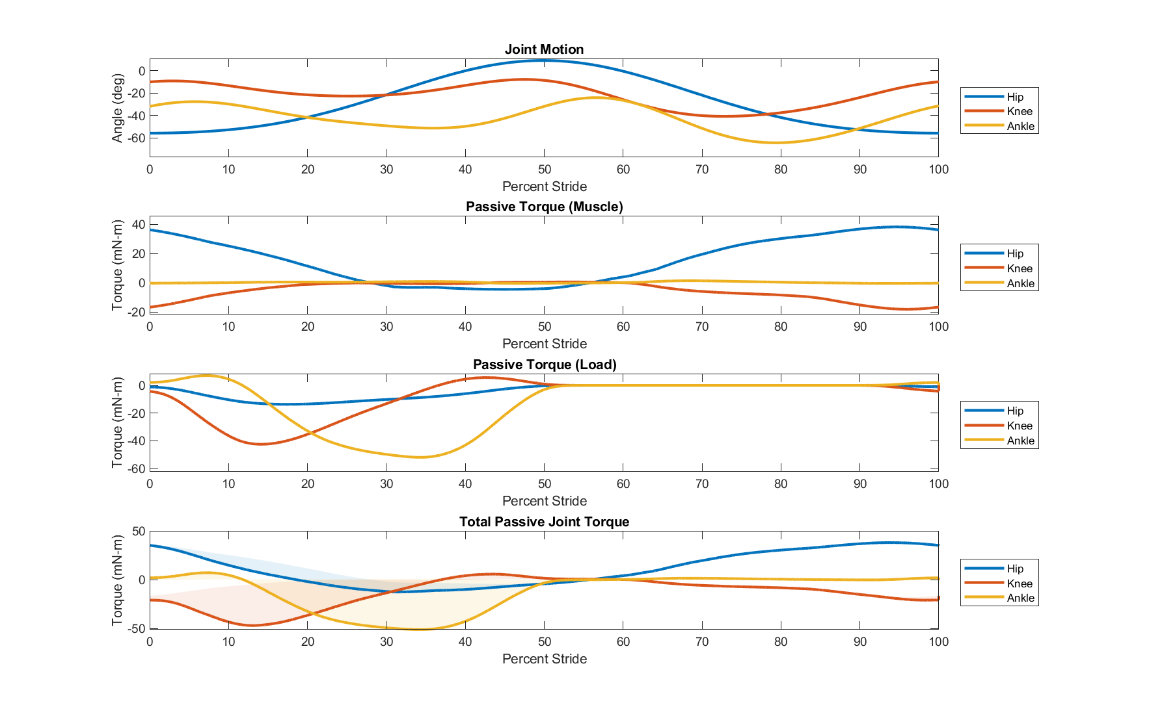

**Figure 3** Passive torque for hindlimb joints. Torque and joint angles are represented as extension-positive. Shaded areas in the total passive joint torque subplot represent the impact of the passive load torque on the muscle torque.

Passive elastic muscle force is only generated when the muscle length is extended beyond the resting muscle length. I calculate passive elastic force by evaluating the Hill equation without stimulus. Torque generated by passive elastic muscle force is the passive muscle force multiplied by the muscle moment arm at each time step during stride. This value is summed for all muscles about a specific joint.

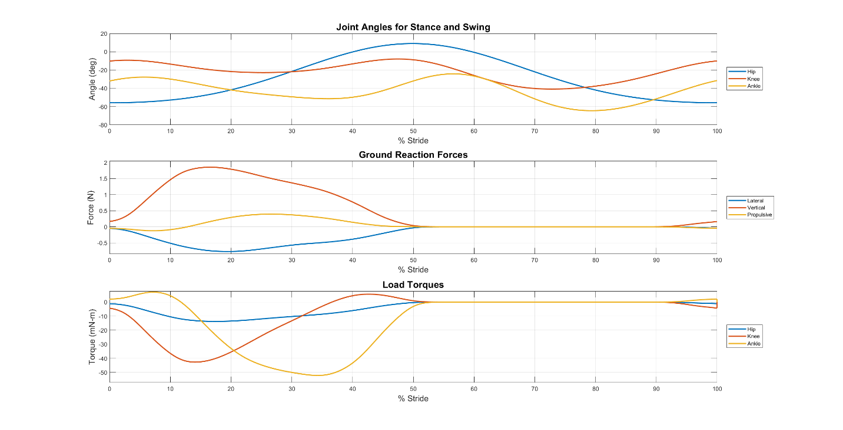

**Figure 4** Passive torques resulting from ground reaction forces. Ground reaction force data exists in three dimensions, although only the vertical and propulsive forces generate load torques in the sagittal hinge joints. Angles and torques are presented as extension-positive, meaning that high load torques cause hindlimb joint to flex.

Passive joint torque also manifests from the body weight of the animal pushing down on the hip joint during walking. I calculated this value, shown in Figure 4, by treating the leg as a multi-segment arm and using the ground reaction forces (GRFs) to calculate the induced joint torque. Passive torque from body weight was calculated by computing the spatial manipulator Jacobian, an operator for converting end effector forces into torques at the joints (Murray, Li, and Sastry 1994). GRFs were generated from the three dimensional data from Muir et al. (Muir and Whishaw 1999).

## Completed Work: Implemented Multiple Optimization Functions

To distribute the total torque profile between individual muscle contributions, I implemented multiple optimization criteria. Force optimization is a common method of addressing the infinite possible solutions that exist for force generation of the over actuated muscle system. Most methods distribute forces based on a physiological metric, such as muscle length or cross section.

Previous approaches minimize cumulative muscle parameters such as force (Pedotti, Krishnan, and Stark 1978; Penrod, Davy, and Singh 1974), stress (Crowninshield and Brand 1981), activation (Kaufman et al. 1991), and fatigue (Prilutsky and Zatsiorsky 2002). These optimization methods have been applied to force sharing in cat hindlimbs but, although some cost functions are better in certain situations, none of the aforementioned methods perfectly recreate experimental results (Herzog and Leonard 1991). The development of an optimization method that perfectly recreates experimentally recorded data is an ongoing research topic.

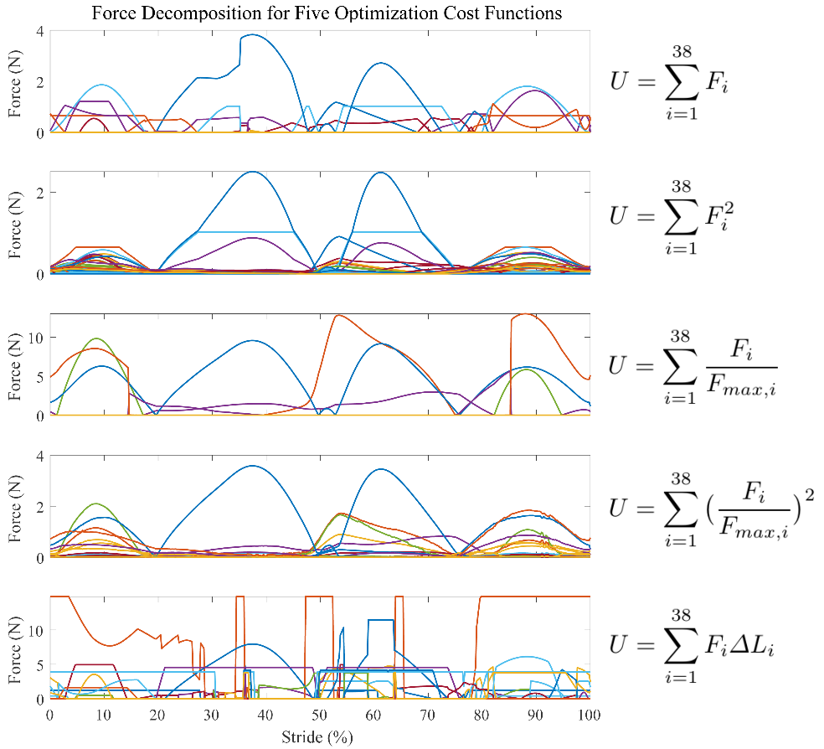Initially, I minimized the summed muscle forces at each time step during a single stride using linear optimization. While it is true that the torque profile is comprised of a linear combination of muscle torques (i.e. ), linear optimization solutions fall on what Crowninshield et al. refers to as an “optimization corner” of the solution space. Optimization corners cause jagged force profiles, shown in Figure 5, that are not indicative of actual muscle contractions. The failure of this method to produce viable force profiles demanded a nonlinear optimization equation instead.

**Figure 5** Force decomposition using five different optimization cost functions analyzed by Pedotti et al. Muscle force profiles are bounded such that they are always positive and less than the maximum muscle force. In each case, the function on the right is minimized such that the summation of the resulting individual muscle torques equals the experimentally derived global torque profile.

I have evaluated force distribution results from multiple cost functions from Pedotti et al. and Seireg et al. (Seireg and Arvikar 1973), including linear and nonlinear cost functions. The results of this analysis are shown in Figure 5, with the most suitable cost function appearing to be the fourth cost function from Pedotti et al., which relates muscle forces to their maximum values squared.

## Aim 2 Proposed Work: Analyzing How the Hill Parameter Space Affects Force Decomposition and EMG Modeling

A number of musculoskeletal models use Hill muscles but few discuss parameter calculations, underlying assumptions, or whether the model matches experimental data for individual muscles. Using muscle force or EMG data from research partners, it would be possible to make the model more biologically representative by optimizing muscle parameters. A publication that explores how varying the Hill parameter space impacts the optimized force distribution could identify parameters that are more important for neuromechanical modeling.

Additionally, modeled EMG signals can be compared to muscle recordings gathered by research collaborators. To find the neural stimulation necessary to induce the optimized force profiles, the ST equation can be solved for motorneuron voltage. Varying Hill parameters could provide insight into which muscular properties have the biggest impact on EMG signals.

## Aim 2 Proposed Work: Neural Control Based on Synergy Decomposition of Modeled EMGs

Statistical methods are used to decompose aggregate electromyography (EMG) measurements from many muscles into synergies. Multiple matrix factorization techniques have been used to characterize synergy profiles (Tresch, Cheung, and d’Avella 2006; Torres-Oviedo and Ting 2007; Taborri et al. 2018), with the most common being nonnegative matrix factorization (NNMF) (D. D. Lee and Seung 2001; Berry et al. 2007; Ting et al. 2012). In NNMF, rectified, low-pass filtered EMG recordings are decomposed into a set of spatial vectors, representing time invariant muscle activation profiles, and temporal vectors, representing the timing of synergy coactivation. These vectors can then be compared across subjects or a variety of tasks to identify recurring features that may suggest the underlying neural basis for specific synergy profiles.

I have already applied NNMF algorithms to the raw force data, as shown in Figure 6. This algorithm has been tested on the force data first because EMG data has not been derived from the force waveforms yet. The process for NNMF will be identical when the input is EMG data. The number of synergies is commonly determined by meeting a Pearson correlation value between the recombined signal and the original signal. For this work, the synergy number was set to 5 for simplicity.

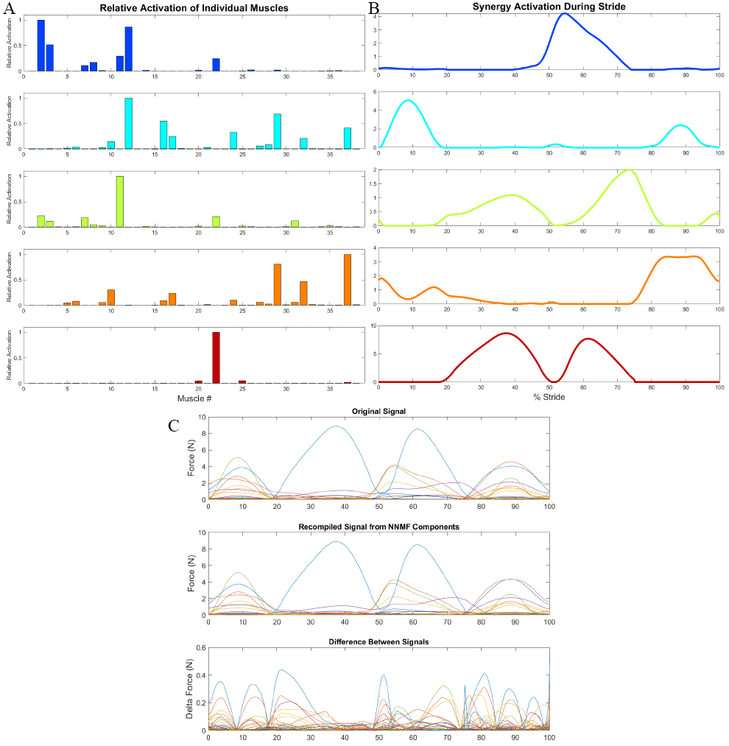

**Figure 6** NNMF Applied to optimized force data from the multi-muscle hindlimb model. A) Time-invariant, relative activation of individual muscles within five synergies. B) Magnitude of synergy activation during stride. C) The original input signal and the signal generated by recombining the synergy components derived by the NNMF process. The difference between the signals is shown in the third panel.

Using the data from the NNMF decomposition, it is possible to integrate the synergy profiles as groups of synaptic connections from a single “synergy” neuron that is driven by upstream CPGs. Further work needs to be done to identify specific neural topology capable of coordinating locomotion using this technique. The integration of biarticular muscle (muscles that span more than one joint) control has been explored in the context of Hunt’s model but not et implemented into the full-muscle model (Deng et al. 2019).

One possibility for this integration is through a design process for the creation of large-scale, stable models of the nervous system using modular components called functional subnetworks (FSNs) with known input-output relationships (Szczecinski, Hunt, and Quinn 2017). The implementation of a nervous system using the FSN approach allows for modular expansion of a system as new biological systems are discovered. The focus on functional relationships also makes the FSN a useful tool for robotic control networks, as has been shown in a robot modeled after a praying mantis (Szczecinski et al. 2017).

## Aim 2 Proposed Work: Investigating the Impact of Perturbed vs. Nominal Environments on EMG Signal Generation

Stimuli in the form of environmental perturbations (irregular ground conditions, obstacles, etc.) that are implemented in experimental protocols cause changes in locomotion that suggest novel reflexive connections in the nervous system. Sensory feedback systems modulate reflexes in the absence of cognitive activity, providing an unbiased glimpse into the activity of locomotion pathways. Implementing perturbations in simulation would allow for the comparison of experimental data and provide insight into necessary modifications of nervous systems designed for nominal locomotion.

# Aim 3 – Design a novel simulation package for morphological neural network control of physics-based, muscular neuromechanical models in dynamic environments.

## Motivation

To facilitate the kind of holistic analysis necessary to capture multi-level effects of the environment on nervous system development, I propose a novel simulation package developed in an open-source engine that is capable of implementing large-scale morphological neural networks, physics-based body dynamics, and dynamic environments.

To better understand neural systems across species, it is imperative that simulation tools exist that facilitate generalizable research focuses but also detailed enough to answer questions about specific biological systems. Contemporary biological modeling environments each have their own strengths and weaknesses. Most notably, few simulation tools allow users to model *both* the neural and body systems. The few simulation environments that do have a number of shortcomings that restrict the development of morphological nervous systems.

As FSN design implementation matures, a novel simulation environment is necessary to meet the complexity demands of large-scale FSN system design. Hunt's six-muscle model used over 40 neurons to control locomotion, suggesting that a thirty-eight-muscle model would require hundreds of neurons to generate the same performance. While the reduced complexity through hardcoded synergies is promising, this method is not generalizable to other neural systems.

## Background

There are many tools used in computational neuroscience today, many of which are highly specialized for a specific research goal. Simulation environments relevant to this work largely fall into three categories: neural, physics, or both. In developing a novel simulation package, it is important understand the current landscape of tools used today.

Simulation tools that analyze the nervous system often do so in isolation from the body. This is useful because it reduces the complexity of the experimental design by discounting the complex feedback mechanisms from afferent sensory signals. However, simulating the nervous system in isolation fails to acknowledge the co-evolution of the system in conjunction with peripheral body systems (Chiel and Beer 1997).

Physics-only simulation environments like OpenSim (Seth et al. 2011) and Gazebo are useful for investigating body system dynamics. The body’s ability to manipulate the world is crucial to understanding what the body *can* do and is oftentimes the easiest system to analyze because it can be done noninvasively by studying kinematics. Physics-only environments fail to capture the control schemes used by animals, though, which are fundamental to the task-level compliance that allows animals to respond to changes in the environment.

Two known simulation packages are capable of modeling all three systems simultaneously: Animatlab (Cofer et al. 2010) and the Human Brain Project’s Neurorobotics platform (NRP) (Falotico et al. 2017). These packages allow users to implement a specific neural system onto a physic-based body and deploy it in an environment. Although each environment has individual strengths, both have a number of shortcomings that make designing a complete animal difficult.

Animatlab has been used in multiple FSN design projects but restricts large-scale network design due to a number of application constraints. Oftentimes, it is important to understand the underlying basis for how data is being calculated in a model to make predictions for experimental design. Animatlab is compiled in the C programming language, making it difficult to modify underlying calculations or understand what calculations are happening "under the hood" of the program.

Animatlab’s Hill-type muscle model includes a number of simplifications that fail to capture the complete activity of muscle activation. A simplified ST-curve fails to capture many of the nuances associated with the stimulation mechanics of muscles, such as twitch mechanics (Spector et al. 1980) or the time delay between EMG signal onset and measured force (Buchanan et al. 2004; Corcos et al. 1992). Animatlab’s LT-curve has an identical relationship during lengthening and shortening and fails to account for the effects of fatigue over time. Features like an explicit force-velocity relationship or the inclusion of a muscle’s pennation angle are also absent.

Additionally, navigating Animatlab’s user interface is tenuous when designing large-scale nervous systems. In the physics module, it is impossible to wrap muscles around bone, prevent muscle pass-through, or create muscle insertion lines along surfaces. Basic quality of life functionality such as an “undo” button is also missing. Finally, Animatlab is no longer supported by the developer which makes its functionality in future software updates increasingly unlikely.

As an alternative, the NRP is a platform with a strong financial and technical support network. The NRP acts as an integration hub for many other simulation tools, thus outsourcing the computational burden onto different subcomponents individually. Users are able to develop nervous systems in PyNN, a neural network environment for Python that supports NEURON, NEST, and Brian. PyNN is a powerful tool for modeling populations of neurons and allows for large-scale implementation of neural systems. For the body systems, the NRP uses Gazebo, a popular robotic platform for prototyping robot designs in physics environments.

The NRP is a valuable tool for robotic modeling but fails to capture the morphological basis of neural design that is important for biological study. Neural control uses pools of neurons for mapping brain structures similar to deep learning algorithms where direct synaptic connections are largely ignored. This approach to neural control deprioritizes the structure of the nervous system in favor of functional relationships.

## Aim 3 Proposed Work: A Novel Neuromechanical Simulation Package

I propose the development of a novel simulation package developed on an open source platform that integrates FSN design principles with sophisticated muscle models in dynamic physics-based environments. A simulation package of this nature would aid research on many animal systems and allow for customization over time from a variety of developers. It would also be capable of implementing effects not currently available in simulation environments, such as the implementation of scaling effects for animals of different sizes.

As a first step in creating a novel simulation package, I have developed a Matlab project called “Canvas” that allows users to automatically generate FSN subsystems and deploy the networks in Animatlab for simulation. This simulation project contains an FSN "toolbox" that reduces the burden of hand-designing networks through the automatic calculations of synaptic parameters.

A simulation package with the maximum possible availability should rely on open-source materials to avoid any portions of the project being blocked by paywalls. Although Canvas is a useful first step for large-scale FSN design, Matlab is proprietary software with limited user engagement. Although Matlab functionality is expanding through the implementation of self-contained “projects”, the program was not created to handle the types of user interaction necessary to rival software like Animatlab. For this reason, it is necessary to consider alternatives for developing neuromechanical simulators.

Python is an open-source programming language with a wealth of community resources for project development and has been deployed in millions of research and commercial projects. Most notably, Python contains a repository of open-source packages related to creating things in physics environments and generating GUI's.

## References

Avella, Andrea d’, Philippe Saltiel, and Emilio Bizzi. 2003. “Combinations of Muscle Synergies in the Construction of a Natural Motor Behavior.” *Nature Neuroscience* 6 (3): 300–308. https://doi.org/10.1038/nn1010.

Beer, Randall D., Hillel J. Chiel, and John C. Gallagher. 1999. “Evolution and Analysis of Model CPGs for Walking: II. General Principles and Individual Variability.” *Journal of Computational Neuroscience* 7 (2): 119–47. https://doi.org/10.1023/A:1008920021246.

Beer, Randall D., Roger D. Quinn, Hillel J. Chiel, and Roy E. Ritzmann. 1997. “Biologically Inspired Approaches to Robotics: What Can We Learn from Insects?” *Commun. ACM* 40 (3): 30–38. https://doi.org/10.1145/245108.245118.

Berry, Michael W., Murray Browne, Amy N. Langville, V. Paul Pauca, and Robert J. Plemmons. 2007. “Algorithms and Applications for Approximate Nonnegative Matrix Factorization.” *Computational Statistics & Data Analysis* 52 (1): 155–73. https://doi.org/10.1016/j.csda.2006.11.006.

Buchanan, Thomas S., David G. Lloyd, Kurt Manal, and Thor F. Besier. 2004. “Neuromusculoskeletal Modeling: Estimation of Muscle Forces and Joint Moments and Movements From Measurements of Neural Command.” *Journal of Applied Biomechanics* 20 (4): 367–95.

Chang, Sarah R., Mark J. Nandor, Lu Li, Rudi Kobetic, Kevin M. Foglyano, John R. Schnellenberger, Musa L. Audu, Gilles Pinault, Roger D. Quinn, and Ronald J. Triolo. 2017. “A Muscle-Driven Approach to Restore Stepping with an Exoskeleton for Individuals with Paraplegia.” *Journal of NeuroEngineering and Rehabilitation* 14 (1): 48. https://doi.org/10.1186/s12984-017-0258-6.

Charles, James P., Ornella Cappellari, Andrew J. Spence, Dominic J. Wells, and John R. Hutchinson. 2016. “Muscle Moment Arms and Sensitivity Analysis of a Mouse Hindlimb Musculoskeletal Model.” *Journal of Anatomy* 229 (4): 514–35. https://doi.org/10.1111/joa.12461.

Chiel, Hillel J., and Randall D. Beer. 1997. “The Brain Has a Body: Adaptive Behavior Emerges from Interactions of Nervous System, Body and Environment.” *Trends in Neurosciences* 20 (12): 553–57. https://doi.org/10.1016/S0166-2236(97)01149-1.

Chiel, Hillel J., Randall D. Beer, and Leon S. Sterling. 1988. “Heterogeneous Neural Networks for Adaptive Behavior in Dynamic Environments.” In *Proceedings of the 1st International Conference on Neural Information Processing Systems*, 577–585. NIPS’88. Cambridge, MA, USA: MIT Press. http://dl.acm.org/citation.cfm?id=2969735.2969802.

Chiel, Hillel J., Lena H. Ting, Örjan Ekeberg, and Mitra J. Z. Hartmann. 2009. “The Brain in Its Body: Motor Control and Sensing in a Biomechanical Context.” *Journal of Neuroscience* 29 (41): 12807–14. https://doi.org/10.1523/JNEUROSCI.3338-09.2009.

Cofer, David, Gennady Cymbalyuk, James Reid, Ying Zhu, William J. Heitler, and Donald H. Edwards. 2010. “AnimatLab: A 3D Graphics Environment for Neuromechanical Simulations.” *Journal of Neuroscience Methods* 187 (2): 280–88. https://doi.org/10.1016/j.jneumeth.2010.01.005.

Corcos, Daniel M., Gerald L. Gottlieb, Mark L. Latash, Gil L. Almeida, and Gyan C. Agarwal. 1992. “Electromechanical Delay: An Experimental Artifact.” *Journal of Electromyography and Kinesiology* 2 (2): 59–68. https://doi.org/10.1016/1050-6411(92)90017-D.

Crowninshield, Roy D., and Richard A. Brand. 1981. “A Physiologically Based Criterion of Muscle Force Prediction in Locomotion.” *Journal of Biomechanics* 14 (11): 793–801. https://doi.org/10.1016/0021-9290(81)90035-X.

Deng, Kaiyu, Nicholas S. Szczecinski, Dirk Arnold, Emanuel Andrada, Martin S. Fischer, Roger D. Quinn, and Alexander J. Hunt. 2019. “Neuromechanical Model of Rat Hindlimb Walking with Two-Layer CPGs.” *Biomimetics* 4 (1): 21. https://doi.org/10.3390/biomimetics4010021.

Eng, Carolyn M., Laura H. Smallwood, Maria Pia Rainiero, Michele Lahey, Samuel R. Ward, and Richard L. Lieber. 2008. “Scaling of Muscle Architecture and Fiber Types in the Rat Hindlimb.” *Journal of Experimental Biology* 211 (14): 2336–45. https://doi.org/10.1242/jeb.017640.

Falotico, Egidio, Lorenzo Vannucci, Alessandro Ambrosano, Ugo Albanese, Stefan Ulbrich, Juan Camilo Vasquez Tieck, Georg Hinkel, et al. 2017. “Connecting Artificial Brains to Robots in a Comprehensive Simulation Framework: The Neurorobotics Platform.” *Frontiers in Neurorobotics* 11. https://doi.org/10.3389/fnbot.2017.00002.

Fischer, Martin S., Nadja Schilling, Manuela Schmidt, Dieter Haarhaus, and Hartmut Witte. 2002. “Basic Limb Kinematics of Small Therian Mammals.” *Journal of Experimental Biology* 205 (9): 1315–38.

Greene, E. C. 1955. *Anatomy of the Rat.* New York: Hafner Publishing Co. https://www.cabdirect.org/cabdirect/abstract/19561405416.

Herzog, W., and T. R. Leonard. 1991. “Validation of Optimization Models That Estimate the Forces Exerted by Synergistic Muscles.” *Journal of Biomechanics*, Proceedings of the NASA Symposium on the Influence of Gravity and Activity on Muscle and Bone, 24 (January): 31–39. https://doi.org/10.1016/0021-9290(91)90375-W.

Hill Archibald Vivian. 1938. “The Heat of Shortening and the Dynamic Constants of Muscle.” *Proceedings of the Royal Society of London. Series B - Biological Sciences* 126 (843): 136–95. https://doi.org/10.1098/rspb.1938.0050.

Hunt, Alexander. 2016. “Neurologically Based Control for Quadruped Walking.” Cleveland, OH: Case Western Reserve University.

Hunt, Alexander, Manuela Schmidt, Martin Fischer, and Roger D. Quinn. 2014. “Neuromechanical Simulation of an Inter-Leg Controller for Tetrapod Coordination.” In *Biomimetic and Biohybrid Systems*, edited by Armin Duff, Nathan F. Lepora, Anna Mura, Tony J. Prescott, and Paul F. M. J. Verschure, 142–53. Lecture Notes in Computer Science. Springer International Publishing.

Hunt, Alexander, Nicholas Szczecinski, and Roger Quinn. 2017. “Development and Training of a Neural Controller for Hind Leg Walking in a Dog Robot.” *Frontiers in Neurorobotics* 11. https://doi.org/10.3389/fnbot.2017.00018.

Hunt, Alexander, Nicholas S. Szczecinski, Emanuel Andrada, Martin Fischer, and Roger D. Quinn. 2015. “Using Animal Data and Neural Dynamics to Reverse Engineer a Neuromechanical Rat Model.” In *Biomimetic and Biohybrid Systems*, edited by Stuart P. Wilson, Paul F.M.J. Verschure, Anna Mura, and Tony J. Prescott, 211–22. Lecture Notes in Computer Science. Springer International Publishing.

Johnson, W. L., D. L. Jindrich, H. Zhong, R. R. Roy, and V. R. Edgerton. 2011. “Application of a Rat Hindlimb Model: A Prediction of Force Spaces Reachable Through Stimulation of Nerve Fascicles.” *IEEE Transactions on Biomedical Engineering* 58 (12): 3328–38. https://doi.org/10.1109/TBME.2011.2106784.

Johnson, Will L., Devin L. Jindrich, Roland R. Roy, and V. Reggie Edgerton. 2008. “A Three-Dimensional Model of the Rat Hindlimb: Musculoskeletal Geometry and Muscle Moment Arms.” *Journal of Biomechanics* 41 (3): 610–19. https://doi.org/10.1016/j.jbiomech.2007.10.004.

Kaufman, K. R., K. -N. An, W. J. Litchy, and E. Y. S. Chao. 1991. “Physiological Prediction of Muscle Forces—I. Theoretical Formulation.” *Neuroscience* 40 (3): 781–92. https://doi.org/10.1016/0306-4522(91)90012-D.

Kutch, Jason J., and Francisco J. Valero-Cuevas. 2011. “Muscle Redundancy Does Not Imply Robustness to Muscle Dysfunction.” *Journal of Biomechanics* 44 (7): 1264–70. https://doi.org/10.1016/j.jbiomech.2011.02.014.

Lakatos, D., A. Albu-Schäffer, C. Rode, and F. Loeffl. 2016. “Dynamic Bipedal Walking by Controlling Only the Equilibrium of Intrinsic Elasticities.” In *2016 IEEE-RAS 16th International Conference on Humanoid Robots (Humanoids)*, 1282–89. https://doi.org/10.1109/HUMANOIDS.2016.7803435.

Lee, Daniel D., and H. Sebastian Seung. 2001. “Algorithms for Non-Negative Matrix Factorization.” In *Advances in Neural Information Processing Systems 13*, edited by T. K. Leen, T. G. Dietterich, and V. Tresp, 556–562. MIT Press. http://papers.nips.cc/paper/1861-algorithms-for-non-negative-matrix-factorization.pdf.

Lee, Sang Wook, Hua Chen, Joseph D. Towles, and Derek G. Kamper. 2008. “Estimation of the Effective Static Moment Arms of the Tendons in the Index Finger Extensor Mechanism.” *Journal of Biomechanics* 41 (7): 1567–73. https://doi.org/10.1016/j.jbiomech.2008.02.008.

Lee, Wynne A. 1984. “Neuromotor Synergies as a Basis for Coordinated Intentional Action.” *Journal of Motor Behavior* 16 (2): 135–70. https://doi.org/10.1080/00222895.1984.10735316.

McCrea, David A., and Ilya A. Rybak. 2008. “Organization of Mammalian Locomotor Rhythm and Pattern Generation.” *Brain Research Reviews*, Networks in Motion, 57 (1): 134–46. https://doi.org/10.1016/j.brainresrev.2007.08.006.

Muir, G. D., and Ian Q. Whishaw. 1999. “Ground Reaction Forces in Locomoting Hemi-Parkinsonian Rats: A Definitive Test for Impairments and Compensations.” *Experimental Brain Research* 126 (3): 307–14. https://doi.org/10.1007/s002210050739.

Murray, Richard M., Zexiang Li, and S. Shankar Sastry. 1994. *A Mathematical Introduction to Robotic Manipulation*. CRC Press.

Nishikawa, Kiisa, Andrew A. Biewener, Peter Aerts, Anna N. Ahn, Hillel J. Chiel, Monica A. Daley, Thomas L. Daniel, et al. 2007. “Neuromechanics: An Integrative Approach for Understanding Motor Control.” *Integrative and Comparative Biology* 47 (1): 16–54. https://doi.org/10.1093/icb/icm024.

Pedotti, A., V. V. Krishnan, and L. Stark. 1978. “Optimization of Muscle-Force Sequencing in Human Locomotion.” *Mathematical Biosciences* 38 (1): 57–76. https://doi.org/10.1016/0025-5564(78)90018-4.

Penrod, D.D., D.T. Davy, and D.P. Singh. 1974. “An Optimization Approach to Tendon Force Analysis.” *Journal of Biomechanics* 7 (2): 123–29. https://doi.org/10.1016/0021-9290(74)90050-5.

Perreault, Eric J., Kuifu Chen, Randy D. Trumbower, and Gwyn Lewis. 2008. “Interactions With Compliant Loads Alter Stretch Reflex Gains But Not Intermuscular Coordination.” *Journal of Neurophysiology* 99 (5): 2101–13. https://doi.org/10.1152/jn.01094.2007.

Pfeifer, Rolf, Max Lungarella, and Fumiya Iida. 2007. “Self-Organization, Embodiment, and Biologically Inspired Robotics.” *Science* 318 (5853): 1088–93. https://doi.org/10.1126/science.1145803.

Prilutsky, Boris I., and Vladimir M. Zatsiorsky. 2002. “Optimization-Based Models of Muscle Coordination.” *Exercise and Sport Sciences Reviews* 30 (1): 32.

Schrade, Stefan O., Katrin Dätwyler, Marius Stücheli, Kathrin Studer, Daniel-Alexander Türk, Mirko Meboldt, Roger Gassert, and Olivier Lambercy. 2018. “Development of VariLeg, an Exoskeleton with Variable Stiffness Actuation: First Results and User Evaluation from the CYBATHLON 2016.” *Journal of NeuroEngineering and Rehabilitation* 15 (1): 18. https://doi.org/10.1186/s12984-018-0360-4.

Seireg, A., and R.J. Arvikar. 1973. “A Mathematical Model for Evaluation of Forces in Lower Extremeties of the Musculo-Skeletal System.” *Journal of Biomechanics* 6 (3): 313–26. https://doi.org/10.1016/0021-9290(73)90053-5.

Seth, Ajay, Michael Sherman, Jeffrey A. Reinbolt, and Scott L. Delp. 2011. “OpenSim: A Musculoskeletal Modeling and Simulation Framework for in Silico Investigations and Exchange.” *Procedia IUTAM*, IUTAM Symposium on Human Body Dynamics, 2 (January): 212–32. https://doi.org/10.1016/j.piutam.2011.04.021.

Shadmehr, Reza, and Michael A. Arbib. 1992. “A Mathematical Analysis of the Force-Stiffness Characteristics of Muscles in Control of a Single Joint System.” *Biological Cybernetics* 66 (6): 463–77. https://doi.org/10.1007/BF00204111.

Sharbafi, Maziar Ahmad, Christian Rode, Stefan Kurowski, Dorian Scholz, Rico Möckel, Katayon Radkhah, Guoping Zhao, Aida Mohammadinejad Rashty, Oskar von Stryk, and Andre Seyfarth. 2016. “A New Biarticular Actuator Design Facilitates Control of Leg Function in BioBiped3.” *Bioinspiration & Biomimetics* 11 (4): 046003. https://doi.org/10.1088/1748-3190/11/4/046003.

Spector, S. A., P. F. Gardiner, R. F. Zernicke, R. R. Roy, and V. R. Edgerton. 1980. “Muscle Architecture and Force-Velocity Characteristics of Cat Soleus and Medial Gastrocnemius: Implications for Motor Control.” *Journal of Neurophysiology* 44 (5): 951–60. https://doi.org/10.1152/jn.1980.44.5.951.

Szczecinski, Nicholas S., Andrew P. Getsy, Joshua P. Martin, Roy E. Ritzmann, and Roger D. Quinn. 2017. “Mantisbot Is a Robotic Model of Visually Guided Motion in the Praying Mantis.” *Arthropod Structure & Development*, From Insects to Robots, 46 (5): 736–51. https://doi.org/10.1016/j.asd.2017.03.001.

Szczecinski, Nicholas S., Alexander J. Hunt, and Roger D. Quinn. 2017. “A Functional Subnetwork Approach to Designing Synthetic Nervous Systems That Control Legged Robot Locomotion.” *Frontiers in Neurorobotics* 11. https://doi.org/10.3389/fnbot.2017.00037.

Taborri, Juri, Valentina Agostini, Panagiotis K. Artemiadis, Marco Ghislieri, Daniel A. Jacobs, Jinsook Roh, and Stefano Rossi. 2018. “Feasibility of Muscle Synergy Outcomes in Clinics, Robotics, and Sports: A Systematic Review.” Research article. Applied Bionics and Biomechanics. 2018. https://doi.org/10.1155/2018/3934698.

Ting, Lena H., Stacie A. Chvatal, Seyed A. Safavynia, and J. Lucas McKay. 2012. “Review and Perspective: Neuromechanical Considerations for Predicting Muscle Activation Patterns for Movement.” *International Journal for Numerical Methods in Biomedical Engineering* 28 (10): 1003–14. https://doi.org/10.1002/cnm.2485.

Ting, Lena H., and Jane M. Macpherson. 2005. “A Limited Set of Muscle Synergies for Force Control During a Postural Task.” *Journal of Neurophysiology* 93 (1): 609–13. https://doi.org/10.1152/jn.00681.2004.

Torres-Oviedo, Gelsy, and Lena H. Ting. 2007. “Muscle Synergies Characterizing Human Postural Responses.” *Journal of Neurophysiology* 98 (4): 2144–56. https://doi.org/10.1152/jn.01360.2006.

Tresch, Matthew C., Vincent C. K. Cheung, and Andrea d’Avella. 2006. “Matrix Factorization Algorithms for the Identification of Muscle Synergies: Evaluation on Simulated and Experimental Data Sets.” *Journal of Neurophysiology* 95 (4): 2199–2212. https://doi.org/10.1152/jn.00222.2005.

Tresch, Matthew C, and Anthony Jarc. 2009. “The Case for and against Muscle Synergies.” *Current Opinion in Neurobiology*, Motor systems • Neurology of behaviour, 19 (6): 601–7. https://doi.org/10.1016/j.conb.2009.09.002.

Visser, J. J., J. E. Hoogkamer, M. F. Bobbert, and P. A. Huijing. 1990. “Length and Moment Arm of Human Leg Muscles as a Function of Knee and Hip-Joint Angles.” *European Journal of Applied Physiology and Occupational Physiology* 61 (5): 453–60. https://doi.org/10.1007/BF00236067.

Webster-Wood, Victoria A., Ozan Akkus, Umut A. Gurkan, Hillel J. Chiel, and Roger D. Quinn. 2017. “Organismal Engineering: Toward a Robotic Taxonomic Key for Devices Using Organic Materials.” *Science Robotics* 2 (12): eaap9281. https://doi.org/10.1126/scirobotics.aap9281.

Williams, S. B., A. M. Wilson, L. Rhodes, J. Andrews, and R. C. Payne. 2008. “Functional Anatomy and Muscle Moment Arms of the Pelvic Limb of an Elite Sprinting Athlete: The Racing Greyhound (Canis Familiaris).” *Journal of Anatomy* 213 (4): 361–72. https://doi.org/10.1111/j.1469-7580.2008.00961.x.

Yeo, Sang Hoon, Christopher H. Mullens, Thomas G. Sandercock, Dinesh K. Pai, and Matthew C. Tresch. 2011. “Estimation of Musculoskeletal Models from in Situ Measurements of Muscle Action in the Rat Hindlimb.” *Journal of Experimental Biology* 214 (5): 735–46. https://doi.org/10.1242/jeb.049163.

Young, Fletcher, Alexander J. Hunt, and Roger D. Quinn. 2018. “A Neuromechanical Rat Model with a Complete Set of Hind Limb Muscles.” In *Biomimetic and Biohybrid Systems*, 527–37. Paris, France: Springer.

Young, Fletcher, Christian Rode, Alex Hunt, and Roger Quinn. 2019. “Analyzing Moment Arm Profiles in a Full-Muscle Rat Hindlimb Model.” *Biomimetics* 4 (1): 10. https://doi.org/10.3390/biomimetics4010010.

Zajac, F. E. 1989. “Muscle and Tendon: Properties, Models, Scaling, and Application to Biomechanics and Motor Control.” *Critical Reviews in Biomedical Engineering* 17 (4): 359–411.