## 2021数模准备

[竞赛网站](https://www.comap.com/undergraduate/contests/)

### 题目说明

1. **类型**

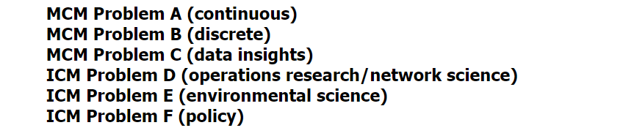

2.**获奖情况**

