Single Trial detection toolbox for Evoked Potentials
Single Trial detection toolbox for EPilepsy (Version 1.1)
— STEP1 User Manual (May 11, 2012)

Li Hu
Southwest University
E-mail: huli@swu.edu.cn; hulitju@gmail.com
Contents
1 Introduction..........................................................................................................................(2)
2 Software requirements.........................................................................................................(2)
3 Installation, quick start guide & getting help........................................................................(2)
4 Importing/Exporting data into STEP1...................................................................................(3)
5 Pre-processing in STEP1........................................................................................................(5)
6 Single-trial analysis...............................................................................................................(8)
6.1 Time domain..............................................................................................................(8)
6.1.1 Wavelet Filter (WF, filter only) ........................................................................(8)
6.1.2 Multiple Linear Regression (MLR) ...................................................................(9)
6.1.3 Multiple Linear Regression with Dispersion Term (MLRd) ............................(11)
6.1.4 WF+MLR........................................................................................................(13)
6.1.5 WF+MLRd......................................................................................................(14)
6.2 Plotting Single-trial analysis results..........................................................................(14)
6.3. Saving estimated Single-trial values........................................................................(14)
7 Spectral analysis.................................................................................................................(14)
8 Time-frequency analysis.....................................................................................................(16)
8.1 Preliminary time-frequency analysis........................................................................(16)
8.2 Time-frequency ROI analysis....................................................................................(17)

1 Introduction
This manual provides an overview of (1) the Single Trial detection toolbox for Evoked potentials and EPilepsy, and (2) spectral and time-frequency analysis of EEG responses (version 1.1: STEP1). STEP1 is an interactive Matlab toolbox for performing single-trial estimation of EEG (ERP/Epilepsy) parameters in the time domain and the estimation of EEG spectrum and time-frequency distribution. In the time domain, single-trial detection methods in STEP1 includes (1) Wavelet filtering (WF), (2) Multiple linear regression (MLR), (3) Multiple Linear Regression with Dispersion Term (MLRd), (4) the combination of WF and MLR (WF+MLR), (5) the combination of WF and MLRd (WF+MLRd). In addition, the EEG spectrum is estimated using fast Fourier transform (FFT), and the time-frequency distribution of EEG responses is calculated using continuous Wavelet transform (CWT).

2 Software requirements
STEP1 requires the MATLAB system to be installed. In addition, STEP1 is fully compatible with EEGLAB, which is an Open Source Matlab Toolbox for Electrophysiological Research. EEGLAB is required to be installed in the host computer.

3 Installation, quick start guide & getting help
To install EEGLAB and STEP1:
- Download (from http://$$$$) and Unzip the file eeglab.zip and STEP.zip.
2. Start Matlab and list eeglab and STEP and all of their subdirectories in the Matlab search path (Fileset path). Hit "save" in the pathtool window, which will make eeglab and STEP1 available for future Matlab sessions.

To start STEP1:
- Start Matlab.
- Type “STEP1” at the Matlab command line and hit enter. The main STEP1 window below should pop up, with its five menu headings: File Edit ST_A TF_A View.

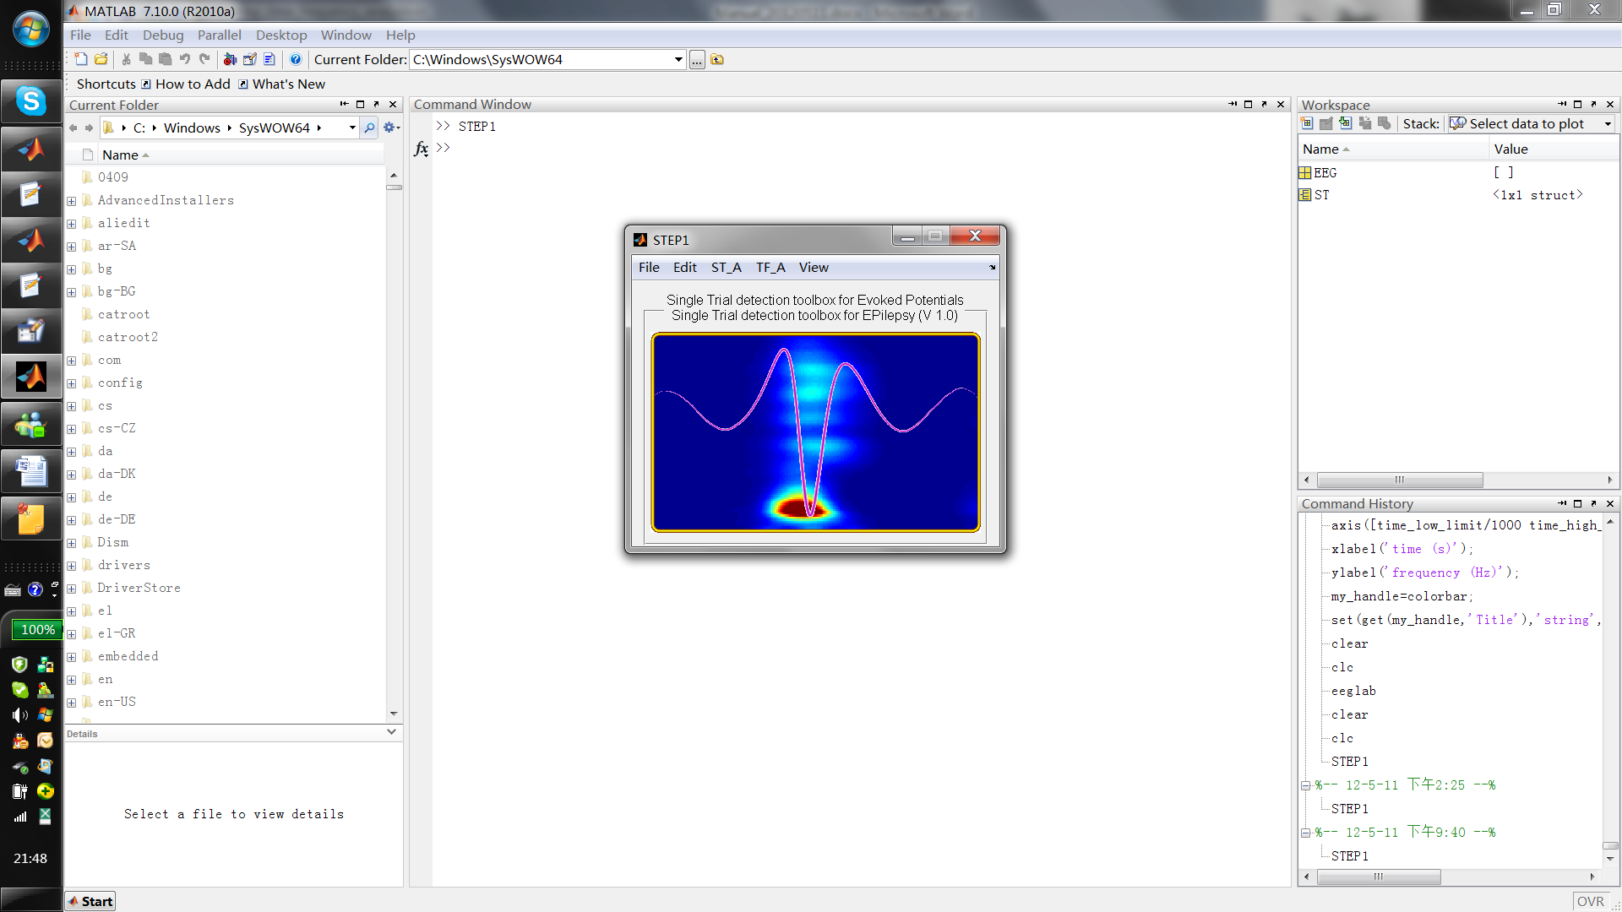
To get Help:
- Search in this manual.
- Refer to the following papers:
  - Hu, L., Mouraux, A., Hu, Y., Iannetti, G.D., 2010. A novel approach for enhancing the signal-to-noise ratio and detecting automatically event-related potentials (ERPs) in single trials. Neuroimage 50, 99-111.
  - Hu, L., Zhang, Z.G., Hung, Y.S., Luk, K.D., Iannetti, G.D., Hu, Y., 2011. Single-trial detection of somatosensory evoked potentials by probabilistic independent component analysis and wavelet filtering. Clinical Neurophysiology 122, 1429-1439.
  - Hu, L., Liang, M., Mouraux, A., Wise, R.G., Hu, Y., Iannetti, G.D., 2011. Taking into Account Latency, Amplitude and Morphology: Improved Estimation of Single-trial ERPs by wavelet filtering and multiple linear regression, Journal of Neurophysiology 106(6):3216-29..
- Email to Li Hu: huli@swu.edu.cn; hulitju@gmail.com.

4 Importing/Exporting data into STEP1
To import data from Matlab array (2-D Matlab array should contain EEG data in which rows are channels and columns are data points):
- Pop up Import dataset window by: FileImport EEG data
- Specify the data file, the Dataset name, and the Data sampling rate accordingly (marked in red, green, and blue respectively), and click Ok.

- Pop up Import event window by: FileImport Markers
- Specify the Event file, the Input field name, the Number of file header lines, and the Time unit (sec) accordingly (marked in red, green, blue, and pink respectively), and click Ok.

Note that the Marker file (.txt) should be arranged as the following way (three columns).

To import data from Brain Vision Data Exchange format (.vhdr, .vmrk, .dat):
- Pop up Import dataset window by: FileImport Brain Vision data, and select the .vhdr file.
- Specify the Time Interval and the Channels (normally we accept the default setting and keep these fields in blank), and click Ok.

To load data in EEGLAB format:
- Pop up load dataset window by: FileLoad EEGLAB data
- Specify the file name and path, and click Load.

To save data in EEGLAB format (saving frequently is recommended):
- Pop up save dataset window by: FileSaveSave EEGLAB data
- Specify the file name and path, and click Save.

5 Pre-processing in STEP1
To filter the dataset:
- Pop up Filter the data window by: EditFilter
- Specify the Lower edge of the frequency pass band (High pass filter) and unclick Plot frequency response (marked in red and green respectively), and click Ok.
Note that the Higher edge of the frequency pass band (Low pass filter) can also be specified according to the requirement.

- Pop up Scroll channel activities window by: ViewContinous EEG

To epoch the dataset:
- Pop up by: EditEpoch
- Specify the Time-locking event type(s) (the type of marker(s)) and the Epoch limits (marked in red and green respectively), and click Ok.

- Pop up Scroll channel activities window by: ViewContinous EEG

- Pop up Channel ERP image window by: ViewEpoched EEG

To perform Baseline correction (Optional, this step maybe not necessary in Epilepsy study):
- Pop up by: EditBaseline correction
- Specify the Baseline latency range and click Ok.

6 Single-trial analysis
6.1 Time domain
6.1.1 Wavelet Filtering (WF, filter only)
To increase the signal-to-noise ratio of single-trial EEG/ERP waveforms, Wavelet filtering, which is a type of time-frequency filtering, is recommended:
- Pop up by: ST_ATime domainWF (filter only).
- Select the Channel, which you are interested in, and click Confirm. Note that only one channel can be selected at one time.

- Specify (1) X Limits (time); (2) Y Limits (frequency); and (3) Threshold value, and click Confirm. Note that this procedure will be slow, and a wait bar, which display the calculation progress, will be pop up.

The following figure shows the comparison of waveform before (left panel) and after (right panel) wavelet filtering.

6.1.2 Multiple Linear Regression (MLR)
To perform time-domain single trial parameters detection using Multiple linear regression:
- Pop up by: ST_ATime domainMLR.
- Select the Channel, which you are interested in, and click Confirm. Note that only one channel can be selected at one time.
- Specify the Number of peaks and click either Auto or Manual to either automatically and manually select the peaks. The automatic selection will select the maximal/minimal peaks, which may or may not correct. In contrast, the manual selection will select the peaks that you are really interested in. Note that the peaks will be marked by red stars.

When you are satisfied with the selected peaks, click Confirm.
Specify the Time interval (the signal should be located at: marked in red) and the peak intervals (the peak should be located at: marked in green), and click confirm.

Specify the Time interval (the signal should be located at: marked in red) and the peak intervals (the peak should be located at: marked in green), and click confirm.
When several plots, of which the number should be equal to the number of peaks, are displayed, the single-trial parameters (including peak amplitudes, latencies, and the corresponding coefficients of each regressor) have been estimated, and we can find the single-trial values at the Matlab workspace.

6.1.3 Multiple Linear Regression with Dispersion Term (MLRd)
To perform time-domain single trial parameters detection using Multiple linear regression with Dispersion term (MLRd) (Recommended in Epilepsy study):
- Pop up by: ST_ATime domainMLRd.
- Select the Channel, which you are interested in, and click Confirm. Note that only one channel can be selected at one time.
- Specify the Number of peaks and click either Auto or Manual to either automatically and manually select the peaks. The automatic selection will select the maximal/minimal peaks, which may or may not correct. In contrast, the manual selection will select the peaks that you are really interested in. Note that the peaks will be marked by red stars.

- When you are satisfied with the selected peaks, click Confirm.
- Specify the Time interval (the signal should be located at: marked in red) and the peak intervals (the peak should be located at: marked in green), and click confirm.

- Specify the Time interval (the signal should be located at: marked in red) and the peak intervals (the peak should be located at: marked in green), and click confirm.
- When several plots, of which the number should be equal to the number of peaks, are displayed, the single-trial parameters (including peak amplitudes, latencies, and the corresponding coefficients of each regressor) have been estimated, and we can find the single-trial values at the Matlab workspace.

6.1.4 WF+MLR
The combination of wavelet filtering and multiple linear regression is to (1) increase the signal-to-noise ratio and (2) detect single-trial parameters accurately. The whole procedure can be start from: ST_ATime domainWF+MLR. For a detail explanation of following procedures, please refer to 6.1.1 Wavelet Filtering and 6.1.2 Multiple Linear Regression with Dispersion Term (MLRd).

6.1.5 WF+MLRd
The combination of wavelet filtering and multiple linear regression with dispersion term is to (1) increase the signal-to-noise ratio and (2) detect single-trial parameters accurately. The whole procedure can be start from: ST_ATime domainWF+MLRd. For a detail explanation of following procedures, please refer to 6.1.1 Wavelet Filtering and 6.1.3 Multiple Linear Regression (MLR).

6.2. Plotting Single-trial analysis results
To plot the generated regressors of all peaks, obtained by both MLR and MLRd, Click: ViewRegressors.

6.3. Saving estimated Single-trial values
To save the estimated single-trial values in the time domain:
- Pop up save window by: FileSaveSave single trial values.
- Specify the file name and path, and click Save.

7. Spectral analysis
To perform spectral analysis and obtain the value and scalp distribution of the power at different frequency band (i.e., delta, theta, alpha, beta, and gamma bands):
1. Pop up by: TF_AFrequency analysis.
2. Select the files, which you want to analyze, and click OK. Note that multiple files can be selected at the same time.
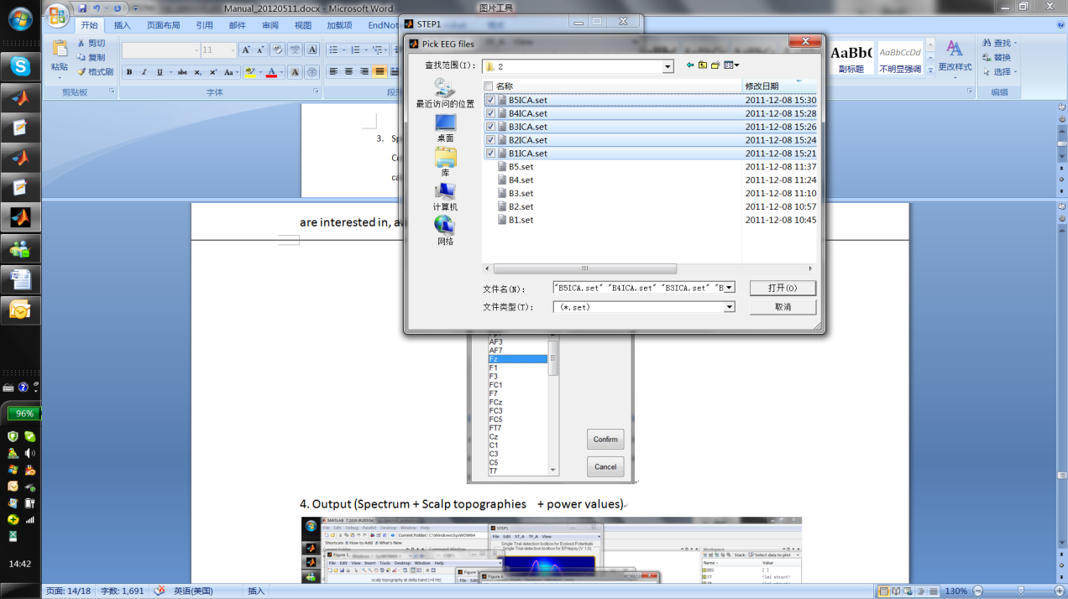
3. Specify (1) Epoch time range and (2) Frequency range, and select the Channel, which you are interested in, and click Confirm. Note that only one channel can be selected at one time.
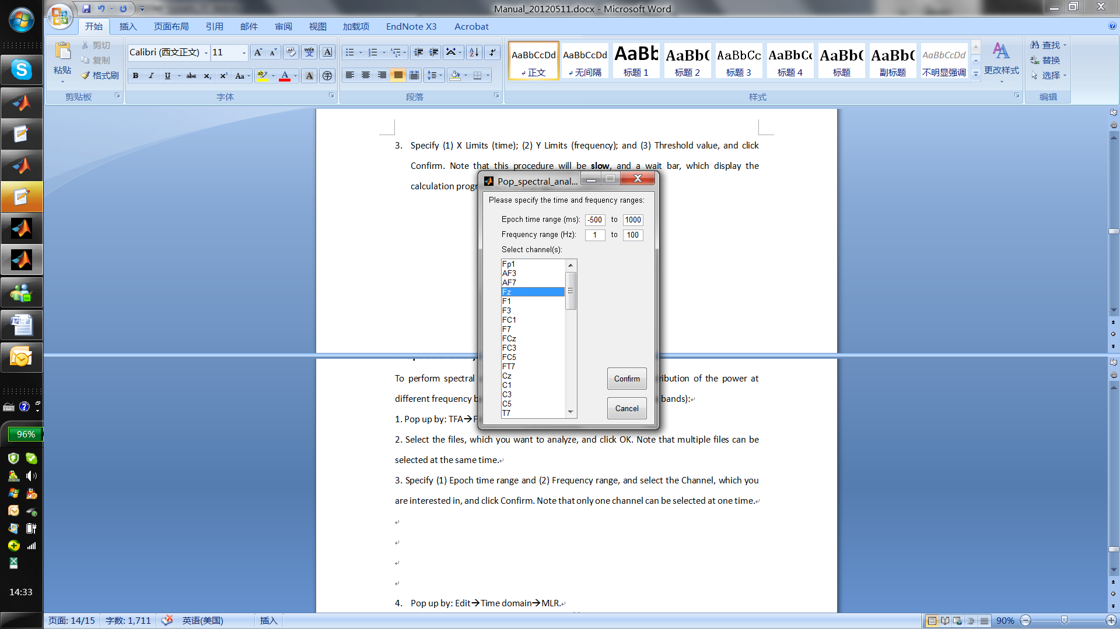
4. Output (Spectrum + Scalp topographies + power values)
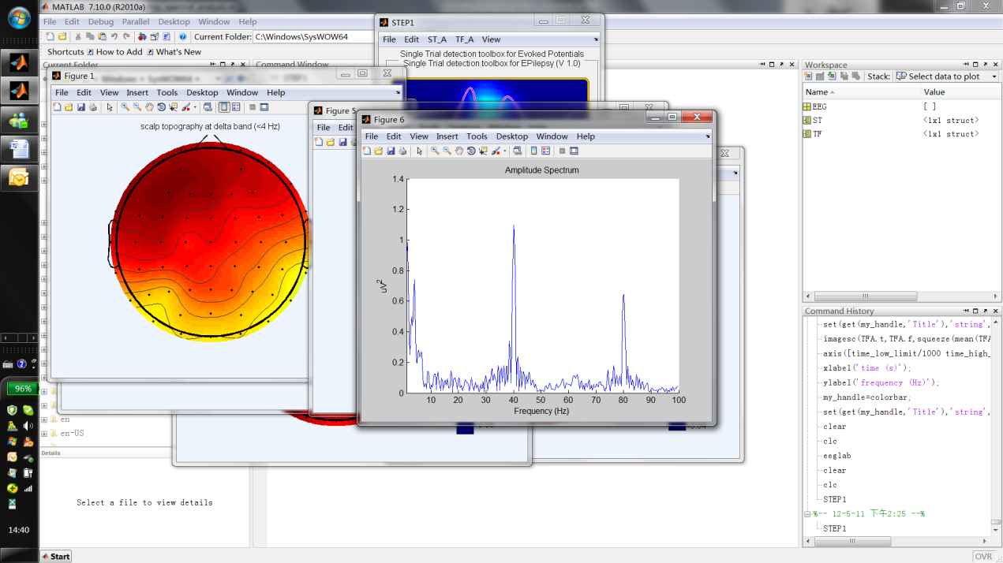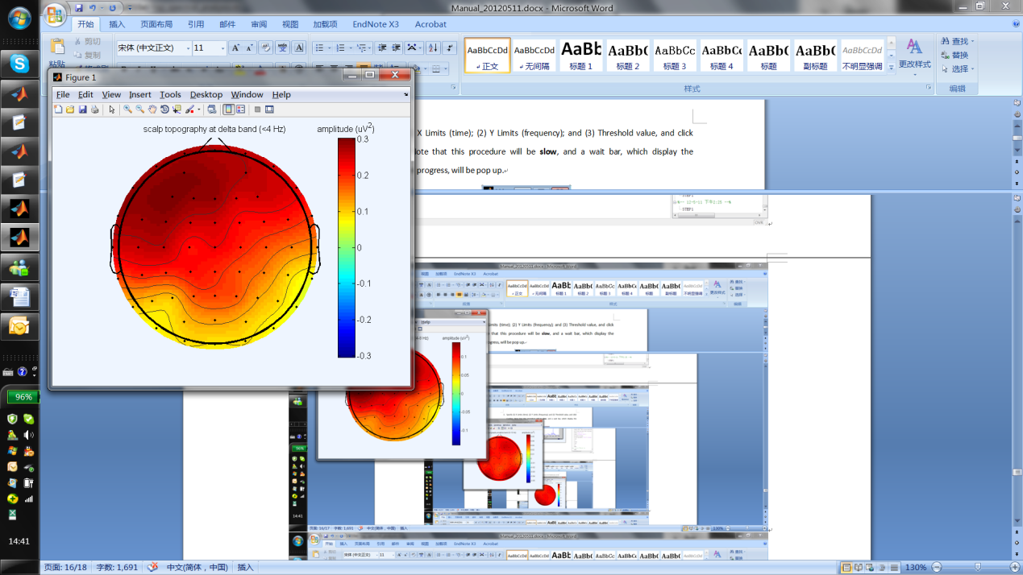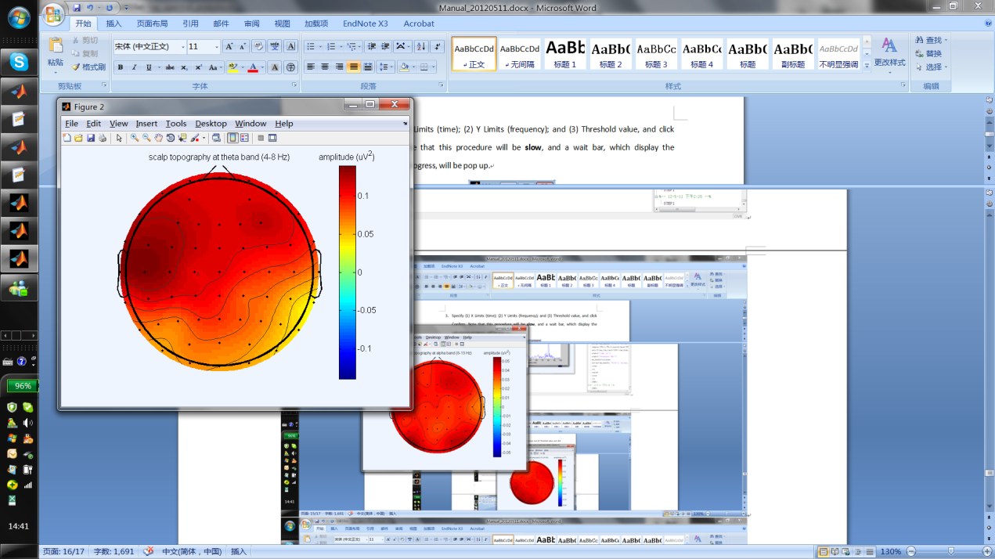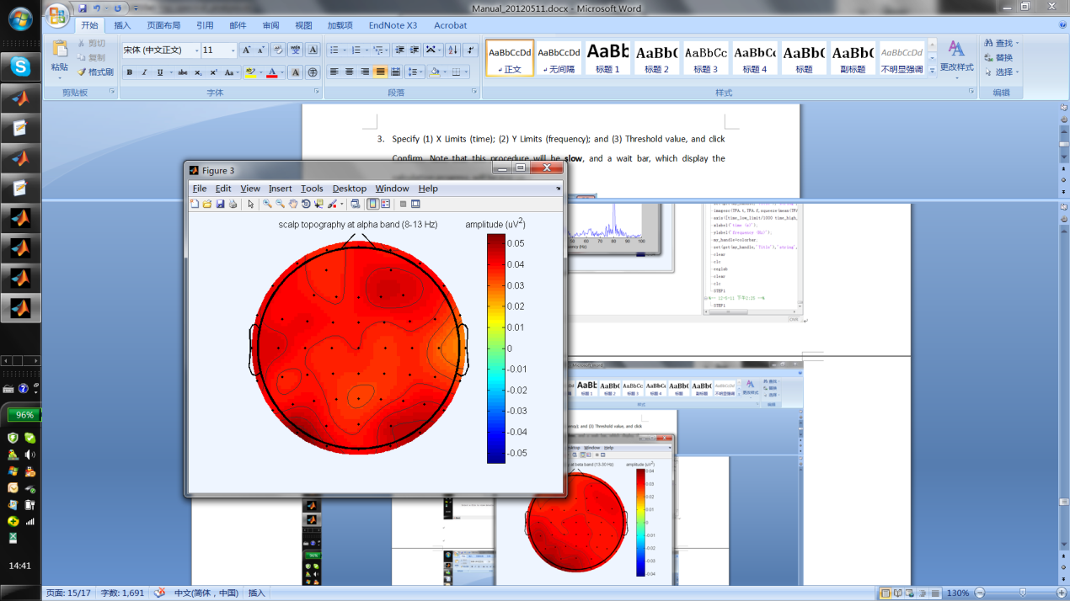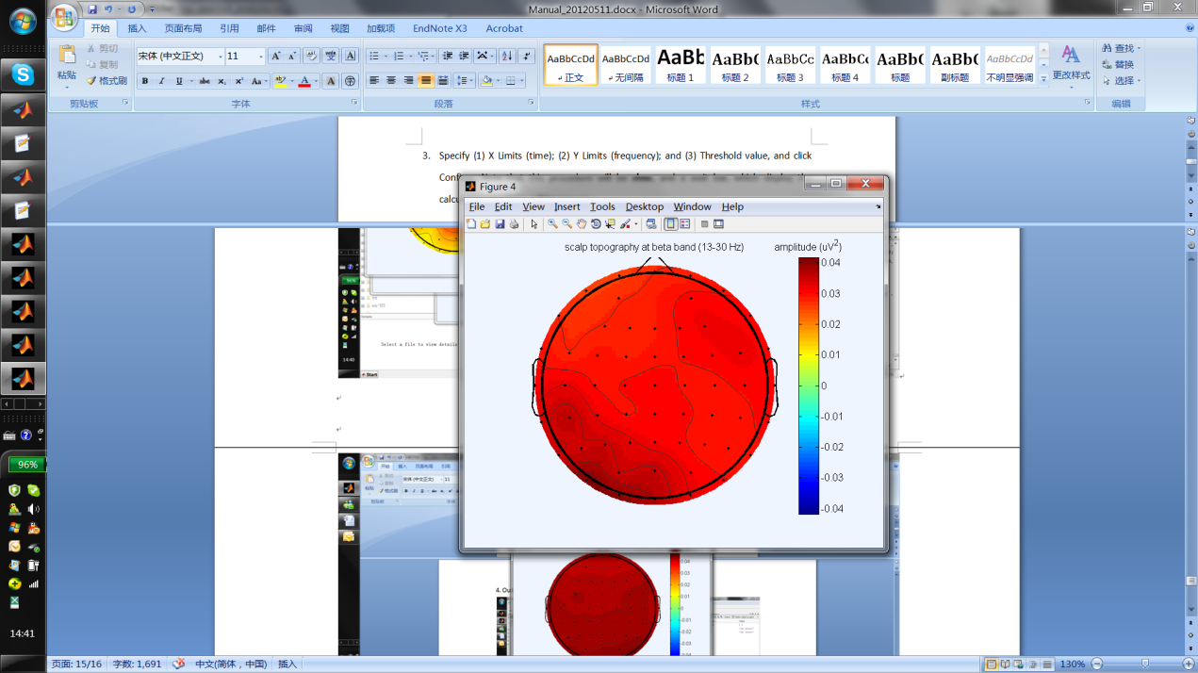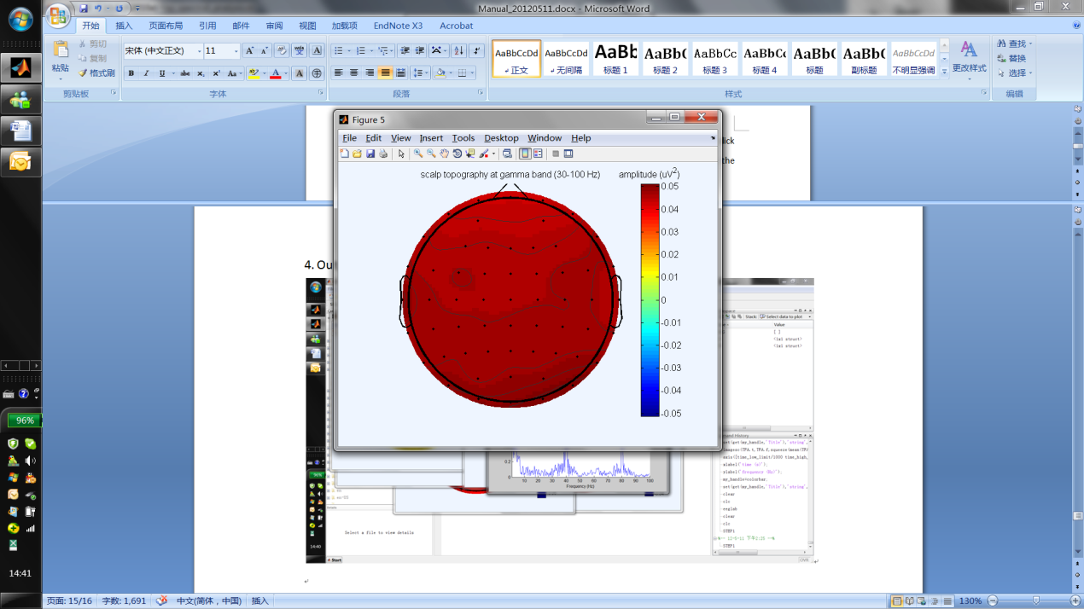
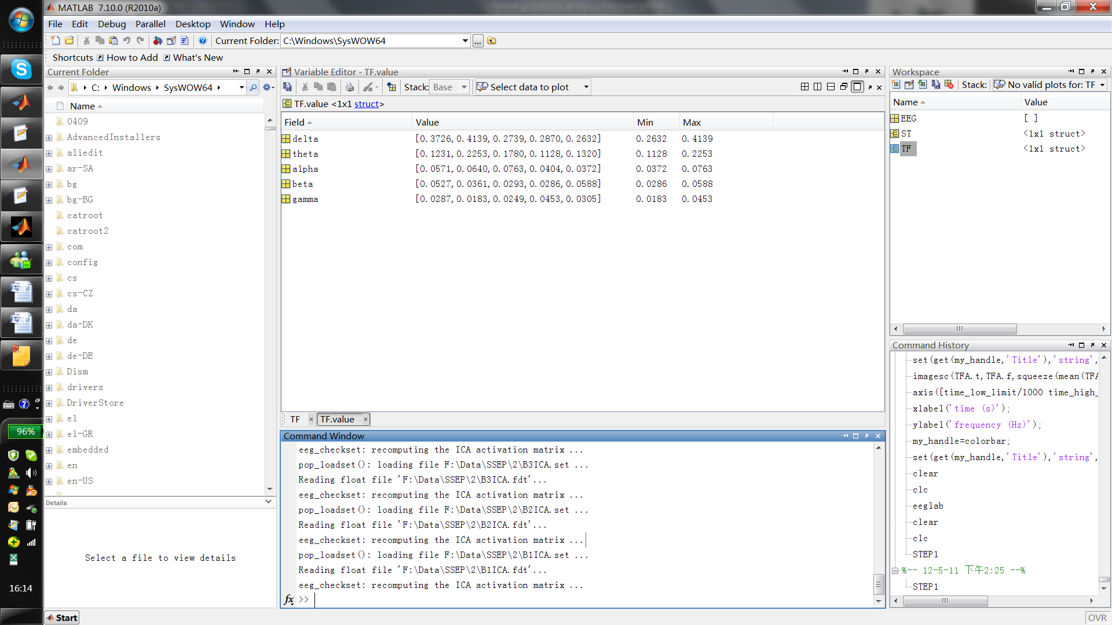

8. Time-frequency analysis
8.1 Preliminary time-frequency analysis
To perform time-frequency analysis and to observe the group-level time-frequency distributions at the specified channel:
1. Pop up by: TF_ATime-frequency analysis.
2. Select the files, which you want to analyze, and click OK. Note that multiple files can be selected at the same time.

3. Specify (1) Epoch time range and (2) Frequency range, and select the Channel, which you are interested in, and click Confirm. Note that only one channel can be selected at one time.
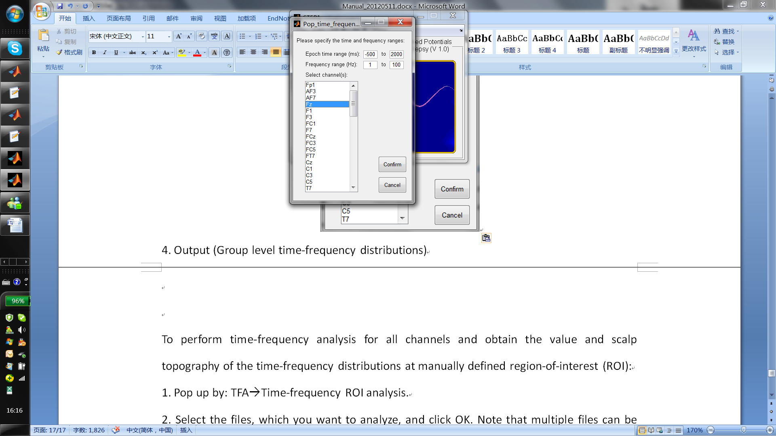
4. Output (Group level time-frequency distributions) for fast observation.
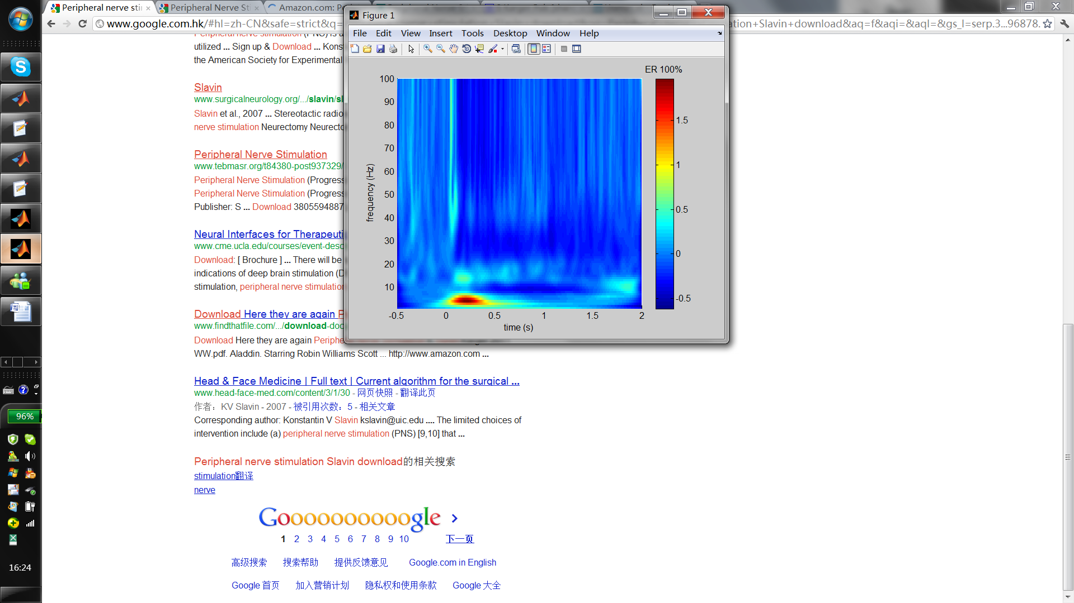

8.2 Time-frequency ROI analysis
To perform time-frequency analysis for all channels and obtain the value and scalp topography of time-frequency distributions at manually defined region-of-interest (ROI):
1. Pop up by: TF_ATime-frequency ROI analysis.
2. Select the files, which you want to analyze, and click OK. Note that multiple files can be selected at the same time.

3. Specify (1) X Limits (time); (2) Y Limits (frequency); (3) the baseline interval (time); and click Update. Note that time-frequency analysis will be performed on all files and all channels, so it will take a period of time to calculate.
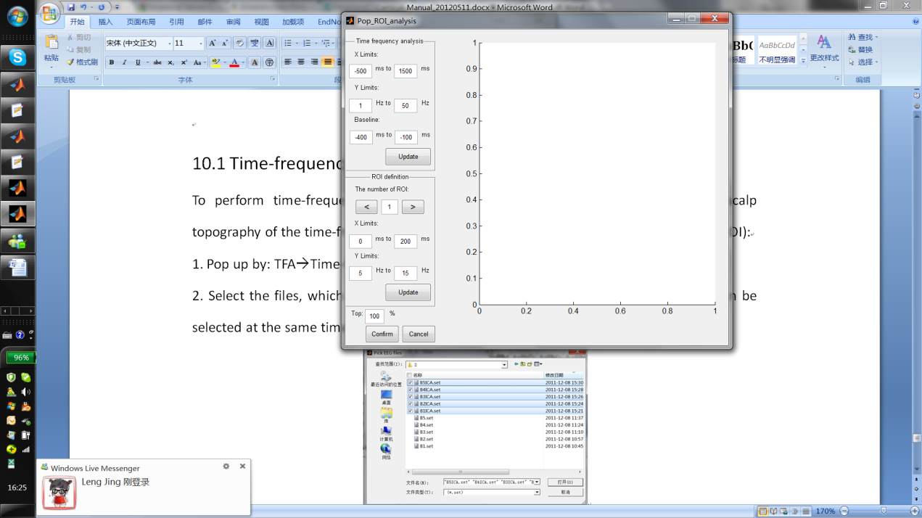

4. ROI definition
Specify (1) X Limits (time); (2) Y Limits (frequency); and click Update. A rectangle labeled "ROI1" will show up. Change the X Limits and Y Limits and click Update to adjust the boundary of ROI1.
Click ">" to specify the next ROI (e.g., ROI2), the same with the definition of ROI1.
After defining all ROIs, click Confirm.
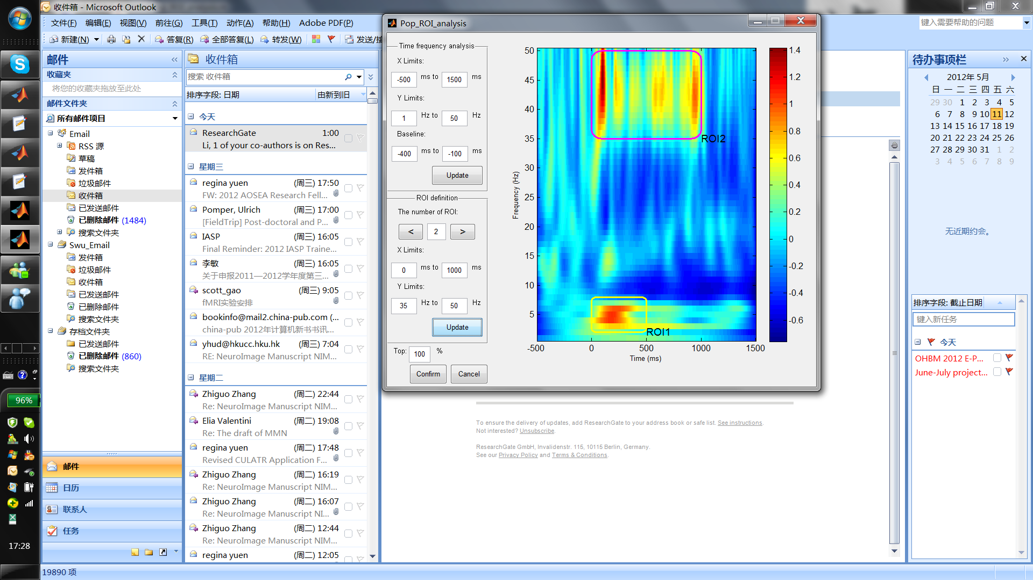

5. Output (Group level time-frequency distributions + Scalp topographies + ROI values)
