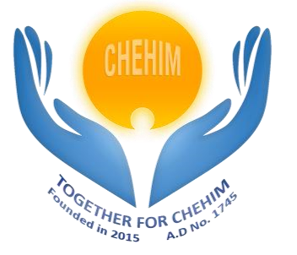

**Internship Agreement**

Between the undersigned:

* **Association « Together For Chehim »**, located at Chehim, Lebanon, represented by Mr. Fawzi Al Hajjar, as the president.
* **Intern**, Ms. **Lyn Shafik RAMMAL**, born on 14/06/2004, residing at Nabatiye

Douier, hereafter referred to as "The Intern".

The following has been agreed:

# Article 1 - Purpose

The purpose of this agreement is to define the conditions under which the Intern will carry out an internship within the Host Organization.

# Article 2 - Duration of the Internship

The internship will start on 17/03/2025 and will end on 17/05/2025, for a total duration of two months.

# Article 3 - Modalities of the Internship

The internship will be conducted remotely, with the possibility for the Intern to attend in-person meetings or short periods of on-site work.

# Article 4 - Supervision

The internship will be supervised by a member of the CRPC committee of the Host Organization.

# Article 5 - Confidentiality

All information and data handled or acquired during the internship will be considered confidential and may not under any circumstances be communicated to third parties outside of the Host Organization's team.

Initials

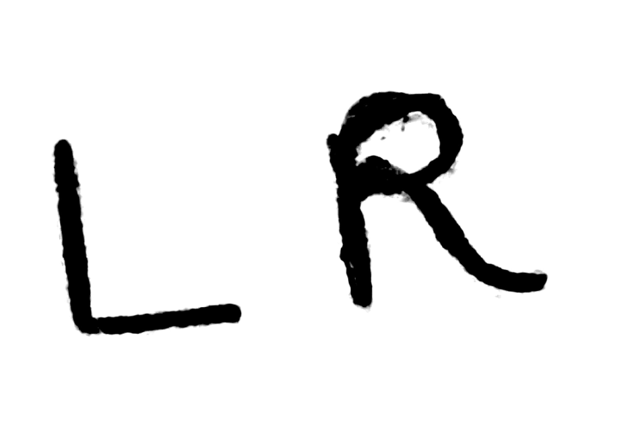



# Article 6 - Deliverables

The Intern commits to delivering the following before the end of the internship:

1. An oral or written presentation of the work carried out.
2. A final report detailing the activities and results achieved. 3. The source code of the programs or systems developed, annotated and documented.

# Article 7 - Working Hours

Although the internship will be conducted remotely, the Intern commits to working a significant number of hours per day, reaching a minimum of 35 hours per week.

# Article 8 - Meetings and Presentations

The Intern must adhere to the meeting schedules set by the supervisory team. At each meeting, the Intern is required to present an update of 10 to 15 minutes on the progress of their internship and work.

# Article 9 – Remuneration and Bonus

The project is not funded, and therefore, no financial compensation will be provided for this internship. However, in the case of funded projects, a financial bonus may be granted to the intern.

# Article 10 - Penalties and Warnings

In the event the Intern fails to comply with the conditions stated in this agreement, a warning will be issued. Accumulation of three such warnings will result in the immediate and permanent termination of the internship.

**Article 11 – Signature**

Made in two copies at Chehim, on 17/03/2025.

|  |  |
| --- | --- |
| Intern | President of the Association  “Together for Chehim” |
| Lyn Shafik Rammal | Fawzi Al Hajjar |

