

**EDUCATION AND QUALIFICATIONS**

**WASSIM AL HAJJAR**

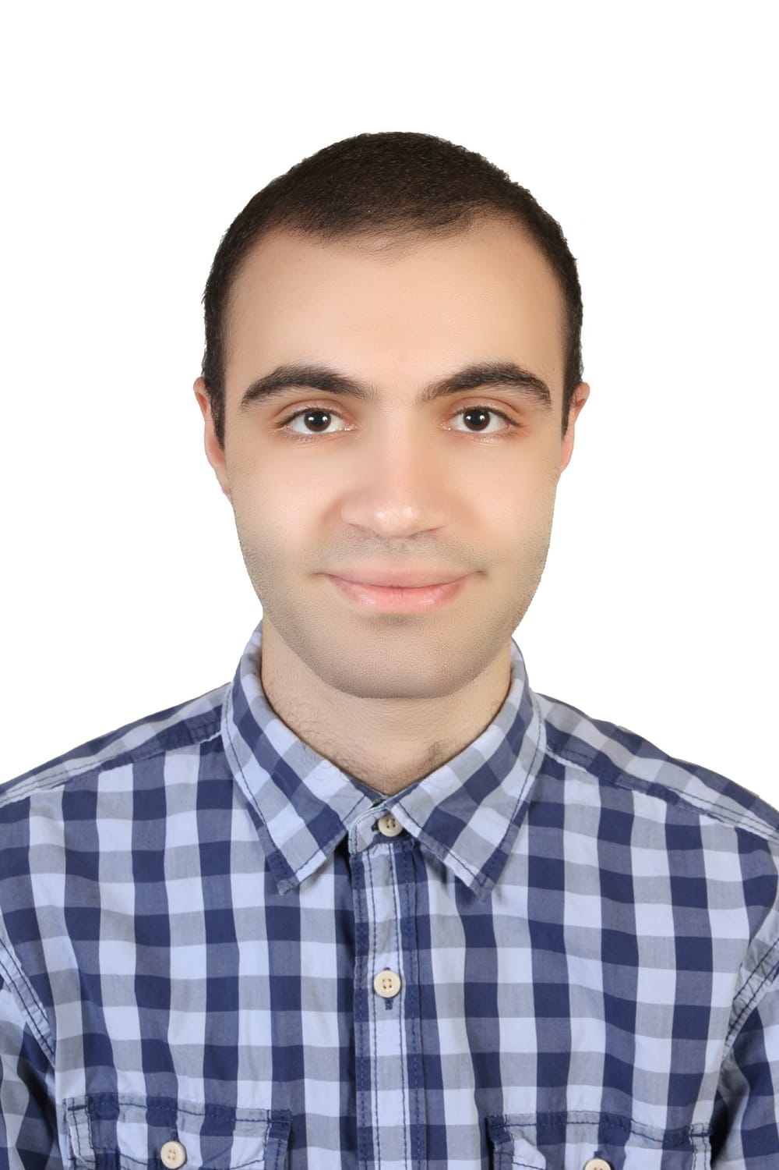



Self-motivated, hard-working, and determined, my goal is to expand my knowledge and acquire new skills.

I am looking for a job in technology field (telecommunications, operating systems, networks, programming).

**2021-2024**

**LEBANESE UNIVERSITY-FACULTY OF TECHNOLOGY,** SAIDA, LEBANON

**Bachelor in Computer Systems Networking and Telecommunication**

**2020-2021**

**COLLEGE NOTRE DAME DES SOEURS SALVATORIENNES,** JOUN, LEBANON

Lebanese Baccalaureate obtained with highest honours

Specialization General Science

**JULY 2024**

**END OF STUDIES PROJECT,** ***LEBANESE UNIVERSITY-FACULTY OF TECHNOLOGY, LEBANON***

Web security analysis and proposed solutions for an existing website.

* Performing multiple cyber attacks to find vulnerabilities

**JULY 2024**

**PRACTICE INTERNSHIP,** ***TOGETHER FOR CHEHIM ASSOCIATION, CHEHIM, LEBANON***

Building a fullstack web application using Django-Rest Framework for Back-end REACT JS and Bootstrap CSS Frameworks were used for Front-end.

* Responsive Website
* Upload and download and modify files.
* API linking Front-end with Back-end

**JULY 2023**

**PRACTICE INTERNSHIP,** ***BLUEMINT COMPANY, BEIRUT, LEBANON***

Building a fullstack web application for movies including many advanced features using Laravel Framework for Back-end

HTML, CSS and JavaScript were used for Frontend

* Filtered search
* Administrative page for manipulating data.

**Networking and Security:** Router and switch configuration via Cisco Packet Tracer (Competent), Wireshark (Competent), IP addressing and subnetting (Competent), Familiarity with Linux and Windows Servers [FTP, SSH, WEB, Active Directory, DNS, DHCP] (Competent), Types of cyber-attacks

, Installing and using virtual machines via Virtual-Box (Competent), VMWare (Competent).

**Programming languages:** C(Proficient), C#(Proficient), Web Development [HTML, CSS, JavaScript, PHP,Laravel framework, React framework, Django-Rest framework] (Proficient), VB.net(Proficient), Python (Competent), SQL (Competent), VHDL(Competent),PostgreSQL (Competent).

**Telecom:** Transmission lines simulation using ADS Software (Competent), Antenna simulation using PCAAD Software (Competent).

**Other Software:** Microsoft Office [Word, Access, Excel, PowerPoint] (Competent).

So



**PROFESSIONAL SKILLS**

**PROFESSIONAL EXPERIENCE *(References upon request)***