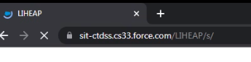

Unauthenticated (public) community

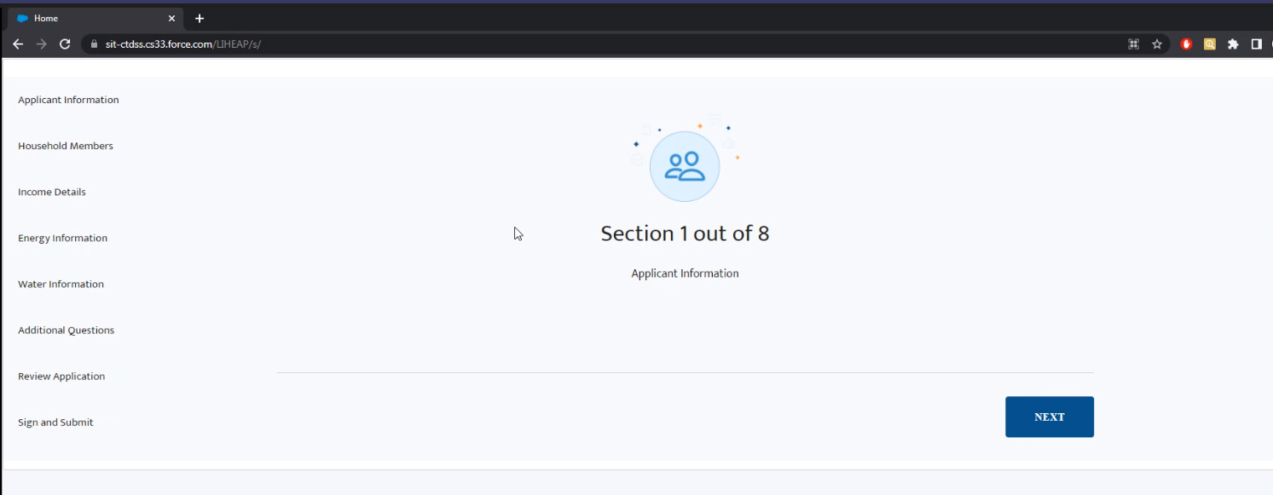

Heating or water assistance

Example

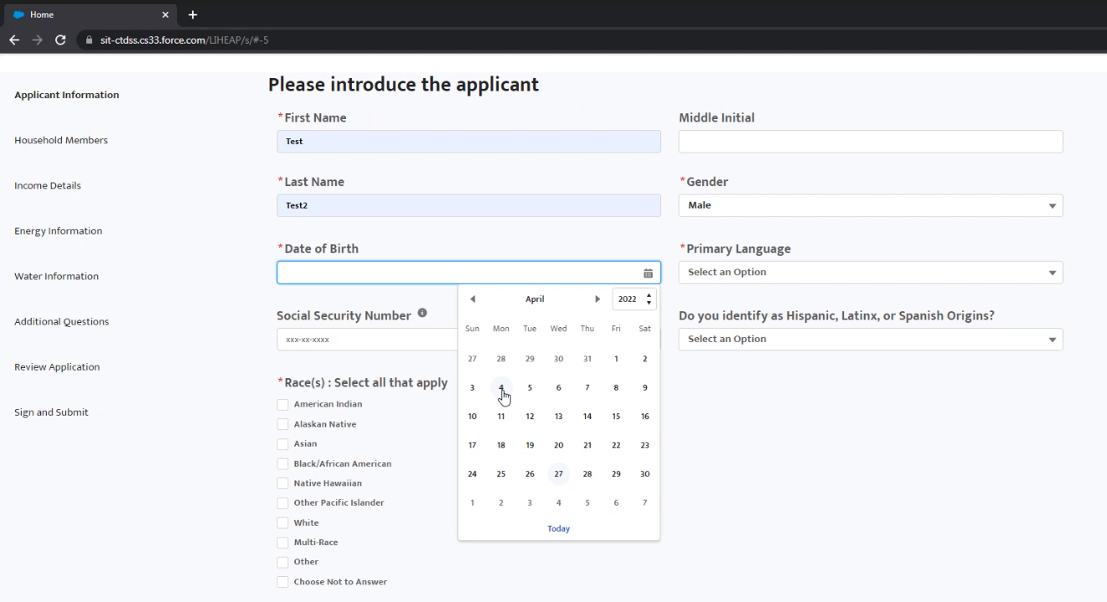

Validations are in javascript

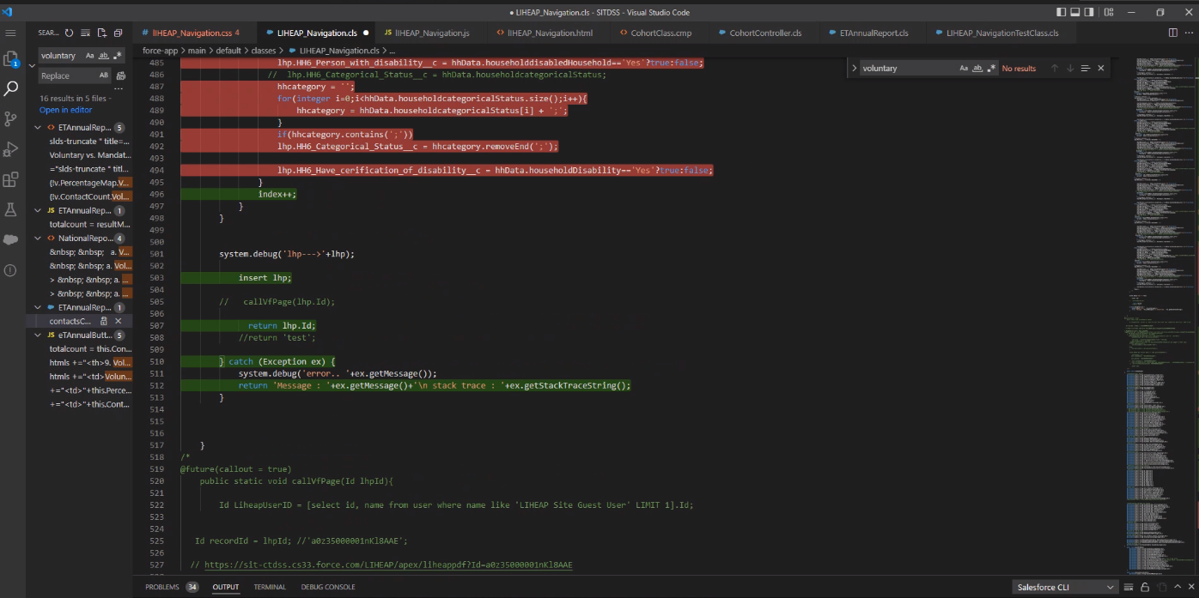

Again, external files sent to us

Only 1 profile: liheap guest user

App submitted…goes into the liheap app

Salesforce Flow was not used

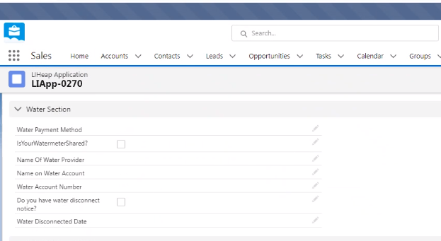

Files were generated

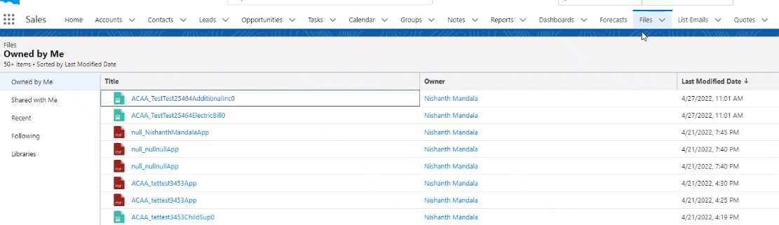

Trigger will fire and convert the doc to a pdf after a few minutes

Liheap admin users do not use salesforce

There is a batch job that transmits files into FTP folders (Subu’s liheap process)

Integration user created for the batch process to login to salesforce

Pulling navigation items from the controller

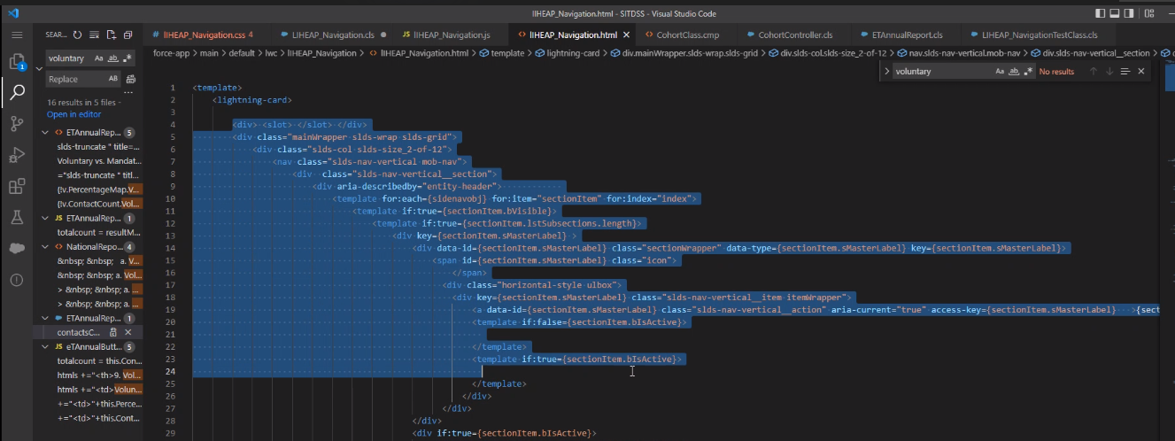

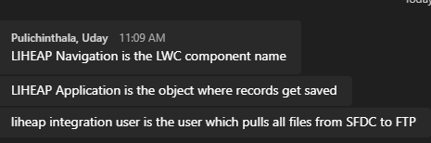

Limit to number of characters in a components so he created subcomponents



Request: Notify Agency when an application is submitted

Will implement on the java side

Phase 2 will start

Renewals, etc…