Invoice

We will not see it

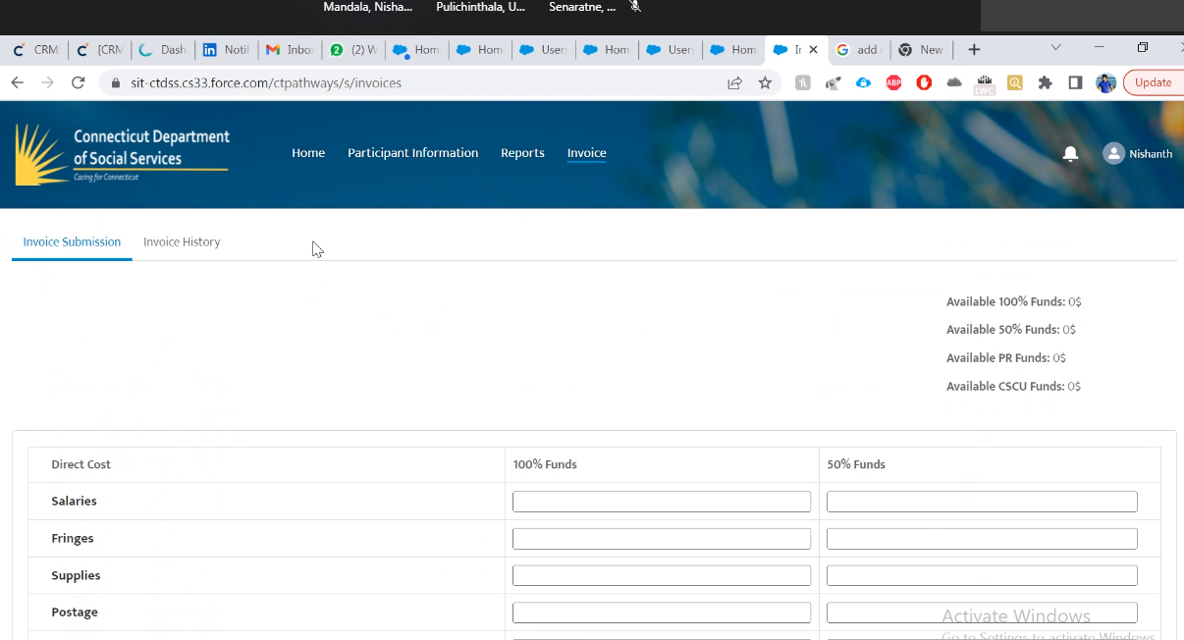

Login as a Coordinator to see the Invoice module

Salesforce has built in impersonation with Profiles

Contacts can login directly to the community

Reminder: This is a Salesforce extension (Salesforce Inspector)

Go to Contacts

Contact Record Type (ignore C4K for now) find coordinator

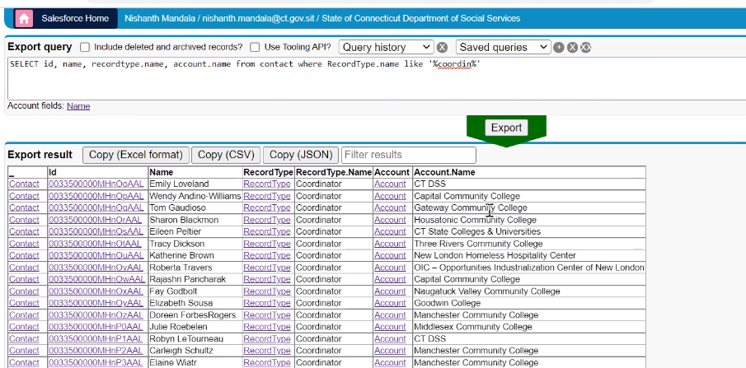

To login as Tom

Tom is a user and a contact (coordinators and students are both contacts)

Coordinator is a community plus user

User can login to salesforce, but not communities

Only contacts can login to communities

Right click on the ID, select View in Salesforce to open the Contact record

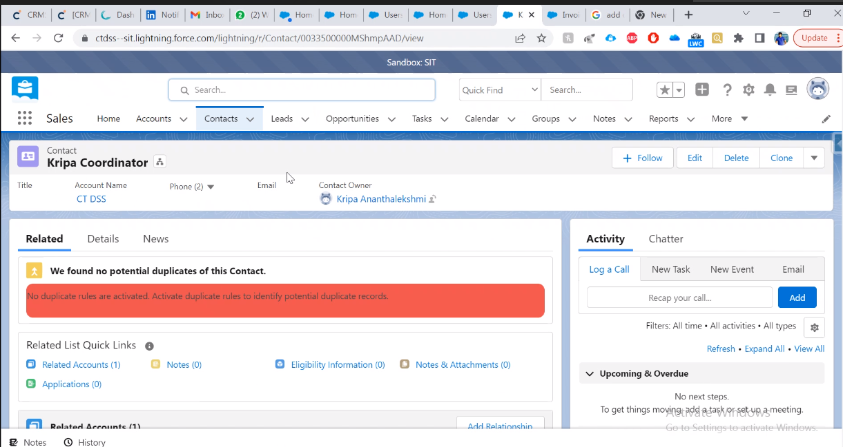

Select dropdown to log in as this user:

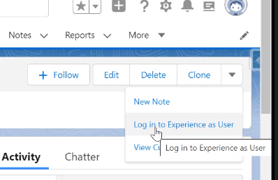

This will open the app in the community:

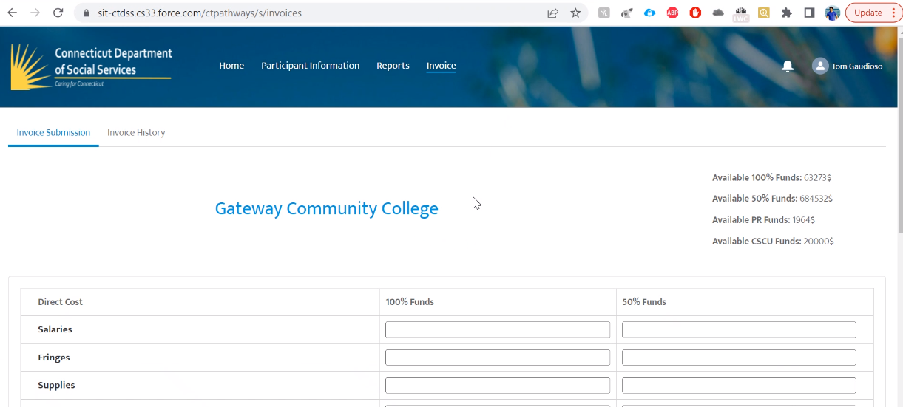

Numbers up top come from Account (Account is the College)

Licenses not required for community users

As you enter data, the account totals change

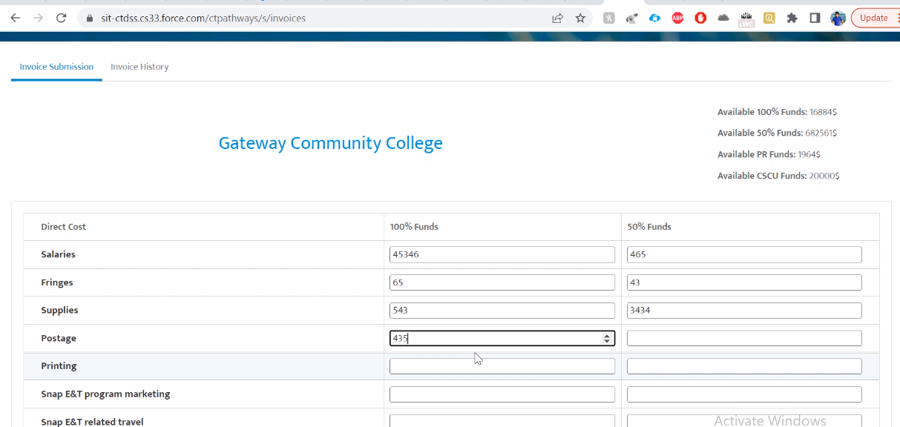

Every community college, we are able to see available funding

This is entered in the backend

Enter data

Submit

Invoice sent to DSS

Invoice record created in Salesforce

Print Invoice –

Prod and UAT are working, but they are not being used

Bill, Jenna and Rob are DSS contacts who enter and approve Funding

Search for the college name

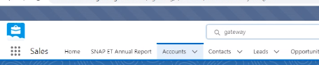

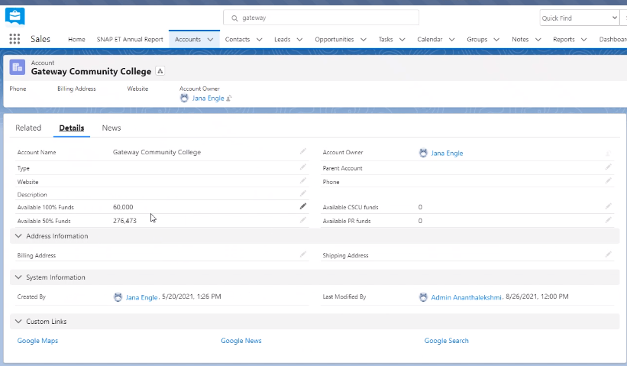

To view errors:

Search Logs

Select debug logs

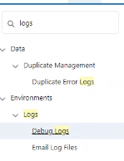

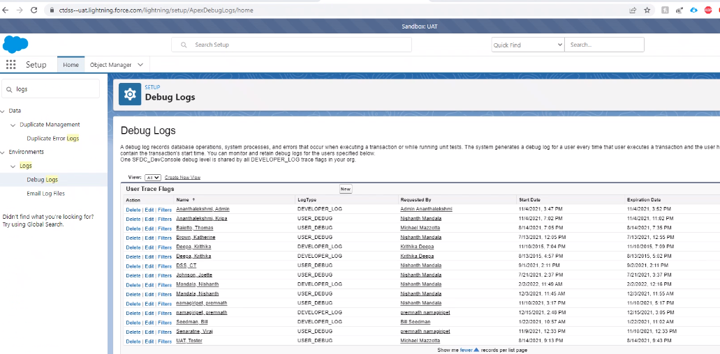

Turn on a trace

Finest level

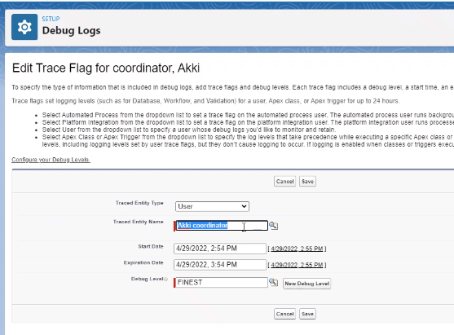

Recreate the error

Had to make this user Active to see the link to login

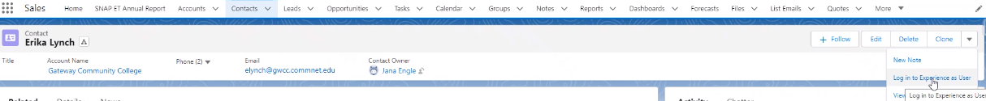

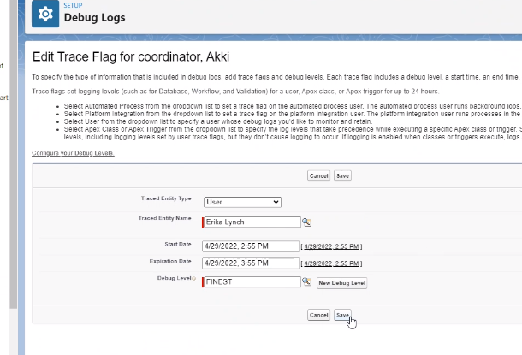

Recr

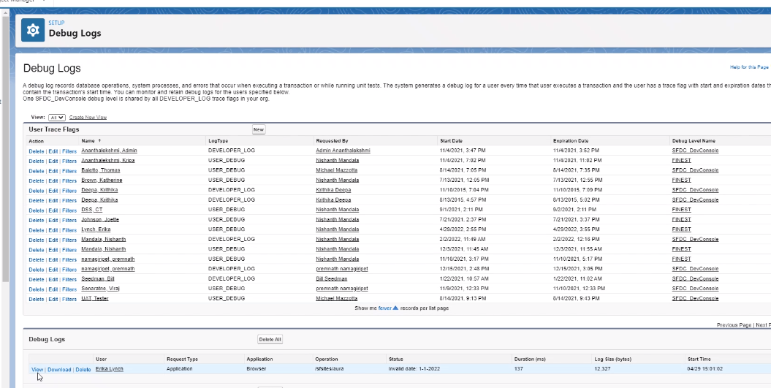

Log appears at the bottom

