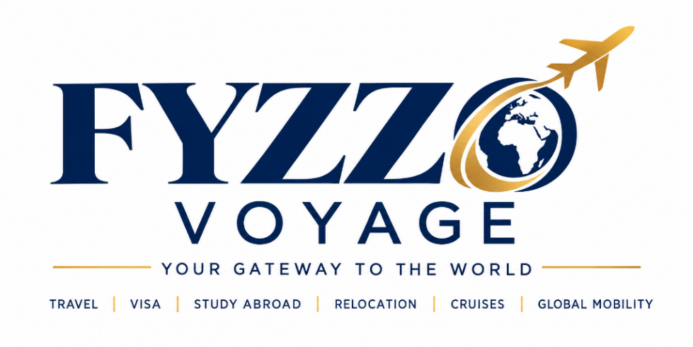

THE 2027 STUDY ABROAD & VISA SUCCESS BLUEPRINT

10 Bank Statement & Proof of Funds (POF) Rules + Low-Tuition University Directory
Published By: Fyzzo Voyage Global Education Desk (A Division of Fyzzo Global)
Direct Desk: WhatsApp: 08062499796 · Email: voyage@fyzzo.com · IG: @voyagebyfyzzo
Core Motto: YOUR GATEWAY TO THE WORLD

Welcome from the Fyzzo Voyage Advisory Team:
Every year, thousands of Nigerian students receive unconditional admission offers from prestigious universities abroad, only to have their travel dreams shattered by visa refusal letters. Over 80% of student and visit visa refusals are NOT caused by academic performance—they are triggered by improper Proof of Funds (POF) presentation, unseasoned accounts, and unexplained lump-sum deposits. This blueprint is your ultimate insider shield.

PART 1: The 10 Golden Proof of Funds (POF) Rules
- The 28-Day Consecutive Balance Rule (UKVI Standard): Your statutory funds (unpaid course tuition plus 9 months living maintenance: £9,207 outside London or £12,006 in London) must remain continuously in the bank account for a minimum of 28 consecutive days without dropping below the threshold for even one second. The statement must not be older than 31 days on the date of application.
- Beware the "Lump Sum Trap": Never borrow money into an account 2 days before generating a statement. Embassies look at the 6-month transaction history. A sudden deposit of ₦30 Million into an account with an average monthly balance of ₦200,000 is an immediate red flag for visa fraud. All lump sums must have documented paper trails (e.g. deed of land sale, company dividend payout, gratuity letter).
- The OANDA Currency Fluctuation Buffer (15% Rule): Embassies convert Naira to GBP, USD, or CAD using official spot rates (such as OANDA.com) on the exact date of visa assessment. Because exchange rates fluctuate daily, always maintain at least a 15% financial buffer above the statutory requirement.
- Sponsor Legitimacy Hierarchy: Immigration authorities favor first-degree relatives (biological parents or legal spouse) as personal sponsors. If an uncle or corporate organization is sponsoring you, a legally sworn affidavit of support, birth certificates proving lineage, and corporate board resolutions are mandatory.
- Personal Accounts vs Business Accounts: If submitting a business corporate bank statement, you must provide the Certificate of Incorporation (CAC Form 1.1 / Status Report) showing the sponsor is a majority shareholder, alongside personal bank statements.
- Electronic Bank Letterhead & QR Code Verification: Modern embassies verify statements digitally via NIBSS and direct bank audit desks. Ensure your bank issues a signed, stamped statement with a scannable verification QR code or authentic branch officer contact.
- Tuition Deposit Pre-Payment Advantage: Paying a larger initial tuition deposit directly to the university (e.g. £4,000 – £8,000) reduces the cash balance you need to show in your bank statement and drastically boosts your visa credibility.
- Third-Party International Student Loans: If personal funds are tight, explore verified no-cosigner education loans (such as MPOWER Financing or Prodigy Finance for STEM and MBA degrees). An official loan sanction letter satisfies embassy funding criteria 100%.
- Supplementary Asset Documents: For visit visas and student permits, submit verified proof of ties: landed property deeds, vehicle registrations, pension fund statements, and long-term investment portfolios.
- The Master Financial Explanation Table (LOE): Always include a 1-page financial breakdown table in your Letter of Explanation detailing: Tuition Due, Living Maintenance Benchmark, Exchange Rate Used, Bank Account Number, Closing Balance, and Sponsor Relationship.

PART 2: Top January Intake Universities Welcoming Nigerian Students
Institution | Location | Intake Sessions | Accepts 2:2 / HND? | WAEC C6 English Exemption?
University of Wolverhampton | Wolverhampton, UK | January & September | Yes (Pre-Master / Direct Entry) | Yes (C6 or above in WAEC/NECO)
Coventry University | Coventry & London, UK | January, May & September | Yes (BSc 2:2 & HND) | Yes (WAEC C6 accepted)
University of Hertfordshire | Hatfield, UK | January & September | Yes (Wide course selection) | Yes (WAEC C6 accepted)
Teesside University | Middlesbrough, UK | January & September | Yes (Affordable deposits) | Yes (WAEC C6 accepted)
Griffith College / NCI | Dublin, Ireland | January & September | Yes (Post-study work permit) | Yes (English waivers available)

PART 3: Fast-Track Your File with Fyzzo Voyage
Need Hands-On Support?
Fyzzo Voyage provides complete end-to-end guidance: from school application and SOP drafting to Proof of Funds structuring, visa lodging, flight booking, arrival hotels, and fast settlement.
📲 Chat with our Senior Counselor on WhatsApp: 08062499796
✉️ Official Email: voyage@fyzzo.com / fyzzovoyage@gmail.com
📸 Instagram: @voyagebyfyzzo

