  - Personal Project 2025

MITM Chat Application Simulation

December 12, 2025

Built by:
Angeline Nicole Faina
Cybersecurity and Threat Management
2nd Semester Student
Seneca Polytechnic

Objective

Tools

Installation, Update, and Upgrade

Kali Linux
Network Adapter: NAT (Internet connection)
Kali Linux Setup
- Created a new kali vm through ovf.
- Download and install the latest archive keyring since the new vm doesn’t have any.
- Update and upgrade the system.
- Install required tools:
  - Python3
  - Wireshark
  - TCP Dump
  - ARP Spoof
  - D Sniff
  - Ettercap
# Check available keyring
wget http://http.kali.org/kali/pool/main/k/kali-archive-keyring/
# View the available version
cat index.html
# Download the latest Kali archive keyring
wget https://http.kali.org/kali/pool/main/k/kali-archive-keyring/kali-archive-keyring_2025.1_all.deb
# Install the keyring package
sudo dpkg -I kali-archive-keyring_2025.1_all.deb
# Update system
sudo apt update && sudo apt upgrade -y
# Install required tools
sudo apt install -y python3 python3-pip wireshark tcpdump arpspoof dsniff Ettercap-text-only

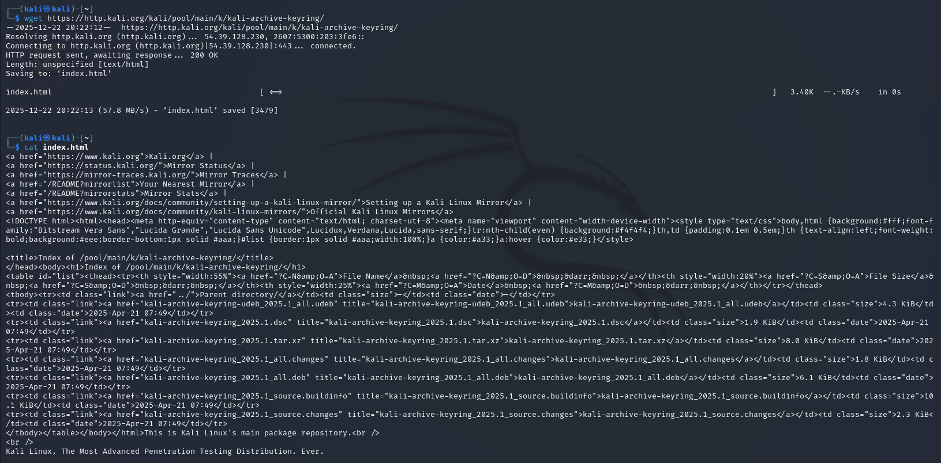
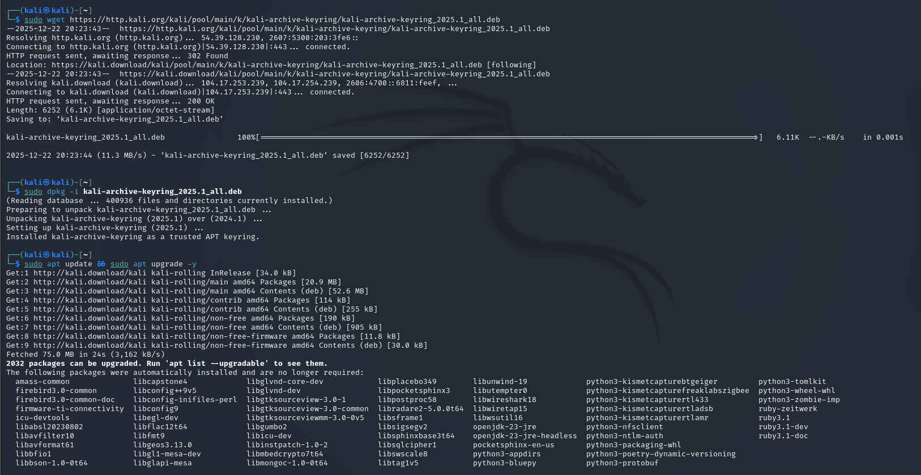
Error: Unable to locate package arpspoof
- arpspoof is not a standalone package in newer Kali versions, it is part of the dsniff package.
# Troubleshoot and checking
# Check if dsniff is actually installed
dpkg -l | grep dsniff
# If not installed, install it
sudo apt install dsniff -y
# Verify arpspoof is available
which arpspoof
# Test it
arpspoof --help

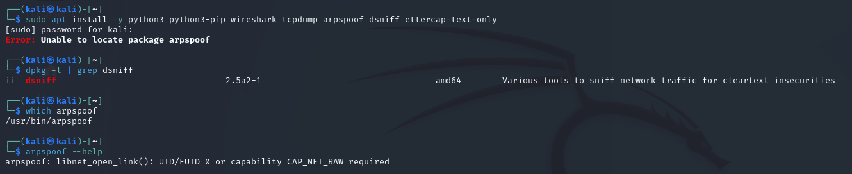
- Install Python libraries for the app
  - Scapy
  - Cryptography
  - Flask
# Python libraries to install for the app
pip3 install scapy flask socketio cryptography
# Troubleshoot
# Install pipx
Sudo apt install pipx -y
# Ensure pipx path is set
pipx ensurepath
# Install packages with pipx
pipx install scapy
sudo apt install python3-cryptography -y
pipx install flask

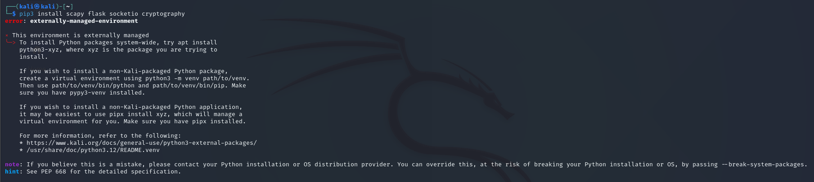
Error: externally-managed-environment
This is a new security feature in Debian-based systems to prevent pip from breaking system packages. To fix this, we have to use pipx.
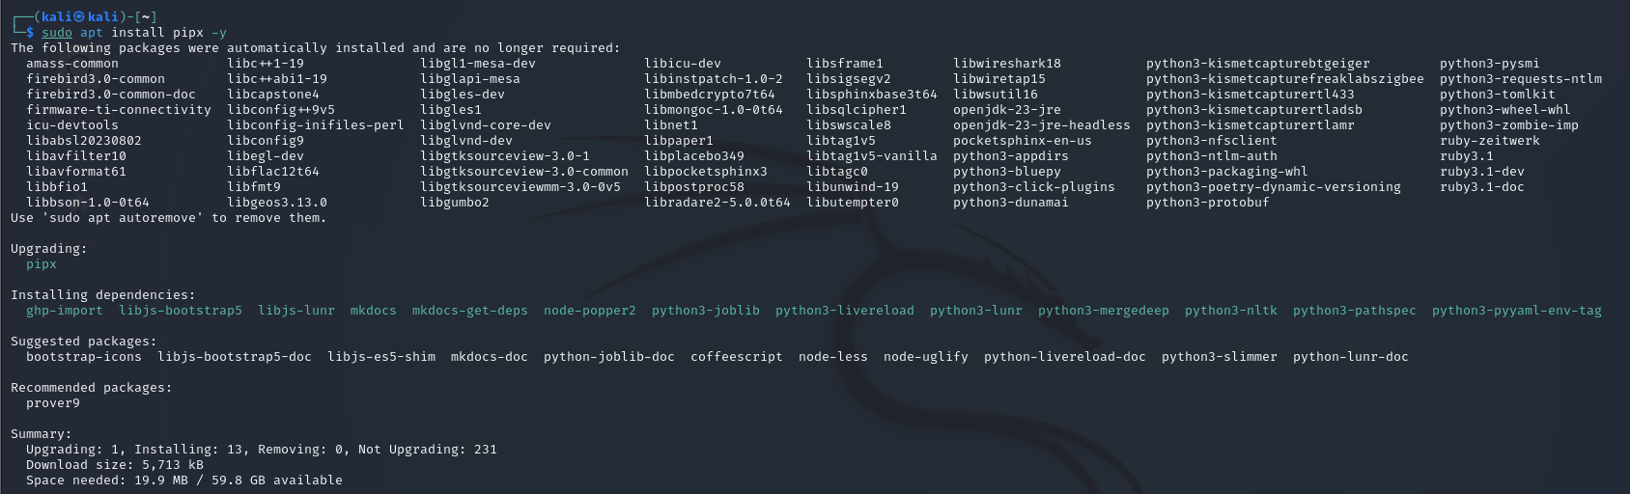
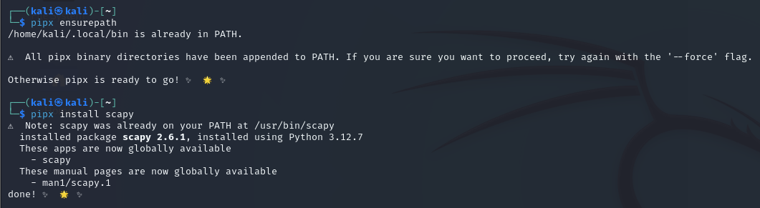
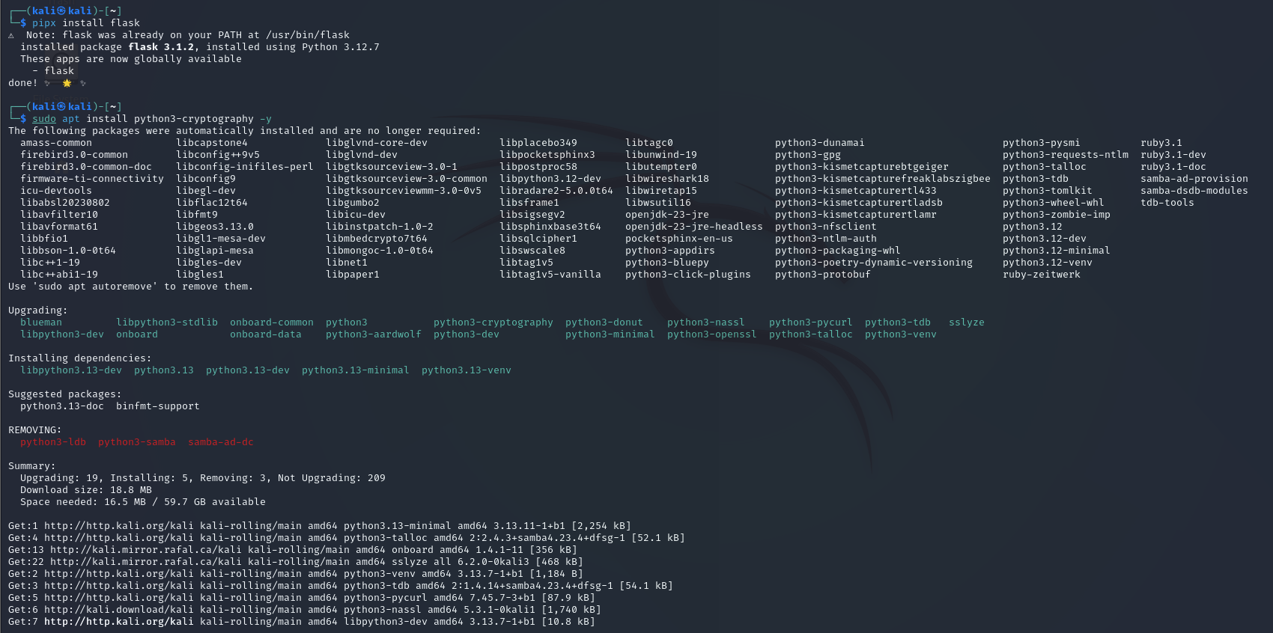

Windows 11
Network Adapter: NAT (Internet connection)
Windows 11 Setup
- Install Python 3.11.9
# Run Windows Powershell as Administrator
# Set download URL
$pythonUrl = https://www.python.org/ftp/python/3.11.9/python-3.11.9-amd64.exe
$installerPath = “$env:TEMP\python-3.11.8-amd64.exe”
# Download Python installer
Write-Host “Downloading Python 3.11.9…” -ForegroundColor Cyan
Invoke-WebRequest -Uri $pythonUrl -OutFile $installerPath
Write-Host “Download Complete: $installerPath” -ForegroundColor Green
- Silent installation via PowerShell
# Run Windows Powershell as Administrator
# Install Python silently with all options
$installerPath = “$env:TEMP\python-3.11.9-amd64.exe”
# Install with PATH and all users
Start-Process -FilePath $installerPath -ArgumentList ‘/quiet’, ‘InstallAllUsers=1’, ‘PrependPath=1’, ‘Include_test=0’ -Wait
Write-Host “Python 3.11.9 installed successfully!” -ForegroundColor Green
- Verify installation
# Open a new Powershell window
# Check Python version
python -–version
# Check pip version
pip -–version
# Check where Python is installed
where.exe python
# Verify PATH
$env:Path -split ‘;’ | Select-String -Pattern “Python311”
- Upgrade pip and install packages
# Upgrade pip to latest version
python -m pip install -–upgrade pip
# Install required packages
pip install cryptography
# Verify cryptography installation
python -c “from cryptography.fernet import Fernet; print(‘Cryptography OK’)”
Write-Host “`n[SUCCESS] Windows 11 Python setup complete!” -ForegroundColor Green
