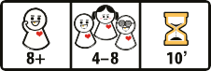

Cheese Thief Moderator App
Available Now!




In this game, players receive a secret role of either the Cheese Thief or a Sleepyhead. Everyone closes their eyes to sleep for the night and only wake up at specific times decided by their own dice roll. The Cheese Thief will steal the cheese, while the Sleepyheads may check around. During the subsequent discussion, the Cheese Thief will try to get away with the cheese undetected and the Sleepyheads will try to hunt the thief down together.

Components
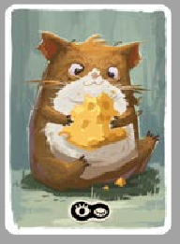
8 character cards
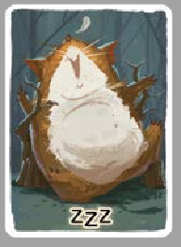






(1 Cheese Thief , 7 Sleepyheads )

1 Fall Mouse card 
(only used in the Fall Mouse Variant)


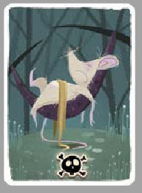

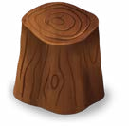


8 dice cups 8 six-sided dice 1 cheese token

Preparation
- Take as many Sleepyhead cards as there are number of players minus one. Shuffle them with the single Cheese Thief card.
- Deal one card face down to each player. Each player secretly looks at their card.
- Place the cheese token in the middle of the table within easy reach of all players.
- Give each player a dice and a dice cup. They roll the dice inside their cup, turn the cup upside down on the table and secretly peek at the dice result inside (i.e. this is the hour to wake up during the night phase). They then carefully slide their cup slightly towards the cheese token without changing the dice result, so that all cups can be reached by everyone easily.
- Select a player to be the Moderator of the game concurrently (or download the Cheese Thief Moderator App to facilitate the game).

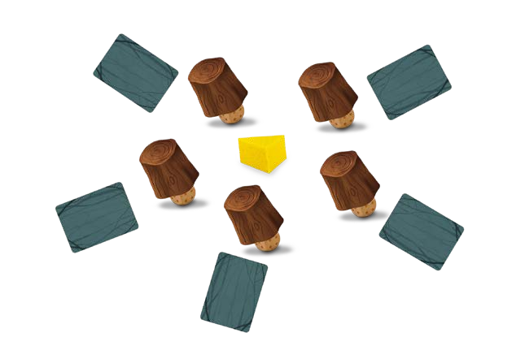

Setup example for a 5-player game:
Player 1
Player 5
Player 2
Player 4
Player 3
Game Play
- Night Phase
  - Waking-up sequence
All players (including the Moderator) should keep their eyes closed during the night phase. The Moderator announces the hours from 1 to 6. The players can only open their eyes when the Moderator calls the time that matches their dice result. The Moderator then gives them 10 seconds to take their corresponding allowed action.
A sample script for the Moderator:
- The night phase now begins and you should all go to sleep. All players please close your eyes without peeking.
- It is now 1 a.m. For those who have rolled a 1, open your eyes and act now. 10, 9, 8… 1 (counting 10 seconds down). Now close your eyes.
- It is now 2 a.m. For those who have rolled a 2, open your eyes and act now. 10, 9, 8… 1 (counting 10 seconds down). Now close your eyes.
- … (continue till the 6 a.m. call is finished)
- The night is over. Everyone now open your eyes. Oh no, the cheese has been stolen! You may start the discussion to find the Cheese Thief.
2. Possible actions to take

When a player’s time is called, they will act according to their character card. All actions must be done silently:
    - When the Cheese Thief’s time is called, they must take away and hide the cheese token somewhere safe, whether or not other players also have their eyes open.
    - If a Sleepyhead opens their eyes and is the only one to do so, they may peek at ONE (and only one) other player’s dice inside their cup.
    - If a Sleepyhead opens their eyes and sees any other players doing the same, they must do nothing or simply smile at them silently.


For a 5 to 8-player game, the following rules are added to introduce one or more Followers to the game. (For the 4-player game play, please refer to the section below.) A Follower switches sides and now plays with the Cheese Thief. They are forbidden from sharing or exchanging actual information about any dice results during the night phase.
3. Additional rules
For 5 players: If the Cheese Thief steals in the sight of a Sleepyhead, the Sleepyhead becomes a Follower. If more than one Sleepyhead is looking at the Cheese Thief, the thief must immediately choose one of them to be a Follower by pointing to their choice.
For 6 players: After the 6 a.m. call and before everyone opens their eyes, the Moderator adds the following instructions: “Everyone please reach out your right hand towards the centre. Cheese Thief, please open your eyes and choose your Follower by silently touching one of the hands. 5, 4, 3, 2, 1 (counting 5 seconds down). Follower, please
open your eyes and make eye contact with the Cheese Thief. 5, 4, 3, 2, 1 (counting 5 seconds down). Now you two please close your eyes.” In this way, the Cheese Thief chooses a Follower and they know each other.
For 7 players: After the 6 a.m. call and before everyone opens their eyes, the Moderator adds the following instructions: “Everyone please reach out your right hand towards the centre. Cheese Thief, please open your eyes and choose 2 Followers by silently touching any 2 hands. 5, 4, 3, 2, 1 (counting 5 seconds down). Followers, do not open your eyes if your hand has been touched. Cheese Thief, now close your eyes. Followers, now open your eyes and make eye contact with each other. 5, 4, 3, 2, 1 (counting 5 seconds down). Now you two please close your eyes.” In this way, 2 Followers are added. They know each other but do not know who the Cheese Thief is.
For 8 players: After the 6 a.m. call and before everyone opens their eyes, the Moderator adds the following instructions: “Everyone please reach out your right hand towards the centre. Cheese Thief, please open your eyes and choose 2 followers by silently touching any 2 hands. 5, 4, 3, 2, 1 (counting 5 seconds down). Followers, please open your
eyes and make eye contact with the Cheese Thief. 5, 4, 3, 2, 1 (counting 5 seconds down). Now you three please close your eyes.” In this way, the Cheese Thief chooses 2 Followers and they all know each other.

- Day Phase
1. Discussion
During the discussion, while the Sleepyheads make every effort to identify and pin down the Cheese Thief, the Cheese Thief can also try to cover up and even find a scapegoat with the help of the Followers.
Players are allowed to say anything but they cannot reveal their character cards nor show their dice to any others. Players can decide on the duration of the discussion and when the discussion is mature enough they can call for a vote.
2. Vote
The discussion ends in a vote in which each player must participate to show (or pretend to show) who they think the Cheese Thief is. The result decides which of the opposing team wins the game. The Cheese Thief and the Follower(s) win or lose together, and casting a smart vote may save your side from losing the game.
The Moderator leads the vote by saying, “Who is the Cheese Thief? 3, 2, 1, VOTE!” Then everyone points simultaneously to another player of their choice and the player with the highest number of votes reveals their character card. If more than one player receives the highest number of votes, all their cards are revealed.


Winning & Losing
- If the Cheese Thief receives the highest number of votes, regardless of any other cards being revealed, all Sleepyheads win the game together.
- As long as the Cheese Thief is not revealed, even if a Follower receives the most votes, the Cheese Thief and the Follower(s) win together.

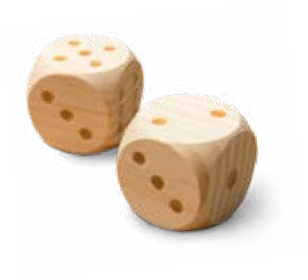
4-player game variant
All rules apply except for the following changes:
- Preparation: Every player takes and roll 2 dice.
- Waking-up sequence during the Night Phase:
  - the Sleepyheads must choose to wake up once according to one of their 2 dice;
  - the Cheese Thief can wake up at both hours as shown on their dice; if both dice rolls are the same, they wake up once according to one of the dice.
- Possible actions to take: even when a Sleepyhead wakes up alone, they may NOT peek at any dice but do nothing.
- Additional rules: No Follower is introduced to the game play.

The Fall Mouse Variant
The Fall Mouse card can only be added to a 6 to 8-player game. All rules apply except for the following changes:
- Preparation: Replace one of the Sleepyhead cards with the Fall Mouse card.
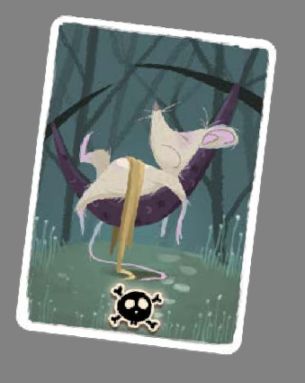
- The Fall Mouse follows the rules as a Sleepyhead does but tries to win by receiving the most votes.
- Winning & Losing:
The Fall Mouse wins alone if they receive the highest number of votes, even if they are chosen as a Follower, regardless of any other cards being revealed together.



Credits
Game design: Dongxu Li Illustration: Moyo Graphic design: Ming Li
Game development: Jolly Thinkers

