* Step 1

Download the elastix toolbox binary files from <http://elastix.isi.uu.nl/download.php>,

Or you can find the binary files in the folder /elastix.

* Step 2

Add the elastix toolbox to the system PATH; (paste the binary files folder direction to the PATH)

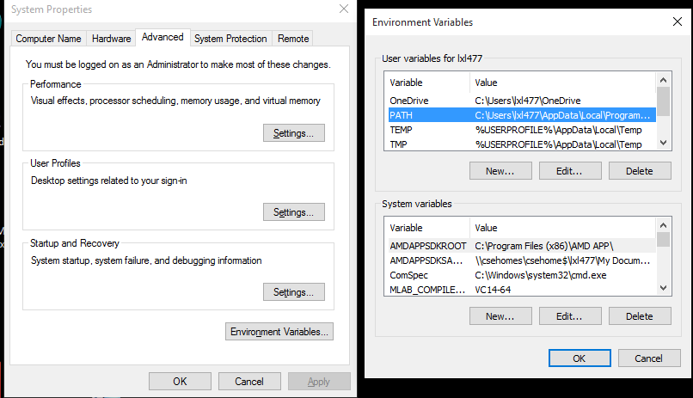

* Step 3

Run the file downsampleHist.m in folder /01_preprocess to down sample the histology image. In the processing, you will be required to manually corp out the prostate ROI bounding box. According to the size of the bounding box, the origianl histopathology image is downsampled. (as shown in the following figure)

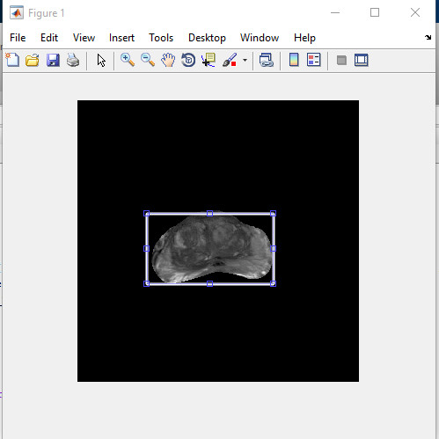 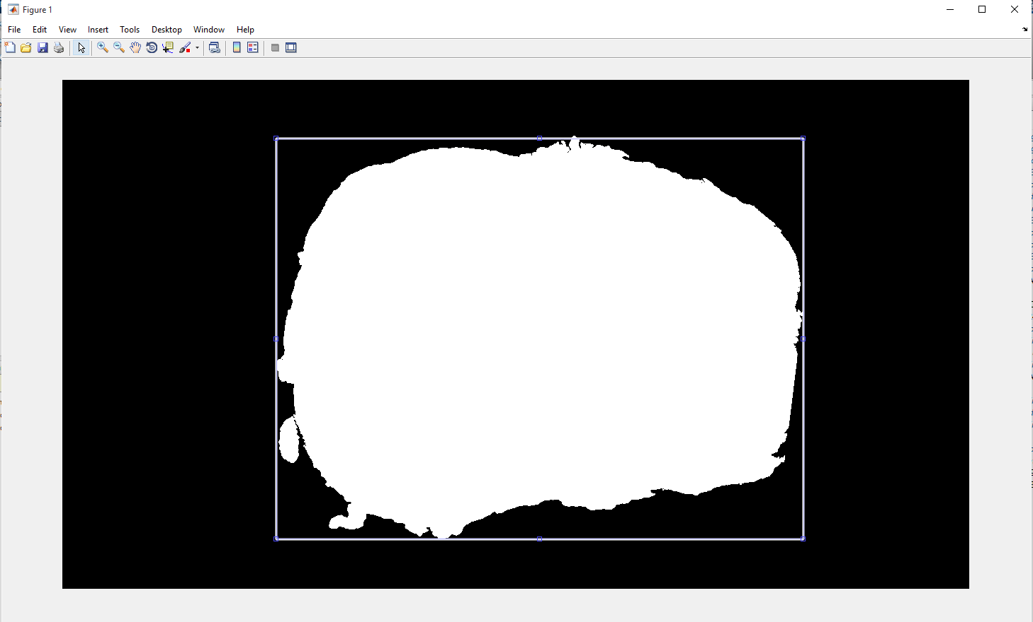

* Step 4

Affine registration

Run the file affineMain.m in folder \02_affine_registration

Step 5 spectral embedding representation calculation

Run the file SE_main.m in folder \03_SEcalc;

* Step 5

MSERg

Run the file MSERGmain.mat in folder \04_MSERg to start the registration.

To visualize the registration result, the code will require you to crop out part of the background of the transformed histology images to adjust the background intensity to 0. (as shown in the following figure)

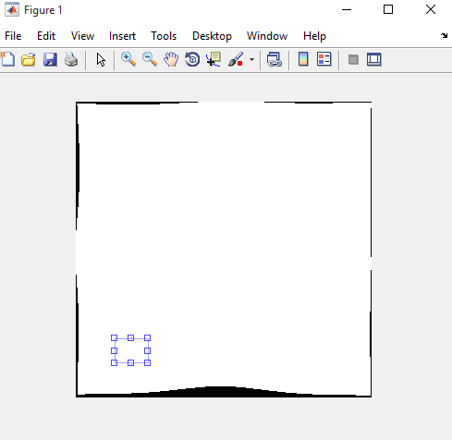

The visualization results are shown in the following figure. The left images illustrate the landmark alignment results. (cyan landmarks on MRI and red on the histology image)

