

**GROUP 13**

**AMOIT LYNN B20813 M23B38/007**

**ATWIJUKIRWE APOPHIA B23592 M23B23/051**

**LAKICA LETICIA B20720 M23B23/023**

**Topics of Interest**

We sat down and discussed our interests as a group which included skin care, agriculture and health. We then narrowed it down and decided to focus on agriculture.

**Selected Research Topic**

Agriculture

**Background statement**

Agriculture is the predominant economic activity in rural areas which harbors about 76 percent of Uganda's population. The farmers in rural areas face a challenge of efficiently matching consumer supply and demand especially for perishable goods. This is often as a result of limited access to real time market data regarding consumer demand for specific produce items, and as a result a gap is created leading to significant inefficiencies in the food supply chain leading to negative consequences. Farmers find difficulty in making informed decisions regarding crops to grow, resulting in the possibility of oversupply or undersupply, spoilage and missed market opportunities. Due to their perishable nature, many agricultural products are affected as delays in accessing market information can potentially lead to substantial losses. On the other hand, Consumers are faced with limited access to diverse produce and price volatility due to lack of transparency and information which undermines the sustainability and resilience of the agricultural sector, impacting both food security and the livelihood of farmers. The existing market information systems often fail to reach farmers in rural or underserved areas, they lack user friendly interfaces or don’t provide data tailored specifically to a farmer’s needs. Poor connections to markets impacts farmers’ incomes directly and keeps them in a cycle of low investment and productivity (Private Sector Solutions to Helping Smallholders Succeed by world bank group). Bridging this information gab is crucial for empowering farmers, reducing food waste, and ensuring a stable and accessible food supply.

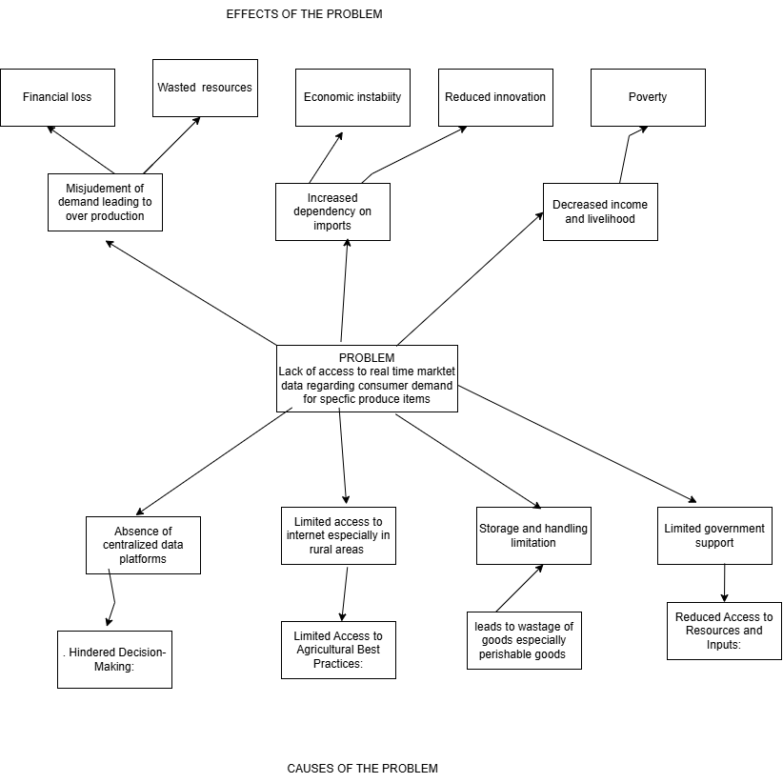

**Problem statement**

A lack of transparent and readily available information about agricultural products hinders both farmers and consumers. Farmers struggle to make informed decisions about what crops to grow based on market demand and consumer preferences keeping them in cycle of low investment and productivity. Consumers, on the other hand, often lack information about the origin, quality, and production methods of the food they purchase, leading to mistrust and potentially limiting their ability to support sustainable and ethical farming practices.

**Existing solutions**

1.Mobile based market apps

**Gaps:** Lack of localized data

2.Exploring block chain technology

**Gaps:** Cost and complexity

3.Improving internet access in rural areas

**Gaps:** Neglection of digital literacy

**Solutions Proposed**

1.Developing user friendly Market information platforms

**SDG 12: Responsible Consumption and Production:** By reducing food waste and optimizing agricultural production, these platforms contribute to more sustainable consumption and production patterns in the food system.

**Vision 2040: Economic Growth:** Most national development plans emphasize the importance of agricultural development for overall economic growth. By improving market access and productivity for farmers, these platforms contribute to the growth of the agricultural sector and its contribution to the national economy.

2.Connecting Farmers directly with consumers through farmer market partnerships groups

**SDG 2: Zero Hunger:** Direct connections reduce post-harvest losses by providing immediate market access for perishable goods. This increases food availability and reduces waste, contributing to food security. It also allows farmers to diversify and grow what consumers demand, improving nutrition.

**Vision 2040:Agricultural Transformation:** Vision 2040 prioritizes agricultural transformation. Direct market access empowers farmers to modernize their operations, increase productivity, and become more commercially oriented. This shift from subsistence to commercial farming is crucial for agricultural transformation.