[Computer Vision I] Homework 4

學號: R07943087姓名: 林啟源

**Write a program to generate images and histograms:**

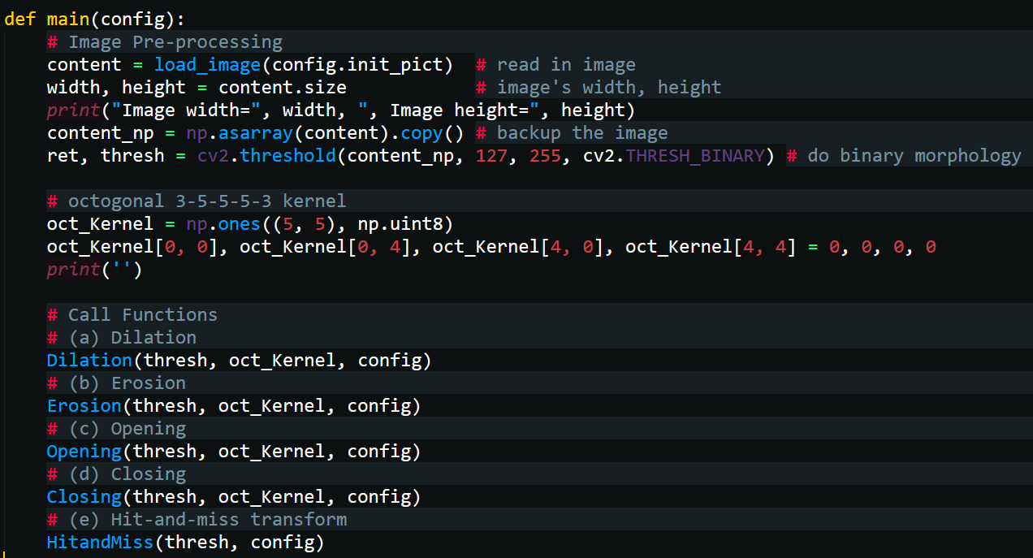

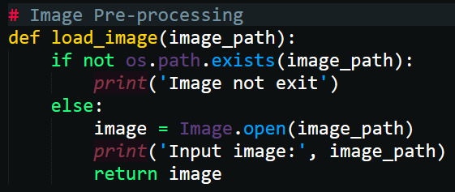

1. **Dilation**

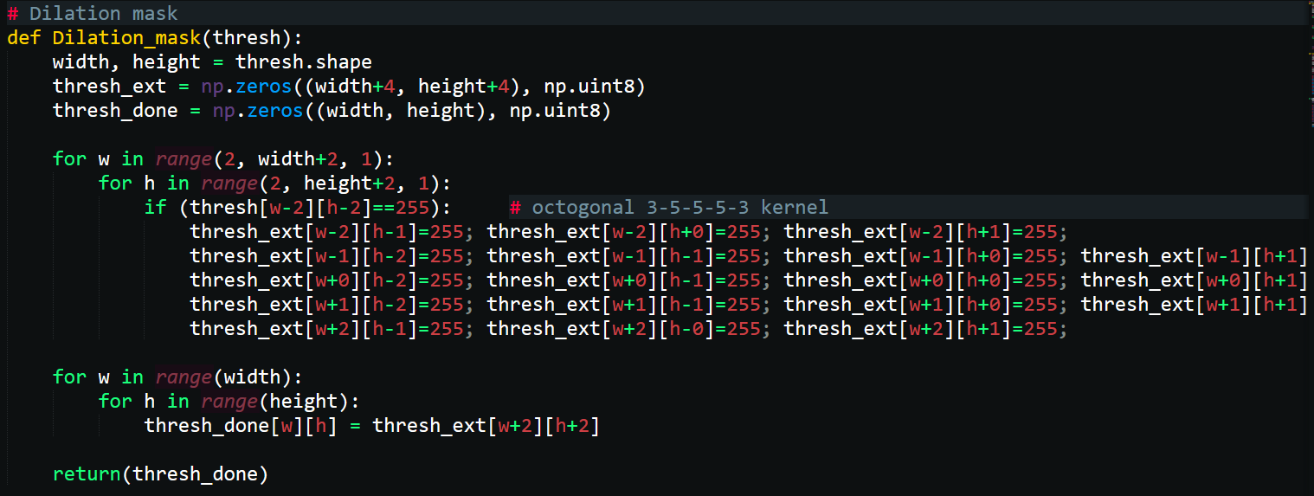

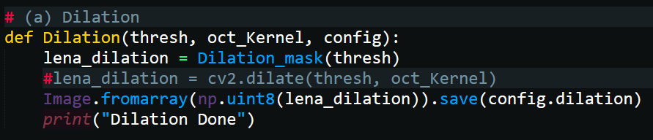

* def Dilation(thresh, oct_Kernel, config) call function “Dilation_mask()”
* “Dilation_mask()”使用2個for loop掃描比對filter和binary圖片，並將if判斷後的結果儲存於”thresh_done” np array
* if (thresh[w-2][h-2]==255)，只要目標pixel=255，便會將周圍的pixel數值依照filter圖形更改為255
* thresh_ext = np.zeros((width+4, height+4), np.uint8)會是516 * 516大小np array，經過處理會刪除多餘的邊緣，並儲存於”thresh_done” np array (shape=512*512)

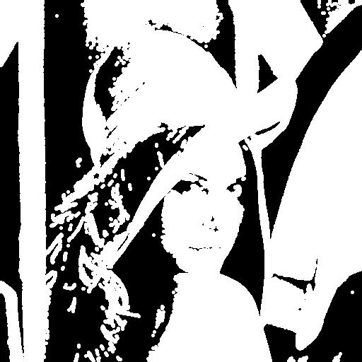

1. **Erosion**

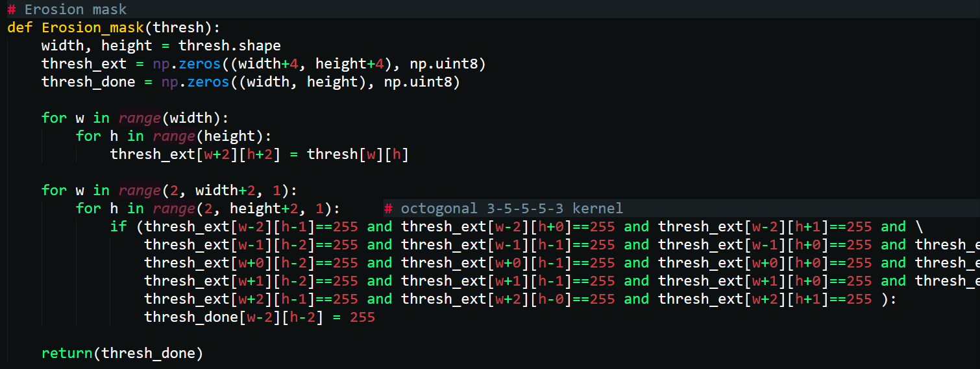

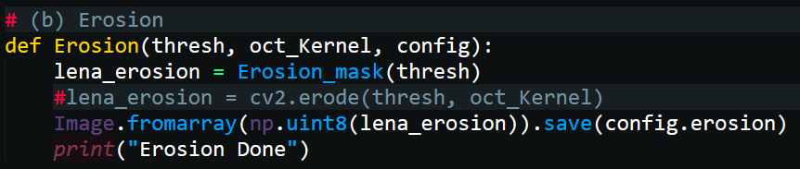

* def Erosion (thresh, oct_Kernel, config) call function “Erosion_mask ()”
* “Erosion_mask ()”使用2個for loop掃描比對filter和binary圖片，並將if判斷後的結果儲存於”thresh_done” np array
* If條件必須要filter覆蓋範圍的pixel值都為255，才會將中心pixel值保留為255
* thresh_ext = np.zeros((width+4, height+4), np.uint8)會是516 * 516大小np array，經過處理會刪除多餘的邊緣，並儲存於”thresh_done” np array (shape=512*512)

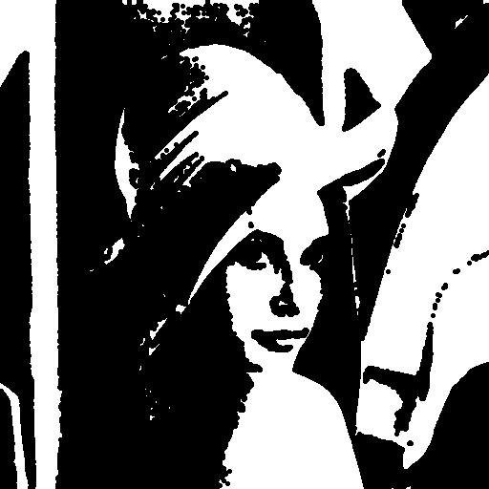

1. **Opening**

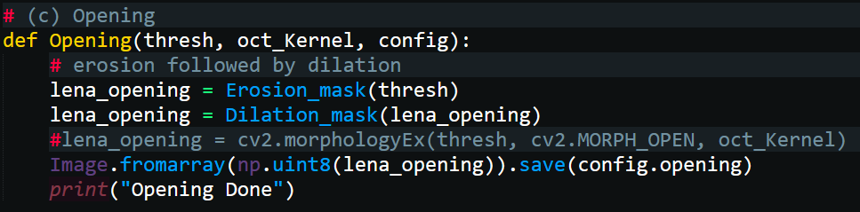

* erosion followed by dilation:

lena_opening = Erosion_mask(thresh)

lena_opening = Dilation_mask(lena_opening)

* #lena_opening = cv2.morphologyEx(thresh, cv2.MORPH_OPEN, oct_Kernel)

使用cv2函數直接產生Opening結果

* Image.fromarray(np.uint8(lena_opening)).save(config.opening)

儲存圖片

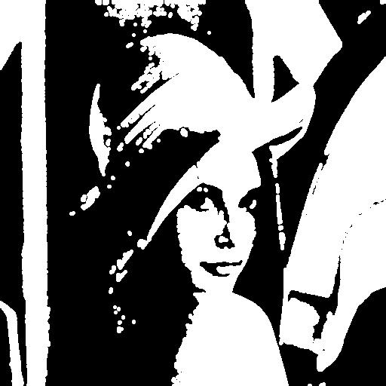

1. **Closing**

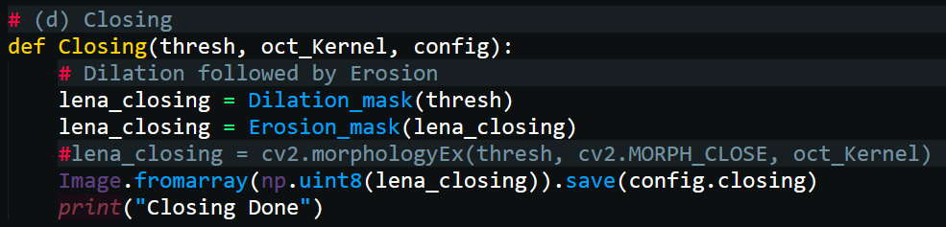

* Dilation followed by Erosion:

lena_closing = Dilation_mask(thresh)

lena_closing = Erosion_mask(lena_closing)

* #lena_closing = cv2.morphologyEx(thresh, cv2.MORPH_CLOSE, oct_Kernel)

使用cv2函數直接產生Closing結果

* Image.fromarray(np.uint8(lena_closing)).save(config.closing)

儲存圖片

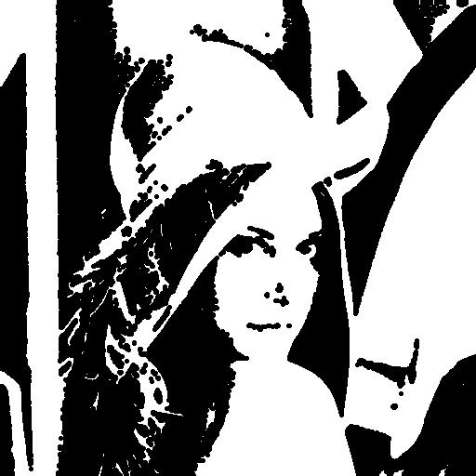

1. **Hit-and-miss transform**

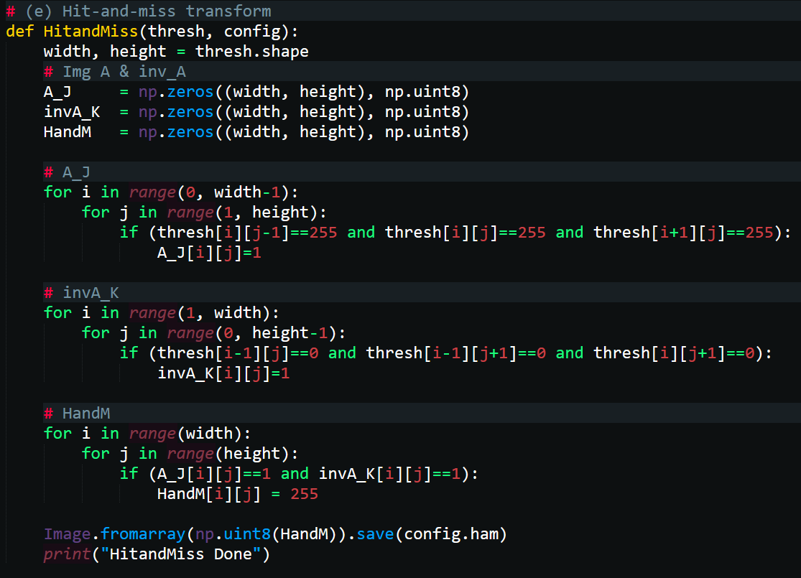

* Use 2 for loop算出A和J的intersection of erosions，A_J[i][j]

Use 2 for loop算出inv A和K的intersection of erosions，invA_K[i][j]

Use 2 for loop算出A_J[i][j]和invA_K[i][j]的intersection of erosions，HandM[i][j]

* Image.fromarray(np.uint8(HandM)).save(config.ham)

儲存圖片

