[Computer Vision I] Homework 5

學號: R07943087姓名: 林啟源

**Write a program to generate images and histograms:**

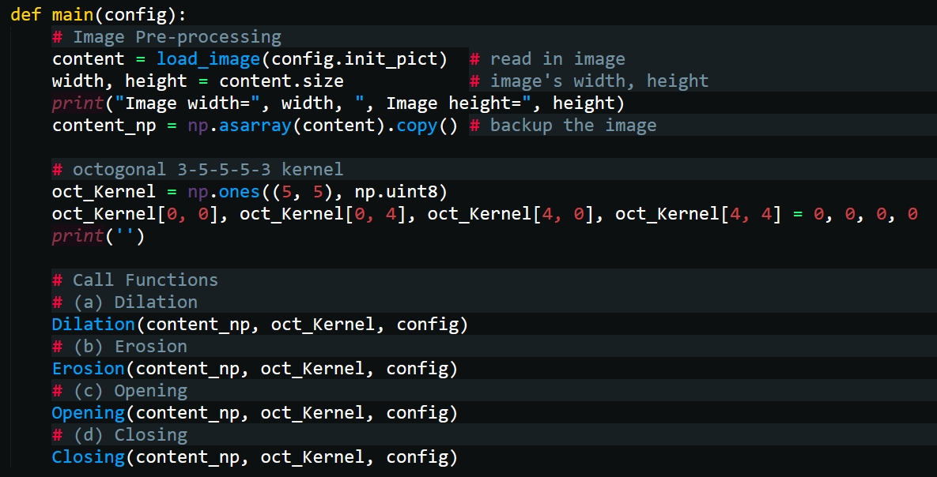

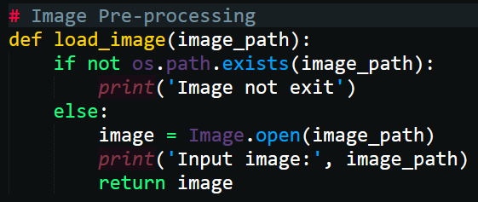

1. **Dilation**

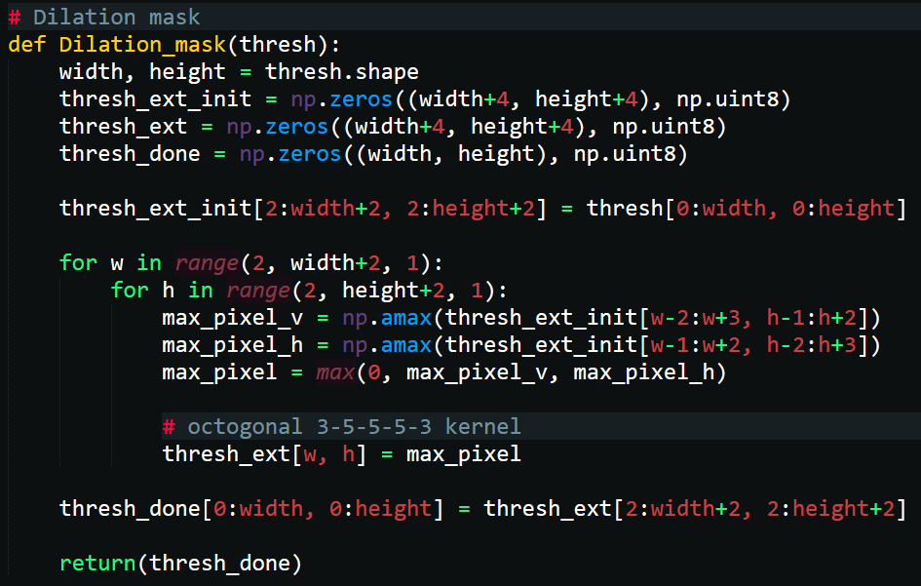

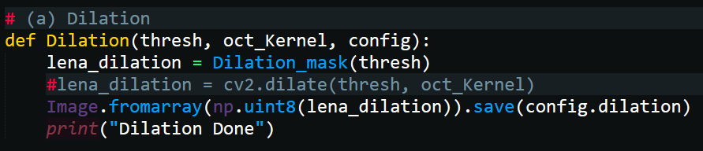

* def Dilation(thresh, oct_Kernel, config) call function “Dilation_mask()”
* thresh_ext_init[2:width+2, 2:height+2] = thresh[0:width, 0:height]建立一個比原始圖片各邊長多4的np array，並將gray level圖片數據存於其中
* 使用2個for loop掃描比對filter和gray level圖片，並找出filter範圍內pixel最大值” max_pixel”
* 將filter涵蓋部分中間值的pixel值改為” max_pixel”
* thresh_done[0:width, 0:height] = thresh_ext[2:width+2, 2:height+2]刪除多餘的邊緣，並儲存於”thresh_done” np array (shape=512*512)

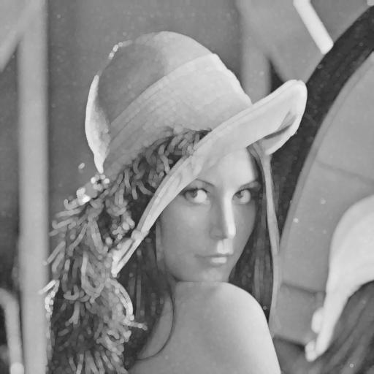

1. **Erosion**

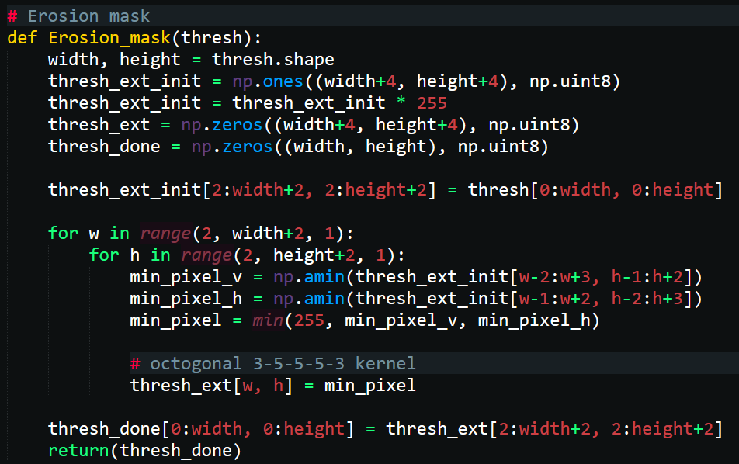

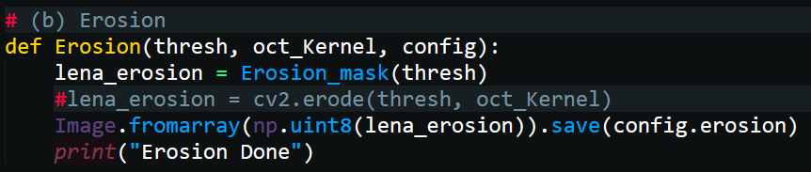

* def Erosion (thresh, oct_Kernel, config) call function “Erosion_mask ()”
* thresh_ext_init[2:width+2, 2:height+2] = thresh[0:width, 0:height]建立一個比原始圖片各邊長多4的np array，並將gray level圖片數據存於其中
* 使用2個for loop掃描比對filter和gray level圖片，並找出filter範圍內pixel最小值” min_pixel”
* 將filter涵蓋部分中間值的pixel值改為” min_pixel”
* thresh_done[0:width, 0:height] = thresh_ext[2:width+2, 2:height+2]刪除多餘的邊緣，並儲存於”thresh_done” np array (shape=512*512)

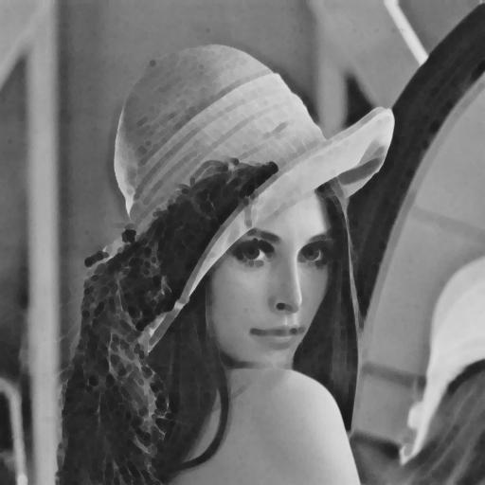

1. **Opening**

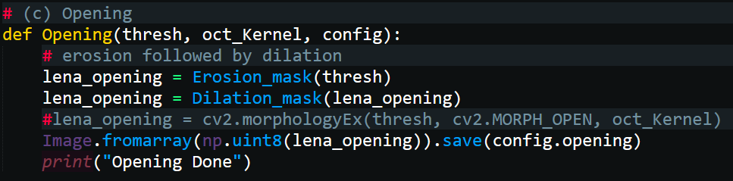

* erosion followed by dilation:

lena_opening = Erosion_mask(thresh)

lena_opening = Dilation_mask(lena_opening)

* #lena_opening = cv2.morphologyEx(thresh, cv2.MORPH_OPEN, oct_Kernel)

使用cv2函數直接產生Opening結果

* Image.fromarray(np.uint8(lena_opening)).save(config.opening)

儲存圖片

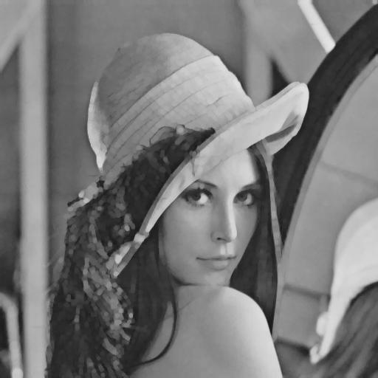

1. **Closing**

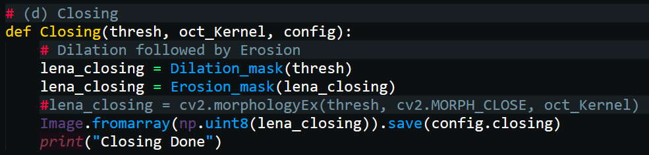

* Dilation followed by Erosion:

lena_closing = Dilation_mask(thresh)

lena_closing = Erosion_mask(lena_closing)

* #lena_closing = cv2.morphologyEx(thresh, cv2.MORPH_CLOSE, oct_Kernel)

使用cv2函數直接產生Closing結果

* Image.fromarray(np.uint8(lena_closing)).save(config.closing)

儲存圖片

