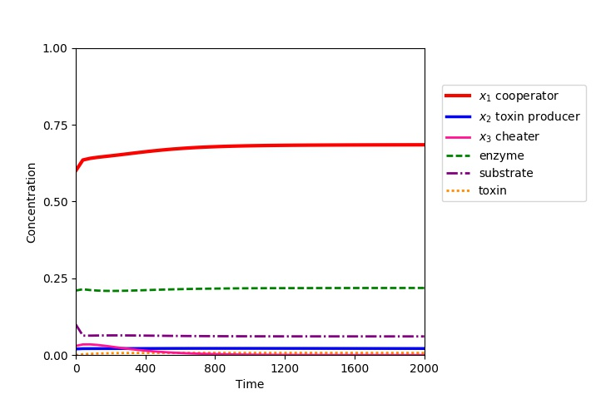  
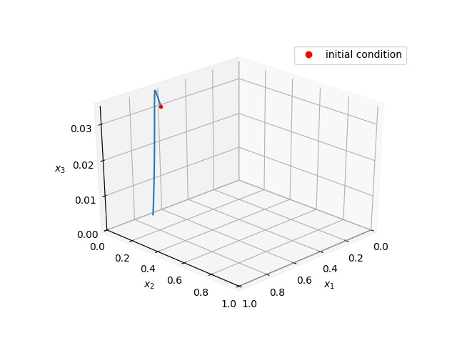  
Constants:   
k3=0.99, k1=0.015, s0=1.0, d=0.01, q1=0.24, q2=0.25

Initial conditions:

s=0.1, e=0.21, t=0, x1=0.6, x2=0.02, x3=0.03

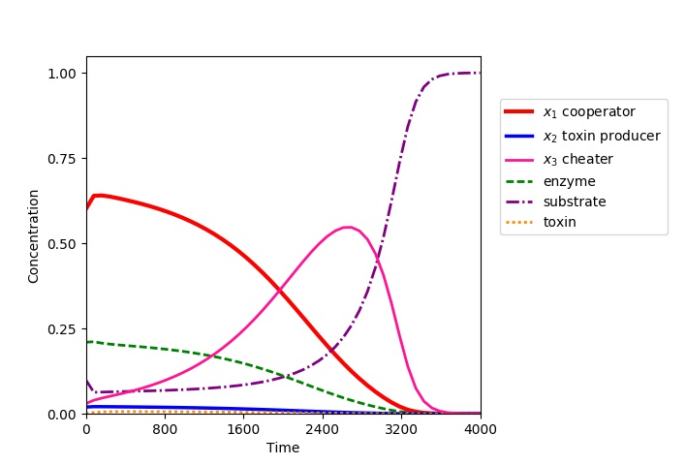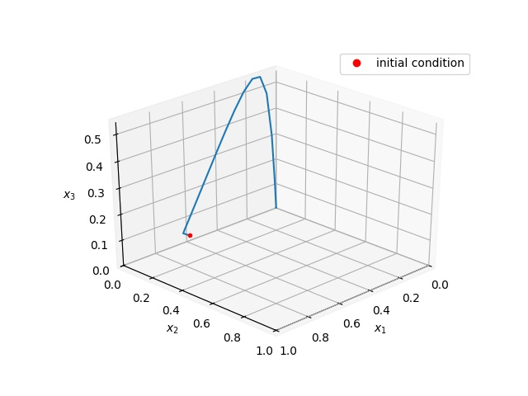

Constants:   
k3=0.3, k1=0.015, s0=1.0, d=0.01, q1=0.24, q2=0.25

Initial conditions:

s=0.1, e=0.21, t=0, x1=0.6, x2=0.02, x3=0.03

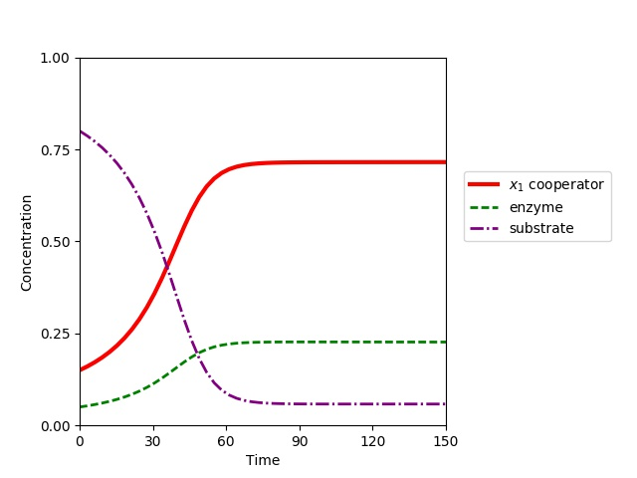

Constants:   
s0=1.0, d=0.01, q1=0.24, q2=0.25

Initial conditions:

s=0.8, e=0.05, t=0, x1=015, x2=0.0, x3=0.0

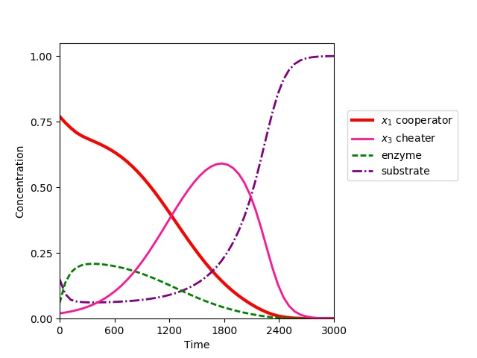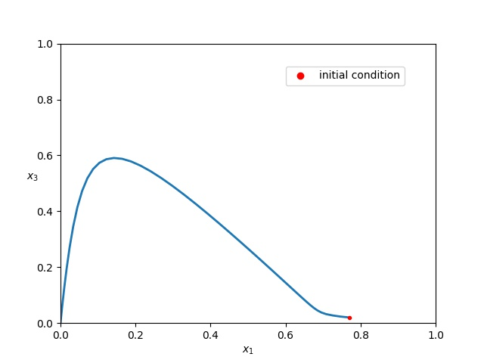

Constants:   
s0=1.0, d=0.01, q1=0.24, q2=0.25

Initial conditions:

s=0.15, e=0.06, t=0, x1=0.77, x2=0.0, x3=0.02

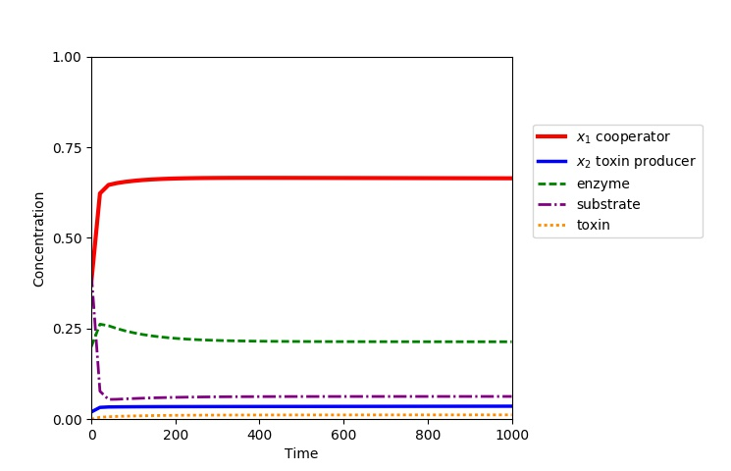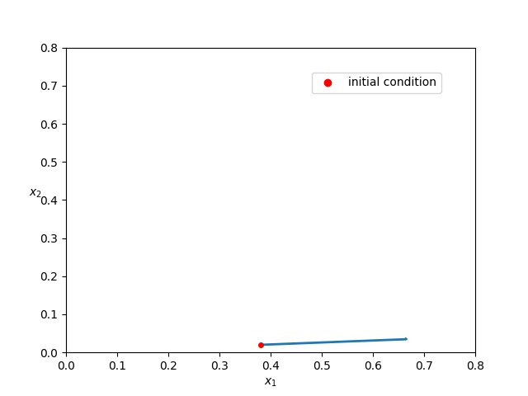

Constants:   
k1=0.015, s0=1.0, d=0.01, q1=0.24, q2=0.25

Initial conditions:

s=0.4, e=0.2, t=0, x1=0.38 x2=0.02, x3=0.0

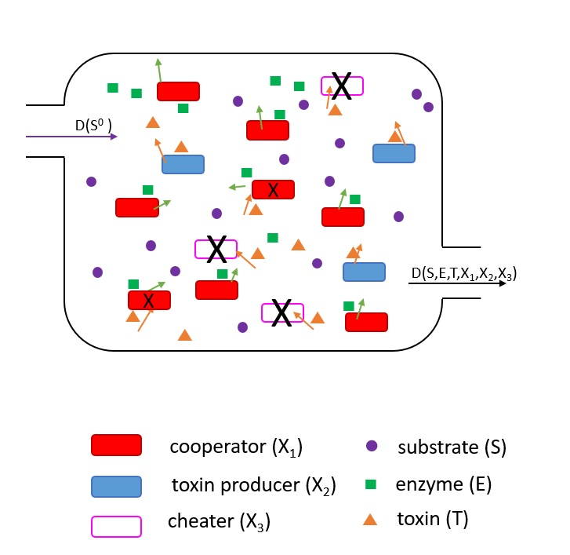

SERIES: k1=0.015, s0=1.0, d=0.01, q1=0.24, q2=0.25  
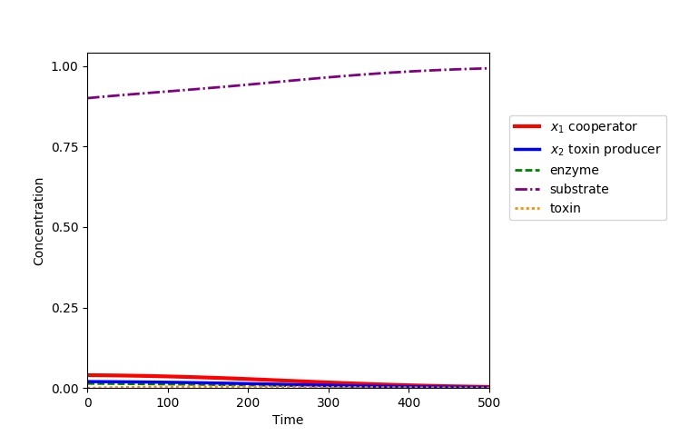

s= 0.9, e=0.014, t=0, x1=0.04, x2=0.02, x3= 0.0

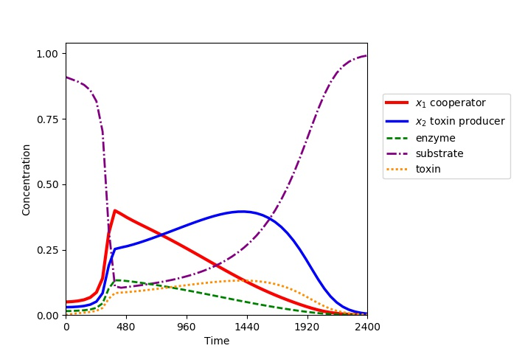

s=0.91, e=0.015, t=0, x1=0.05, x2=0.03, x3=0.0

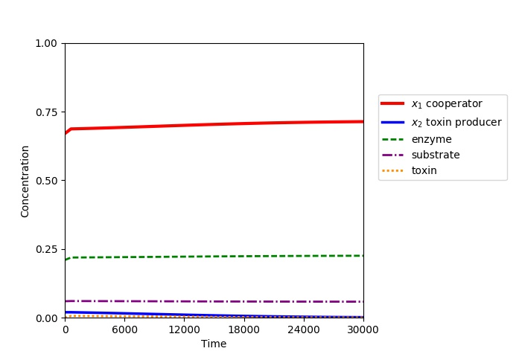

s=0.06, e=0.21, t=0, x1=0.67, x2=0.02, x3=0.0

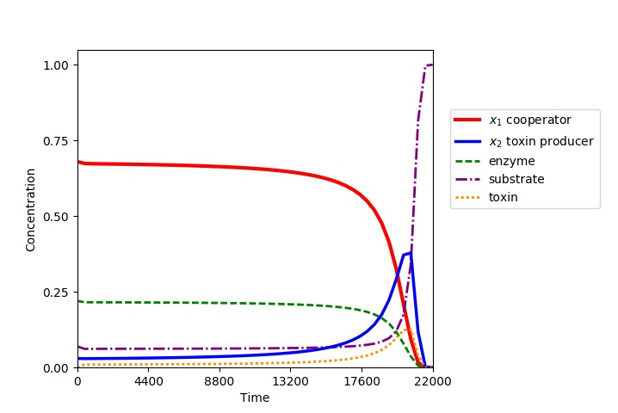

s=0.07, e=0.22, t=0, x1=0.68, x2=0.03, x3=0.0