# Original incorrect graphs, paired with graph with (many) more timesteps to show instability

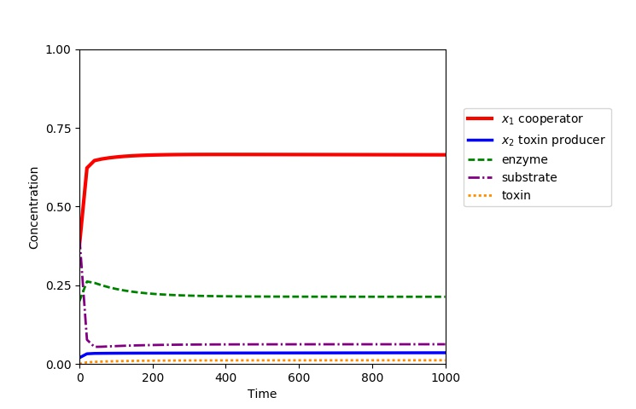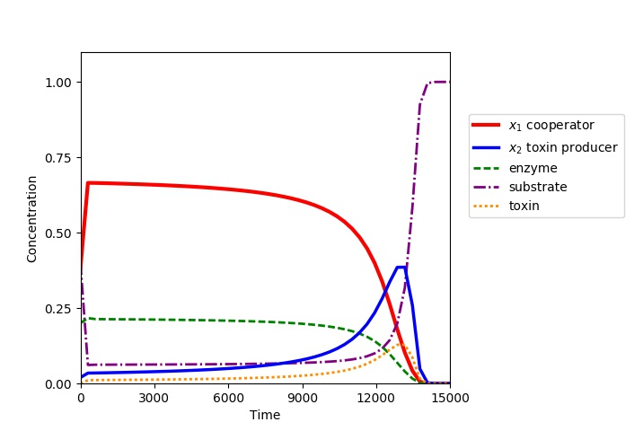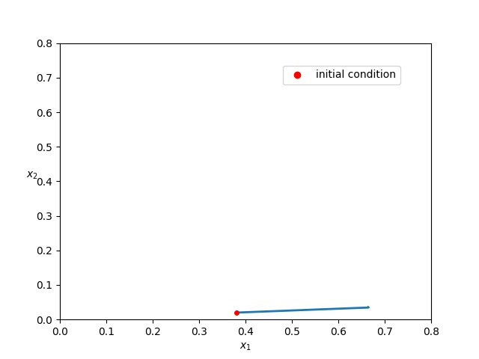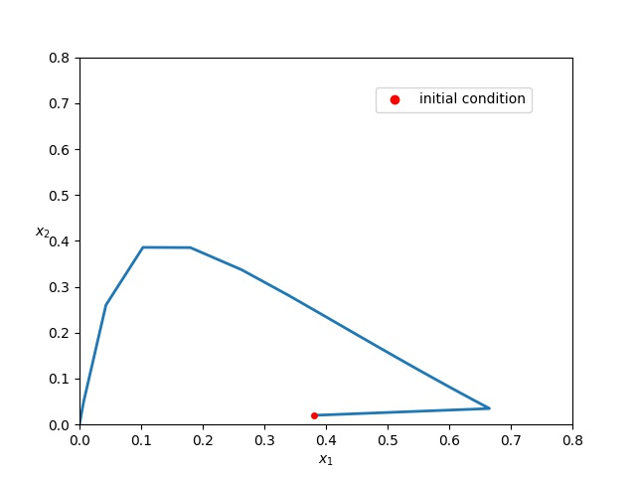

Constants:   
k1=0.015, s0=1.0, d=0.01, q1=0.24, q2=0.25

Initial conditions:

s=0.4, e=0.2, t=0, x1=0.38 x2=0.02, x3=0.0

# New graph at correct stable equilibrium. d needed to be increased to get stability

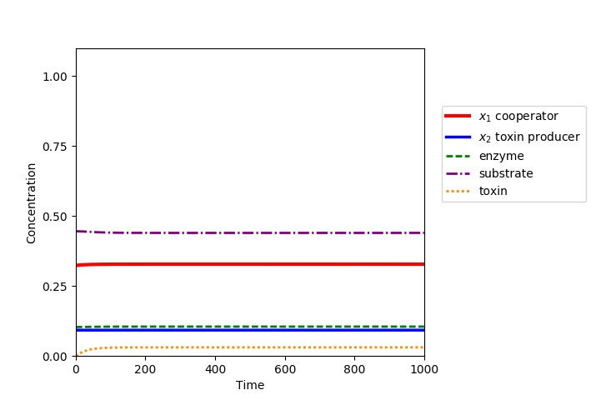

Constants:   
k1=0.015, s0=1.0, d=0.0346, q1=0.24, q2=0.25

Initial conditions:

s=0.4456, e=0.1035, t=0, x1=0.3235 x2=0.0923, x3=0.0

# Series to show d’s impact on stability. (here a=50, previous graphs all have a=1)

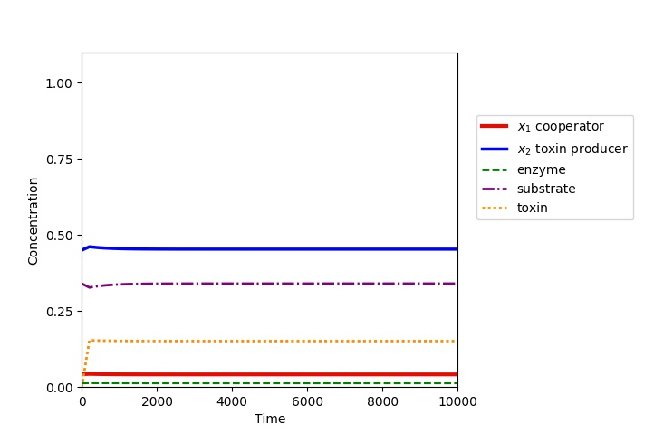Initial conditions:

d=0.17, s=0.34, e=0.0135, t=0, x1=0.042 x2=0.45, x3=0.0

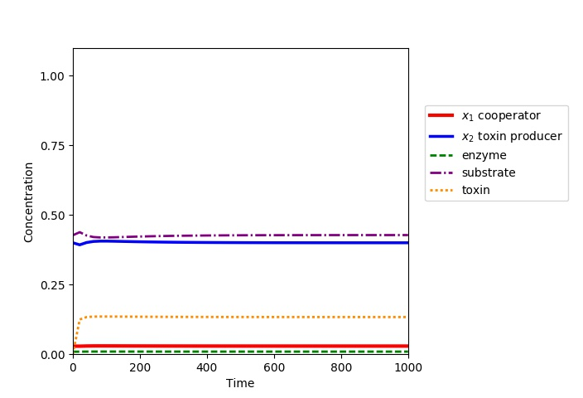

Initial conditions:

d=0.15, s=0.427, e=0.009, t=0, x1=0.029, x2=0.4, x3=0.0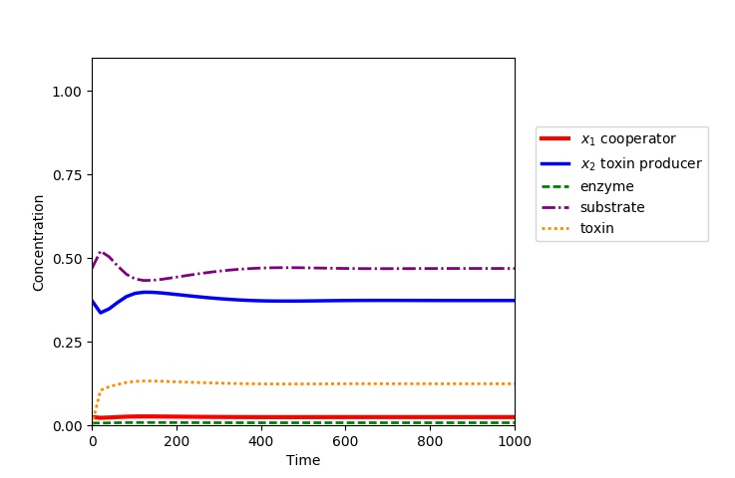  
Initial conditions:   
d=0.14, s=0.469, e=0.007, t=0, x1=0.042 x2=0.373, x3=0.0

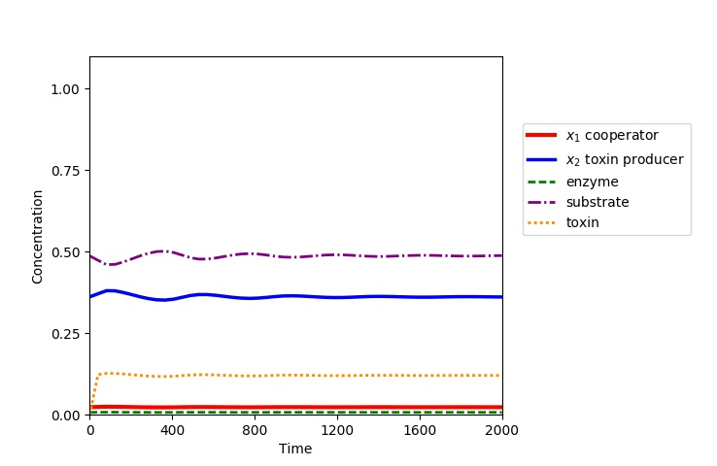

Initial conditions:

d=0.1355, s=0.487, e=0.0074, t=0, x1=0.0231 x2=0.3613, x3=0.0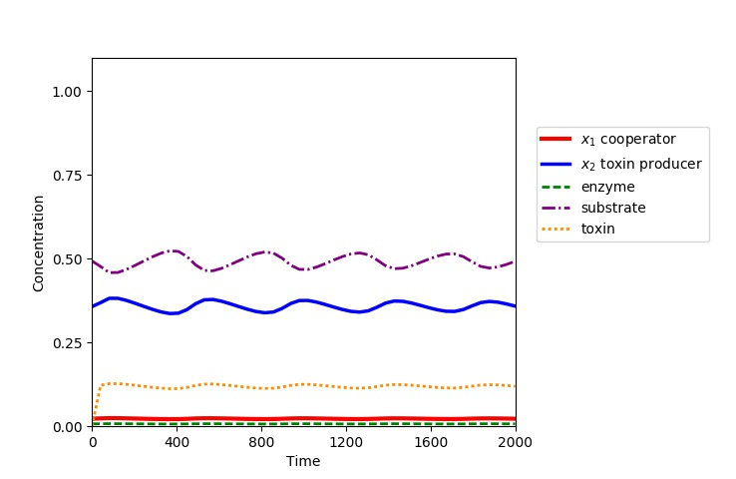

Initial conditions:

d=0.134, s=0.493, e=0.0072, t=0, x1=0.0226 x2=0.357, x3=0.0

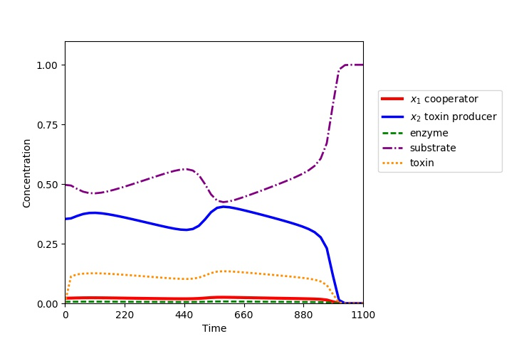

Initial conditions:

d=0.133, s=0.497, e=0.0071, t=0, x1=0.0222, x2=0.354, x3=0.0