constants:

a: 5.0 d: 0.05 q1: 0.24 q2: 0.25 k1: 0.01 s0: 1.0

sol:

s: 0.0857950075608 e: 0.155409198185 x1: 0.485653744329 x2: 0.2

d: 0.05

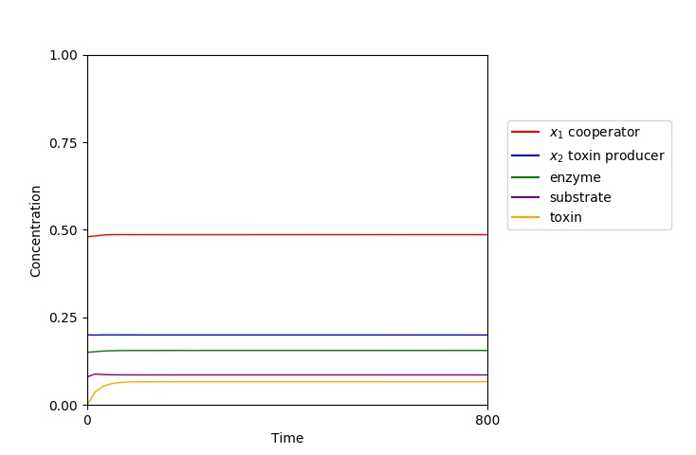  
  
d: 0.04

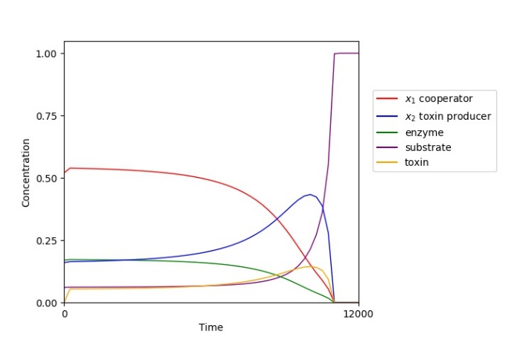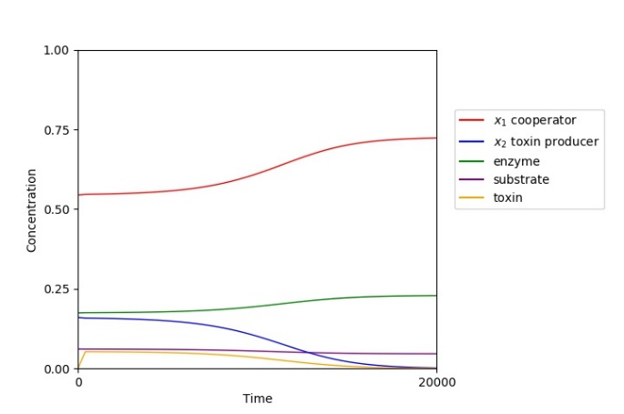  
[0.061269, 0.174095, 0, 0.54404, 0.16, 0.0] [0.061, 0.17, 0, 0.52, 0.16, 0.0]

~~-redo d0.04 w/ initial conditions closer to corresponding st.state for that d~~-search for ‘wiggles’  
-routh-horowitz check sign changes (d change)