Foxwall Crew Portal

User Guide



Contents

Introduction 2

Logging In 2

Logging Out 2

The Main Menu 2

The Dashboard 3

Calls 3

Add a Call 4

Search for a Call 5

Call Reports 5

Editing a Call 6

People 6

# Introduction

The Foxwall Portal is a web application designed for Foxwall crew members. Currently it can be used to log calls, but it will likely be expanded in the future. You can find the portal here:

**http://www.foxwall.org/crew**

# Logging In

You must log in to use the dashboard. If you forget your username and/or password, you must contact Linda or Gordy. Someday there will be a “forgot password” link.

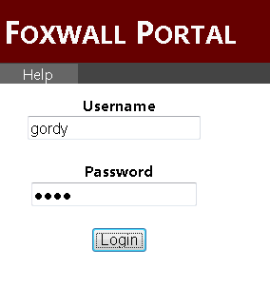

# Logging Out

For security purposes, please remember to log out of the website when you’re finished using it. Closing the browser doesn’t hurt, either. To log out, just click the *Log Out* button in the upper right.

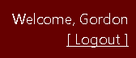

# 

# The Main Menu

Once you’re logged in, you will see the main menu in gray across the top of the page. Here you can access important areas of the website, explained in more detail later.

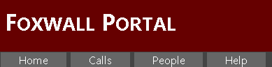

* Home = Takes you back to the main dashboard.
* Calls = Add, search for, or report on calls.
* People = Manage people (administrators only).
* Help = View this help document online.

# The Dashboard

The main dashboard shows you important notices, as well as menu options for common activities. You can return to the dashboard at any time by clicking the *Home* main menu item.

**Note:** The dashboard will warn you if you have outstanding tripsheets. Remember that tripsheets must be filed in EMSCharts within 24 hours for ALL calls.

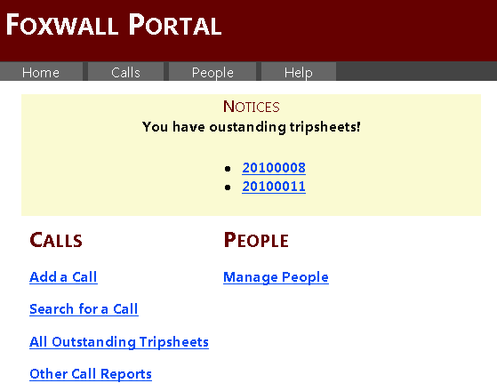

# Calls

The Calls section of the website allows you to add and edit calls, search for them, and generate reports about them. You can access the Calls section either through the dashboard or through the *Calls* main menu item. From the Calls section, you can:

* Log (add) a new call.
* Search for an old call.
* View call reports.

These options are accessible via a sub-menu underneath the main menu when you’re in the Calls section.

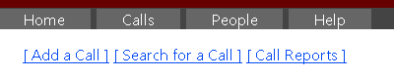

## Add a Call

Adding a call is the default option when you access the Calls section. You will see a form to fill out with the call information.

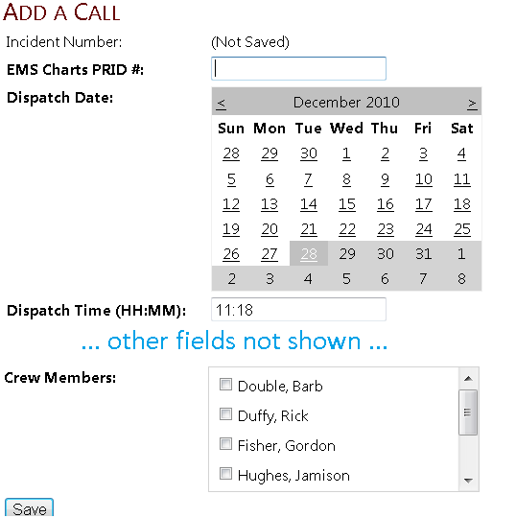

Click the *Save* button once you’ve entered all the call data.

|  |  |
| --- | --- |
| **Incident Number** | The Incident Number will not appear until after you click the Save button.  **Note:** Once you’ve saved a call, the Incident Number is assigned and cannot be deleted. If you mistakenly add a call, contact Linda or Gordy. |
| **EMS Charts PRID #** | This is where you enter the “PRID” number from EMS Charts.  You can initially leave the EMS Charts # blank, and fill it in later once the tripsheet is written. |
| **Dispatch Date** | The date will be defaulted to today’s date. Click another day on the calendar to change it. Use the little < > icons on the calendar to select the next or previous month. |
| **Dispatch Time** | The time will be defaulted to the current time. Enter the correct time in HH:MM format using 24-hour time (for example: 02:42 or 18:30). |
| **Location** | Enter the location/address of the call. |
| **Borough** | Select a borough from the list. If the borough is not listed, select “Other”. |
| **Chief Complaint / Dispatch** | Enter the patient’s chief complaint. If there is no patient, enter a short summary of the reason for dispatch (e.g. “Wires Down” or “Fire Alarm”). |
| **Age** | Enter the patient’s age. For young children, you can use the drop-down to select months or days instead of years. Leave this field “0 years” for calls that have no patient. |
| **Disposition** | Select the disposition form the list. If none is applicable, select “Other”. |
| **Crew Members** | Click the check boxes next to crew member names to assign one or more crew to the call. Note that you can assign St. Margaret’s response team medics as well – just select “SMMH Medic” as the crew member. |

## Search for a Call

You can search for a call from the main dashboard or from the Calls section sub-menu. Currently you can only search for a call by Incident Number. This will be expanded in the future. Just enter the incident number and click *Search*. You will be shown a list of matching calls.

**Note:** You can search for partial incident numbers. For instance, entering “2010” will allow you to search for all calls in 2010.

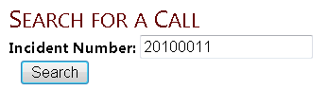

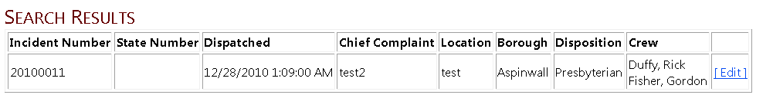

## Call Reports

A variety of call reports are available, with more to be added in the future. You can access the call reports from the main dashboard or through the Calls section sub-menu. Just select a report and you will be shown a list of relevant calls.

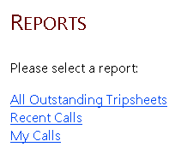

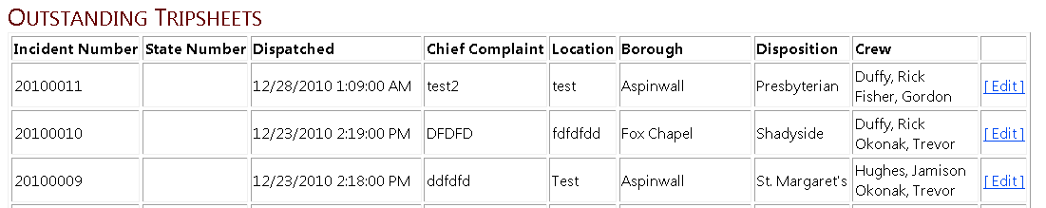

## Editing a Call

From either the search results page or a call report page, you can choose to edit an existing call. Click the *Edit* button next to the call’s entry, and you will be taken to the edit page. The Edit page is the same as the Add a Call page, except that all the data is already filled in for you.

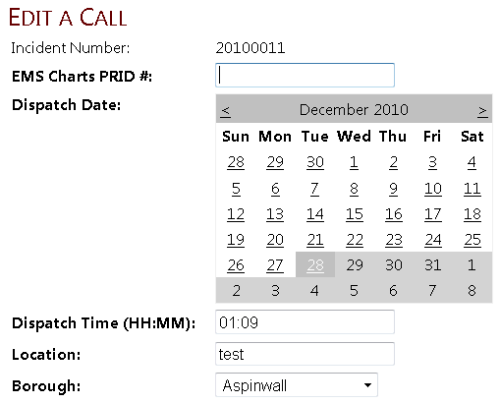

# People

Help coming soon.