- The stack buffer overflow occurs in H3C's web management service program, located at /bin/webs
At 0x10050a38, we can see that the sprintf function performs no length check on param3; param3 comes from the parameter named param.
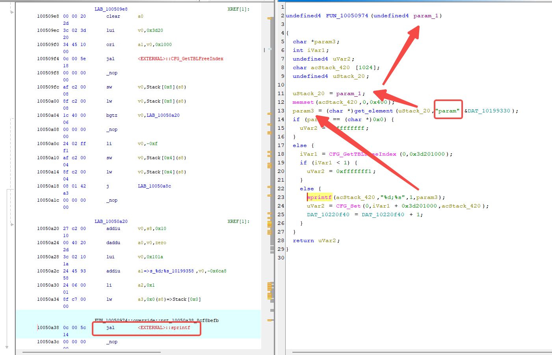
2. Tracking param3, we can see that it is initially passed in via the parameter param_1.
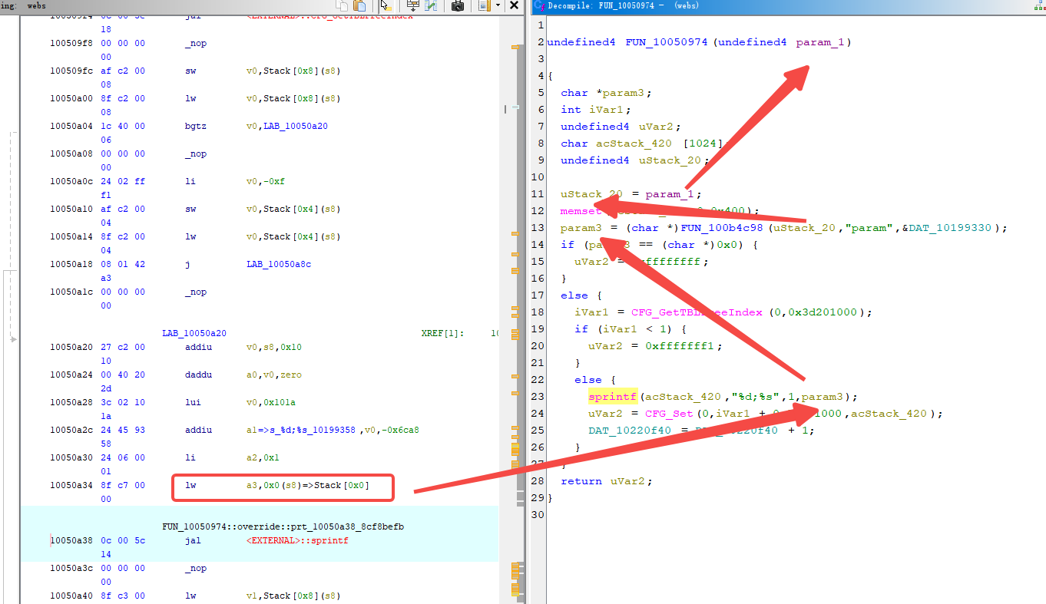

3. Tracking the function, we find that it is named AddIKEProposalList. All the other related functions are stored in a table whose base address is 0x10208e80, in (function name, address) form.
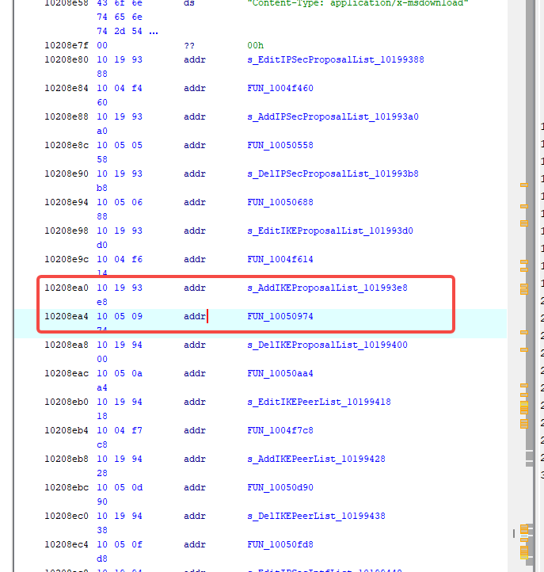
4. MIPS has no absolute addresses; they are all assembled from two instructions, lui + addiu.
The address 0x10208e80 cannot appear as a direct immediate value; the compiler must have split it into:
lui vX, 0x1021 ; vX = 0x10210000
addiu vX, vX, -29056 ; vX = 0x10210000 - 0x7180 = 0x10208e80
The reference point is found at 0x1002b12c.
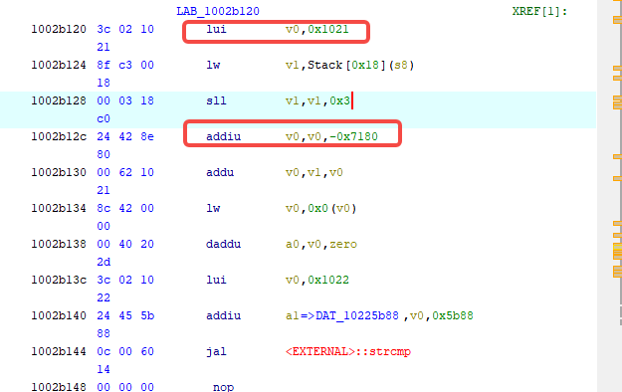
5. Continuing the trace, AddIKEProposalList is called at 0x1002b194.
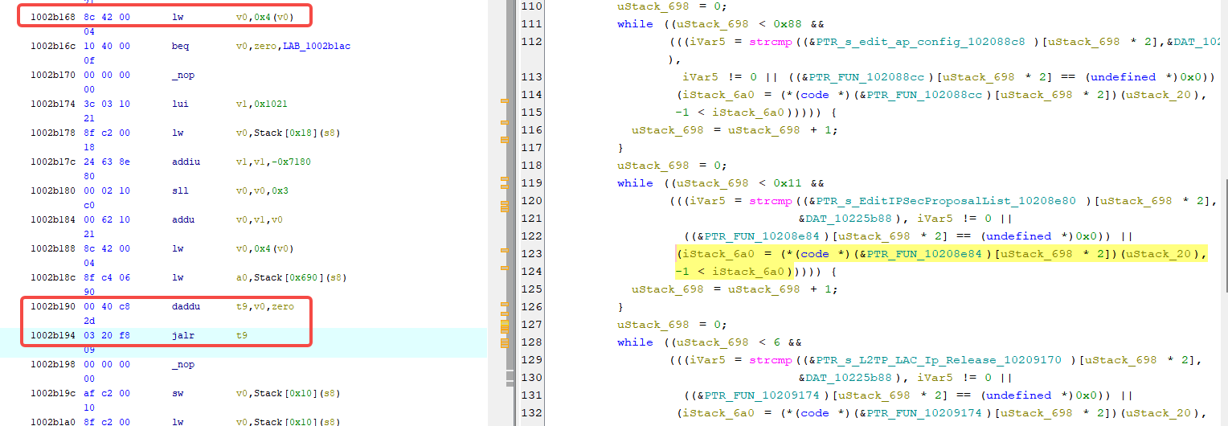

6. Its enclosing function fun_1002a980 is the method that handles the request. Continuing the trace to 0x10018af8, we can see that fun_1009e888 calls 1002a980.
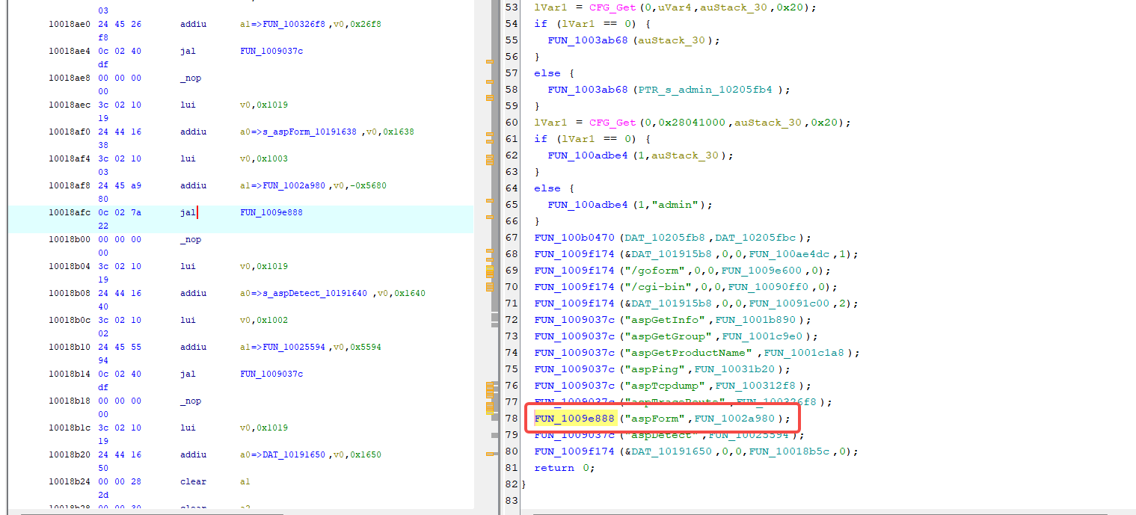
7. Searching for aspForm shows that the complete endpoint is /goform/aspForm.
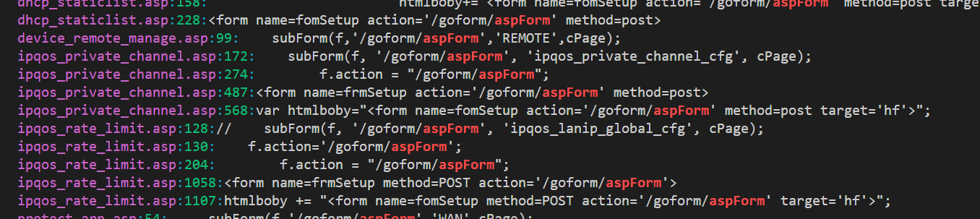
8. According to step 3, the AddIKEProposalList function name tells us that its purpose is most likely to add a predefined IKE proposal to the system configuration or to a particular connection configuration. The endpoint was found in the front-end pages, and from step 1 we know that param is the parameter that triggers the overflow.
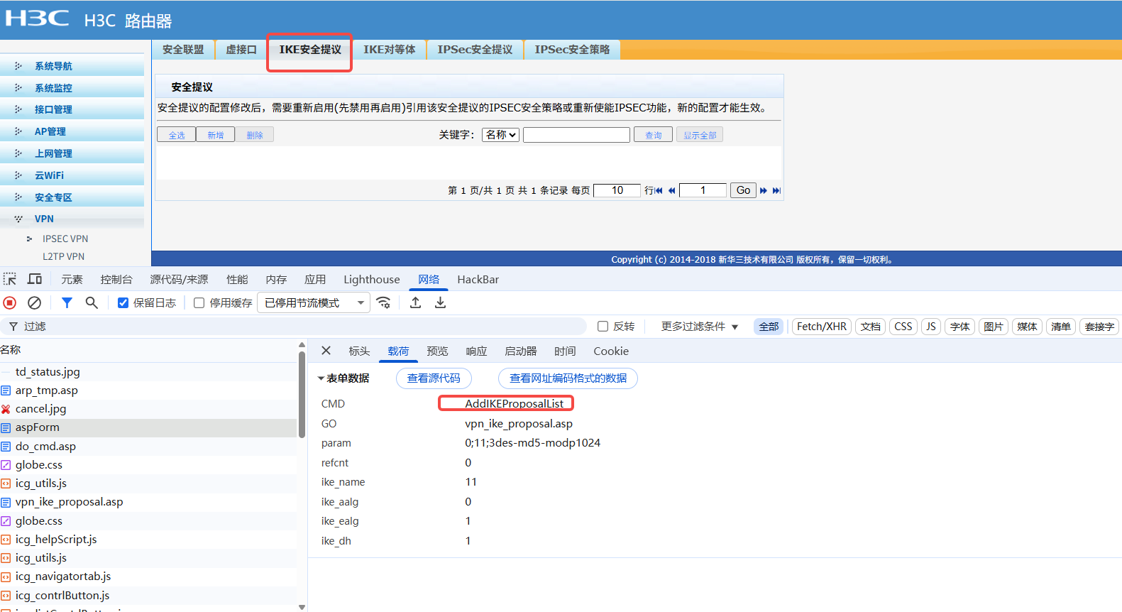

- Returning to the overflowing function from step 1, we can see that sprintf stores the processed input parameter in the acstack_420 buffer.
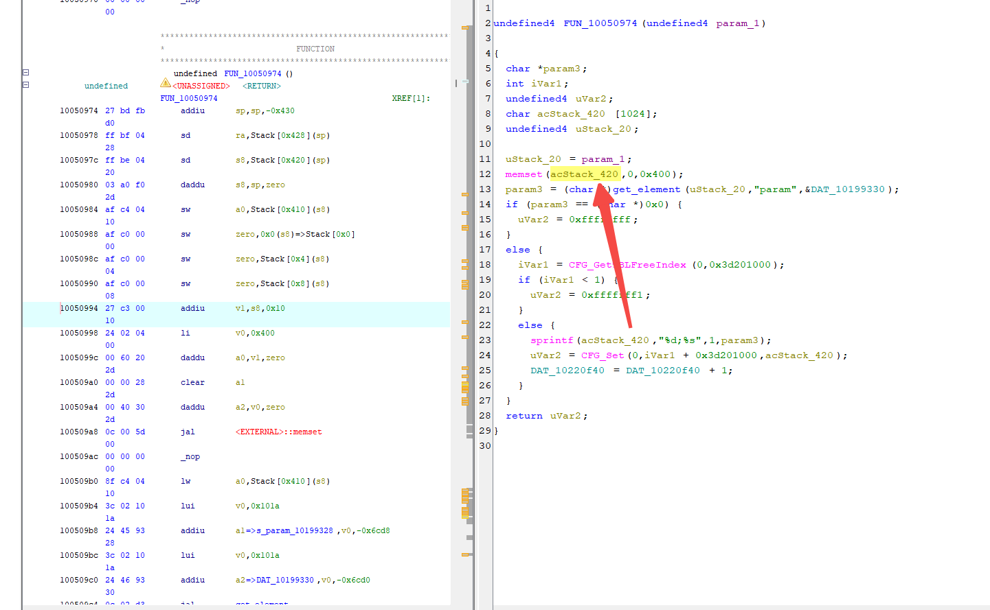

10. The end of the buffer at sp+1039 is only 32 bytes away from the end of the stack frame at sp+1072, so overflowing by a few dozen bytes is enough to reach s8/ra and crash the program. Craft a PoC with an input longer than 1039 bytes.

sp+16 +---------------------------+
| |
| target buffer 1024 bytes | (1)
| sp+16 .. sp+1039 |
sp+1040 +---------------------------+
| local var (saved a0) |
sp+1056 +---------------------------+
| saved s8 (frame ptr) | (2)
sp+1064 +---------------------------+
| saved ra (return addr) | (3)
sp+1072 ============================ end of stack frame
(1) sprintf writes here
(2) overwritten first
(3) overwritten second -> jr ra jumps away
11. After running the PoC (python3 poc_01_AddIKEProposalList.py --host 127.0.0.1:8080 --cookie "JSESSIONID=$SID"), crash information appears in the kernel log and ra is overwritten with an abnormal value.
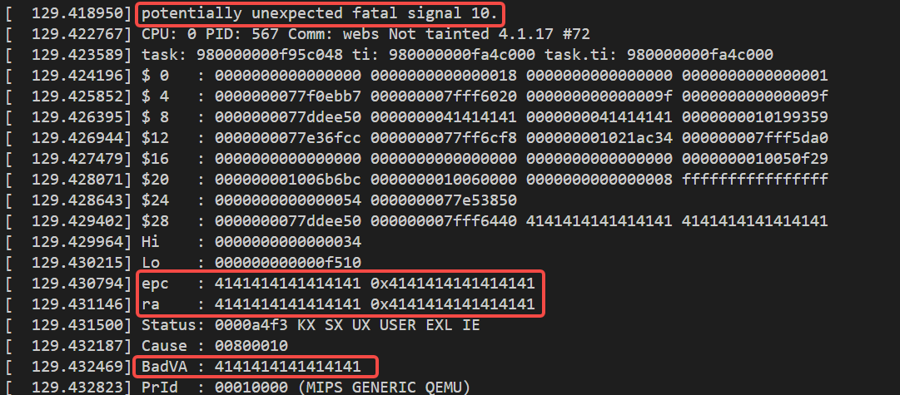
12. The front-end UI shows the web service exiting abnormally; see poc_01_AddIKEProposalList.mp4.

