


Leadership Style Indicator® Copyright 2002 by Somerville Partners

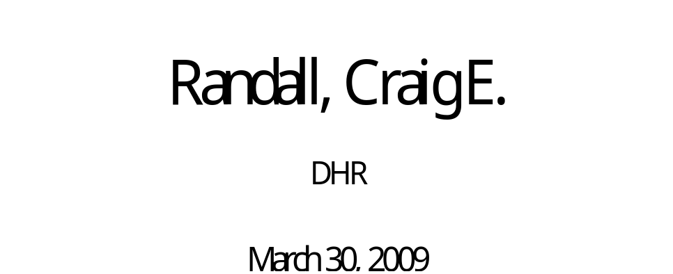

Somerville Partners
The Cairn Building
727 East 16th Avenue
Denver, CO 80203-2003
Phone: (303) 830-0900
Fax: (303) 830-6773
www.somervillepartners.com

Leadership Style Indicator® -- Introduction

Leadership Style Indicator® (LSI®) Background

When studying effective leaders, one consistent theme emerges -- people are complex and varied. There is no one effective leadership style. One individual may be effective in one situation and ineffective when placed in another. The situations can vary based on internal factors such as follower characteristics, organizational culture, organizational structure and the pressures on the work group to perform. External factors also play a role. Factors such as market position, competition faced and stage of company development all can have a significant impact on the leadership style required. We have found that, regardless of the situation, effective leaders understand their strengths and weaknesses in addition to leveraging their strengths and compensating for weaknesses. We have also found that exceptionally effective leaders go one step further; they use their insights into people to tap the unique set of needs and motives required to drive high performance of those with whom they work.

All leaders bring innate traits or talents, learned skills and unique experiences to each organizational situation Skills and experiences help build each person’s beliefs, values and attitudes, which ultimately shape work style behavior. Effective leaders know themselves and which situations call for what characteristics; they also recognize when a situation calls for characteristics they don’t have. Where they can leverage complementary characteristics in other members of their team, they are successful; where these complementary characteristics are not anywhere to be found, they wisely take a different direction. The LSI® report is designed to provide you with comprehensive and detailed information about your specific leadership style, based on the results from Somerville Partners’ Leadership Style Indicator®.

In addition to skilled individuals, it is important for an organization to have people who have differing strengths and leadership styles. In other words, in certain organizational situations, some people will be more effective than others based on their individual leadership styles. In another situation, other people will be most effective based on a different leadership style. Therefore, if all the people in a work group have homogeneous leadership styles, some situations will not go well because the necessary leadership style is not available to be utilized. Complexity and diversity among individual members make strong teams. Individuals bring their own set of traits, skills and experiences and, hence, make their own unique contributions to a team. Visioning, strategizing, planning and problem solving are then accomplished from a variety of perspectives creating richer, fuller results.

Interpreting Your Leadership Style Indicator®

An effective leadership style depends, to some degree, on the context and particular needs of the situation. Since the effectiveness of any work style is dependant on the circumstance, the most crucial step in professional development is to gain insight into your particular leadership style and the organizational conditions that best fit with your style. Armed with this understanding, you can accurately assess requirements for a particular situation and determine the degree of stretch required for you to succeed. You can then analyze how your style interfaces with the challenges in your current position and what actions you need to take to compensate for weaknesses and build on strengths in order to be optimally successful.

Structure of the Leadership Style Indicator®

Over time, through statistical and qualitative analyses of Somerville Partners’ database, five leadership style factors have emerged which distinguish the ways people lead. Section 1 on page 3 of this report depicts the characteristics associated with your leadership style. Section 2, starting on page 5, provides detailed information on the underlying dimensions that are salient to each of the leadership factors. Carefully read the descriptions of the styles on page 4, study the graphs in Section 2 and read the notations under Contributions and Limitations that follow each graph. Write out any questions you have that you would like to discuss with your consultant or coach.

The Leadership Style Indicator® is based on responses of almost five thousand executives and professionals in our database. These people are primarily executives, managers and other professionals from a wide range of industries. A suite of our instruments used to assess patterns of motivation and personality style was subjected to a factor analysis yielding five factors with 46 underlying dimensions.

Because of the special nature of the people in our database who make up the norm group, the instruments make subtle discriminations between traits, motives and styles among highly effective people. This facilitates comparing your traits, motives and styles with those of other executives and professionals in ways that have proven important to individual and team effectiveness.

Section 1 – Leadership Style Indicator®

Characteristics Associated with Different Leadership Styles

The different styles of effective people are determined by various combinations of their intellectual, emotional and social approach to the world. The graph below illustrates the five factors comprising one’s leadership style. To determine which combination is best in a given situation, you must consider the challenge you’re facing, the styles of other members of your team(s), the development stage of your organization, characteristics of the market place and your role in the organization. The graph below displays results of your self-assessment using Somerville Partners’ (SP) Leadership Style Indicator®(LSI®). In general, when the bar extends beyond one line from the centerline, some to many of the characteristics associated with that style are associated with you.
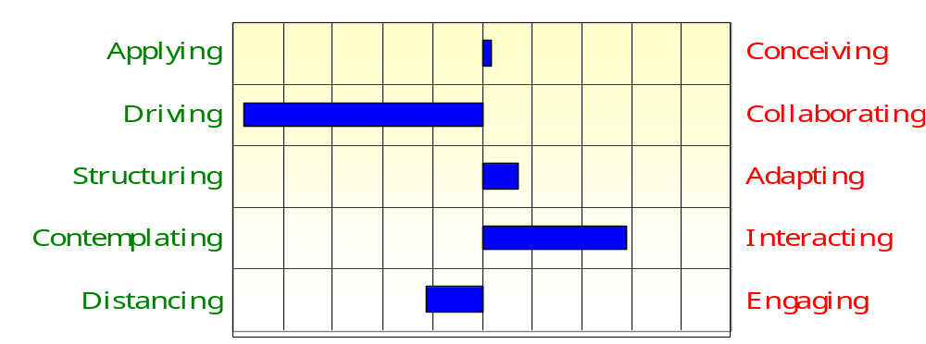
The themes of the behaviors associated with each extreme of the five factors can be found on page 4. When reading these descriptions, keep in mind that the longer the bar, the more closely you fit the theme as it is described for that side of the factor.
In Section 2, you can find those attributes found to be characteristic of you based on your responses to the items on the survey. The aggregations of the descriptions make up how you are most similar to each of the five factors.
LSI® Factors -- Behavioral Descriptions
FACTOR 1 – STRATEGY ORIENTATION: Applying—Conceiving: This factor describes how one works with strategy. Those whose preference falls on the left side of the continuum toward Applying are both conservative and practical about strategy. They dig into the details to see implications for different alternatives. They look for evidence from experiences for validation of alternatives. They avoid being distracted by attractive sounding concepts; instead, they test ideas against their background and experience and what they know to have been successful in the past. Those whose preference falls on the right side of the continuum toward Conceiving wrestle with concepts and frameworks within which action takes place. They insist on developing a thorough understanding of all the variables in operation before proposing ideas for dealing with the issues and challenges. They keep the big picture clearly in mind as they apply their imagination and creativity to the challenges being faced.
FACTOR 2 – ORIENTATION TO EXECUTION: Driving—Collaborating: This factor describes one’s orientation to executing strategy. Those whose preference falls on the left side of the continuum toward Driving are focused on doing things to beat the competition, serving their ambition for greater responsibility, leveraging their ability to persuade people to follow their lead, staying the course in the face of criticism, having a significant impact on their organization, wasting little time on endeavors with little chance of success, and showing little patience with those holding back progress. Those whose preference falls toward the right side of the continuum toward Collaborating are focused on working behind the scenes, collaborating with all those involved, balancing work and other interests, keeping one’s options open, inviting criticism, showing thoughtfulness, and pushing ahead in the face of significant obstacles.
FACTOR 3 – PROCESS & METHODS: Structuring—Adapting: This factor describes one’s preferences for going about getting things done. Those whose preference falls to the left side of the continuum toward Structuring seek clarity in roles and responsibilities, find systematic, methodical, and scheduled approaches to the tasks at hand, put things in their proper order, get started early, follow well conceived plans and move cautiously and steadily ahead. Those whose preference falls to the right side of the continuum toward Adapting rush in, figure out what needs doing in the moment, seek lots of variety and change, readily shift focus and methods to adjust to changing circumstances, wait until the last moment to tackle the next priority, live in the moment and readily take risks.
FACTOR 4 – INFORMATION GATHERING: Contemplating—Interacting: This factor describes one’s preferences for gathering and incorporating information. Those whose preference falls on the left side of the continuum toward Contemplating take in information and think about it before reaching conclusions, keep a measure of autonomy and independence as they mull things over reflectively and without demonstrations of emotion. Those whose preference falls on the right side of the continuum toward Interacting actively engage people in information exchanges, invite expressions of criticism and ideas, bring in all points of view, exude enthusiasm for the work ahead and share their thinking for all to see.
FACTOR 5 – RELATIONSHIPS: Distancing—Engaging: This factor describes one’s preferences for working with others. Those whose preference falls on the left side of the continuum toward Distancing take a position emphasizing objectivity and distance – critically evaluating what people tell them, insisting on applying logic and reason to most issues, and placing great value on metrics and analysis. Those whose preference falls to the right side of the continuum toward Engaging take a position emphasizing the quality of relationships, sharing joy and disappointment and surrounding themselves with people with whom they enjoy mutual respect and trust.
The most salient aspect of your leadership style is found by finding the strongest two factors. Your style and the implications for it can be found in the table below. First there is a description of your preferred style of leading. Next there is a description of the environment to which your style is well-suited. Finally, the third table contains a description of the environment to which your style is not well-suited. By finding the right environment for your preferred style, you will optimize your chances of success.

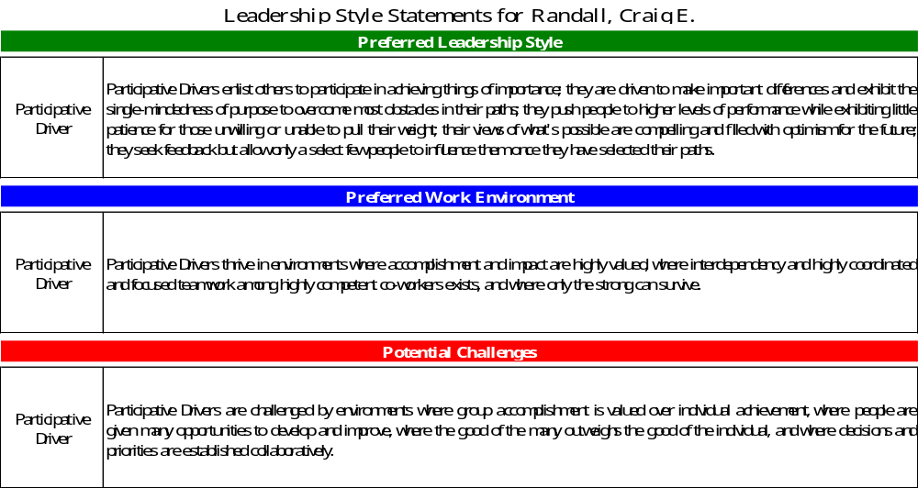

Section 2 – Leadership Style Indicator®

FACTOR 1 –ORIENTATION TO STRATEGY – How leaders work with strategy

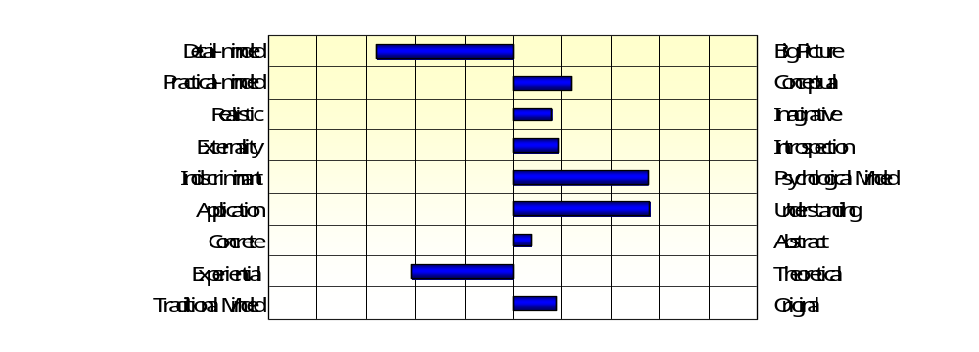
In the graph above, your score on Factor 1 – Applying -- Conceiving is depicted by the striped blue bar. If it is more than one line away from the centerline, several of the characteristics associated with the attributes are likely to represent aspects of your leadership style that others will find salient. Make note of the solid blue bars that extend beyond one line from the centerline.

Now, refer to the table on page 8 that depicts the most salient attributes for Applying -- Conceiving along with brief descriptions of behaviors associated with each. Each vertical line represents one-half standard deviation from the average compared to SP’s extensive database. The greater the number of lines exceeded, the stronger the characteristic and the more likely it is that the characteristic will be salient for those people who work with you.
Contributions and Limitations of Conceiving and Acting
Contributions of Applying: | Contributions of Conceiving:
- Pays attention to details and leave little to chance  - Seeks most practical and straight forward approaches  - Insists on taking approaches with best chances of success  - Pays attention to what is occurring in the immediate environment  - Seeks solutions and tools that have immediate applications  - Insists on experiencing things first hand before endorsing them  - Reflects a reverence for ways things have worked in the past | - Keeps the larger picture clearly in mind when taking action or making recommendations  - Builds frameworks to help understand complex issues  - Thinks out-of-the-box; contribute ideas that few others would not have considered or that no one has attempted before  - Pays attention to personal impact on others and how others impact them  - Comfortable working with things that cannot be touched  - Builds theoretical framework to aid understanding interrelationships between variables

Limitations of Applying: | Limitations of Conceiving:
- Gets overly engrossed in the details and lose sight of the objectives  - Discounts valuable concepts by placing excessive emphasis on practicality  - Rejects potential good ideas because they seem too unrealistic  - Loses sight of own impact on others  - Experiences difficulty working with very different personalities  - Moves too quickly to apply a tool without understanding all the implications  - Rejects ideas or methods outside of one’s personal experience  - Becomes too wedded to methods that have worked in the past | - Pushes to adopt large objective without adequate consideration of the details required  - Falls in love with grand ideas and overlook practicalities associated with implementation  - Becomes so concerned with impact that needed actions are needlessly delayed  - Spends excessive time and effort trying to understand each person and lose focus on what needs to be done  - Fails to move quickly enough while developing a thorough understanding of all aspects of the situation  - Seduced by interesting ideas without sufficient appreciation for trusted and valued ways of the past

Applying--Conceiving Subscales -- Behavioral Descriptions
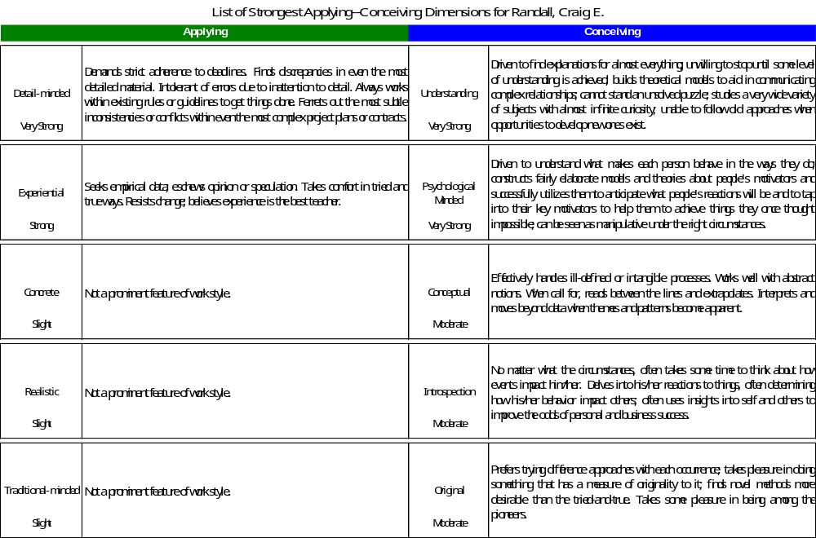

FACTOR 2 –ORIENTATION TO IMPLEMENTATION – How leaders go about getting things done
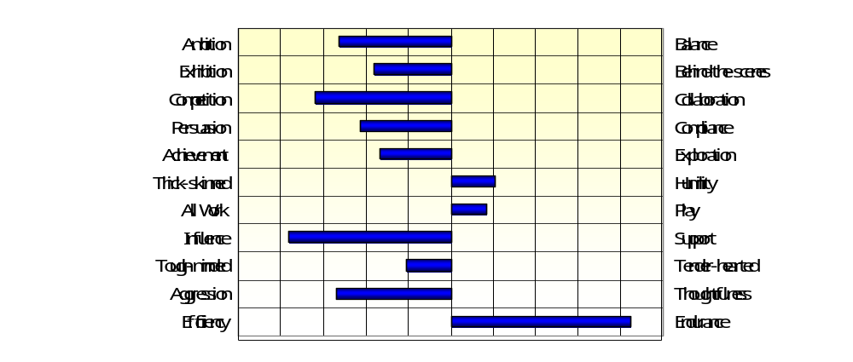
In the top graph above, your score on Factor 2 – Driving -- Collaborating is depicted by the striped blue bar. If it is more than one line away from the centerline, several of the characteristics measured by the attributes are likely to represent aspects of your leadership style that others will find salient. Make note of the solid blue bars that extend beyond one line from the centerline on the lower graph. Then refer to the following page that depicts the Contributions and Limitations of Driving and Collaborating along with brief descriptions of the behaviors that are associated with each.
Now, refer to the table on page 11 that depicts the most salient attributes for Driving and Supportive Collaborating along with brief descriptions of behaviors associated with each. Each vertical line represents one-half standard deviation from the average compared to SP’s extensive database. The greater the number of lines exceeded, the stronger the characteristic and the more likely it is that the characteristic will be salient for those people who work with you.
Contributions and Limitations of Driving and Collaborating
Contributions of Driving: | Contributions of Collaborating:
- Focuses on doing those things that bring increased responsibility  - Takes center stage and get people’s attention  - Pushes to do what ever it takes to beat the competition  - Applies strong persuasiveness to change people’s perspectives and opinions about important issues  - Pushes for achieving important objectives  - Resists allowing criticism to deter people from moving forward  - Puts work above all other priorities  - Takes a hard line with people and require top performance  - Wastes no time on endeavors unlikely to produce success | - Keeps a solid work-life balance  - Orchestrates activities from back stage while others are in the spotlight  - Puts people in and work collaboratively  - Relies on laying out the evidence to influence people’s opinions  - Stays on the alert for new opportunities  - Invites feedback and divert attention and credit to other members of the team  - Takes time to encourage everyone to have some fun  - Supports the efforts of others  - Treats people with care and understanding  - Never gives up
Limitations of Driving: | Limitations of Collaborating:
- Has difficulty with those placing more emphasis on achieving balance between work and business lives  - Falls victim to needing to be the center of attention  - Gets into competition with co-workers  - Appears indifferent or closed to criticism or feedback  - Fails to appreciate the need many have to take some time to have fun  - Appears to be too hard on people  - Comes across as too quick to give up | - Gives some people impression that they lack dedication to the job  - Avoids taking the spotlight even when it needs to be done  - Unwillingness to defend position can lead to perception of lack of conviction  - Deflection of credit can result in perception of lack of self confidence  - Willingness to support others may lead to being seen as lacking own sense of mission  - Thoughtfulness and tenderness can result in being seen as lacking the strength to take hard positions  - Difficulty in giving up can lead to perception of stubbornness

Driving- Collaborating Subscales -- Behavioral Descriptions
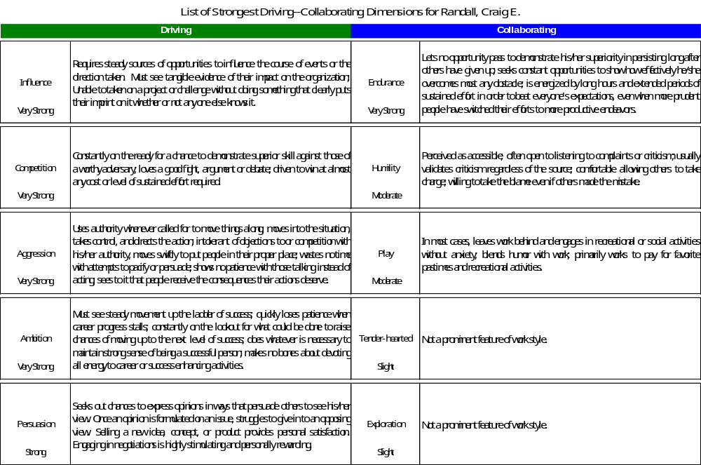

FACTOR 3 – ORIENTATION to PROCESS– How leaders go about making progress

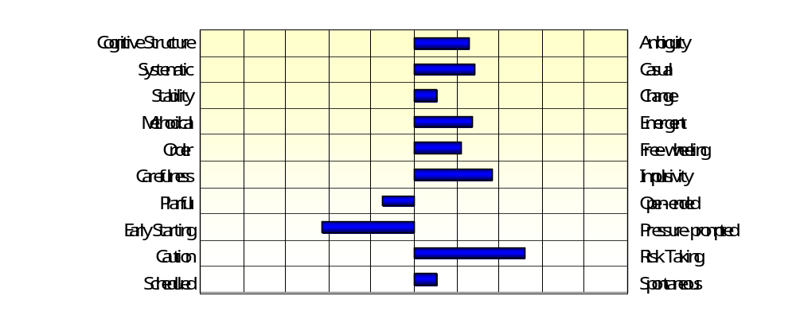
In the top graph above, your score on Factor 3 – Structuring -- Adapting is depicted by the striped blue bar. If it is more than one line away from the centerline, several of the characteristics associated with the attributes are likely to represent aspects of your leadership style that others will find salient. Make note of the solid blue bars that extend beyond one line from the centerline in the lower graph. Then refer to the following page that depicts the Contributions and Limitations of Structuring and Adapting along with brief descriptions of the behaviors that are associated with each.
Now, refer to the table on page 14 that depicts your most salient attributes for Structuring and Adapting along with brief descriptions of behaviors associated with each. Each vertical line represents one-half standard deviation from the average compared to SP’s extensive database. The greater the number of lines exceeded, the stronger the characteristic and the more likely it is that the characteristic will be salient for those people who work with you.
Contributions and Limitations of Structuring and Adapting
Contributions of Structuring: | Contributions of Adapting:
- Pushes for clarity around roles and responsibilities  - Takes systematic and repeatable approaches to work  - Establishes stable and predictable work environments  - Employs tried and true methods  - Arranges and maintain things in logical and organized ways  - Carefully assesses risk and move cautiously  - Creates thorough plans and follow them meticulously  - Gets an early start and puts in the time needed  - Ensures safety nets are in place before trying something untested  - Follows the schedule and delivers on time | - Jumps into situations and do what needs to be done  - Follows procedures only as long as they prove effective  - Readily adapts to changing circumstances and seek variety  - Modifies process to meet changing needs  - Pushes to change and adapt in the moment to shifting conditions  - Jumps on opportunities ahead of those more cautious  - Waits until the last minute while keeping many balls in the air at the same time  - Readily takes risks  - Easily shifts schedule to adjust to changing needs

Limitations of Structuring: | Limitations of Adapting:
- Resists taking action until path is clearly defined  - Becomes frustrated with haphazard approaches  - Easily rattled by unexpected changes  - Feels somewhat lost without well-delineated methods to follow  - Gets bogged down with arranging things when action is demanded  - Hesitates too long when faced with opportunities  - Resists changing plans even when change is needed  - Becomes frustrated when not enough time allowed to prepare  - Shies away from opportunities where the risks can not easily be assessed  - Tries to stick to schedule even when expediting is needed | - Comfort with ambiguity leads to confusion over boundaries  - Casual attitude toward systems can lead to variance in quality of outcomes  - Sometimes introduces change for change sake  - Abandons methods that work for those unproven  - Disorganized approaches waste energy  - Jumps on opportunities that subsequently prove unwise  - Dislike for adhering to plan results in undesirable outcomes

Structuring--Adapting Subscales -- Behavioral Descriptions
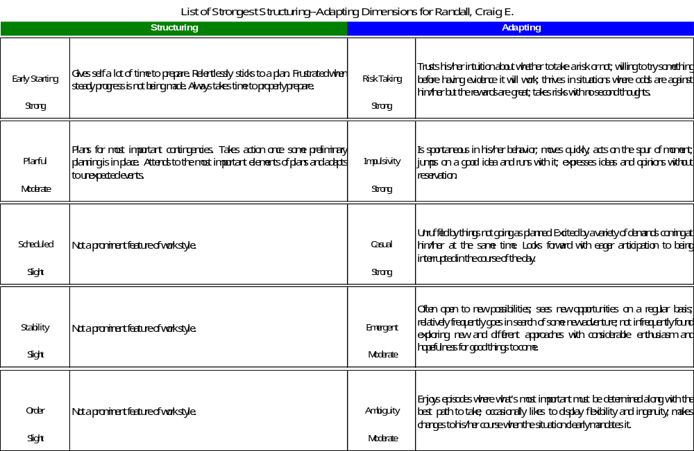

FACTOR 4 – ORIENTATION to INFORMATION – Collecting and utilizing information

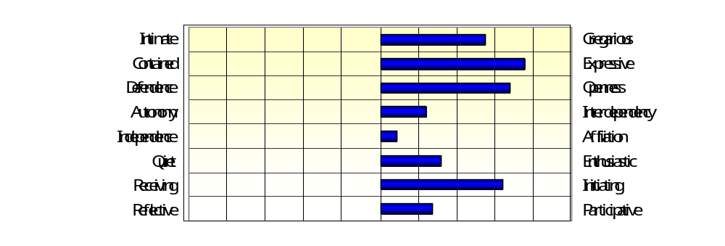

In the top graph above, your score on Factor 4 – Contemplating -- Interacting is depicted by the striped blue bar. If it is more than one line away from the centerline, several elements of information style measured by the attributes are likely to represent aspects of your leadership style that others will find salient. Make note of the solid blue bars that extend beyond one line from the centerline in the lower graph. Then refer to the following page that depicts the Contributions and Limitations of Contemplating and Interacting along with brief descriptions of the behaviors that are associated with each.
Next, refer to the table on page 17 that depicts the most salient attributes for Contemplating and Interacting along with brief descriptions of behaviors associated with each. Each vertical line represents one-half standard deviation from the average compared to SP’s extensive database. The greater the number of lines exceeded, the stronger the characteristic and the more likely it is that the characteristic will be salient for those people who work with you.
Contributions and Limitations of Contemplating & Interacting
Contributions of Contemplating: | Contributions of Interacting:
- Engage people in one-on-one conversations where in-depth discussions take place  - Keeps feelings and thoughts to self  - Takes and hold unpopular positions in spite of criticism or attempts to redirect them  - Works without a need for much support  - Stays out of the issues associated with maintaining relationships  - Keeps a cool head and plays cards close to the vest  - Listens more than talks  - Takes time to reflect on what has been learned before offering conclusions or suggestions | - Seeks out people  - Expresses thoughts and feelings easily  - Invites criticism; projects openness to input  - Relies on others for help in achieving success  - Builds and nurtures networks of friends and associates with ease  - Shows enthusiasm for ideas and opportunities readily  - Takes to initiative in meeting people  - Invites everyone into the discussion on onto the team
Limitations of Contemplating: | Limitations of Interacting:
- Shies away from large group activities  - Finds sharing feelings or thoughts awkward and difficult  - Appears defensive when challenged and doesn’t easily incorporate constructive feedback.  - Can lose contact with rest of organization and get out on a tangent  - Shows little emotion contributing to the impression that he/she is not involved or committed  - Important ideas or opinions may not be expressed without others pulling them out | - Attempts to connect with everyone leave some areas explored inadequately  - May express feelings or opinions that would best remain unexpressed  - Openness to input can contribute to perception of uncertainty or lack of confidence  - Need to rely on others can put too much of a burden on people  - Time devoted to networks can detract from direct contributions to work products  - Expressions of enthusiasm can diminish credibility  - Attempts to engage others can put some off
Contemplating--Interacting Subscales -- Behavioral Descriptions
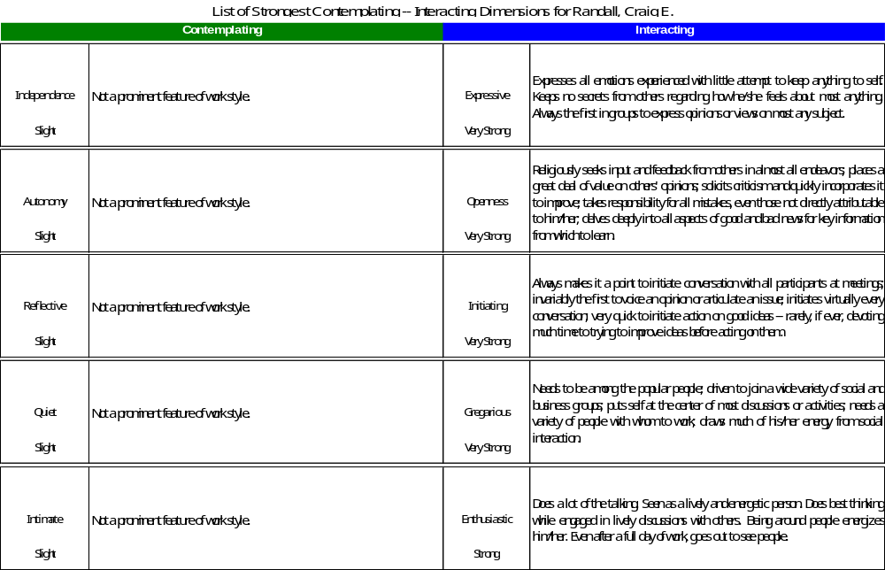
FACTOR 5 – ORIENTATION to RELATIONSHIPS – How leaders relate to others

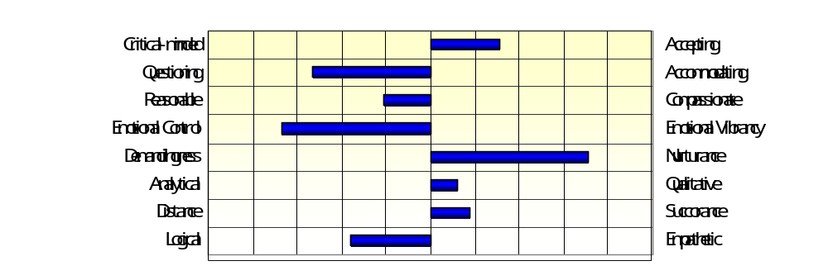

In the top graph above, your score on Factor 5 – Distancing -- Engaging is depicted by the striped blue bar. If it is more than one line away from the centerline, several of the characteristics measured by the attributes are likely to represent aspects of your leadership style that others will find salient. Make note of the solid blue bars that extend beyond one line from the centerline in the lower graph. Then refer to the following page that depicts the Contributions and Limitations for Distancing and Engaging along with brief descriptions of the behaviors that are associated with each.
Now, refer to the table on page 20 that depicts the most salient attributes for Distancing and Engaging along with brief descriptions of behaviors associated with each. Each vertical line represents one-half standard deviation from the average compared to SP’s extensive database. The greater the number of lines exceeded, the stronger the characteristic and the more likely it is that the characteristic will be salient for those people who work with you.
Contributions and Limitations of Distancing and Engaging
Contributions of Distancing: | Contributions of Engaging:
- Carefully evaluates the validity of information people provide  - Probe beyond the superficial, challenges assumptions, pushes for evidence supporting opinion  - Influences others to take the most reasonable approach to the issues they face  - Maintains control of emotions even when others are becoming frantic  - Pushes people to meet their obligations and produce the quality of work needed  - Places great emphasis on examining what the numbers say about how things are going  - Keeps personal relationships with co-workers at bay; maintains professional distance  - Takes a logical approach to understanding the issues and prescribing a course of action to take | - Makes everyone feel comfortable and ready to contribute  - Seeks to find the common ground or objectives that pull people together  - Shows genuine concerned for other members of the team and looks out for their interests  - Expresses passion and demonstrates connections to people and causes  - Ensures people get what they need to grow and develop as professionals  - Attends to the opinions, observations and viewpoints of all those involved  - Encourages work environment characterized by openness, trust, and credibility  - Takes the perspective of those who may be adversely impacted by a proposed course of action
Limitations of Distancing: | Limitations of Engaging:
- Can come across as critical and skeptical – running the risk of turning off some people  - Pointing questioning can cause some to take a defensive posture and either compromise or block disclosure  - Always pushing for what’s reasonable can lead to being perceived as cold and calculating  - Keeping emotions in check sometimes leads to the perception of disinterest or uncaring  - Pushing for performance can lead to people feeling that they are being mistreated or even abused  - Relying on numerical data can result in some feeling their experience and observations have no value  - Keeping distance can result in the perception of being an outsider – not really “one of us” | - May take what people say at face value when more confirmatory evidence is needed  - May accommodation to the needs of special interests that compromise the quality of the product  - Can allow personal feelings to influence decisions and judgments  - Expressions of emotion can rise to the level of disrupting effective communications and lead to blaming  - Concern with helping people can lead to delays in taking the action needed  - Reliance on opinion and verbal reports alone can open one up to being deceived by those with hidden agendas  - Sharing personal thoughts and feelings with others can cause issues around boundaries  - Desire to see things from the perspectives of others can lead to the appearance of being too soft

Distancing--Engaging Subscales -- Behavioral Descriptions
