Random Forest 调参

Flourishing:

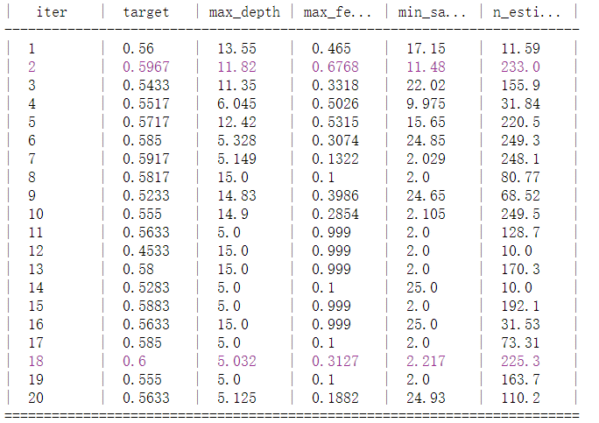

{'target': 0.6, 'params': {'max_depth': 5, 'max_features': 0.313, 'min_samples_split': 2, 'n_estimators': 225}}

Panas_N:

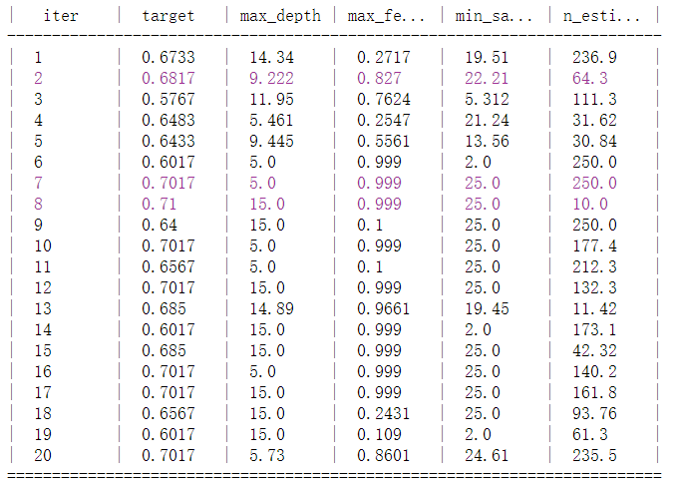

{'target': 0.71, 'params': {'max_depth': 15.0, 'max_features': 0.999, 'min_samples_split': 25.0, 'n_estimators': 250}}

Panas_P:

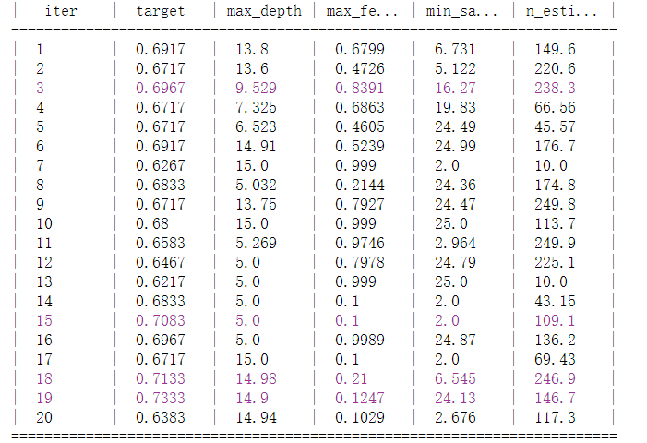

{'target': 0.733, 'params': {'max_depth': 14, 'max_features': 0.124, 'min_samples_split': 24., 'n_estimators': 146}}

SVC:

Panas_p

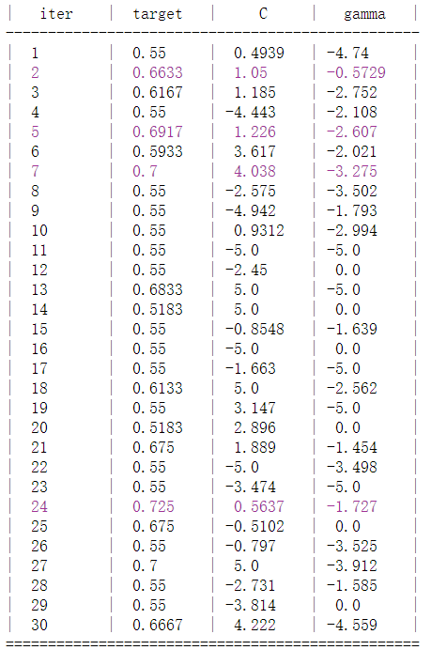

{'target': 0.725, 'params': {'C': 0.5637293559234761, 'gamma': -1.7272651458575339}}

Panas_N:

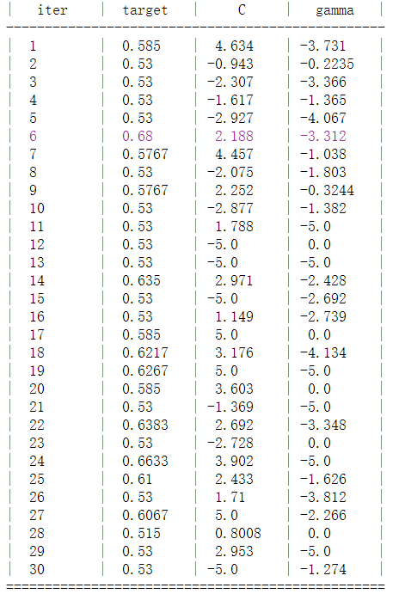

{'target': 0.68, 'params': {'C': 2.188098110503227, 'gamma': -3.3123626049823542}}

Flourishing:

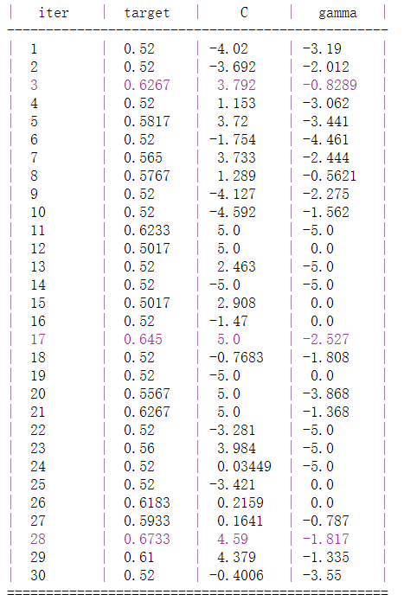

{'target': 0.673, 'params': {'C': 4.590468571688005, 'gamma': -1.81702476072107}}

LoRegression:

Panas_p

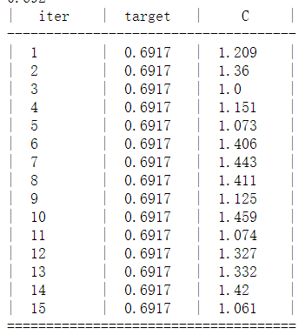

{'target': 0.692, 'params': {'C': 1.208511002351287}}

Panas_n:

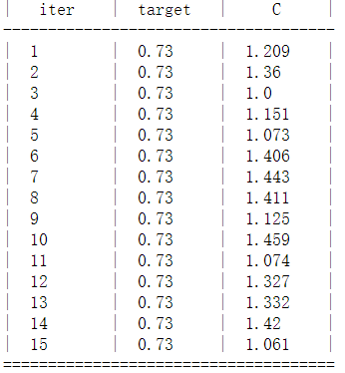

{'target': 0.7300000000000001, 'params': {'C': 1.208511002351287}}

Flourishing:

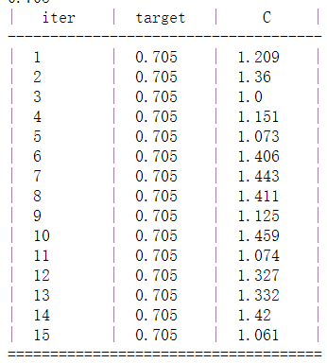

{'target': 0.705, 'params': {'C': 1.208511002351287}}