Fall 2025
Joseph Fuh Che
Aliyah Ighodaro
Lyndsey Rasco
Abigael Julao
Sezim Duishenbieva
Github: https://github.com/lynrasco/PRJ566NBB_2261_Group05
iSALAJ Inc | Group 5
Flipvalue

Software Requirements Specification

Executive Summary

Background

Description

Company Value Add

End-User Value Add

Scope

What is Included

What is Not Included

Justification

Table of Contents
Executive Summary 1
Background 1
Description 1
Company Value Add 1
End-User Value Add 1
Scope 1
What is Included 1
What is Not Included 1
Justification 1
Section 1 4
1.1 Document Authors 4
1.2 Document Revision History 4
1.3 Document Purpose 5
1.4 Audience 5
1.5 Group Agreement 5
Team # 5
Project Title 5
Project Time Frame 5
Team Members 5
Team Leadership 5
Team Functions/Roles 5
Team Meetings 6
Team Problems 6
Team Commitment 6
Section 2 7
2.1 Project Proposal 7
2.1.1 Project Background 7
2.1.2 Problem Statement 8
2.1.3 Product Vision 8
2.2 Stakeholders and Users 9
2.3 Project Scope 10
2.4 System Rosks 11
2.5 Operating Environment 12
2.6 Functional Requirements 13
2.7 Nonfunctional Requirements 16
2.8 UI/UX Interface Mock-ups 17
Section 3 24
3.1 Workflow Diagrams Error! Bookmark not defined.
3.2 Data Modelling and Flow 24
3.3 Use Case Scenarios 24
3.4 Activity Diagrams 26
3.5 Business Rules 30
Section 4 – Domain Class 31
Section 5 – Database 32
Section 6 – Project Management 36
6.1 Work Breakdown Structure 36
6.2 Milestones & Acceptance Criteria 36
Section 7 – Product Backlog & Implementation Schedule 36
Section 8 – Client/Faculty Sign-off 36

Section 1

1.1 Document Authors
Lyndsey Rasco
Joseph Fuh Che
Aliyah Ighodaro
Abigael Julao
Sezim Duishenbieva

1.2 Document Revision History

WEEK | DATE | Revisions
1 | January 19, 2026 | - Created initial Problem Statement  - Defined initial Product Vision  - Created public GitHub repo and added members
2 | January 22 - 25, 2026 | - Added and modified Section 1  - Modified Problem Statement, Product Vision, and added Product Background
3 | January 26-31, 2026 | - Added stakeholders and users, scope, risks, and operating environment sections  - Added probability matrix for risks
4 | February 2, 2026 | - Created interview questions for users and partner companies
5 | February 5-8, 2026 | - Added answers to interview questions under functional requirements  - Fixed formatting for section 2.1.1 and added sources
6
7
8
9
11
12
13
14

1.3 Document Purpose
This document serves as a blueprint and framework for FlipValue. All stakeholders will use this as a reference to fully understand how the application works in its intended environment and what it will need for it to work. It should include the following:
- A description of the app’s functionality and features
- Any limitations in a specific environment or condition, preferably should satisfy the audience’s needs
- Labels any technical and operational requirements such as in this case, the use of AI is required
- Designs to visualize how the application would appear to the viewer through UI/UX designs

1.4 Audience
Resellers

1.5 Group Agreement

Team: #5

Project Title: FlipValue

Project Time Frame:
The entire project should span around two semesters, so roughly January 5, 2026 – April 17, 2026 for the design and planning, and May 4, 2026 – August 14, 2026, for the execution and creation of the actual application.

Team Members:
Joseph Fuh Che,
Aliyah Ighodaro,
Lyndsey Rasco,
Abigael Julao,
Sezim Duishenbieva

Team Leadership:
Joseph Fuh Che

Team Functions/Roles:
We will share information through: Microsoft Teams, Microsoft Word, and in-person meetings.
Programmers & Testers: Joseph Fuh Che, Aliyah Ighodaro, Sezim Duishenbieva
Designers: Abigael Julao, Lyndsey Rasco

Team Meetings:
Utilizing our weekly Thursday presentations as well as Monday lectures:
Monday: 13:30 – 15:15
Thursday: 11:40 – 13:25
We may also meet via Teams at any other time, if necessary.

Team Problems:
Miscommunication: Team must be present during meetings as well as communicating effectively via Teams. If communication between members is unclear and disorganized, it leads to misunderstanding and delayed progress within the group, so report to the team leader if a member (s) struggles to communicate.
Unequal Workloads: An uneven distribution of work among team members is usually caused by unclear roles and responsibilities, an over-reliance on those who are actively contributing, and inadequate leadership. To solve this, we should be able to lay out clear roles and responsibilities prior to doing any of the actual work.

Team Commitment:
Each team member is committed to contributing their parts and findings to the project and participating in all team meetings. If a member is struggling or if any problems occur, it should be communicated to the team, specifically the team leader and should be resolved immediately.

The undersigned members agree to work together on the project until the end of the PRJ666 next Semester. They recognize that as a team and individually they are equally responsible for the quality of all deliverables.

Name | Date | Signature
Abigael Julao | Jan 19, 2026 | AMJ
Lyndsey Rasco | Jan 19, 2026 | LDTR
Sezim Duishenbieva | Jan 19, 2026 | SD
Aliyah Ighodaro | Jan 19, 2026 | AI
Joseph Fuh Che | Jan 22, 2026 | JFC

Section 2

2.1 Project Proposal

2.1.1 Project Background:
Features | Poshmark | Depop | Karrot | eBay | FlipValue
Item Listing & Selling | ✔ | ✔ | ✔ | ✔
Market-Based Price Suggestions |  |  |  |  | ✔
Real-time Price Trends |  |  |  |  | ✔
AI Price Prediction |  |  |  |  | ✔
Condition-Based Pricing |  |  |  |  | ✔
Cross-Platform Comparison |  |  |  |  | ✔
Historical Sales Analysis |  |  |  | Limited

Poshmark [1]
Poshmark is a commerce platform focused on fashion resale, allowing users to list, buy, and sell second-hand clothing and accessories. While the platform provides visibility into similar listings, pricing decisions are left completely to the seller. Users must manually compare listings, which may vary in condition, age, and demand. Poshmark does not provide real-time market trends or inaccurate pricing decisions.

Depop [2]
Depop targets a younger demographic and emphasizes heavily in trend-driven sales. The platform provides basic price suggestions based on item category, brand, and condition; however, these recommendations are limited in scope and do not analyze real-time market demand or historical sale trends. Depop does not offer pricing analytics, trends visualization, or predictive pricing tools, requiring sellers to rely on subjective judgement and manual comparisons when setting prices.

Karrot [3]
Karrot focuses on local resale and emphasizes quick, community-based transactions. The platform provides a general pricing guide through educational content, such as tips on negotiation strategies, perceived value, and effecive item presentation. However, this guidance is not data-driven, item specific, does not have historical sales analysis, market demand, or pricing suggestions. As a result, sellers must rely on personal judgement and compare similar listing manually.

eBay [4]
eBay focuses on global resale, offering both fixed pricing and auctions. The platform allows sellers to view completed and sold listings, offering limited insight into past sale prices for similar items. While this feature may help with basic price estimation, the data is not in depth and does not consider sale trends, item condition, age, or brand. Advanced pricing analytics are available through their in-app tools, however they are locked behind a paywall thus the standard user cannot experience pricing support. As a result, seller rely on manual analysis, which may lead to inconsistent or inaccurate pricing.

While existing platforms provide the infrastructure for buying and selling second-hand goods, they offer limited support for pricing decisions. Sellers must manually assess the market value of their items across multiple platforms.
FlipValue proposes a supporting mobile application designed to address this gap by leveraging AI and real-time market data. Rather than acting as a resale marketplace, FlipValue aims to analyze comparable listings, historical sales data, and demand trends across partner platform to generate accurate and competitive price suggestions. This enables seller to make informed pricing decision efficiently, reducing uncertainty and improving overall sales.

2.1.2 Problem Statement
The problem of | fixing the right prices for used products.
affects | Resellers who struggle to price their products due to lack of real-time market data
the impact of which is | Overpricing which can discourage a potential buyer or under-pricing which can lead to loss of revenue.
a successful solution would be | a mobile application infused with AI to help these resellers by suggesting prices curated from partner websites which could easily lead to a sale.

2.1.3 Product Vision
For | Resellers
Who | want to sell items with a fair price
The (product name) | FlipValue
That | helps resellers figure out the reasonable prices for items
Unlike | Poshmark, Depop, and Karrot who only provide the platform through which sales could be made
Our product | Uses real-time market data to suggest fair prices for those items, increasing business operations.

2.2 Stakeholders and Users
Internal:
- Abigael – Designer
- Joseph- Team leader, Programmer/Tester
- Lyndsey- Designer
- Sezim – Programmer/Tester
- Aliyah – Programmer/Tester
External:
- Resellers – Individuals who sell items but struggle with accurate pricing
- Partner Companies – External stakeholders that provide the real resale data used by the AI to suggest fair prices
- AI/ML Service Providers - Third-party APIs and services used for image recognition and pricing analytics
- Shoppers/Buyers - Indirect beneficiaries

Stakeholder Name | Project Role | Internal/External | Engagement Level | Level of Interest | Level of Power
Abigael | Designer | Internal | Leading | High | High
Joseph | Team leader, Programmer/Tester | Internal | Leading | High | High
Lyndsey | Designer | Internal | Leading | High | High
Sezim | Programmer/Tester | Internal | Leading | High | High
Aliyah | Programmer/Tester | Internal | Leading | High | High
Resellers | Individuals who sell items but struggle with accurate pricing | External | Supportive | High | High
Partner Companies | provide the real resale data used by AI to suggest fair prices | External | Neutral | Low | High
AI/ML Service Providers | Third-party APIs/ services used for image recognition and pricing analytics | External | Supportive | Medium | Medium
Shoppers/Buyers | Indirect beneficiaries | External | Unaware | Low | Low

2.3 Project Scope
The scope of FlipValue is to design and propose a mobile application that assists reseller in determining fair and competitive resale prices for second-hand items. The objective of the system is to reduce the time and uncertainty involved in manual market research by utilizing an AI-assisted analysis and comparable real-time resale data. The application focuses on usability, accuracy, and efficiency to make informed pricing decisions and improve profitability.
In Scope:
- Mobile application accessible on iOS and Android
- User account registration and profile management
- Image-based item recognition using AI-assisted analysis
- Price recommendation based on:
  - Similar item listings on resale platforms (Poshmark, Karrot, Depop)
  - Market trends
  - Item attributes (brand, condition, category)
- Display suggested price ranges and resale insights
- Ability so save, edit, and manage listings
- Market comparison summaries from selected resale platforms
- Basic analytics for tracking pricing history and sale performance
- Cloud-hosted backend for data storage
Out of Scope:
- Direct buying or selling of items within the application
- Payment processing or financial transactions
- Messaging between buyers and sellers
- Full integration with all third-party resale platforms

2.4 System Risks
Market Risks:
- Competition from other companies resulting in the project’s irrelevance
- Possible lack of customer demand for the product
Financial Risks:
- Increases in material costs due to inflation
- Poor budget planning
Technical Risks:
- Performance failures due to bugs in the software
- Data/Security breaches, especially due to the use of AI in our application
- AI isn’t always reliable, and may be biased towards certain companies and their items
- Since we rely on third-party APIs, they may change and synchronization isn’t always possible
People Risks:
- Poor communication between stakeholders
- Incompetent team members result in delayed and poor progress
- Conflict within team members as well as other stakeholders
- Team members going on break or getting a Co-op placement next semester
Structure/Process Risks:
- Inadequate testing procedures for quality control
- Lack of structure within the organization, such as not establishing clear roles and responsibilities
Probability/Impact Matrix:
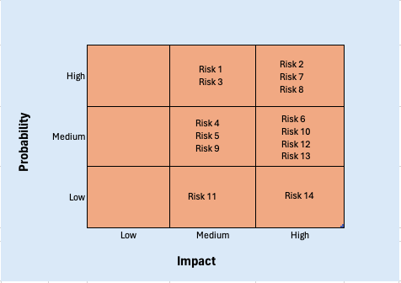

2.5 Operating Environment
The FlipValue application is intended to run in a mobile and cloud-based environment. Since the primary users are resellers who mainly use smartphones, the system is designed to be accessible on common mobile devices and operating systems.

Hardware / Devices Supported
- Smartphones and tablets with camera functionality
- Devices capable of installing modern mobile applications

Operating Systems
- Android (version 10 or later)
- iOS (version 14 or later)

Software Dependencies
- Mobile application framework for cross-platform development
- Cloud-based backend services for data storage and processing
- Third-party AI/ML services for image recognition and pricing analysis
- Secure user authentication services

Internet Connection
- An internet connection is required to use core features such as image uploads, AI price suggestions, and real-time market data access
- Limited offline access may be available for viewing saved items only

2.6 Functional Requirements

User Interviews:
- Name: Jane Doe
- Age: 28
- Status: Resells clothing and accessories on Depop and Poshmark
- Financial Situation: Moderate, relies on reselling as supplemental income
As a reseller, how many times have you inaccurately priced clothing and accessories? What were those experiences like and how can FlipValue prevent that?
“Plenty of times. Sometimes, I forget to do my research and underestimate my item’s conditions. I also get too sentimental with some of my things that I often set them higher, even lower prices. On one occasion, I priced a pair of jeans at a higher price than it should, thinking that was a fair decision, but later discovered that they had some stains on them. I hope that FlipValue can help prevent that by helping me compare prices of similar items from other different brands, as well as giving me a better idea on how to price my things.”
We are using AI to help resellers, such as yourself, to make better decisions when selling items. What would make you trust/not trust their suggestions?
“If the AI model were to give me their reasoning behind their suggestions, such as trends, then yeah, I would trust it, because it shows some transparency rather than giving me the suggestion, I want to know the ‘why’. If AI wasn’t so transparent, I would think twice before taking their suggestion to account. I would still like to be able to choose for myself, so I am hoping that FlipValue does not force us to follow the AI’s suggestions blindly and we still have the choice if we want to accept or even adjust them. As a user, I would like my confidentiality honored, so if the AI starts asking questions such as personal info, it will feel like an invasion of privacy and would make me feel less confident about accepting their suggestions.”
What features would you like to see on the dashboard? Are there any deal breakers or must-haves you would like us to know?
“Honestly, I want the dashboard to be minimalistic. I don't want the dashboard to be cluttered with information, specifically unnecessary information; it would be difficult to navigate through the app. Visuals are a huge deal breaker for me. I wouldn’t mind some colour, such as a muted and consistent colour palette and font designs, not super contrasted. Another feature I would love to see are filters; it would make my life so much easier without me having to manually type out what I want to see and helps make me better decisions.”

Partner Companies Interviews:
- Name: John Doe
- Status: Shares information on clothing and accessories
- Occupation: Data Partnership Manager
- Age: 51
- Financial Situation: Stable, focused on sustainable revenue growth
What data/information should our AI model track? Are there certain things that the AI model should or shouldn’t access?
“Our company can share basic information like item type, brand, condition, selling price and how long it took to sell, and general location. This helps your AI understand market trends and give better price suggestions. However, we will not share personal user information, private messages, or payment details. User privacy must always be protected.”
What concerns might prevent your organization from entering this partnership?
“Our biggest concerns are data safety and privacy. We want to be sure our information is not misused or shared without our permission. We are also worried about how much time and effort it takes to connect our systems. If the integration process is too difficult or risky, we may not want to participate. Clear rules and agreements would help us feel more comfortable.”
Would you prefer your platform to be visible to users or used only in background analysis?
“I would prefer our platform to be visible to users as one of the sources used for price comparisons. This helps build trust because users can see where the information is coming from. It also gives our company more recognition and shows that we are a part of a reliable system. At the same time, I am okay with our data being used in the background if it helps improve accuracy and protects privacy. As long as our data is being used responsibly, kept secure, and properly credited, both options can work well for us”

2.6.1 Core Functional Requirements
This section outlines the main functions that the FlipValue system must support to help resellers accurately price their items. These requirements are based on user and partner interviews as well as the defined project scope.

User Account Management
- The system shall allow users to create an account using an email and password.
- The system shall allow users to log in and log out of their account.
- The system shall allow users to view and update basic profile information.
- The system shall retain user data and preferences across sessions.

Item Entry and Management
- The system shall allow users to manually enter item details such as category, brand, condition, and description.
- The system shall allow users to upload images of items using their mobile device.
- The system shall allow users to save item listings for future reference.
- The system shall allow users to edit or delete saved items.

AI-Assisted Item Analysis
- The system shall analyze uploaded images to identify item characteristics such as brand, style, and material.
- The system shall use both image analysis and user-provided information to improve pricing accuracy.
- The system shall ensure that AI analysis only uses data necessary for pricing purposes.

Price Recommendation
- The system shall collect comparable resale data from partner platforms.
- The system shall generate a suggested resale price range based on market data and item attributes.
- The system shall display basic factors influencing the suggested price, such as item condition or demand.
- The system shall allow users to adjust or ignore the suggested price if desired.

Market Comparison and Insights
- The system shall display comparable prices from selected resale platforms.
- The system shall provide simple market trend insights for similar items.
- The system shall indicate whether an item is priced below, above, or within the average market range.

User Dashboard
- The system shall provide a dashboard displaying all saved items and their suggested prices.
- The system shall allow users to filter and sort items by category or price.
- The system shall present information in a clean and easy-to-understand layout.

Data Storage and Retrieval
- The system shall securely store user accounts, item information, images, and pricing history.
- The system shall retrieve stored data when the user logs into the application.
- The system shall keep stored data consistent and up to date.

Partner Data Integration
- The system shall use resale data provided by approved partner companies for pricing analysis.
- The system shall ensure that partner data is used only for comparison and pricing purposes.

2.7 Nonfunctional Requirements
- Usability:
- Simple and minimalistic UI
- User Friendly

- Reliability:
- The application works correctly over time with low failure rates.
- The application handles errors gracefully
- Security:
- Authentication and authorization.
- Protection against cyber-attacks.
- Data encryption.

- Maintainability:
- Easy to fix bugs.
- Easy to update and improve.
- Well documented code following the approved layers of programming to ease maintenance.

- Portability:
- Runs on many platforms
- Minimal changes require during environment change.

- Compatibility
- Works with other systems, APIs, browsers, AI, or devices.
- Backward compatibility.

- Efficiency:
- Optimal use of CPU, memory, battery and network.
- Data is gathered, processed and displayed to the users withing seconds

- Legal Compliance:
- Meets laws, standards and regulations.

- Availability:
- Accessible at all times.

2.8 UI/UX Interface Mock-ups
Figma Project: Figma Link FlipValue
Welcome Page:

Sign Up:
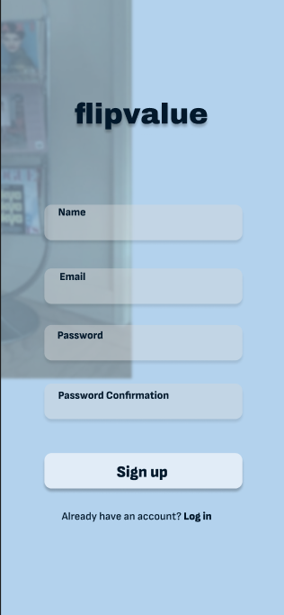
Log In:

Homepage:
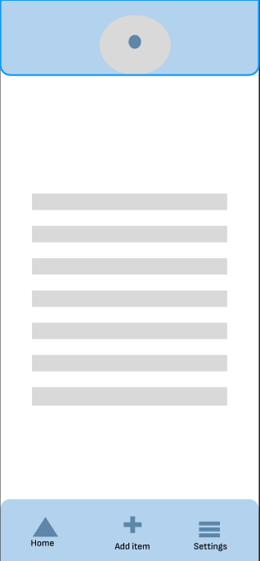
Camera:

Item details:

Listings from Partners:

Settings:


Section 3

3.1 Data Flow Diagrams
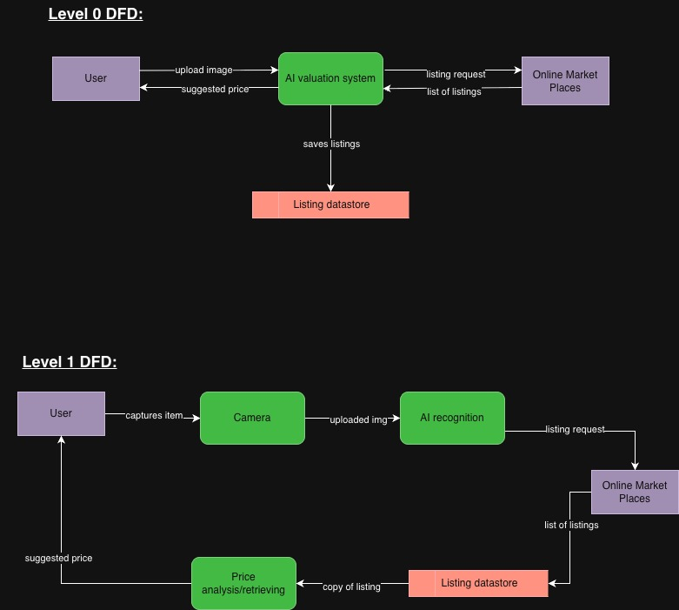

3.2 User Stories and related Use Case Scenarios
Use Case # | Use Case Name | Actor(s) | Trigger | Outcome | Priority
UC-1 | Login/Authenticate User | User | The user wants to log in to their account | The user has successfully logged in to FlipValue | High
UC-2 | Enter Item Details | User | The user requests to enter the details of their item | Item details have been entered and filled in. | High
UC-3 | Request Market Comparison Insight | User | The user asks the AI model for a market comparison insight for their item | The AI successfully displays pricing trends, average prices, and other similar items | High
UC-4 | Generate/Price Suggestion | User, AI/ML Service Provider | The user wants a pricing suggestion when selling their item. | The AI model successfully gives the user a suggested price for the item | High
UC-5 | View Data Analytics | Partner Company | The partner company wants to see how the AI model is using their info | The app shows AI usage trends, and other analytics on the dashboard | High

3.2.1 Login/Authenticate User
User Story: As a user, I want to log in to my FlipValue account so that I can start listing my items for sale.

3.2.2 Enter Item Details
User Story: As a user, I want to enter the details of my item so that the AI model can provide pricing suggestions.

3.2.3 View Market Comparison Insight
User Story: As a user, I want to request a market comparison analysis generated from the AI so that I can evaluate market trends and see how the price of my item compares to other similar items.

3.2.4 Generate/Price Suggestion
User Story: As a user, I want to request the AI to generate a pricing suggestion for me so that I can make better listing decisions.

3.2.5 View Data Analytics
User Story: As the manager of a partner company, I want to view the data analytics so that I can see how the AI is utilizing our data in pricing suggestions and ensure transparency.

3.3 Activity Diagrams
AD1:
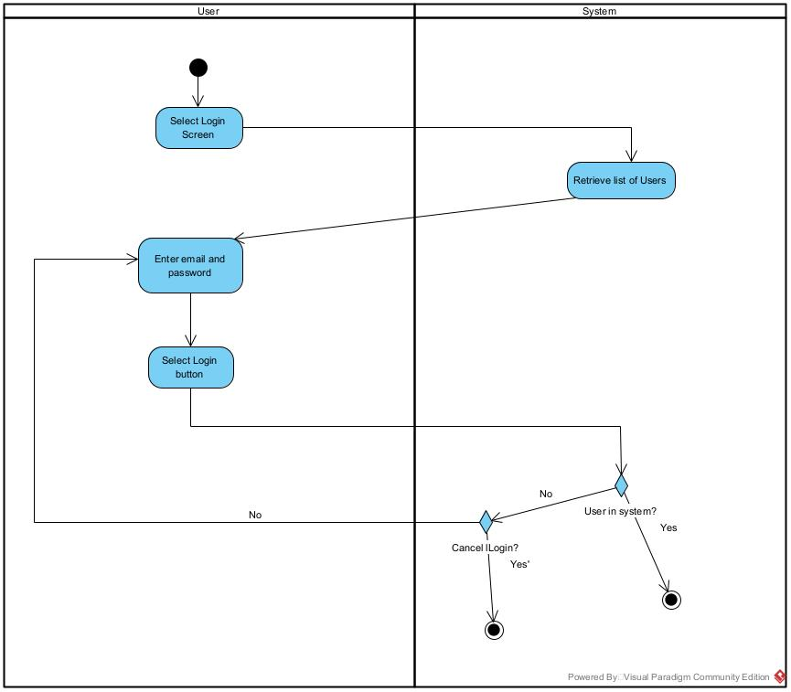
AD2: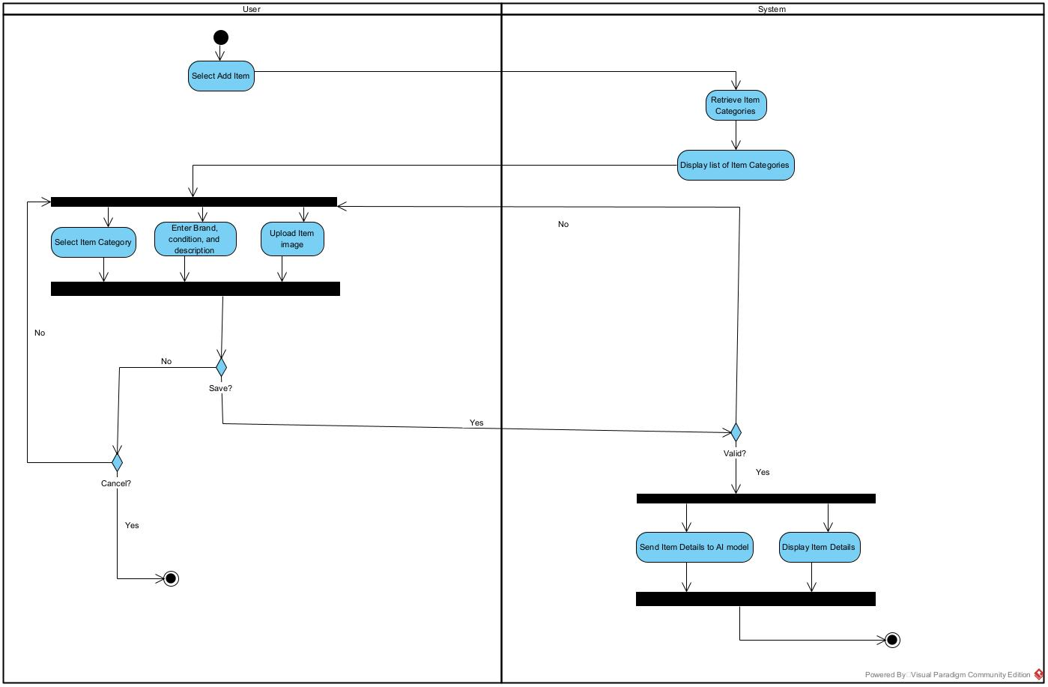
AD3:
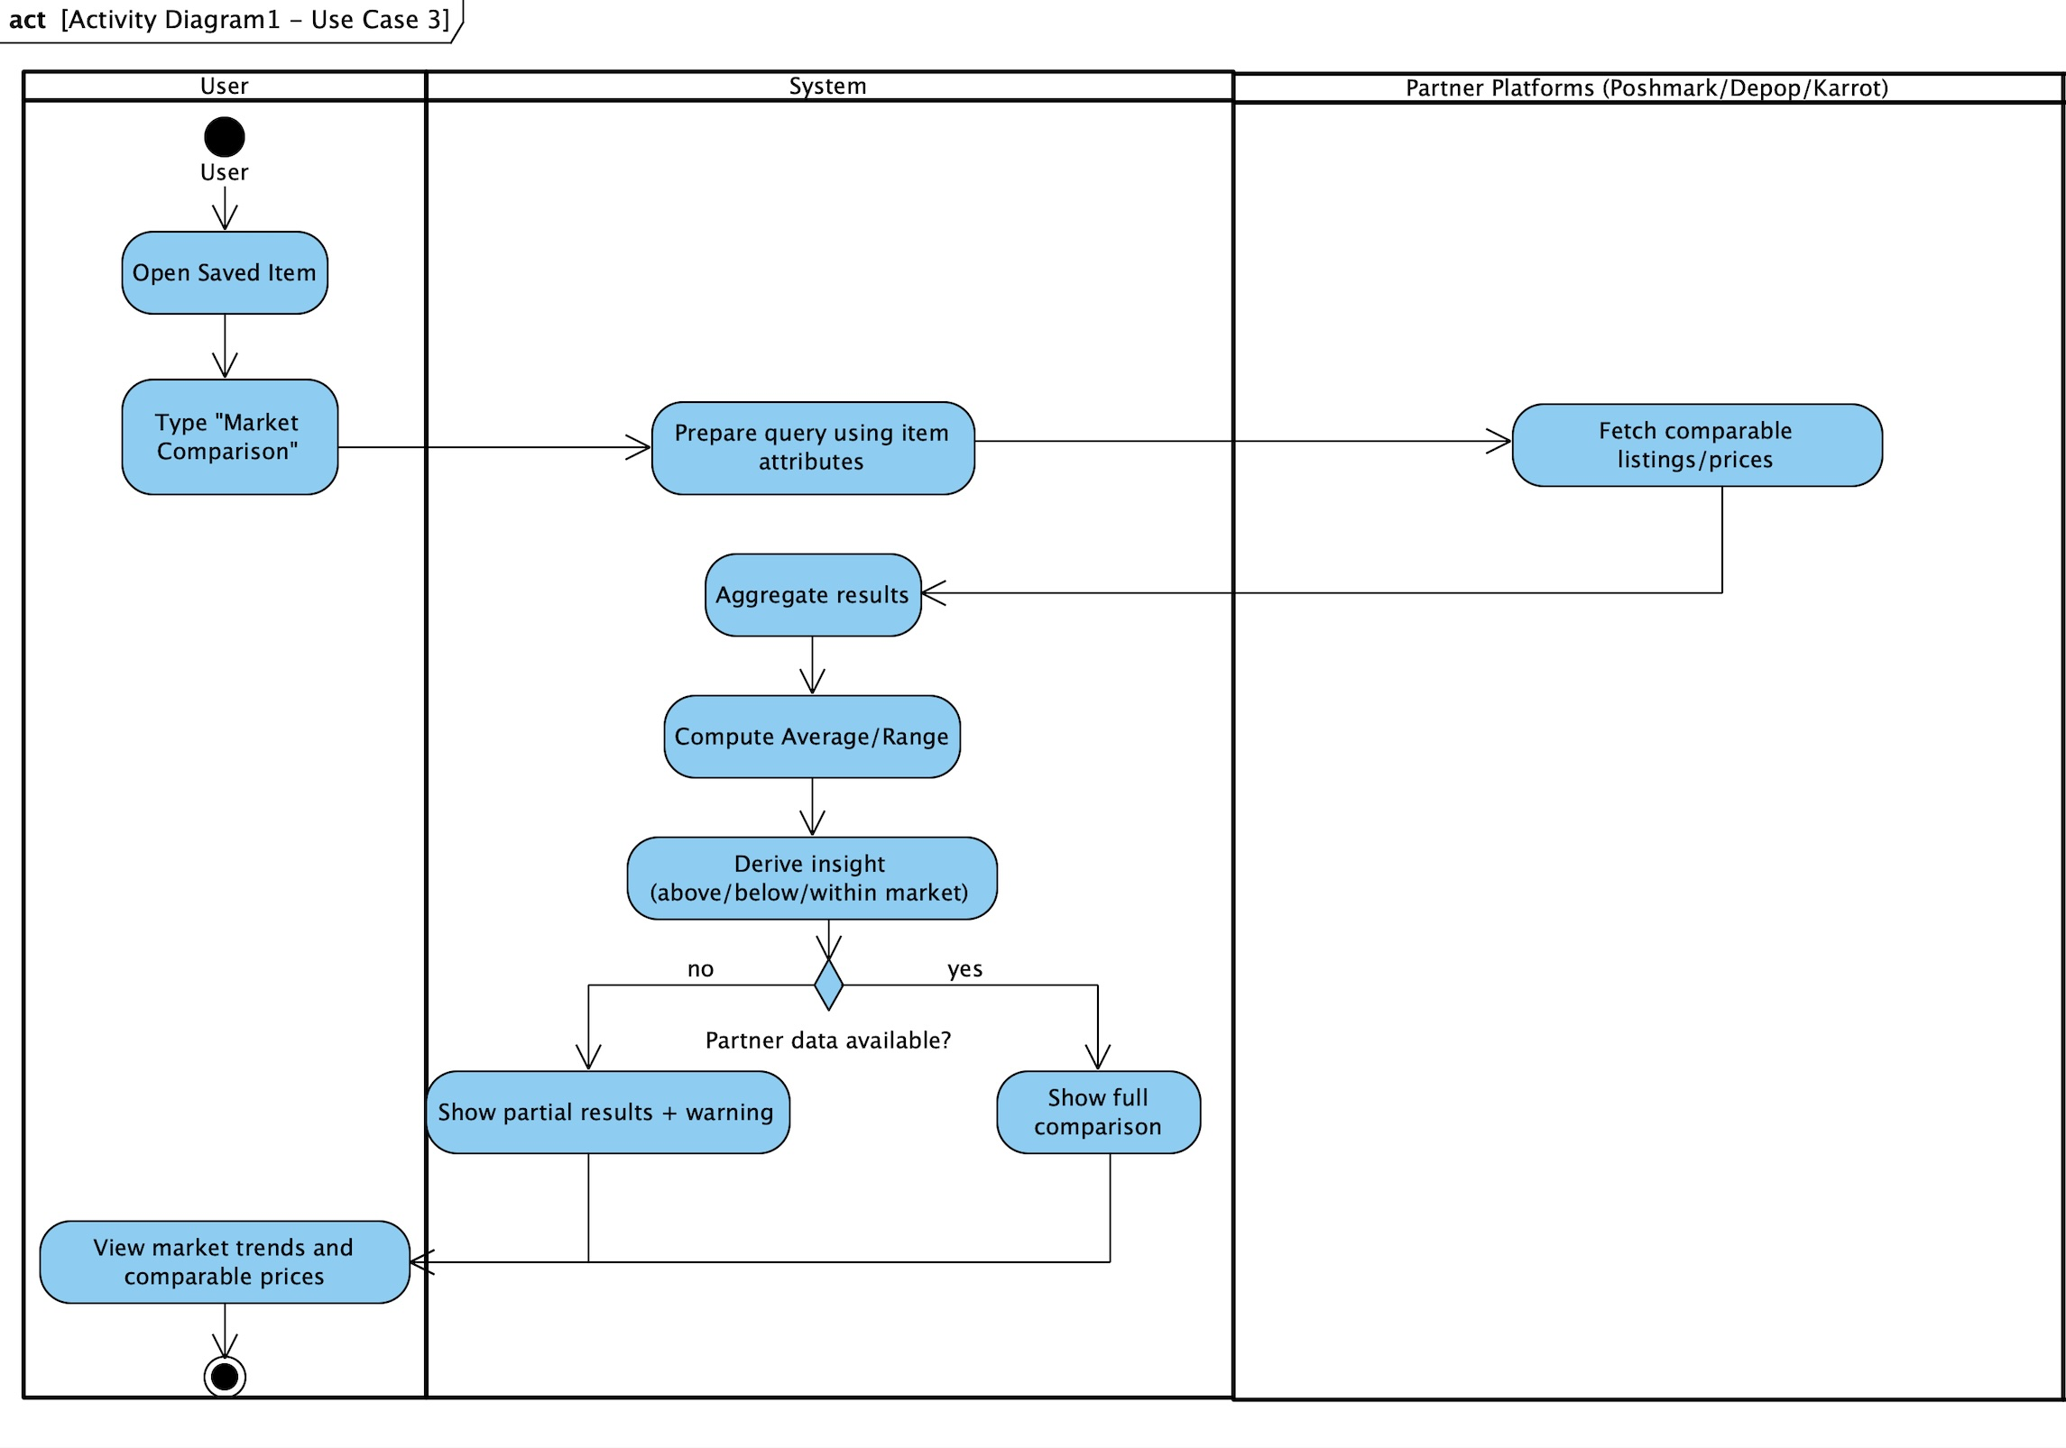
AD4:

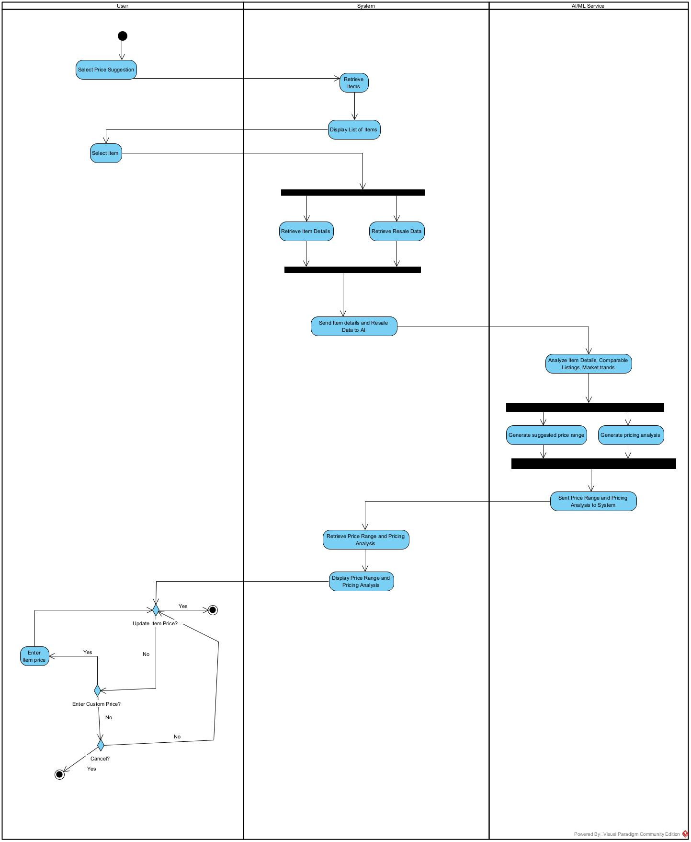
AD5:
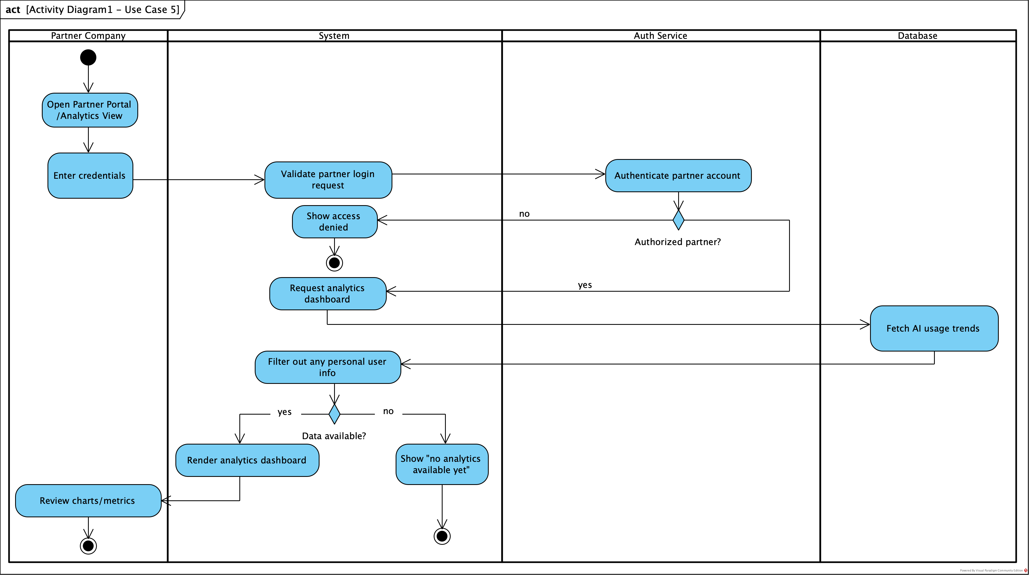

3.4 Business Rules

Business Rule # | Description | Activity Diagram | Related UCS | UI  Mock-up
BR1 | The system must authenticate users using valid email and password credentials before granting access to protected features. | AD1 | UC1 | UI 2.7.2
BR2 | User must enter category, brand, condition, and at least one image before any analysis can be done. | AD2 | UC2 | UI 2.7.3
BR3 | The system will use partner resale data for pricing analysis and will not store or expose personal information from user. | AD3 | UC3 | UI 2.7.4
BR4 | Market price, price range, and comparable listings must be shown when displaying market insights. | AD3 | UC3 | UI 2.7.4
BR5 | AI/ML will generate price suggestions based only on the given item details, historical sales data, and real-time market data. | AD4 | UC4 | UI 2.7.6
BR6 | Users may modify or reject AI-generated price suggestions before saving the final listing price. | AD4 | UC4 | UI 2.7.6
BR7 |  | AD7 | UC6 | UI 2.7.7
BR8 |  | AD8 | UC7 | UI 2.7.8
BR9 |  | AD8 | UC7 | UI 2.7.8
BR10 |  | AD8 | UC7 | UI 2.7.8
BR11 |  | AD8 | UC7 | UI 2.7.8
BR12 |  | AD8 | UC7 | UI 2.7.8
BR13 |  | AD9 | UC8 | UI 2.7.9
BR14 |  | AD9 | UC8 | UI 2.7.9
BR15 |  | AD9 | UC8 | UI 2.7.9
BR16 |  | AD9 | UC8 | UI 2.7.9
BR17 |  | AD10 | AD9 | UI 2.7.9
BR18 |  | AD10 | AD9 | UI 2.7.9
BR19 |  | AD10 | AD9 | UI 2.7.9

Section 4 – Domain Class

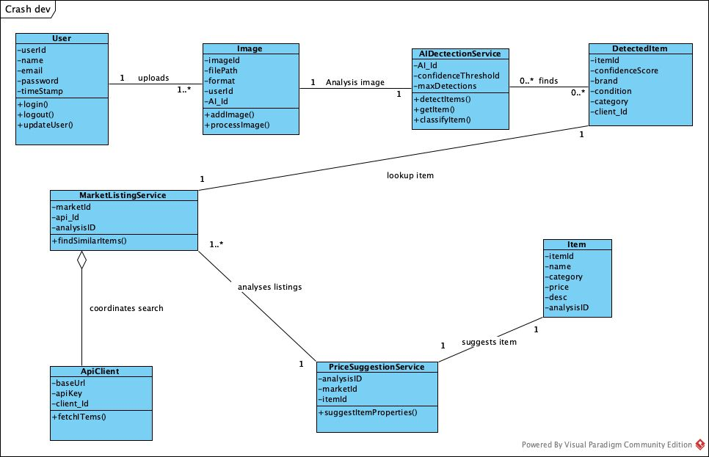

Section 5 – Database
The FlipValue system uses a relational database to store user information, item details, uploaded images, AI analysis results, price suggestions, and comparable market listings. The database schema consists of six main entities: User, Item, Image, AIAnalysis, PriceSuggestion, and MarketListing.
Primary keys uniquely identify each record, while foreign keys establish relationships between tables to maintain referential integrity. This structure supports the core functionality of the application, including item management, AI-assisted pricing analysis, and cross-platform market comparison.

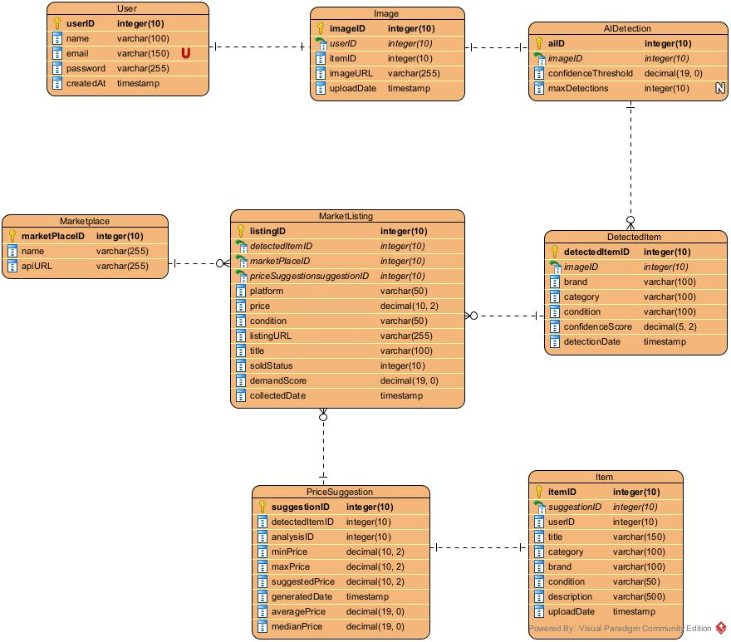
Data Dictionary
User
Attribute | Data type | Key | Description
userID | INT | PK | Unique identifier for each user
name | VARCHAR(100) |  | User’s full name
email | VARCHAR(100) | UNIQUE | User login email
password | VARCHAR(255) |  | Encrypted Password
createdAt | TIMESTAMP |  | Date account was created

Image
Attribute | Data type | Key | Description
imageID | INT | PK | Unique image identifier
userID | INT | FK | User who uploaded image
itemID | INT | FK | Item associated with image
imageURL | VARCHAR(255) |  | Location of image
uploadDate | TIMESTAMP |  | Date image was uploaded

AIDetection
Attribute | Data type | Key | Description
aiID | INT | PK | AI Image detection ID
imageID | INT | FK | Image analyzed
confidenceThreshold | DECIMAL |  | Minimum confidence for detection
maxDetections | INT |  | Maximum number of detected items

DetectedItem
Attribute | Data type | Key | Description
detectedItemID | INT | PK | Unique detected item identifier
imageID | INT | FK | Image with detected item
brand | VARCHAR(100) |  | Detected brand
category | VARCHAR(100) |  | Detected category
condition | VARCHAR(100) |  | Estimated item condition
confidenceScore | DECIMAL(5,2) |  | AI confidence score
detectionDate | TIMESTAMP |  | Detection timestamp

PriceSuggestion
Attribute | Data type | Key | Description
suggestionID | INT | PK | Unique price suggestion identifier
detectedItemID | INT | FK | Detected item reference
analysisID | INT | FK | AI analysis reference
minPrice | DECIMAL(10,2) |  | Min market price
maxPrice | DECIMAL(10,2) |  | Max market price
suggestedPrice | DECIMAL(10,2) |  | Recommended selling price
generatedDate | TIMESTAMP |  | Date suggestion was generated
averagePrice | DECIMAL(10,2) |  | Average market price
medianPrice | DECIMAL(10,2) |  | Median market price

Marketplace
Attribute | Data type | Key | Description
marketPlaceID | INT | PK | Unique marketplace identifier
name | VARCHAR(255) |  | Marketplace name
apiURL | VARCHAR(255) |  | API endpoint

MarketListing
Attribute | Data type | Key | Description
listingID | INT | PK | Unique listing identifier
detectedItemID | INT | FK | Detected item
marketPlaceID | INT | FK | Marketplace where listing appears
priceSuggestionID | INT | FK | Price suggestion
platform | VARCHAR(50) |  | Listing platform
price | DECIMAL(10,2) |  | Listing price
condition | VARCHAR(50) |  | Item condition
listingURL | VARCHAR(255) |  | Link to listing
title | VARCHAR(100) |  | Listing title
soldStatus | INT |  | Whether item is sold
demandScore | DECIMAL |  | Estimated demand score
collectedDate | TIMESTAMP |  | Date listing data collected

Item
Attribute | Data type | Key | Description
itemID | INT | PK | Unique item identifier
priceSuggestionID | INT | FK | Reference to price suggestion
userID | INT | FK | User who uploaded item
title | VARCHAR(150) |  | Item title
category | VARCHAR(100) |  | Item category
brand | VARCHAR(100) |  | Item brand
condition | VARCHAR(50) |  | Condition of item
description | VARCHAR(500) |  | Item description
uploadDate | TIMESTAMP |  | Date item uploaded to marketplace

Section 6 – Project Management

6.1 Work Breakdown Structure

6.2 Milestones & Acceptance Criteria

Section 7 – Product Backlog & Implementation Schedule

Section 8 – Client/Faculty Sign-off

