Case Study: Development of a web application for Assurance Al Maghrebia
Table of Contents
1. Project Introduction 1
2. Study of the existing situation 2
2.1. Existing Market Analysis (Competition) 2
2.2. Strengths and weaknesses of Al Maghrebia 3
2.3. Solutions 3
3. Problem Statement 3
4. Functional requirements 4
4.1. Key features 4
5. Non-functional requirements 6
➢ Performances and Scalability 6
➢ Security 6
➢ Accessibility 6
6. Application architecture: physical and logical 7
6.1. Physical Architecture 7
6.2. Logical Architecture 7
7. Diagrams UML 8
7.1. Use Case Diagram 8
7.2. Class Diagram 9
8. Product Backlog 9

January 26, 2025

Project Introduction
The project objective is to design and develop a redesigned version of the Assurances Al Maghrebia website, with a focus on improving the user experience, integrating interactive features, and implementing a modern and responsive design.

Study of the existing situation

Existing Market Analysis (Competition)
- Tunisian insurance Companies:
  - Strengths: Established services, diverse offerings, nationwide coverage.
  - Weaknesses: Slow claims process, lack of personalization, outdates user experience.
- International players (AXA, Allianz, AIG,etc.) :
  - Strengths: High-performing online portals, transparent processes, innovative insurance products.
  - Weaknesses: Difficulty adapting to the local context, often high costs.

Feature/Module | Assurance Star  (star.com.tn) | AIG  (aig.com) | Lloyd Tunisie  (lloyd.com.tn)
Homepage Design | Simple, clean, but outdated | Modern, professional, and visually appealing | Clean,and professional
Navigation | Basic navigation, limited dropdown menus | Intuitive and user-friendly navigation | Easy-to-use navigation
Mobile Responsiveness | Partially responsive | Fully responsive | Fully responsive
Language Options | French and Arabic | Multiple languages | French and Arabic
Customer Portal | Limited functionality | Advanced customer portal with account management | Basic customer portal
Claims Management | Basic information, no online claims | Advanced online claims submission and tracking | Basic information, no online claims
Contact Options | Phone,email,and branch locator | Phone, email, chat, and branch locator | Phone, email, and branch locator
Blog/Resources | No blog or resources | Extensive resources,blogs, and FAQs | No blog or resources
Security Features | Basic SSL certificate | Advanced security features | Basic SSL certificate
Accessibility | Limited accessibility features | Strong accessibility features(screen reader support…) | Limited accessibility features
Table 1:Market Analysis

Strengths and weaknesses of Al Maghrebia
- Points forts :
  - Strong reputation in the Tunisian market.
  - Deep understanding of local needs.
  - Extensive network of agents in the country.
- Weaknesses :
  - Lack of a robust digital platform.
  - Manual processes for most procedures (subscription, claim).
  - Limited integration of digital solutions for users and agents.

Solutions
Develop a modern and secure digital platform for Al Maghrebia that enhances:
- Modernize Design and User Interface (UI)
- Enhance User Experience (UX)
- Add Valuable Content and Resources (Blog/Resources)
- Improve Accessibility and Security
- Integrate Social Media and Communication Tools
- Add Interactive Features
- Collect User Feedback

Problem Statement
How can we develop a modern and secure digital platform for Al Maghrebia that enhances user experience, automates key processes, and effectively competes with market players, while adhering to local legal and technical constraints?

Functional requirements

Key features
- User Management
  - Registration and authentication (client, agent, administrator)
  - Role and permission management
  - Updating user profile (personal information, contact details, password)
  - Login/logout management and password recovery
- Contract Management
  - Creation and subscription of an insurance contract
  - Viewing and downloading ongoing contracts
  - Modification and termination of a contract
  - Archiving old contracts
  - Notifications and reminders for renewal
- Auto-Approval for Low-Risk Contracts (Use Spring Rules Engine to check if auto-approval applies. If approved, generate the contract and notify the client instantly)
- Auto-Generated Insurance Contracts (The client fills out a form with their personal details, insurance needs, and specific preferences (e.g., car model, home details, coverage type)
- Pre-Filled Contract Templates (Speed up contract creation by allowing users to use pre-filled templates instead of starting from scratch)
- Appointments & Claims Service
  - Appointment Management
  - Booking an appointment with an advisor
  - Confirmation and cancellation of appointments
  - Appointment history
  - Notifications and reminders
- Utilizing machine learning algorithms to optimize appointment distribution based on request history, agent availability, and customer location.
- Intelligent prioritization of appointments based on urgency level and customer profile.
- An AI assistant that guides users through the claims process and provides real-time responses based on a dynamic knowledge base.
- Quote Management
  - Online quote simulation
  - Quote generation and download
  - Validation and conversion of a quote into a contract
- Automate PDF generation for quotes and allow clients to download or send them via email
- Automate quote follow-ups and notify clients in real-tim
- Integrate an online payment system so clients can pay directly when accepting a quote
- Forum & Support
  - Creating topics and discussions on insurance products
  - User interactions and responses
  - Moderation and content management by administrators
  - Search engine to find discussions
  - Reacts and feedback
- AI-Powered Comment Moderation
- Blog Post Search & Filtering
- Chatbot
- Claims & Incidents Management.
  - Declaration of an incident (accident, theft, fire, etc.)
  - Adding supporting documents (photos, reports, etc.)
  - Tracking the processing of the incident (status, progress)
  - Communication with an insurance expert
- Integrate advanced features like AI-powered damage assessment, OCR for document processing.
- Real-time claim tracking will improve reliability.
- Automated notifications and video call support can enhance user experience.
- Integrating location tracking.
- Consultation.
  - Viewing ongoing and archived contracts
  - History of claims and incidents
  - Consultation of insurance guarantees and conditions
  - Viewing past appointments and quotes
- Rating and review system after a consultation.
- Email/SMS notifications to remind appointments.
- Intelligent chatbot with AI to answer frequently asked questions.

Non-functional requirements

Performances and Scalability
- Page and API response time: <2 seconds.
- Load management: Use of load balance to distribute requests across multiple instances.
- The system should be able to add new microservices without impacting overall performance.

Security
- Implementation of the HTTPS protocol for all communications.
- Endpoint protection with Spring Security.
- JWT (JSON Web Tokens) based authentication.

Accessibility
- Responsive design for mobiles and desktops.
- Interface available in French, Arabic and English.
- Responsive and optimized interface

Application architecture: physical and logical

Physical Architecture
Physical architecture illustrates a three-tier structure comprising the frontend, backend, and database layers. The front-end is built using Angular, where users interact with an in-browser application. This application communicates with the backend via HTTP requests and responses. The backend, developed using Spring Boot, serves as a Web API, processing client requests and interacting with a MySQL database to fetch or store data.
Figure 1:Physical Architecture
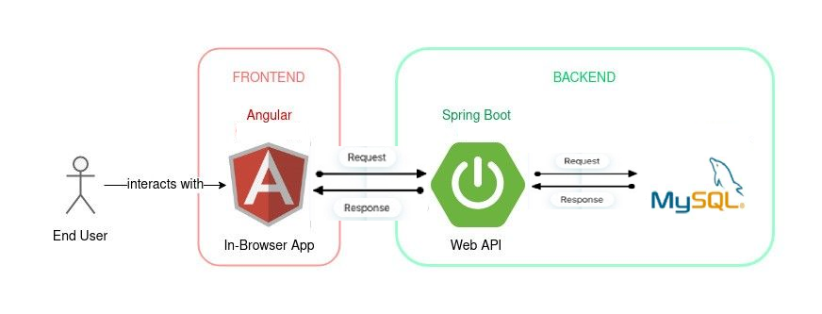

This architecture ensures a structured and efficient flow of information between the user interface, application logic, and data storage.

Logical Architecture
The logical architecture represents a microservices-based system managed through an API Gateway, which serves as an entry point for client requests. The system is composed of multiple independent services, each handling a specific function, promoting scalability and modularity. These services are orchestrated under a management layer, ensuring smooth interactions and coordination.
Figure 2:Logical Architecture
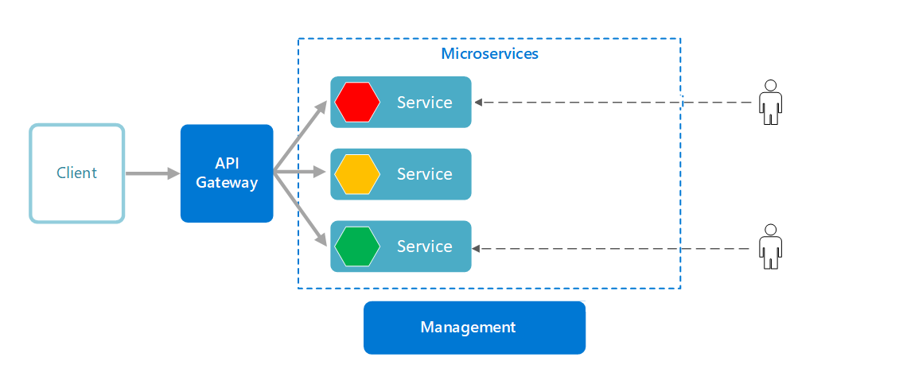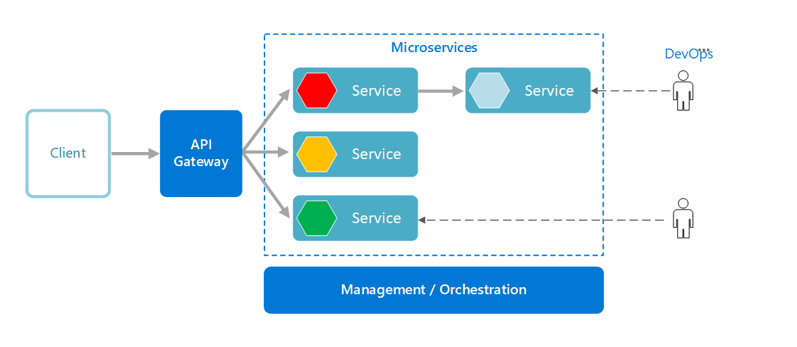

Diagrams UML

Use Case Diagram
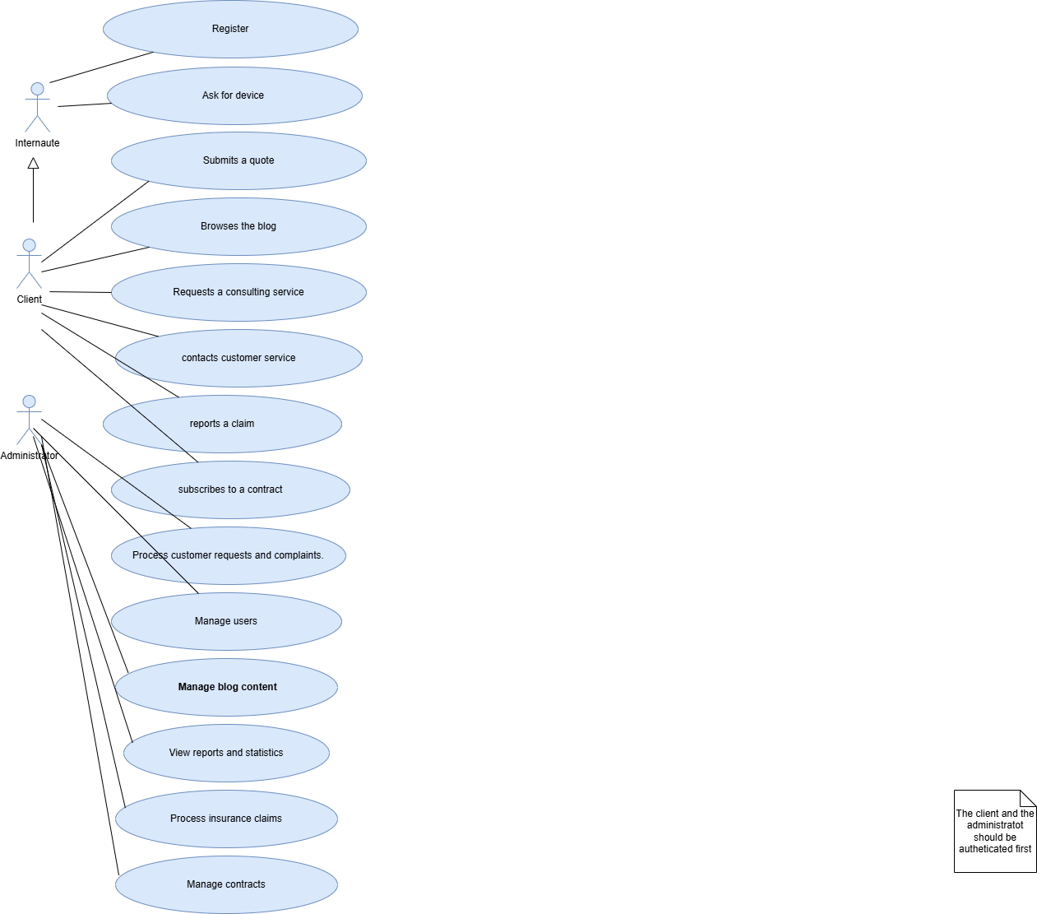
Figure 3: Use Case Diagram:

Class Diagram
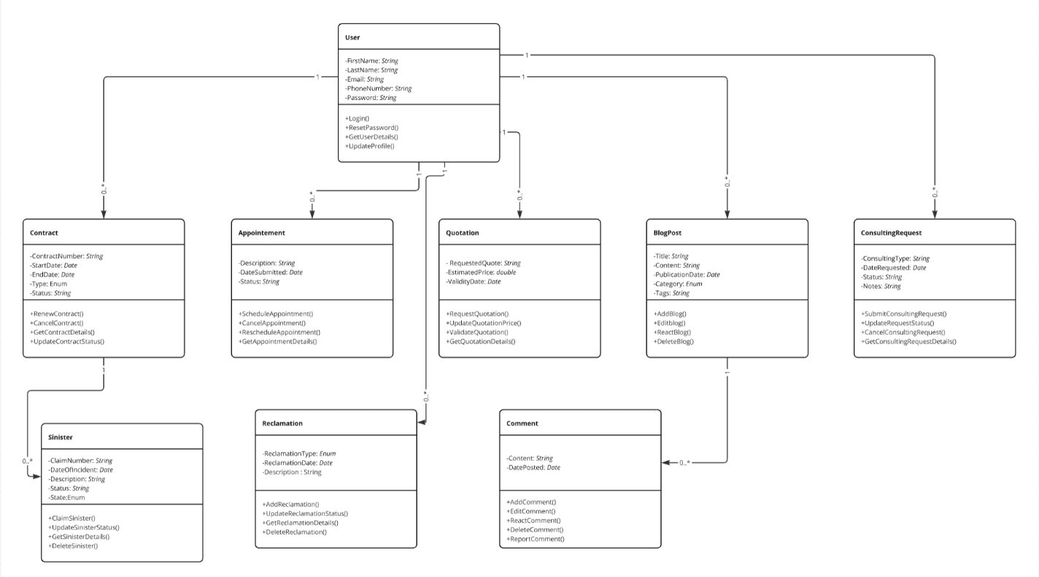
Figure 4: Class Diagram

Product Backlog

Gestion | Action | User Story | Priority | Status
 | Add | As a Visitor, I want to fill out a form to automatically generate a quote. | High | To Do
 | View | As a User, I want to view my saved quotes in my personal space. | High | To Do
Quote |  | As a User, I want to download my quote in PDF format. | Medium | To Do
 | Notify | As a User, I want to receive notifications about quote updates. | Medium | To Do
 | Add | As a User, I want to sign a contract after accepting a quote. | High | To Do
 | View | As a User, I want to view the details of my active contract. | High | To Do
Contract | Process Payment | As a User, I want to make a payment for the contract. | High | To Do
 | Cancel | As an Admin, I want to cancel a contract if necessary. | Medium | To Do
 | Add | As a User, I want to report a claim by submitting the necessary documents. | High | To Do
 | Modify | As an Administrator, I want to analyze, modify, and validate reported claims. | High | To Do
Claims | Notify | As an Administrator, I want to process the compensation payments after validation. | Medium | To Do
 | Cancel | As an Admin, I want to cancel or close claims if necessary. | Medium | To Do
 | View | As a Visitor, I want to view the available services. | High | To Do
 | Add | As a User, I want to subscribe to additional services. | Medium | To Do
Services | Cancel Subscription | As a User, I want to cancel my subscription to a service if I no longer need it. | High | To Do
 | Add / Modify | As an Administrator, I want to add, modify, and delete services. | High | To Do
 | View | As a Visitor/User, I want to view the blog articles. | High | To Do
 | Add / Modify | As a User, I want to add and modify my comments on the blog articles. | Medium | To Do
Blog | Delete | As a User, I want to delete my own posts or comments on blog articles. | High | To Do
 | Approve | As an Administrator, I want to approve blog posts before they go live. | Medium | To Do
 | Add | As a User, I want to add a request for a consultation with an expert. | High | To Do
Consulting | Add / Modify | As an Administrator, I want to assign and modify the expert in charge of a consultation. | High | To Do
 | View | As an Administrator, I want to manage and view the consultation reports. | Medium | To Do
 | Notify | As a User, I want to receive a confirmation or reminder for the consultation. | Medium | To Do
Table 2: BackLog Produit

