|  |
| --- |
| AutoTester |
| Documentation |
|  |
| **Petr Rašek** |

| Document History and Version Overview: | | | | |
| --- | --- | --- | --- | --- |
| Version | Date | Author | Page(s) | Remarks |
| 1.0 | 04.01.2015 | Petr Rašek | 48 | Initial revision |
| 1.1 | 18.01.2015 | Petr Rašek | 50 | Added LOV functions, test data repository, maintenance |

Table of Contents

1. Introduction 5

1.1 Purpose 5

1.2 Scope 5

1.3 Download 5

2. Installation 6

2.1 Operating system 6

2.2 Java 6

2.3 Application server 6

2.3.1 Maintenance script 6

2.4 Database 7

2.5 Application 7

2.5.1 Glassfish configuration 7

2.5.2 Application configuration 8

2.6 Deployment 8

3. User manual 10

3.1 User interface 10

3.2 Test case workflow 13

3.3 Scheduled execution 13

4. Scripting 15

4.1 Introduction 15

4.2 Examples 15

4.2.1 CLF 15

4.2.2 DWH 22

4.2.3 AMX 25

4.2.4 CNH 26

4.2.5 AP 28

4.2.6 WS 29

4.3 Functions 34

4.3.1 Common 34

4.3.2 CLF 35

4.3.3 DWH 37

4.3.4 AMX 38

4.3.5 AP 39

4.3.6 CNH 39

4.3.7 WS 39

5. System documentation 40

5.1 Architecture 40

5.1.1 Deployment 40

5.1.2 Test case administration 41

5.1.3 Test case execution 42

5.2 Class diagrams 43

5.2.1 Utilities 43

5.2.2 Beans 44

5.2.3 Database model 45

5.2.4 Customer structure 46

5.2.5 Services 47

5.2.6 Business services 47

5.2.7 LOV 49

5.2.8 Properties 49

5.3 Maintenance 50

# Introduction

## Purpose

AutoTester is application designed for preparation, execution and maintenance of automated test cases.

## Scope

The scope of this document is to

* Describe installation of the AutoTester application
* Describe the application usage
* Describe scripting capabilities
* Describe system design

## Download

The application is distributed under GNU GPL v2 license.

Source code is available on <https://github.com/lynusbowman/AutoTester/tree/1.0>

# Installation

## Operating system

The AutoTester application is implemented on J2EE technology so it can be deployed on any usual operating system (verified on Windows and Linux). Following manual describes detailed installation procedure for Linux (target OS in TMCZ).

## Java

Install Java 7 development kit (i.e. JDK 1.7.0_80).

Extract the archive to folder /usr/java.

Set environment variables PATH and JAVA_HOME which point to Java bin folder.

export PATH=$PATH:/usr/java/jdk1.7.0_80/bin

export JAVA_HOME=/usr/java/jdk1.7.0_80/bin

## Application server

Install Glassfish 4.1 application server.

Extract the archive to folder /opt/glassfish

Create maintenance script /etc/init.d/glassfish and set execute permission (chmod a+x).

Add the script to RC update-rc.d glassfish defaults

### Maintenance script

The script is used to start, stop or restart application server and database.

#! /bin/sh

GLASSFISHPATH=/opt/glassfish/bin

case "$1" in

start)

echo "starting glassfish from $GLASSFISHPATH"

sudo $GLASSFISHPATH/asadmin start-domain domain1

sudo $GLASSFISHPATH/asadmin start-database

;;

stop)

echo "stopping glassfish from $GLASSFISHPATH"

sudo $GLASSFISHPATH/asadmin stop-database

sudo $GLASSFISHPATH/asadmin stop-domain domain1

;;

restart)

$0 stop

$0 start

;;

*)

echo $"usage: $0 {start|stop|restart}"

exit 3

;;

esac

:

## Database

Glassfish contains embedded Derby database which is used as test case repository. Separate installation is not needed.

## Application

### Glassfish configuration

Configure JDBC connection pool for Derby database.

Configuration file is located in /opt/glassfish/glassfish/domains/domain1/config/domain.xml.

Add following text to element resources

<jdbc-connection-pool datasource-classname="org.apache.derby.jdbc.ClientDataSource40" name="TestPool" res-type="javax.sql.DataSource">

<property name="TraceFileAppend" value="false"></property>

<property name="SecurityMechanism" value="4"></property>

<property name="ConnectionAttributes" value="create=true"></property>

<property name="User" value="APP"></property>

<property name="DatabaseName" value="TEST"></property>

<property name="Ssl" value="off"></property>

<property name="RetrieveMessageText" value="true"></property>

<property name="LoginTimeout" value="0"></property>

<property name="ServerName" value="localhost"></property>

<property name="TraceLevel" value="-1"></property>

<property name="PortNumber" value="1527"></property>

<property name="Password" value="APP"></property>

</jdbc-connection-pool>

<jdbc-resource pool-name="TestPool" jndi-name="jdbc/TestDS"></jdbc-resource>

Add following test to element servers

<resource-ref ref="jdbc/TestDS"></resource-ref>

### Application configuration

Configure application log folder in file log4j2.xml

<Property name="log-path">/home/lynus/private/autotester/log</Property>

Configure test case folder in file config.properties

testCasesPath=/home/lynus/private/autotester/tests/

## Deployment

Make new build AutoTester-1.0.war with updated configuration files.

Start application server (default admin port 4848, default application port 8080) and database (default port 1527). Try to ping connection pool.

Copy war file AutoTester-1.0.war to /opt/glassfish/glassfish/domains/domain1/autodeploy/AutoTester.war

Open URL <http://localhost:8080/AutoTester>

Check server.log (located in /opt/glassfish/glassfish/domains/domain1/logs) and app.log (located in log4j2 folder) for exceptions.

Check database - connection string:jdbc:derby://localhost:1527/TEST, user APP, pass APP. Following tables are created TEST_CASE_GROUP, TEST_CASE, TEST_RUN, TEST_RUN_LOG.

# User manual

## 3.1 User interface

Application has web graphical interface (see fig 1).

Each user control is explained in tab 1.

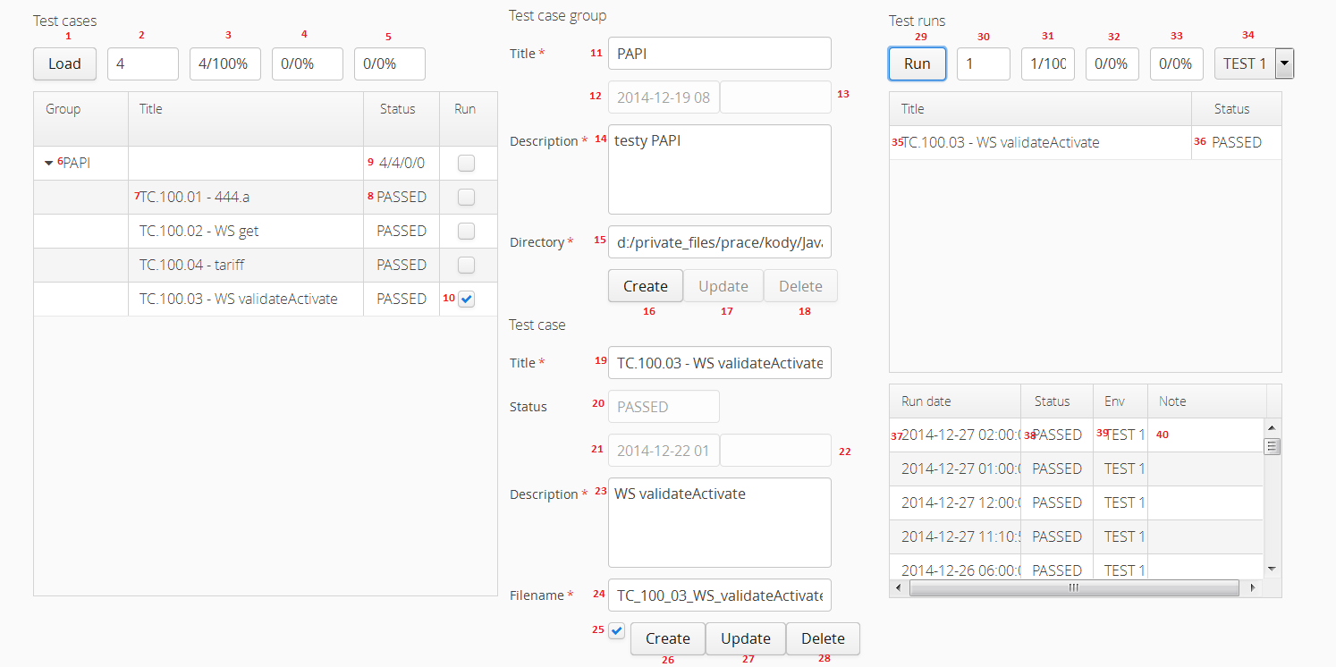

Figure : GUI

|  |  |  |
| --- | --- | --- |
| **Control ID** | **Control title** | **Description** |
| 1 | Load test cases | * Load all test cases and groups from DB * Populate table and counters (controls 2-5) * Clear test runs |
| 2 | Total test cases | * Count of test cases in DB |
| 3 | Passed test cases | * Count of passed test cases in DB (including percentage) |
| 4 | Failed test cases | * Count of failed test cases in DB (including percentage) |
| 5 | Not run test cases | * Count of not run test cases in DB (including percentage) |
| 6 | Test case group title | * Test case group title * Form Test case group is pre-filled after cell click event |
| 7 | Test case title | * Test case title * Forms Test case group and Test case after pre-filled after cell click event |
| 8 | Test case status | * Test case status * Options PASSED, FAILED, NOTRUN |
| 9 | Group counters | * Test case status counters within group * Total/Passed/Failed/Not run |
| 10 | Run test case | * Add/Remove test case to/from test runs table * Checkbox in group row adds/removes all test cases within group |
| 11 | Group title | * Test case group title, mandatory, stored in column TITLE |
| 12 | Group create date | * Test case group create date, stored in column CREATE_DATE |
| 13 | Group modify date | * Test case group modify date, stored in column MODIFY_DATE |
| 14 | Group description | * Test case group description, mandatory, stored in column DESCRIPTION |
| 15 | Group directory | * Test case group directory, mandatory, stored in column DIRECTORY * The field is pre-filled with configured property testCasesPath |
| 16 | Create group | * Create test case group * Insert record to table TEST_CASE_GROUP and create directory on filesystem * Mandatory fields Title, Description, Directory |
| 17 | Update group | * Update test case group * Update record in table TEST_CASE_GROUP and directory on filesystem * Available fields Title, Description, Directory |
| 18 | Delete group | * Delete test case group * Delete record in table TEST_CASE_GROUP and directory on filesystem * Test cases within group are also deleted |
| 19 | Case title | * Test case title, mandatory, stored in column TITLE |
| 20 | Case status | * Test case status, stored in column STATUS * Options PASSED, FAILED, NOTRUN |
| 21 | Case create date | * Test case create date, stored in column CREATE_DATE |
| 22 | Case modify date | * Test case modify date, stored in colum MODIFY_DATE |
| 23 | Case description | * Test case description, mandatory, stored in column DESCRIPTION |
| 24 | Case filename | * Test case filename, mandatory, stored in column FILENAME * The field is pre-filled with configured property testCaseSuffix |
| 25 | Auto test case | * Test case will be executed automatically by scheduler, stored in column AUTO |
| 26 | Create case | * Create test case * Insert record to table TEST_CASE an create file on filesystem * Mandatory fields Title, Description, Filename, Test case group Title |
| 27 | Update case | * Update test case * Update record in table TEST_CASE and file on filesystem * Available fields Title, Description, Filename, Auto test case, Test case group |
| 28 | Delete case | * Delete test case * Delete record in table TEST_CASE and file on filesystem * Test case history is also deleted |
| 29 | Run test cases | * Run test cases in table on selected environment * Populate counters (controls 30-33) |
| 30 | Total test cases | * Count of test cases |
| 31 | Passed test cases | * Count of passed test cases |
| 32 | Failed test cases | * Count of failed test cases |
| 33 | Not run test cases | * Count of not run test cases |
| 34 | Environment | * Test environment * Options TEST1, TEST2 |
| 35 | Case title | * Title of run test case |
| 36 | Case status | * Status of run test case |
| 37 | Case run date | * Date of test case run |
| 38 | Case run status | * Status of test case run |
| 39 | Case run environment | * Enviroment of test case run |
| 40 | Case run note | * Note of test case run * It is editable in DB only |

Table - User controls

## 3.2 Test case workflow

Typical application usage is displayed on fig 2.

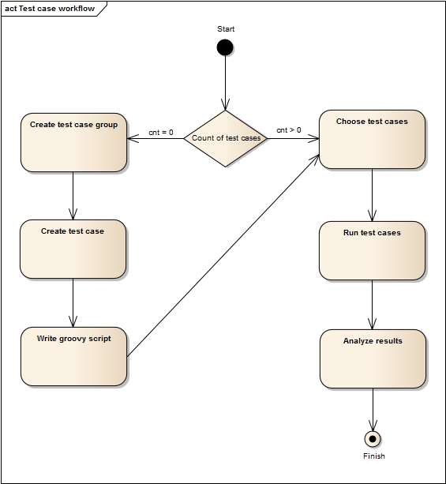

Figure - Test case workflow

## 3.3 Scheduled execution

Test cases which are markered with checkbox Auto test case are executed automatically by scheduler (currently configured at 17:15).

The result is reported via email (currently sent to [petr.rasek@t-mobile.cz](mailto:petr.rasek@t-mobile.cz)), see fig 3.

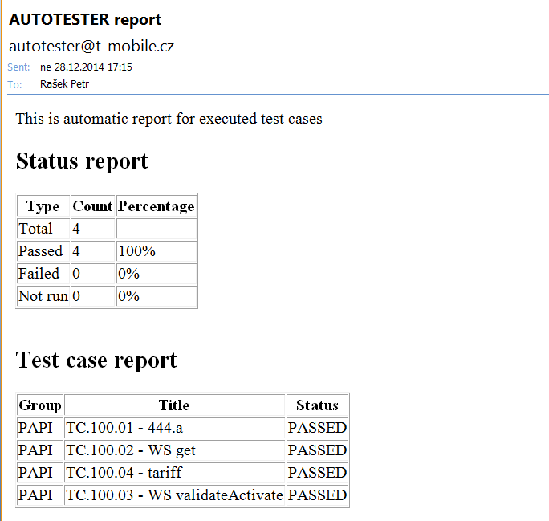

Figure - Email report

# Scripting

## Introduction

Test scripts are written in Groovy language which runs on JVM so it can easily cooperate with Java. AutoTester application contains functions which facilitate testing of TMCZ applications.

Covered applications:

* Clarify
* operates with QCLF DB
* covers customer structure, services, PAPI, LOVs
* DWH
* operates with QDTW DB
* covers customer structure (in ODS), services (in ODS, MTX), LOVs (in ODS and replication to QAP)
* Billing
* operates with QAMECU DB
* covers customer structure, offers on SU level, LOVs
* DTS
* operates with QAP DB
* covers DTS tables designed for any consumer (VCC, CRM applications)
* Notifications
* operates with QCNH DB
* covers notifications triggered by any application which uses CNH
* Business services
* operates with SA web service endpoint
* covers operations: get, activate, modify, deactivate (including validation)

## Examples

### CLF

#### Customer structure

Script TC_EX_CLF_01_Customer_structure.groovy

*// initialization*

**import** com.bowman.autotester.Utilities

result = 0

util = **new** Utilities(logID)

**try** {

*// start*

util.log("START")

*// setup*

MSISDN = "603847346"

util.clf.connect(env)

*// get customer hierarchy*

hier = util.clf.getCustHierarchy(MSISDN)

CU = util.clf.getCU(MSISDN)

LE = util.clf.getLE(MSISDN)

OU = util.clf.getOU(MSISDN)

EU = util.clf.getEU(MSISDN)

BA = util.clf.getBA(MSISDN)

SU = util.clf.getSU(MSISDN)

*// check hierarchy*

**assert** util.check("CU", hier.getCU().getExtID(), CU) == 1

**assert** util.check("LE", hier.getLE().getExtID(), LE) == 1

**assert** util.check("OU", hier.getOU().getExtID(), OU) == 1

**assert** util.check("EU", hier.getEU().getExtID(), EU) == 1

**assert** util.check("BA", hier.getBA().getExtID(), BA) == 1

**assert** util.check("SU", hier.getSU().getExtID(), SU) == 1

*// bilcycle*

BC = util.clf.getBillCycle(MSISDN)

**assert** util.check("BC", BC.getID(), 52) == 1

*// segment*

segment = util.clf.getSegment(MSISDN)

**assert** util.check("Segment", segment.getTitle(), "LE") == 1

*// market*

market = util.clf.getMarket(MSISDN)

**assert** util.check("Market", market.getTitle(), "GSM") == 1

*// tariff*

tariff = util.clf.getTariff(MSISDN)

**assert** util.check("Tariff", tariff.getID(), 204) == 1

*// contract duration*

contr = util.clf.getContractDuration(MSISDN)

**assert** util.check("Contract duration", contr.getTitle(), "Indefinite") == 1

*// teardown*

util.clf.disconnect()

*// finish, test passed*

util.log("FINISH")

result = 1

}

**catch** (AssertionError e) {

*// teardown*

util.clf.disconnect()

*// error, test failed*

util.err("ERR")

result = 0

}

#### Services

Script TC_EX_CLF_02_Services.groovy

*// initialization*

**import** com.bowman.autotester.Utilities

result = 0

util = **new** Utilities(logID)

**try** {

*// start*

util.log("START")

*// setup*

MSISDN = "603847346"

util.clf.connect(env)

*// SU services*

SU = util.clf.getSU(MSISDN)

suSrv = util.clf.getSUServices(SU)

suSrv.each { srv -> util.log(srv.getID()) }

*// service 897*

srv = util.clf.getSUService(SU, 897)

**assert** util.checkNok("Instance", srv.getInstanceID(), 0) == 1

**assert** util.check("Status", srv.getStatus(), "a") == 1

**assert** util.checkNok("Param 1531", srv.getParam(1531), "0") == 1

**assert** util.checkLike("Param 1534", srv.getParam(1534), "Z1-2") == 1

*// teardown*

util.clf.disconnect()

*// finish, test passed*

util.log("FINISH")

result = 1

}

**catch** (AssertionError e) {

*// teardown*

util.clf.disconnect()

*// error, test failed*

util.err("ERR")

result = 0

}

#### PAPI get

Script TC_EX_CLF_03_PAPI_get.goovy

*// initialization*

**import** com.bowman.autotester.Utilities

result = 0

util = **new** Utilities(logID)

**try** {

*// start*

util.log("START")

*// setup*

MSISDN = "603847346"

util.clf.connect(env)

*// PAPI 506, service deactive*

util.log("PAPI 506")

SU = util.clf.getSU(MSISDN)

PAPI = util.clf.callPAPI("SU", SU, 506, "G")

**assert** util.check("Status", PAPI.getStatus(), "d") == 1

*// PAPI 430, service active*

util.log("PAPI 430")

PAPI = util.clf.callPAPI("SU", SU, 430, "G")

**assert** util.check("Status", PAPI.getStatus(), "a") == 1

**assert** util.check("Attr 1 reason_status", PAPI.getAttr(1), "1") == 1

**assert** util.check("Attr 1738 national_calls", PAPI.getAttr(1738), "CZ=1000,") == 1

*// teardown*

util.clf.disconnect()

*// finish, test passed*

util.log("FINISH")

result = 1

}

**catch** (AssertionError e) {

*// teardown*

util.clf.disconnect()

*// error, test failed*

util.err("ERR")

result = 0

}

#### PAPI activate

Script TC_EX_CLF_04_PAPI_activate.groovy

*// initialization*

**import** com.bowman.autotester.Utilities

result = 0

util = **new** Utilities(logID)

**try** {

*// start*

util.log("START")

*// setup*

MSISDN = "603847346"

util.clf.connect(env)

*// get, service deactive*

util.log("Get")

SU = util.clf.getSU(MSISDN)

PAPI = util.clf.callPAPI("SU", SU, 1, "G")

**assert** util.check("Status", PAPI.getStatus(), "d") == 1

*// activation*

util.log("Activation")

PAPI = util.clf.callPAPI("SU", SU, 1, "a", [1, 735, 736, 813], [21, "OBE", "OBE", "lynus@seznam.cz"])

*// get, service active*

util.log("Get")

PAPI = util.clf.callPAPI("SU", SU, 1, "G")

**assert** util.check("Status", PAPI.getStatus(), "a") == 1

**assert** util.check("Attr 1 reason_status", PAPI.getAttr(1), "21") == 1

**assert** util.check("Attr 735 notification_type", PAPI.getAttr(735), "OBE") == 1

**assert** util.check("Attr 736 message_type", PAPI.getAttr(735), "OBE") == 1

**assert** util.check("Attr 813 email_address", PAPI.getAttr(813), "lynus@seznam.cz") == 1

**assert** util.check("Attr 1223 inkaso", PAPI.getAttr(1223), "N") == 1

*// teardown*

util.clf.disconnect()

*// finish, test passed*

util.log("FINISH")

result = 1

}

**catch** (AssertionError e) {

*// teardown*

util.clf.disconnect()

*// error, test failed*

util.err("ERR")

result = 0

}

#### PAPI modify

Script TC_EX_CLF_05_PAPI_modify.groovy

*// initialization*

**import** com.bowman.autotester.Utilities

result = 0

util = **new** Utilities(logID)

**try** {

*// start*

util.log("START")

*// setup*

MSISDN = "603847346"

util.clf.connect(env)

*// get, service active*

util.log("Get")

SU = util.clf.getSU(MSISDN)

PAPI = util.clf.callPAPI("SU", SU, 1, "G")

**assert** util.check("Status", PAPI.getStatus(), "a") == 1

**assert** util.check("Attr 1 reason_status", PAPI.getAttr(1), "21") == 1

**assert** util.check("Attr 735 notification_type", PAPI.getAttr(735), "OBE") == 1

**assert** util.check("Attr 736 message_type", PAPI.getAttr(736), "OBE") == 1

**assert** util.check("Attr 813 email_address", PAPI.getAttr(813), "lynus@seznam.cz") == 1

**assert** util.check("Attr 1223 inkaso", PAPI.getAttr(1223), "N") == 1

*// modification*

util.log("Modification")

PAPI = util.clf.callPAPI("SU", SU, 1, "m", [735, 736, 813, 1223], ["UHRADA", "EMAIL", "lynus@centrum.cz", "A"])

*// get, service modified*

util.log("Get")

PAPI = util.clf.callPAPI("SU", SU, 1, "G")

**assert** util.check("Status", PAPI.getStatus(), "a") == 1

**assert** util.check("Attr 735 notification_type", PAPI.getAttr(735), "UHRADA") == 1

**assert** util.check("Attr 736 message_type", PAPI.getAttr(736), "EMAIL") == 1

**assert** util.check("Attr 813 email_address", PAPI.getAttr(813), "lynus@centrum.cz") == 1

**assert** util.check("Attr 1223 inkaso", PAPI.getAttr(1223), "A") == 1

*// teardown*

util.clf.disconnect()

*// finish, test passed*

util.log("FINISH")

result = 1

}

**catch** (AssertionError e) {

*// teardown*

util.clf.disconnect()

*// error, test failed*

util.err("ERR")

result = 0

}

#### PAPI deactivate

Script TC_EX_CLF_06_PAPI_deactivate.groovy

*// initialization*

**import** com.bowman.autotester.Utilities

result = 0

util = **new** Utilities(logID)

**try** {

*// start*

util.log("START")

*// setup*

MSISDN = "603847346"

util.clf.connect(env)

*// get, service active*

util.log("Get")

SU = util.clf.getSU(MSISDN)

PAPI = util.clf.callPAPI("SU", SU, 1, "G")

**assert** util.check("Status", PAPI.getStatus(), "a") == 1

*// deactivation*

util.log("Dectivation")

PAPI = util.clf.callPAPI("SU", SU, 1, "d", [1], [22])

*// get, service deactive*

util.log("Get")

PAPI = util.clf.callPAPI("SU", SU, 1, "G")

**assert** util.check("Status", PAPI.getStatus(), "d") == 1

**assert** util.check("Attr 1 reason_status", PAPI.getAttr(1), "22") == 1

*// teardown*

util.clf.disconnect()

*// finish, test passed*

util.log("FINISH")

result = 1

}

**catch** (AssertionError e) {

*// teardown*

util.clf.disconnect()

*// error, test failed*

util.err("ERR")

result = 0

}

#### Cases

Script TC_EX_CLF_07_Cases.groovy

*// initialization*

**import** com.bowman.autotester.Utilities

result = 0

util = **new** Utilities(logID)

**try** {

*// start*

util.log("START")

*// setup*

MSISDN = "603847346"

util.clf.connect(env)

*// CASE C1878*

cas = util.clf.getCase(MSISDN, "C1878")

**assert** cas != **null**

util.log(cas.getID())

**assert** util.check("Process", cas.getProcess(), "ZMĚNY ZÁKAZNICKÉHO PROFILU") == 1

**assert** util.check("Subject", cas.getSubject(), "Tarif") == 1

**assert** util.check("Subsubject", cas.getSubsubject(), "Žádost zákazníka") == 1

**assert** util.check("Step", cas.getStep(), "...") == 1

**assert** util.check("Status", cas.getStatus(), "OPEN") == 1

**assert** util.check("MFFT1 Predchozi tarif", cas.getMFFT()[0], "Profi na míru 1") == 1

**assert** util.check("MFFT2 Novy tarif", cas.getMFFT()[1], "Profi na míru 2") == 1

*// teardown*

util.clf.disconnect()

*// finish, test passed*

util.log("FINISH")

result = 1

}

**catch** (AssertionError e) {

*// teardown*

util.clf.disconnect()

*// error, test failed*

util.err("ERR")

result = 0

}

### DWH

#### Customer structure

Script TC_EX_DWH_01_Customer_structure.groovy

*// initialization*

**import** com.bowman.autotester.Utilities

result = 0

util = **new** Utilities(logID)

**try** {

*// start*

util.log("START")

*// setup*

MSISDN = "603847346"

util.dwh.connect(env)

*// get customer hierarchy*

hier = util.dwh.getCustHierarchy(MSISDN)

CU = util.dwh.getCU(MSISDN)

LE = util.dwh.getLE(MSISDN)

OU = util.dwh.getOU(MSISDN)

EU = util.dwh.getEU(MSISDN)

BA = util.dwh.getBA(MSISDN)

SU = util.dwh.getSU(MSISDN)

*// check hierarchy*

**assert** util.check("CU", hier.getCU().getExtID(), CU) == 1

**assert** util.check("LE", hier.getLE().getExtID(), LE) == 1

**assert** util.check("OU", hier.getOU().getExtID(), OU) == 1

**assert** util.check("EU", hier.getEU().getExtID(), EU) == 1

**assert** util.check("BA", hier.getBA().getExtID(), BA) == 1

**assert** util.check("SU", hier.getSU().getExtID(), SU) == 1

*// bilcycle*

BC = util.dwh.getBillCycle(MSISDN)

**assert** util.check("BC", BC.getID(), 52) == 1

*// segment*

segment = util.dwh.getSegment(MSISDN)

**assert** util.check("Segment", segment.getTitle(), "LE") == 1

*// market*

market = util.dwh.getMarket(MSISDN)

**assert** util.check("Market", market.getTitle(), "GSM") == 1

*// tariff*

tariff = util.dwh.getTariff(MSISDN)

**assert** util.check("Tariff", tariff.getID(), 204) == 1

*// teardown*

util.clf.disconnect()

*// finish, test passed*

util.log("FINISH")

result = 1

}

**catch** (AssertionError e) {

*// teardown*

util.dwh.disconnect()

*// error, test failed*

util.err("ERR")

result = 0

}

#### Services

Script TC_EX_DWH_02_Services.groovy

*// initialization*

**import** com.bowman.autotester.Utilities

result = 0

util = **new** Utilities(logID)

**try** {

*// start*

util.log("START")

*// setup*

MSISDN = "603847346"

util.dwh.connect(env)

*// SU services*

SU = util.dwh.getSU(MSISDN)

suSrv = util.dwh.getSUServices(SU)

suSrv.each { srv -> util.log(srv.getID()) }

*// service 897*

srv = util.dwh.getSUService(SU, 897)

**assert** util.checkNok("Instance", srv.getInstanceID(), 0) == 1

**assert** util.check("Status", srv.getStatus(), "a") == 1

**assert** util.checkNok("Param 1531", srv.getParam(1531), "0") == 1

**assert** util.checkLike("Param 1534", srv.getParam(1534), "Z1-2") == 1

*// service 501 in MTX*

srv = util.dwh.getMTXService(SU, 501)

**assert** util.check("Status", srv.getStatus(), "d") == 1

*// teardown*

util.dwh.disconnect()

*// finish, test passed*

util.log("FINISH")

result = 1

}

**catch** (AssertionError e) {

*// teardown*

util.dwh.disconnect()

*// error, test failed*

util.err("ERR")

result = 0

}

### AMX

#### Customer structure

Script TC_EX_AMX_01_Customer_structure.groovy

*// initialization*

**import** com.bowman.autotester.Utilities

result = 0

util = **new** Utilities(logID)

**try** {

*// start*

util.log("START")

*// setup*

MSISDN = "603847346"

util.amx.connect(env)

*// SU*

SU = util.amx.getSU(MSISDN)

**assert** util.check("SU", SU, 41999702)

*// CU*

CU = util.amx.getCU(MSISDN)

**assert** util.check("CU", CU, 100005344)

*// teardown*

util.amx.disconnect()

*// finish, test passed*

util.log("FINISH")

result = 1

}

**catch** (AssertionError e) {

*// teardown*

util.amx.disconnect()

*// error, test failed*

util.err("ERR")

result = 0

}

#### Offers

Script TC_EX_AMX_02_Offers.groovy

*// initialization*

**import** com.bowman.autotester.Utilities

result = 0

util = **new** Utilities(logID)

**try** {

*// start*

util.log("START")

*// setup*

MSISDN = "603847346"

util.amx.connect(env)

*// SU offers*

SU = util.amx.getSU(MSISDN)

suOffer = util.amx.getSUOffers(SU)

suOffer.each { offer -> util.log(offer.getID() + ":" + offer.getStatus()) }

*// offer 457028096*

offer = util.amx.getSUOffer(SU, 457028096)

**assert** util.check("Status", offer.getStatus(), "A") == 1

**assert** util.check("Title", offer.getTitle(), "Tariff Profi (60+1)") == 1

*// offer 983*

offer = util.amx.getSUOffer(SU, 983)

**assert** util.check("Status", offer.getStatus(), "C") == 1

**assert** util.check("Title", offer.getTitle(), "FUOM Bez hranic na miru") == 1

*// teardown*

util.amx.disconnect()

*// finish, test passed*

util.log("FINISH")

result = 1

}

**catch** (AssertionError e) {

*// teardown*

util.amx.disconnect()

*// error, test failed*

util.err("ERR")

result = 0

}

### CNH

#### Notifications

Script TC_EX_CNH_01_Notifications.groovy

*// initialization*

**import** com.bowman.autotester.Utilities

result = 0

util = **new** Utilities(logID)

**try** {

*// start*

util.log("START")

*// setup*

util.cnh.connect(env)

*// SMS*

util.log("SMS")

MSISDN = "603713546"

notif = util.cnh.getNotification(MSISDN)

**assert** util.check("Template", notif.getTemplate(), "pactum2_insurance_deactivate_sms") == 1

**assert** util.check("Status", notif.getStatus(), 108) == 1

params = notif.getParameters()

params.each {key, value -> util.log(key + ":" + value)}

**assert** util.check("SERVICE", notif.getParam("SERVICE"), "T-Mobile pro jistotu") == 1

*// EMAIL*

util.log("EMAIL")

EMAIL = "martin.zima@t-mobile.cz"

notif = util.cnh.getNotification(EMAIL)

**assert** util.check("Template", notif.getTemplate(), "pactum2_insurance_deactivate_email") == 1

**assert** util.check("Status", notif.getStatus(), 103) == 1

params = notif.getParameters()

params.each {key, value -> util.log(key + ":" + value)}

**assert** util.checkNok("CODE", notif.getParam("CODE"), "0") == 1

*// teardown*

util.cnh.disconnect()

*// finish, test passed*

util.log("FINISH")

result = 1

}

**catch** (AssertionError e) {

*// teardown*

util.cnh.disconnect()

*// error, test failed*

util.err("ERR")

result = 0

}

### AP

#### DTS for VCC

Script TC_EX_AP_01_DTS_for_VCC.groovy

*// initialization*

**import** com.bowman.autotester.Utilities

result = 0

util = **new** Utilities(logID)

**try** {

*// start*

util.log("START")

*// setup*

SU = 41999702

util.ap.connect(env)

*// RC_SWITCH*

util.log("RC_SWITCH")

dts = util.ap.callDTS("SU", SU, "RC_SWITCH", ["NEW_TARIFF"], ["433"])

**assert** util.check("Result", dts.getResult(), "RC_T8") == 1

**assert** util.check("Action 1", dts.getAction("WARN_ABOUT_UNUSED_FUOMS_LOST")[0], "WARN_ABOUT_UNUSED_FUOMS_LOST") == 1

**assert** util.check("Action 2", dts.getAction("ROAMING_DAILY_PASS_ACTIVATE")[0], "ROAMING_DAILY_PASS_ACTIVATE") == 1

params = dts.getParameters()

params.each { key, value -> util.log(key + ":" + value) }

*// teardown*

util.ap.disconnect()

*// finish, test passed*

util.log("FINISH")

result = 1

}

**catch** (AssertionError e) {

*// teardown*

util.ap.disconnect()

*// error, test failed*

util.err("ERR")

result = 0

}

#### DTS for CCM

Script TC_EX_AP_02_DTS_for_CCM.groovy

*// initialization*

**import** com.bowman.autotester.Utilities

result = 0

util = **new** Utilities(logID)

**try** {

*// start*

util.log("START")

*// setup*

SU = 41999702

util.ap.connect(env)

*// TO_SU*

util.log("TO_SU")

dts = util.ap.callDTS("SU", SU, "TO_SU")

**assert** util.check("Result", dts.getResult(), "2") == 1

**assert** util.checkLike("Warning", dts.getWarnings()[0], "vod je mo")

params = dts.getParameters()

params.each { key, value -> util.log(key + ":" + value) }

*// teardown*

util.ap.disconnect()

*// finish, test passed*

util.log("FINISH")

result = 1

}

**catch** (AssertionError e) {

*// teardown*

util.ap.disconnect()

*// error, test failed*

util.err("ERR")

result = 0

}

### WS

#### GetStatus

Script TC_EX_WS_01_GetStatus.groovy

*// initialization*

**import** com.bowman.autotester.Utilities

result = 0

util = **new** Utilities(logID)

**try** {

*// start*

util.log("START")

*// setup*

SU = 41999702

util.ws.connect(env)

*// MissedCallsRegister - service deactive*

WS = util.ws.callWS("SU", SU, "MissedCallsRegister", "getStatus")

**assert** util.check("Status", WS.getStatus(), "d") == 1

**assert** util.checkNok("CorrelationId", WS.getCorrelationId(), "") == 1

*// allowed action - MissedCallsRegister.ACTIVATE*

util.log("AA MissedCallsRegister.ACTIVATE")

AA = WS.getAllowedAction("MissedCallsRegister.ACTIVATE")

**assert** util.check("Allowed", AA.getAllowed(), **true**) == 1

*// allowed action - MissedCallsRegister.DEACTIVATE*

util.log("AA MissedCallsRegister.DEACTIVATE")

AA = WS.getAllowedAction("MissedCallsRegister.DEACTIVATE")

**assert** util.check("Allowed", [AA.getAllowed(), AA.getBreData().get(0)], [**false**, "SERVICE_NOT_ACTIVE"]) == 1

*// teardown*

util.ws.disconnect()

*// finish, test passed*

util.log("FINISH")

result = 1

}

**catch** (AssertionError e) {

*// teardown*

util.ws.disconnect()

*// error, test failed*

util.err("ERR")

result = 0

}

#### Activate

Script TC_EX_WS_02_Activate.groovy

*// initialization*

**import** com.bowman.autotester.Utilities

result = 0

util = **new** Utilities(logID)

**try** {

*// start*

util.log("START")

*// setup*

SU = 41999702

util.ws.connect(env)

*// getStatus - service deactive*

util.log("GetStatus");

WS = util.ws.callWS("SU", SU, "MyBill", "getStatus")

**assert** util.check("Status", WS.getStatus(), "d") == 1

*// validateActivate*

util.log("ValidateActivate");

WS = util.ws.callWS("SU", SU, "MyBill", "validateActivate",

"service", ["notificationType", "messageType", "emailAddress", "directDebit"], ["OBE", "OBE", "lynus@seznam.cz", "A"],

"action", ["reason_status"], [21])

**assert** util.check("OrderStatus", WS.getOrderStatus(), "VALIDATED") == 1

*// activate*

util.log("activate");

WS = util.ws.callWS("SU", SU, "MyBill", "activate",

"service", ["notificationType", "messageType", "emailAddress", "directDebit"], ["OBE", "OBE", "lynus@seznam.cz", "A"],

"action", ["reason_status"], [21])

**assert** util.check("OrderStatus", WS.getOrderStatus(), "COMPLETED") == 1

*// getStatus - service active*

util.log("GetStatus");

WS = util.ws.callWS("SU", SU, "MyBill", "getStatus")

**assert** util.check("Status", WS.getStatus(), "a") == 1

**assert** util.check("notificationType", WS.getServiceParam("notificationType"), "OBE") == 1

**assert** util.check("messageType", WS.getServiceParam("messageType"), "OBE") == 1

**assert** util.check("emailAddress", WS.getServiceParam("emailAddress"), "lynus@seznam.cz") == 1

**assert** util.check("directDebit", WS.getServiceParam("directDebit"), "A") == 1

**assert** util.check("reason_status", WS.getActionParam("reason_status"), "21") == 1

*// teardown*

util.ws.disconnect()

*// finish, test passed*

util.log("FINISH")

result = 1

}

**catch** (AssertionError e) {

*// teardown*

util.ws.disconnect()

*// error, test failed*

util.err("ERR")

result = 0

}

#### Modify

Script TC_EX_WS_03_Modify.groovy

*// initialization*

**import** com.bowman.autotester.Utilities

result = 0

util = **new** Utilities(logID)

**try** {

*// start*

util.log("START")

*// setup*

SU = 41999702

util.ws.connect(env)

*// getStatus - service active*

util.log("GetStatus");

WS = util.ws.callWS("SU", SU, "MyBill", "getStatus")

**assert** util.check("Status", WS.getStatus(), "a") == 1

**assert** util.check("notificationType", WS.getServiceParam("notificationType"), "OBE") == 1

**assert** util.check("messageType", WS.getServiceParam("messageType"), "OBE") == 1

**assert** util.check("emailAddress", WS.getServiceParam("emailAddress"), "lynus@seznam.cz") == 1

**assert** util.check("directDebit", WS.getServiceParam("directDebit"), "A") == 1

*// validateModify*

util.log("ValidateModify");

WS = util.ws.callWS("SU", SU, "MyBill", "validateModify",

"service", ["notificationType", "messageType", "emailAddress", "directDebit"], ["UHRADA", "EMAIL", "lynus@centrum.cz", "N"])

**assert** util.check("OrderStatus", WS.getOrderStatus(), "VALIDATED") == 1

*// modify*

util.log("modify");

WS = util.ws.callWS("SU", SU, "MyBill", "modify",

"service", ["notificationType", "messageType", "emailAddress", "directDebit"], ["UHRADA", "EMAIL", "lynus@centrum.cz", "N"])

**assert** util.check("OrderStatus", WS.getOrderStatus(), "COMPLETED") == 1

*// getStatus - service modified*

util.log("GetStatus");

WS = util.ws.callWS("SU", SU, "MyBill", "getStatus")

**assert** util.check("Status", WS.getStatus(), "a") == 1

**assert** util.check("notificationType", WS.getServiceParam("notificationType"), "UHRADA") == 1

**assert** util.check("messageType", WS.getServiceParam("messageType"), "EMAIL") == 1

**assert** util.check("emailAddress", WS.getServiceParam("emailAddress"), "lynus@centrum.cz") == 1

**assert** util.check("directDebit", WS.getServiceParam("directDebit"), "N") == 1

*// teardown*

util.ws.disconnect()

*// finish, test passed*

util.log("FINISH")

result = 1

}

**catch** (AssertionError e) {

*// teardown*

util.ws.disconnect()

*// error, test failed*

util.err("ERR")

result = 0

}

#### Deactivate

Script TC_EX_WS_04_Deactivate.groovy

*// initialization*

**import** com.bowman.autotester.Utilities

result = 0

util = **new** Utilities(logID)

**try** {

*// start*

util.log("START")

*// setup*

SU = 41999702

util.ws.connect(env)

*// getStatus - service active*

util.log("GetStatus");

WS = util.ws.callWS("SU", SU, "MyBill", "getStatus")

**assert** util.check("Status", WS.getStatus(), "a") == 1

*// validateDeactivate*

util.log("ValidateDeactivate");

WS = util.ws.callWS("SU", SU, "MyBill", "validateDeactivate",

"action", ["reason_status"], ["22"])

**assert** util.check("OrderStatus", WS.getOrderStatus(), "VALIDATED") == 1

*// modify*

util.log("deactivate");

WS = util.ws.callWS("SU", SU, "MyBill", "deactivate",

"action", ["reason_status"], ["22"])

**assert** util.check("OrderStatus", WS.getOrderStatus(), "COMPLETED") == 1

*// getStatus - service deactivated*

util.log("GetStatus");

WS = util.ws.callWS("SU", SU, "MyBill", "getStatus")

**assert** util.check("Status", WS.getStatus(), "d") == 1

*// teardown*

util.ws.disconnect()

*// finish, test passed*

util.log("FINISH")

result = 1

}

**catch** (AssertionError e) {

*// teardown*

util.ws.disconnect()

*// error, test failed*

util.err("ERR")

result = 0

}

## Functions

### Common

#### Utilities

* **public Utilities (int iLogID)**

#### check

* **public int check (String sLog, Object oValue, Object oCheck)**
* **public int check (String sLog, List<Object> oValues, List<Object> oChecks)**
* **public int check (String sLog, HashMap<Object, Object> oValues, List<Object> oCheckedKeys, List<Object> oCheckedValues)**

#### checkLike

* **public int checkLike (String sLog, Object oValue, Object oCheck)**

#### checkNok

* **public int checkNok (String sLog, Object oValue, Object oCheck)**

#### connect

* **public int connect (String sEnvironment)**

#### disconnect

* **public int disconnect ()**

#### err

* **public void err (Object oErr)**

#### getTestData

* **public int getTestData (String sEnvironment)**

#### log

* **public void log (Object oLog)**

#### pause

* **public void pause (float fDuration)**

### CLF

#### callPAPI

* **public PAPI callPAPI (String sLevel, int iExtID, int iPropertyID, String sAction)**
* **public PAPI callPAPI (String sLevel, int iExtID, int iPropertyID, String sAction, List<Integer> iAttrIDs, List<String> sAttrValues)**

#### connect

* **public int connect (String sEnvironment)**

#### disconnect

* **public int disconnect ()**

#### getBA

* **public int getBA (String sMSISDN)**

#### getBADetail

* **public BADetail getBADetail (int iExtID)**

#### getBAService

* **public Service getBAService (int iExtID, int iServiceID)**

#### getBAServices

* **public List<Service> getBAServices (int iExtID)**

#### getBillCycle

* **public BillCycle getBillCycle (String sMSISDN)**

#### getCU

* **public int getCU (String sMSISDN)**

#### getCase

* **public Case getCase (String sMSISDN, String sCaseType)**

#### getContractDuration

* **public ContractDuration getContractDuration (String sMSISDN)**

#### getCustHierarchy

* **public CustHierarchy getCustHierarchy (String sMSISDN)**

#### getEU

* **public int getEU (String sMSISDN)**

#### getLE

* **public int getLE (String sMSISDN)**

#### getLov

* **public Lov getLE (String sLovType, Object oID)**
* **covered LOVs: TARIFF, NON_PUBLIC_OFFER, TARIFF_PROMO, RETENTION_OFFER, SERVICE (details, parameters, resource, offers), PAPI (actions, attributes)**

#### getMarket

* **public Market getMarket (String sMSISDN)**

#### getOU

* **public int getOU (String sMSISDN)**

#### getOUDetail

* **public OUDetail getOUDetail (int iExtID)**

#### getOUService

* **public Service getOUService (int iExtID, int iServiceIS)**

#### getOUServices

* **public List<Service> getOUServices (int iExtID)**

#### getSU

* **public int getSU (String sMSISDN)**

#### getSUDetail

* **public SUDetail getSUDetail (int iExtID)**

#### getSUService

* **public Service getSUService (int iExtID, int iServiceID)**

#### getSUServices

* **public List<Service> getSUServices (int iExtID)**

#### getSegment

* **public Segmet getSegment (String sMSISDN)**

#### getStatus

* **public String getStatus (String sMSISDN)**

#### getTariff

* **public Tariff getTariff (String sMSISDN)**

### DWH

#### connect

* **public int connect (String sEnvironment)**

#### disconnect

* **public int disconnect ()**

#### getBA

* **public int getBA (String sMSISDN)**

#### getBAService

* **public Service getBAService (int iExtID, int iServiceID)**

#### getBAServices

* **public List<Service> getBAServices (int iExtID)**

#### getBillCycle

* **public BillCycle getBillCycle (String sMSISDN)**

#### getCU

* **public int getCU (String sMSISDN)**

#### getContractDuration

* **public ContractDuration getContractDuration (String sMSISDN)**

#### getCustHierarchy

* **public CustHierarchy getCustHierarchy (String sMSISDN)**

#### getEU

* **public int getEU (String sMSISDN)**

#### getLE

* **public int getLE (String sMSISDN)**

#### getLov

* **public Lov getLov (String sLovType, Object oID)**
* **covered LOVs: TARIFF, NON_PUBLIC_OFFER, TARIFF_PROMO, DISCOUNT_PROPERTY, RETENTION_OFFER, SERVICE (parameters)**

#### getMTXService

* **public Service getMTXService (int iExtID, int iServiceID)**

#### getMarket

* **public Market getMarket (String sMSISDN)**

#### getOU

* **public int getOU (String sMSISDN)**

#### getOUService

* **public Service getOUService (int iExtID, int iServiceID)**

#### getOUServices

* **public List<Service> getOUServices (int iExtID)**

#### getSU

* **public int getSU (String sMSISDN)**

#### getSUService

* **public Service getSUService (int iExtID, int iServiceID)**

#### getSUServices

* **public List<Service> getSUServices (int iExtID)**

#### getSegment

* **public Segment getSegment (String sMSISDN)**

#### getStatus

* **public String getStatus (String sMSISDN)**

#### getTariff

* **public Tariff getTariff (String sMSISDN)**

### AMX

#### connect

* **public int connect (String sEnvironment)**

#### disconnect

* **public int disconnect ()**

#### getCU

* **public int getCU (String sMSISDN)**

#### getLov

* **public Lov getLov (String sLovType, Object oID)**
* **covered LOVs: OFFER (details)**

#### getSU

* **public int getSU (String sMSISDN)**

#### getSUOffer

* **public Offer getSUOffer (int iExtID, int iOfferID)**

#### getSUOffers

* **public List<Offer> getSUOffers (int iExtID)**

### AP

#### callDTS

* **public DTS callDTS (String sLevel, int iExtID, String sTitle)**
* **public DTS callDTS (String sLevel, int iExtID, String sTitle, List<String> sParamNames, List<String> sParamValues)**

#### connect

* **public int connect (String sEnvironment)**

#### disconnect

* **public int disconnect ()**

#### getLov

* **public Lov getLov (String sLovType, Object oID)**
* **covered LOVs: TARIFF, NON_PUBLIC_OFFER, TARIFF_PROMO, DISCOUNT_PROPERTY, RETENTION_OFFER, SERVICE (parameters)**

### CNH

#### connect

* **public int connect (String sEnvironment)**

#### disconnect

* **public int disconnect ()**

#### getNotification

* **public Notification getNotification (String sMSISDN)**

### WS

#### callWS

* **public WS callWS (String sLevel, int iExtID, String sService, String sAction)**
* **public WS callWS (String sLevel, int iExtID, String sService, String sAction, String sParamsType, List<String> sParamNames, List<String> sParamValues)**
* **public WS callWS (String sLevel, int iExtID, String sService, String sAction, String sParamsType1, List<String> sParamNames1, List<String> sParamValues1, String sParamsType2, List<String> sParamNames2, List<String> sParamValues2)**

#### connect

* **public int connect (String sEnvironment)**

#### disconnect

* **public int disconnect ()**

# System documentation

## Architecture

### Deployment

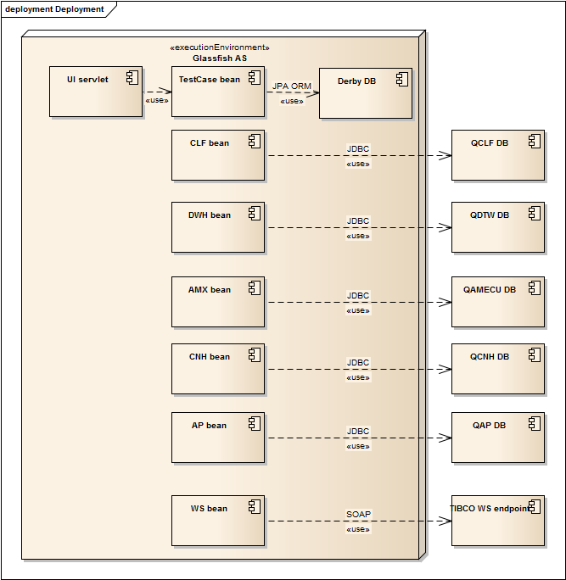

Figure - Deployment

### Test case administration

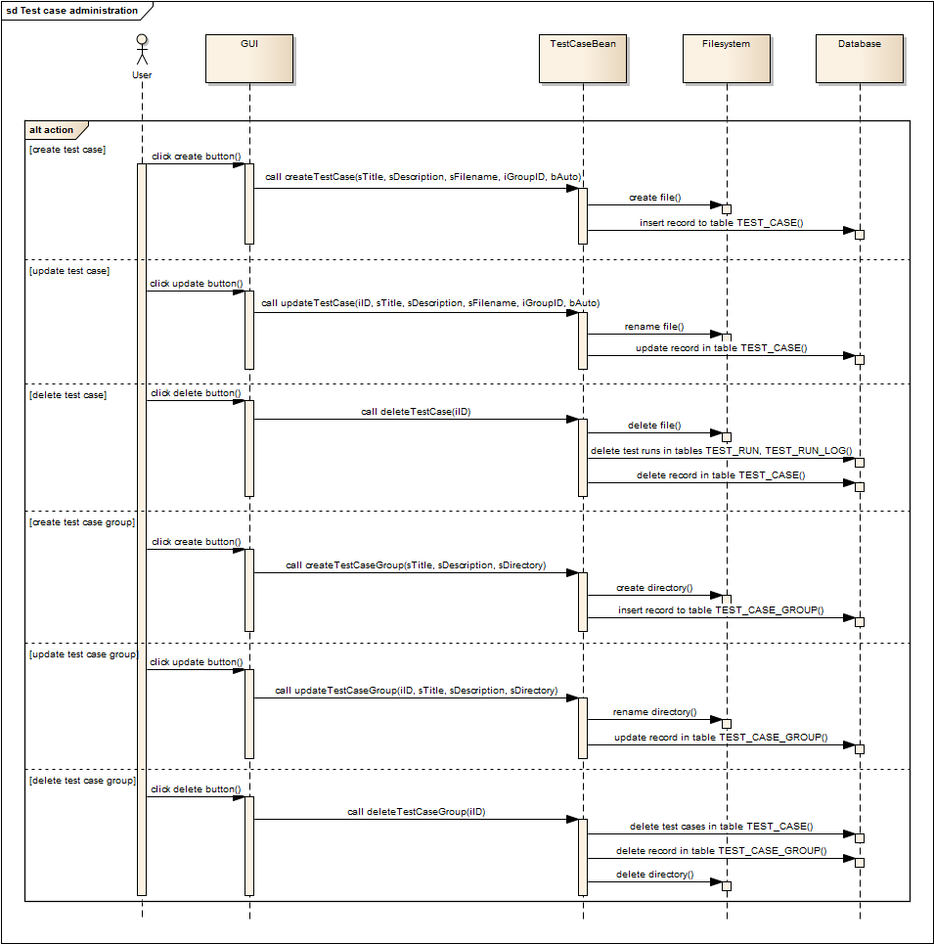

Figure - Test case administration

### Test case execution

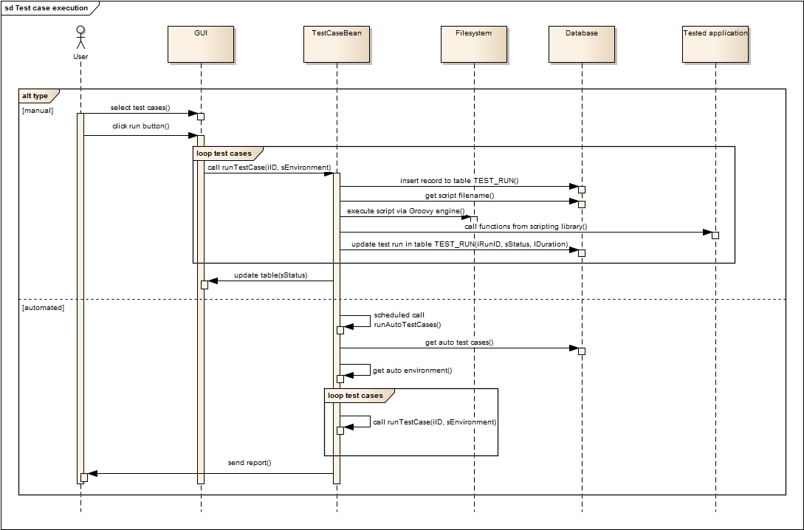

Figure - Test case execution

## Class diagrams

### Utilities

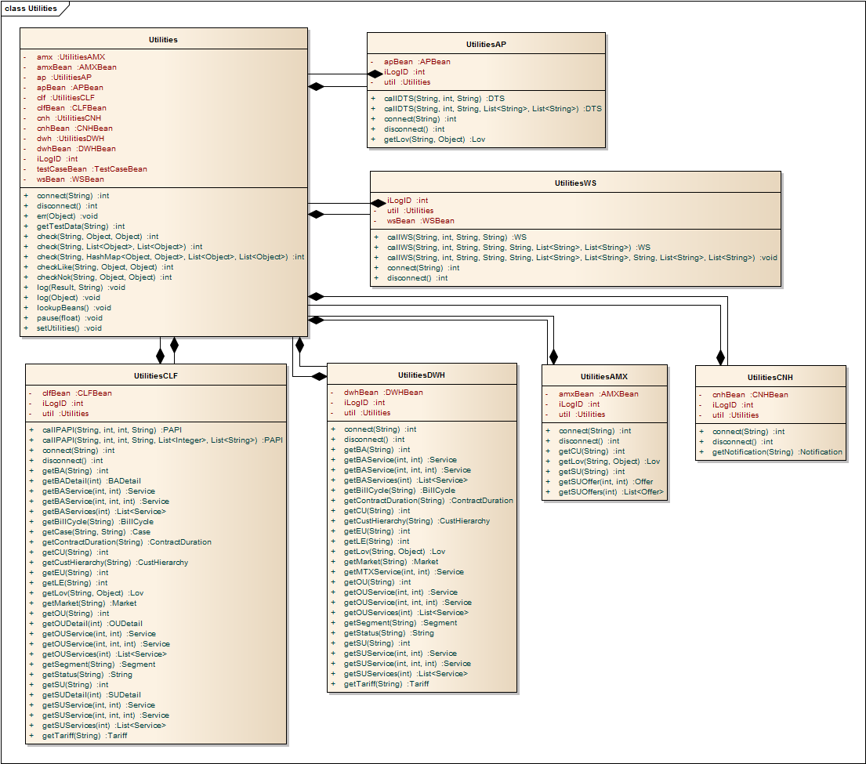

Figure - Utilities

### Beans

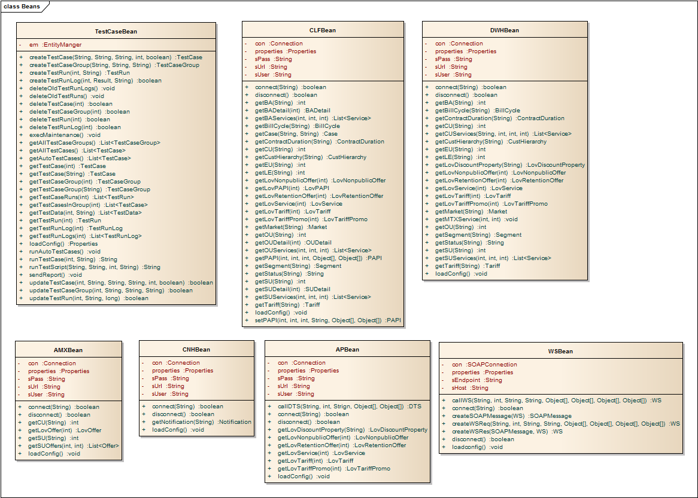

Figure - Beans

### Database model

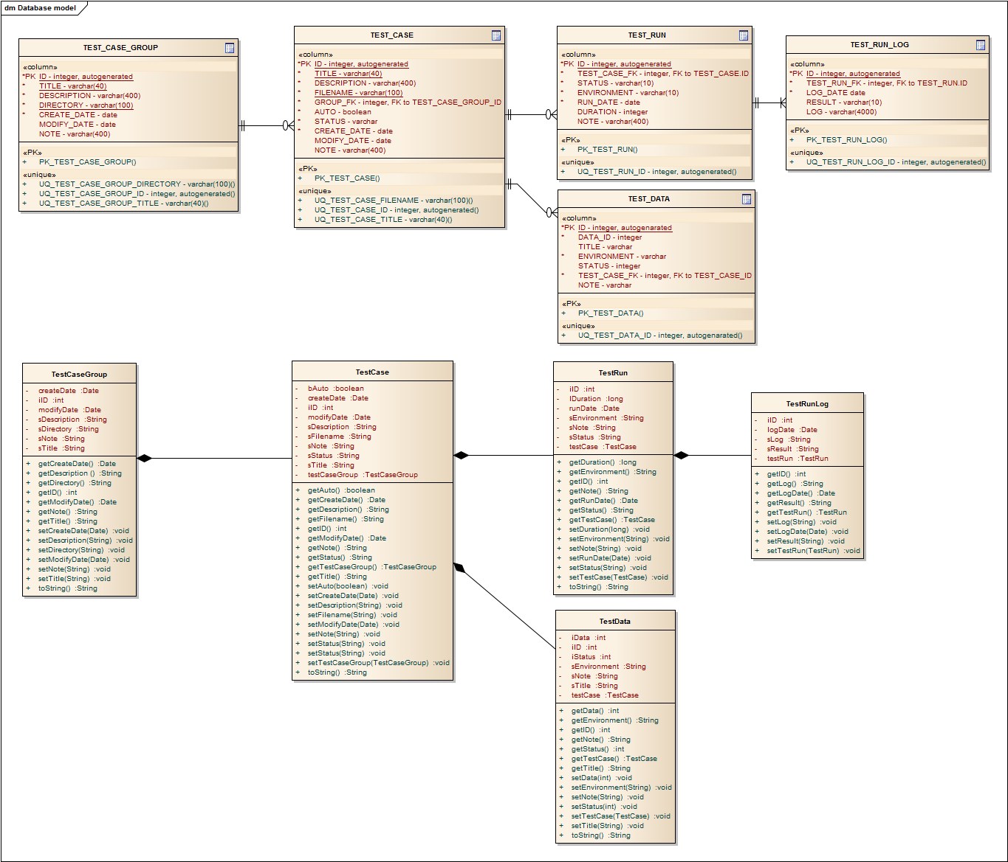

Figure - Database model

### Customer structure

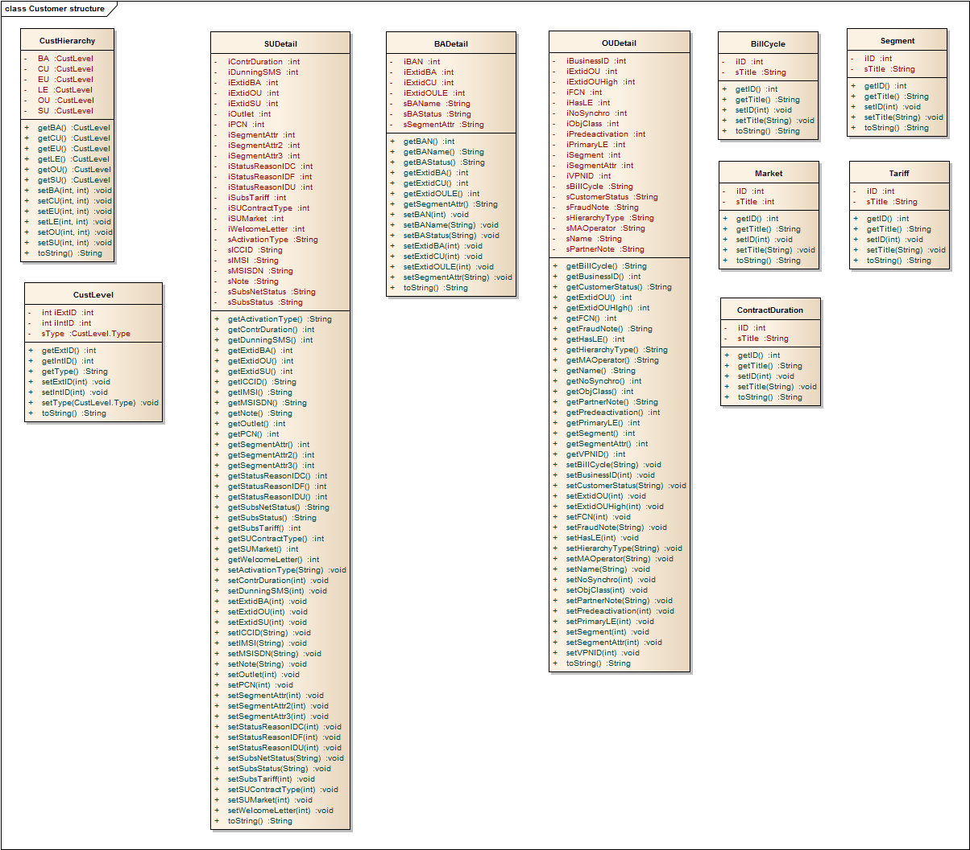

Figure - Customer structure

### Services

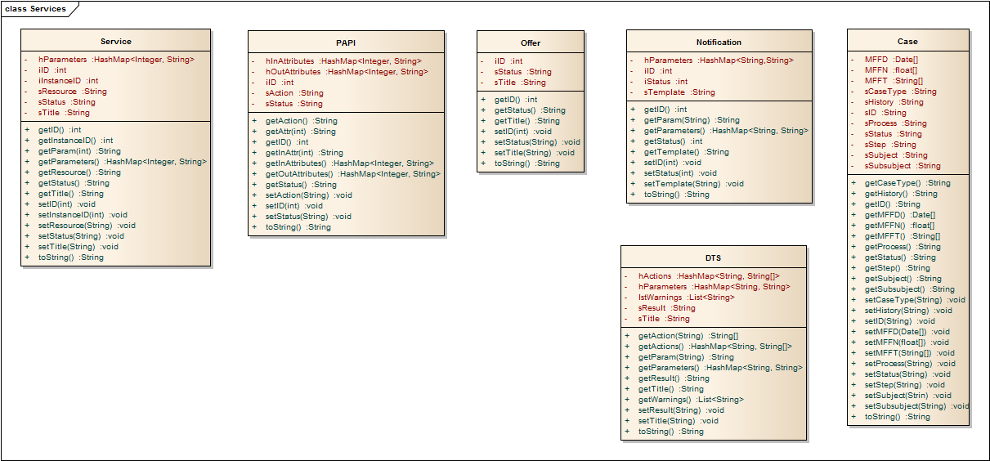

Figure - Services

### Business services

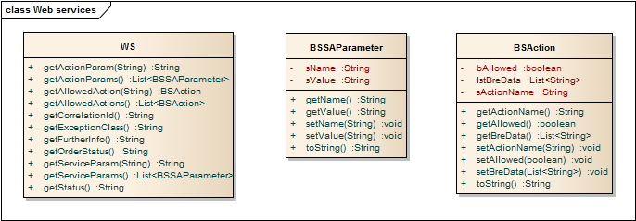

Figure - Web services

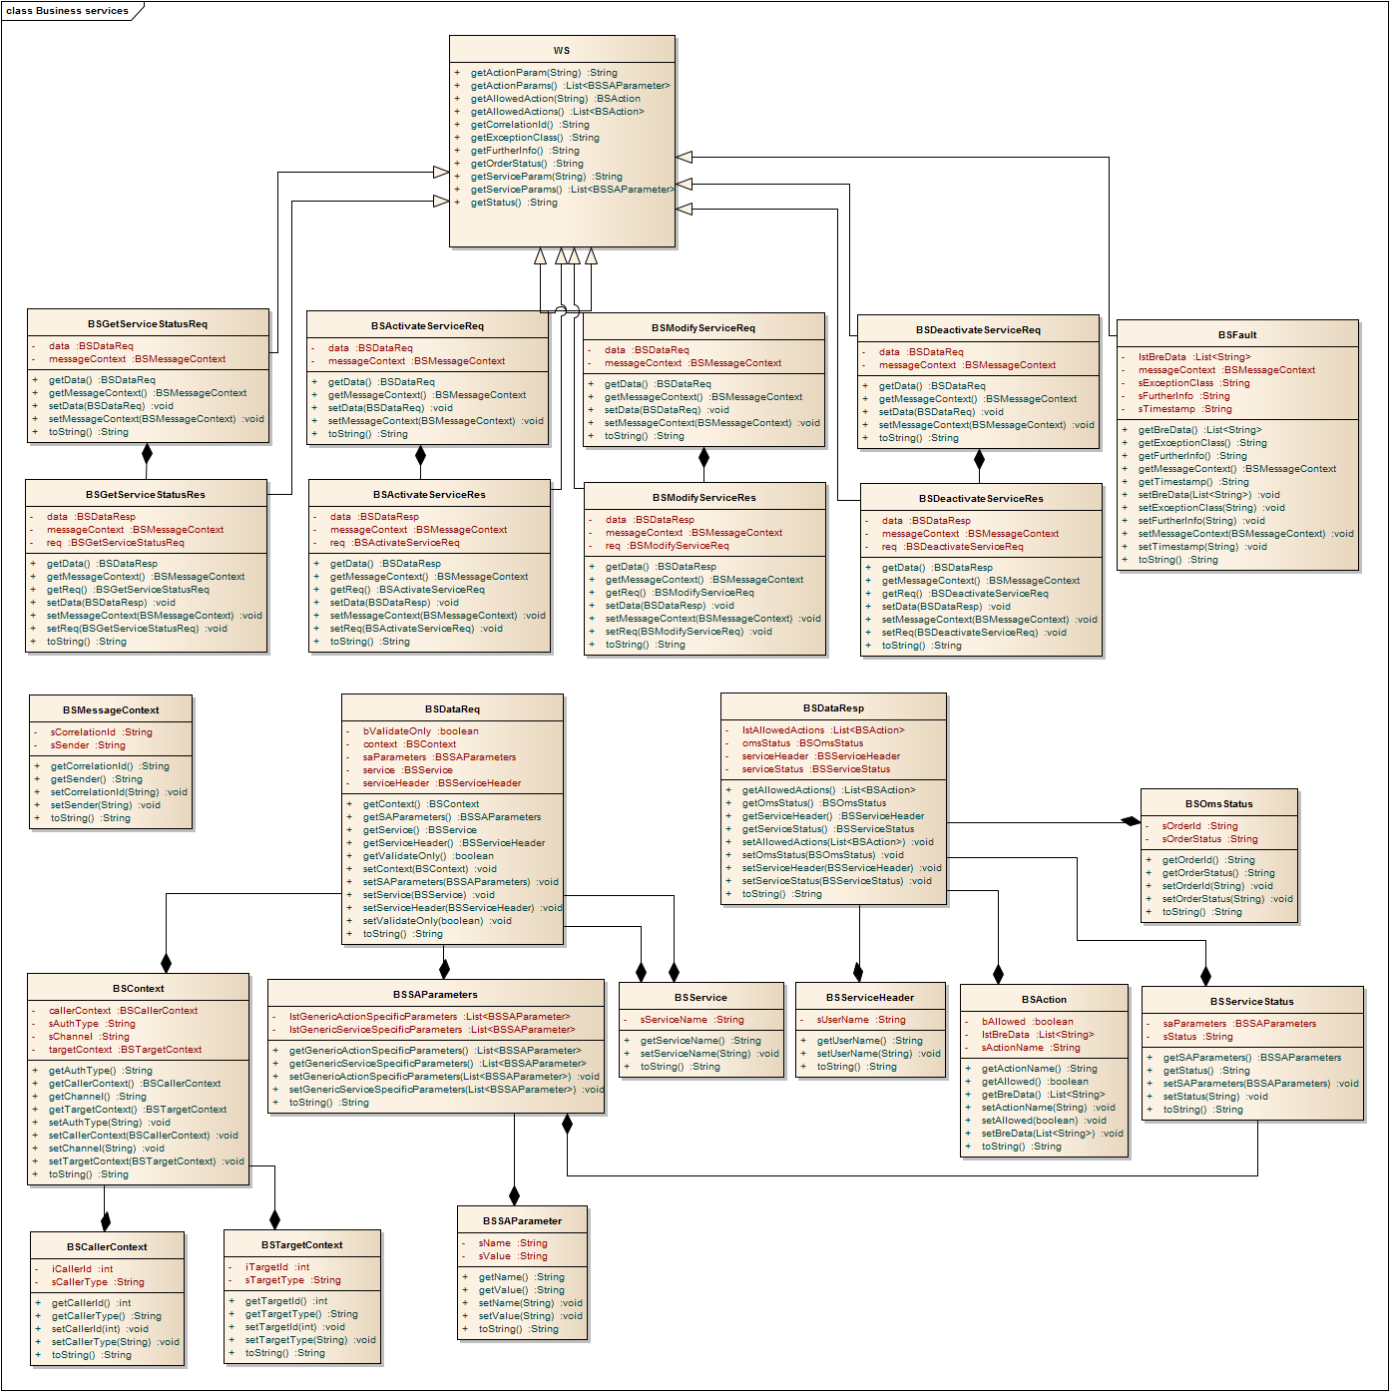

Figure - Business services

### LOV

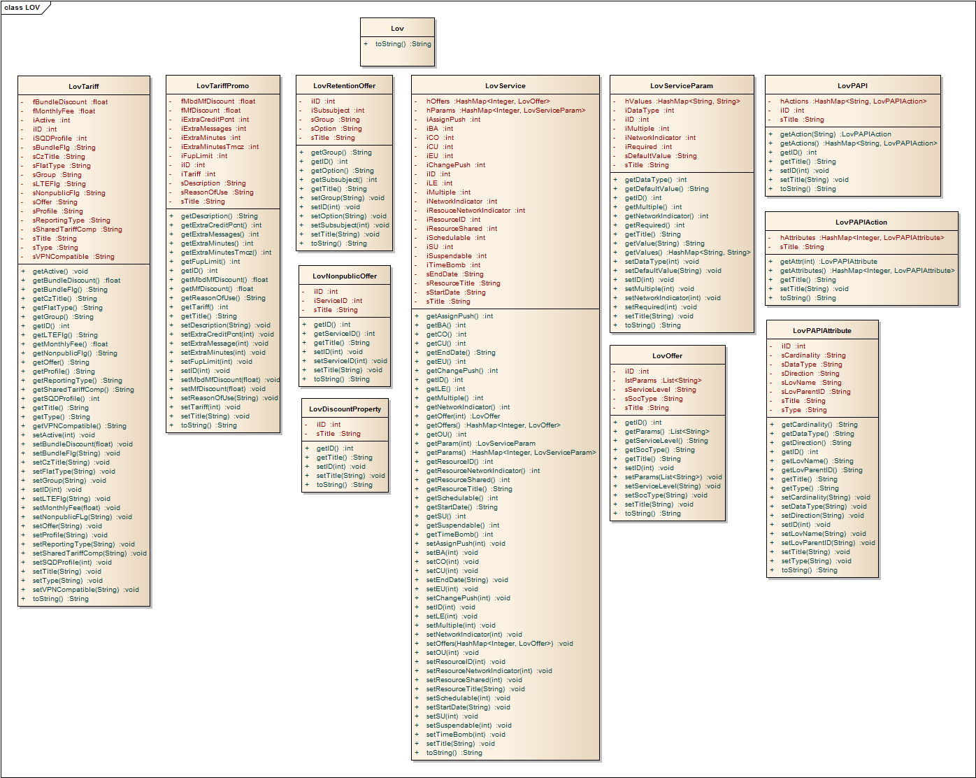

Figure - LOV

### Properties

|  |  |
| --- | --- |
| **Name** | **Value** |
| testCasesPath | /home/lynus/private/autotester/tests/ |
| testCaseSuffix | .groovy |
| autoEnvironment | TEST 1 |
| test1 | TEST 1 |
| test1CLFUrl | jdbc:oracle:thin:@rztclt13.cz.tmo:1526/QCLF12.world |
| test1CLFUser | APPTEST |
| test1CLFPass | ittc |
| test1DWHUrl | jdbc:oracle:thin:@rztdtwt.cz.tmo:1580/QDTW2.world |
| test1DWHUser | APPTEST |
| test1DWHPass | ittc |
| test1APUrl | jdbc:oracle:thin:@rztapt.cz.tmo:1584/QAP01.world |
| test1APUser | TIBUSR |
| test1APPass | tibco |
| test1CNHUrl | jdbc:oracle:thin:@hkpow104.cz.tmo:1529/QCNH01.world |
| test1CNHUser | APPTEST |
| test1CNHPass | ittc |
| test1AMXUrl | jdbc:oracle:thin:@hkpowm02.cz.tmo:1520/QAMECU01.world |
| test1AMXUser | TMCDB2 |
| test1AMXPass | TMCDB2 |
| test1TIBCO | http://hktibt1.cz.tmo:9990 |
| testWSEndpoint | /WebServices/SA/SA.serviceagent/SaPortTypeEndpoint |
| test2 | TEST 2 |
| test2CLFUrl | jdbc:oracle:thin:@rztclt14.cz.tmo:1626/Q2CLF12.world |
| test2CLFUser | APPTEST |
| test2CLFPass | ittc |
| test2DWHUrl | jdbc:oracle:thin:@hkpowm03.cz.tmo:1680/Q2DTW2.world |
| test2DWHUser | APPTEST |
| test2DWHPass | ittc |
| test2APUrl | jdbc:oracle:thin:@hkpowm03.cz.tmo:1684/Q2AP01.world |
| test2APUser | TIBUSR |
| test2APPass | tibco |
| test2CNHUrl | jdbc:oracle:thin:@hkpow104.cz.tmo:1529/QCNH01.world |
| test2CNHUser | APPTEST |
| test2CNHPass | ittc |
| test2AMXUrl | jdbc:oracle:thin:@hkpowm02.cz.tmo:1520/QAMECU01.world |
| test2AMXUser | TMCDB2 |
| test2AMXPass | TMCDB2 |
| test2TIBCO | http://hktibt2.cz.tmo:9990 |

Table – Properties

## Maintenance

Logfiles older than 30 days are deleted. This is implemented using log4j configuration.

Records in tables TEST_RUN and TEST_RUN_LOG older than 1 month are deleted. Function execMaintenance is scheduled to 23:15.