Computer Architecture Lab
(EL-2012)
LABORATORY REPORT

Fall 2026

(Lab#1)
Computer Architecture Lab

Student Name: HAIDER IRFAN Roll No: 24I-6505 Section: A

Date performed: August 18, 2026

MARKS AWARDED: ________ / 10

Signature and date of Instructor: _________________
Lab Instructors: Dr. Nasir Ali Shah, Engr. Fasih Ahmad

______________________________________________________________________________________________________________________________________________________

NATIONAL UNIVERSITY OF COMPUTER AND EMERGING SCIENCES, ISLAMABAD
Prepared by: | Fasih Ahmad |  | Version: 1.0
Verified by: | Dr. Nasir Ali Shah |  | Updated: Fall 2026

Task 1:

Description:
In this task, I wrote Verilog codes for all the basic gates using structural modelling. I verified the results by running the waveform simulations. The NOT gate is different as it only has one input and one output.

Code:
AND:

module LogicGates(a, b, c);

input a;
input b;

output c;

and a1(c, a, b); // in this gate func, output comes first in paramters

endmodule

module testbench(); // dont pass any parameter in test bench
reg x;
reg y;
wire z;

LogicGates uut (x,y,z);

initial
begin
x = 0; y = 0;
#50 x = 0; y = 1;
#50 x = 1; y = 0;
#50 x = 1; y = 1;

end

endmodule

OR:

module LogicGates(a, b, c);

input a;
input b;

output c;

or a1(c, a, b); // in this gate func, output comes first in paramters

endmodule

module testbench(); // dont pass any parameter in test bench
reg x;
reg y;
wire z;

LogicGates uut (x,y,z);

initial
begin
x = 0; y = 0;
#50 x = 0; y = 1;
#50 x = 1; y = 0;
#50 x = 1; y = 1;

end

endmodule

NOT:
module LogicGates(a, z);

input a;

output z;

not a1(z, a); // in this gate func, output comes first in paramters

endmodule

module testbench(); // dont pass any parameter in test bench
reg x;
wire z;

LogicGates uut (x,z);

initial
begin
x = 0;
#50 x = 1;

end

endmodule

Output:
AND:
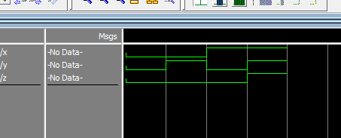
OR:
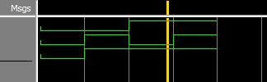
NOT:
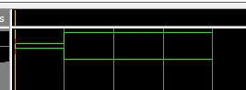

Task 2:

Description:
In this task, I wrote Verilog codes for basic gates in dataflow flow modeling, using the ‘assign’ keywords. The results were verified using a module known as testbench, simulations of which were shown.

Code:
AND:
module LogicGates(a, b, c);

input a;
input b;

output c;

assign c = a & b;

endmodule

module testbench(); // dont pass any parameter in test bench
reg x;
reg y;
wire z;

LogicGates uut (x,y,z);

initial
begin
x = 0; y = 0;
#50 x = 0; y = 1;
#50 x = 1; y = 0;
#50 x = 1; y = 1;

end

endmodule

OR:
module LogicGates(a, b, c);

input a;
input b;

output c;

assign c = a | b;

endmodule

module testbench(); // dont pass any parameter in test bench
reg x;
reg y;
wire z;

LogicGates uut (x,y,z);

initial
begin
x = 0; y = 0;
#50 x = 0; y = 1;
#50 x = 1; y = 0;
#50 x = 1; y = 1;

end

endmodule

NOT:
module LogicGates(a, b);

input a;

output b;

assign b = ~a;

endmodule

module testbench(); // dont pass any parameter in test bench
reg x;

wire z;

LogicGates uut (x,z);

initial
begin
x = 0;
#50 x = 1;
#50 x = 0;
#50 x = 1;

end

endmodule

Output:
AND :
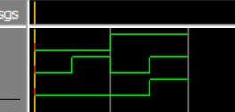
OR:
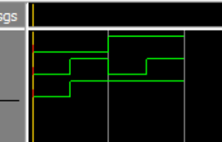
NOT:
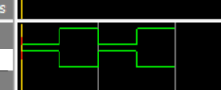

Task 3:

Description:
In this task, I tested the basic logic gates on Logism, checking which input combinations lead to a true output. An AND gate gives a true output if both inputs are true. An OR gate gives a true output even if one input is true. The NOT gate inverts the truth state of the input.

Screenshots:
AND:
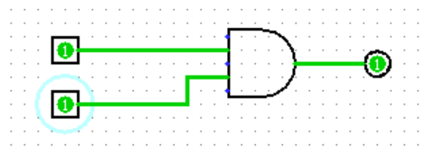
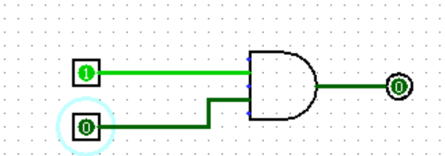
OR:
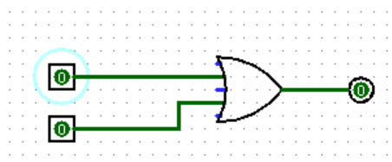
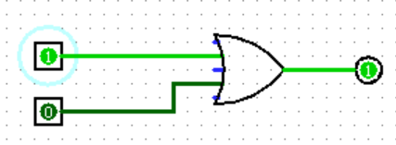
NOT:
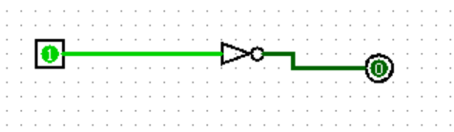
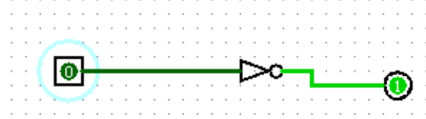

Task 4:

Description:
In this task, we had to represent the behavior of an XOR gate using Verilog code, specifically gate level and data flow modelling.

Code:
GATE LEVEL MODELLING:
module LogicGates(a, b, c);

input a;
input b;

output c;

// in this gate func, output comes first in paramters
wire nota;
wire notb;
wire and1;
wire and2;

not n1(nota, a);
not n2(notb, b);

and a1(and1, nota, b);
and a2(and2, notb, a);

or ans(c, and1, and2);

endmodule

module testbench(); // dont pass any parameter in test bench
reg x;
reg y;
wire z;

LogicGates uut (x,y,z);

initial
begin
x = 0; y = 0;
#50 x = 0; y = 1;
#50 x = 1; y = 0;
#50 x = 1; y = 1;

end

endmodule

DATA FLOW MODELLING:

module LogicGates(a, b, c);

input a;
input b;

output c;

assign c = (a*(~b)) + ((~a)*b);

endmodule

module testbench(); // dont pass any parameter in test bench
reg x;
reg y;
wire z;

LogicGates uut (x,y,z);

initial
begin
x = 0; y = 0;
#50 x = 0; y = 1;
#50 x = 1; y = 0;
#50 x = 1; y = 1;

end

endmodule

Output:
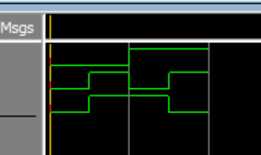

Task 5:

Description:
In this task, we had to construct the given circuit in Logism, and then observe its behavior. The circuit turned out to have the behavior of an XOR gate, representing its Boolean equation.

Output:
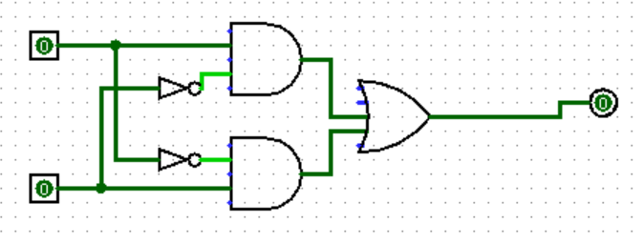
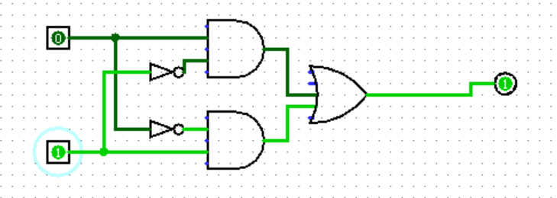
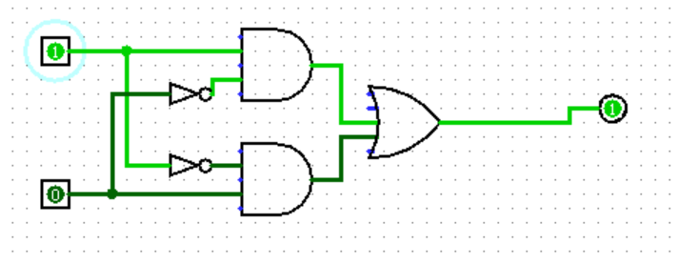
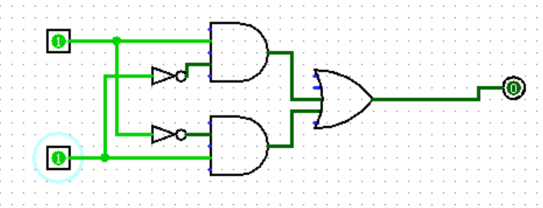

Task 6:

Description:
In this task, we had to write and simulate Verilog code to find the 1’s complement of 4 binary bits using gate level and data flow modelling. The idea of 4 NOT gates is used to flip each bit individually. The testbench is used to give different input combinations and the input and output bits have been arranged conveniently in the waveform for better observation.

Code:
USING GATE LEVEL MODELLING:
module onescompliment(a, b, c, d, nota, notb, notc, notd);

input a;
input b;
input c;
input d;

output nota;
output notb;
output notc;
output notd;

not n1(nota, a);
not n2(notb, b);
not n3(notc, c);
not n4(notd, d);

endmodule

module testbench(); // dont pass any parameter in test bench
reg a;
reg b;
reg c;
reg d;

wire nota;
wire notb;
wire notc;
wire notd;

onescompliment uut (a, b, c, d, nota, notb, notc, notd);

initial
begin
a = 0; b = 0; c = 0; d = 0;
#50 a = 1; b = 0; c = 0; d = 0;
#50 a = 1; b = 1; c = 0; d = 0;
#50 a = 1; b = 1; c = 1; d = 0;
#50 a = 1; b = 1; c = 1; d = 1;
end

endmodule

USING DATA FLOW MODELLING:

module onescompliment(a, b, c, d, nota, notb, notc, notd);

input a;
input b;
input c;
input d;

output nota;
output notb;
output notc;
output notd;

assign nota = ~a;
assign notb = ~b;
assign notc = ~c;
assign notd = ~d;

endmodule

module testbench(); // dont pass any parameter in test bench
reg a;
reg b;
reg c;
reg d;

wire nota;
wire notb;
wire notc;
wire notd;

onescompliment uut (a, b, c, d, nota, notb, notc, notd);

initial
begin
a = 0; b = 0; c = 0; d = 0;
#50 a = 1; b = 0; c = 0; d = 0;
#50 a = 1; b = 1; c = 0; d = 0;
#50 a = 1; b = 1; c = 1; d = 0;
#50 a = 1; b = 1; c = 1; d = 1;
end

endmodule

Output:
USING GATE LEVEL MODELLING:
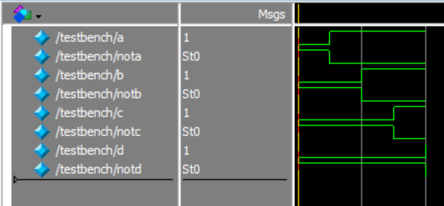
USING DATA FLOW MODELLING:

