Computer Architecture Lab
(EL-2012)
LABORATORY REPORT

Fall 2026

(Lab#2)
Combinational Circuits Using Verilog

Student Name: HAIDER IRFAN Roll No: 24I-6505 Section: A

Date performed: August 25, 2026

MARKS AWARDED: ________ / 10

Signature and date of Instructor: _________________
Lab Instructors: Dr. Nasir Ali Shah, Engr. Fasih Ahmad

______________________________________________________________________________________________________________________________________________________

NATIONAL UNIVERSITY OF COMPUTER AND EMERGING SCIENCES, ISLAMABAD
Prepared by: | Fasih Ahmad |  | Version: 1.0
Verified by: | Dr. Nasir Ali Shah |  | Updated: Fall 2026

Task 1:

Description:
In this task, I made a half adder and used two of those modules to make a full adder, which is a bottom-up approach. The second half adder’s inputs were an external cin and the sum of the first half adder. The outputs gave a final sum and a carry out. These were simulated using a testbench and also designed on Logisim.

Code:
GATE LEVEL MODELLING:
module ha1(sum,carry,a,b);

input a,b;
output sum,carry;

xor(sum,a,b);
and(carry,a,b);

endmodule

module ha2(sum,carry,a,b);

input a,b;
output sum,carry;

xor(sum,a,b);
and(carry,a,b);

endmodule

module fa(SUM,cout,a,b,cin);

input a,b,cin;
output SUM,cout;

ha1 h1(sum1,c1,a,b);
ha2 h2(SUM,c2,sum1,cin);
or(cout,c1,c2);

endmodule

module testbench(); // dont pass any parameter in test bench

reg a;
reg b;
reg cin;

wire SUM;
wire cout;

fa uut(SUM,cout,a,b,cin);

initial
begin

a = 0; b = 0; cin = 0;
#50 a = 0; b = 0; cin = 1;
#50 a = 0; b = 1; cin = 0;
#50 a = 0; b = 1; cin = 1;
#50 a = 1; b = 0; cin = 0;
#50 a = 1; b = 0; cin = 1;
#50 a = 1; b = 1; cin = 0;
#50 a = 1; b = 1; cin = 1;

end

endmodule
DATAFLOW LEVEL MODELLING:
module ha1(sum,carry,a,b);

input a,b;
output sum,carry;

assign sum = a ^ b;
assign carry = a & b;

endmodule

module ha2(sum,carry,a,b);

input a,b;
output sum,carry;

assign sum = a ^ b;
assign carry = a & b;

endmodule

module fa(SUM,cout,a,b,cin);

input a,b,cin;
output SUM,cout;

ha1 h1(sum1,c1,a,b);
ha2 h2(SUM,c2,sum1,cin);
assign cout = c1 + c2;

endmodule

module testbench(); // dont pass any parameter in test bench

reg a;
reg b;
reg cin;

wire SUM;
wire cout;

fa uut(SUM,cout,a,b,cin);

initial
begin

a = 0; b = 0; cin = 0;
#50 a = 0; b = 0; cin = 1;
#50 a = 0; b = 1; cin = 0;
#50 a = 0; b = 1; cin = 1;
#50 a = 1; b = 0; cin = 0;
#50 a = 1; b = 0; cin = 1;
#50 a = 1; b = 1; cin = 0;
#50 a = 1; b = 1; cin = 1;

end

endmodule

Logisim Circuit:
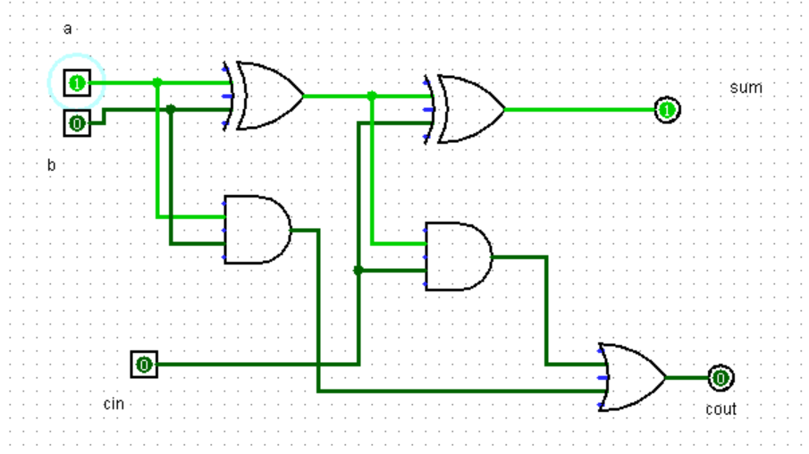
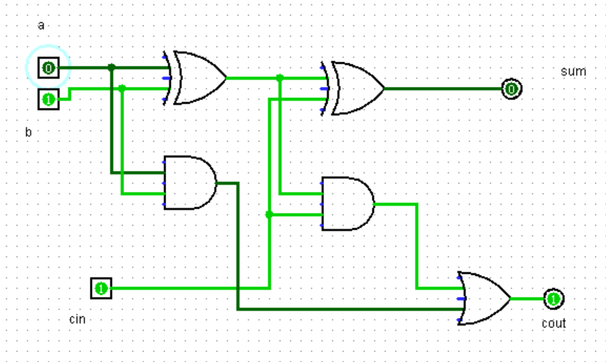
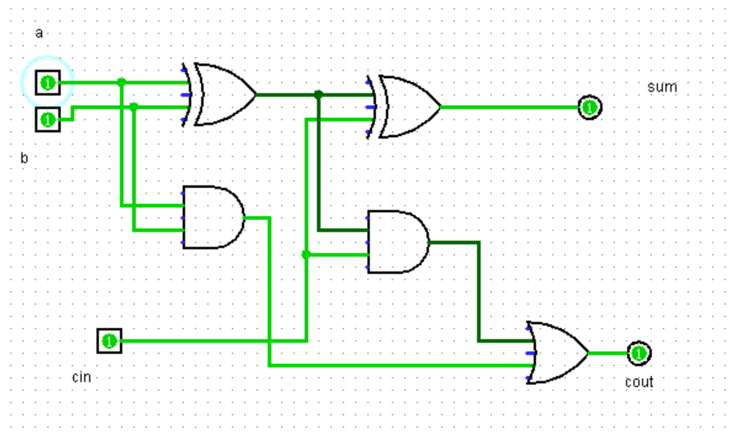
Output:
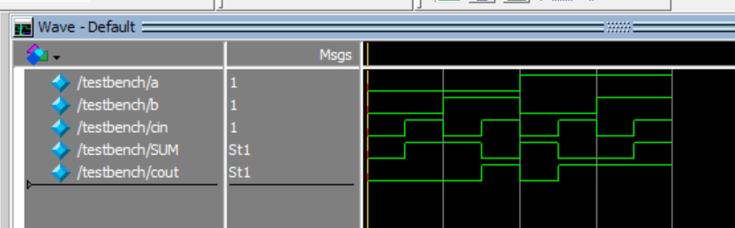

Task 2:

Description:
In this task, I had to make a 3x8 decoder for which I made a truth table first and found out the minterm combination for each output. I then replicated the combinations in Verilog with both gate level and dataflow level modelling. Similarly, the circuit was constructed in Logisim as well.

Code:
GATE LEVEL MODELLING:

module decoder(y0,y1,y2,y3,y4,y5,y6,y7,a,b,c);

input a,b,c;
output y0,y1,y2,y3,y4,y5,y6,y7;

wire nota;
wire notb;
wire notc;

not(nota,a);
not(notb,b);
not(notc,c);

and(y0,nota,notb,notc);
and(y1,nota,notb,c);
and(y2,nota,b,notc);
and(y3,nota,b,c);
and(y4,a,notb,notc);
and(y5,a,notb,c);
and(y6,a,b,notc);
and(y7,a,b,c);

endmodule

module testbench(); // dont pass any parameter in test bench

reg a;
reg b;
reg c;

wire y0;
wire y1;
wire y2;
wire y3;
wire y4;
wire y5;
wire y6;
wire y7;

decoder uut(y0,y1,y2,y3,y4,y5,y6,y7,a,b,c);

initial
begin

a = 0; b = 0; c = 0;
#50 a = 0; b = 0; c = 1;
#50 a = 0; b = 1; c = 0;
#50 a = 0; b = 1; c = 1;
#50 a = 1; b = 0; c = 0;
#50 a = 1; b = 0; c = 1;
#50 a = 1; b = 1; c = 0;
#50 a = 1; b = 1; c = 1;

end

endmodule

DATAFLOW LEVEL MODELLING:

module decoder(y0,y1,y2,y3,y4,y5,y6,y7,a,b,c);

input a,b,c;
output y0,y1,y2,y3,y4,y5,y6,y7;

wire nota;
wire notb;
wire notc;

assign nota = ~a;
assign notb = ~b;
assign notc = ~c;

assign y0 = nota & notb & notc;
assign y1 = nota & notb & c;
assign y2 = nota & b & notc;
assign y3 = nota & b & c;
assign y4 = a & notb & notc;
assign y5 = a & notb & c;
assign y6 = a & b & notc;
assign y7 = a & b & c;

endmodule

module testbench(); // dont pass any parameter in test bench

reg a;
reg b;
reg c;

wire y0;
wire y1;
wire y2;
wire y3;
wire y4;
wire y5;
wire y6;
wire y7;

decoder uut(y0,y1,y2,y3,y4,y5,y6,y7,a,b,c);

initial
begin

a = 0; b = 0; c = 0;
#50 a = 0; b = 0; c = 1;
#50 a = 0; b = 1; c = 0;
#50 a = 0; b = 1; c = 1;
#50 a = 1; b = 0; c = 0;
#50 a = 1; b = 0; c = 1;
#50 a = 1; b = 1; c = 0;
#50 a = 1; b = 1; c = 1;

end

endmodule

Logisim Circuit:
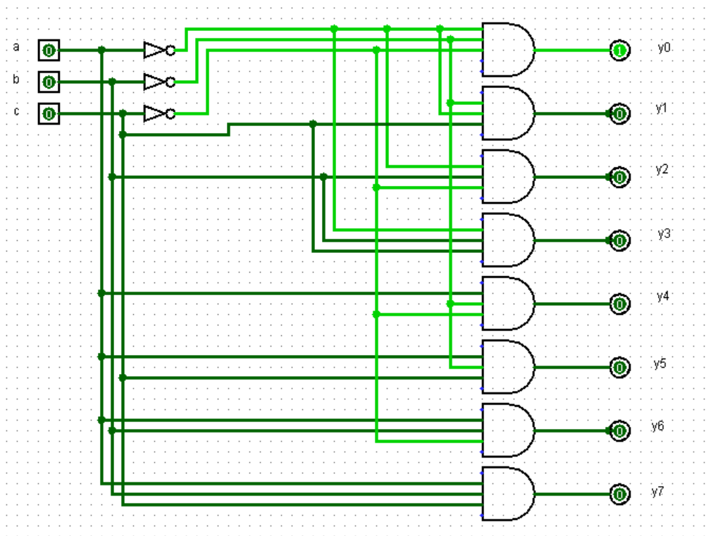
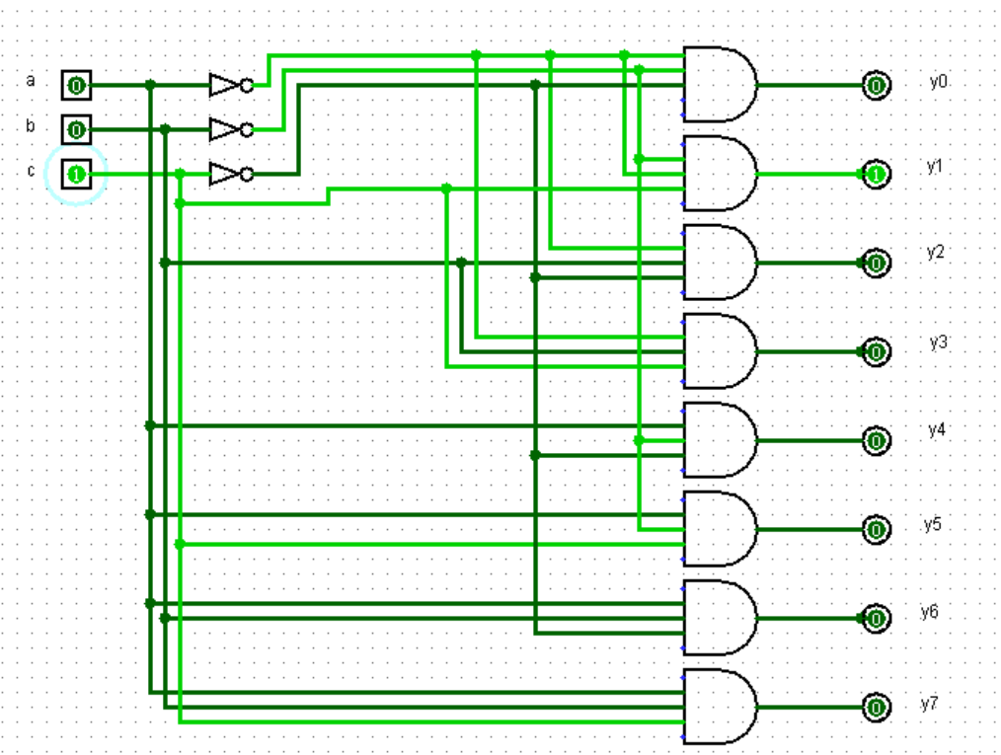

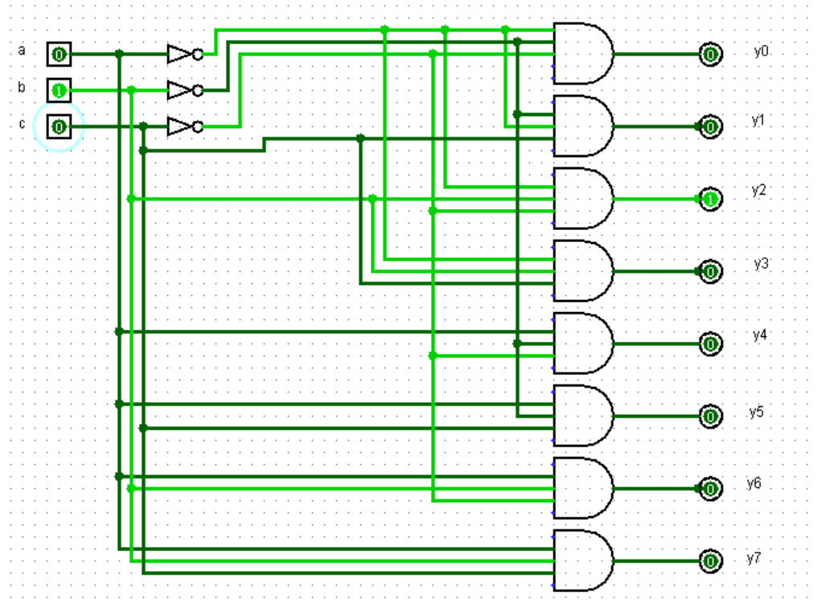

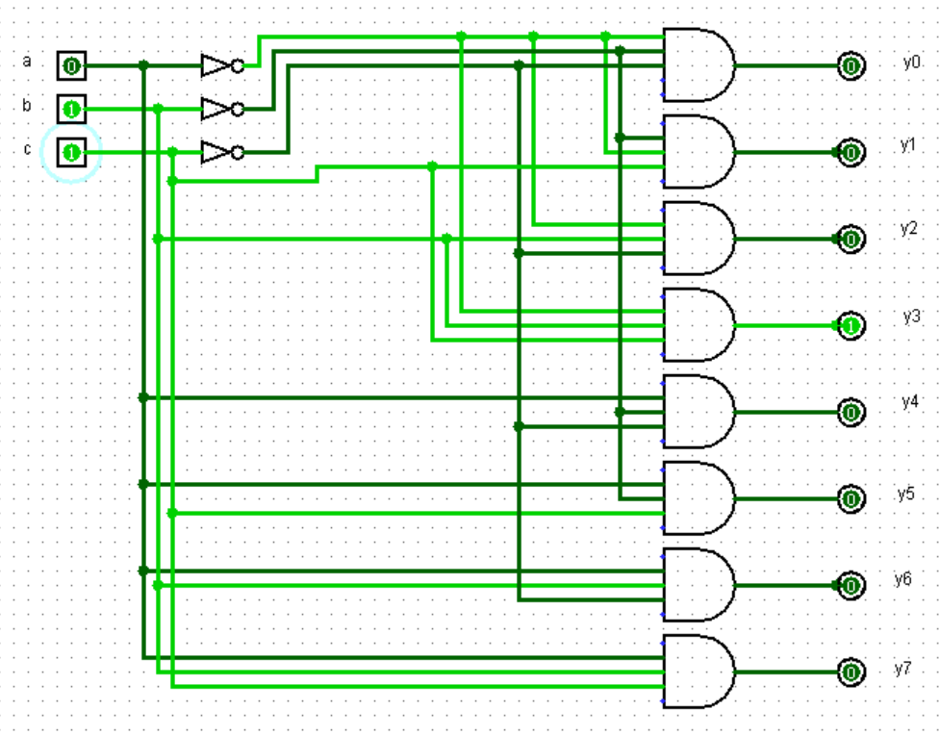
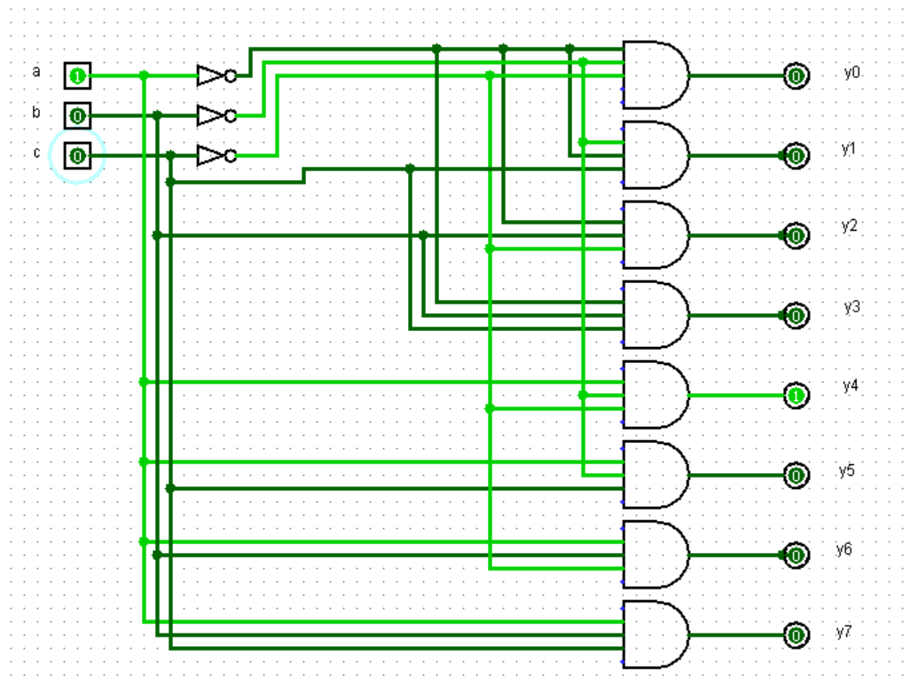
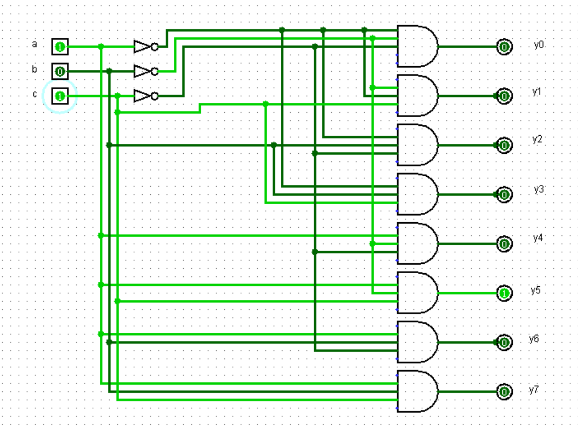
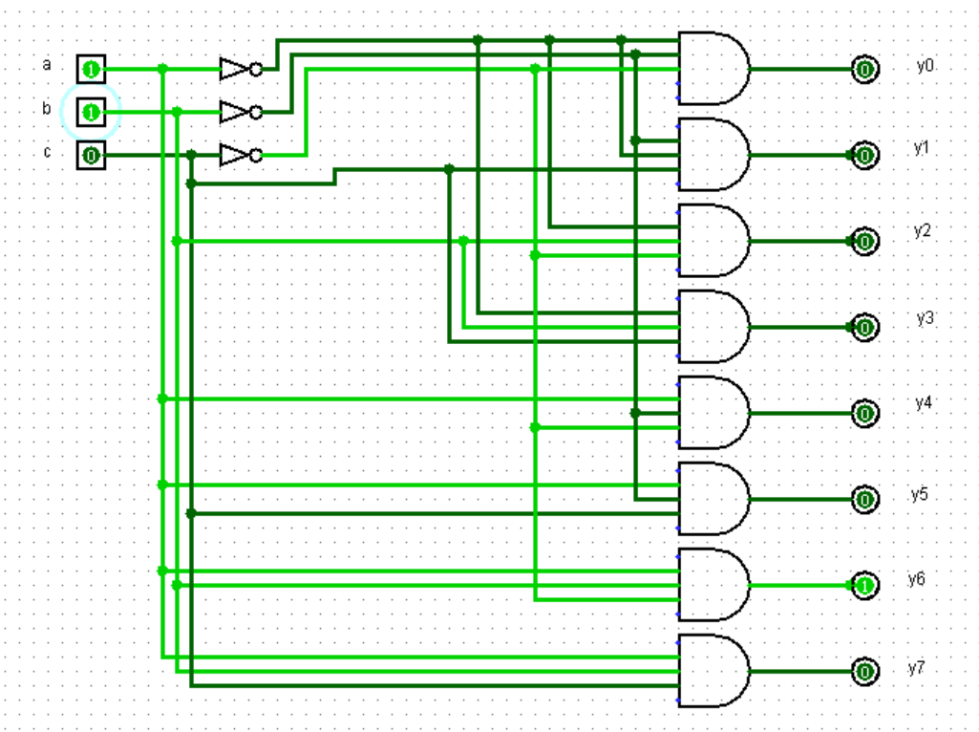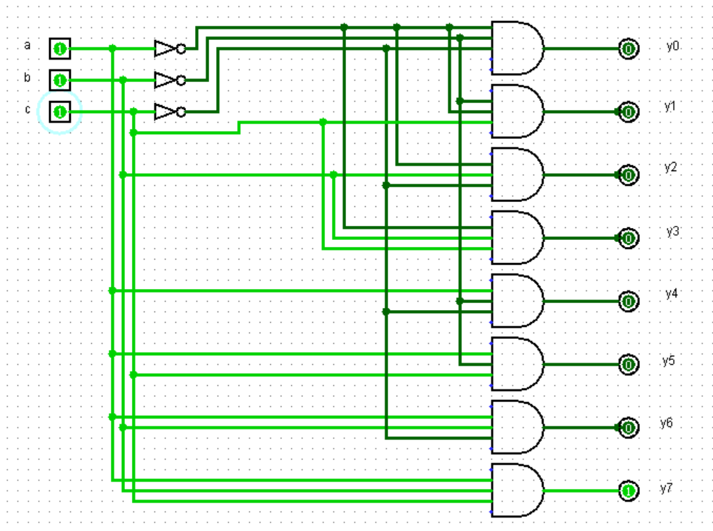

Output:
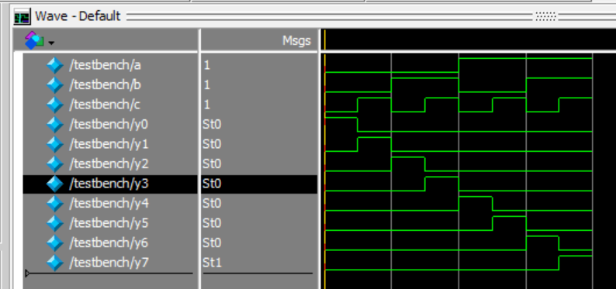

Task 3:

Description:
In this task, I had to make a 8x1 multiplexer which used three select lines to choose one out of 8 possible outputs. The combination of the select lines selected a different output each time. This was represent in Logisim and also simulated in Modelsim. The inputs were given supposed values to check whether the multiplexer worked properly.

Code:
GATE LEVEL MODELLING:
module multiplexer(y0,y1,y2,y3,y4,y5,y6,y7,a,b,c,z);

input a,b,c,y0,y1,y2,y3,y4,y5,y6,y7;
output z;

wire nota;
wire notb;
wire notc;

not(nota,a);
not(notb,b);
not(notc,c);

wire w0,w1,w2,w3,w4,w5,w6,w7;

and(w0,y0,nota,notb,notc);
and(w1,y1,nota,notb,c);
and(w2,y2,nota,b,notc);
and(w3,y3,nota,b,c);
and(w4,y4,a,notb,notc);
and(w5,y5,a,notb,c);
and(w6,y6,a,b,notc);
and(w7,y7,a,b,c);

or(z,w0,w1,w2,w3,w4,w5,w6,w7);

endmodule

module testbench(); // dont pass any parameter in test bench

reg a; // select lines
reg b;
reg c;

reg y0;
reg y1;
reg y2;
reg y3;
reg y4;
reg y5;
reg y6;
reg y7;

wire z;

multiplexer uut(y0,y1,y2,y3,y4,y5,y6,y7,a,b,c,z);

initial
begin

y0 = 0;
y1 = 0;
y2 = 1;
y3 = 1;
y4 = 0;
y5 = 0;
y6 = 1;
y7 = 0;

a = 0; b = 0; c = 0;
#50 a = 0; b = 0; c = 1;
#50 a = 0; b = 1; c = 0;
#50 a = 0; b = 1; c = 1;
#50 a = 1; b = 0; c = 0;
#50 a = 1; b = 0; c = 1;
#50 a = 1; b = 1; c = 0;
#50 a = 1; b = 1; c = 1;

end

endmodule

DATAFLOW LEVEL MODELLING:
module multiplexer(y0,y1,y2,y3,y4,y5,y6,y7,a,b,c,z);

input a,b,c,y0,y1,y2,y3,y4,y5,y6,y7;
output z;

wire nota;
wire notb;
wire notc;

assign nota = ~a;
assign notb = ~b;
assign notc = ~c;

wire w0,w1,w2,w3,w4,w5,w6,w7;

assign w0 = y0 & nota & notb & notc;
assign w1 = y1 & nota & notb & c;
assign w2 = y2 & nota & b & notc;
assign w3 = y3 & nota & b & c;
assign w4 = y4 & a & notb & notc;
assign w5 = y5 & a & notb & c;
assign w6 = y6 & a & b & notc;
assign w7 = y7 & a & b & c;

assign z = w0 + w1 + w2 + w3 + w4 + w5 + w5 + w6 + w7;

endmodule

module testbench(); // dont pass any parameter in test bench

reg a; // select lines
reg b;
reg c;

reg y0;
reg y1;
reg y2;
reg y3;
reg y4;
reg y5;
reg y6;
reg y7;

wire z;

multiplexer uut(y0,y1,y2,y3,y4,y5,y6,y7,a,b,c,z);

initial
begin

y0 = 0;
y1 = 0;
y2 = 1;
y3 = 1;
y4 = 0;
y5 = 0;
y6 = 1;
y7 = 0;

a = 0; b = 0; c = 0;
#50 a = 0; b = 0; c = 1;
#50 a = 0; b = 1; c = 0;
#50 a = 0; b = 1; c = 1;
#50 a = 1; b = 0; c = 0;
#50 a = 1; b = 0; c = 1;
#50 a = 1; b = 1; c = 0;
#50 a = 1; b = 1; c = 1;

end

endmodule

Logisim Circuit:
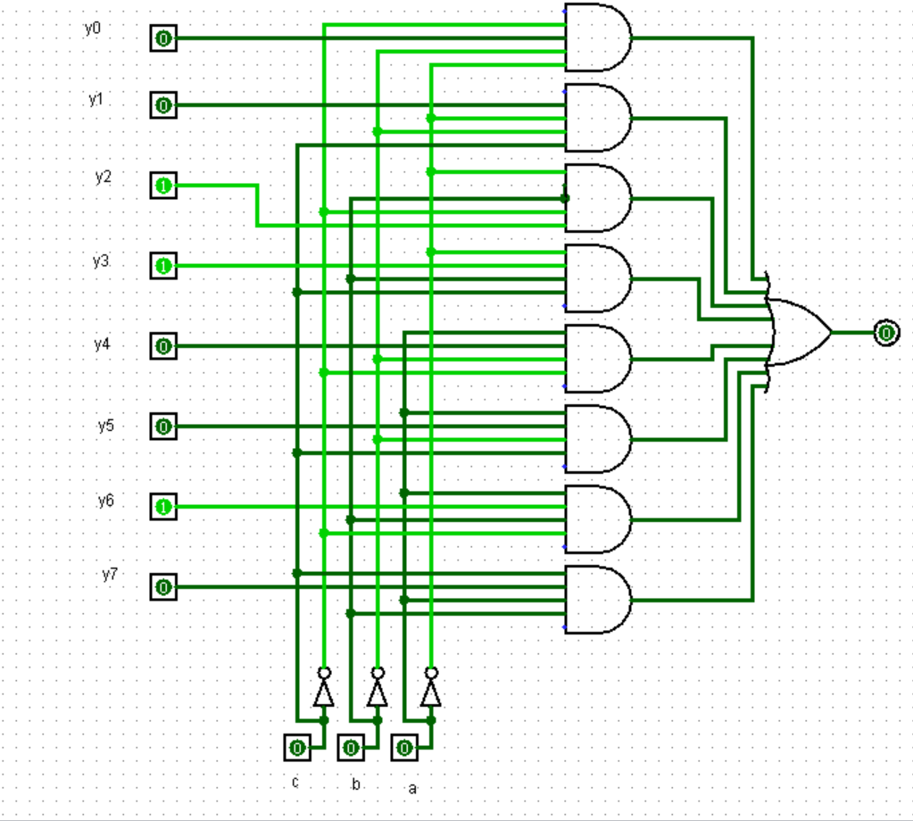
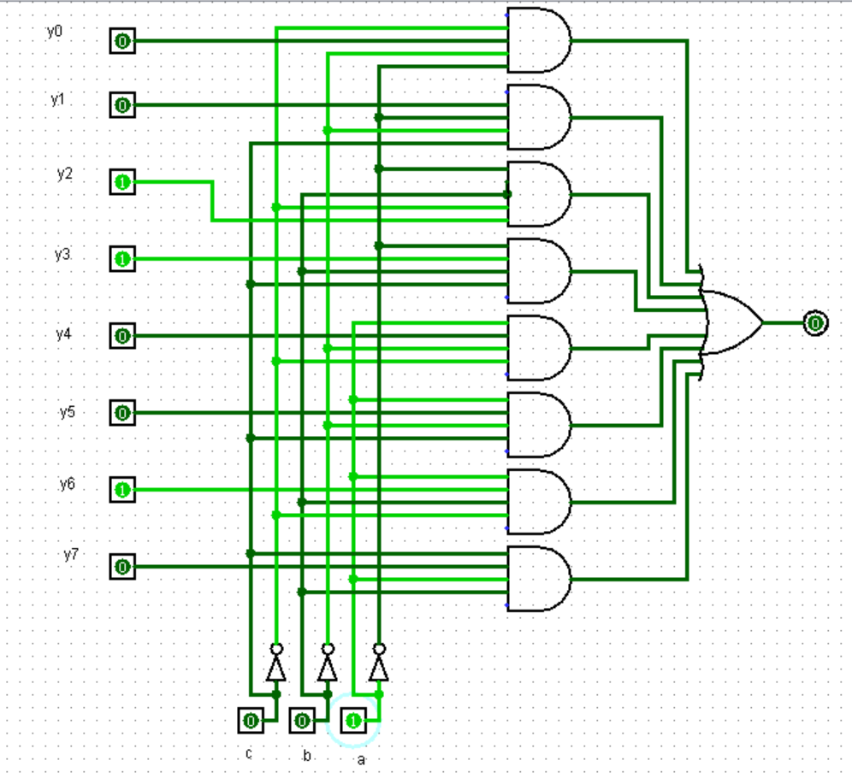
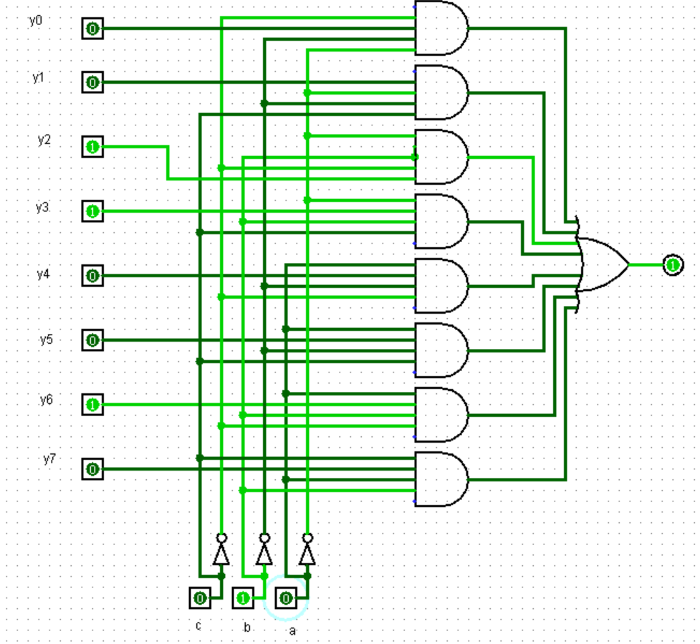

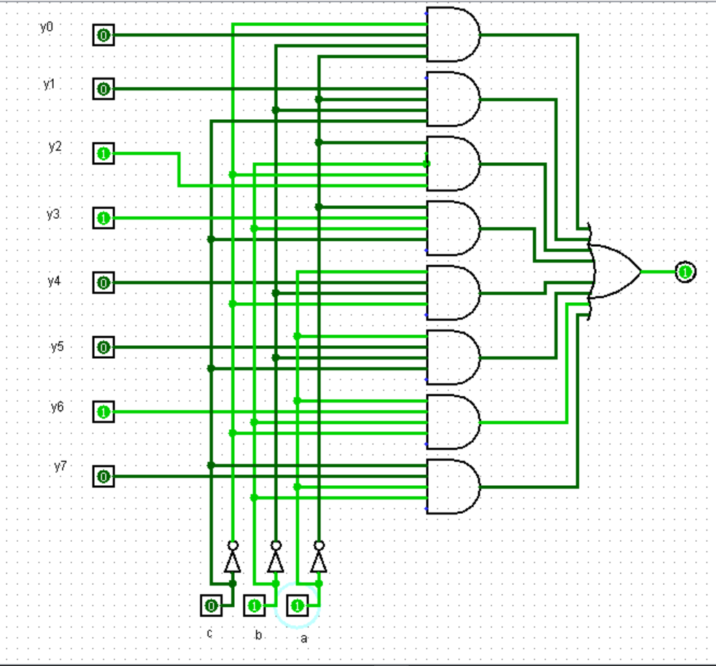
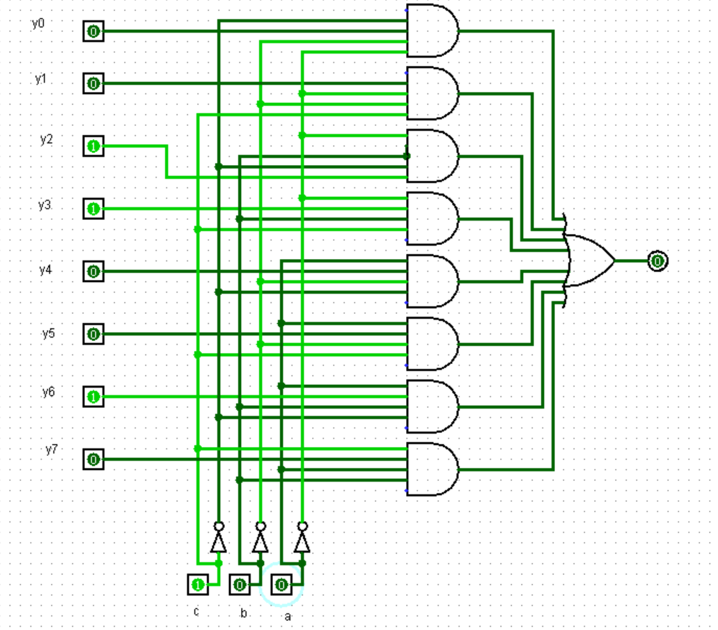
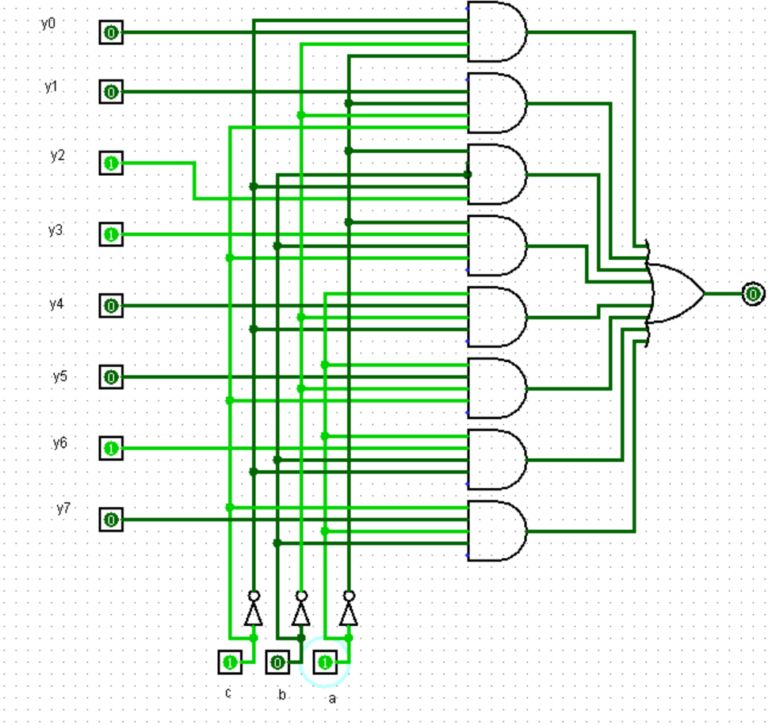
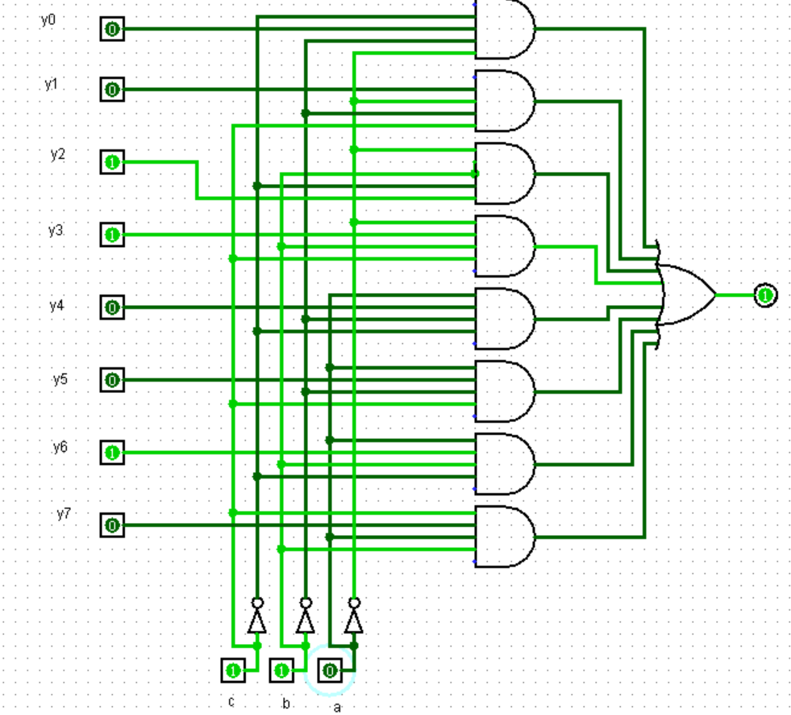
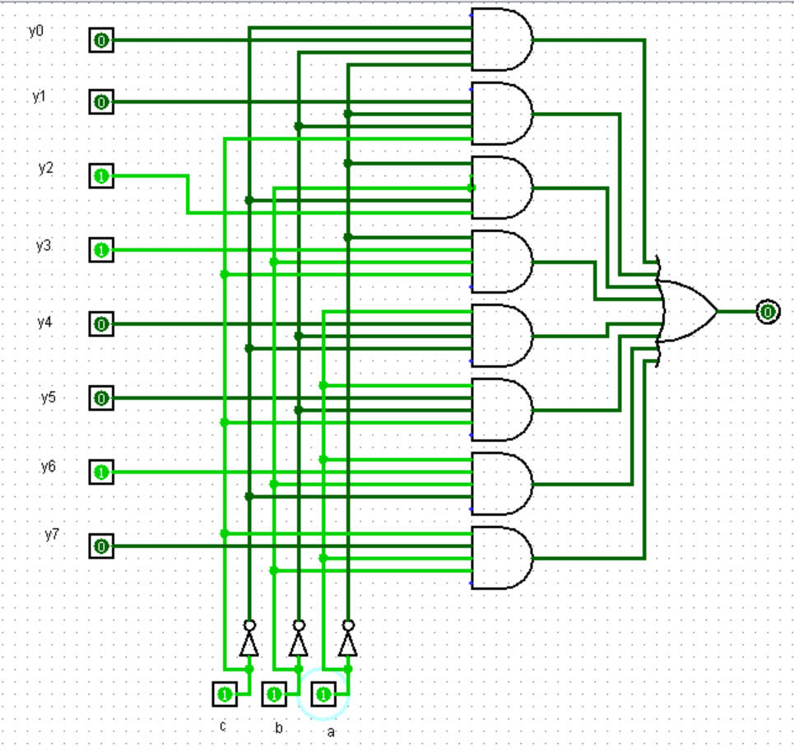
Output:
