Computer Architecture Lab
(EL-2012)
LABORATORY REPORT

Fall 2026

(Lab#3)
Behavioral-Level Verilog

Student Name: HAIDER IRFAN Roll No: 24I-6505 Section: A

Date performed: September 1, 2026

MARKS AWARDED: ________ / 10

Signature and date of Instructor: _________________
Lab Instructors: Dr. Nasir Ali Shah, Engr. Fasih Ahmad

______________________________________________________________________________________________________________________________________________________

NATIONAL UNIVERSITY OF COMPUTER AND EMERGING SCIENCES, ISLAMABAD
Prepared by: | Fasih Ahmad |  | Version: 1.0
Verified by: | Dr. Nasir Ali Shah |  | Updated: Fall 2026

Task 1:

Description:
In this task, I made a 4-bit binary adder-subtractor. The inputs numbers and output were 4-bit binary numbers, while the control input decided whether the numbers were added or subtracted, with 1 representing subtraction and the 0 representing addition.

Code:
module addsub(a,b,control,c);

input [3:0] a,b;
input control;
output reg [3:0] c;

always @ *
begin

if (control == 0)
c = a + b;
else if (control == 1)
c = a - b;
end

endmodule

module testbench();

reg [3:0] a,b;
reg control;
wire [3:0] c;

addsub uut(a,b,control,c);

initial
begin
a = 4'b0000; b = 4'b0101; control = 0;
#50;
a = 4'b0110; b = 4'b0011; control = 1;
#50;
end
endmodule

Output:
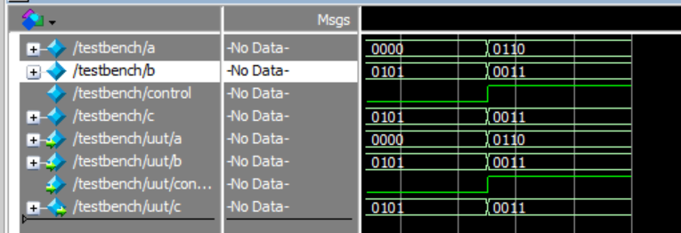

Task 2:

Description:
We had to make a 2x1 MUX, where the select bit decided whether the output would be ‘a & b’ or ‘a | b’. This was to be done using behavior level Verilog.

Code:
module twoonemux(a,b,select,c);

input a,b;
input select;
output reg c;

always @ *
begin

if (select == 0)
c = a & b;
else if (select == 1)
c = a + b;
end

endmodule

module testbench();

reg a,b;
reg select;
wire c;

twoonemux uut(a,b,select,c);

initial
begin
a = 0; b = 0; select = 0;
#10;
a = 0; b = 1; select = 0;
#10;
a = 1; b = 0; select = 0;
#10;
a = 1; b = 1; select = 0;
#10;
a = 0; b = 0; select = 1;
#10;
a = 0; b = 1; select = 1;
#10;
a = 1; b = 0; select = 1;
#10;
a = 1; b = 1; select = 1;
#10;
end
endmodule

Output:
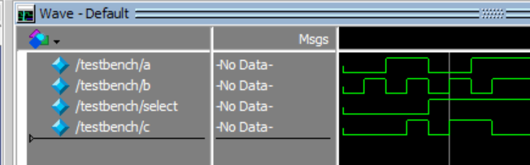

Task 3:

Description:
In this task, we had to make a two-bit magnitude comparator in Verilog, using behavior level Verilog. It was then simulated using a testbench. I took two 2-bit binary numbers and compared them. There were three variables for the equal, greater and lesser scenarios, and whichever one was fulfilled gave a true output.

Code:
module comparator(a,b,greater,equal,lesser);

input [1:0] a,b;
output reg greater, equal, lesser;

always @ *
begin

greater = 0; equal = 0; lesser = 0;
if (a > b)
greater = 1;
else if (a == b)
equal = 1;
else
lesser = 1;

end

endmodule

module testbench();

reg [1:0] a,b;
wire greater, equal, lesser;

comparator uut(a,b,greater,equal,lesser);

initial
begin
a = 2'b01; b = 2'b10;
#10;
a = 2'b11; b = 2'b10;
#10;
a = 2'b00; b = 2'b01;
#10;
a = 2'b10; b = 2'b10;

end
endmodule

Output:
