Computer Architecture Lab
(EL-2012)
LABORATORY REPORT

Fall 2026

(Lab#7)
Arithmetic Logic Unit

Student Name: HAIDER IRFAN Roll No: 24I-6505 Section: A

Date performed: October 5, 2026

MARKS AWARDED: ________ / 10

Date and Signature of Instructor: _________________
Lab Instructors: Dr. Nasir Ali Shah, Engr. Fasih Ahmad

______________________________________________________________________________________________________________________________________________________

NATIONAL UNIVERSITY OF COMPUTER AND EMERGING SCIENCES, ISLAMABAD
Prepared by: | Fasih Ahmad |  | Version: 1.0
Verified by: | Dr. Nasir Ali Shah |  | Updated: Fall 2026

Task 1:

Description:
In this task, we had to design a 1-bit ALU using Verilog, at all three levels of abstraction: gate level, data-flow level and behavioral-level Verilog. A testbench was included in the behavioral Verilog version to monitor how the code works. The Logisim circuit is also attached.

Code:
Behavioral Level:
module alu1bit(a, b, carryin, binv, select, result, carryout);

input a, b;
input carryin;
input binv;
input [1:0] select;
output reg result;
output reg carryout;

reg m;
reg sum;
reg cout;

always @ *
begin
m = b ^ binv;
{cout, sum} = a + m + carryin;
result = 0;
carryout = 0;

if (select == 2'b00)
result = a & b;
else if (select == 2'b01)
result = a | b;
else if (select == 2'b10)
begin
result = sum;
carryout = cout;
end
else
result = 0;
end

endmodule

module testbenchalu();

reg a, b, carryin, binv;
reg [1:0] select;
wire result, carryout;

alu1bit uut(a, b, carryin, binv, select, result, carryout);

initial
begin

select = 2'b00;
a = 0; b = 1; carryin = 0; binv = 0; #10;
a = 1; b = 1; #10;

select = 2'b01;
a = 0; b = 0; #10;
a = 1; b = 0; #10;

select = 2'b10;
binv = 0; carryin = 0; // addition
a = 0; b = 1; #10;
a = 1; b = 1; #10;

binv = 1; carryin = 1; // subtraction
a = 0; b = 1; #10;
a = 1; b = 0; #10;
end

endmodule

Dataflow Level:
module alu1bit(a, b, carryin, binv, select, result, carryout);

input a, b;
input carryin, binv;
input [1:0] select;
output result;
output carryout;

wire m;
wire x1, sum;
wire c1, c2, cout;
wire andans, orans;
wire seland, selor, selmath;

assign m = b ^ binv;

assign x1 = a ^ m;
assign sum = x1 ^ carryin;

assign c1 = a & m;
assign c2 = x1 & carryin;
assign cout = c1 | c2;

assign andans = a & b;
assign orans = a | b;

assign seland = ~select[1] & ~select[0];
assign selor = ~select[1] & select[0];
assign selmath = select[1] & ~select[0];

assign result = (seland & andans) |
(selor & orans) |
(selmath & sum);

assign carryout = selmath & cout;

endmodule
Gate Level:
module alu1bit(a, b, carryin, binv, select, result, carryout);
input a, b;
input carryin, binv;
input [1:0] select;
output result;
output carryout;

wire m;
wire x1, sum;
wire c1, c2, cout;
wire andans, orans;
wire seland, selor, selmath;

xor (m, b, binv);

xor (x1, a, m);
xor (sum, x1, carryin);

and (c1, a, m);
and (c2, x1, carryin);
or (cout, c1, c2);

and (andans, a, b);
or (orans, a, b);

wire n1, n0;
not (n1, select[1]);
not (n0, select[0]);

and (seland, n1, n0);
and (selor, n1, select[0]);
and (selmath, select[1], n0);

wire r1, r2, r3;
and (r1, seland, andans);
and (r2, selor, orans);
and (r3, selmath, sum);

or (result, r1, r2, r3);

and(carryout, selmath, cout);

endmodule

Output:
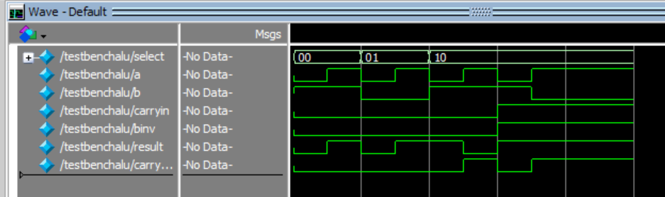
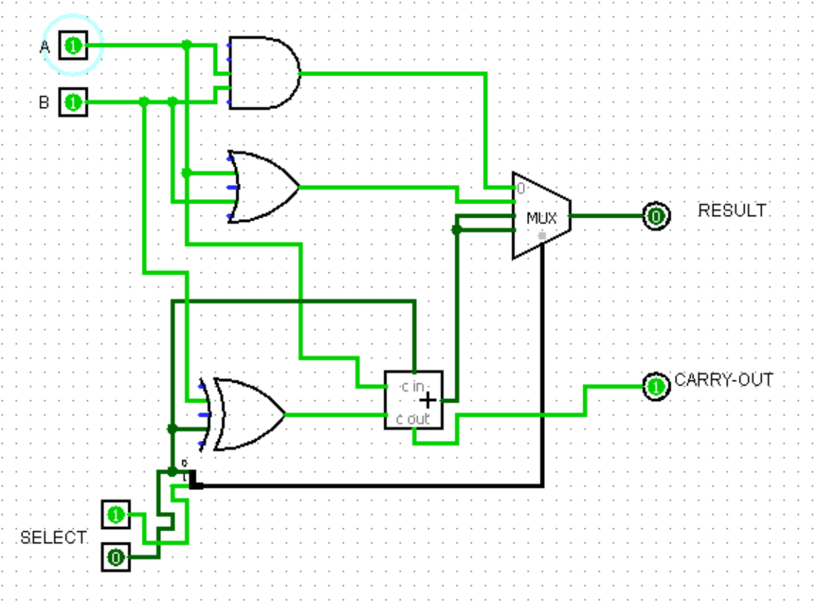

Task 2:

Description:
In this task, I made a 4-bit ALU by cascading four 1-bit ALUs in Verilog. An SLT function was also added to the original 1-bit ALU. A three bit input was used since there were five outputs, and four out of the eight possible combinations were mapped onto the 1-bit ALUs. A testbench was also written to test out the functioning of the code.

Code:
module alu1bit(a, b, carryin, binv, less, select, result, carryout);

input a, b;
input carryin;
input binv;
input less;
input [1:0] select;

output reg result;
output reg carryout;

reg m;
reg sum;
reg cout;

always @*
begin
m = b ^ binv;
{cout, sum} = a + m + carryin;

result = 0;
carryout = 0;

if (select == 2'b00)
result = a & b;
else if (select == 2'b01)
result = a | b;
else if (select == 2'b10)
begin
result = sum;
carryout = cout;
end
else
result = less;
end

endmodule

module alu4bit(a, b, op, result, CF, SF, ZF, OF);

input [3:0] a, b;
input [2:0] op;

output reg [3:0] result;
output reg CF, SF, ZF, OF;

wire binv;
wire [4:0] carry;
wire [3:0] tempresult;
wire lessbit;
wire overflow;

reg [1:0] select;

always @*
begin

if (op == 3'b000)
select = 2'b00;
else if (op == 3'b001)
select = 2'b01;
else if (op == 3'b111)
select = 2'b11;
else
select = 2'b10;

end

assign binv = (op == 3'b110 || op == 3'b111);
assign carry[0] = binv;

alu1bit bit0(a[0], b[0], carry[0], binv, lessbit,
select, tempresult[0], carry[1]);

alu1bit bit1(a[1], b[1], carry[1], binv, 1'b0,
select, tempresult[1], carry[2]);

alu1bit bit2(a[2], b[2], carry[2], binv, 1'b0,
select, tempresult[2], carry[3]);

alu1bit bit3(a[3], b[3], carry[3], binv, 1'b0,
select, tempresult[3], carry[4]);

assign overflow = carry[3] ^ carry[4];
assign lessbit = tempresult[3] ^ overflow;

always @ *
begin
result = tempresult;

CF = 0;
SF = result[3];
ZF = (result == 4'b0000);
OF = 0;

if (op == 3'b010 || op == 3'b110 || op == 3'b111)
begin
CF = carry[4];
OF = overflow;
end

end

endmodule

module testbench();

reg [3:0] a, b;
reg [2:0] op;

wire [3:0] result;
wire CF, SF, ZF, OF;

alu4bit uut(a, b, op, result, CF, SF, ZF, OF);

initial
begin

a = 5; b = 3; op = 3'b000; // and
#10;

a = 5; b = 3; op = 3'b001; // or
#10;

a = 5; b = 3; op = 3'b010; // add
#10;

a = 5; b = 3; op = 3'b110; // or
#10;

a = 3; b = 5; op = 3'b111; // slt
#10;

end

endmodule

Output:
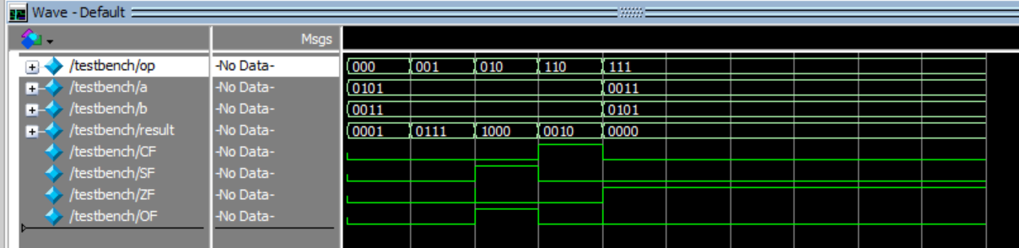

Task 3:

Description:
In this task, we had to use parametrization to make the ALU code generalized for any N number of bits. The Verilog code performs addition, subtraction and the basic logical operations.

Code:
module alu#(parameter N = 4) (
input [N-1:0] a,
input [N-1:0] b,
input [2:0] control,
output reg [N-1:0] result
);

always @*
begin
case (control)

3'b000: result = a + b; // add
3'b001: result = a - b; // sub
3'b010: result = a & b; // and
3'b011: result = a | b; // or
3'b100: result = ~a; // not
3'b101: result = a ^ b; // xor
default: result = 0;
endcase
end

endmodule

module testbench();

reg [3:0] a, b;
reg [2:0] control;
wire [3:0] result;

alu #(4) uut(a, b, control, result);

initial
begin
a = 5; b = 3;

control = 3'b000; #10;
control = 3'b001; #10;
control = 3'b010; #10;
control = 3'b011; #10;
control = 3'b100; #10;
control = 3'b101; #10;

end

endmodule

Output:
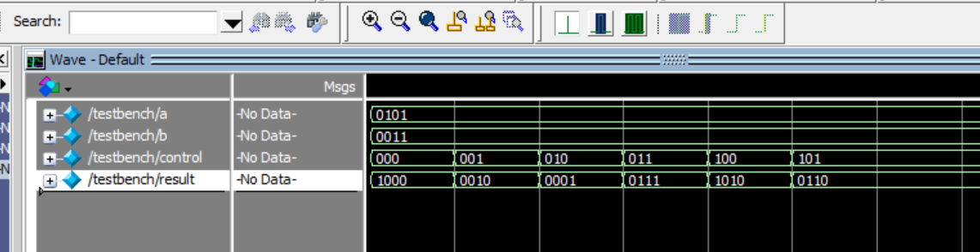

Task 4:

Description:
Had to make a fully functional 32-bit ALU using Verilog. The ALU performs ten operations: addition, subtraction, AND, OR, XOR, signed and unsigned comparison, logical left shift, logical right shift and arithmetic right shift. The operation is selected using a 4-bit control input.

Code:
module alu (a, b, alu_op, result);

input [31:0] a, b;
input [3:0] alu_op;
output reg [31:0] result;
output zero;

always @*
begin
case (alu_op)

4’b0000: result = a + b; // add
4’b0001: result = a – b; // sub
4’b0010: result = a & b; // and
4’b0011: result = a | b; // or
4’b0100: result = a ^ b; // xor

// slt: signed less than
4’b0101: begin
if (a[31] != b[31])
result = a[31] ? 1 : 0;
else if ($signed(a) < $signed(b))
result = 1;
else
result = 0;
end

// sltu: unsigned less than
4’b0110: begin
if (a < b)
result = 1;
else
result = 0;
end

4’b0111: result = a << b[4:0]; // sll
4’b1000: result = a >> b[4:0]; // srl
4’b1001: result = $signed(a) >>> b[4:0]; // sra

default:
result = 0;

endcase
end

assign zero = (result == 0);

endmodule

Task 5:

Description:
We had to make a 32-bit ALU circuit in Logisim, which has been implemented below. Bit extenders and splitters were used to solve issues of incompatible widths.

Output:
