Computer Architecture Lab
(EL-2012)
LABORATORY REPORT

Fall 2026

(Lab#4)
Register Level Execution

Student Name: HAIDER IRFAN Roll No: 24I-6505 Section: A

Date performed: September 8, 2026

MARKS AWARDED: ________ / 10

Signature and date of Instructor: _________________
Lab Instructors: Dr. Nasir Ali Shah, Engr. Fasih Ahmad

______________________________________________________________________________________________________________________________________________________

NATIONAL UNIVERSITY OF COMPUTER AND EMERGING SCIENCES, ISLAMABAD
Prepared by: | Fasih Ahmad |  | Version: 1.0
Verified by: | Dr. Nasir Ali Shah |  | Updated: Fall 2026

Task 1:

Description:
We had to write RISC-V assembly code for the provided C programs, where A = 5 and B = 4. Then we had to identify the different fields of each instruction according to the instruction format, and represent the field values in decimal.

Code:
addi t0, x0, 5
addi t1, x0, 4

add t2, t0, t1
sub t3, t0, t1
mul t4, t0, t1
mul t5, t0, t0

add t2, t0, t1

funct7: 0
rs2: 6
rs1: 5
funct3: 0
rd: 7
opcode: 51

sub t3, t0, t1

funct7: 32
rs2: 6
rs1: 5
funct3: 0
rd: 28
opcode: 51

mul t4, t0, t1

funct7: 1
rs2: 6
rs1: 5
funct3: 0
rd: 29
opcode: 51

mul t5, t0, t0

funct7: 1
rs2: 5
rs1: 5
funct3: 0
rd: 30
opcode: 51

Output:
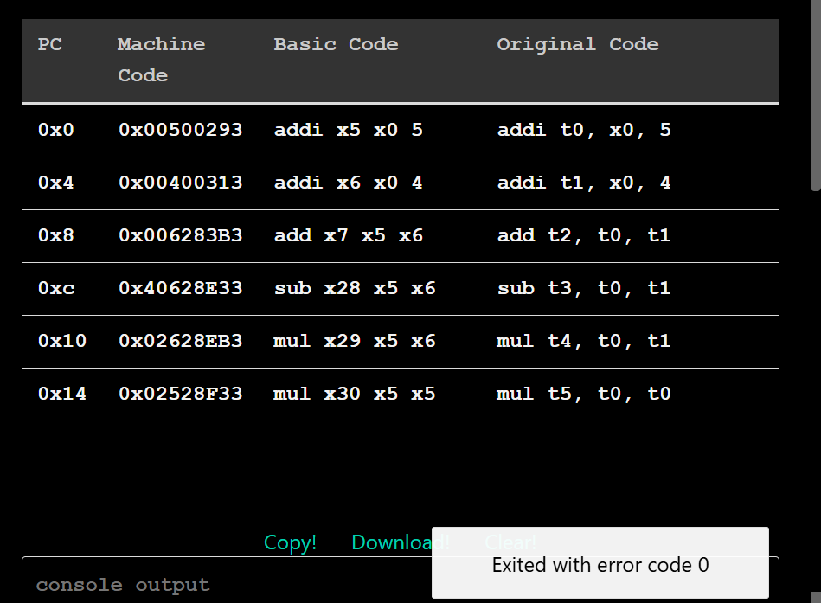
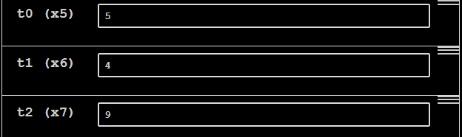
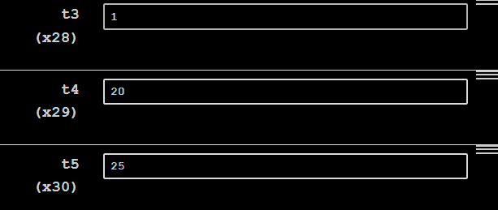

Task 2:

Description:
We had to convert the given expression into assembly language. Each variable was assigned a register. t6 was used to store one temporary result, and since there is no t7, the other temporary result was stored in s0.

Code:
sub t6, t0, t1
add s0, t2, t3
mul s0, s0, t4
add t5, t6, s0
# a = t0, c = t1, d = t2, e = t3, f = t4, m = t5

Output:
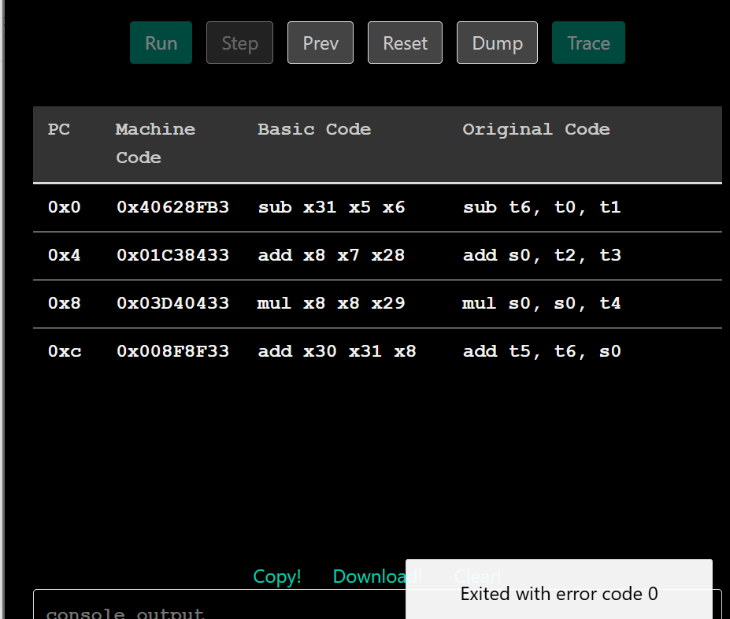

Task 3:

Description:
We had to use RISC-V assembly language code to perform the AND, OR and XOR operations on the given hexadecimal numbers.

Code:
li t0, 0xFFF
li t1, 0xF0F

and t2, t0, t1
or t3, t0, t1
xor t4, t0, t1

Output:
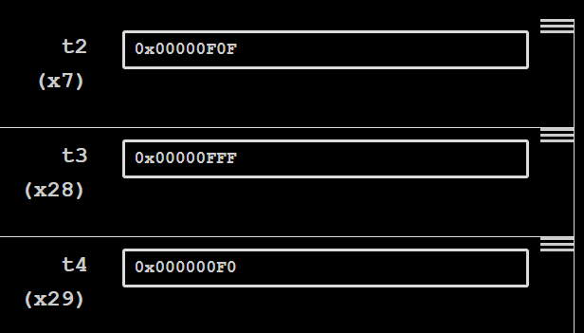

Task 4:

Description:
We had to test the given code and check the register values to see if it was working as intended. To make it work, a main program was added that gave initial values to the variables, and the labels were changed to make the code work in the Venus Simulator. The final value was also printed in the console output in the final part of the code.

Code:
.data
array: .word 10, 20, 30

.text
main:
la a0, array
li a1, 3

jal ra, arraysum
j done
# When we get here, a0 should be 60
arraysum:
# a0 = int a[]
# a1 = int size
# t0 = ret
# t1 = i
li t0, 0 # ret = 0
li t1, 0 # i = 0
loop: # For loop
bge t1, a1, finish # if i >= size, break
slli t2, t1, 2 # Multiply i by 4 (1 << 2 = 4)
add t2, a0, t2 # Update memory address
lw t2, 0(t2) # Dereference address to get integer
add t0, t0, t2 # Add integer value to ret
addi t1, t1, 1 # Increment the iterator
j loop # Jump back to start of loop (1 backwards)
finish:
mv a0, t0 # Move t0 (ret) into a0
ret # Return via return address register
done:
mv a1, a0
li a0, 1
ecall

Output:
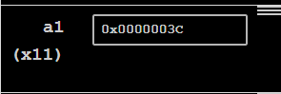
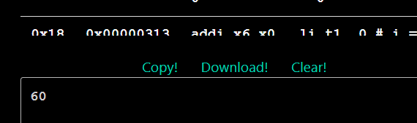

Task 5:

Description:
We had to write an assembly program that initialized the value of two at the start and then loaded those values into registers. Since the temporary registers only go up to t6, the rest of the values were stored in s1 onwards, using the lw instruction.

Code:
.data
tableoftwo: .word 2,4,6,8,10,12,14,16,18,20

.text
main:
la t0, tableoftwo
lw t1, 0(t0)
lw t2, 4(t0)
lw t3, 8(t0)
lw t4, 12(t0)
lw t5, 16(t0)
lw t6, 20(t0)
lw s1, 24(t0)
lw s2, 28(t0)
lw s3, 32(t0)
lw s4, 36(t0)

Output:
