Computer Architecture Lab
(EL-2012)
LABORATORY REPORT

Fall 2026

(Lab#10)
Implementation of Data Path

Student Name: HAIDER IRFAN Roll No: 24I-6505 Section: A

Date performed: October 27, 2026

MARKS AWARDED: ________ / 10

Signature and date of Instructor: _________________
Lab Instructors: Dr. Nasir Ali Shah, Engr. Fasih Ahmad

______________________________________________________________________________________________________________________________________________________

NATIONAL UNIVERSITY OF COMPUTER AND EMERGING SCIENCES, ISLAMABAD
Prepared by: | Fasih Ahmad |  | Version: 1.0
Verified by: | Dr. Nasir Ali Shah |  | Updated: Fall 2026

Task 1:

Description:
In this task, we had to design a 32-bit single-cycle datapath using Verilog. This datapath has a Program Counter, Instruction Memory, Register File, Immediate Generator, ALU, Branch Comparator, multiplexers and adders. The components work together to execute the provided instructions in a given clock cycle.
Each module performs its specific function, while control signals such as PCSel, RegWEn, ASel, BSel, ALUSel, ImmSel and WBSel determine how data moves through the datapath. The design was tested using a testbench containing ADDI, ADD, SUB and BEQ instructions. The expected register values were checked through simulation. However, the design has some limitations, including the absence of a control unit and fully implemented data memory, so control signals have to be provided manually.

Code:
alu.v
module alu (a, b, alu_op, result, zero);

input [31:0] a, b;
input [2:0] alu_op;
output reg [31:0] result;
output zero;

always @*
begin
case (alu_op)

3'b000: result = a + b; // add
3'b001: result = a - b; // sub
3'b010: result = a & b; // and
3'b011: result = a | b; // or
3'b100: result = a ^ b; // xor

3'b101: begin // slt
if ($signed(a) < $signed(b))
result = 1;
else
result = 0;
end

3'b110: begin // sltu
if (a < b)
result = 1;
else
result = 0;
end

3'b111: result = a << b[4:0]; // sll

default: result = 0;

endcase
end

assign zero = (result == 0);

endmodule

pc_reg.v
module pc_reg(clk, reset, next_pc, pc);

input clk;
input reset;
input [31:0] next_pc;
output reg [31:0] pc;

always @(posedge clk or posedge reset)
begin
if (reset)
pc <= 32'h00000000;
else
pc <= next_pc;
end

endmodule
pc_adder.v
module pc_adder(pc, pc4);

input [31:0] pc;
output [31:0] pc4;

assign pc4 = pc + 32'd4;

endmodule
mux.v
module mux(a, b, sel, out);

input [31:0] a, b;
input sel;
output reg [31:0] out;

always @*
begin
if (sel == 0)
out = a;
else
out = b;
end

endmodule
instruction_memory.v
module instruction_memory(addr, instruction);

input [31:0] addr;
output reg [31:0] instruction;

reg [31:0] memory [0:15];

integer i;

initial
begin
for (i = 0; i < 16; i = i + 1)
memory[i] = 32'h00000000;
end

always @*
begin
if (addr[31:2] < 16)
instruction = memory[addr[5:2]];
else
instruction = 32'h00000000;
end

endmodule
register_file.v
module register_file(clk, RegWEn, AddrA, AddrB, AddrD, DataD, DataA, DataB);

input clk;
input RegWEn;
input [4:0] AddrA, AddrB, AddrD;
input [31:0] DataD;

output [31:0] DataA, DataB;

reg [31:0] registers [0:31];

integer i;

initial
begin
for (i = 0; i < 32; i = i + 1)
registers[i] = 0;
end

assign DataA = (AddrA == 0) ? 32'd0 : registers[AddrA];
assign DataB = (AddrB == 0) ? 32'd0 : registers[AddrB];

always @(posedge clk)
begin
if (RegWEn && AddrD != 0)
registers[AddrD] <= DataD;

registers[0] <= 0;
end

endmodule
branch_comparator.v
module branch_comparator(DataA, DataB, BrEq, BrLT);

input [31:0] DataA, DataB;
output BrEq, BrLT;

assign BrEq = (DataA == DataB);
assign BrLT = ($signed(DataA) < $signed(DataB));

endmodule
immediate_generator.v
module immediate_generator(inst, ImmSel, Imm);

input [31:0] inst;
input [1:0] ImmSel;
output reg [31:0] Imm;

always @*
begin
case (ImmSel)

2'b00: begin // i-type
Imm = {{20{inst[31]}}, inst[31:20]};
end

2'b01: begin // s-type
Imm = {{20{inst[31]}}, inst[31:25], inst[11:7]};
end

2'b10: begin // b-type
Imm = {{19{inst[31]}}, inst[31], inst[7],
inst[30:25], inst[11:8], 1'b0};
end

2'b11: begin // j-type
Imm = {{11{inst[31]}}, inst[31], inst[19:12],
inst[20], inst[30:21], 1'b0};
end

default: Imm = 0;

endcase
end

endmodule
datapath.v
module datapath_top(
input clk,
input reset,

input PCSel,
input RegWEn,
input ASel,
input BSel,

input [2:0] ALUSel,
input [1:0] ImmSel,
input [1:0] WBSel,

output [31:0] pc,
output [31:0] inst,
output [31:0] alu_result,
output [31:0] wb,

output BrEq,
output BrLT
);

wire [31:0] pc4;
wire [31:0] next_pc;
wire [31:0] target;

wire [31:0] DataA, DataB;
wire [31:0] Imm;

wire [31:0] ALU_A, ALU_B;

wire [31:0] DataD;

wire zero;

assign target = pc + Imm;

// Program Counter

pc_reg PC(
.clk(clk),
.reset(reset),
.next_pc(next_pc),
.pc(pc)
);

// PC + 4

pc_adder PC_ADD(
.pc(pc),
.pc4(pc4)
);

// Instruction Memory

instruction_memory IMEM(
.addr(pc),
.instruction(inst)
);

// Register File

register_file RF(
.clk(clk),
.RegWEn(RegWEn),
.AddrA(inst[19:15]),
.AddrB(inst[24:20]),
.AddrD(inst[11:7]),
.DataD(wb),
.DataA(DataA),
.DataB(DataB)
);

// Immediate Generator

immediate_generator IMM_GEN(
.inst(inst),
.ImmSel(ImmSel),
.Imm(Imm)
);

// ALU Input A MUX

mux MUX_A(
.a(DataA),
.b(pc),
.sel(ASel),
.out(ALU_A)
);

// ALU Input B MUX

mux MUX_B(
.a(DataB),
.b(Imm),
.sel(BSel),
.out(ALU_B)
);

// ALU

alu ALU(
.a(ALU_A),
.b(ALU_B),
.alu_op(ALUSel),
.result(alu_result),
.zero(zero)
);

// Branch Comparator

branch_comparator COMP(
.DataA(DataA),
.DataB(DataB),
.BrEq(BrEq),
.BrLT(BrLT)
);

// Write Back MUX

reg [31:0] wb_temp;

assign wb = wb_temp;

always @*
begin
case (WBSel)

2'b00: wb_temp = alu_result;
2'b01: wb_temp = pc4;

default: wb_temp = 32'b0;

endcase
end

// PC Selection MUX

mux MUX_PC(
.a(pc4),
.b(target),
.sel(PCSel),
.out(next_pc)
);

endmodule
datapath_tb.v
module alu (a, b, alu_op, result, zero);

input [31:0] a, b;
input [2:0] alu_op;
output reg [31:0] result;
output zero;

always @*
begin
case (alu_op)

3'b000: result = a + b; // add
3'b001: result = a - b; // sub
3'b010: result = a & b; // and
3'b011: result = a | b; // or
3'b100: result = a ^ b; // xor

3'b101: begin // slt
if ($signed(a) < $signed(b))
result = 1;
else
result = 0;
end

3'b110: begin // sltu
if (a < b)
result = 1;
else
result = 0;
end

3'b111: result = a << b[4:0]; // sll

default: result = 0;

endcase
end

assign zero = (result == 0);

endmodule
Output:
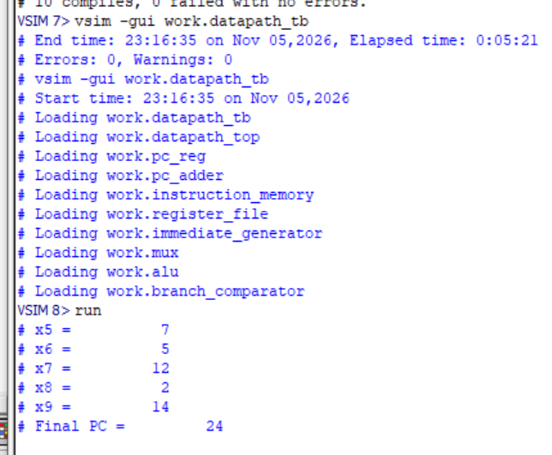

Task 2:

Description:
The datapath was implemented in Logisim by connecting the required components, including the program counter, instruction memory, register file, ALU, multiplexers and immediate generator.

Output:


