Computer Architecture Lab
(EL-2012)
LABORATORY REPORT

Fall 2026

(Lab#9)
Register File Using Modelsim

Student Name: HAIDER IRFAN Roll No: 24I-6505 Section: A

Date performed: October 20, 2026

MARKS AWARDED: ________ / 10

Date and Signature of Instructor: _________________
Lab Instructors: Dr. Nasir Ali Shah, Engr. Fasih Ahmad

______________________________________________________________________________________________________________________________________________________

NATIONAL UNIVERSITY OF COMPUTER AND EMERGING SCIENCES, ISLAMABAD
Prepared by: | Fasih Ahmad |  | Version: 1.0
Verified by: | Dr. Nasir Ali Shah |  | Updated: Fall 2026

Task 1:

Description:
In this task, we had to write the Verilog code for a 4x4 register file. This register file used four 4-bit registers, and decoder and multiplexer modules for the selection of which registers we want to read to or write from.

Code:
module decoder_2_to_4(output reg [3:0] dec_out, input [1:0] wr, input write_enable);

always @ *
begin
if (write_enable)
begin
case(wr)
2'b00: dec_out = 4'b0001;
2'b01: dec_out = 4'b0010;
2'b10: dec_out = 4'b0100;
2'b11: dec_out = 4'b1000;
default: dec_out = 4'b0000;
endcase
end
else
begin
dec_out = 4'b0000;
end
end
endmodule

module mux4_1(output reg [3:0] out, input [3:0] in0, in1, in2, in3, input [1:0] sel);

always @ *
begin
if (sel == 2'b00)
out = in0;
else if (sel == 2'b01)
out = in1;
else if (sel == 2'b10)
out = in2;
else if (sel == 2'b11)
out = in3;
else
out = 4'b0000;
end
endmodule

module register_4bit(q, d, load, clk);

output reg [3:0] q;
input [3:0] d;
input load;
input clk;

always @(posedge clk) begin
if (load)
q <= d;
end
endmodule

module register_file_4x4(data_out1, data_out2, data_in, write_enable, wr, rd1, rd2, clk);

output [3:0] data_out1, data_out2;

input [3:0] data_in;
input [1:0] wr;
input write_enable;
input [1:0] rd1, rd2; //select lines
input clk;

wire [3:0] dec_out;
wire [3:0] q0, q1, q2, q3;

// instantiate decoder
decoder_2_to_4 dec(dec_out, wr, write_enable);

//instantiate four 4-bit registers
register_4bit reg0(q0, data_in, dec_out[0], clk);
register_4bit reg1(q1, data_in, dec_out[1], clk);
register_4bit reg2(q2, data_in, dec_out[2], clk);
register_4bit reg3(q3, data_in, dec_out[3], clk);

// instantiate two 4-to-1 multiplexers for reading
mux4_1 mux1(data_out1, q0, q1, q2, q3, rd1);
mux4_1 mux2(data_out2, q0, q1, q2, q3, rd2);

endmodule

Task 2:

Description:
We had to write 6 into Register 1, 3 into Register 2 and 13 into Register 3. Then we had to read Register 21 and Register 2 on out1 and out2 respectively.

Code:
module decoder_2_to_4(output reg [3:0] dec_out, input [1:0] wr, input write_enable);

always @ *
begin
if (write_enable)
begin
case(wr)
2'b00: dec_out = 4'b0001;
2'b01: dec_out = 4'b0010;
2'b10: dec_out = 4'b0100;
2'b11: dec_out = 4'b1000;
default: dec_out = 4'b0000;
endcase
end
else
begin
dec_out = 4'b0000;
end
end
endmodule

module mux4_1(output reg [3:0] out, input [3:0] in0, in1, in2, in3, input [1:0] sel);

always @ *
begin
if (sel == 2'b00)
out = in0;
else if (sel == 2'b01)
out = in1;
else if (sel == 2'b10)
out = in2;
else if (sel == 2'b11)
out = in3;
else
out = 4'b0000;
end
endmodule

module register_4bit(q, d, load, clk);

output reg [3:0] q;
input [3:0] d;
input load;
input clk;

always @(posedge clk) begin
if (load)
q <= d;
end
endmodule

module register_file_4x4(data_out1, data_out2, data_in, write_enable, wr, rd1, rd2, clk);

output [3:0] data_out1, data_out2;

input [3:0] data_in;
input [1:0] wr;
input write_enable;
input [1:0] rd1, rd2; //select lines
input clk;

wire [3:0] dec_out;
wire [3:0] q0, q1, q2, q3;

// instantiate decoder
decoder_2_to_4 dec(dec_out, wr, write_enable);

//instantiate four 4-bit registers
register_4bit reg0(q0, data_in, dec_out[0], clk);
register_4bit reg1(q1, data_in, dec_out[1], clk);
register_4bit reg2(q2, data_in, dec_out[2], clk);
register_4bit reg3(q3, data_in, dec_out[3], clk);

// instantiate two 4-to-1 multiplexers for reading
mux4_1 mux1(data_out1, q0, q1, q2, q3, rd1);
mux4_1 mux2(data_out2, q0, q1, q2, q3, rd2);

endmodule

module testbench();

reg [3:0] data_in;
reg write_enable;
reg [1:0] wr, rd1, rd2;
reg clk;

wire [3:0] data_out1, data_out2;

register_file_4x4 uut(data_out1, data_out2, data_in, write_enable, wr, rd1, rd2, clk);

initial begin
clk = 0;
forever #5 clk = ~clk;
end

initial begin
data_in = 4'b0000;
write_enable = 0;
wr = 2'b00;
rd1 = 2'b00;
rd2 = 2'b00;

#10;
write_enable = 1;

wr = 2'b01;
data_in = 4'b0110;

#10;
wr = 2'b10;
data_in = 4'b0011;

#10;
wr = 2'b11;
data_in = 4'b1101;

#10;
write_enable = 0;

rd1 = 2'b01;
rd2 = 2'b10;

#10;
$display("Register 1 output: %d", data_out1);
$display("Register 2 output: %d", data_out2);
end
endmodule

Output:
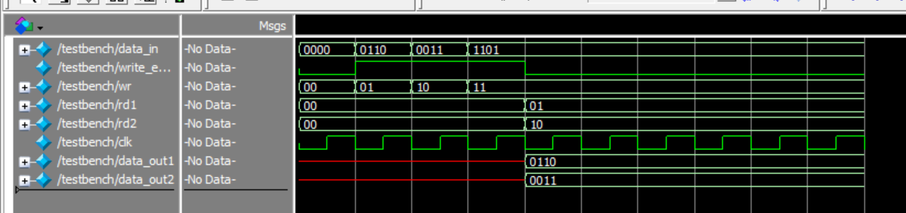
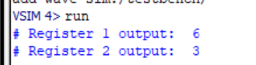

Task 3:

Description:
We made a RISC-V 32-bit register file that contains 32 registers and each register is 32 bits wide. It has two read ports, and one write port. Each register is selected using a 5-bit address because 2⁵ = 32. x0 is permanently 0 according to the RISC-V architecture convention.

Code:
module register_file_32bit(
input clk,
input rst,
input [4:0] rs1,
input [4:0] rs2,
input [4:0] rd,
input [31:0] wdata,
input reg_write,
output reg [31:0] rdata1,
output reg [31:0] rdata2
);

reg [31:0] registers [0:31];
integer i;

always @(posedge clk or posedge rst) begin
if (rst) begin
for (i = 0; i < 32; i = i + 1) begin
registers[i] <= 32'b0;
end
end
else begin
if (reg_write && rd != 5'd0) begin
registers[rd] <= wdata;
end
end
end

always @(*) begin
if (rs1 == 5'd0)
rdata1 = 32'b0;
else
rdata1 = registers[rs1];

if (rs2 == 5'd0)
rdata2 = 32'b0;
else
rdata2 = registers[rs2];
end

endmodule

module testbench;

reg clk, rst, reg_write;
reg [4:0] rs1, rs2, rd;
reg [31:0] wdata;
wire [31:0] rdata1, rdata2;

register_file_32bit uut (
.clk(clk),
.rst(rst),
.rs1(rs1),
.rs2(rs2),
.rd(rd),
.wdata(wdata),
.reg_write(reg_write),
.rdata1(rdata1),
.rdata2(rdata2)
);

initial begin
clk = 0;
forever #5 clk = ~clk;
end

initial begin
rst = 1;
reg_write = 0;
rs1 = 0;
rs2 = 0;
rd = 0;
wdata = 0;

#10 rst = 0;

rd = 1;
wdata = 100;
reg_write = 1;
#10;

rd = 2;
wdata = 200;
#10;

reg_write = 0;
rs1 = 1;
rs2 = 2;
#1;

$display("x1 = %d", rdata1);
$display("x2 = %d", rdata2);

rs1 = 0;
#1;
$display("x0 = %d", rdata1);

end

endmodule

Output:
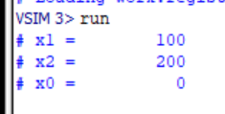

Task 4:

Description:
In this task, instead of a simple register, I made a 4-bit register file in Logisim, which implements the first task as a circuit. It has a decoder and two multiplexers, along with an input and two outputs.

Output:


