

**PAN AFRICAN MINING**

**MURIEL MINE**

**PROJECT PROPOSAL FOR DEVELOPING**

**A SHE DOCUMENT CONTROL**

**APPLICATION BY T MUDZAMIRI (SHE GT)**

**AND L MUCHENJE (IT GT)**

**HOD SHE: MR B NYEVERA. . . . . . . . . . . . . . . . . . . . . . . . DATE . . . . . . . . . . . . . . .**

**HOD IT: MS D MUPAKO. . . . . . . . . . . . . . . . . . . . . . . .. DATE . . . . . . . . . . . . . . . . .**

# **1. EXECUTIVE SUMMARY**

It has been observed that recording, keeping and referring to SHE documents is a challenge due to the haphazard nature of filing especially in computer systems. The filing system (IMS) in place, which consists of hard copy IMS folders could be complimented by soft copies for updating and reference purpose. A SHE documents control application serves time as each folder is organised in the same manner as that of the hard copies. It makes updating easier and consolidates all information in one place for easy use by new employees, reviewers, auditors, SHE personnel as well as the management.

# **2. PROJECT DESCRIPTION**

The computer application consists of a log in portal for SHE personnel succeeded by a menu which displays all IMS folders from clause four to ten and a blank forms folder. Each folder is numbered and named according to the IMS system. When a cursor is moved over a folder, all documents contained within it are displayed. The user can choose the folder in which the document they want to use is filed in and click to open. All subfolders and files contained become visible for use.

# **3. OBJECTIVE OF THE PROJECT**

The project’s overall objective is to present SHE documents in an easy to find and up to date manner saving time and maximising efficiency and production. The application will do away with the hustles of retrieving SHE documents as is being experienced currently.

# **4. PROJECT WORK PLAN**

The project will require a month to fully develop and another month to run trials most preferably during the document review period. Considering that the project will not be interfering with normal day to day activities the time stated might be exceeded. At the completion of the development, the application will be presented to the SHE and IT HODs for review

# **5. PROPOSED BUDGET**

|  |  |
| --- | --- |
| **INTENDED USE** | **AMOUNT** |
| Cloud Hosting | USD $5/MONTH |
| BUNDLES (DATA AND VOICE) | USD $50/MONTH |
| TOTAL | USD $55/MONTH |

Backup will be required to ensure security of the application by using multiple servers i.e. PAM and another commercial server. Bundles will be used for updates and communication during weekends and after work as the project will not be interfering with day to day activities of the Trainees.

# **6. ATTACHMENTS**

## **6.1 LOG IN PORTAL**

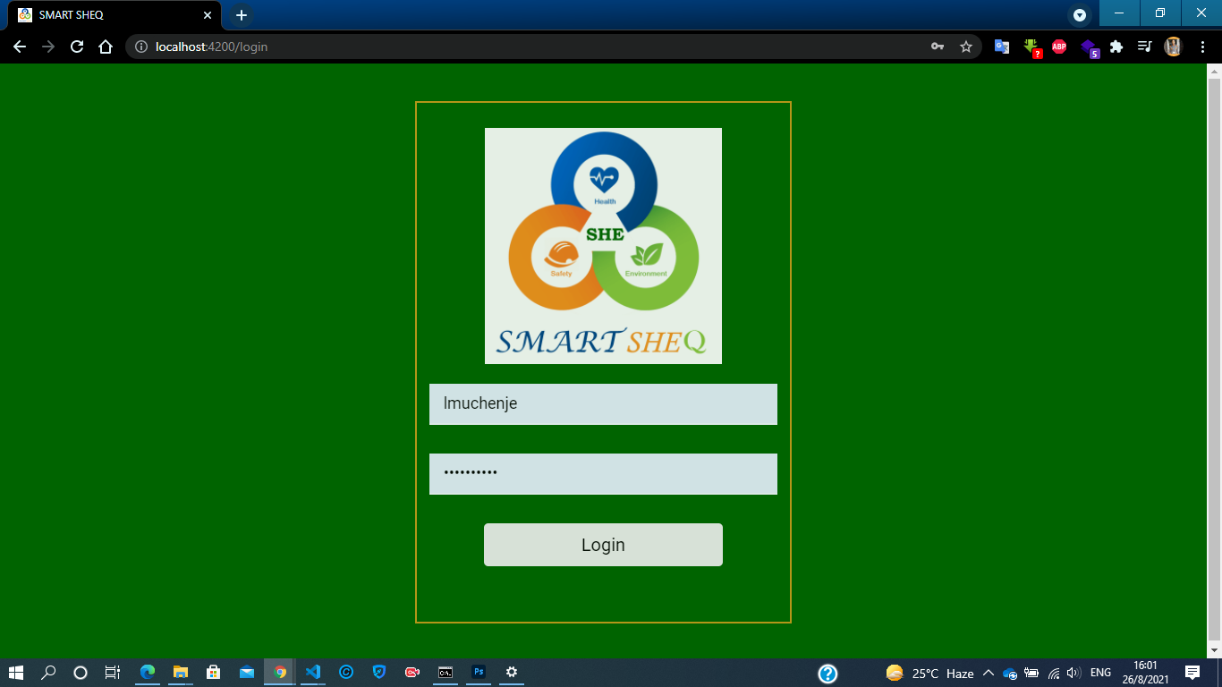

## **6.2 MENU**

