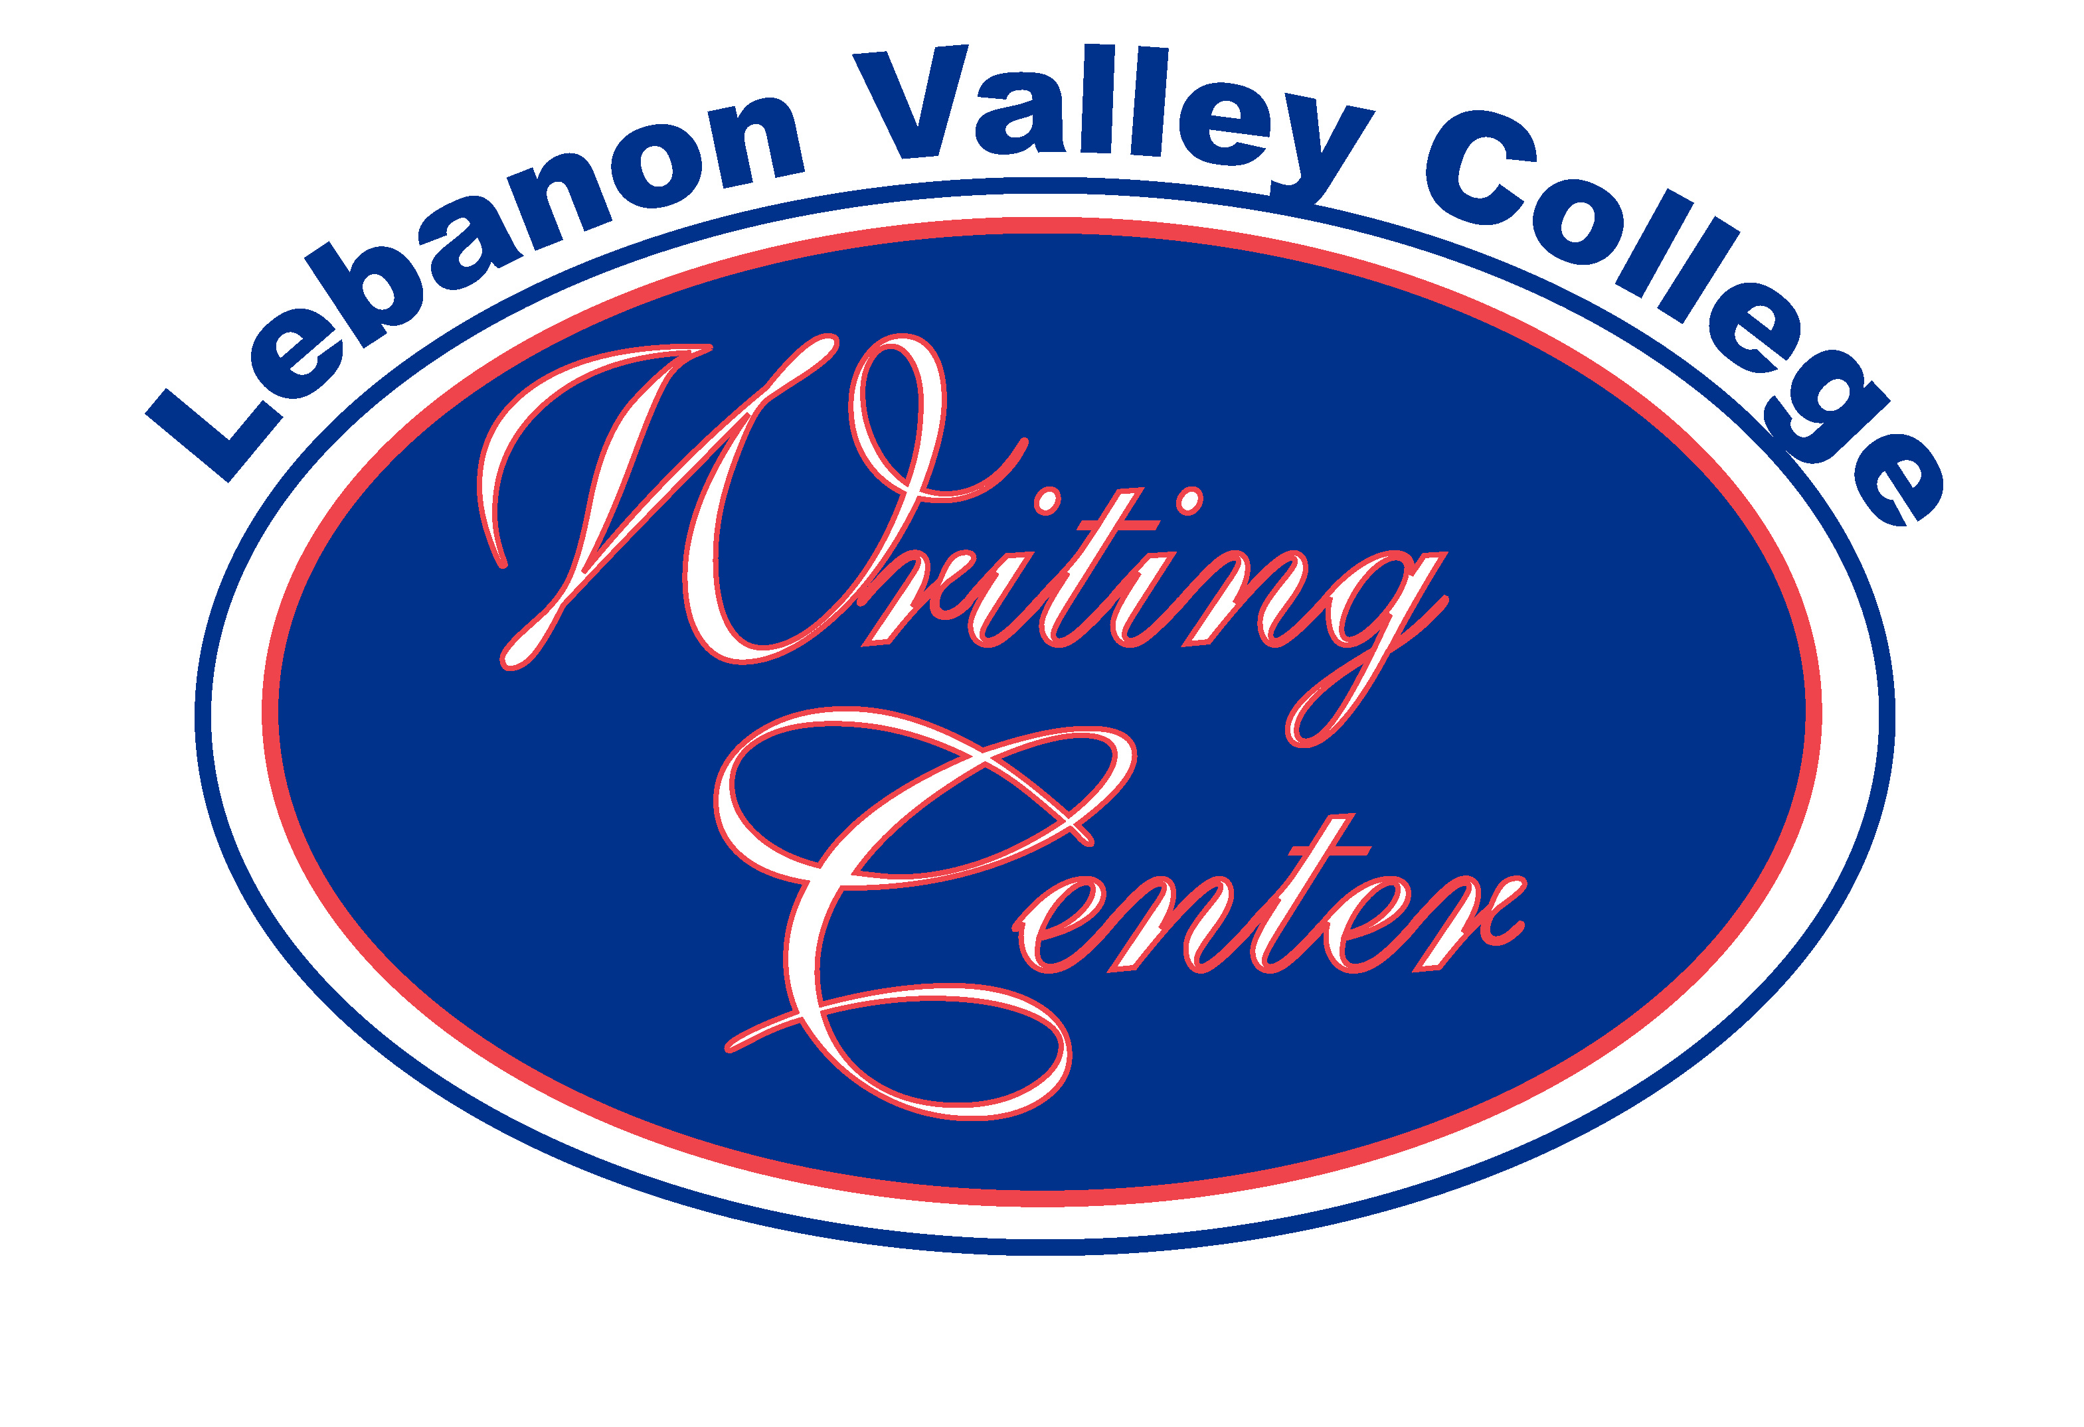

GOALS BASED UPON THE SELF-STUDY OF THE WRITING CENTER AND THE RECOMMENDATIONS OF THE VISITING COMMITTEE

COMPLETED SINCE THE SELF-STUDY TITLED
“WHERE WE ARE GOING.”

1. Instituted a strong outreach program across campus by establishing the Writing Center’s tutoring connections to the athletic program, the LVEP program, and the physical therapy program. The Director has also done “Time Management Workshops” for the RAs and the Multicultural group.

2. Presented two presentations at the IWCA conference in Hershey in October 2003. The Director and two students and two alumni participated in these presentations for an international audience. This responds to the goal in the self-evaluation that suggested that the Writing Center needed to participate in more conferences in order to network.
The Director will be attending a weeklong Writing Center Summer Institute at Clark University in Worcester, MA in July. This institute is composed of forty writing center directors from around the world and is under the auspices of IWCA [International Writing Center Association].

3. Instituted committees that will involve tutors in the process of helping to develop the organization. These include the following: publicity, hospitality, policy, recruitment, training, and service.
We hope to get more of the people who work for us to feel a part of the organization rather than just one piece of the puzzle.
The publicity committee headed by Craig Layne has already had two articles in La Vie Collegienne profiling the improvements in the Center’s physical environment and profiling two of the people who work for us who have distinguished themselves in other ways on campus as well. For example, we profiled Jennifer Borgerding who is one of our coordinators and who participated in a very successful internship at the Baltimore Aquarium. We are getting the word out that talented and special people work for the Writing Center.

4. Recruited an Advisory Board consisting of representatives from student services, general education, physical therapy, multicultural affairs, and athletics. This Advisory Board is an excellent across-campus connection to the needs of the student body.

5. Instituted a communication link to our staff through the use of Blackboard. Though we are posting notices about meetings or training sessions, sending e-mail simultaneously to all staff, making training articles available to all, we have just begun to explore the possibilities of this form of communication.

6. Modified our Client Feedback Form so the client may choose to give us permission to share what has transpired during a tutoring session with the professor of the course the client is taking. If the student gives us that permission, the professor will receive an e-mail notifying him or her that the student has attended a tutoring session and what was covered during that session. The professor is then free to communicate with both the student and the tutor to recommend other areas that might help the student to succeed. We are trying to establish a partnership for learning.

7. Created a “team” identity. Desk people at the Writing Center are now wearing the new t-shirts that identify them as a “Writing Center Consultant.” This increases the visibility of the staff and advertises the organization while making our tutors feel a part of the learning team.

IMMEDIATE [1-2 years]

1. Create a clearly worded and focused mission statement for the Writing Center as an organization. This task was suggested by the visiting committee and by the self-study. The policy committee of the Writing Center is charged with addressing this task and bringing it to the administrative staff and the Director. This will then be disseminated to the general staff of tutors through Blackboard for feedback and revision as necessary. Ratification by the entire staff is the final step in the process.

2. Increase the regularity of meetings of the Advisory Board for the Writing Center which is an excellent across-campus connection to the needs of the student body. This board should meet monthly. Currently it does not because of scheduling problems.

4. Hire dedicated tutors--this is an on-going process. The recruitment committee will serve as a preliminary screening body that will help with quality control in the hiring of staff.

5. Establish a stronger connection to WLVC as part of our publicity campaign. The radio station did do a profile of the Center in fall 2003. By working with the station advisor and program director, The Center may discover additional opportunities for publicity about its services and the people who work for it.

6 Solicit a list of needs from the tutors. The training committee will perform this function and will work to encourage professors to conduct training sessions for the purpose of helping tutors to understand the thinking processes in the specific disciplines. This will accomplish two points: it will strengthen the tutoring skills of the staff, and it will provide the faculty with a vested interest in the tutoring of their students.

7. Plan social events for the Writing Center. The hospitality committee will work on this task which may include hosting a writing tutor conference, soliciting guest speakers, or planning the senior staff recognition ceremony for the spring.

SHORT RANGE [2-3 years]

1. Conduct a once a month faculty lunch during the academic year to foster a dialog about the writing across that is going on across the campus and the curriculum. Currently, this happens as part of the FYS program but only lasts while the FYS classes meet.

2. Create an additional advisory board made up of faculty from the various disciplines. If each department had one representative who could act as the liaison to the department from the Writing Center, then communication would be improved. The Director needs to visit the department meetings or needs to visit a Chairs’ meeting to present this proposal as well as to engage the Chairs in the mission of the Writing Center. The visiting committee felt strongly that this would help to open lines of communication.

3. Ask for time at a faculty/staff business meeting to provide the campus with a clear mission statement for the Writing Center and to present relevant statistics to demonstrate the growth of the organization. This would not be a long presentation, but the visiting committee suggested that it would raise awareness and possibly support for the Writing Center.

4. Foster a closer working relationship with the advisor to Greenblotter for the purpose of holding readings in the Writing Center and providing a venue for the magazine’s meetings or guest speakers.

5. Submit to the Associate Dean, the Dean, and the faculty a proposal for a one-credit course to “certify” all tutors who work for the Writing Center. This would enhance the “professionalism” of the Center in the eyes of the faculty and would provide the training necessary to be an effective tutor. This action would address the recommendation by the outside committee as well as the self-study.

6. Create and sponsor a campus wide writing contest in a variety of genres—short story, essay, poetry, play, creative nonfiction. The winners—judged by a campus-wide panel representative of faculty, staff, students, and administration—would receive campus wide recognition with public readings of their work—perhaps in Leedy Theater, publication of their work in Greenblotter and La Vie as well as play on WLVC with accompanying interviews. This would address the recommendation for publicity for the Writing Center and for a general campus-wide recognition of the talented people we have on campus. The drama entry may even be given an in-hand script reading that would be open to the public.

7. Re-evaluate the effectiveness of the work that is being done. This can be accomplished by surveying the campus community for input and suggestion. A SWOT analysis should be held every two years in preparation for the faculty evaluation every seven years.

LONG RANGE [3-5 years]

1. Evaluate the status and “health” of the organization through a survey of the campus personnel including faculty, staff, administration and Writing Center personnel.

2. Create, revise, or validate the mission statement of the organization.

3. Evaluate the progress made and reassess the direction of the organization. This includes deciding if the Writing Center and the Academic Support Tutoring should be separated and re-focused in light of need and growth. The visiting committee suggested the divorce of the Writing Center and the Tutoring Center much earlier than this. However, within the present economic climate and because the organization has gained such momentum, the Director feels that this should be a long-range consideration.

NEEDS

1. Acquire additional funding. The budget submitted for 2004-05 indicates that a significant amount of money ($2000+) in student salaries is needed to continue the work the Center has begun.
Also included in that budget was a request for $300 for printing a Writing Center brochure that will help with the recruitment of students to the college. It could be included with recruitment information sent to prospective students.
A sum of $150 is requested to allow the Director to network with other writing centers in the area by visiting and speaking with other directors to “put us in play” on a larger scale.
Funding is needed also in order for the Center to host events including speakers and recognition ceremonies.

3. Hire a full or part-time Administrative Assistant who would be able to help the Director with the “nuts and bolts” of the organization. Currently this position is handled by one of the student coordinators who amassed a total of 92.25 hours in the fall semester of 2003. The visiting committee’s thought on this was that if the organization “gets that big,” then the division of services is recommended.

4. Exploring the possibilities of hiring retired teachers or professors to act as consultants/tutors within the organization remains an option. The visiting committee did not see this as viable because it diminished the “peer tutoring” concept. Yet, this concept is still worthy of exploration.

5. Extend the outreach program to include area high schools where tutors and the Director could conduct some training sessions for schools that have a writing or tutoring center or where we could help a school “visualize” how a center could be part of their building and academic life.

6. Re-evaluate the current space based upon the needs of the students and staff.

CLOSING NOTE

The Writing Center at Lebanon Valley College is a viable entity that can contribute much to the overall campus community. In the future, the current configuration of the organization may change. We will make whatever changes necessary to assure our growth and the success of our clientele. We have begun to move in a positive direction. Momentum is on our side. The Writing Center staff and administration believe that what we are doing is important and worthwhile and we want collectively and individually to serve our college community to the best of our ability.

Respectfully submitted,

Walter Labonte
Director

