**计算方法课内上机实习报告一**

姓名：刘宇鹏

学号：20181003174

班级：191181班

题目一：

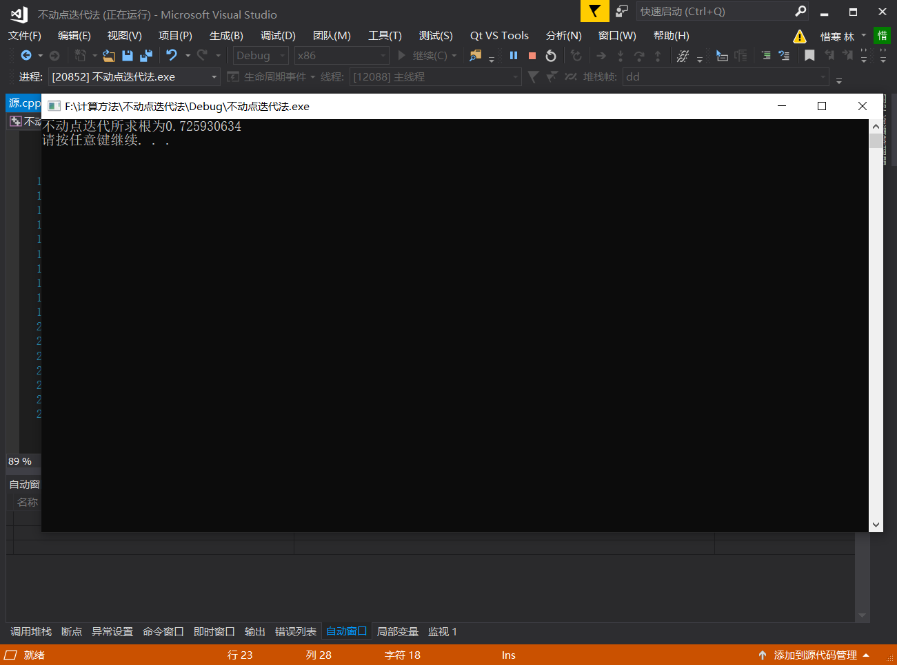

代码如下：

#include<iostream>

#include<iomanip>

#include<math.h>

using namespace std;

double k(double d) {

return pow((pow(d,5)-2*d*d+2)/3,1.0/3);

}

double dd(double c, double d) //不定点迭代法

{

int t = 0;

while (fabs(d-c) >= 1e-9) {

c = d;

d = k(d);

}

return d;

}

int main() {

double a=dd(0, 1);

cout << "不动点迭代所求根为"<<setprecision(9) << a << endl;

system("pause");

return 0;

}

题目二：

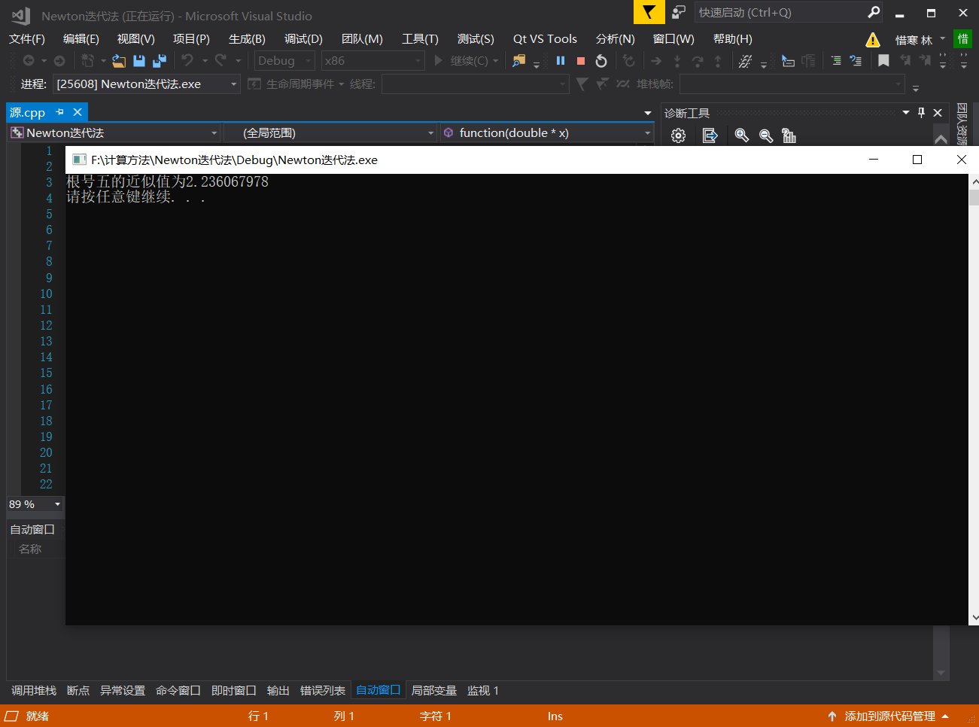

代码如下：

#include<iostream>

#include<math.h>

#include<iomanip>

using namespace std;

double f(double x) {

return x * x - 5;

}

double f1(double x) {

return 2*x;

}

double function(double *x) {

int i = 0;

do {

x[i + 1] = x[i] - f(x[i]) / f1(x[i]);

i++;

} while (fabs(f(x[i]) - f(x[i - 1])) > 0.000000001);

return x[i - 1];

}

int main() {

double x[1000] = {0};

x[0] = 0.5;

double sc = 0.0;

sc = function(x);

cout <<"根号五的近似值为"<< setprecision(10)<<sc<<endl;

system("pause");

return 0;

}

题目三高斯消去法：

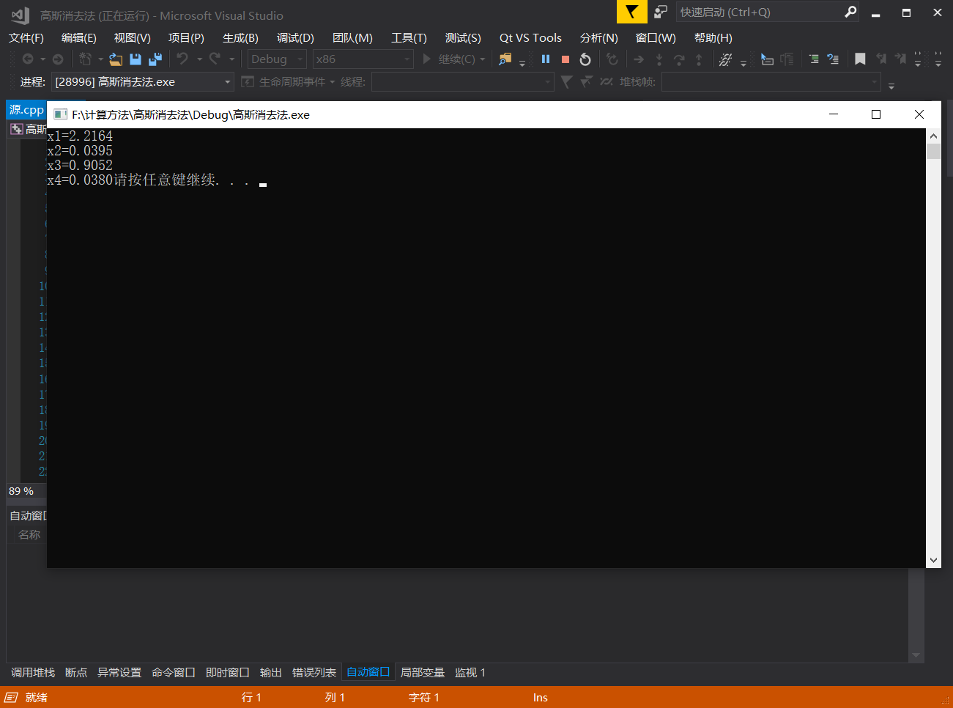

代码如下：

#include<iostream>

#include<math.h>

#include<iomanip>

using namespace std;

double f(double x) {

return x * x - 5;

}

double f1(double x) {

return 2*x;

}

double function(double *x) {

int i = 0;

do {

x[i + 1] = x[i] - f(x[i]) / f1(x[i]);

i++;

} while (fabs(f(x[i]) - f(x[i - 1])) > 0.000000001);

return x[i - 1];

}

int main() {

double x[1000] = {0};

x[0] = 0.5;

double sc = 0.0;

sc = function(x);

cout <<"根号五的近似值为"<< setprecision(10)<<sc<<endl;

system("pause");

return 0;

}

题目三雅各比迭代法：

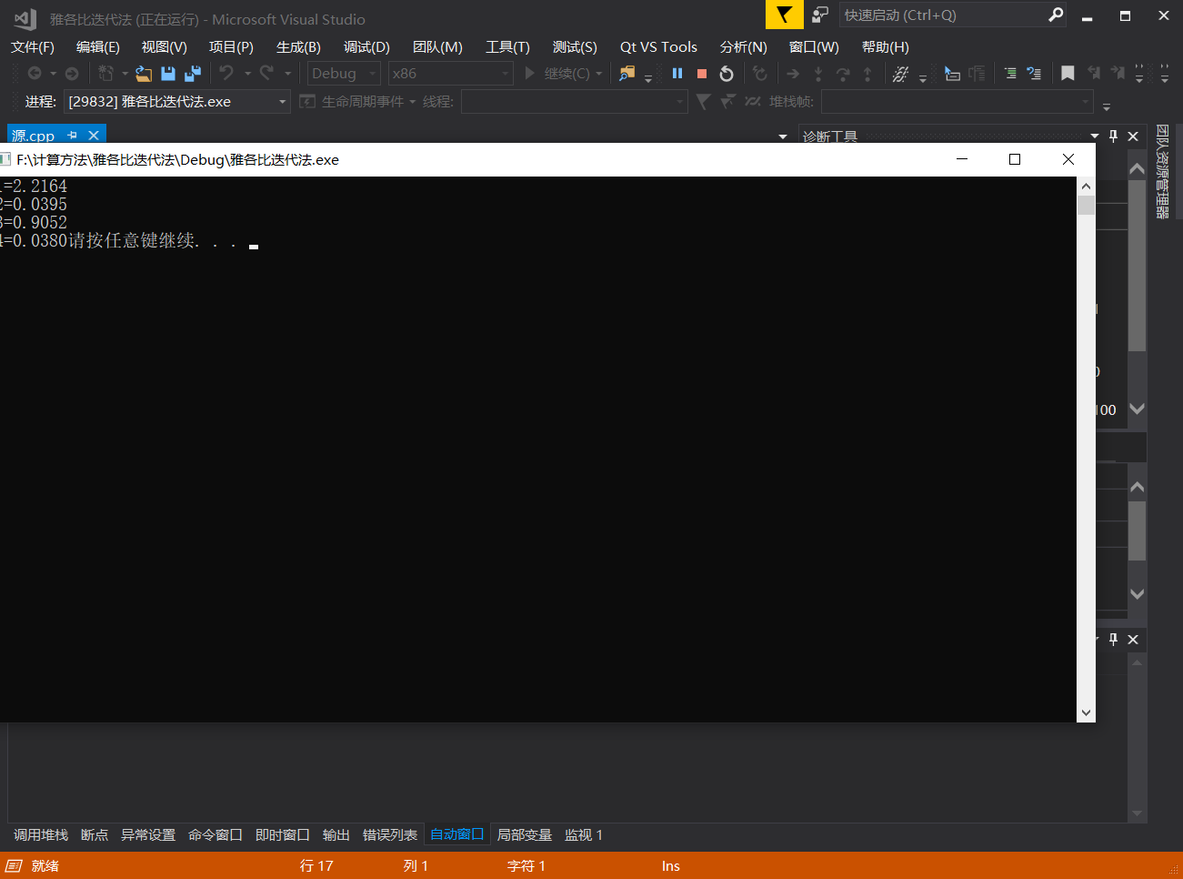

代码如下：

#include<iostream>

#include<math.h>

#include<iomanip>

using namespace std;

double JACOBI(double A[4][4], double x[20][4], double*b) {

int i = 0;

while (i < 20) {

x[i + 1][0] = (b[0] - A[0][1] * x[i][1] - A[0][2] * x[i][2] - A[0][3] * x[i][3]) / A[0][0];

x[i + 1][1] = (b[1] - A[1][0] * x[i][0] - A[1][2] * x[i][2] - A[1][3] * x[i][3]) / A[1][1];

x[i + 1][2] = (b[2] - A[2][0] * x[i][0] - A[2][1] * x[i][1] - A[2][3] * x[i][3]) / A[2][2];

x[i + 1][3] = (b[3] - A[3][0] * x[i][0] - A[3][1] * x[i][1] - A[3][2] * x[i][2]) / A[3][3];

i++;

}

cout << "x1=" << setprecision(5) << x[i - 1][0] << endl;

cout << "x2=" << setprecision(3) << x[i - 1][1] << endl;

cout << "x3=" << setprecision(4) << x[i - 1][2] << endl;

printf("x4=%4.4f", x[i - 1][3]);

return 0;

}

int main() {

double A1[4][4] = { 4,1,-1,0,1,-5,-1,-3,2,-1,-6,1,5,4,4,30 };

double b1[4] = { 8,1,-1,16 };

double x[20][4];

x[0][0] = 1, x[0][1] = 1, x[0][2] = 1,x[0][3]=1;

JACOBI(A1, x, b1);

system("pause");

return 0;

}

题目三高斯-塞德尔迭代法：

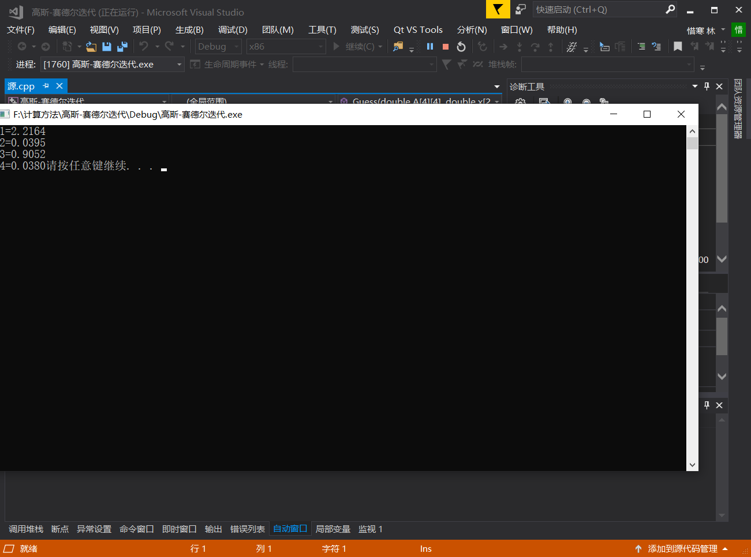

代码如下：

#include<iostream>

#include<math.h>

#include<iomanip>

using namespace std;

double Guess(double A[4][4], double x[20][4], double b[4]) {

int i = 0;

while (i < 10) {

x[i + 1][0] = (b[0] - A[0][1] * x[i][1] - A[0][2] * x[i][2]-A[0][3]*x[i][3]) / A[0][0];

x[i + 1][1] = (b[1] - A[1][0] * x[i+1][0] - A[1][2] * x[i][2]-A[1][3]*x[i][3]) / A[1][1];

x[i + 1][2] = (b[2] - A[2][0] * x[i+1][0] - A[2][1] * x[i+1][1]-A[2][3]*x[i][3]) / A[2][2];

x[i + 1][3] = (b[3] - A[3][0] * x[i + 1][0] - A[3][1] * x[i + 1][1]-A[3][2]*x[i+1][2]) / A[3][3];

i++;

}

cout <<"x1="<<setprecision(5)<< x[i - 1][0] << endl;

cout << "x2=" << setprecision(3) << x[i - 1][1] << endl;

cout << "x3=" << setprecision(4) << x[i - 1][2] << endl;

printf("x4=%4.4f", x[i - 1][3]);

return 0;

}

int main() {

double A[4][4] = { 4,1,-1,0,1,-5,-1,-3,2,-1,-6,1,5,4,4,30 };

double b[4] = { 8,1,-1,16};

double x[20][4];

x[0][0] = 1, x[0][1] = 1, x[0][2] = 1,x[0][3]=1;

Guess(A, x, b);

system("pause");

return 0;

}

题目四：

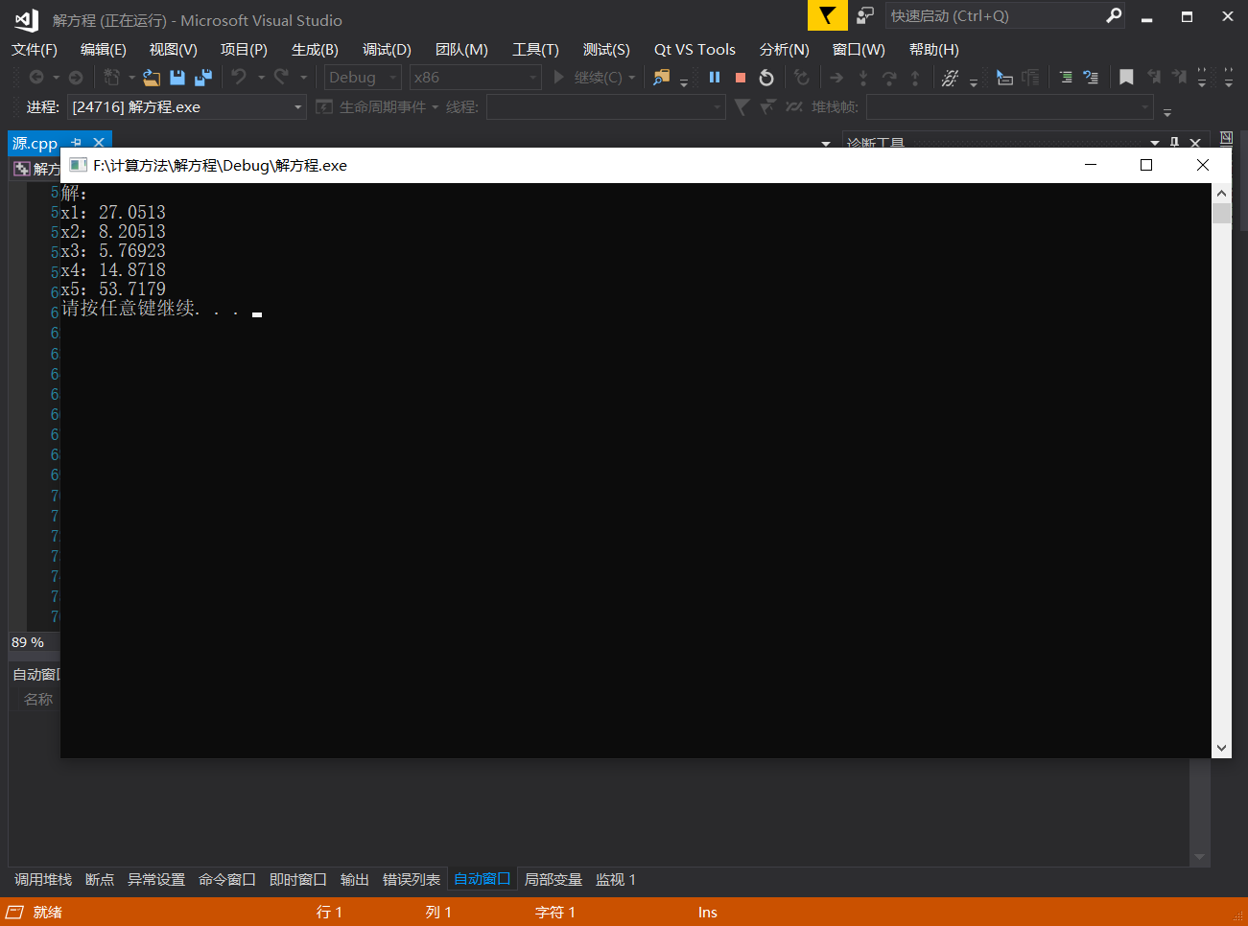

代码如下：

#include<iostream>

#include<math.h>

using namespace std;

void LU(int n, double *A, double *b)//n为阶数 A为系数矩阵 b为常数矩阵

{

double *L = new double[n*n];//开辟L矩阵空间

double *U = new double[n*n];//开辟U矩阵空间

double *y = new double[n];//开辟y矩阵空间

double *x = new double[n];

for (int i = 0; i < n; i++)

{

for (int j = 0; j < n; j++)

{

*(U + i * n + j) = 0;//暂时全部赋值为0

if (i == j)

{

*(L + i * n + j) = 1;//对角线赋值为1

}

else

{

*(L + i * n + j) = 0;//其他暂时赋值为0

}

}

}

for (int k = 0; k < n; k++)//计算u和l矩阵的值

{

for (int j = k; j < n; j++)

{

*(U + k * n + j) = *(A + k * n + j);//第一行

for (int r = 0; r < k; r++)//接下来由L的前一列算u的下一行

{

*(U + k * n + j) = *(U + k * n + j) - (*(L + k * n + r)*(*(U + r * n + j)));

}

}

for (int i = k + 1; i < n; i++)//计算L的列

{

*(L + i * n + k) = *(A + i * n + k);

for (int r = 0; r < k; r++)

{

*(L + i * n + k) = *(L + i * n + k) - (*(L + i * n + r)*(*(U + r * n + k)));

}

*(L + i * n + k) = *(L + i * n + k) / (*(U + k * n + k));

}

}

for (int i = 0; i < n; i++)//由Ly=b算y

{

*(y + i) = *(b + i);

for (int j = 0; j < i; j++)

{

*(y + i) = *(y + i) - *(L + i * n + j)*(*(y + j));

}

}

for (int i = n - 1; i >= 0; i--)//由Ux=y算x

{

*(x + i) = *(y + i);

for (int j = i + 1; j < n; j++)

{

*(y + i) = *(y + i) - *(U + i * n + j)*(*(x + j));

}

*(x + i) = *(y + i) / (*(U + i * n + i));

}

cout << "解：\n";

for (int i = 0; i < n; i++)

{

cout << "x" << i + 1 << "：" << *(x + i) << endl;

}

delete[]L;

delete[]U;

delete[]y;

}

int main() {

double A[25] = { 4,-1,0,0,0,-1,4,-1,0,0,0,-1,4,-1,0,0,0,-1,4,-1,0,0,0,-1,4};

double b[5] = {100,0,0,0,200 };

LU(5, A, b);

system("pause");

return 0;

}

题目五第一问：

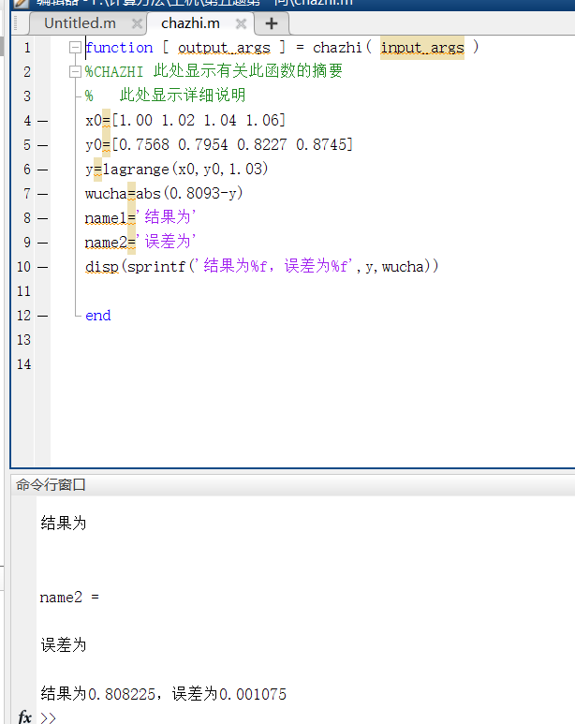

代码如下：

lagrange.m:

function y=lagrange(x0,y0,x);

n=length(x0);

m=length(x);

for i=1:m

z=x(i);

s=0.0;

for k=1:n

p=1.0;

for j=1:n

if j~=k

p=p*(z-x0(j))/(x0(k)-x0(j)); end

end

s=p*y0(k)+s;

end

y(i)=s;

end

**f.m:**

function g = f( x )

%UNTITLED ´Ë´¦ÏÔÊ¾ÓÐ¹Ø´Ëº¯ÊýµÄÕªÒª

% ´Ë´¦ÏÔÊ¾ÏêÏ¸ËµÃ÷

%x0=1.00,x1=1.02,x3=1.04,x4=1.06

%y0=0.7568,y1=0.7954,y2=0.8227,y3=0.8745

g=exp(x)*(3*x-exp(x))

end

**chazhi.m:**

function [ output_args ] = chazhi( input_args )

%CHAZHI ´Ë´¦ÏÔÊ¾ÓÐ¹Ø´Ëº¯ÊýµÄÕªÒª

% ´Ë´¦ÏÔÊ¾ÏêÏ¸ËµÃ÷

x0=[1.00 1.02 1.04 1.06]

y0=[0.7568 0.7954 0.8227 0.8745]

y=lagrange(x0,y0,1.03)

wucha=abs(0.8093-y)

name1='½á¹ûÎª'

name2='Îó²îÎª'

disp(sprintf('½á¹ûÎª%f£¬Îó²îÎª%f',y,wucha))

end

题目五第二问：

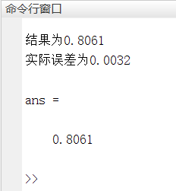

**代码如下：**

**hermite.m：**

function[y,R,Hc,Hk,wcgs,Cw] = hermite(X,Y,Y1,x,M)

n = length(X);

m = length(x);

%x=[1.00 1.05]

%y=[0.7568 0.8354]

%y1=[1.5316 1.2422M)

for t = 1 : m

z = x(t);

H = 0;

q = 1;

c1 = 1;

for k = 1 : n

s = 0;

V = 1;

for i = 1 : n

if k ~= i

s = s + (1/(X(k)-X(i)));

V = conv(V,poly(X(i)))/(X(k)-X(i));

end

end

h = poly(X(k));

g = ([0 1]-2 * h * s);

G = g * Y(k) + h * Y1(k);

H = H + conv(G,conv(V,V));%hermite²åÖµ¶àÏîÊ½

b = poly(X(k));

b2 = conv(b,b);

q = conv(q,b2);

end

name1='Êµ¼ÊÎó²îÎª0.0032'

name2='½á¹ûÎª0.8061'

Hc = H;

Hk = poly2sym(H);

Q = poly2sym(q);

for i = 1 : 2*n

c1 = c1 * i;

end

wcgs = M * Q / c1;

Cw = M * q / c1;

y(t) = polyval(Hc,x(t));

R(t) = polyval(Cw,x(t));

disp(name2)

disp(name1)

end

**f.m:**

function g = f( x )

%UNTITLED ´Ë´¦ÏÔÊ¾ÓÐ¹Ø´Ëº¯ÊýµÄÕªÒª

% ´Ë´¦ÏÔÊ¾ÏêÏ¸ËµÃ÷

g=3*x*exp(x)+3*exp(x)-2*exp(2*x)

end

**题目六：**

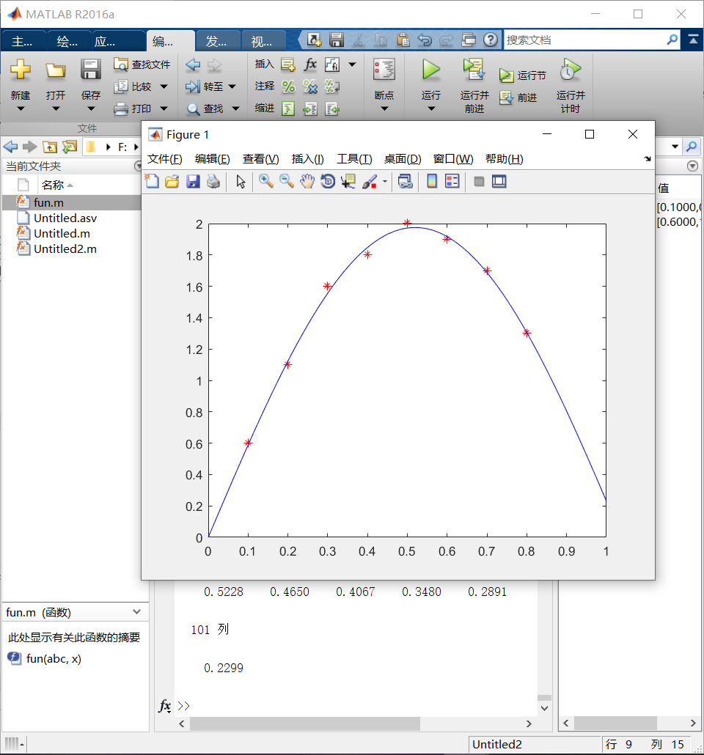

**代码如下：**

**fun.m**

function y= fun( abc,x )

y=abc(1)*sin(abc(2)*x)

end

**Unititled.m:**

function [ output_args ] = Untitled2( input_args )

x=[0.1 0.2 0.3 0.4 0.5 0.6 0.7 0.8]

y=[0.6 1.1 1.6 1.8 2.0 1.9 1.7 1.3]

x1=[0:0.01:1]

abc=lsqcurvefit(@fun,x1,x,y)

y1=abc(1)*sin(abc(2)*x1)

plot(x,y,'r*',x1,y1,'b-')

end

**题目七第一问**

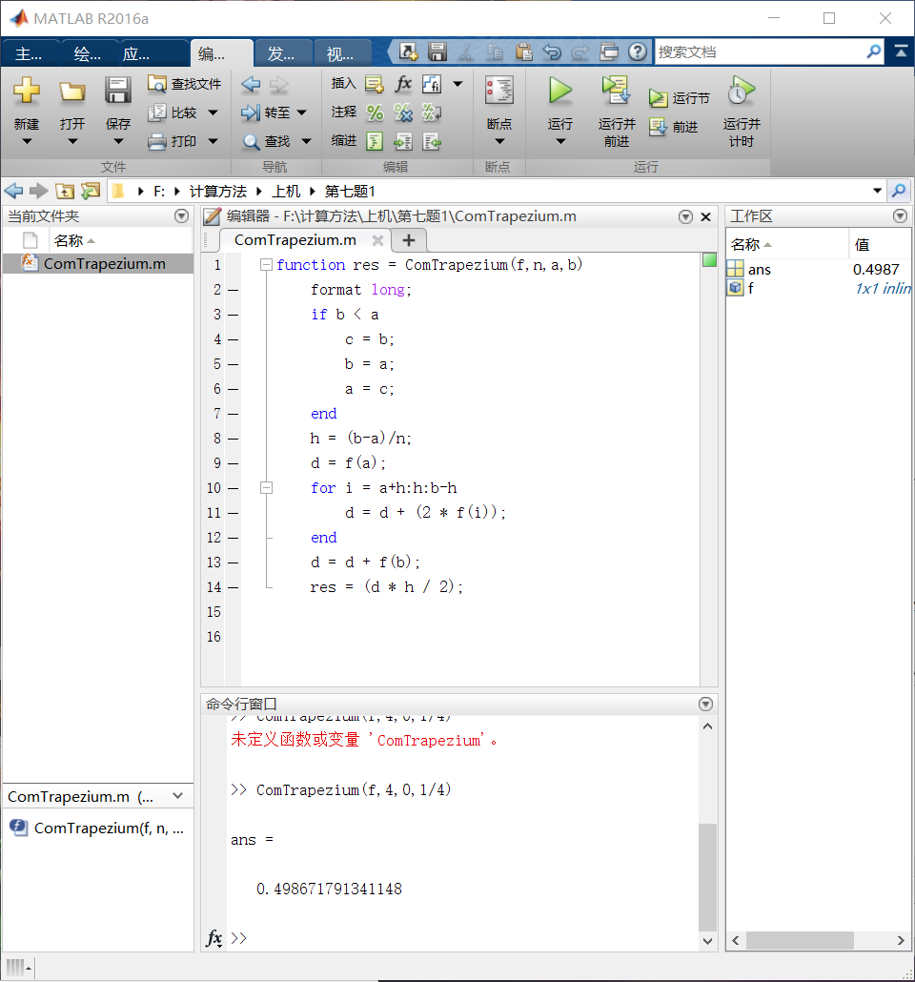

**代码如下：**

**ComTrapezium.m：**

function res = ComTrapezium(f,n,a,b)

format long;

if b < a

c = b;

b = a;

a = c;

end

h = (b-a)/n;

d = f(a);

for i = a+h:h:b-h

d = d + (2 * f(i));

end

d = d + f(b);

res = (d * h / 2);

**题目七第二问：**

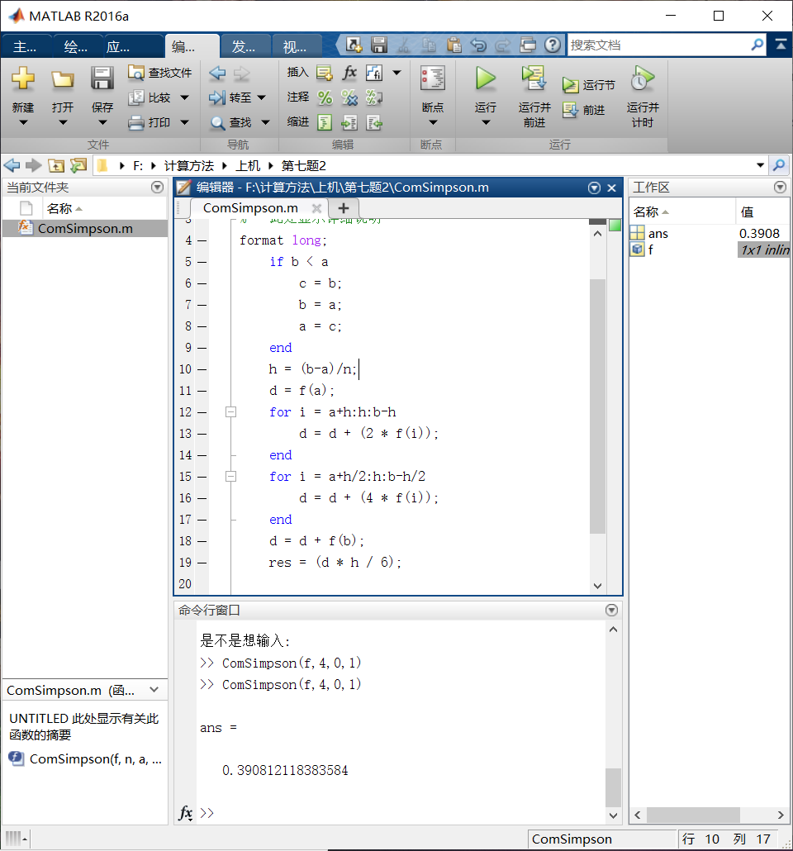

**代码如下：**

**ComSimpson.m:**

function res=ComSimpson(f,n,a,b)

%UNTITLED ´Ë´¦ÏÔÊ¾ÓÐ¹Ø´Ëº¯ÊýµÄÕªÒª

% ´Ë´¦ÏÔÊ¾ÏêÏ¸ËµÃ÷

format long;

if b < a

c = b;

b = a;

a = c;

end

h = (b-a)/n;

d = f(a);

for i = a+h:h:b-h

d = d + (2 * f(i));

end

for i = a+h/2:h:b-h/2

d = d + (4 * f(i));

end

d = d + f(b);

res = (d * h / 6);

end

**题目八：**

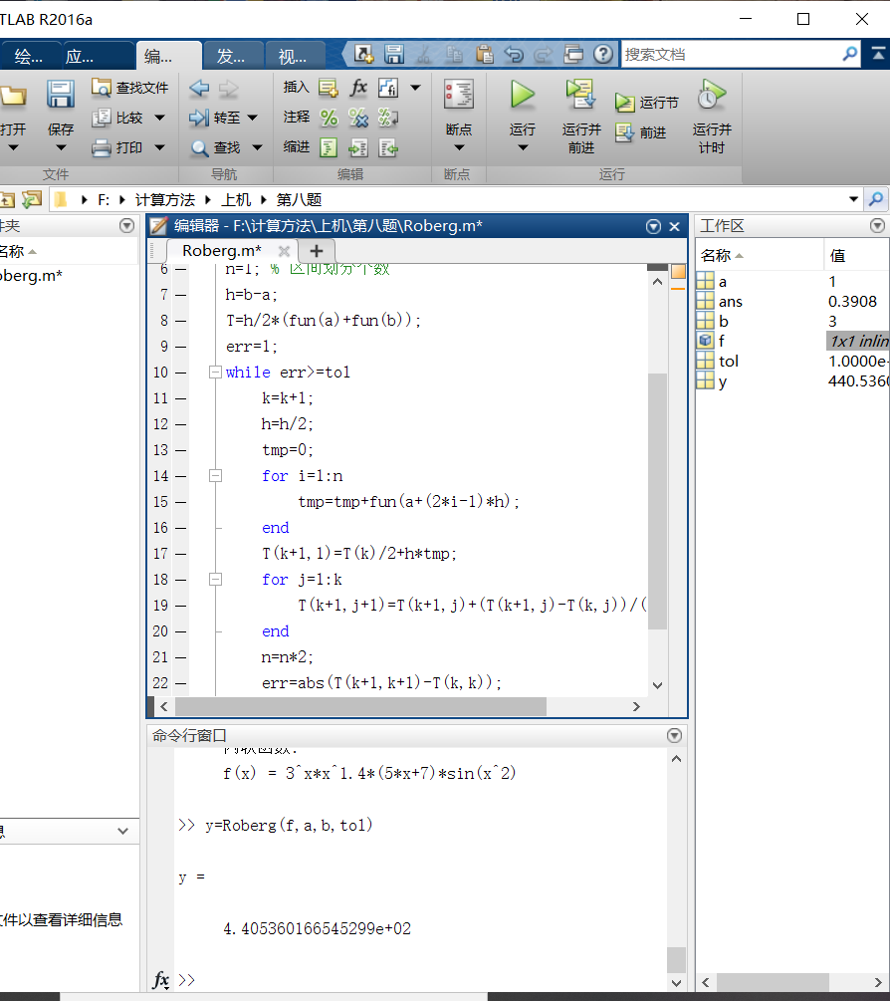

**代码如下：**

**Roberg.m:**

function [R,k,T]=romberg(fun,a,b,tol)

% -fun£º»ý·Öº¯Êý

% -a/b£º»ý·ÖÉÏÏÂÏÞ

% -tol£º»ý·ÖÎó²î

k=0; % µü´ú´ÎÊý

n=1; % Çø¼ä»®·Ö¸öÊý

h=b-a;

T=h/2*(fun(a)+fun(b));

err=1;

while err>=tol

k=k+1;

h=h/2;

tmp=0;

for i=1:n

tmp=tmp+fun(a+(2*i-1)*h);

end

T(k+1,1)=T(k)/2+h*tmp;

for j=1:k

T(k+1,j+1)=T(k+1,j)+(T(k+1,j)-T(k,j))/(4^j-1);

end

n=n*2;

err=abs(T(k+1,k+1)-T(k,k));

end

R=T(k+1,4);

题目九：

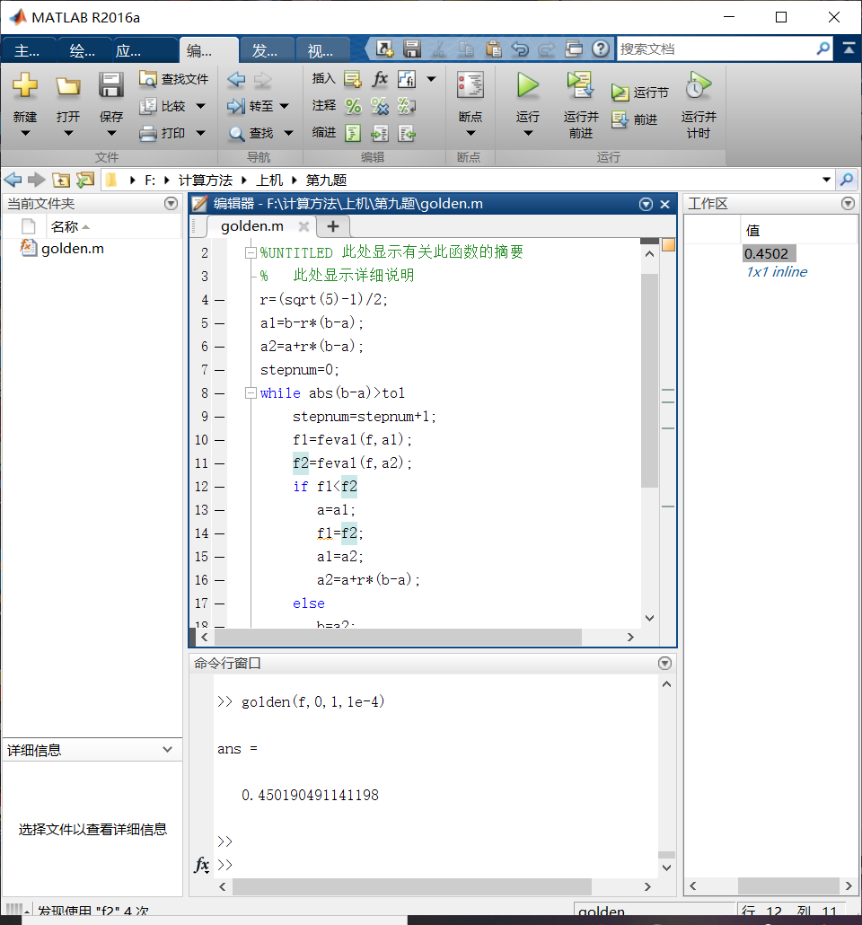

代码如下：

function [ x_opt,f_opt,stepnum ] =golden(f,a,b,tol)

%UNTITLED ´Ë´¦ÏÔÊ¾ÓÐ¹Ø´Ëº¯ÊýµÄÕªÒª

% ´Ë´¦ÏÔÊ¾ÏêÏ¸ËµÃ÷

r=(sqrt(5)-1)/2;

a1=b-r*(b-a);

a2=a+r*(b-a);

stepnum=0;

while abs(b-a)>tol

stepnum=stepnum+1;

f1=feval(f,a1);

f2=feval(f,a2);

if f1<f2

a=a1;

f1=f2;

a1=a2;

a2=a+r*(b-a);

else

b=a2;

a2=a1;

f2=f1;

a1=b-r*(b-a);

end

x_opt=(a+b)/2;

f_opt=feval(f,x_opt);

end