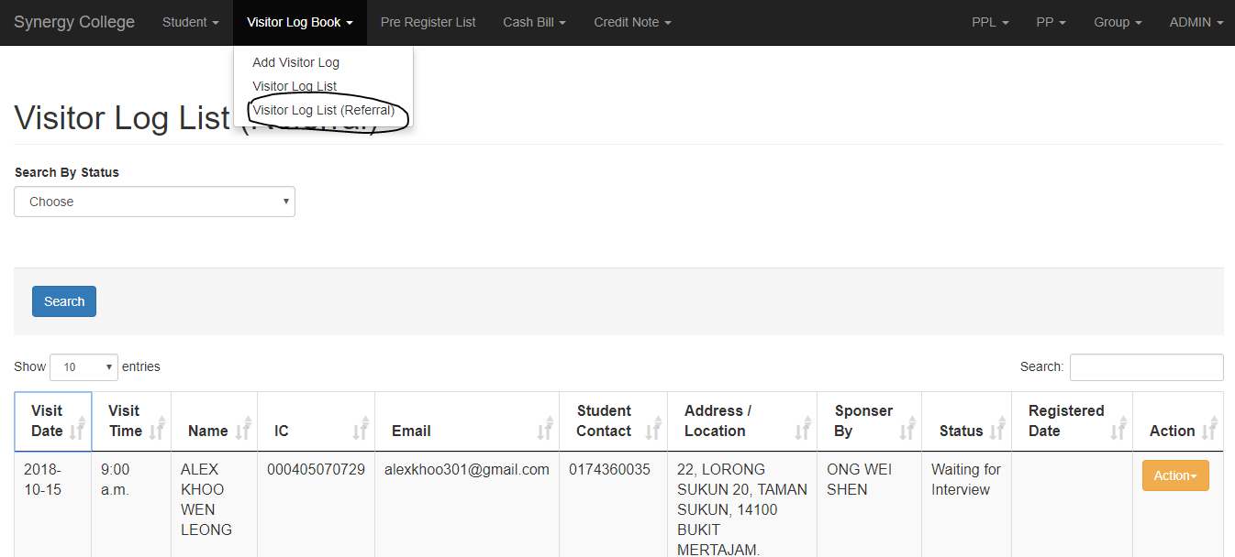

Go to <http://registration.synergy-college.org> to view the referral visitor list.

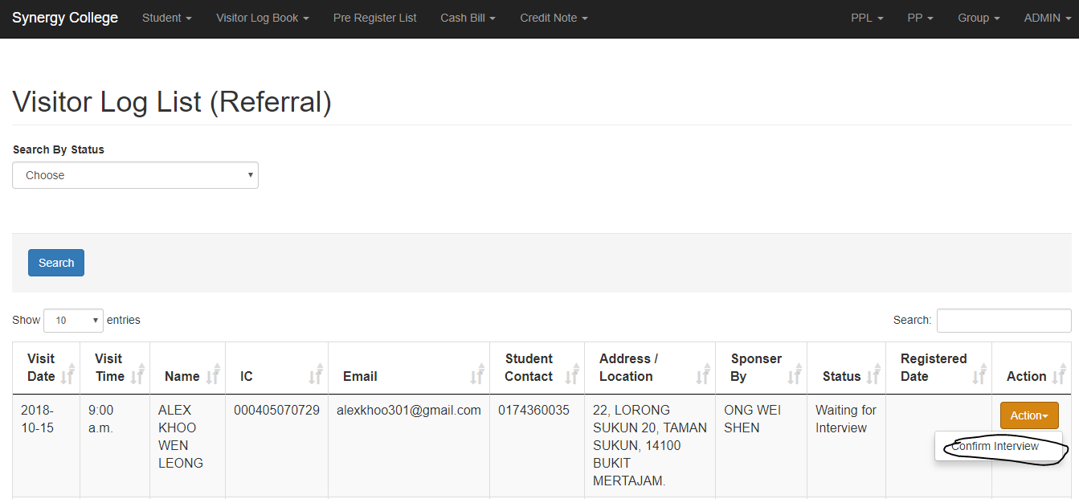

After make the interview, click the confirm button. The list will disappear after 5 days, if the visitor absent.

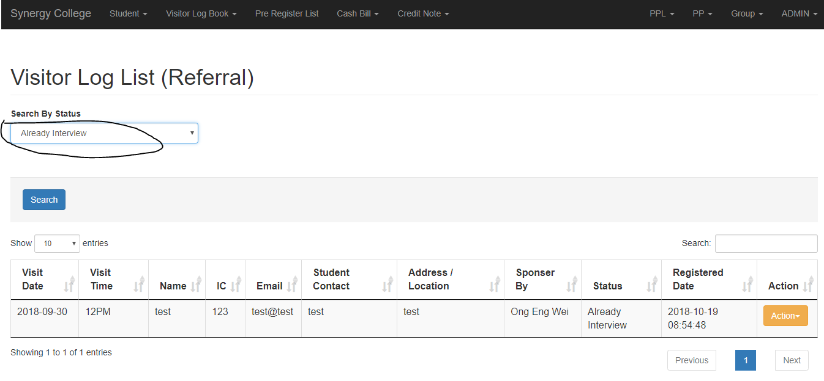

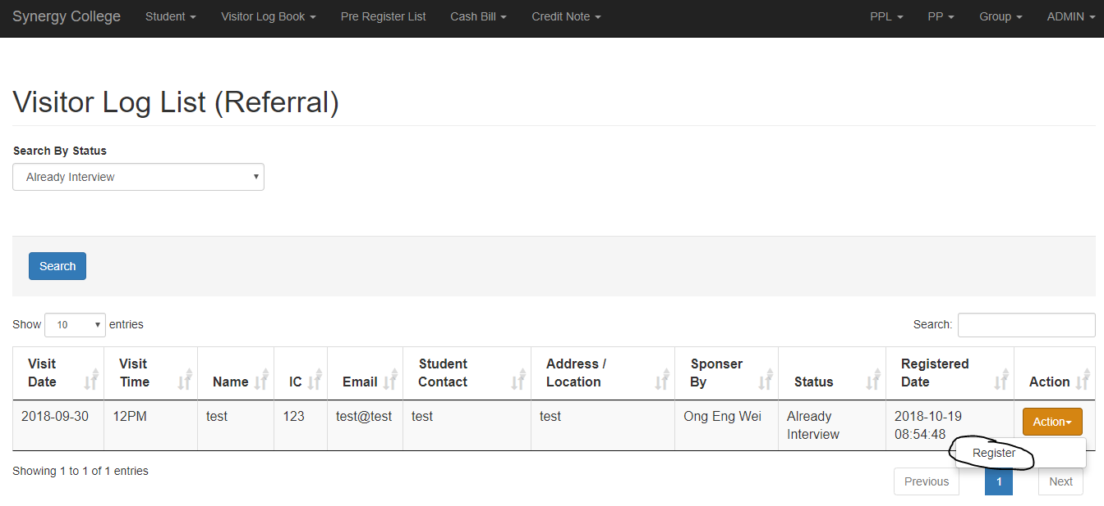

You can search by Already Interview, then click register button to register. The list will disappear after 60 days, if the student didn't become our student, and this student is not longer valid for the referral program.

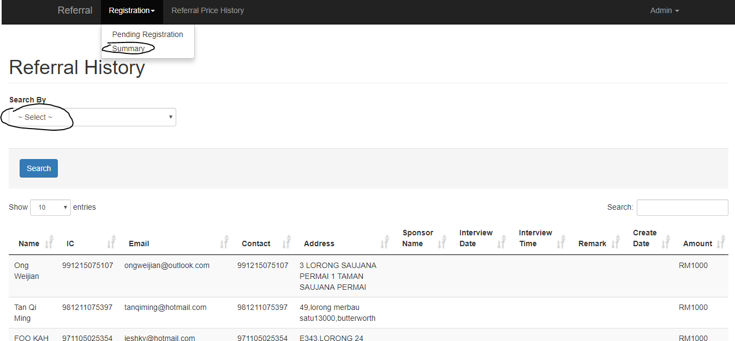

You can go to <http://register.synergy-college.org> , click summary, then search the status, to view the approval, expired, and reject referral list.