??????
?????

??? | ???????
??? | ???????
??? | ??
??? | 20231060024
??? | ???

06/2026

?????????
?????????????? Hugging Face Transformers ?????????????????????????????????????????? BERT?GPT-2?T5 ?????????????
- ?? BERT ??????Transformer ?????????????????
- ???? BERT ????????????????????????????
- ???? GPT-2 ?????????????????????????
- ???? T5/mT5 ?????????????-??????????????
- ??????????????????????????????????????????

??????
?? | ???? | ??? | ??????
??? | BERT ?????? | SST-2 ???? | Accuracy
??? | BERT ?????? | GLUE RTE ???? | Accuracy
??? | BERT ??????? | SQuAD ???? | EM / F1 / Eval Loss
??? | BERT ???? | CoNLL-2003 NER | Precision / Recall / F1 / Accuracy
??? | GPT-2 ???? | WikiText-2 ???? | Perplexity
??? | T5/mT5 ???? | IWSLT2017 ???? | BLEU / Loss / ????

????????
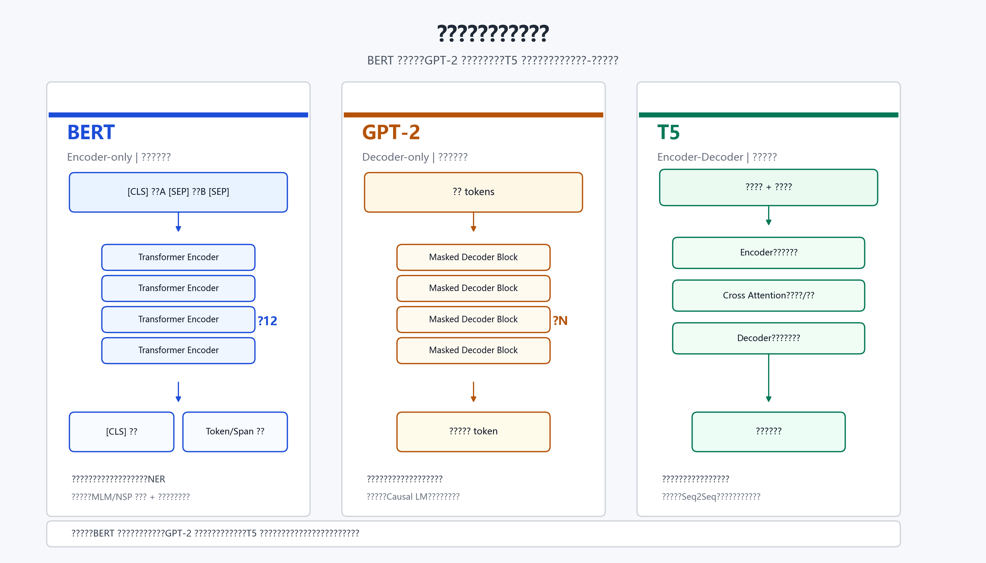
?1 BERT?GPT-2 ? T5 ???????
?? | ???? | ????? | ????/?? | ???? | ???????
BERT | Encoder-only | ?????? | ???? -> ????/?? | ????????????? | SSC?SPC?MRC?NER
GPT-2 | Decoder-only | ?????????? | ?? -> ??? token/???? | ?????????? | WikiText ??????
T5/mT5 | Encoder-Decoder | ?????????????????? | ?????????? -> ???? | ??????????? | IWSLT ????
?????BERT ????????????????????????????????GPT-2 ?????????????????????????T5/mT5 ?????-??????????????????????????????????????????????
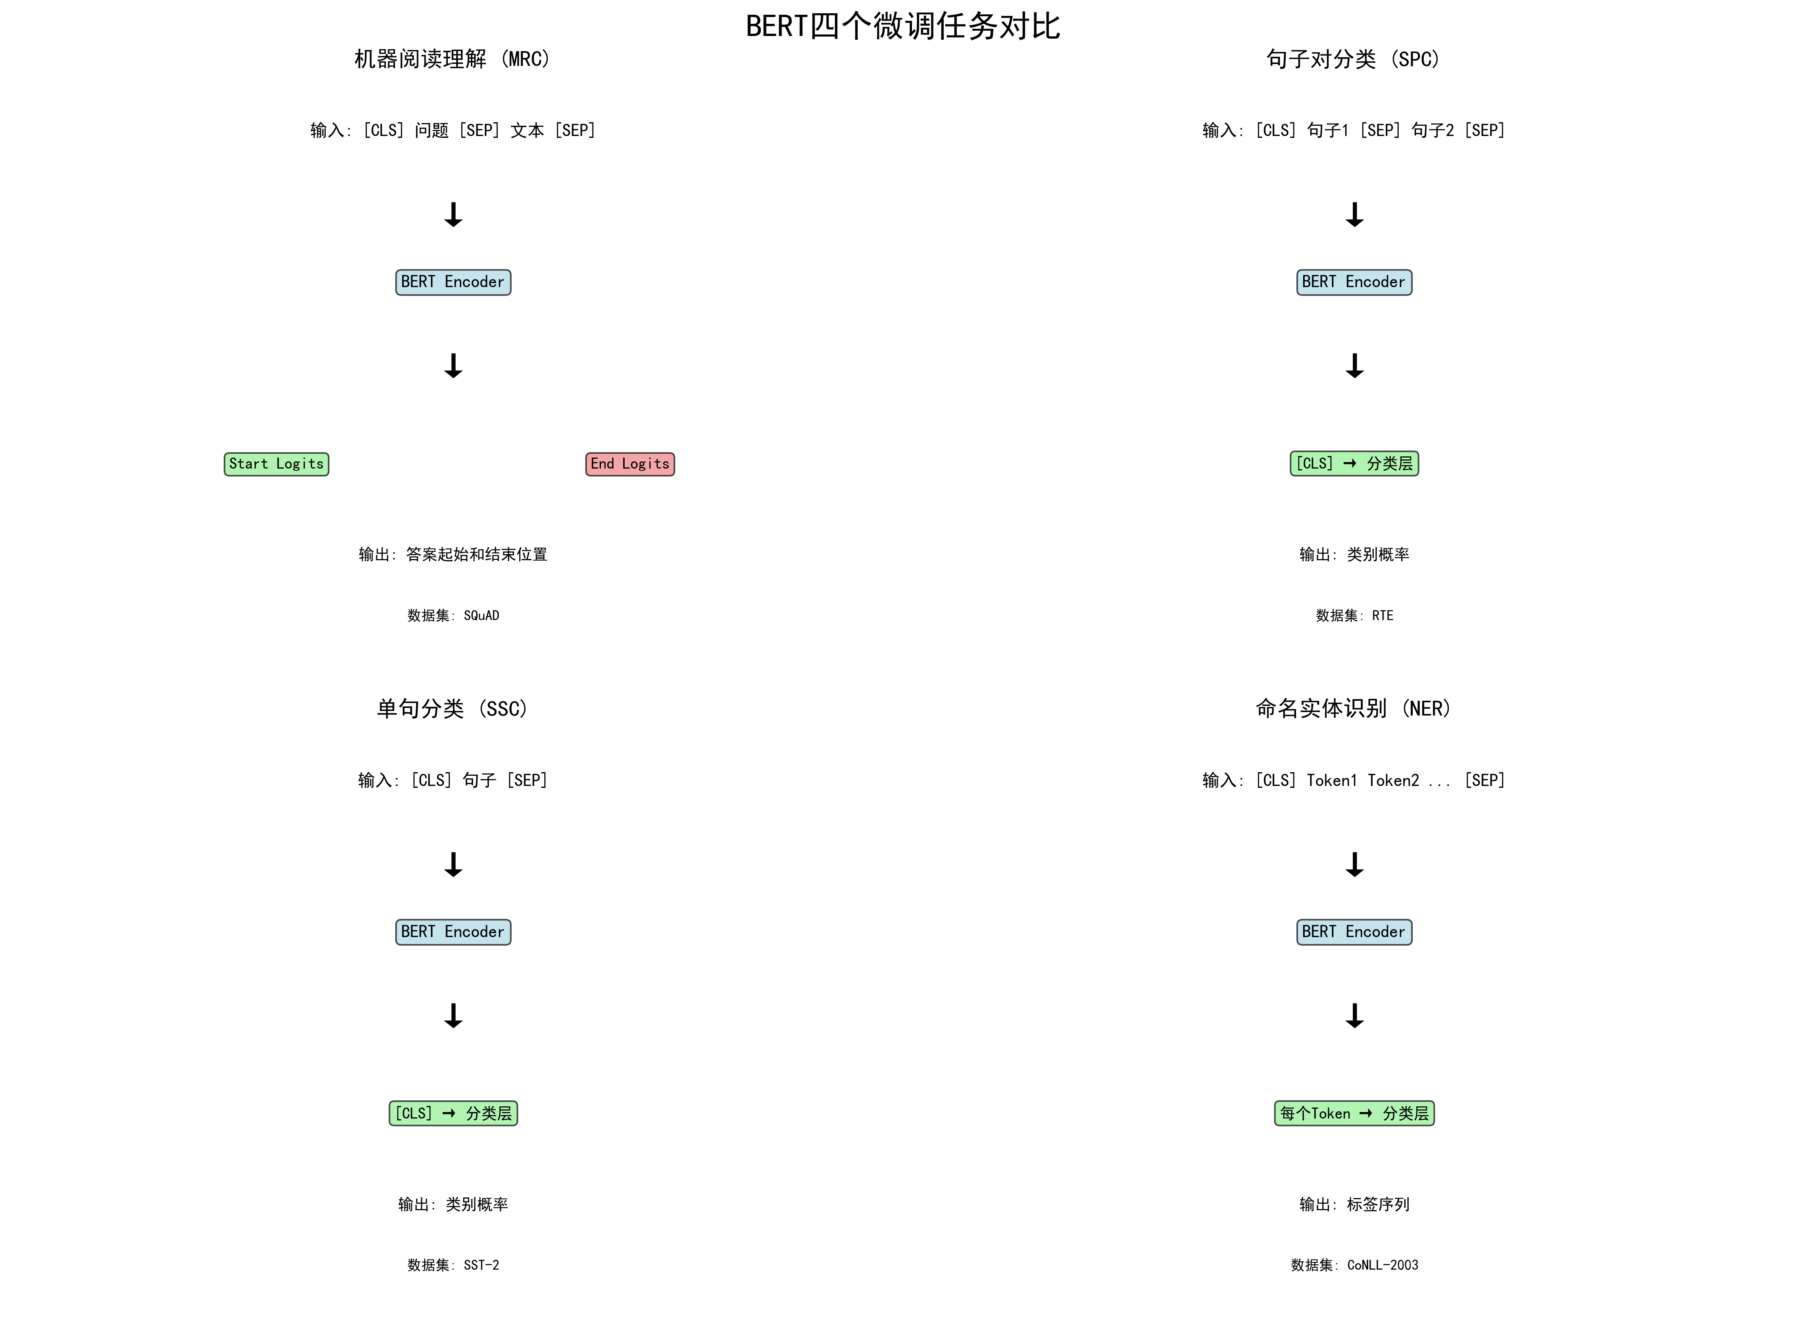
?2 BERT ??????????????

??????????????

4.1 ????BERT ???????????????
????? SST-2 ???????????????????????? positive/negative ?????????? bert-base-cased??????? BertForSequenceClassification ????????
dataset = load_dataset('nyu-mll/glue', 'sst2')
tokenizer = BertTokenizerFast.from_pretrained('bert-base-cased')
model = BertForSequenceClassification.from_pretrained(
'bert-base-cased', num_labels=2, return_dict=True
)
def tokenize(examples):
return tokenizer(examples['sentence'], truncation=True, padding='max_length')
- ?????? SST-2 ????BERT ??????????SST-2 ???????????????? sentence ???????
- tokenizer ??? input_ids?token_type_ids ? attention_mask??? attention_mask ???? padding ??????? token ???????
- BertForSequenceClassification ? [CLS] ??? pooled output?? dropout ??????????? logits?
- compute_metrics ?? np.argmax ??????????? GLUE/SST-2 ? accuracy ???????????
- ???????????????? batch size ?????? gradient_accumulation_steps=2 ? fp16=True????/??????????????????
?????????????????????????????????? BERT ?????????????????????????????????SST-2 ???????????????????????????????????????????????????????????????????????????????????????????????????????? BERT ? [CLS] ????????????????
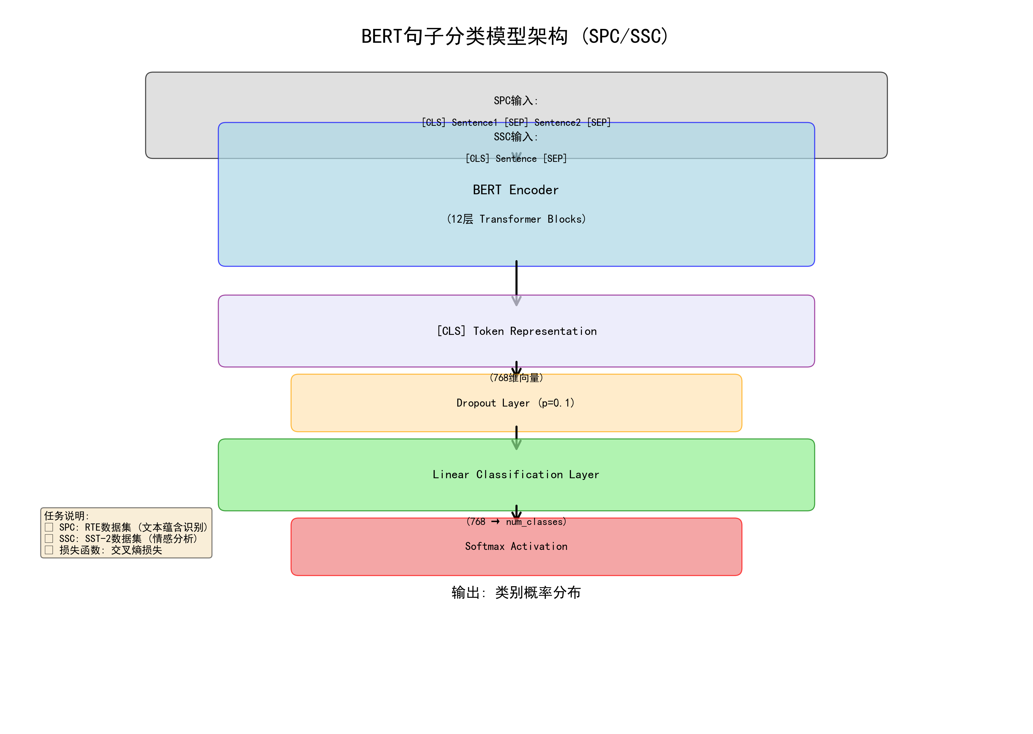
?3 BERT ??/????????

4.2 ????BERT ???????????????
????? GLUE RTE ??????????????? sentence1 ? sentence2 ???????? entailment ? not entailment?
dataset = load_dataset('glue', 'rte')
tokenizer = BertTokenizerFast.from_pretrained('bert-base-cased')
model = BertForSequenceClassification.from_pretrained('bert-base-cased', return_dict=True)
def tokenize(examples):
return tokenizer(examples['sentence1'], examples['sentence2'],
truncation=True, padding='max_length')
- ?????????? [CLS] sentence1 [SEP] sentence2 [SEP]?token_type_ids ???????????
- ??????????????????????????????????????????
- ???????????? 2e-5 ? 2 ? epoch???????????????????????????
- ?????? GLUE/RTE ??????? accuracy?
?????RTE ??????????????????????????????? SST-2 ??????BERT ? segment embedding ???????????????????????????????????????????????????????????????????????????????????????????????????????????????????????

4.3 ????BERT ???????????
????? SQuAD ???????????????????????????????????????????? token ????? token ???
dataset = load_dataset('rajpurkar/squad')
tokenizer = BertTokenizerFast.from_pretrained('bert-base-cased')
model = BertForQuestionAnswering.from_pretrained(
'bert-base-cased', return_dict=True
)
def prepare_train_features(examples):
tokenized_examples = tokenizer(
examples['question'], examples['context'],
truncation='only_second', max_length=384, stride=128,
return_overflowing_tokens=True,
return_offsets_mapping=True,
padding='max_length'
)
- ??? question ??????context ????????? truncation="only_second"????????????????? context?
- max_length=384 ? stride=128 ????????? context ??????????????????????????????
- return_offsets_mapping ?? token ????????????????????????????? token ? start_positions ? end_positions?
- BertForQuestionAnswering ??? token ??? start logits ? end logits????????????????????
- ? notebook ????? eval_loss ????????????? SQuAD EM/F1???????? start/end logits ???????????? squad metric?
??????????????????????????????????????????????????????????????????????????????????????????????????????????????????????????????????SQuAD ??????????????? BERT ??????????????????????????????????????
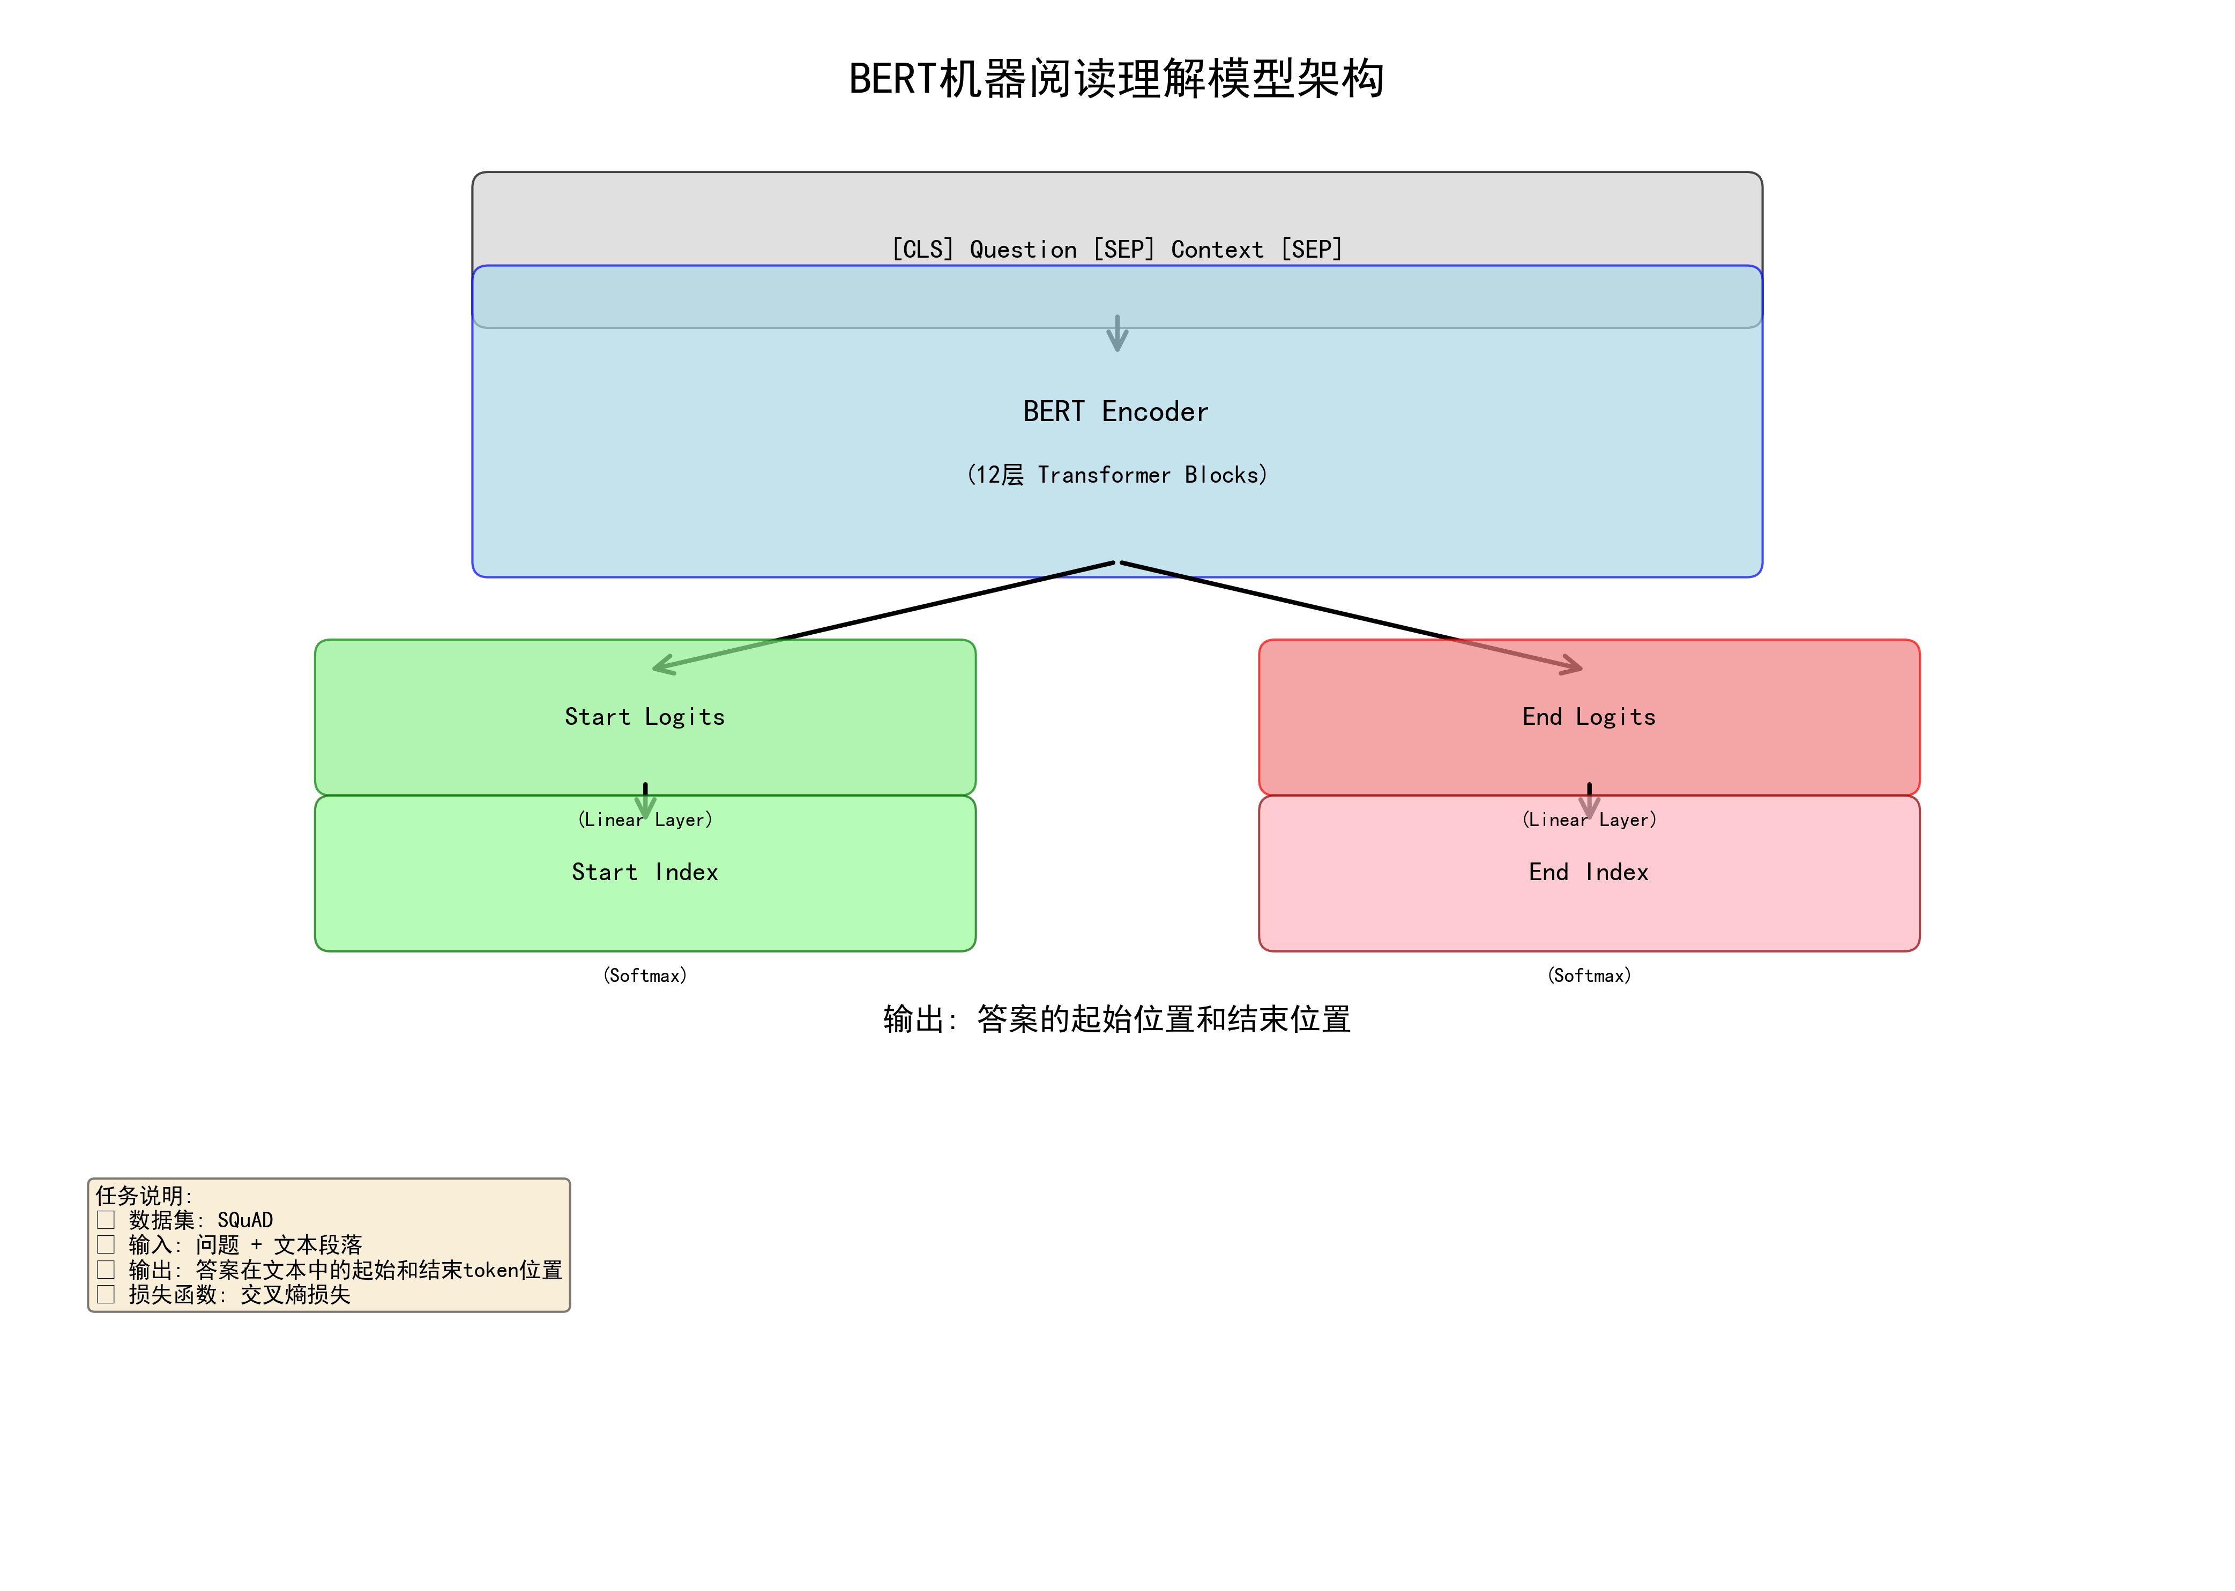
?4 BERT ???????????

4.4 ????BERT ???????????????
????? CoNLL-2003 ????? NER?????????NER ??????????? token ???? BIO ????? B-PER?I-ORG?B-LOC ??
label2id = {
'O': 0, 'B-MISC': 1, 'I-MISC': 2, 'B-PER': 3, 'I-PER': 4,
'B-ORG': 5, 'I-ORG': 6, 'B-LOC': 7, 'I-LOC': 8
}
tokenized_inputs = tokenizer(examples['tokens'], truncation=True,
is_split_into_words=True)
word_ids = tokenized_inputs.word_ids(batch_index=i)
# ?? token ?? -100??? loss ?????
model = BertForTokenClassification.from_pretrained(
'bert-base-cased', num_labels=len(label_list),
id2label=id2label, label2id=label2id
)
- ??? GitHub ???? CoNLL-2003 ? train/validation/test ???????? 9 ? BIO ?????
- tokenizer ?? is_split_into_words=True????????????BERT WordPiece ??????????????????? word_ids ????????????
- ???? [CLS]?[SEP] ? padding ?????? -100?PyTorch ??????????????????????
- DataCollatorForTokenClassification ???? padding???? labels ? input_ids ?????
- seqeval ????? precision?recall?F1 ? accuracy???? token accuracy ??????????????????
?????NER ????????????????????????? F1 ??????? BERT ?????????????????????????????? ?Washington? ??????????????????????????????????MISC ??????????????? WordPiece ????????????????BERT + token classification head ???????????????????
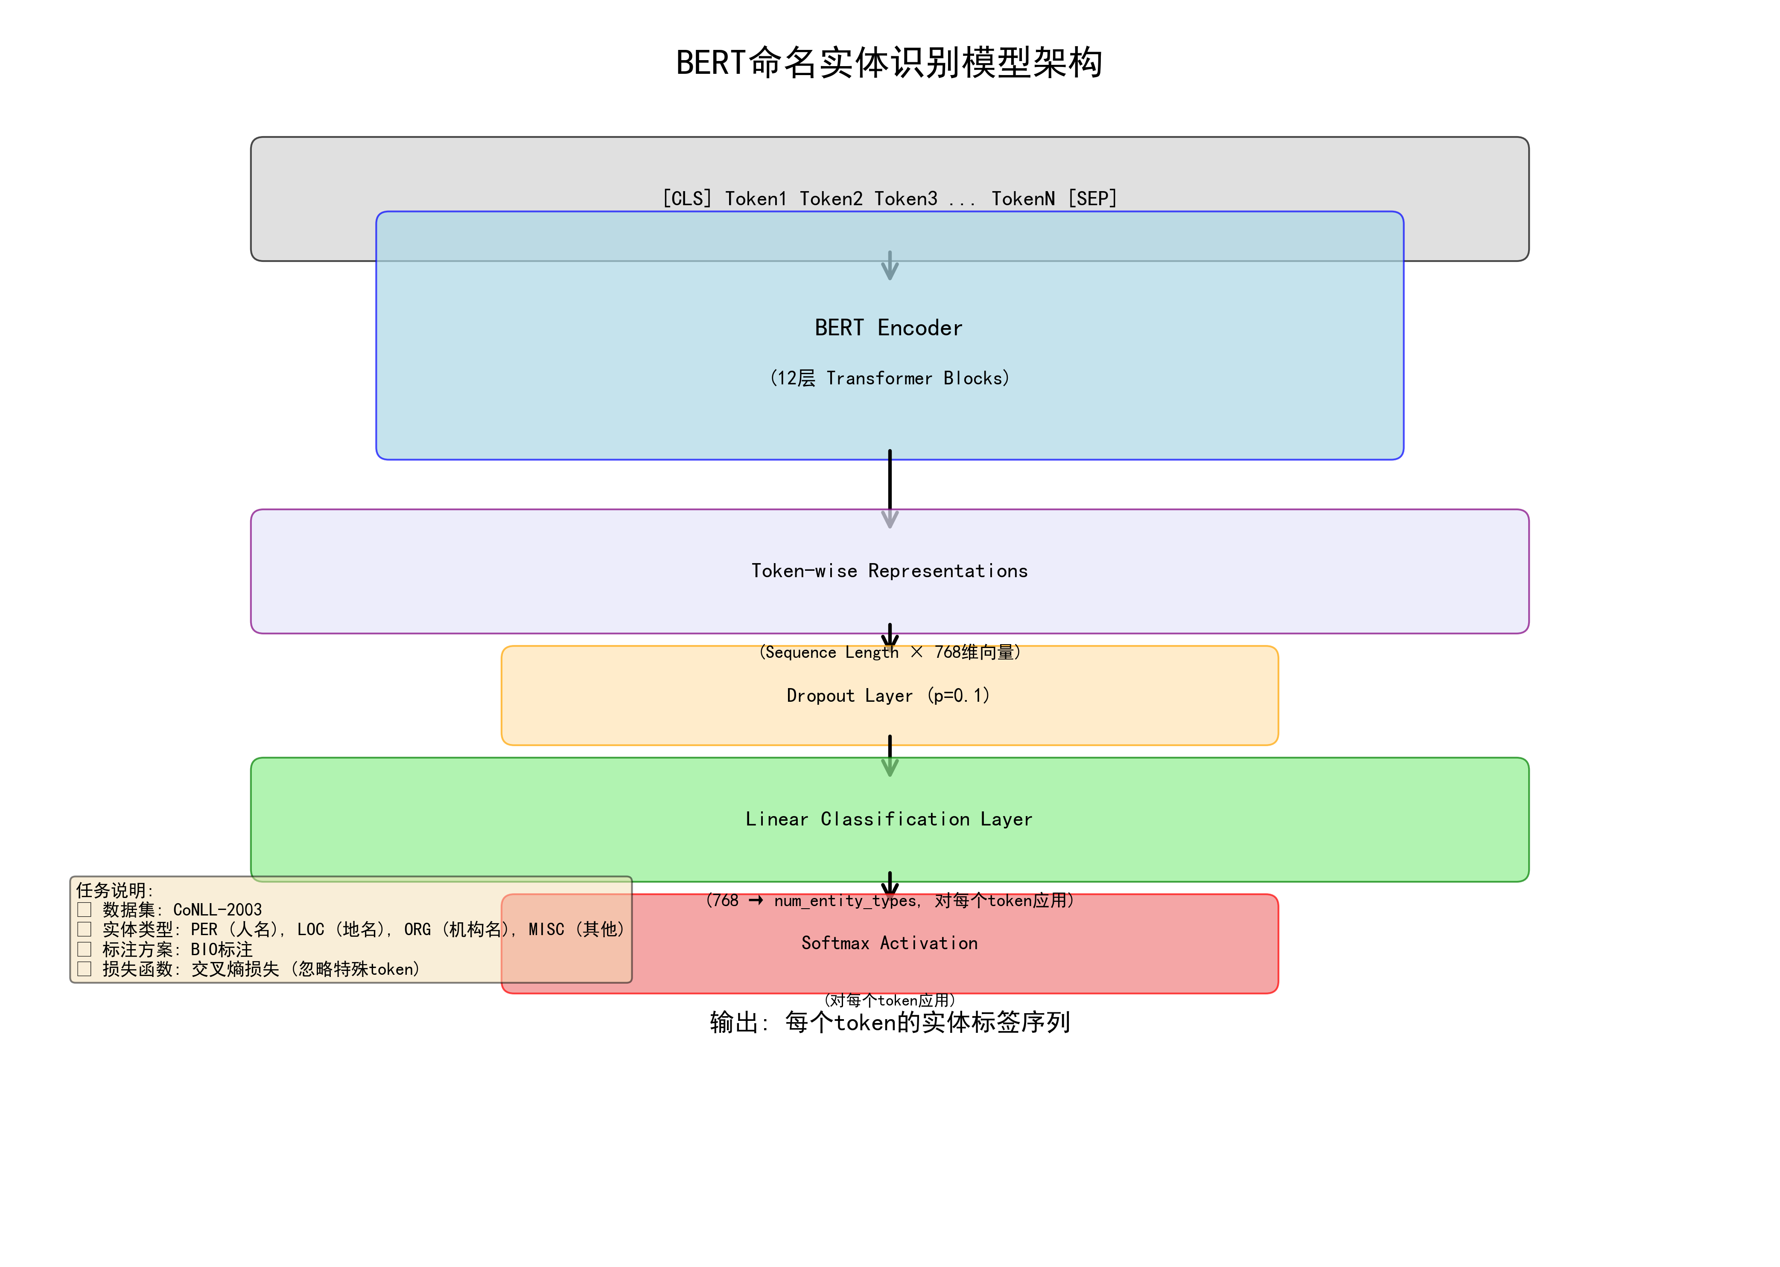
?5 BERT ??????????

4.5 ????GPT-2 ?????????????????
????? WikiText-2 ???? GPT-2 ????????????????????? gpt2????? distilgpt2????? GPT-2 ??????????????
wikitext_data = load_dataset('wikitext', 'wikitext-2-v1')
tokenizer = AutoTokenizer.from_pretrained('gpt2')
model = AutoModelForCausalLM.from_pretrained('distilgpt2')
def group_texts(examples):
concatenated = {k: sum(examples[k], []) for k in examples.keys()}
result = {k: [t[i:i+128] for i in range(0, total_length, 128)]
for k, t in concatenated.items()}
result['labels'] = result['input_ids'].copy()
- preprocess_function ??????? token ???group_texts ??????? block_size=128 ?????
- labels ???? input_ids??????????????? token?????????????????
- DataCollatorForLanguageModeling ?? mlm=False?????? BERT ?????????? GPT ???????
- ?????? perplexity = exp(eval_loss)????????????????????????????
?????GPT-2 ?????? BERT ?????BERT ???????????????????? GPT-2 ????????????? token ???????????? eval_loss ???perplexity ??????????????????????????????????? loss???????????? top_k?top_p?temperature ??????????????????????????????

4.6 ????T5/mT5 ????????
? notebook ?????? iwslt2017-zh-en ???? google/mt5-small ???????????????????????????????????????????????????????
model_name = 'google/mt5-small'
iwslt_data = load_dataset('iwslt2017', 'iwslt2017-zh-en')
prefix = 'translate Chinese to English: '
def preprocess_function(examples):
inputs = [prefix + ex['zh'] for ex in examples['translation']]
targets = [ex['en'] for ex in examples['translation']]
return tokenizer(inputs, text_target=targets,
max_length=128, truncation=True)
- T5/mT5 ???????????????? translate Chinese to English: ??????????????
- tokenizer(inputs, text_target=targets) ???????????????? decoder ??????????????
- DataCollatorForSeq2Seq ????? encoder ???decoder ????? padding??????? decoder_input_ids?
- Seq2SeqTrainer ????????compute_metrics ???? sacrebleu ?? BLEU ?????????? do_eval=False???????????????????
- ?????? checkpoint-10000 ??????? generate ???????? top_k/top_p ??????????
????????????????? 0~5000 ????? 13.4 ??????? mT5 ????????????????5000~20000 ?????????????????????????????20000~31500 ???????? 2.94~3.00 ???????????????????????????????????????????????????????????????????????? BLEU ??????????????? loss ??????

??????

5.1 ????????????????
- ?????????????????????????????????? MLM?Causal LM?Seq2Seq ????????????
- ??????????????????????????????????????????????????
- ??????????????????????????????????????????????????????

5.2 ???? GPT ? BERT ?????
????GPT ? BERT ??? Transformer?????????????????????????????????????????????????????
????BERT ? Encoder-only ???????????????????? MLM/NSP?????????GPT ? Decoder-only ????????????????????????????????? token??????????

5.3 BERT ??????????????
Transformer ????????????????????????????????? token???????????????????????????????????????????????? token ?????????? BERT ?????????????????????????????????????????????????????????????????????

5.4 MLM?WWM ? NM ???????
???????????? BERT ???????????????????????????????????????????????????????????????????????????????????
?? | ??????? | ????????
MLM | ?????? token????????????? WordPiece ??? | ??????????? BERT ???
WWM | Whole Word Masking???????????????????????? | ??????????????????????????????
NM | ??? N-gram Masking??????? token ????????????????????? | ????? MLM/WWM ?????????????????????????????

????????????
- ??????????SQuAD ????? URI ??????????????? rajpurkar/squad ?????????????? datasets ? huggingface_hub?
- ???????SST-2 ????? OOM/RAM ?????????? per_device_train_batch_size??? gradient_accumulation_steps ?????????? fp16 ?????
- NER ??????????CoNLL-2003 ??? Hugging Face ????????? GitHub ??????????????????????
- ????????????T5/mT5 ????????????????????? checkpoint???????????????????????
- ?????????????????????????????? span ?????NER ?? token ???GPT-2/T5 ???????????????????????????????????

??????
??????????????????????? NLP ?????????BERT ???????????????????????????????GPT-2 ?????????????????T5/mT5 ?????????????????????????????????????????????????????????????????????????????????????-????????????????????????????????????????batch size????????????????
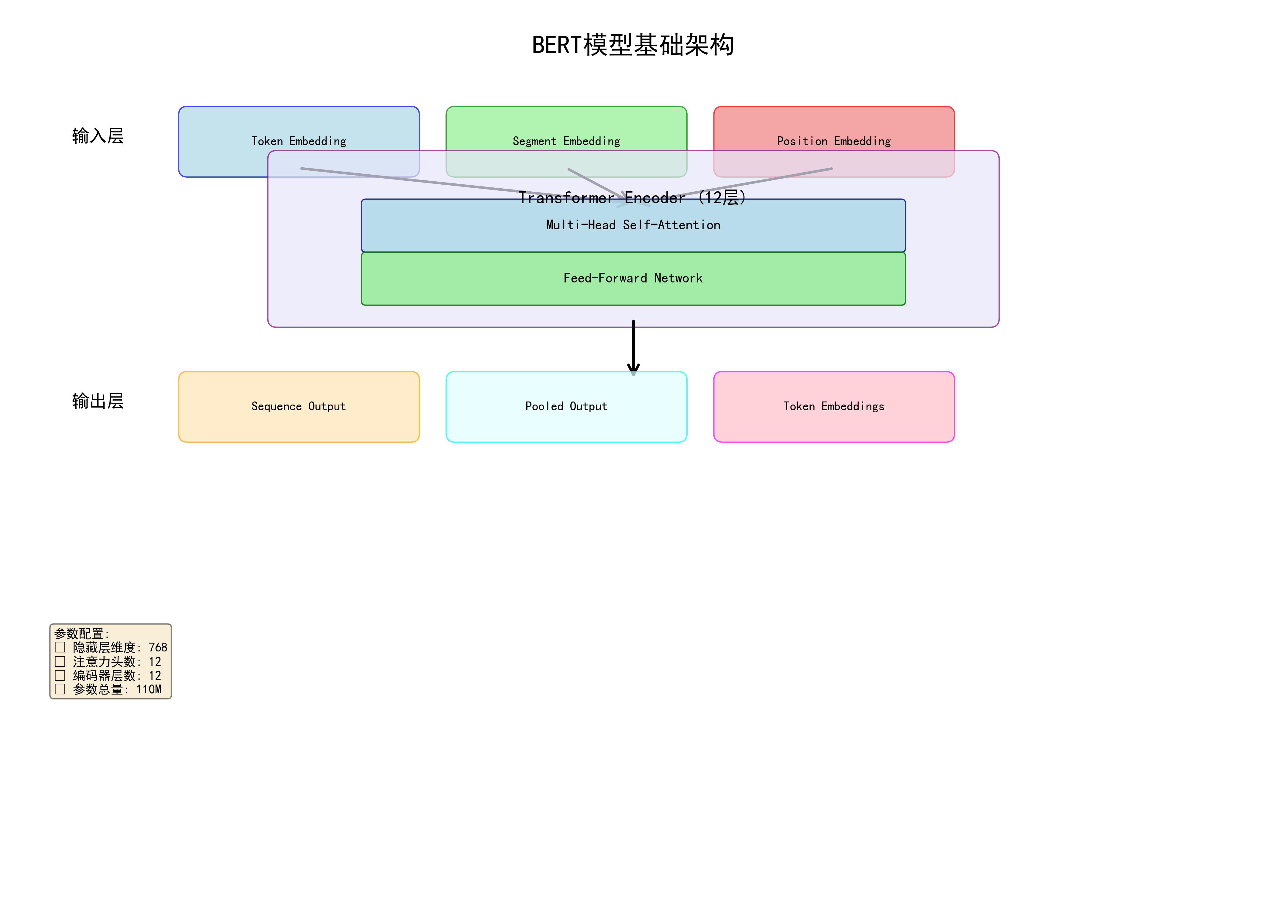
?6 BERT ???????

