试编写Java程序，实现三层结构的学生信息管理程序。建立学生数据库，库表中包含学号、姓名、性别、专业和年级5个字段。能通过单击“上记录”和“下记录”等按钮依次读取数据库各个记录 ，并能按学号“查找”、“添加”和“删除”记录，还能一次性“浏览”所有记录。运行界面参考下列图形。
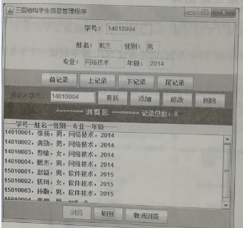
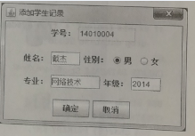
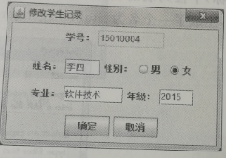
另外，要求数据库名和主要的类名以个人学号的后3位结尾。
评分标准：
- 正确实现数据层，得分30分；
- 正确实现业务逻辑层，得分30分；
- 正确实现表示层，得分30分；
- 系统能够正确运行，得分10分；
- 上述第1、2、3点评分标准中，数据库名和主要类名没有以个人学号后3位结尾的，成绩以50%计算。

- 数据层（MySQLUtils336，数据库名称student336）
public static Connection getConnection(){
try {
Class.forName("com.mysql.cj.jdbc.Driver");
String url = "jdbc:mysql://localhost:3306/student336?useSSL=true&serverTimezone=UTC";
String username = "root";
String password = "123456";
connection = DriverManager.getConnection(url, username, password);
return connection;
} catch (ClassNotFoundException e) {
throw new RuntimeException(e);
} catch (SQLException e) {
throw new RuntimeException(e);
}
}
- 业务逻辑层（StudentsDao336）
/**
* 查询所有学生数据
*/
public static ResultSet findAll(){
String sql = "select * from students";
Connection connection = MySQLUtils336.getConnection();
Statement statement = null;
try {
statement = connection.createStatement();
} catch (SQLException e) {
throw new RuntimeException(e);
}
ResultSet resultSet = null;
try {
resultSet = statement.executeQuery(sql);
} catch (SQLException e) {
throw new RuntimeException(e);
}
return resultSet;
}
/**
* 通过学号查询
*/
public static ResultSet findByNumber(String number){
String sql = "select * from students where number = ?";
Connection connection = MySQLUtils336.getConnection();
PreparedStatement preparedStatement = null;
try {
preparedStatement = connection.prepareStatement(sql);
} catch (SQLException e) {
throw new RuntimeException(e);
}
try {
preparedStatement.setString(1,number);
} catch (SQLException e) {
throw new RuntimeException(e);
}
ResultSet resultSet = null;
try {
resultSet = preparedStatement.executeQuery();
} catch (SQLException e) {
throw new RuntimeException(e);
}
return resultSet;
}
/**
* 查询首条数据
*/
public static ResultSet findFirst(){
String sql = "SELECT * FROM students LIMIT 0,1";
Connection connection = MySQLUtils336.getConnection();
Statement statement = null;
try {
statement = connection.createStatement();
} catch (SQLException e) {
throw new RuntimeException(e);
}
ResultSet resultSet = null;
try {
resultSet = statement.executeQuery(sql);
} catch (SQLException e) {
throw new RuntimeException(e);
}
return resultSet;
}
/**
* 查询最后一条数据
*/
public static ResultSet findfinal(){
String sql = "select * from students where id=(select max(id) from students)";
Connection connection = MySQLUtils336.getConnection();
Statement statement = null;
try {
statement = connection.createStatement();
} catch (SQLException e) {
throw new RuntimeException(e);
}
ResultSet resultSet = null;
try {
resultSet = statement.executeQuery(sql);
} catch (SQLException e) {
throw new RuntimeException(e);
}
return resultSet;
}
/**
* 查询上一条数据
*/
public static ResultSet findLast(int id){
String sql = "select * from students where id = " +
"(select max(id) from students where id < " + id + ")" ;
Connection connection = MySQLUtils336.getConnection();
Statement statement = null;
try {
statement = connection.createStatement();
} catch (SQLException e) {
throw new RuntimeException(e);
}
ResultSet resultSet = null;
try {
resultSet = statement.executeQuery(sql);
} catch (SQLException e) {
throw new RuntimeException(e);
}
return resultSet;
}
/**
* 查询下一条数据
*/
public static ResultSet findNext(int id){
String sql = "select * from students where id = " +
"(select min(id) from students where id > " + id + ")" ;
Connection connection = MySQLUtils336.getConnection();
Statement statement = null;
try {
statement = connection.createStatement();
} catch (SQLException e) {
throw new RuntimeException(e);
}
ResultSet resultSet = null;
try {
resultSet = statement.executeQuery(sql);
} catch (SQLException e) {
throw new RuntimeException(e);
}
return resultSet;
}
/**
* 添加学生 insert into students(number,NAME,sex,profession,grade) value('14010008','aa','男','web','2016')
*/
public static int add(String number,String name,String sex,String profession,String grade){
try {
ResultSet byNumber = StudentsDao336.findByNumber(number);
if(byNumber.next()){
return 3;
}else {
Connection connection = MySQLUtils336.getConnection();
String sql = "insert into students(number,name,sex,profession,grade) values(?,?,?,?,?)";
PreparedStatement preparedStatement = connection.prepareStatement(sql);
preparedStatement.setString(1,number);
preparedStatement.setString(2,name);
preparedStatement.setString(3,sex);
preparedStatement.setString(4,profession);
preparedStatement.setString(5,grade);
int i = preparedStatement.executeUpdate();
return i;
}
} catch (SQLException e) {
throw new RuntimeException(e);
}
}
/**
* 删除学生
*/
public static int del(Integer id){
try {
Connection connection = MySQLUtils336.getConnection();
String sql = "DELETE FROM students where id = ?";
PreparedStatement preparedStatement = connection.prepareStatement(sql);
preparedStatement.setInt(1,id);
int i = preparedStatement.executeUpdate();
return i;
} catch (SQLException e) {
throw new RuntimeException(e);
}
}
/**
* 修改学生信息 update students set number = ?,name=?,sex=?,profession=?,grade=? where id =?
*/
public static int upd(String number,String name,String sex,String profession,String grade,Integer id){
try {
Connection connection = MySQLUtils336.getConnection();
String sql = "update students set number = ?,name = ?,sex = ?,profession = ?,grade = ? where id =?";
PreparedStatement preparedStatement = connection.prepareStatement(sql);
preparedStatement.setString(1,number);
preparedStatement.setString(2,name);
preparedStatement.setString(3,sex);
preparedStatement.setString(4,profession);
preparedStatement.setString(5,grade);
preparedStatement.setInt(6,id);
int i = preparedStatement.executeUpdate();
return i;
} catch (SQLException e) {
throw new RuntimeException(e);
}
}
/**
* 获取数据总条数 SELECT COUNT(*) FROM students
*/
public static ResultSet findCount(){
String sql = "SELECT COUNT(*) FROM students";
Connection connection = MySQLUtils336.getConnection();
Statement statement = null;
try {
statement = connection.createStatement();
} catch (SQLException e) {
throw new RuntimeException(e);
}
ResultSet resultSet = null;
try {
resultSet = statement.executeQuery(sql);
} catch (SQLException e) {
throw new RuntimeException(e);
}
return resultSet;
}
- 表示层(Add336、Index336)
{
private Integer id;
private int updId;
public Index336() {
initComponents();
findCounts();
findAll();
ButtonGroup group=new ButtonGroup();//按钮组
group.add(radioButton1);//把按钮放在按钮组中
group.add(radioButton2);
}
public static void main(String[] args) {
new Index336().setVisible(true);
}
/**
* 获取所有数据
*/
private void findAll(){
ResultSet date = StudentsDao336.findAll();
String s = "";
try {
while (date.next()){
s = s + date.getString(1) + "," + date.getString(2) + "," + date.getString(3) + "," + date.getString(4) + "," + date.getString(5) + "\n";
}
} catch (SQLException ex) {
throw new RuntimeException(ex);
}
all.setText(s);
}
/**
* 获取数据总数
*/
private void findCounts(){
ResultSet date = StudentsDao336.findCount();
try {
while (date.next()){
count.setText(String.valueOf(date.getInt(1)));
}
} catch (SQLException ex) {
throw new RuntimeException(ex);
}
}
/**
* 查找第一条数据
* @param e
*/
private void findFirst(ActionEvent e) {
// TODO add your code here
ResultSet first1 = StudentsDao336.findFirst();
try {
while (first1.next()){
number.setText(first1.getString(1));
name.setText(first1.getString(2));
sex.setText(first1.getString(3));
profession.setText(first1.getString(4));
grade.setText(first1.getString(5));
id = first1.getInt(6);
}
} catch (SQLException ex) {
throw new RuntimeException(ex);
}
}
/**
* 查找上一条记录
* @param e
*/
private void findlast(ActionEvent e) {
// TODO add your code here
ResultSet first1 = StudentsDao336.findLast(id);
try {
while (first1.next()){
number.setText(first1.getString(1));
name.setText(first1.getString(2));
sex.setText(first1.getString(3));
profession.setText(first1.getString(4));
grade.setText(first1.getString(5));
id = first1.getInt(6);
}
} catch (SQLException ex) {
throw new RuntimeException(ex);
}
}
/**
* 查找下一条记录
* @param e
*/
private void findnext(ActionEvent e) {
// TODO add your code here
ResultSet first1 = StudentsDao336.findNext(id);
try {
while (first1.next()){
number.setText(first1.getString(1));
name.setText(first1.getString(2));
sex.setText(first1.getString(3));
profession.setText(first1.getString(4));
grade.setText(first1.getString(5));
id = first1.getInt(6);
}
} catch (SQLException ex) {
throw new RuntimeException(ex);
}
}
/**
* 查找最后一条记录
* @param e
*/
private void findatlast(ActionEvent e) {
// TODO add your code here
ResultSet first1 = StudentsDao336.findfinal();
try {
while (first1.next()){
number.setText(first1.getString(1));
name.setText(first1.getString(2));
sex.setText(first1.getString(3));
profession.setText(first1.getString(4));
grade.setText(first1.getString(5));
id = first1.getInt(6);
}
} catch (SQLException ex) {
throw new RuntimeException(ex);
}
}
private void findByNumber(ActionEvent e) {
// TODO add your code here
ResultSet date = StudentsDao336.findByNumber(findnunber.getText());
int idd = 0;
try {
while (date.next()){
number.setText(date.getString(1));
name.setText(date.getString(2));
sex.setText(date.getString(3));
profession.setText(date.getString(4));
grade.setText(date.getString(5));
id = date.getInt(6);
idd = date.getInt(6);
}
if(idd == 0){
JOptionPane.showMessageDialog(Index336.this,"该学号不存在请重新输入");
}
} catch (SQLException ex) {
throw new RuntimeException(ex);
}
}
private void del(ActionEvent e) {
// TODO add your code here
ResultSet date = StudentsDao336.findByNumber(findnunber.getText());
int idd = 0;
try {
while (date.next()){
idd = date.getInt(6);
}
} catch (SQLException ex) {
throw new RuntimeException(ex);
}
if(idd == 0){
JOptionPane.showMessageDialog(Index336.this,"该学号不存在请重新输入");
}else {
int del1 = StudentsDao336.del(idd);
if(del1 == 1){
JOptionPane.showMessageDialog(Index336.this,"删除成功");
}else {
JOptionPane.showMessageDialog(Index336.this,"删除失败");
}
}
}
private void refesh(ActionEvent e) {
// TODO add your code here
findAll();
findCounts();
}
private void look(ActionEvent e) {
// TODO add your code here
panel1.setVisible(true);
}
private void unlook(ActionEvent e) {
// TODO add your code here
panel1.setVisible(false);
}
private void add(ActionEvent e) {
// TODO add your code here
new Add336().setVisible(true);
}
private void upd(ActionEvent e) {
// TODO add your code here
ResultSet date = StudentsDao336.findByNumber(findnunber.getText());
int idd = 0;
try {
while (date.next()){
idd = date.getInt(6);
number2.setText(date.getString(1));
name2.setText(date.getString(2));
// sex.setText(date.getString(3));
profession2.setText(date.getString(4));
grade2.setText(date.getString(5));
updId = date.getInt(6);
if(date.getString(3).equals("男")){
radioButton1.doClick();
}else {
radioButton2.doClick();
}
}
} catch (SQLException ex) {
throw new RuntimeException(ex);
}
if(idd == 0){
JOptionPane.showMessageDialog(Index336.this,"该学号不存在请重新输入");
}else {
desktopPane1.setVisible(true);
}
}
private void close(ActionEvent e) {
// TODO add your code here
desktopPane1.setVisible(false);
}
private void doUpd(ActionEvent e) {
// TODO add your code here
String sex2 = "";
if(radioButton1.isSelected()){
sex2 = "男";
}
if(radioButton2.isSelected()){
sex2 = "女";
}
int upd1 = StudentsDao336.upd(number2.getText(), name2.getText(), sex2, profession2.getText(), grade2.getText(), updId);
if(upd1 == 1){
JOptionPane.showMessageDialog(Index336.this,"更新成功");
desktopPane1.setVisible(false);
}else {
JOptionPane.showMessageDialog(Index336.this,"更新失败");
}
}
private void initComponents() {
// JFormDesigner - Component initialization - DO NOT MODIFY //GEN-BEGIN:initComponents @formatter:off
desktopPane1 = new JDesktopPane();
internalFrame1 = new JInternalFrame();
label10 = new JLabel();
number2 = new JTextField();
label11 = new JLabel();
name2 = new JTextField();
label12 = new JLabel();
label13 = new JLabel();
profession2 = new JTextField();
radioButton1 = new JRadioButton();
radioButton2 = new JRadioButton();
button2 = new JButton();
label14 = new JLabel();
grade2 = new JTextField();
button6 = new JButton();
label1 = new JLabel();
number = new JTextField();
label2 = new JLabel();
name = new JTextField();
label3 = new JLabel();
sex = new JTextField();
label4 = new JLabel();
profession = new JTextField();
label5 = new JLabel();
grade = new JTextField();
first = new JButton();
last = new JButton();
next = new JButton();
atlast = new JButton();
label6 = new JLabel();
findnunber = new JTextField();
find = new JButton();
add = new JButton();
upd = new JButton();
del = new JButton();
label7 = new JLabel();
count = new JTextField();
label8 = new JLabel();
panel1 = new JPanel();
scrollPane1 = new JScrollPane();
all = new JTextArea();
label9 = new JLabel();
refesh = new JButton();
button4 = new JButton();
button5 = new JButton();
//======== this ========
setTitle("\u4e09\u5c42\u7ed3\u6784\u5b66\u751f\u4fe1\u606f\u7ba1\u7406\u7a0b\u5e8f");
Container contentPane = getContentPane();
contentPane.setLayout(null);
//======== desktopPane1 ========
{
desktopPane1.setVisible(false);
//======== internalFrame1 ========
{
internalFrame1.setVisible(true);
Container internalFrame1ContentPane = internalFrame1.getContentPane();
internalFrame1ContentPane.setLayout(null);
//---- label10 ----
label10.setText("\u5b66\u53f7\uff1a");
internalFrame1ContentPane.add(label10);
label10.setBounds(75, 30, 50, 40);
//---- number2 ----
number2.setEditable(false);
internalFrame1ContentPane.add(number2);
number2.setBounds(125, 35, 100, 30);
//---- label11 ----
label11.setText("\u59d3\u540d\uff1a");
internalFrame1ContentPane.add(label11);
label11.setBounds(75, 85, 36, 17);
internalFrame1ContentPane.add(name2);
name2.setBounds(125, 80, 100, 30);
//---- label12 ----
label12.setText("\u6027\u522b\uff1a");
internalFrame1ContentPane.add(label12);
label12.setBounds(270, 85, 36, 17);
//---- label13 ----
label13.setText("\u4e13\u4e1a\uff1a");
internalFrame1ContentPane.add(label13);
label13.setBounds(75, 135, 36, 17);
internalFrame1ContentPane.add(profession2);
profession2.setBounds(125, 130, 100, 30);
//---- radioButton1 ----
radioButton1.setText("\u7537");
internalFrame1ContentPane.add(radioButton1);
radioButton1.setBounds(305, 80, 50, 21);
//---- radioButton2 ----
radioButton2.setText("\u5973");
internalFrame1ContentPane.add(radioButton2);
radioButton2.setBounds(375, 80, 50, 21);
//---- button2 ----
button2.setText("\u53d6\u6d88");
button2.addActionListener(e -> close(e));
internalFrame1ContentPane.add(button2);
button2.setBounds(275, 210, 78, 30);
//---- label14 ----
label14.setText("\u5e74\u7ea7\uff1a");
internalFrame1ContentPane.add(label14);
label14.setBounds(275, 135, 36, 17);
internalFrame1ContentPane.add(grade2);
grade2.setBounds(315, 130, 100, 30);
//---- button6 ----
button6.setText("\u786e\u5b9a");
button6.addActionListener(e -> doUpd(e));
internalFrame1ContentPane.add(button6);
button6.setBounds(new Rectangle(new Point(145, 210), button6.getPreferredSize()));
{
// compute preferred size
Dimension preferredSize = new Dimension();
for(int i = 0; i < internalFrame1ContentPane.getComponentCount(); i++) {
Rectangle bounds = internalFrame1ContentPane.getComponent(i).getBounds();
preferredSize.width = Math.max(bounds.x + bounds.width, preferredSize.width);
preferredSize.height = Math.max(bounds.y + bounds.height, preferredSize.height);
}
Insets insets = internalFrame1ContentPane.getInsets();
preferredSize.width += insets.right;
preferredSize.height += insets.bottom;
internalFrame1ContentPane.setMinimumSize(preferredSize);
internalFrame1ContentPane.setPreferredSize(preferredSize);
}
}
desktopPane1.add(internalFrame1, JLayeredPane.DEFAULT_LAYER);
internalFrame1.setBounds(15, 10, 485, 340);
}
contentPane.add(desktopPane1);
desktopPane1.setBounds(35, 55, 510, 355);
//---- label1 ----
label1.setText("\u5b66\u53f7\uff1a");
contentPane.add(label1);
label1.setBounds(new Rectangle(new Point(160, 25), label1.getPreferredSize()));
//---- number ----
number.setEditable(false);
contentPane.add(number);
number.setBounds(200, 20, 120, number.getPreferredSize().height);
//---- label2 ----
label2.setText("\u59d3\u540d\uff1a");
contentPane.add(label2);
label2.setBounds(new Rectangle(new Point(125, 70), label2.getPreferredSize()));
//---- name ----
name.setEditable(false);
contentPane.add(name);
name.setBounds(165, 65, 80, name.getPreferredSize().height);
//---- label3 ----
label3.setText("\u6027\u522b\uff1a");
contentPane.add(label3);
label3.setBounds(new Rectangle(new Point(275, 70), label3.getPreferredSize()));
//---- sex ----
sex.setEditable(false);
contentPane.add(sex);
sex.setBounds(310, 65, 60, sex.getPreferredSize().height);
//---- label4 ----
label4.setText("\u4e13\u4e1a\uff1a");
contentPane.add(label4);
label4.setBounds(new Rectangle(new Point(90, 115), label4.getPreferredSize()));
//---- profession ----
profession.setEditable(false);
contentPane.add(profession);
profession.setBounds(130, 110, 125, profession.getPreferredSize().height);
//---- label5 ----
label5.setText("\u5e74\u7ea7\uff1a");
contentPane.add(label5);
label5.setBounds(new Rectangle(new Point(280, 115), label5.getPreferredSize()));
//---- grade ----
grade.setEditable(false);
contentPane.add(grade);
grade.setBounds(320, 110, 80, grade.getPreferredSize().height);
//---- first ----
first.setText("\u9996\u8bb0\u5f55");
first.addActionListener(e -> findFirst(e));
contentPane.add(first);
first.setBounds(new Rectangle(new Point(45, 160), first.getPreferredSize()));
//---- last ----
last.setText("\u4e0a\u8bb0\u5f55");
last.addActionListener(e -> findlast(e));
contentPane.add(last);
last.setBounds(new Rectangle(new Point(150, 160), last.getPreferredSize()));
//---- next ----
next.setText("\u4e0b\u8bb0\u5f55");
next.addActionListener(e -> findnext(e));
contentPane.add(next);
next.setBounds(new Rectangle(new Point(255, 160), next.getPreferredSize()));
//---- atlast ----
atlast.setText("\u5c3e\u8bb0\u5f55");
atlast.addActionListener(e -> findatlast(e));
contentPane.add(atlast);
atlast.setBounds(new Rectangle(new Point(365, 160), atlast.getPreferredSize()));
//---- label6 ----
label6.setText("\u8bf7\u8f93\u5165\u5b66\u53f7\uff1a");
contentPane.add(label6);
label6.setBounds(new Rectangle(new Point(15, 210), label6.getPreferredSize()));
contentPane.add(findnunber);
findnunber.setBounds(90, 205, 120, findnunber.getPreferredSize().height);
//---- find ----
find.setText("\u67e5\u627e");
find.addActionListener(e -> findByNumber(e));
contentPane.add(find);
find.setBounds(new Rectangle(new Point(220, 205), find.getPreferredSize()));
//---- add ----
add.setText("\u6dfb\u52a0");
add.addActionListener(e -> add(e));
contentPane.add(add);
add.setBounds(new Rectangle(new Point(300, 205), add.getPreferredSize()));
//---- upd ----
upd.setText("\u4fee\u6539");
upd.addActionListener(e -> upd(e));
contentPane.add(upd);
upd.setBounds(new Rectangle(new Point(385, 205), upd.getPreferredSize()));
//---- del ----
del.setText("\u5220\u9664");
del.addActionListener(e -> del(e));
contentPane.add(del);
del.setBounds(new Rectangle(new Point(475, 205), del.getPreferredSize()));
//---- label7 ----
label7.setText("----------------------\u6d4f\u89c8\u533a-------------------\u603b\u8bb0\u5f55\u6570\uff1a");
contentPane.add(label7);
label7.setBounds(new Rectangle(new Point(35, 255), label7.getPreferredSize()));
//---- count ----
count.setEnabled(false);
contentPane.add(count);
count.setBounds(325, 250, 60, count.getPreferredSize().height);
//---- label8 ----
label8.setText("---------------------------------");
contentPane.add(label8);
label8.setBounds(new Rectangle(new Point(385, 255), label8.getPreferredSize()));
//======== panel1 ========
{
panel1.setLayout(null);
//======== scrollPane1 ========
{
scrollPane1.setVerticalScrollBarPolicy(ScrollPaneConstants.VERTICAL_SCROLLBAR_ALWAYS);
scrollPane1.setViewportView(all);
}
panel1.add(scrollPane1);
scrollPane1.setBounds(15, 10, 520, 160);
{
// compute preferred size
Dimension preferredSize = new Dimension();
for(int i = 0; i < panel1.getComponentCount(); i++) {
Rectangle bounds = panel1.getComponent(i).getBounds();
preferredSize.width = Math.max(bounds.x + bounds.width, preferredSize.width);
preferredSize.height = Math.max(bounds.y + bounds.height, preferredSize.height);
}
Insets insets = panel1.getInsets();
preferredSize.width += insets.right;
preferredSize.height += insets.bottom;
panel1.setMinimumSize(preferredSize);
panel1.setPreferredSize(preferredSize);
}
}
contentPane.add(panel1);
panel1.setBounds(20, 315, 545, 175);
//---- label9 ----
label9.setText("\u5b66\u53f7-\u59d3\u540d-\u6027\u522b-\u4e13\u4e1a-\u5e74\u7ea7");
contentPane.add(label9);
label9.setBounds(new Rectangle(new Point(35, 285), label9.getPreferredSize()));
//---- refesh ----
refesh.setText("\u5237\u65b0");
refesh.addActionListener(e -> refesh(e));
contentPane.add(refesh);
refesh.setBounds(new Rectangle(new Point(365, 495), refesh.getPreferredSize()));
//---- button4 ----
button4.setText("\u6d4f\u89c8");
button4.addActionListener(e -> look(e));
contentPane.add(button4);
button4.setBounds(new Rectangle(new Point(270, 495), button4.getPreferredSize()));
//---- button5 ----
button5.setText("\u53d6\u6d88\u6d4f\u89c8");
button5.addActionListener(e -> unlook(e));
contentPane.add(button5);
button5.setBounds(new Rectangle(new Point(460, 495), button5.getPreferredSize()));
{
// compute preferred size
Dimension preferredSize = new Dimension();
for(int i = 0; i < contentPane.getComponentCount(); i++) {
Rectangle bounds = contentPane.getComponent(i).getBounds();
preferredSize.width = Math.max(bounds.x + bounds.width, preferredSize.width);
preferredSize.height = Math.max(bounds.y + bounds.height, preferredSize.height);
}
Insets insets = contentPane.getInsets();
preferredSize.width += insets.right;
preferredSize.height += insets.bottom;
contentPane.setMinimumSize(preferredSize);
contentPane.setPreferredSize(preferredSize);
}
setSize(585, 570);
setLocationRelativeTo(null);
// JFormDesigner - End of component initialization //GEN-END:initComponents @formatter:on
}
// JFormDesigner - Variables declaration - DO NOT MODIFY //GEN-BEGIN:variables @formatter:off
private JDesktopPane desktopPane1;
private JInternalFrame internalFrame1;
private JLabel label10;
private JTextField number2;
private JLabel label11;
private JTextField name2;
private JLabel label12;
private JLabel label13;
private JTextField profession2;
private JRadioButton radioButton1;
private JRadioButton radioButton2;
private JButton button2;
private JLabel label14;
private JTextField grade2;
private JButton button6;
private JLabel label1;
private JTextField number;
private JLabel label2;
private JTextField name;
private JLabel label3;
private JTextField sex;
private JLabel label4;
private JTextField profession;
private JLabel label5;
private JTextField grade;
private JButton first;
private JButton last;
private JButton next;
private JButton atlast;
private JLabel label6;
private JTextField findnunber;
private JButton find;
private JButton add;
private JButton upd;
private JButton del;
private JLabel label7;
private JTextField count;
private JLabel label8;
private JPanel panel1;
private JScrollPane scrollPane1;
private JTextArea all;
private JLabel label9;
private JButton refesh;
private JButton button4;
private JButton button5;
// JFormDesigner - End of variables declaration //GEN-END:variables @formatter:on
}
- 运行截图
点击首记录
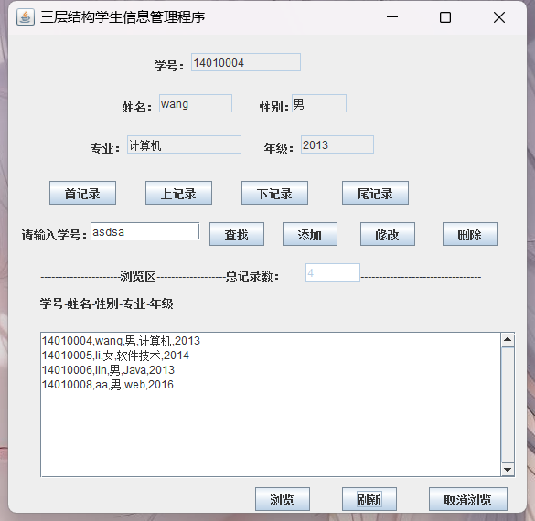

点击下记录
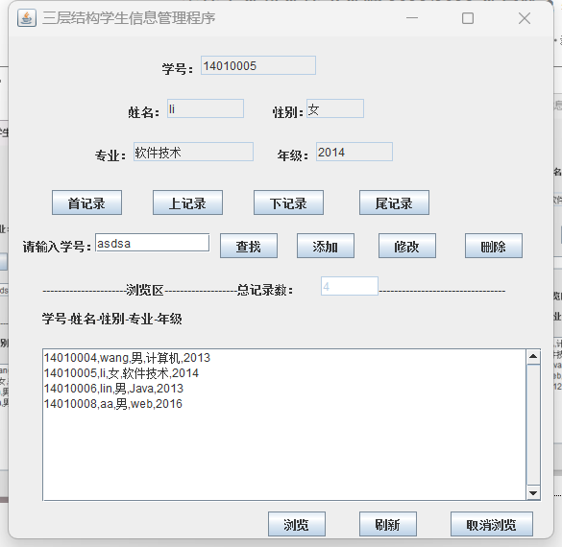
点击上记录
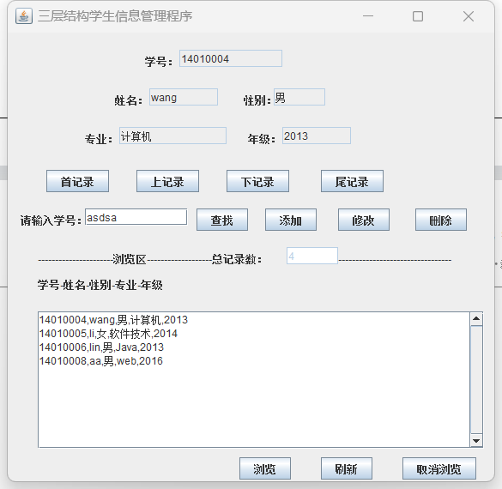

点击尾记录
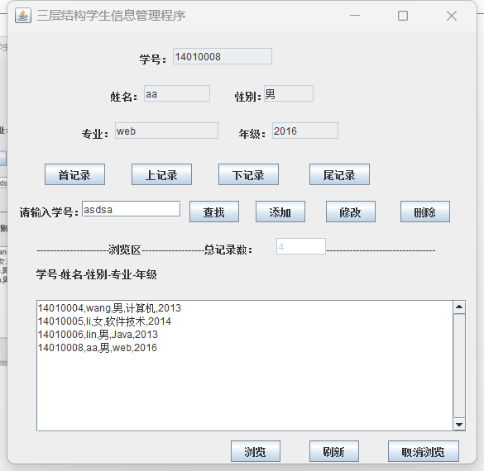
查找功能具体实现
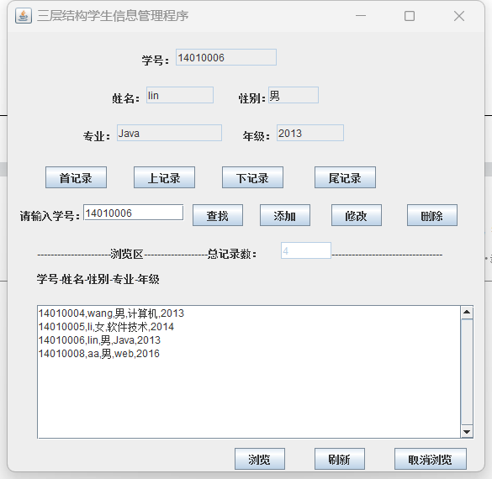

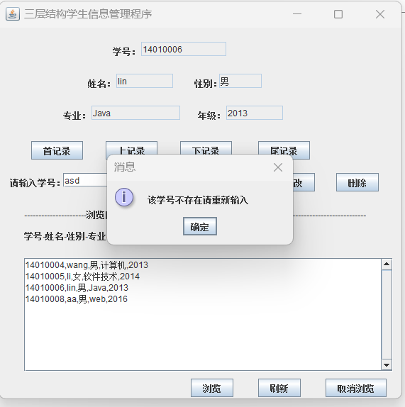
修改功能具体实现
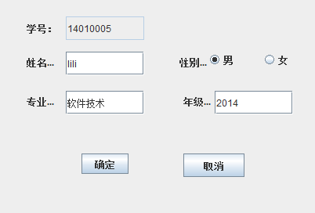
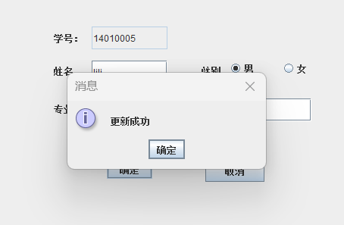
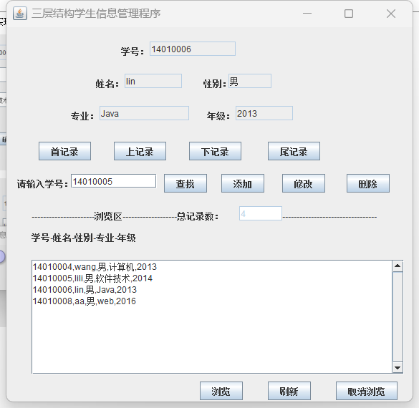
添加功能具体实现
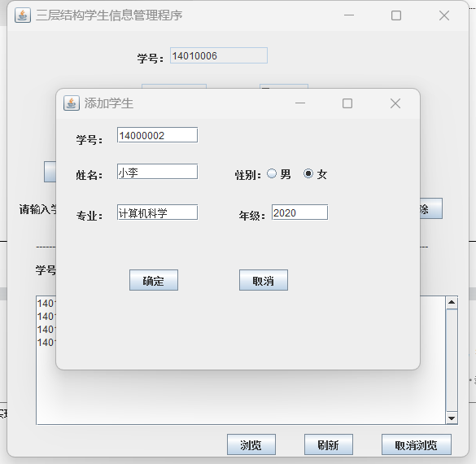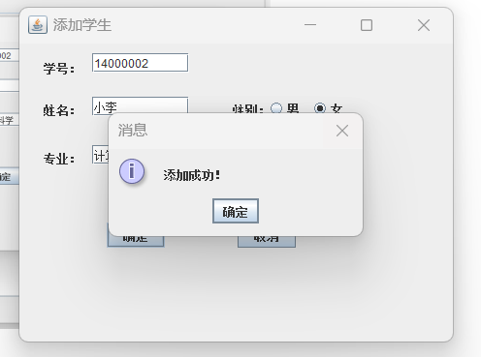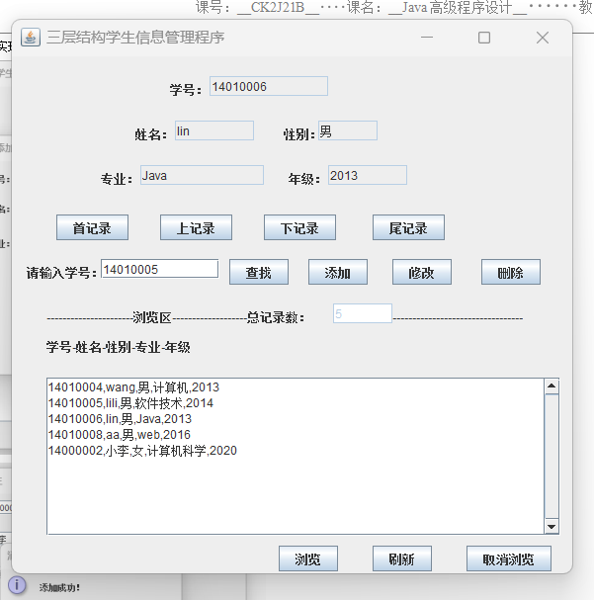
删除功能具体实现
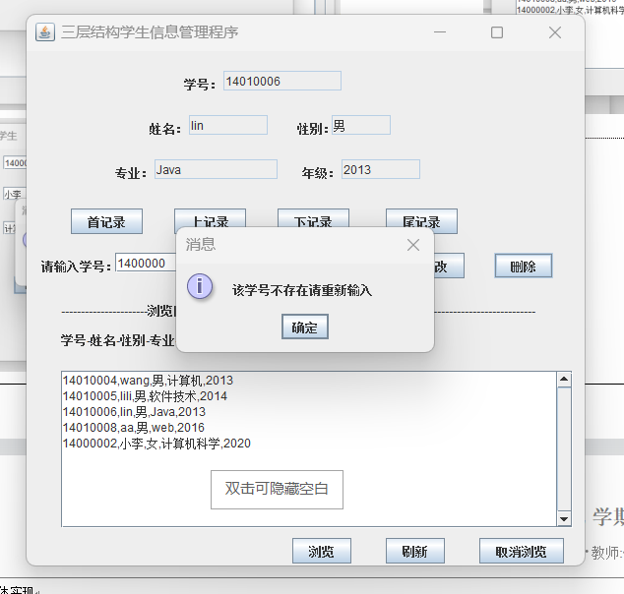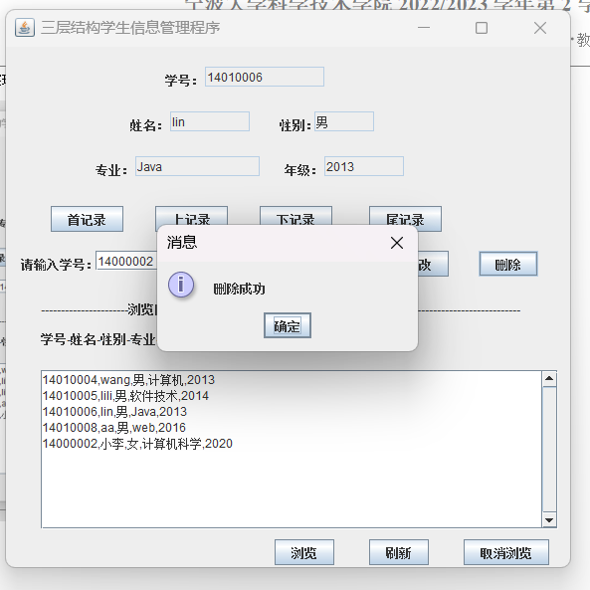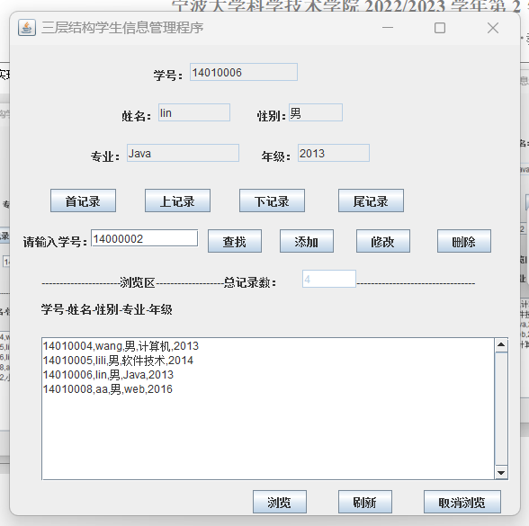
点击取消浏览
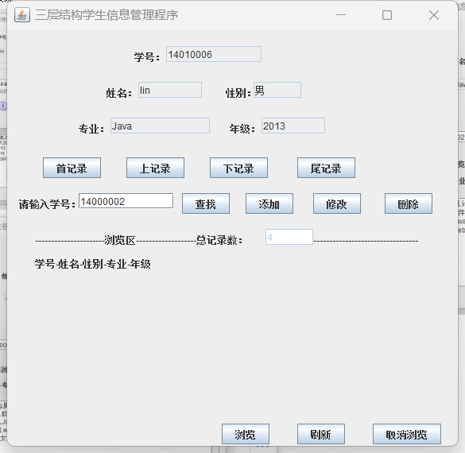

点击浏览
