Certified Kubernetes Administrator (CKA)

Architecture
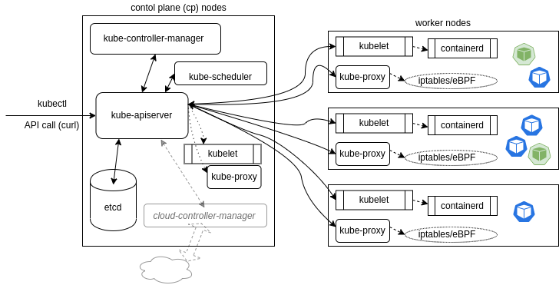
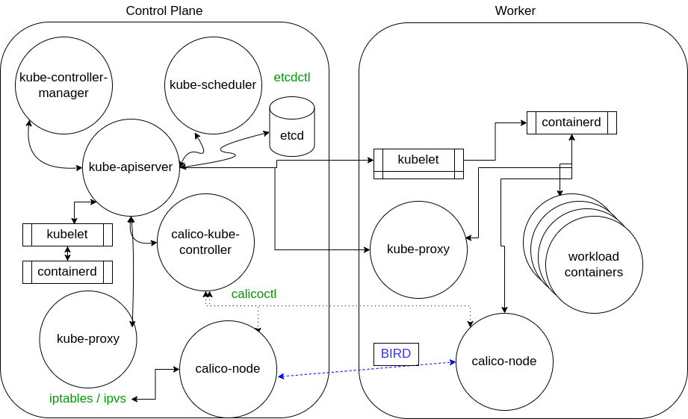

Nodes
A node is an API object created outside the cluster, representing an instance. Types :
- Control Plane (CP) : Node running the various pods responsive for ensuring the current cluster state matches the desired state.
- Workers : An instance implementing kubelet, kube-proxy and the container engine on which pods can be deployed. A worker node can be added to the cluster manually (join command) or automatically (--register-node kubelet flag)

# Allow / Prevent pod scheduling on a node.
kubectl uncordon|cordon <nodeName>

Components
service-operators / controllers
- Connect/Reconnect resources together.
- Listens to the endpoint operator to provide a persistent IP for Pods.
- Sends messages via the kube-apiserver which forwards settings to kube-proxy on every node.
- Handle access policies for inbound requests.
- Connect Pods together, Expose Pods to Internet, Decouple settings, Define Pod access policy.
- Ex: Informer, SharedInformer, Workqueue, endpoints, namespace, serviceaccounts...
kube-apiserver
- Act as a CP process for the cluster, and as the frontend for the cluster shared state.
- Handle all calls, accept and validate actions.
- Is the only connection point to the etcd database.
kube-scheduler
- Decide on which node a pod should be deployed depending on pod configuration (taints, and toleration, metadata…), and available resources using an algorithm.
etcd database
- Keep persistent information (cluster's state, networking...) in a b+tree key-value store.
- Data are appended at the end, previous are marked for removal.
- All request go through the kube-apiserver who will return a 409 in case of simultaneous requests (based on a version parameter).
- A non-collocated database cluster (multi CP), may have leader/followers/non voting nodes.
- etcd should be protected and secured (not decoupled as other services): etcdctl snapshot save/restore.
kube-controller-manager
- A core control loop daemon interacting with the kube-apiserver to determine the state of the cluster.
cloud-controller-manager (CCM)
- Optional agent handling kube-controller-manager tasks related to external resources.
- When used each kubelet should pass the --cloud-provider-external option to the binary.
Other Agents
- The network plugin use various pods to control network traffic.
- The CoreDNS server handle DNS queries and k8s service discovery.
kubelet
- Systemd process responsive for changing configuration on the worker nodes.
- Interact with the container engine checking that containers are effectively running.
- Uses PodSpecs, mount volumes to Pods, download secrets, passes requests to local container engine, report pods/node status to cluster…
- Will try to mount every resource found in /etc/kubernetes/manifests/.
kube-proxy
- Manages the network connectivity to the containers, using iptables entries.
- Userspace mode : monitors services and endpoints using a random port to proxy traffic via ipvs.

Pods
A pod is an API object representing a group of co-located containers with some associated data volumes.
Pods are the smallest unit that can be interacted with to manage containers lifecycle.
Containers within a pod may communicate with each other using IPC, the lo, or a shared filesystem.
Network
- There is one IP address per pod, and all pod’s containers share the same network namespace.
- A pause container is used to get/set an IP address / namespace to a pod.

Containers
Kubernetes does not allow direct container manipulation, but resources they are allowed to consume, through :
- The PodSpec object (CPU and memory, min / max).
- A ResourceQuota object ( CPU, memory and more, hard/soft).

Initiation :
- Containers are sent to the container engine at the same time and may start in any order.
- LivenessProbes, ReadinessProbes, and StatefulSets (complex) may be used to determine the start order.
- An init container may also be used, typically waiting for the other to initialize before starting the app (PodSpec: spec.initContainers).

Network
- Since 1.6 kubernetes standardizes on the Container Network Interface (CNI), that allow to configure the container network (type, IP range and subnet, routes) in a language agnostic way.
- All pod’s containers use the ephemeral pod’s IP (set before pod starts).
- Pod IP communicate with services associated to the pod.
- The network plugin must allow Pod to Pod communication without using NAT.
- Services provide an API (same namespace than cluster IP) to communicate and with the outside world (through NodePort / Ingress / …).

API

Overview
Kubernetes works with a REST-based API, through the kube-apiserver (port 6443 by default), hosting different API versions/group (specified in a request).
kubectl is calling curl to make API request (--v verbose=10 will show the request).
The format of the API resource definition is JSON (automatic conversion from YAML when using kubectl).

kubectl command pattern : kubectl [command] [type] [name] [flag]
API URI pattern : xx

# Curl command.
curl --cert <userCert.pem> --key <userCertKey.pem> --cacert <caCert.pem> https://<apiTargetUri>

Kubectl configuration file
~/.kube/config hold the configuration information for the cluster API access, and especially the TLS certificates (user, key and CA) required to query the API from outside the cluster (unsecured request will not allow much).
Configuration can also be seen executing “kubectl config view”.

Keys :
- apiVersion: Instructs the kube-apiserver where to assign the data.
- clusters: List of clusters, with name, certificate-authority-data (to authenticate the api request).
- contexts: Allow easy access to multiple clusters, as various users (set namespace, user, cluster).
- current-context: Which cluster and user kubectl will use (can also be passed in the command).
- kind: Type of kubernetes object (Config).
- preferences: Optional setting (coloring output...).
- users: Nickname associated with client credentials (kubectl config set-credentials).

Concurrency
Based on optimistic concurrency : An object is not locked from the time it has been read until it is written.
The resourceVersion field is used to manage concurrency :
- Sent with the API request and checked, a 409 is returned if changed.
- Unique to the namespace, kind (type of object) and server.
- Backed in the modifiedIndex etcd database field.

API access control

Overview
https://kubernetes.io/docs/concepts/security/controlling-access/
In addition to TLS, they are 3 main steps to access the API :
- Authentication : Tokens / certificates / passwords.
- Authorization : Role Based Access Control (RBAC) / webhook.
- Admission controllers.

Authentication
Done through authentication modules. Input is an HTTP request (over TLS) which is rejected (401) when cannot be authenticated. More than one module can be used at a time, two at least should be used, one for service account usage, another one for non service account usage.

Service accounts
Kubernetes stores service/system accounts to allow its processes to perform operations among cluster.
Authorization plugin are used to set permissions on service accounts.
Dedicated tokens are used to authenticate a service account request.

# List / delete services account.
kubectl get serviceaccounts
kubectl delete serviceaccount/<serviceAccountName>

# Create a service account, and an associated token (JWT).
kubectl create serviceaccount <serviceaccountName> -n <ns>
kubectl create token <serviceaccountName>

Other authentication modules
Kubernetes does not store any user object / information in its own API, but use usernames from :
- X509 client certificates : signed by the cluster’s CA, using the subject field as username.
- User stores (google accounts…).
- Static token file : token,user,uid,”grp1,grp2” (--token-auth-file).
- Static password file (--basic-auth-file).
- OpenID connect tokens (--oidc-issuer-url).

Authorizations
Main authorization modes :
- RBAC: --authorization-mode=RBAC
- Webhook: --authorization-mode=Webhook
- Always Deny (global): --authorization-mode=AlwaysDeny
- Always Allow (global): --authorization-mode=AlwaysAllow

Authorizations implement policies to allow requests (request attributes checked against policies).

RABC
RBAC is writing rules to allow or deny operations by subject upon resources.

Rules are operations (REST verbs) that can act upon an API group.
Roles are a group of rules scoping a namespace to target resources. “ClusterRoles” scope an entire cluster.
4 objects:
- ClusterRole|Role : Define a set of permissions for the whole cluster or a single namespace.
- ClusterRoleBinding|RoleBinding : Connect a set of permissions with an account and define on what (whole cluster vs. single namespace) it’s applied.

4 object but only 3 combinations:
- Role + RoleBinding: available in single Namespace, applied in single Namespace.
- ClusterRole + ClusterRoleBinding: available cluster-wide, applied cluster-wide.
- ClusterRole + RoleBinding: available cluster-wide, applied in single Namespace.
- Role + ClusterRoleBinding: NOT POSSIBLE (available in single Namespace, applied cluster-wide).

# Role creation exemple.
# kubectl -n <namespace> create role <roleName> --verb create,delete --resource pods,deployments,sts

# Role binding creation example.
kubectl -n <namespace> create rolebinding <roleBindingName> --role <roleName> --user smoke
kubectl -n <namespace> create rolebinding <roleBindingName> --clusterrole <clusterRoleName> --user smoke

# ClusterRole binding (with service accounts).
kubectl create clusterrolebinding <name> --clusterrole <clusterRole> --serviceaccount <ns>:<name>

# Check authorizations commands.
kubectl auth can-i delete|create|get|list deployments|secrets|pods|sts –as <userName> --namespace <ns>
k auth can-i list secrets --as system:serviceaccount:<ns>:<name> -A

Webhook
HTTP callback (POST)

Admission controllers
Validate and/or mutate an object after request authorized. They can only apply to / limit write operations.
# See enabled admission controllers plugins.
kube-apiserver -h | grep enable-admission-plugins
Built-in feature, to enable/disable plugins start the kube-apiserver with flags :
- --enable-admission-plugins=Initializers,NamespaceLifecycle,LimitRanger
- --disable-admission-plugins=PodNodeSelector

API components

Resources (objects)
Nodes / pods along with services, events, deployments, jobs, igress, roles (...etc) are API objects, and can be managed through kubectl.
Resources can be namespaced, or apply to the entire cluster (xx?).

API Groups
Collection of groups for each main object categories / maturity (alpha, beta, stable=v1).
Examples:
- apps/v1
- authorization.k8s.io/v1
- batch/v1
- events.k8s.io/v1
- node.k8s,io/v1
- resource.k8s.io/v1alpha1

# List available API groups.
curl https://localhost:6443/apis --header "Authorization: Bearer $token" -k

Namespaces
The term is used both for the kernel feature and for the API object segregation.
All API request include a namespace (default when not specified).

Exisitng namespaces when cluster created :
- default : Where resources are assumed unless set otherwise.
- kube-node-lease : Worker node lease information.
- kube-public : General information, readable by all (not auth required).
- kube-system : Infrastructure pods.

# Create/describe/delete namespace commands.
kubectl create|get|describe|delete ns <namespaceName>

Labels
Key/Value pairs (tags) allowing to select the object through kubectl.
Part of metadata object’s section, used in spec sections by selectors (nodeSelector).
A label selector is immutable (strongly discouraged to change it after creation).

# Get object’s labels.
kubectl get pods –show-labels

# Add label to a given object.
kubectl label pods <podName> <labelKey>=<labelValue>

# Remove a label from a given object.

# Get objects by labels (key).
kubectl get pods -L <labelKey>

# Get objects by labels (key AND value).
kubectl get pods -l <labelKey>=<labelValue>

Annotations
Similar but different from labels (tags), they are used to add metadata to API objects and used by third party application or administrative tracking.
Part of metadata object’s section.
Cannot be used to select API objects with kubectl.
# Create/update/delete annotation commands.
kubectl annotate pods --all <annotationKey>="<annotationValue>"
kubectl annotate --overwrite pod podName> <annotationKey>="<annotationValue>"
kubectl annotate pod <podName> <annotationKey>-

Config maps
A configMap object allows to store parts of another object configuration in a “decoupled” object. Namespaced.
Pod environment variables, pod commands, volumes, system components and controllers.

# Basic commands.
kubectl get configmap configmap-name -o yaml

# Definition as YAML file.
kind: ConfigMap
apiVersion: v1
metadata:
name: configmap-name
data:
config.js: |
{
}

# Usage example: Pod spec container configuration, environment variable.
# ConfigMap must exist prior to usage unless marked as optional.
env:
- name: MY_ENV_NAME
valueFrom:
configMapKeyRef:
name: configmap-name
key: my.key.value

# Usage example: pod spec volume configuration.
volumes:
- name: configmap-volume
configMap:
name: configmap-name

Workload Resources
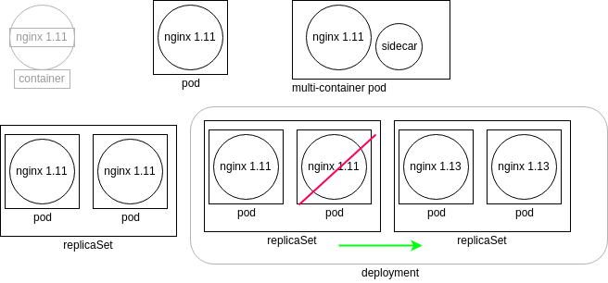

A Deployment object manages ReplicaSet object, that manages Pod objects.
When a deployment is created/updated, a new ReplicaSet is created, all pods belonging to old ReplicaSet are shut down and new pods are created.
A deployment is server-side managed (better that RC, client-side managed).

ReplicationControllers (RC) is a controller ensuring that a specified number of pods are running in one time, and give the ability to perform rolling update from the client side (problems when client loose connectivity).

Each ReplicaSet is a controller running as a thread of the kube-controller-manager. They query the kube-apiserver (worker) for the current state of the object they watch. The local (worker) kubelet send back the object state.
Do not manage ReplicaSet objects managed by a Deployment object.

Deployment

Configuration
apiVersion: apps/v1
# Deployment | DaemonSet | StatefulSet
# When DaemonSet, the controller will ensure one pod is running on every node of the cluster.
# Useful for metrics generation/gathering...
kind: Deployment
# Deployment metadata section.
metadata:
…
# Deployment spec section.
spec:
…
# Pod template section, including pod metadata and spec section.
template:
…

Metadata section
# Section for “non-configuration” information storage.
metadata:
# Provide further information that could be helpful to third-party applications.
annotations:
deployment.kubernetes.io/revision: "1"
# When the object was originally created.
creationTimestamp: 2022-12-21T13:57:07Z
# The number of times the resource was edited.
generation: 1
# Allow to select/exclude objects outside of typical object boundaries.
labels:
app: dev-web
# Required, must be unique to the namespace.
name: dev-web
namespace: default
# Tied to etcd database, any change to the object will cause this value to change too (concurrency).
resourceVersion: "774003"
# Unique id for the life of an object.
uid: d52d3a63-e656-11e7-9319-42010a800003

Spec section
# Used to update / create replicaset, an other pec section will be passed to the pod.
spec:
# Time before an error is reported during a change (quotas, image issues, limit ranges...).
progressDeadlineSeconds: 600
# Time before a a created pod be seen as ready (default 0, must be lower than progressDeadlineSeconds).
minReadySeconds: 100
# Number of pods being created. If 0, no containers but still a ReplicaSet and a Deployment.
replicas: 1
# Clean up policy : how many "old" specification to remember for a rollback (default 10).
revisionHistoryLimit: 10
# A collection of values that must all be satisfied for the replica to match.
selector:
# Pod selector requirements (often found with the matchExpressions statement).
matchLabels:
app: dev-web
# Header value for pod update configuration (works with type).
strategy:
rollingUpdate:
# Number (or %) of new pod to be created before deleting the old ones.
maxSurge: 25%
# Number (or %) of pods that can have a state other than "Ready" during deployment.
maxUnavailable: 25%
# Type of strategy used, Recreate (re-created, all existing are killed first) | RollingUpdate (default) .
type: RollingUpdate

Pod template / spec section
# Data passed to the ReplicaSet to deploy an object (here, containers).
template:
metadata:
creationTimestamp: null
labels:
app: dev-web
spec:
# Containers specifications.
containers:
# Image name for the container engine.
- image: nginx:1.17.7-alpine
# Passed to the container engine, should the image be downloaded or used from local cache.
imagePullPolicy: IfNotPresent
# The stub for the pod name (final: dev-web-azerty1234*).
name: dev-web
resources: {}
# Where to output container success/failure information.
terminationMessagePath: /dev/termination-log
# File (default) | FallbackToLogsOnError (last part of container log).
terminationMessagePolicy: File
# Target of DNS query. Default (node's DNS config) | ClusterFirst (coredns). xx?
dnsPolicy: ClusterFirst
# Should the container be restarted if killed.
restartPolicy: Always
# Allow to use a custom scheduler.
schedulerName: default-scheduler
# Additional values to pass to the container (users UID...).
securityContext: {}
# Time to wait for a SIGTERM to run until a SIGKILL is used to terminate the container.
terminationGracePeriodSeconds: 30

Status section
status:
# Number of pods configured by the ReplicaSet (see readyReplicas).
availableReplicas: 2
conditions:
- lastTransitionTime: 2022-12-21T13:57:07Z
lastUpdateTime: 2022-12-21T13:57:07Z
message: Deployment has minimum availability.
reason: MinimumReplicasAvailable
status: "True"
type: Available
- lastTransitionTime: "2021-07-29T06:00:24Z"
lastUpdateTime: "2021-07-29T06:00:33Z"
message: ReplicaSet "test-5f6778868d" has successfully progressed.
reason: NewReplicaSetAvailable
status: "True"
type: Progressing
# Number of times deployment has been updated.
observedGeneration: 2
readyReplicas: 2
replicas: 2
updatedReplicas: 2

Management

Basic tasks
# Get Deployments objects.
kubectl get deployments
kubectl describe deployment <depName>

# Get ReplicaSet objects.
kubectl get rs
# Scale the number of running replicas.
kubectl scale deploy/<depName> --replicas=<replicaNumber>
kubectl autoscale deployment/<depName> --min=10 --max=15 --cpu-percent=80

# Live edit a deployment through kubectl / text editor.
kubectl edit deployment <depName>

# Patch a deployment.
kubectl patch deployment/<depName> -p '<json>'
# Annotate an existing deployment.
kubectl annotate deployment/<depName> <annotationKey>=<annotationValue>”.

# Change a deployment image through kubectl.
kubectl set image deployment/<deploymentName> <depName>=<imageName>:<imageVersion> --all

# Get deployment rollout history and history details.
kubectl rollout history deployment/<depName>
kubectl rollout history deployment/<depName> --revision=<revisionNumber>

# Rollout, show status, pause and resume a deployment.
kubectl rollout status deployment/<depName>
kubectl rollout undo deployment/<depName> [--to-revision=<revisionNumber>]
kubectl rollout pause deployment/<depName>
kubectl rollout resume deployment/<depName>

Status
Get the status? Xx

availableReplicas: Number of replicas configured by the replicaset.
readyReplicas: Number of generated without error replicas.
observedGeneration: How many deployment have been updated.

When a rollout is ongoing, the deployment is marked as “Progressing”.
- type: Progressing
- status: “True”
- reason: NewReplicaSetCreated | reason: FoundNewReplicaSet | reason: ReplicaSetUpdated

Troubleshooting
Deployment failed reasons: Insufficient quota, readiness probe failures, image pull errors, insufficient permissions, limit ranges, application runtime misconfiguration.

After parameter “progressDeadlineSeconds” exceeded, deployment status “Progressing” will be set to “false” with “reason” to “ProgressDeadlineExceeded”.

ReplicaSet

StatefulSets

DaemonSet
Ensure that one pod runs on every node in the cluster.
Typical use : storage, log collection, monitoring.

Volumes and data

Introduction to volumes
A pod may declare multiple volumes. A volume needs a name, a type, and a mount point.
A volume may be available to multiple containers within a pod, and to multiple pods.
No concurrency checking.
Pod request ? Xx

Volume types example :
- GCEpersistentDisk: GCE disk in pod.
- awsElasticBlockStore: AWS EBS disks in pod.
- EmptyDir: An empty directory, not persistent (removed when the pod dies).
- hostPath: resource (directory, file socket, character, block device) mounted from the host node file system.
- DirectoryOrCreate: Will create the resource on the host when not already exists.
- FileOrCreate: Will create the resource on the host when not already exists.
- NFS (Network File System) / iSCSI: good for multiple readers scenarios.
- rbd for block storage / CephFS / GlusterFS : good for multiple writers scenarios.

Persistent volumes and claims
A persistent volume (PV) is a storage abstraction used to store data over pod lifetime. Not namespace.
A pod define persistent volume claim (PVC), the cluster then attach the volume to the pod. Namespaced.
Persistent storage phases :
- Provisioning: From PVs created in advance or requested from a dynamic source (cloud provider).
- Binding: Occurs when a controller on the cp notices the PVC. The controller locates a matching PV or waits for the StorageClass provisioner to create one.
- Use: When the bound volume is mounted for the Pod to use.
- Releasing: When the Pod is done with the volume and an API request is sent, deleting the PVC. The resident data then remains depending the "persistentVolumeReclaimPolicy".
- Reclaim: Retain (keep the data) | Delete (delete API object / storage) | Recycle (-rf /mount deprecated).

# Information commands.
kubectl get pv
kubectl get pvc

PV API object
Each storage type have its own configuration setting, some (cloud) do not need to be configured but claimed from the provider.

# hostPath, a path from host (node) will be mounted into the containers.
kind: PersistentVolume
apiVersion: v1
metadata:
name: 10Gpv01
labels:
type: local
spec:
capacity:
storage: 10Gi
accessModes:
- ReadWriteOnce
hostPath:
path: "/somepath/data01"

PVC API object
# PVC API object definition definition.
kind: PersistentVolumeClaim
apiVersion: v1
metadata:
name: myclaim
spec:
accessModes:
- ReadWriteOnce
resources:
requests:
storage: 8GI

Pod specs examples
# Shared emptyDir. A empty directory is created in the containers, at specified path.
# No persistence, do not need to declare a PersistentVolume object.
spec:
containers:
- name: alpha
image: busybox
volumeMounts:
- mountPath: /alphadir
name: sharevol
- name: beta
image: busybox
volumeMounts:
- mountPath: /betadir
name: sharevol
volumes:
- name: sharevol
emptyDir: {}

# Access a PV from a PVC.
spec:
containers:
....
volumes:
- name: test-volume
persistentVolumeClaim:
# References a metadata.name field from an existing PVC.
claimName: myclaim

Dynamic provisioning
Allow to dynamically provision PV when required.
A StorageClass API object allows an admin to define a PV provisioner.

# StorageClass object example using GCE.
apiVersion: storage.k8s.io/v1
kind: StorageClass
metadata:
name: fast # Could be any name
provisioner: kubernetes.io/gce-pd
parameters:
type: pd-ssd

Secrets
Secrets are base64 encoded, not encrypted (by default), stored in the host tmpfs and limited to 1MB.

# Basic commands.
kubectl get secrets
kubectl create secret <mySecret>
k create secret generic <mySecret> --from-literal=key=val --from-literal=key1=val1
echo <mySecretValue> | base64

Secret encryption requires a EncryptionConfiguration provider (with key and identity), and the kube-apiserver to be started with the “--encryption-provider-config” flag set to this provider.

Secret API object
apiVersion: v1
kind: Secret
metadata:
name: my-secret
data:
my-key: TEZUckAxbgo=

Secret via environment variables
# Pod spec example.
spec:
containers:
- image: mysql:5.5
name: dbpod
env:
- name: MYSQL_ROOT_PASSWORD
valueFrom:
secretKeyRef:
name: my-secret
key: my-key

Mounting secrets as volumes
# Pod spec example.
# Secret will by available at /mysqlpassword/my-key.
spec:
containers:
- image: busybox
volumeMounts:
- mountPath: /mountpath
name: my-secret-mounted
name: busy
volumes:
- name: my-secret-mounted
secret:
secretName: my-secret

Services

Overview
Services are logical objects which declare a policy to access a logical set of Pods.
They are typically assigned with labels to allow persistent access to resources (pods).

Technically, a service is a controller sending API calls via the kube-apiserver to the network plugin and the kube-proxy pods running all nodes. The controller also create an Endpoint operator which query for the IP addresses of pods with a particular label.
The kube proxies also receive API calls to manage the local firewall (iptables, configuration as a flag used in kube proxy initialization).

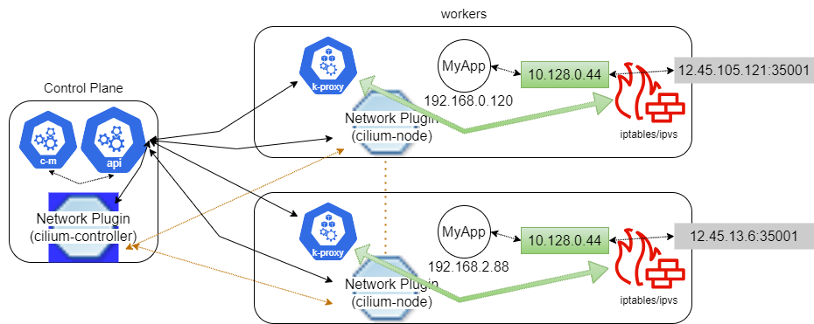
NodePort endpoints redirect the traffic to ClusterIP, passing it to pods (ephemeral) IP addresses.
All nodes use the same firewall rule, so the network plugin will send the traffic to any node running the pod.

Service types:
- ClusterIP (default): Exposes on a cluster-internal IP. Only reachable within cluster. AP address may be static (user defined) or dynamic (range).
- NodePort: Exposes node IP at a static port. NodePort range defined in cluster config. A ClusterIP is also automatically created.
- LoadBalancer: Exposes service externally using cloud providers load balancer. NodePort and ClusterIP automatically created. An async request is sent, if a listener (public cloud) sees it, will create a LoadBalancer, otherwise service status remains as “Pending”.
- ExternalName: Maps service to contents of externalName using a CNAME record.

Management
# List services.
kubectl get svc

# Create a service for a deployment.
# kubectl expose deployment/<depName> --port=<portNumber> --type=<serviceType>

# Create a local service to access a ClusterIP (troubleshooting, development).
kubectl proxy

Ingress controller

Overview
An ingress controller is a daemon running in a Pod which watches the /ingresses endpoint on the API server. It fulfills the Ingress (typically with a load balancer). Required to use an Ingress API object.

An Ingress resource allows easy access to a service routing traffic (typically HTTP) through a edge router (that enforces firewall policy) to pods (that can be deployed on multiple nodes).
Multiple ingress controller can be deployed (use annotations to select), or configure the edge router.

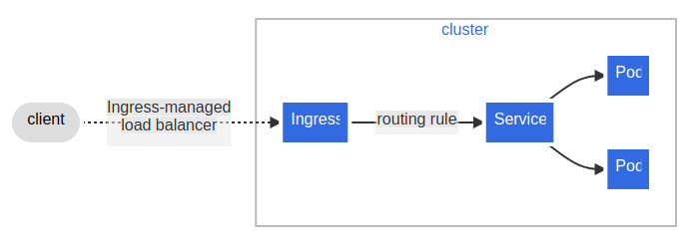

Typically, ingress are used to route HTTP traffic by hostname and path (apache virtualhosts and reroute config…).

Management
# Ingress resource.
apiVersion: networking.k8s.io/v1
kind: Ingress
metadata:
name: ghost
annotations:
# Configure the ingress controller.
nginx.ingress.kubernetes.io/rewrite-target: /
spec:
# default route when a request does not match any rule. Usually set (and left) to the ingress controller config.
DefaultBackend:
# Reference another kubernetes resource. Typically a static asset storage.
resource:
apiGroup: k8s.example.com
kind: StorageBucket
name: static-assets
# Allow to select an ingress controller, through a ingressClassName resource. Optional (default defined).
# ingressClassName:
# Multiple rules may be defined in the same ingress, each forwarding traffic to a specif service.
rules:
# Host may use wildcard “*.nip.io”
- host: ghost.192.168.99.100.nip.io
http:
paths:
# Configure the matching.
# ImplementationSpecific (up to the IngressClass) | Exact (exact match) | Prefix (prefix match).
- pathType: ImplementationSpecific
path: /
backend:
service
# Service name.
name: ghost
port:
# Service port.
number: 2368

# IngressClass resource.
apiVersion: networking.k8s.io/v1
kind: IngressClass
metadata:
labels:
# Allow to define an IngressClass as default for a controller.
# app.kubernetes.io/component: controller
name: external-lb
annotations:
ingressclass.kubernetes.io/is-default-class: "true"
spec:
# Allow to define an IngressClass as default for a controller.
# controller: example.com/ingress-controller
parameters:
apiGroup: k8s.example.com
kind: IngressParameters
name: external-lb

# Deployment exposed with an internal ClusterIP service.
kubectl run ghost --image=ghost
kubectl expose deployments ghost –port=2368
# Describe ingress resource backend.
kubectl describe ingress ingress-resource-backend

# List / create / delete / edit ingresses.
kubectl get ingress
kubectl create -f <ingress.yaml>
kubectl delete ingress <ingress_name>
kubectl edit ingress <ingress_name>

DNS
DNS is provided through CoreDNS by default (plugins available). Client accesses it through kube-dns service.

Troubleshooting DNS: Create a service that connect to the pod and exec a DNS lookup.
nslookup, dig, nc, wireshark, check containers /etc/resolv.conf, network policies and firewalls.

Service Mesh
A service mesh may be used for service discovery, rate limiting, traffic management and advanced metrics.
Service mesh examples :
- Envoy: Modular and extensible proxy. Used as a data plane under other tools of a service mesh.
- Istio: Platform independent tool set which leverages Envoy proxies via a multi-component control plane.
- linkerd: Easy to deploy, fast, and ultralight service mesh.
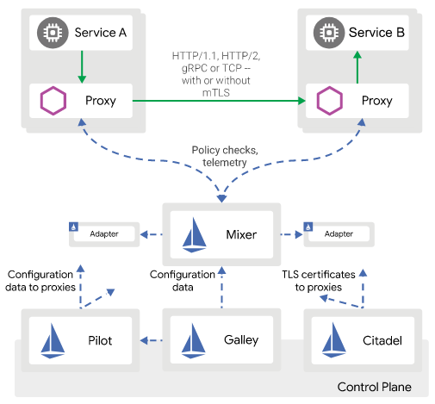

Scheduling

Overview
https://kubernetes.io/docs/concepts/scheduling-eviction/
The kube-scheduler determines which nodes will run a Pod, using a topology-aware algorithm tracking each node.
A priority can be set on a pod (labels/taints/binding), allowing preemption of lower priority pods.
"kubectl get events" allows to see scheduler events.
Can use or code a custom scheduler, when the default scheduler does not fit the needs.

Scheduling configuration

Scheduling stages / Extension points
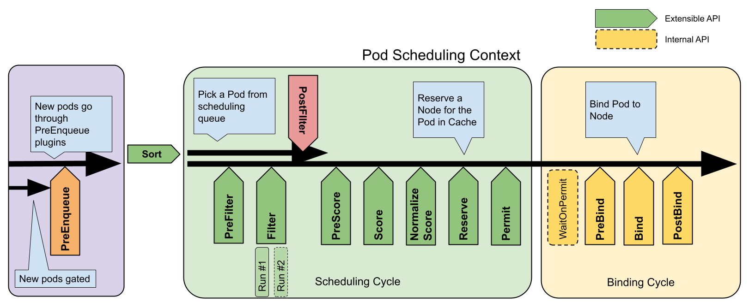
- preEnqueue: Called prior to adding pod to queue, when “Success” is returned, pod added.
- queueSort: An ordering function to sort pending pods in the scheduling queue (one at a time).
- preFilter: Pre-process / check pod information before filtering (can mark pod as unschedulable).
- filter: Identify a set of nodes where the pod can be scheduled. If no node pass the filters, pod marked as unschedulable.
- postFilter: Process unschedulables pods, can mark a pod as schedulable.
- preScore: Informal EP to do pre-scoring work.
- score: Remaining nodes are scored to determine best pod placement (higher weight).
- normalize score: Modify the score before the scheduler computes a final ranking of nodes.
- reserve: Will reserve/unreserve required resources on a node.
- permit: Will approve / deny / wait (timeout, status waiting) the pod for binding.
- preBind: Will perform work (ex: mount a volume on a node) before the pod is bound. If error, pod is sent back to the scheduling queue.
- bind: Set of plugins used to bind a pod to a node (remaining skipped).
- postBind: Perform work (ex: cleaning resources) after a pod is bound to a node.
- multiPoint: xx?

Plugins
https://kubernetes.io/docs/reference/scheduling/config/#scheduling-plugins

Plugins enabled by default, implementing one or more EP :
- NodeName (filter): Checks if the pod spec "node name" match the node.
- NodePorts: Checks if the pod requested "ports" are free on the node.
- NodeUnschedulable (filter): Checks if the node have the spec "unschedulable" set to true.
- NodeResourcesFit/PodFitsResources (filter): Checks if the node has all the resources that the Pod is requesting.
- PodFitsResources (filter): Checks if the node has sufficient resources to fit the pod.
- ImageLocality (score): Favors nodes with pods running the container image.
- NodeResourcesBalancedAllocation (score): Favors nodes that would obtain a more balanced resource usage if pod scheduled.
- NodeAffinity (filter, score): Implements node selectors and affinity.
- PodTopologySpread (preFilter, filter, preScore, score): Implements Pod topology spread.
- TaintToleration (filter, preScore, score): Implements taints and tolerations.

Scheduling profile
The different stages / EP of the scheduler can be configured using scheduling configuration profiles.
A scheduler configuration can run more than one profile.
Pods should define the profile that will be used for their scheduling (using “spec.schedulerName”, defaut-scheduler when not set).

# Configuration example.
apiVersion: kubescheduler.config.k8s.io/v1
kind: KubeSchedulerConfiguration
profiles:
- schedulerName: default-scheduler
- schedulerName: custom-scheduler
plugins:
preFilter:
disabled:
- name: '*'
filter:
disabled:
- name: '*'
postFilter:
disabled:
- name: '*'

Pod / node specifications
Scheduling decisions may be part of a pod spec. Can be do through :
- nodeName and nodeSelector: Assign to a single node or a labeled group of nodes (label key/value).
- affinity and anti-affinity: Assign to a preferred node (see pod affinity rules).
- taints and tolerations: label a node to not be scheduled (taint), tell a pod to ignore a taint (toleration).
- schedulerName: Use a custom scheduler configuration.

Priority classes
# Get priority class (non-namespaced objects).
kubectl get priorityclass

apiVersion: scheduling.k8s.io/v1
kind: PriorityClass
metadata:
name: level3
# PreemptLowerPriority|Never
preemptionPolicy: PreemptLowerPriority
value: 300000000

# Set pod spec.priorityClassName: <priorityClassName>.

Pod affinity rules
The rules apply on node’s pods, not on node itself.
Scheduler will work on previously running pods labels, so need to request each node for pod tracking (performance lost when many nodes).

# Pod yaml file spec section.
spec:
affinity:
# Will try to schedule pods together (used when pods need to communicate a lot).
podAffinity:
# Pod will not be schedule (Pending) unless following operator is true.
# When the operator change to false, the pod is left running.
requiredDuringSchedulingIgnoredDuringExecution:
- labelSelector:
# A pod with a security/S1 label must run on the node so this new pod can be scheduled.
matchExpressions:
- key: security
operator: In
values:
- S1
# Will try to keep nodes on different nodes.
podAntiAffinity:
# The pod will be scheduled even when no node fits the following operator.
preferredDuringSchedulingIgnoredDuringExecution:
- weight: 100
podAffinityTerm:
labelSelector:
matchExpressions:
- key: security
operator: In
values:
- S2

Node affinity rules
Based on node labels, will replace the “nodeSelector” deprecated setting.
# Pod yaml file spec section.
spec:
affinity:
nodeAffinity:
# The pod will be scheduled even when no node fits the following operator.
PreferredDuringSchedulingIgnoredDuringExecution:
# Higher weight will be prefered in case of different rules match.
- weight: 1
preference:
# A node with a diskspeed/quick|fast label will be used/prefered to schedule this pod.
matchExpressions:
- key: diskspeed
operator: In
values:
- quick
- fast

Taints and tolerations
A node with a particular taint will repel Pods without tolerations for that taint (Taints apply to nodes, tolerations to pods).
A taint is expressed as key=value:effect, with effect :
- NoSchedule: No new pod will be scheduled on this node, but existing ones left running.
- PreferNoSchedule: No new pod will be scheduled on this node as far as no other node available. Existing pods left running.
- NoExecute: Running pods not tolerating the taint will be evacuated, and no future pod scheduled (see tolerationSeconds).

# Pod yaml file.
tolerations:
- key: "server"
# Equal (default) | Exists (xx ?, should not be used?).
operator: "Equal"
value: "ap-east"
effect: "NoExecute"
tolerationSeconds: 3600

Custom resources

Overview
Add custom resources (objects or operators) to the cluster:
- Adding a Custom Resource Definition (CRD) to the cluster: Not very flexible.
- Use of Aggregated APIs (AA): Requires a new API server to be written and added to the cluster.
- ThirdPartyResource (TPR): deprecated since 1.8.

Custom resource definition (CRD)
Added under apiextensions.k8s.io/v1, must respond to REST requests just like built in objects.

Resource definition
apiVersion: apiextensions.k8s.io/v1
kind: CustomResourceDefinition
metadata:
# Must match spec.names.plural and spec.plural declarations. "<pluralName>.<group>".
name: backups.stable.linux.com
# Optional. Pre-delete hooks, after deletionTimestamp updated the following list will be executed.
finalizers:
- finalizer.stable.linux.com
spec:
# Part of REST API declaration (/apis/<group>/<version>/<plural>).
group: stable.linux.com
versions: v1
# Namespaced (available in a namespace) | Cluster (available for the entire cluster).
scope: Namespaced
names:
# Part of REST API declaration (ex: /apis/stable/v1/backups).
plural: backups
# For CLI usage.
singular: backup
shortNames:
- bks
# For resource manifests usage, CamelCased singular.
kind: BackUp
# Optional. When not activated, only the attribute existence is checked.
validation:
openAPIV3Schema:
properties:
spec:
properties:
timeSpec:
type: string
pattern: '^(\d+|\*)(/\d+)?(\s+(\d+|\*)(/\d+)?){4}$'
replicas:
type: integer
minimum: 1
maximum: 10

Object definition
# apiVersion/kind match the defined CRD.
apiVersion: "stable.linux.com/v1"
kind: BackUp
metadata:
name: a-backup-object
# Depends on the controller.
spec:
timeSpec: "* * * * */5"
image: linux-backup-image
replicas: 5

Aggregated APIs (AA)
Allows to add a kubernetes type API server (subordinated to the kube-apiserver) to the cluster.
Enable: Add flag in the kube-apiserver start (--enable-aggregator-routing=true).

Helm
Differences heml v3/v2
- Software installation no longer generates a name automatically (provide or pass the –generated-name).
- Tiller pod removed (security).

Charts
A chart is an archived set of kubernetes resource manifests.

Structure
├── Chart.yaml
├── README.md
├── templates
│ ├── NOTES.txt
│ ├── _helpers.tpl
│ ├── configmap.yaml
│ ├── deployment.yaml
│ ├── pvc.yaml
│ ├── secrets.yaml
│ └── svc.yaml
└── values.yaml

Chart.yaml: metadata about the Chart (name, version, keywords...).
values.yaml: keys/values used to generate the release in the cluster. Replaced in the resource manifest.
templates (dir): contains the resources manifests.
Resource manifests: Use the Go templating syntax. When release created, values.yaml injected in the template.

Repositories and hub
Repositories are simple HTTP servers containing index file.
# Repository commands.
helm search hub redis
helm repo add bitnami https://charts.bitnami.com/bitnami
helm repo list
helm search repo bitnami

Deployments
Local agents (such as Tiller) deploy objects based on a chart.
helm install <myPackage>
dependency may be needed (such as PV... Check the README), chart deployment output will tell about missing dependencies.

# Install a local repo.
helm fetch bitnami/apache –untar

Logging and troubleshooting

Overview
https://kubernetes.io/docs/tasks/debug/

Troubleshooting steps
- Command line errors.
- State of Pods, Pod logs.
- Pod DNS and network (shell).
- Node resources allocation, node logs.
- Security settings (RBAC, SELinux, AppArmor).
- kube-apiserver/controllers API calls.
- Auditing (sidecar).
- Inter-node network issues (DNS, firewall).
- Control Plane server controllers.

Commands
# Deploy and log in inside a sidecar container pod/container.
kubectl create deploy busybox --image=busybox --command sleep 3600
kubectl exec -ti <busybox_pod> -- /bin/sh

# Display pod standard output (logs, written to file by kubelet via docker logging driver).
kubectl logs <podName>

Metric server
The metric server will collect metrics (cpu/memory/disk usage…) and expose them as a standard API to allow consumption by other agents (autoscalers…). Enpoint: /apis/metrics/k8s.io/).

Ephemeral containers
Allow to add a container to a pod (not restarted automatically) through the “ephemeralcontainers” handler.
Used to add a shell container (busybox) in a pod when no other shell container available.
kubectl edit is not possible, use “kubectl attach” to join an existing process within the container (exec = new process).

kubectl debug buggypod --image debian –attach

Cluster start sequence
# Using systemd, current state and configuration.
systemctl status kubelet.service
vi /etc/systemd/system/kubelet.service.d/10-kubeadm.conf

# kubelet binary.
# staticPodPath is the directory where any yaml file representing resource will be watched for creation.
Vi /var/lib/kubelet/config.yaml

Scheduler
Binary settings: /var/lib/kubelet/config.yaml
staticPodPath: /etc/kubernetes/manifests/
Create a yaml file in this directory, see if the scheduler read it and create the resource.

Monitoring and logging
Use Prometheus as an integrated metric server for monitoring.
Use Grafana to visualize the data.
Kubelet writes container logs to local files (docker logging driver): kubectl logs.
Use Fluentd to fetch/filter/aggregate/transfer logs across nodes (DaemonSet inside each node).

Manage kubectl plugins (krew)
Plugins can be added to extend kubectl command: use krew (kubectl plugin manager) to manage them.
kubectl plugin list
kubectl krew search
kubectl krew install tail

Network Traffic

Wireshark (sniff plugin)
# -c option used to declare which container in the pod to use for traffic monitoring.
kubectl krew install sniff <podName> -c webcont

Debugging with crictl
https://kubernetes.io/docs/tasks/debug/debug-cluster/crictl/
Crictl is an interface for CRI-compatible container runtimes. Used to inspect containers.

# Containers.
critcl ps -a

# Pods.
crictl pods
crictl pods --label run=nginx

# Images.
crictl images

# Execute a command in a running container.
crictl exec -i -t <containerId> ls

# Get container's logs, and latest lines.
crictl logs <containerId>
crictl logs –tail=100 <containerId>

High Availability
Ability to join multiple CP nodes with collocated etcd databases (redundancy in case of CP down).
3 instances are required to be sure etcd database is not corrupt and elect a leader.

Collocated databases
Use kubeadm command to join at least 2 more CP servers
# --control-plane flag and a certificate-key that need to be generated on the new CP and copied on the existing one.

Non-Collocated databases
An external cluster (needs to be configured first) can be used to store etcd database, resulting in less interruption when a node fail.
The kubeadm-config.yaml file needs to be configured with the etcd (external), endpoints and certificate locations).

Security

Security contexts
https://kubernetes.io/docs/tasks/configure-pod-container/security-context/
Security contexts are security limitations defined per pod or per container.
# Pod resource YAML file.
apiVersion: v1
kind: Pod
metadata:
name: nginx
spec:
# Pod’s containers cannot run their process as the root user.
securityContext:
runAsNonRoot: true
containers:
- image: nginx
name: nginx

Pod Security Policies
Deprecated, removed in 1.25. Replacement feature “Pod Security Admission” in alpha.

Network Security Policies
By default, all pods can reach each other.
Network isolation is not available in all network plugins, and can be configured using the NetworkPolicy resource, applying to namespaces, pods labels or name.
# NetworkPolicy resource YAML file.
apiVersion: networking.k8s.io/v1
kind: NetworkPolicy
metadata:
name: ingress-egress-policy
namespace: default
spec:
podSelector:
matchLabels:
role: db
policyTypes:
- Ingress
- Egress
ingress:
- from:
- ipBlock:
cidr: 172.17.0.0/16
except:
- 172.17.1.0/24
- namespaceSelector:
matchLabels:
project: myproject
- podSelector:
matchLabels:
role: frontend
ports:
- protocol: TCP
port: 6379
egress:
- to:
- ipBlock:
cidr: 10.0.0.0/24
ports:
- protocol: TCP
port: 5978

# Default network policy exemple.
apiVersion: networking.k8s.io/v1
kind: NetworkPolicy
metadata:
name: default-deny
spec:
podSelector: {}
policyTypes:
- Ingress

