Rebecca Ly

August 30, 2020

Foundations of Programming: Python

Assignment 08

<https://github.com/lyrebecca/IntroToProg-Python-Mod08>

**Creating Classes, Constructors, and Methods**

**Introduction**

This week’s assignment had a template for us to allow a user to enter two variables into a list, store the list in memory and write the list to a text data file.

**Initializing the Constructor Class**

In Figure 1 below, the “Product” class initializes two constructors to create two properties called product_name and product_price. Then we can create a string representation using those two properties.

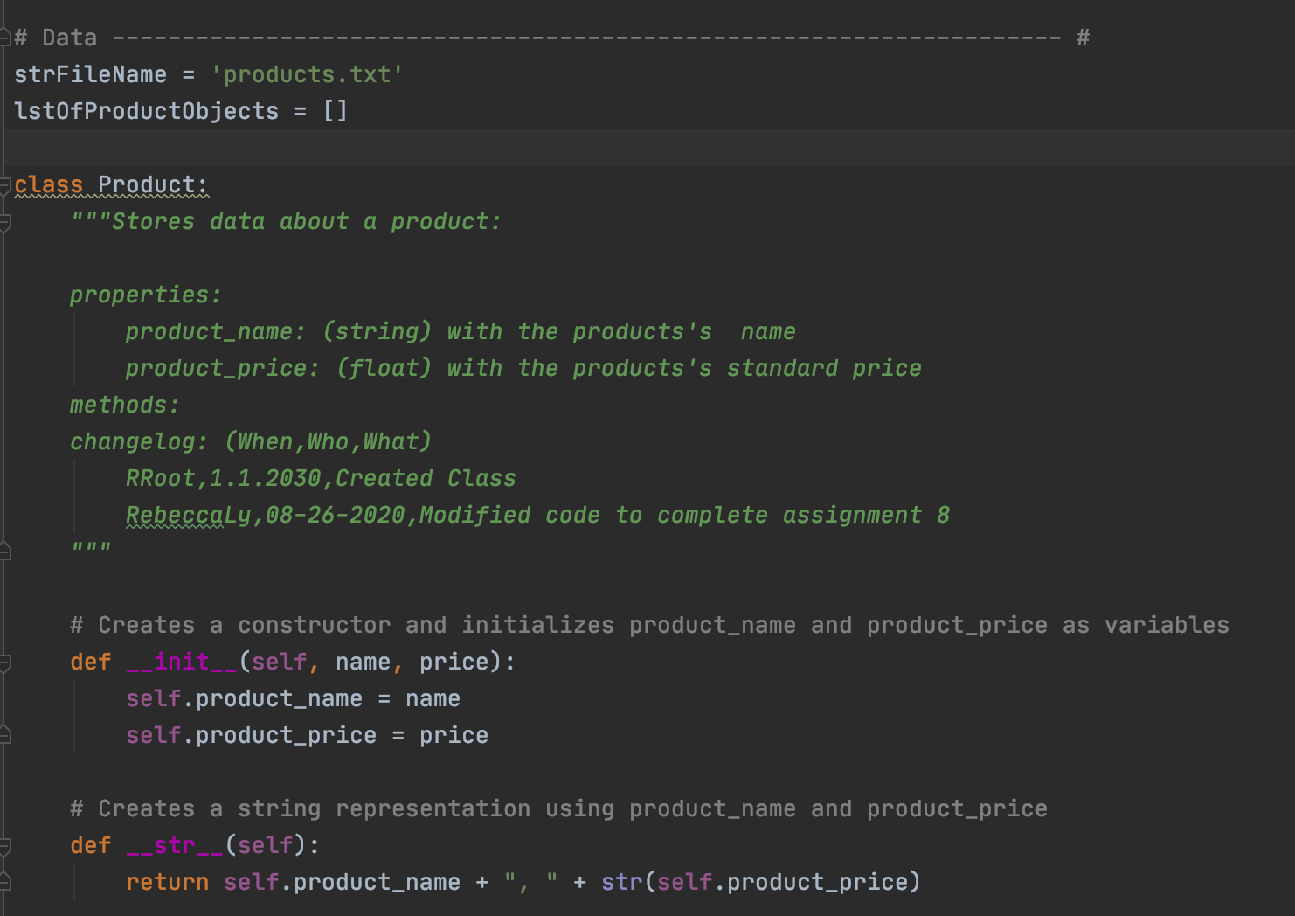

*Figure 1: Product class with two properties*

**Creating the FileProcessor Class**

The FileProcessor class processes data to and from a file and the list of product objects in the “products.txt” which holds two methods as shown in Figure 3 and 4. The method as displayed in Figure 3 opens the file and appends each row of data in a list stored in memory. In Figure 4, the user can save the list in memory to the “products.txt” file.

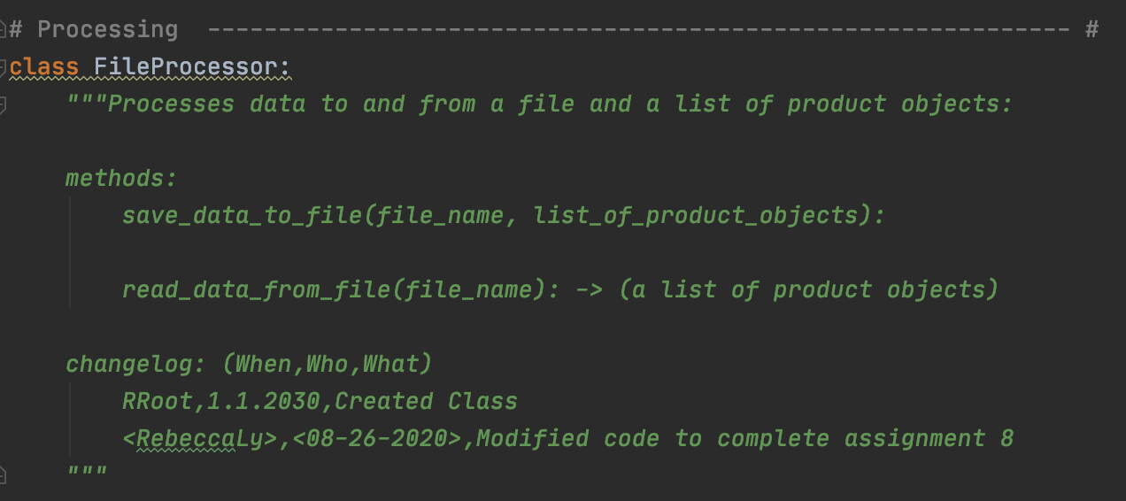

*Figure 2: Docstring explains the FileProcessor class*

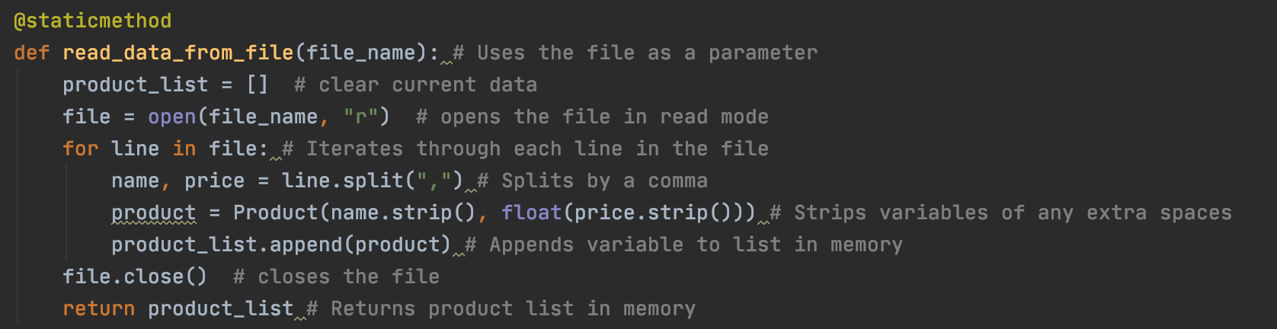

*Figure 3: Method which reads data from the “products.txt” file*

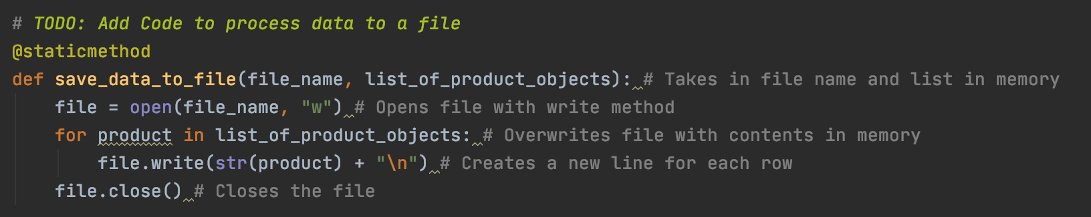

*Figure 4: Method which saves the data in the memory to the “products.txt” file*

**Creating the IO Class**

The IO class is meant to take in user input and provide output to the user as well. For this script, this class will take in a user’s input, read data from the file, and display the menu to the user each time the script is executed.

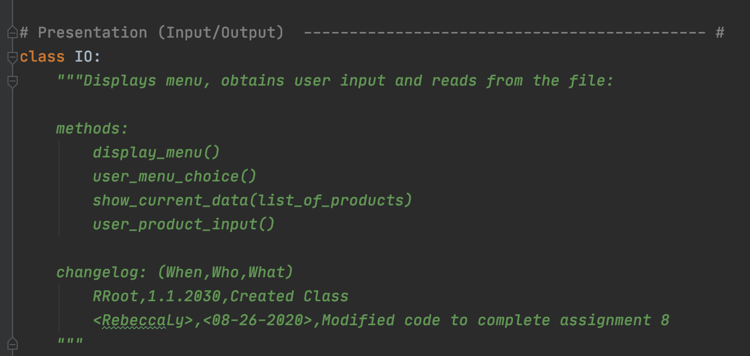

*Figure 5: Displays docstring for IO class*

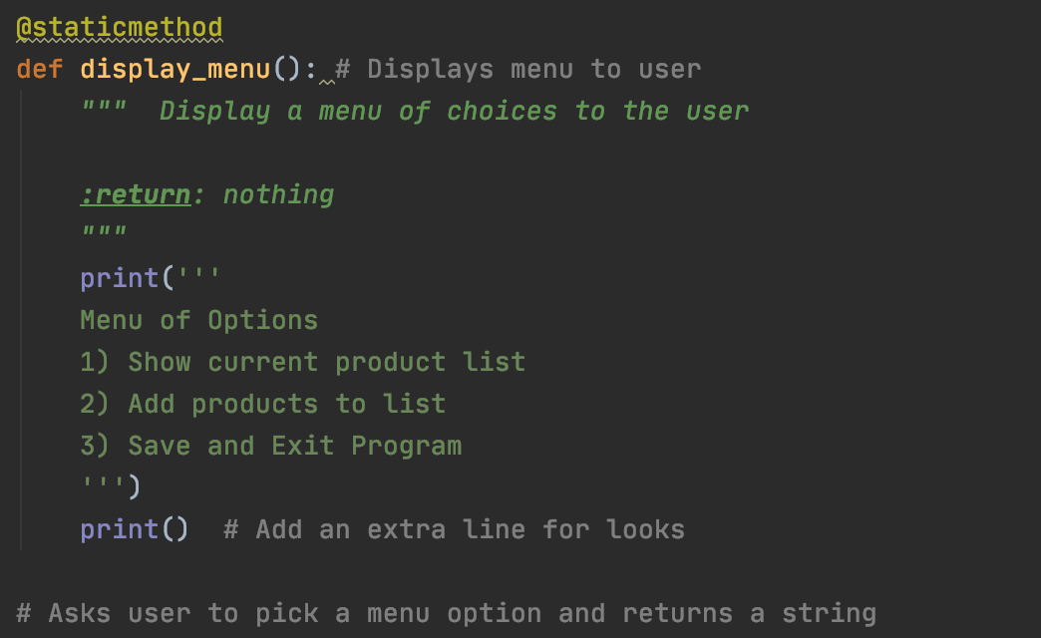

*Figure 6: “Display_menu” method prints the menu to the user*

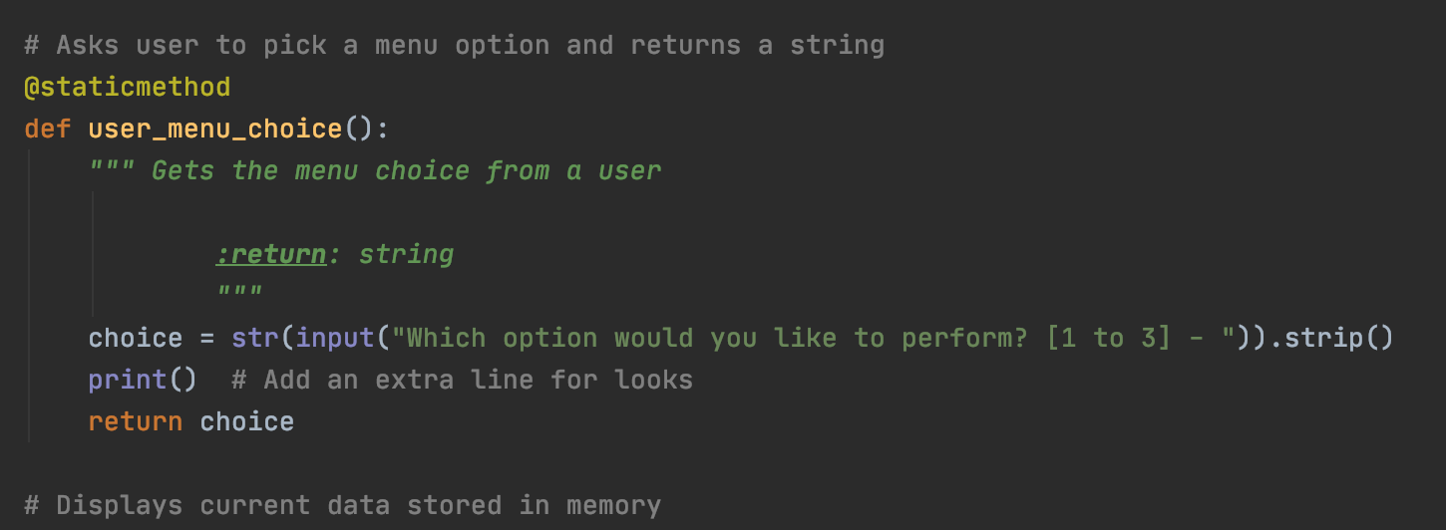

*Figure 7: Grabs user’s input when asked which menu option they want*

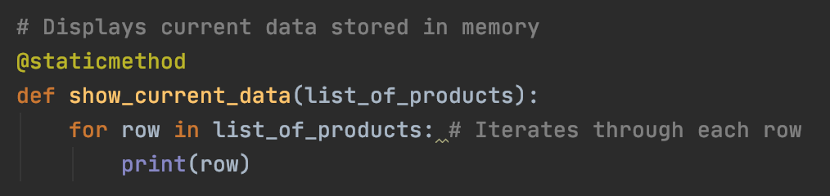

*Figure 8: Displays current data in the list stored in memory*

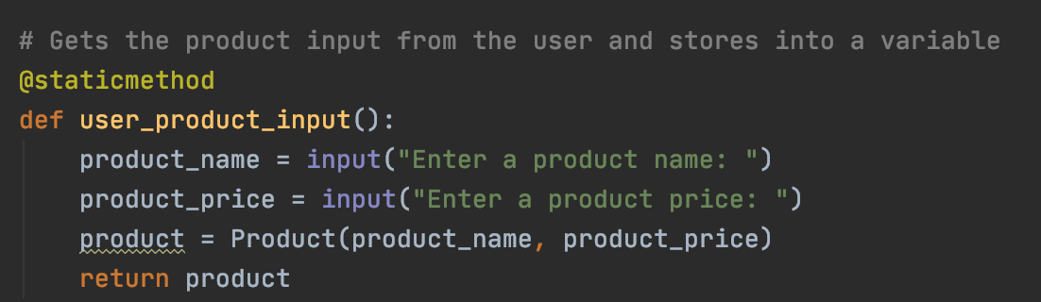

*Figure 9: Method that takes in user’s input for product name and price*

**Creating a While Loop for Menu Options**

The main body of the script has a while loop which lads data from file into a list of product objects when the script starts. The while loop will display the menu each time the loop is ran. Each time, the loop will evaluate the user’s input and run the specific methods as shown in Figure 10.

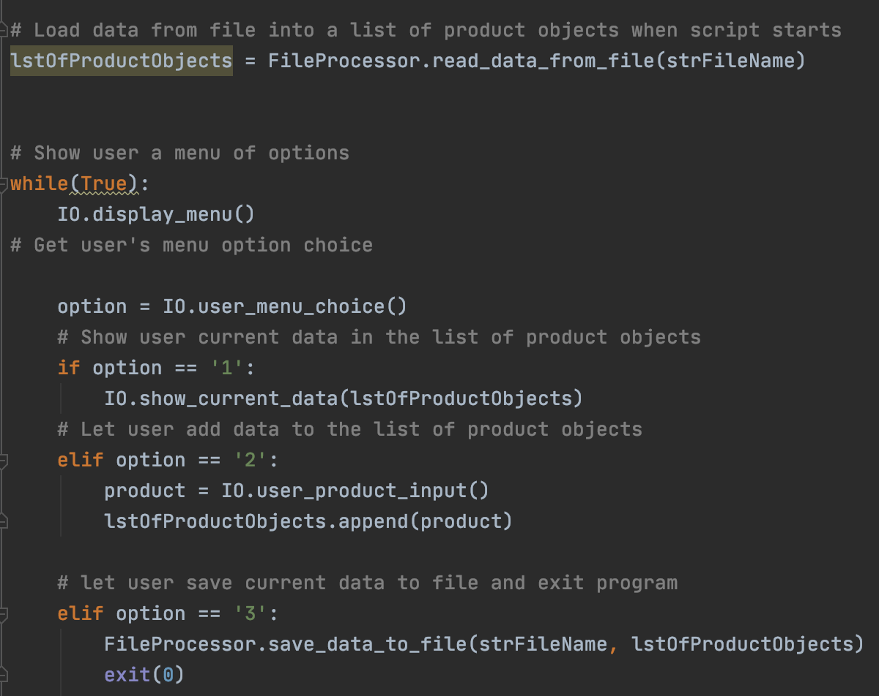

*Figure 10: While loop with an if statement going through each option*

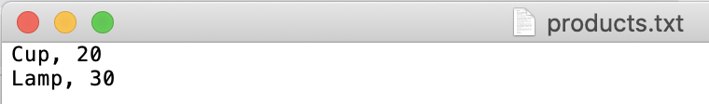

*Figure 11: Result of saving user’s input into the “products.txt” file*

**Summary**

This week’s assignment is to create methods to processing and take in a user’s input and provide output through the use of methods. It was a bit difficult to figure out how to get started and understanding how to use the parameters within the methods. The hardest part of the assignment was creating the IO class as I wasn’t clear on what methods I needed. Understanding that some variables are just placeholders or “magically created” is still a hard concept for me to understand.