Rebecca Ly

August 8, 2020

Foundations of Programming: Python

Assignment 05

<https://github.com/lyrebecca/IntroToProg-Python>

**Writing a List to a File**

**Introduction**

This week’s assignment focused on using Randal Root’s code and inserting our own code to make the entire code work. The python script prints a menu to the user and asks the user to add their tasks and priorities (high, medium, low) into a dictionary and it will append the dictionary into a table.

**Reading the “ToDoList.txt” to the Table**

Prior to displaying the menu to the user, the assignment asked us to write what is currently in the “ToDoList.txt” file to the table variable “lstTable” currently stored in our memory. Below in Figure 1, we open the file and use a for loop to loop through the rows in the file to split them into “tasks” and “priority”. Then we use “task” and “priority” as our keys in our dictionary and append them to the “lstTable” variable.

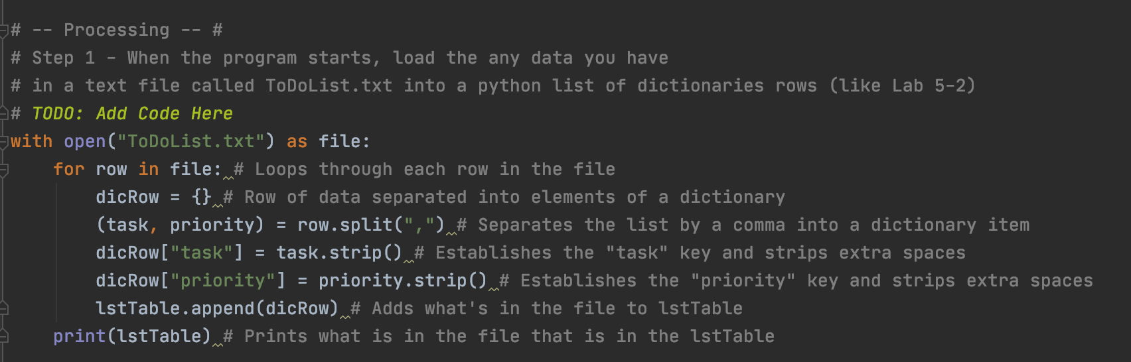

*Figure 1: Reads contents of the file into a dictionary which is then stored in lstTable*

I created a text document called “ToDoList.txt” and entered two values into the file which is printed below as the program is first initialized and prints the current contents of the file and stores it in the “lstTable” variable.

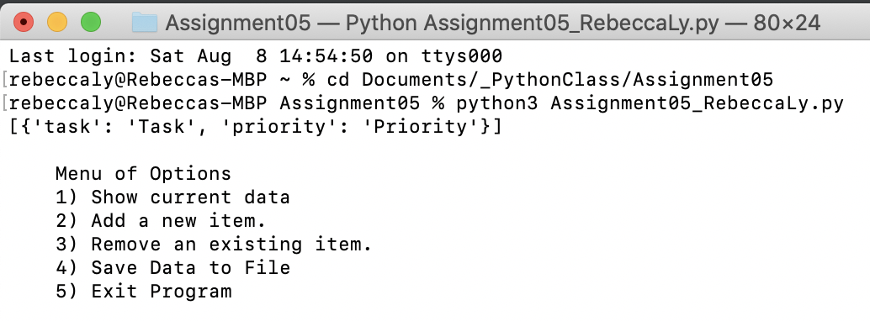

*Figure 2: Output when running the program initially*

**Menu Option One**

The first menu option allows the user to read the contents of the “lstTable” variable in memory. If the first option is selected, for each row (dicRow) in the table (lstTable), it will loop through and print out the keys (task, priority) for each dictionary as shown in Figure 3.

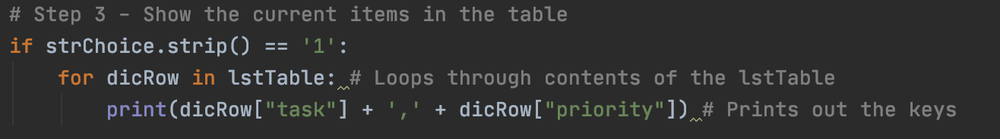

*Figure 3: Option one showing for loop going through each dictionary*

Below in Figure 4, the contents of the “lstTable” variable is printed which only contains the text that I have written into the file directly prior to the start of the program.

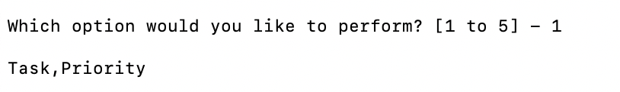

*Figure 4: Output from menu option one*

**Menu Option 2: Appending Items to the Dictionary**

Option 2 allows the user to add tasks and priorities to the dictionary which is then appended to the lstTable variable. “StrTask” and “strPriority” are the variables created to take the user’s inputs and then stores them as values for task and priority in a dictionary. The dictionary is then appended to the lstTable variable.

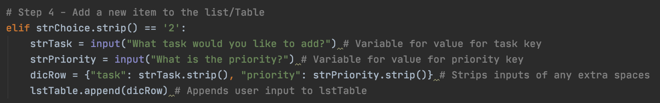

*Figure 5: Option three showing input variables created and assigned into a dictionary*

Below in Figure 6, I added the task to “Wash the car” with a priority of “Medium” which is then appended to the “lstTable” and printed below as I selected option one to display the current contents of “lstTable”.

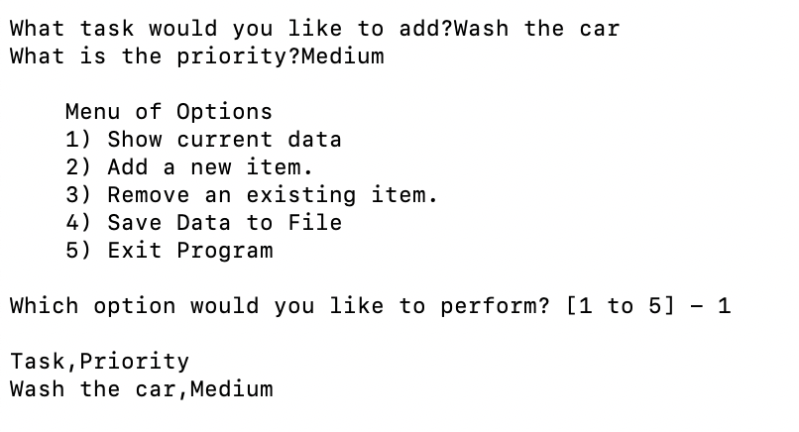

*Figure 6: Adds a task and displays current contents of “lstTable”*

**Menu Option 3: Removing a Task from the Dictionary**

The third option allows the user to remove an item from the list/table. The python script assigns the user’s input for which task to remove into a variable. I created another variable to count the number of rows in the lstTable for comparison at the end to see if a task was removed or not. If a task was not removed, then the task isn’t found. If a task was removed, then it would go through the for loop and remove the task as shown in Figure 7.

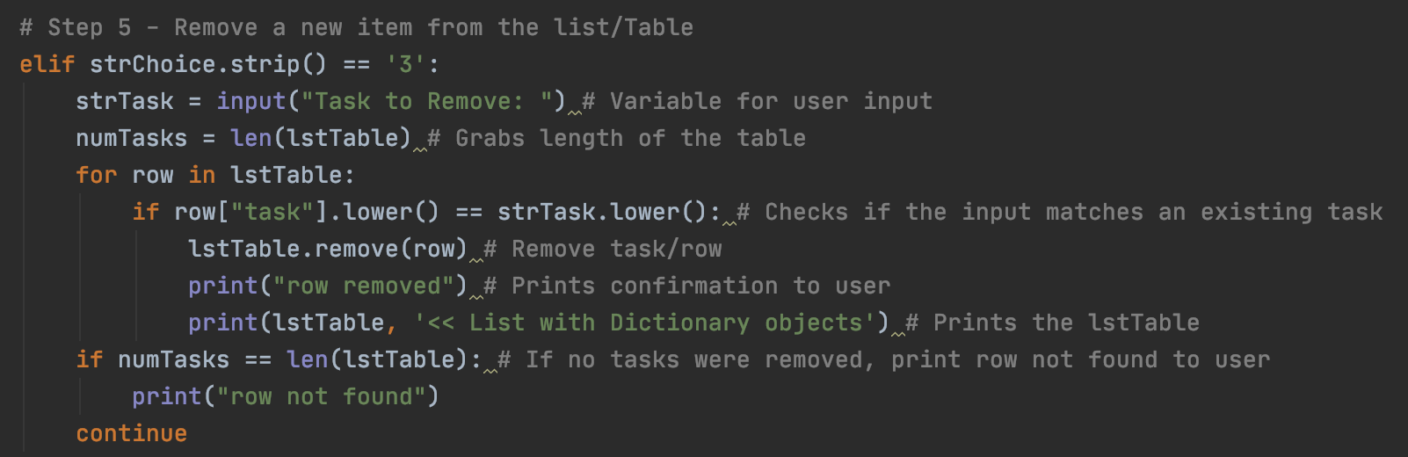

*Figure 7: Option allowing a user to remove a task*

Below in Figure 8 is the output of selecting the third option to remove an item. I removed the task “Wash the car” which was then removed from the “lstTable” and the current contents are then printed below.

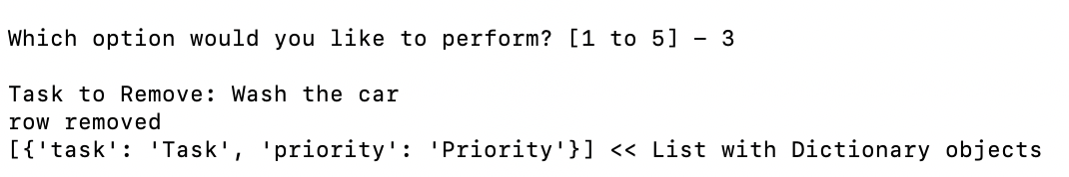

*Figure 8: Output of removing a task*

**Menu Option 4: Writing the Table in Memory to the “ToDoList.txt” File**

The fourth option saves the tasks to the “ToDoList.txt” file from the lstTable variable currently stored in memory. The code in Figure 9 opens the text file and uses a for loop to loop through each dictionary (dicRow) and grabs each value for “task” and “priority” and writes it to the “ToDoList.txt” file as noted by the “w” in Figure 9.

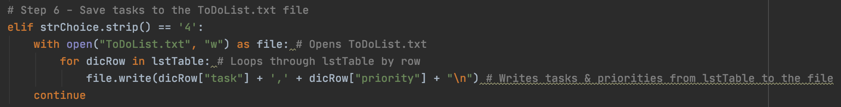

*Figure 9: Saves the contents of lstTable variable to the “ToDoList.txt” File*

Below in Figure 10 and 11, I selected option two in order to add another task “Wash the dishes” to the “lstTable” to demonstrate the process of writing to the “ToDoList.txt” file after selecting option four to save the data to the file which is shown in Figure 11.

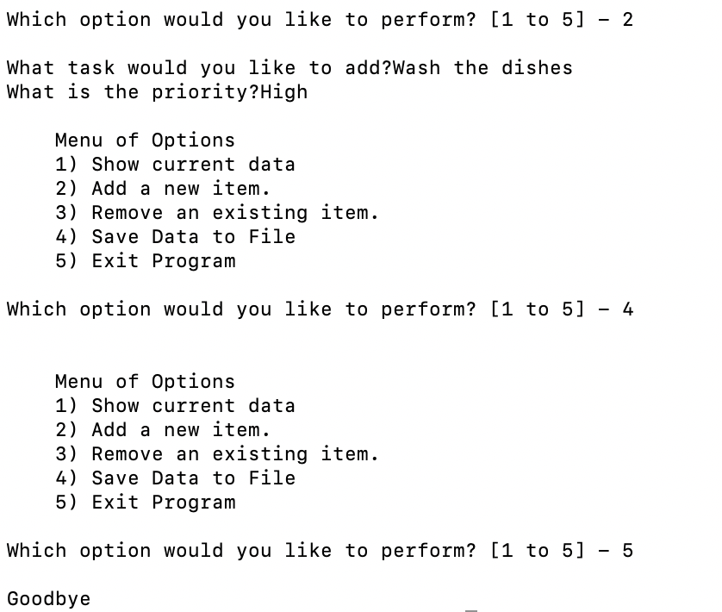

*Figure 10: Adding a task to the “lstTable” and saving the data to the “ToDoList.txt” file*

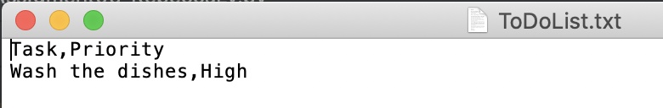

*Figure 11: Output of the “ToDoList.txt” file*

**Summary**

This week’s assignment was difficult for me as I wasn’t sure the connection between lists and tables and entering values into a dictionary. Once I review the modules a couple of times, I was able to understand most of the content enough for this week’s assignment. I misunderstood the assignment where I thought the “task” was the key and the “priority” was the value when both the “task” and “priority” were the keys, and the user’s inputs were the values.