CUT_AXIALLY_LOADED_PILE Program

Theory and User Manual
Program: CUT_Axially_loaded_pile.py or CUT_Axially_loaded_pile.exe
Version: 2.9.2 (Program)
v1 (Manual)
Author: Dr Lysandros Pantelidis
Department of Civil Engineering and Geomatics
Cyprus University of Technology
About: Educational tool — no warranty. Use at your own risk. Free of charge.



Table of Contents
Table of Contents 3
1. Introduction 4
2. Computational Formulations 5
2.1. General concept 5
2.2. Pantelidis Earth-Pressure Formulation 5
2.3. Obtaining $Ko$, the Effect of Over-consolidation, and Treating Displacement Piles 7
2.3.1. Evaluation of $K0$for Normally Consolidated Soils 7
2.3.2. Effect of Over-consolidation 8
2.3.3. Treating Displacement and Non-Displacement Piles 8
3. Program Overview & GUI (graphical user interface) 9
3.1. Left panel — Inputs 9
General & GWT 9
Pile Data 10
Factors & Loads 11
Layers (top to bottom) — $H$ is auto = $∑h$ 12
3.2. Visualization (right panel) 14
3.3. Visualization – OCR vs depth (right panel) 15
3.4. Running an Analysis 17
3.5. Outputs (right panel) 17
Outputs – Main Table 17
Outputs - Tab: Shaft resistance vs depth 18
Outputs - Tab: K0 vs depth 19
- Example: Displacement pile with $aOCR=bOCR=cOCR= 1$ 21
- Example: Driven tubular pile with wall thickness $t=$8 mm (also, $OCR=1$) 22
Outputs - Tab: Slices (point-level) 23
Outputs - Tab: Per-layer (factored) 24
4. Generating a Report 26
Creating the Report 26
Report Contents 26
Important Notes 27
5. Licensing, Copyright, and Disclaimer Statement 27
Licensing 27
NO WARRANTY 27
LIMITATION OF LIABILITY 28

Introduction
The CUT_Axially_Loaded_Pile is an educational software designed to calculate the ultimate bearing capacity of axially loaded piles. The program is based on the Pantelidis analytical method, which provides a fully analytical determination of the shaft resistance for any $c–φ$ soil, whether homogeneous or layered, and under any degree of overconsolidation, expressed through the Overconsolidation Ratio ($OCR$).
Both displacement and non-displacement piles are supported within the same computational framework.
The Pantelidis method bridges the conceptual gap between the traditional α-method (used for purely cohesive soils under undrained conditions) and the $β-$method (used for purely frictional soils under drained conditions). By setting $φ = 0$ (undrained conditions) or $c = 0$ (drained conditions in coarse-grained soils), the method reproduces the results of these classical approaches, while for intermediate $c–φ$ soils it provides a continuous and rational transition between them.
The significance of the Pantelidis method lies in its ability to correctly capture the dual role of soil cohesion under drained conditions. Cohesion acts in two opposite ways:
- Favourably, by contributing an additional shear resistance through adhesion along the pile–soil interface. However, this contribution is often uncertain and may conservatively be ignored in design, since adhesion may not develop fully—particularly above the groundwater table, where the soil is typically too dry to sustain it.
- Unfavourably, by reducing the lateral earth pressures acting on the pile. This reduction occurs in a manner analogous to the development of active earth pressures, but with different magnitude. As a result, the lateral stresses within a cohesive layer are diminished throughout its depth, and a near-surface zone of zero horizontal stress is formed. This is known as the neutral zone, which is conceptually similar—though not identical in depth—to the tensile crack zone that develops in the active state of cohesive soils.
By accounting analytically for both these contrasting effects of cohesion, the Pantelidis method provides a realistic and physically consistent description of the stress field and shaft resistance in $c–φ$ soils under drained conditions.
The model accounts for the full stress–strain behavior of the soil through the at-rest earth pressure coefficient ($K_{0}$), computed using the Pantelidis analytical formulation, which explicitly includes the effects of cohesion ($c$), friction angle ($φ$), vertical seismic coefficient ($k_{v}$), and effective stress variation with depth. For displacement piles, ($K_{0}$) is further modified to include $OCR$ effects and a displacement add-on.
The shaft resistance is integrated along the pile length, combining the cohesive and frictional contributions as functions of depth, interface roughness ($α-$factors), and groundwater conditions. The tip resistance is introduced as a user-defined input and combined with the computed shaft resistance to determine the total axial capacity.

Results are presented both numerically and graphically, including:
- $K_{0}$ vs depth,
- $q_{s}$ vs depth,
- per-slice (per-discretization member) and per-layer resistance tables,
- summary of factored and non-factored capacities, and
- safety ratios for shaft and total resistance.
This educational program thus provides a unified and transparent analytical framework for evaluating the axial capacity of piles in a wide range of soil conditions, serving as a modern and generalized extension of conventional design methods.

Computational Formulations

General concept
The analysis of shaft resistance is a classical earth-pressure problem, since the normal stress acting along the pile–soil interface—responsible for the development of friction—is, in most cases, governed by the at-rest earth pressure of the surrounding soil.
Accordingly, the coefficient of earth pressure at rest, $K_{0}$, plays a central role in the analytical evaluation of the shaft friction.
For displacement piles, the soil state deviates from the at-rest condition because of the radial expansion and densification of the soil during installation. The resulting stress condition may vary between the at-rest and passive states, depending on the degree of displacement, the mechanical properties of the soil (including $E$ and $ν$), and the position along the pile shaft.
Hence, the shaft-resistance problem can be formulated as an earth-pressure problem on a vertical pile with horizontal ground surface, subjected to a stress state anywhere between the at-rest and passive limits.
The CUT_Axially_Loaded_Pile program is based on the comprehensive earth-pressure theory of Pantelidis, which provides a unified analytical formulation applicable to any $c–φ$ soil and any intermediate state between active and passive conditions.
The corresponding equations are summarized below.

Pantelidis Earth-Pressure Formulation
For a vertical retaining wall (here, pile), the coefficient of earth pressure $K_{XE}$​ to be used in the general expression for the normal stress acting on the interface is evaluated using Formula (F.1), where $X=O, A, P, IA$or$IP$ denotes the at-rest, active, passive, intermediate-active, and intermediate-passive state, respectively:
$K_{XE}=\frac{1-(2λ-1)sinφ_{m}}{1+(2λ-1)sinφ_{m}}-(2λ-1)\frac{2c_{m}}{σ_{v}-u}tan\left({45}^{o}-(2λ-1)\frac{φ_{m}}{2}\right)$ (F.1)
The mobilized cohesion of the soil, $c_{m}$​, is obtained from Formula (F.2):
$c_{m}=c'\frac{tanφ_{m}}{tanφ'}$ (F.2)

The mobilized internal friction angle $φ_{m}$​ is derived from the solution of Formula (F.3):
$sinφ_{m}\left(C_{1}-\left(2λ-1\right)B_{1}\frac{{tanφ}_{m}}{tanφ'}\right)=\left|1-A_{0}+\left(2λ-1\right)B_{1}\frac{{tanφ}_{m}}{tanφ'}\right|$ (F.3)
Its analytical solution is given by Formula (F.4):
$φ_{m}=Re\left(\sin^{-1}\left(-\frac{1 }{3α_{ο}}{(b}_{o}+\frac{D_{0}}{C_{0}ζ^{λ}}+C_{0}ζ^{λ})\right)\right)\frac{180}{π} \left(ᵒ\right)$ (F.4)
where,
$a_{o}=\left(2λ-1\right)\left(1+e_{2}^{2}\tan^{2}φ^{'}\right)$,
$b_{o}=1-(2 e_{1}e_{2}+e_{2}^{2})\tan^{2}φ'$,
$c_{o}=\left(2λ-1\right)(e_{1}^{2}+2 e_{1}e_{2})\tan^{2}φ'$,
$d_{o}=-e_{1}^{2} \tan^{2}φ'$,
$D_{0}=b_{o}^{2}-3a_{o} c_{o}$,
$D_{1}=2b_{o}^{3}-9 a_{o} b_{o} c_{o} +27a_{o}^{2} d_{o}$,
$C_{0}=\sqrt[3]{\frac{1}{2}\left(D_{1}-\sqrt{D_{1}^{2}-4D_{0}^{3}}\right)}$,
$e_{1}={\left(1-A_{0}\right)}/{B_{1}}$, $e_{2}={C_{1}}/{B_{1}}$ and $ζ=-\frac{1}{2}+\frac{\sqrt{3}}{2}i$.
The symbol $Re$ indicates that only the real part of the complex number is retained, as its imaginary component is infinitesimally small.
For the active “side” of the problem (any soil state between the at-rest and active states)—not applicable to the axially loaded pile problem—the parameter $λ=1$. In this case:
$A_{0}=\frac{1-sinφ'}{1+sinφ'}\left(1-ξ sinφ^{'}+\frac{k_{h}}{1-k_{v}}tanφ^{'}\left(2+ξ\left( 1- sinφ^{'}\right)\right)\right)$ (F.5)
$B_{1}=\frac{2c'}{\left(1-k_{v}\right)\left(σ_{v}-u\right)}tan\left(\frac{π}{4}-\frac{φ'}{2}\right)$ (F.6)
For the passive “side” of the problem (any soil state between the at-rest and passive states)—the applicable side in the case of an axially loaded pile—the parameter $λ=0$ when $A_{0}≥1$ and $λ=1$ when $A_{0}≤1$. In this case:
$A_{0}={\left(\frac{1+sinφ^{'}}{1-sinφ^{'}}\right)}^{ξ_{1}}\left(1+ξ sinφ^{'}+ξ_{2}\frac{k_{h}}{1-k_{v}}tanφ^{'}\left(2+ξ \left(1+sinφ^{'}\right)\right)\right)$ (F.7)
$B_{1}=\frac{2c'}{\left(1-k_{v}\right) \left(σ_{v}-u\right)}tan\left(\frac{π}{4}-\frac{φ}{2}\right){\left(\frac{tan\left(\frac{π}{4}+\frac{φ'}{2}\right)}{tan\left(\frac{π}{4}-\frac{φ'}{2}\right)}\right)}^{ξ_{1}}$ (F.8)

For both sides of the problem, the following relation applies:
$C_{1}=\frac{2c'}{\left(1-k_{v}\right) \left(σ_{v}-u\right) tanφ'}+1+A_{0}$ (F.9)
while $ξ={\left(m-1\right)}/{\left(m+1\right)}-1$
The parameters $ξ_{1}$ and $ξ_{2}$ are related to the transition from the soil wedge corresponding to the at-rest condition to that of the passive condition:
$ξ_{1}=1+ξ$ and $ξ_{2}=2/m-1$.
The parameter $m$ expresses the relative mobilization of the passive condition and is obtained from Formula (F.10):
$m=\left(1+\frac{Δx}{{Δx}_{M}} {\left(\frac{H}{z}\right)}^{1+\frac{Δx}{{Δx}_{M}}}\right){\left(1-\frac{Δx}{{Δx}_{M}}\right)}^{-1}$ (F.10)
where 0 ≤ $1/m$ ≤1; $m=1$ corresponds to the at-rest state, while $m→+∝$ represents the fully active (not applicable to axially loaded piles) or passive condition.
In this expression, ${Δx}_{M}$​ is the horizontal displacement required for the full development of the active or passive state at the mid-height of the retained soil ($z/H=0.5$).
The parameter $Δx_{max}$​ represents the displacement required for the full development of the active or passive state at depth z, measured from the ground surface.
F$or {0≤z}/H≤0.5$, ${Δx}_{max}$ is evaluated using Formula (F.11); for ${0.5≤z}/H≤1$, it remains equal to its value at $z/H=0.5$.
${Δx}_{max}=\frac{π}{4}\frac{\left(1-ν^{2}\right)}{Ε_{s}}\frac{{\left(1+z/H\right)}^{3}\left(1-z/H\right)}{z/H}H∙ΔK∙\left(1-k_{v}\right)\left(σ_{v}-u\right) for {0≤z}/H≤0.5$ (F.11)
where, $ΔK$= ${{ K}_{OE}-K}_{AE}$ or ${ K}_{PE}-{ K}_{OE}$, depending on the case examined, while E and ν are the elastic modulus and Poisson’s ratio of the retained soil, respectively.

Obtaining $K_{o}$, the Effect of Over-consolidation, and Treating Displacement Piles
The at-rest earth-pressure coefficient ($K_{0}$) is the fundamental link between the general earth-pressure theory and the axial shaft-resistance formulation. In the CUT_Axially_Loaded_Pile program, $K_{0}$ is evaluated analytically using the Pantelidis earth-pressure equations described previously, with the parameter ($λ = 1$) corresponding to the at-rest condition.

Evaluation of $K_{0}$for Normally Consolidated Soils
For normally consolidated soils, $K_{0}$ is derived directly from the general Pantelidis expression (Formula F.1) by substituting the appropriate mobilized strength parameters $c_{m}$ and $φ_{m}$.
Unlike other approaches, the Pantelidis formulation explicitly incorporates the contribution of cohesion and can be applied to soils exhibiting combined cohesive–frictional behavior (so-called $c–φ$ soils), representing any intermediate state between fully drained and undrained conditions. This capability allows the method to yield realistic intermediate $K_{0}$ values for all soil types.

Effect of Over-consolidation
For over-consolidated soils, the stress history modifies the lateral confinement around the pile. The program accounts for this effect through the Over-Consolidation Ratio ($OCR$) according to the generalized relationship:
$K_{0,OCR}=K_{0,NC}∙ {OCR}^{a}$ (F.12)
where $K_0,NC$ is the coefficient for normally consolidated conditions, and the exponent a controls the degree of amplification.
This approach ensures that both lightly and heavily over-consolidated soils are represented within a single, continuous analytical framework.

Treating Displacement and Non-Displacement Piles
For non-displacement piles (bored piles), the soil is removed prior to casting, and the trapped in-situ horizontal stresses, more or less, relax as a result of excavation. Consequently, the lateral stresses acting on the pile shaft are typically lower than those existing away from the immediate vicinity of the excavation, and it is therefore reasonable and on the safe side to assume that
$K=K_{0,NC}$ (F.13)
This assumption represents a conservative estimate for bored piles, reflecting the stress relief caused by excavation and concrete placement.
For displacement piles, however, the soil around the shaft experiences lateral expansion and densification during installation, which increases the radial stress and drives the state toward the passive condition. In such cases, from F. 11, for given displacement $Δx$ (e.g. $Δx=D/2$ for a pile with diameter $D$) and also, earth pressures at rest described by $K_{0,OCR}$, the coefficient of lateral pressure for lateral expansion is:
${ K}_{IP}=K_{0,OCR}+Δx{\left(\frac{π}{4}\frac{\left(1-ν^{2}\right)}{Ε_{s}}\frac{{\left(1+z/H\right)}^{3}\left(1-z/H\right)}{z/H}H∙\left(1-k_{v}\right)\left(σ_{v}-u\right)\right)}^{-1}$ (F.14)
where ${ K}_{IP}$ is the intermediate passive earth pressure coefficient obtained from the Pantelidis formulation ($K_{0}≤K_{IP}≤K_{P}$).
Obviously, the increase in the earth pressure coefficient due to lateral expansion increases with the relative volume displacement and decreases with soil stiffness, $E$, and Poisson’s ratio, $ν$.
Thus, the CUT implementation reproduces all limiting cases:
  - $K = K_{0}$ for non-displacement piles,
  - $K_{0} < K < K_{p}$ for displacement piles with partial mobilization, and
  - $K = K_{p}$ when the fully passive state is approached.
This treatment allows the program to model accurately the stress redistribution along the pile and its influence on the mobilized shaft resistance, ensuring a physically realistic evaluation across all soil conditions and installation types.

Program Overview & GUI (graphical user interface)
The application window is split into a left panel (Inputs) and a right panel that contains an outer Notebook with two tabs: Visualization and Outputs. The layout, labels, defaults, buttons, and tab contents below reflect the actual code.

Left panel — Inputs

General & GWT
- $k_{v}$ (seismic) — vertical pseudo-static coefficient (default 0.0).
- Discetization — number of slices $N$ (default 400; must be ≥ 20).
- Groundwater table (GWT) depth (m) — depth below ground level (default 2.0 m).
The seismic coefficients $k_{h​}$and$k_{v}$​ are included in the Pantelidis formulation, but only $k_{v}$​ has an effect in the case of axially loaded piles. Because of the axisymmetric nature of the problem, the horizontal coefficient $k_{h}$​ cancels out, producing no net influence on the computed earth pressures or shaft resistance.
The vertical coefficient $k_{v}$​ modifies the effective unit weight of the soil and therefore influences both the vertical effective stress $σ_{v}^{'}$​ and the lateral earth pressures acting on the pile. It is essential that the applied axial load $V_{d}$​ is defined using the same $k_{v}$​ value and sign convention to maintain consistency between the external loading and the stress field applied in the soil.
The Discretization parameter ($N$) controls the number of vertical slices used in the integration of shaft resistance. Each slice corresponds to a computational point where all quantities—effective stress, $K$, and $q_{s}$​—are evaluated. A larger $N$ yields a smoother and more accurate variation of $q_{s}\left(z\right)$, particularly in stratified profiles or where the GWT crosses multiple layers.
Since the program is computationally light, users may safely increase $N$ (for example, 5000) to achieve higher numerical precision without noticeable impact on runtime.
The Groundwater Table (GWT) defines the elevation below which effective stress analysis is performed. Below the GWT, the soil weight is reduced to the submerged (buoyant) unit weight $γ'=γ_{sat}-γ_{w}$, ensuring realistic evaluation of effective stresses and, consequently, of $q_{s}(z)$.
If the GWT lies within a soil layer that has no boundary at the same depth, the program automatically subdivides that layer into two sub-layers (above: $γ$; below: $γ' = γ_{sat} - γ_{w}$) and informs the user through a message window.
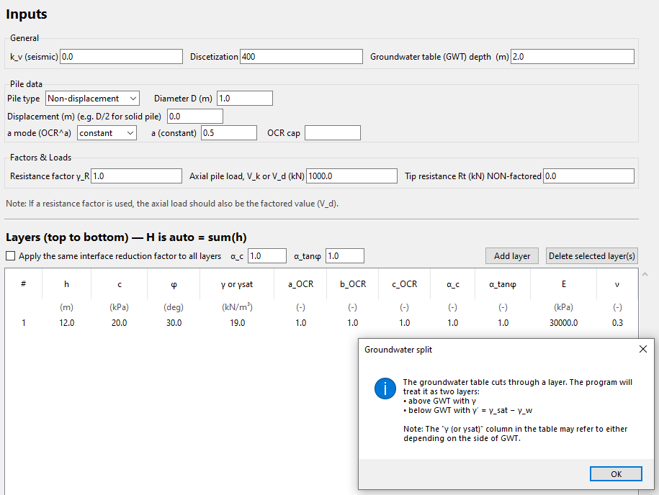
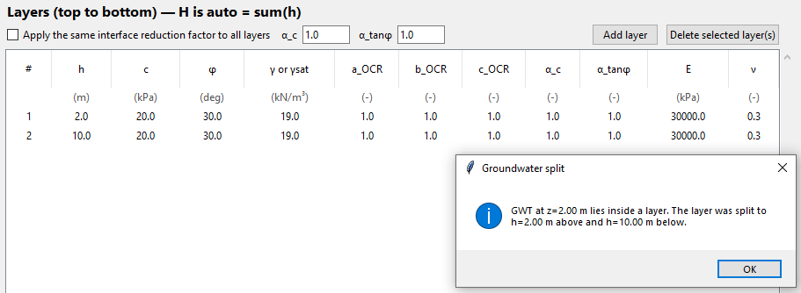

Pile Data
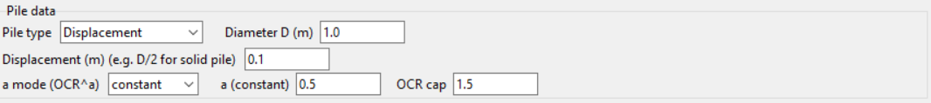
- Pile type = Non-displacement (default) or Displacement
- Diameter $D$ (m) (default = 1.0)
- Displacement (m) (e.g., $D/2$ for solid driven piles; default = 0.0)
- $a$ mode ($OCR^{a}$) = constant or sinφ (default = constant)
- $a$ (constant) (default = 0.5; must be ≤ 1.0, otherwise the program displays an error and stops execution)
- $OCR$ cap = cutoff value (maximum allowable by the program)
The program offers two pile types: Non-displacement (default) and Displacement.
- For Non-displacement piles, any entered $OCR$ and Displacement values are ignored.
- All piles are treated as cylindrical with an external diameter $D$.
This diameter defines both the geometric display in the Visualization tab and the perimeter $πD$ used in computing the total shaft resistance $R_{s}$​.
- The parameter Displacement represents the radial expansion of the surrounding soil caused by pile installation. For example:
  - For solid (massive) driven piles, the typical displacement is equal to the pile radius ($D / 2$).
  - For tubular steel piles, the displacement may be taken as half of the wall thickness ($t / 2$), assuming that the soil will be compressed by $t/2$ externally and by $t/2$ inside the hollow pile.
This displacement value directly enters the add-on term that increases the lateral earth-pressure coefficient $K$ toward the passive limit, depending on depth, soil stiffness $E$, Poisson’s ratio $ν$, and effective stress $σ'ᵥ$.
The program assumes the pile is weightless. Therefore, the self-weight of the pile should be subtracted from the applied axial load $V_{d}$ before it is entered by the user. In practical terms, $V_{d}$ should represent the net design load transmitted to the pile base after deducting the pile’s own weight.
The influence of over-consolidation is applied only to Displacement piles through
$$K_{0,OCR}=K_{0,NC}{OCR}^{a}$$
where the exponent $a$is defined by the selected $a$ mode:
- $a$ mode = constant (default):
The exponent $a$ is entered manually (typically 0.5).
The program enforces $a≤1.0$; if exceeded, a warning appears and the run stops.
- $a$ mode = $sin φ$:
The exponent a is automatically set equal to $sinφ$ of each soil layer.
This causes the amplification of $K₀$ with $OCR$ to scale with the frictional character of the soil—stronger in high-$φ$ materials—providing a more theoretically consistent approach for frictional or mixed $c–φ$ soils.

Factors & Loads
The weight of the pile is included in axial pile load
- Resistance factor $γ_{R}$ (default 1.0).
- Axial pile load, $V_{k}$or$V_{d}$ (kN) (default 1000.0).
- Tip resistance $R_{t}$ (kN) NON-factored (default 0.0).
This group defines the axial load of the pile, its tip resistance and the resistance factor applied in the analysis.
- Resistance factor $γ_{R}$
  - Represents the global partial safety factor for resistance, as used in design standards such as EN 1997.
  - All computed resistances (shaft, tip, and total) are divided by this value to obtain the factored (design) resistances:
$$R_{s,d}=\frac{R_{s}}{γ_{R}}; R_{t,d}=\frac{R_{t}}{γ_{R}}; R_{tot}=R_{s,d}+R_{t,d}$$
When $γ_{R}= 1.0$, the program effectively reports ultimate (unfactored) resistances.
- Axial pile load ($Vₖ$or$V_{d}$)
  - The applied axial design load at the pile head, expressed in kilonewtons (kN).
  - If $γ_{R}> 1$, the input should correspond to the factored load $V_{d}$, that is, the design load after multiplication by the load factor prescribed in the relevant code. If $γ_{R}= 1$, the input should correspond to the unfactored load $V_{k}$,
  - The computed safety ratios are given as
$${Safety}_{shaft}=\frac{R_{s,d}}{V_{d}}$$
$${Safety}_{total}=\frac{R_{tot}}{V_{d}}$$
Important note: The program assumes the pile itself is weightless. Therefore, the self-weight of the pile should be subtracted from the applied axial load $V_{d}$​ before it is entered by the user.
- Tip resistance ($R_{t}$)
  - The non-factored end-bearing resistance at the pile base, entered directly by the user in kN.
  - The program divides this value by $γ_{R}$ to obtain the factored tip resistance shown in the results.
  - If $R_{t}=0$, the analysis considers only shaft resistance (e.g., floating piles or piles in soft soil).

Layers (top to bottom) — $H$ is auto = $∑h$
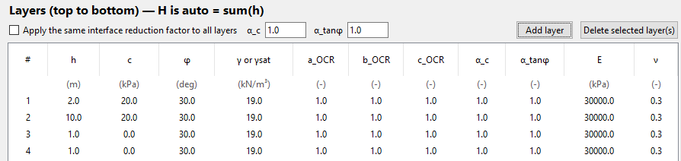
This section defines the stratigraphy and soil properties used for the analysis.
Each row in the table corresponds to a soil layer, entered from the ground surface downward.
The total pile length $H$ is calculated automatically as the sum of all layer thicknesses.

Header controls:
- Apply the same interface reduction factor to all layers — If checked, the entered values of $α_{c}$​ and $α_{tanφ}$​ are applied uniformly to every layer (after running the program).
These factors are automatically clamped to the range [0, 1], and an error message is displayed if a value outside this range is entered.
- Add layer / Delete selected layer(s) — Adds a new layer at the bottom or removes selected layers (multi-select supported).
The table automatically recalculates the cumulative depth $H$.
Editable Table (double-click to edit a cell)
Column | Description | Units / Typical range
# | Layer number (top to bottom) | —
$h$ | Layer thickness | m
$c$ | Cohesion (effective or undrained) | kPa (0–100)
$φ$ | Friction angle | ° (0–45)
$γ$ (or $γ_sat$) | Total or saturated unit weight | kN/m³ (typically 17–21)
$a_{OCR}$ | Coefficient controlling the magnitude and vertical gradient of the best-fit relationship between $OCR$ and depth, defined by the equation:  $$OCR=a_{OCR}z^{-b_OCR}+c_{OCR}$$
$b_{OCR}$ | Exponent governing the rate of decay (curvature) of the $OCR$–depth relationship in the best-fit equation.
$c_{OCR}$ | Constant term defining the asymptotic offset (residual OCR value) of the best-fit $OCR$–depth equation.
$α_{c}$ | Adhesion reduction factor for cohesive component | 0.0–1.0
$α_{tanφ}$ | Interface roughness reduction factor for frictional component | 0.0–1.0
$E$ | Young’s modulus of the soil | kPa (5,000–200,000)
$ν$ | Poisson’s ratio | — (0.25–0.45)

Additional Notes and Guidance
- Cohesion and friction are the principal soil strength parameters; both may be non-zero in mixed $c–φ$ soils. Setting $φ = 0$ (undrained) reproduces conditions typical of clays; setting $c = 0$ (drained) models purely frictional granular soils.
- The $OCR$ value affects $K$ through the relationship $K_{0,OCR}=K_{0,NC}{OCR}^{a}$ but only when the pile type is Displacement.
- The interface factors $α_{c}$​ and $α_{tanφ}$​ reduce the ideal shear strength at the pile–soil contact to account for imperfect adhesion or roughness. For bored piles, these may be lower (e.g., 0.5–0.8), while for driven piles, values near 1.0 are typical.
- The elastic parameters ($E, ν$) are used in the displacement “add-on” calculation for Displacement piles; for Non-displacement piles, they have no effect.
- The GWT position (entered in the General section) automatically adjusts the effective unit weight γ′ below the water table; no manual correction of $γ$ or $γ_{γsat}​$ is required.
- The program automatically performs all necessary interpolations between slice midpoints and layer boundaries. Increasing Discretization ($N$) enhances the accuracy of this process.

Visualization (right panel)
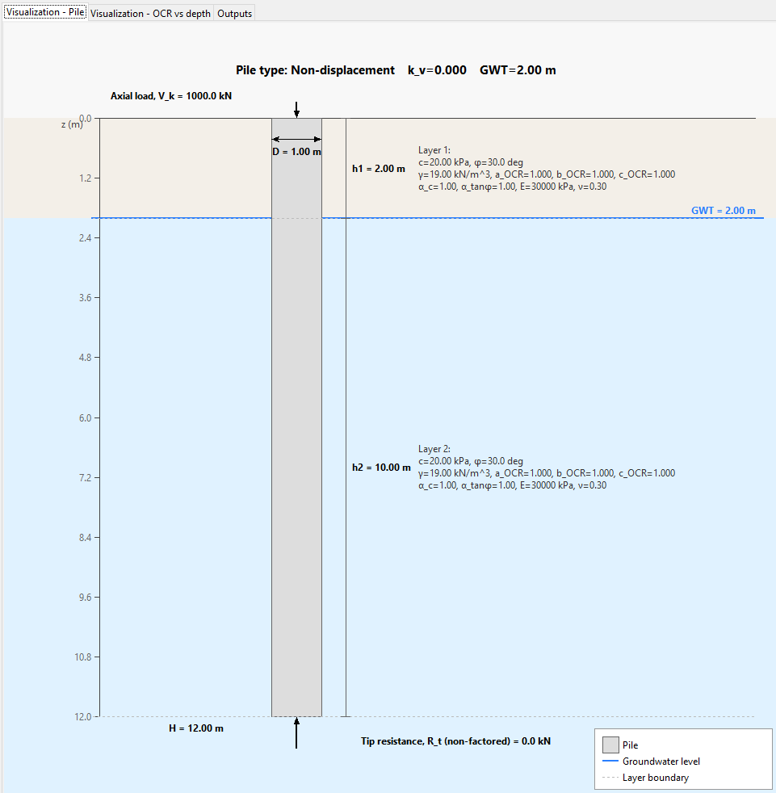
The Visualization tab presents a clean schematic of the pile–soil system to help you verify geometry and inputs before interpreting results. It is a responsive redraw, not a live, zoomable canvas: the figure is re-laid-out to fit the current widget size when it is redrawn (e.g., after running the analysis or refreshing the tab). Fonts, arrows, and line widths follow readability rules and may clamp to minimum sizes.

What you see:
- Ground profile & layers: Horizontal interfaces drawn at the entered depths (top to bottom). Each layer is shown with a distinct fill and labeled in a side block with its parameters $c, φ, γ$ (or $γ_{sat}$), $OCR$, $α_c, α_tanφ, E, ν$.
- Pile geometry: A vertical rectangular outline from $z=0$to$z=H=∑hi​.$ The on-figure annotations show $D$ near the head and $H$ near the toe. All piles are treated as cylindrical with diameter $D$ for perimeter and plotting.
- Groundwater table (GWT): A horizontal blue line is drawn at the specified depth, with blue shading below to indicate the submerged zone.
If the GWT passes through a soil layer without a defined boundary at that depth, the program automatically adjusts the unit weight:
$γ$ (bulk unit weight) is used above the GWT, and $γ' = γ_{sat} - γ_{w}$ (effective or buoyant unit weight) is used below.
The visualization simply displays the GWT line and shading; the unit-weight correction is applied internally during the effective-stress calculations.
- Actions on the pile: A downward arrow at the head labeled Axial load $V_{k}​ ($or$V_{d}​),$ and an upward arrow at the base labeled Tip resistance $R_{t}$​ (non-factored).
- Header info: The current Pile type (Non-displacement or Displacement), $k_{v}$​, and GWT depth are shown in the figure header.
Legend Offset Controls:
Two fields (Legend offset x and Legend offset y) allow the user to adjust the legend’s position inside the chart. Positive values shift the legend slightly left and downward, while negative values shift it right or upward. The default offsets (10, 10) provide a clear placement, and the Apply button updates the chart after any change.
Usage notes:
- Use the Visualization to quickly catch input issues (e.g., unintended layer orders, GWT placement, unrealistic $D$ vs $H$).
- For tubular driven piles you may annotate $t$ in the manual/report text, but the schematic itself renders the pile by its outer diameter $D$ (the capacity calculations also use $πD$ for shaft perimeter).
- The Visualization is illustrative; numerical results (tables/plots) are authoritative for design checks.

Visualization – OCR vs depth (right panel)
This tab displays the variation of the Overconsolidation Ratio (OCR) with depth, based on the empirical best-fit equation defined for each soil layer:
$$OCR(z)=a_{OCR} z^{-b_{OCR}}+c_{OCR}$$
The plotted curve (in purple) represents how $OCR$ changes along the pile length according to the parameters$a_{OCR}$, $b_{OCR}$, and $c_{OCR}$ specified in the Layers table.
- $a_{OCR}$ controls the overall magnitude and vertical gradient of the curve.
- $b_{OCR}$ controls the curvature or rate of decay with depth.
- $c_{OCR}$ defines the offset or residual OCR value at large depths.
The $x-$axis shows the computed $OCR$ values, while the $y-$axis represents depth $z$ (m), measured downward from the ground surface.
At the bottom of the chart, two entry fields (OCR x-min and OCR x-max) allow the user to manually set the horizontal axis limits. Leaving the fields blank restores automatic scaling. Press Apply to update the graph after modifying the limits.
A caption box within the plot shows the analytical expression used for the calculation, helping users verify the current OCR–depth formulation.
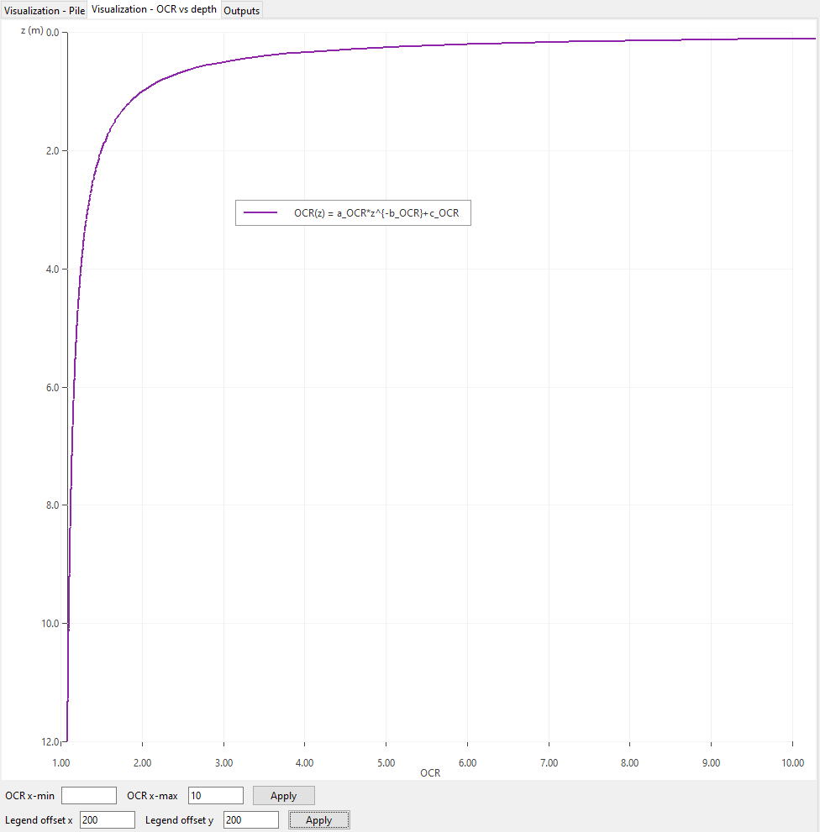
Legend Offset Controls:
Two fields (Legend offset x and Legend offset y) allow the user to adjust the legend’s position inside the chart. Positive values shift the legend slightly left and downward, while negative values shift it right or upward. The default offsets (10, 10) provide a clear placement, and the Apply button updates the chart after any change.

Running an Analysis

After entering the input data, run calculations by clicking the Logo button.

Outputs (right panel)

Outputs – Main Table
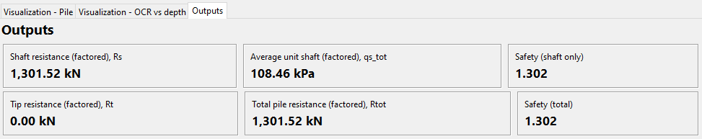
The Outputs tab is organized into a compact summary table followed by the detailed data tabs. The main table appears at the top of the Outputs panel immediately after every successful run. It provides a quick overview of the factored resistances and safety ratios used in the design check. Each value updates automatically when new calculations are executed.
Field | Description
Shaft resistance (factored), $R_{s}$ | The total factored shaft (skin) resistance obtained by integrating the unit shaft resistance ($q_{s}(z)$) over the pile surface area ($πDH$), then dividing by the global resistance factor ($γ_{R}$). Displayed in kN.
Average unit shaft (factored), $q_{s,tot}$ | The average factored unit shaft resistance over the pile length: ($q_{s,tot}= R_{s} / (πDH)$). Displayed in kPa.
Safety (shaft only) | The ratio of factored shaft resistance to the applied axial design load: ($Safety_{shaft}= R_{s}/V_{d}$).
Tip resistance (factored), $R_{t}$ | The factored base resistance, calculated as the user-entered non-factored tip resistance divided by ($γ_{R}$). If the tip contribution is ignored, this value appears as 0.00 kN.
Total pile resistance (factored), $R_{tot}$ | The sum of shaft and tip resistances: ( $R_{tot} = R_{s}+R_{t}$ ). Displayed in kN.
Safety (total) | The global safety ratio: ( $Safety_{total}= R_{tot}/V_{d}$ ).
Appearance and scaling:
Each value is shown in a bordered rectangular box with the result in bold, large font for visibility.
Units are displayed explicitly (kN or kPa).
When ($R_{t}= 0$), both Tip resistance and Total pile resistance fields display the same numerical value as ($R_{s}$), and the two safety ratios coincide.
Interpretation:
This main summary table gives the designer an immediate sense of overall pile performance before examining the detailed results in the lower tabs:
- Shaft resistance vs depth (distribution of $q_{s}$),
- $K_{0}$ vs depth (stress state evolution),
- Slices and Per-layer tables (numerical breakdowns).
- Per-layer (factored)
The safety ratios greater than 1.0 indicate that the computed resistance exceeds the applied design load under the chosen resistance factor ($γ_{R}$).

Outputs - Tab: Shaft resistance vs depth
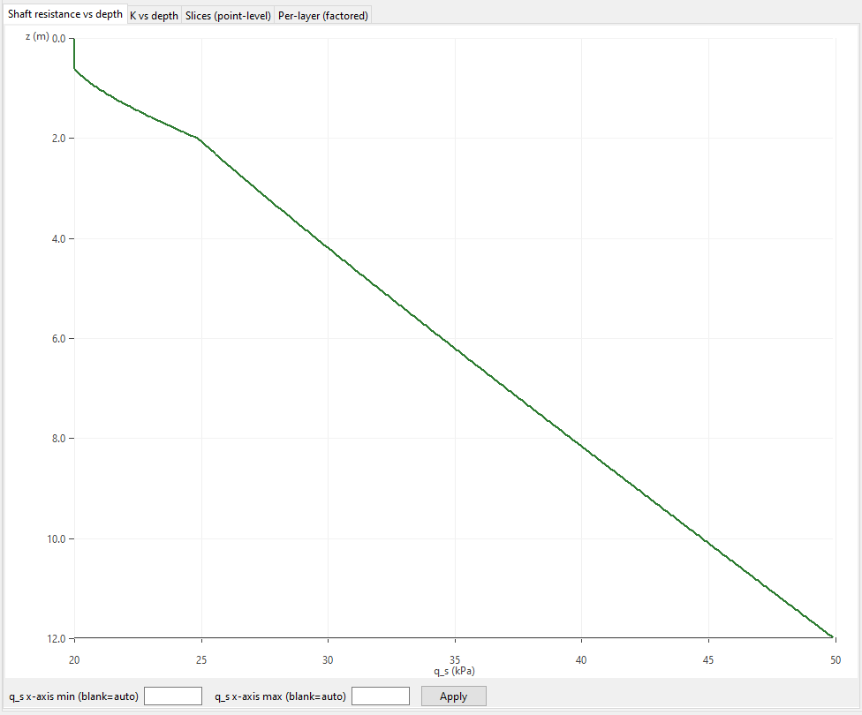
This tab displays the distribution of factored unit shaft resistance ( $q_{s}(z)$ ) along the pile length.
It provides an immediate visual understanding of how skin friction varies with depth and how different soil layers contribute to the overall shaft capacity.
Chart Description:
- The vertical axis ($z$) represents depth in meters, increasing downward from the ground surface ($z = 0$) to the pile toe.
- The horizontal axis ($q_{s}$) shows the factored unit shaft resistance in kilopascals (kPa).
- The green curve plots the computed ( $q_{s}$ ) profile for each discretized slice along the pile.
Interpretation:
- The slope and curvature of the line indicate how ( $q_{s}$ ) changes with depth:
  - In uniform soil, ( $q_{s}$) typically increases almost linearly with effective stress.
  - At layer interfaces, changes in $( c ), ( φ ),$or$( K )$ can cause inflection points.
  - Below the groundwater table, the rate of increase may reduce because of reduced effective stress ( $σ_{v}^{'}$ ).
- A smooth and monotonic increase (like the one shown) suggests homogeneous soil and stable numerical behavior.
Axis controls:
At the bottom of the chart, two optional entry fields allow users to adjust the horizontal axis range:
- $qₛ x-$axis min (blank = auto)
- $qₛ x-$axis max (blank = auto)
Enter custom limits and press Apply to redraw the chart. Leaving both fields blank restores automatic scaling.
Additional Notes:
- The chart automatically uses geotechnical convention with $z$ increasing downward.
- Values plotted are factored; to view or export non-factored data, consult the Slices (point-level) table.
- The same data are exported to the PDF report.

Outputs - Tab: K0 vs depth

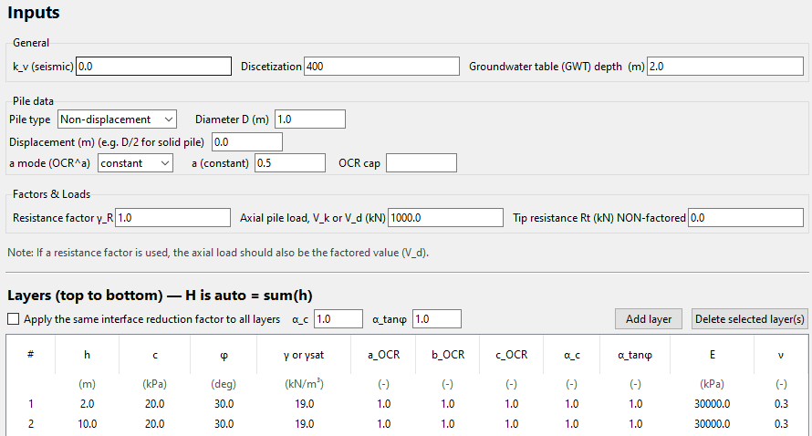

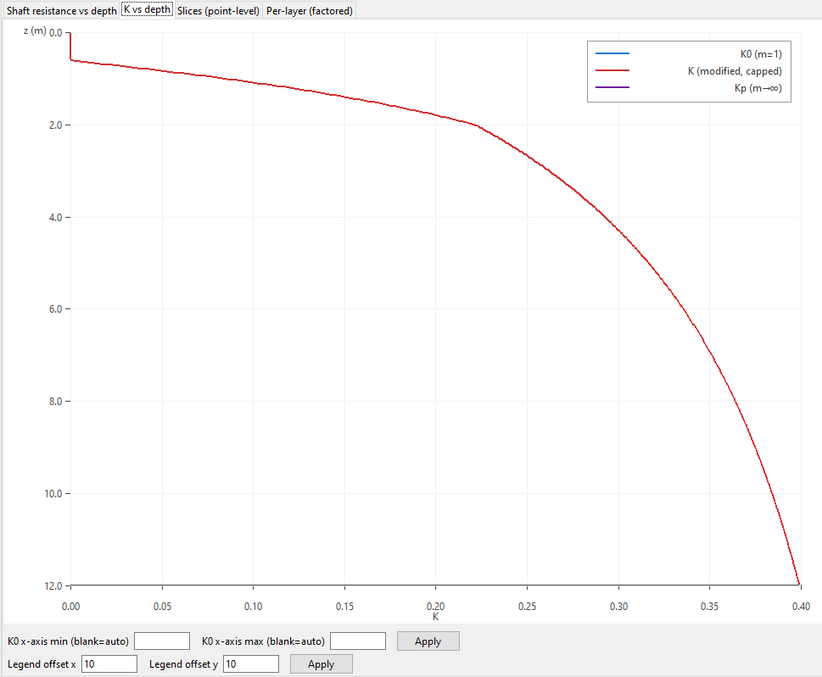
This chart illustrates the variation of the coefficient of lateral earth pressure ($K$) with depth along the pile shaft.
It helps visualize how the soil stress state evolves from at-rest to passive conditions.
Axes
- Vertical axis ($z)$: Depth in meters, increasing downward from the ground surface$(z=0)$to the pile toe.
- Horizontal axis ($K$): Coefficient of lateral earth pressure (dimensionless).
Curves
- Blue curve – $K_{0}$​ ($m = 1$, “Original”): The at-rest coefficient computed for an overconsolidation ratio $OCR=1$ and zero pile displacement.
Represents the initial, unmodified stress state in the soil.
- Red curve – $K$(Modified, capped): The effective coefficient used in the shaft-resistance calculation, incorporating both the $OCR^{a}$ correction and the displacement add-on for displacement piles. This curve accounts for soil densification and stress changes due to pile installation and overconsolidation effects.
- Purple curve – $K_{p}​$ ($m → ∞$, “Passive”): The theoretical passive limit of the earth pressure coefficient, serving as an upper bound for $K$. The red curve (modified $K$) is automatically capped not to exceed $K_{p}$​.

Chart Controls
The fields below the plot allow the user to manually define the x-axis range (K₀ x-axis min and max).
Leaving them blank keeps the automatic scaling. Press Apply to refresh the chart.
Two fields (Legend offset x and Legend offset y) allow the user to adjust the legend’s position inside the chart. Positive values shift the legend slightly left and downward, while negative values shift it right or upward. The default offsets (10, 10) provide a clear placement, and the Apply button updates the chart after any change.

- Example: Displacement pile with $a_{OCR}=b_{OCR}=c_{OCR}= 1$
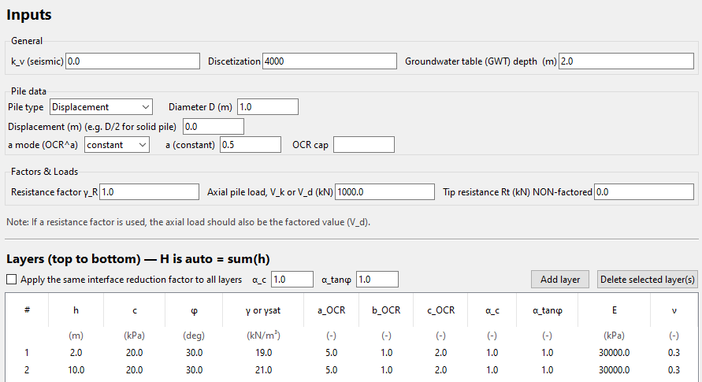

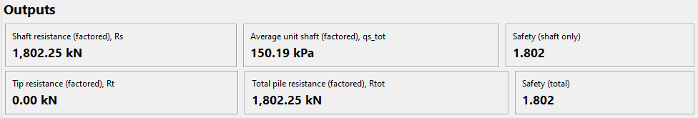
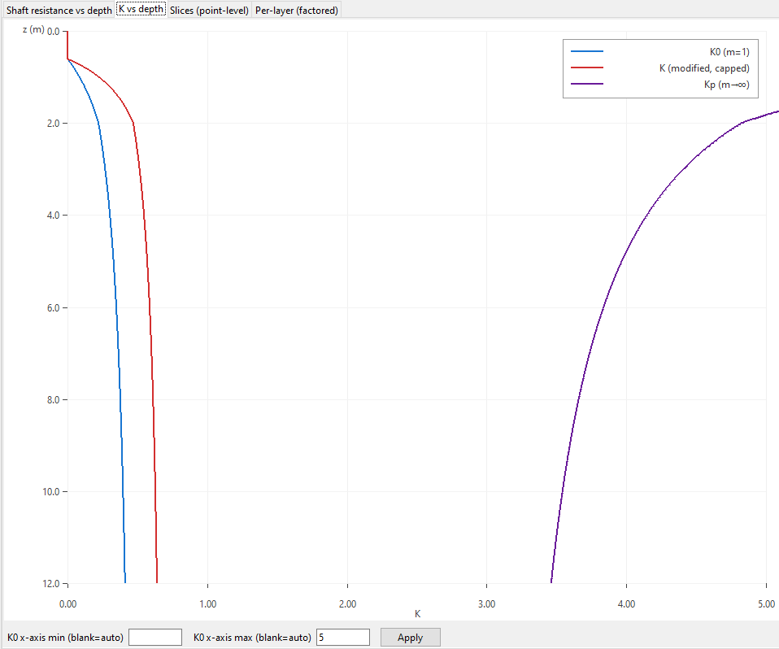

- Example: Driven tubular pile with wall thickness $t=$8 mm (also, $OCR=1$)
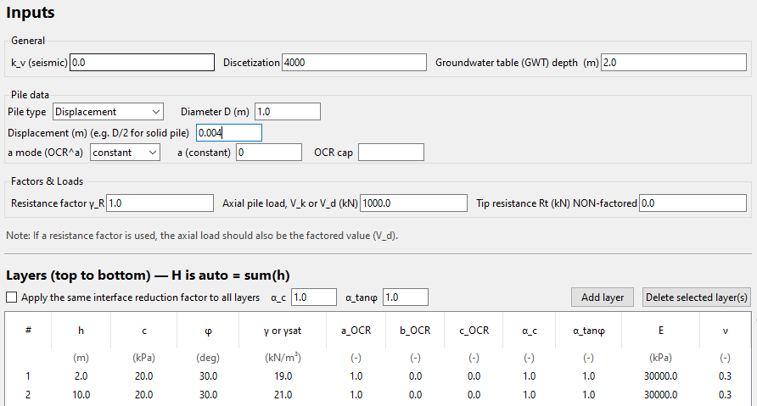

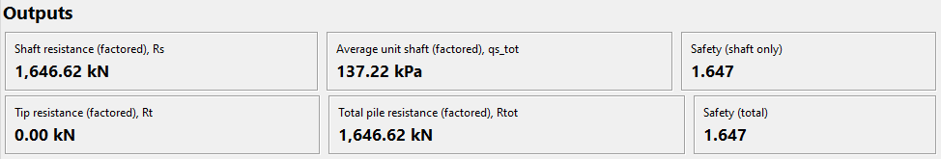
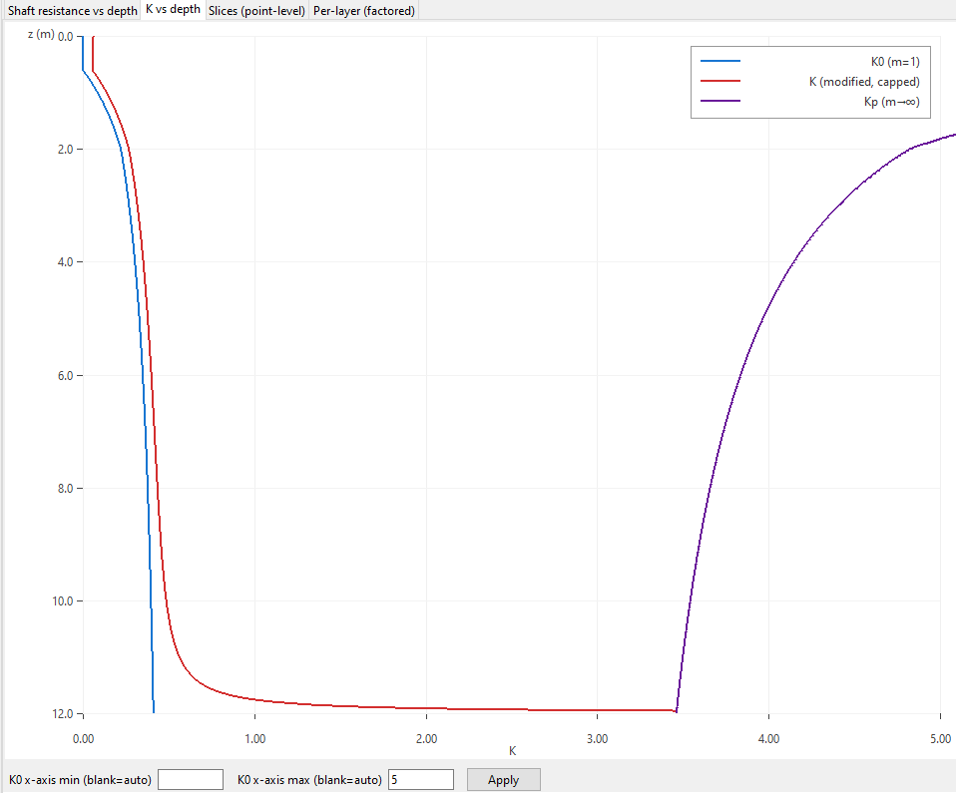

Outputs - Tab: Slices (point-level)
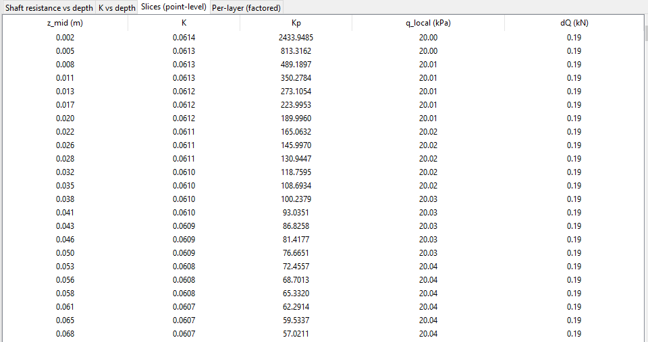
This table presents detailed numerical results for each discretized segment (or slice) of the pile shaft, offering a point-by-point breakdown of the calculations performed along the pile length.
Each row corresponds to the midpoint of a slice ($z_{mid}$​) and lists the following quantities:
Column | Description
$z_{mid}$ (m) | Midpoint depth of the slice, measured from the ground surface downward.
$K$ | Modified lateral earth pressure coefficient used in the calculation, accounting for overconsolidation and displacement effects.
$K_{p}$ | Passive limit of the lateral earth pressure coefficient (theoretical upper bound).
$q_{local}$ (kPa) | Local unit shaft resistance $q_{s}$ at the midpoint of the slice, derived from the combined cohesive and frictional contributions.
$dQ$ (kN) | Incremental shaft resistance contributed by the slice; obtained by integrating $q_{s}​$ over the surface area of the pile within the slice thickness.
The Slices (point-level) tab enables detailed verification of intermediate results and provides insight into how both the stress state and resistance evolve with depth.
It is particularly useful for confirming the accuracy of integration, identifying layer transitions, or validating the influence of $OCR$ and displacement effects.

Outputs - Tab: Per-layer (factored)
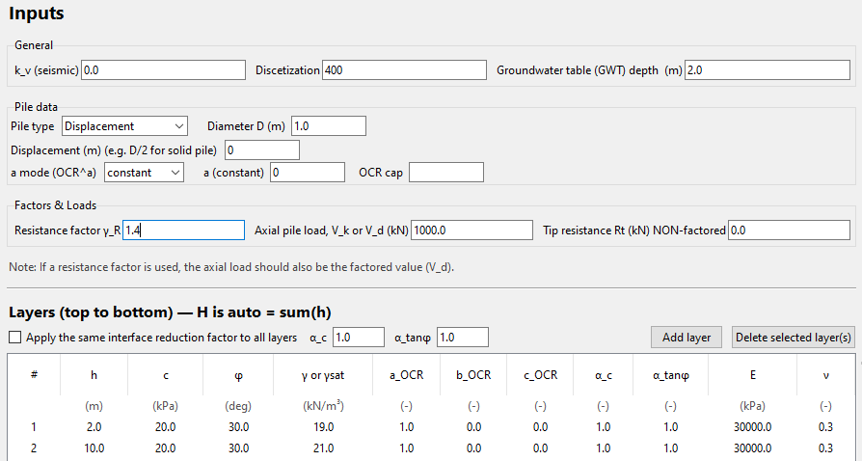
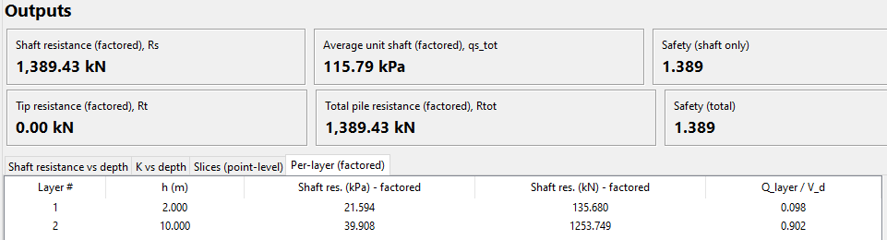
This table summarizes the factored shaft-resistance contribution of each soil layer. It is derived from the slice results by integrating the slices that lie within each layer.
Columns (left → right):
- Layer # — Index of the layer (top = 1).
- h (m) — Layer thickness used in the analysis (truncated at the pile toe if necessary).
- Shaft res. (kPa) – factored — Average factored unit shaft resistance for the layer,
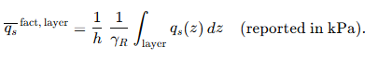
Numerically, this is obtained from the slice $q_{s}​$ values within the layer.
- Shaft res. (kN) – factored — Factored layer capacity,
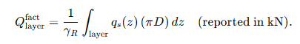
- $Q_{layer}/V_{d}$ — Contribution of the layer to the design check,
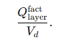
How it’s used:
- The sum of “Shaft res. (kN) – factored” over all rows equals the $R_{s}$ (factored) value in the summary boxes.
- Large values of $Q_{layer}/V_{d}$ highlight dominant layers; small values indicate layers with minor contribution (e.g., soft or thin strata).
Notes & conventions:
- The table reflects factored quantities; slice-level $q_{s}$​ and $dQ$ are non-factored and are factored only on aggregation.
- If the GWT crosses a layer, the effective stress change is already accounted for in the slice calculations; the layer averages naturally reflect it.
- If you enabled the global interface factors checkbox, the same $α_{c}$​ and $α_{tanφ}$​ have been applied to all slices before aggregation.
- Thin layers: increase Discretization (N) if a very thin layer appears under-represented; higher Ν improves the fidelity of the layer average.
Quick check:
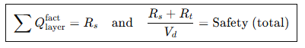
Use this identity to verify internal consistency of results.

Generating a Report
The Report (PDF) button creates a complete, formatted report containing all input data, soil parameters, and computed results, together with the plots and summary tables.
The report is designed to serve both as an educational record and a transparent audit of the calculations performed by the program.

Creating the Report
- After the analysis has been successfully executed, click the Report (PDF) button located at the bottom of the left panel.
- A “Save As…” dialog opens, suggesting a default file name in the format:
CUT_Axially_Loaded_Pile_Report_YYYYMMDD_HHMM.pdf
(where the timestamp corresponds to the moment of export).
- Choose the desired folder and confirm.
- The program generates the report automatically and attempts to open it once saved.

Report Contents
Each exported report includes the following sections:
1. Header Information
- Program name and version
- Author and institution
- File name and timestamp
2. Input Summary
- All General settings: ($k_{v}$), Discretization ($N$), $GWT$ depth
- Pile Data section (Type, $D$, Displacement, ($a$)-mode, ($a$)-value)
- Factors and Loads ($γ_{R}$, $V_{d}$, $R_{t}$)
- Full Layer Table: $h$, $c$, $φ$, $γ$, $OCR$, $α_{c}$, $α_{tanφ}$, $E$, $ν$
3. Results Summary (factored)
- Shaft resistance $R_{s}$ (kN)
- Average unit shaft resistance $q_{s,tot}$ (kPa)
- Tip resistance $R_{t}$ (kN)
- Total resistance $R_{tot}$ (kN)
- Safety ratios: $R_{s}/V_{d}$ and $(R_{s} + R_{t})/V_{d}$
4. Graphical Outputs
Two automatically generated charts:
- $K₀$ vs Depth: showing both the Original ($OCR$ = 1, displ. = 0) and Modified ($OCR$ & displ.) curves.
- Shaft Resistance vs Depth: factored $q_{s}(z)$ profile.
Both graphs are scaled automatically and rendered with the correct geotechnical orientation—the vertical axis inverted ($z = 0$ at top).
5. Numerical Tables
- Per-layer (factored) table summarizing layer contributions.
- Slices (point-level) table with detailed depth-by-depth results.
(because the table is too long, it is exported in MS Office Excel format using the “Export Slices (Excel) button)

Important Notes
- The exported report reflects exactly the data and results of the last completed run.
- If inputs are modified, the analysis must be re-run before exporting a new report.
- The report is intended for educational and illustrative use only; it does not constitute a certified design document.
- All computed quantities are factored using the resistance factor ($γ_{R}$) specified by the user.

Licensing, Copyright, and Disclaimer Statement

Licensing
This program is copyrighted © 2025 Dr. Lysandros Pantelidis. It is distributed free of charge for academic, educational, and research purposes only.
Users may download, install, and employ the software provided that proper citation of the original source and relevant publications is made.
Modification, redistribution, commercial use, or incorporation into other software is strictly prohibited without the explicit written permission of the author.
All intellectual property rights relating to the program, its source code, algorithms, user interface, documentation, figures, and theoretical framework are fully retained by the copyright holder.

NO WARRANTY
THIS PROGRAM IS PROVIDED FREE OF CHARGE “AS IS”, WITHOUT ANY WARRANTY OF ANY KIND.
THE AUTHOR MAKES NO REPRESENTATIONS OR WARRANTIES, EXPRESS OR IMPLIED, INCLUDING BUT NOT LIMITED TO:
- MERCHANTABILITY,
- FITNESS FOR A PARTICULAR PURPOSE,
- NON-INFRINGEMENT,
- ACCURACY OR RELIABILITY OF RESULTS.
THE ENTIRE RISK AS TO THE QUALITY AND PERFORMANCE OF THE PROGRAM IS WITH THE USER.
SHOULD THE PROGRAM PROVE DEFECTIVE, THE USER ASSUMES THE COST OF ALL NECESSARY SERVICING, REPAIR, OR CORRECTION.

LIMITATION OF LIABILITY
IN NO EVENT SHALL THE AUTHOR OR THE CYPRUS UNIVERSITY OF TECHNOLOGY BE LIABLE FOR ANY DAMAGES WHATSOEVER—INCLUDING, WITHOUT LIMITATION:
- GENERAL, SPECIAL, INCIDENTAL, OR CONSEQUENTIAL DAMAGES,
- LOSS OF DATA,
- LOSS OF PROFITS,
- BUSINESS INTERRUPTION,
- OR ANY CLAIM BY A THIRD PARTY—
ARISING FROM THE USE OR INABILITY TO USE THE PROGRAM, EVEN IF THE AUTHOR HAS BEEN ADVISED OF THE POSSIBILITY OF SUCH DAMAGES.

