Stress-Testing

Containerized Microservices

Version 1.0 approved
Prepared by Lysa Phan
University of Waikato
07/06/2019
- Introduction
This Stress-Testing report is written to show the results of stress-test and interpret them by using queueing theory, Markov chains and computer systems.

- Docker Compose
This project makes use of Docker, Flask and Python. There are four files needed for the Docker-Compose, which include app.py, docker-compose.yml, Dockerfile and requirements.txt. The content of these file are shown in the four figures below.

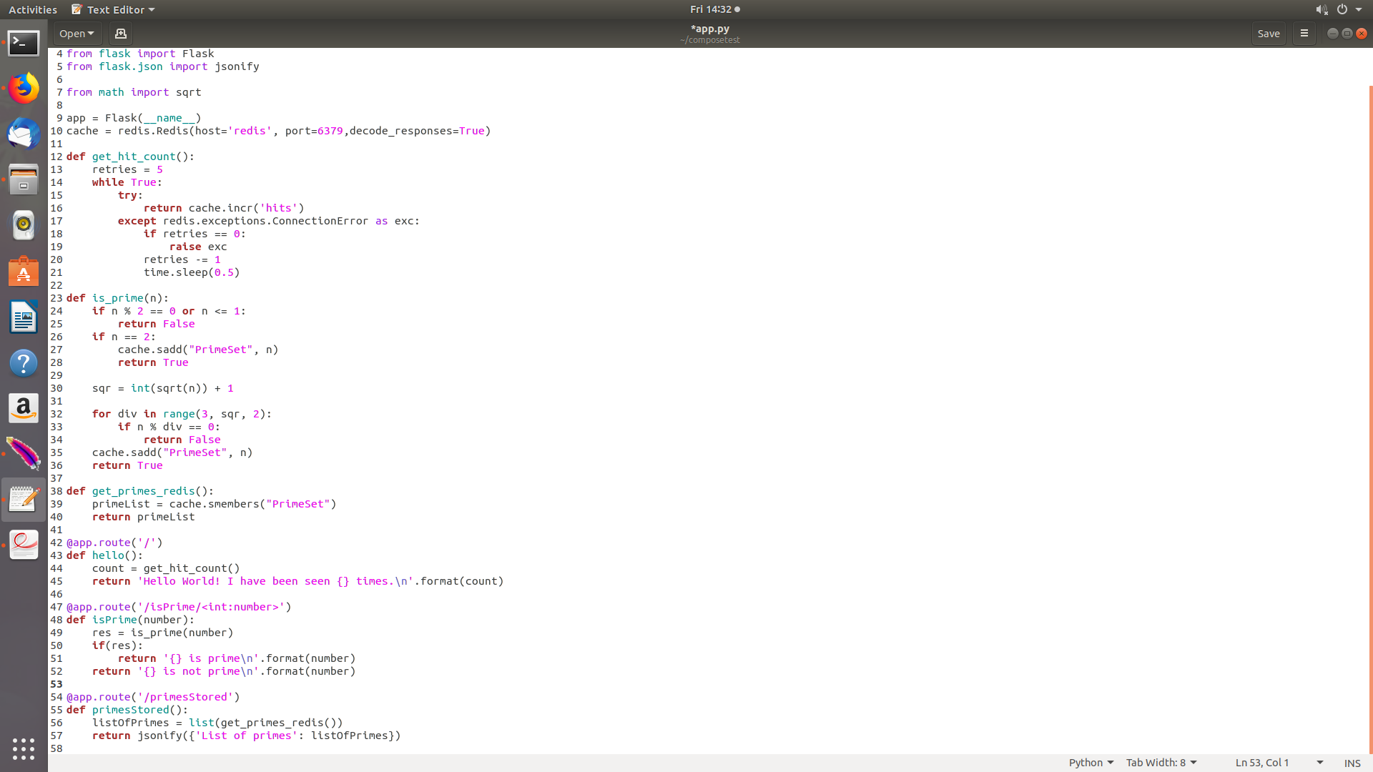
Figure 1. app.py
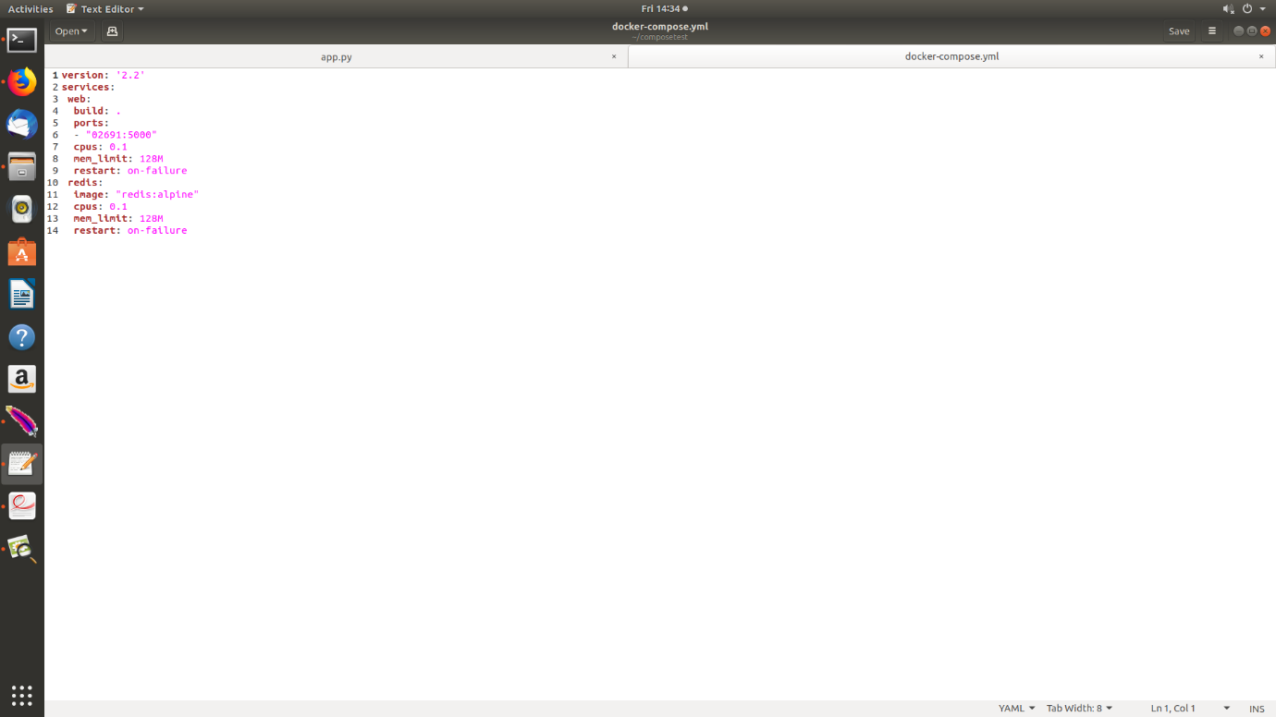
Figure 2. docker-compose.yml

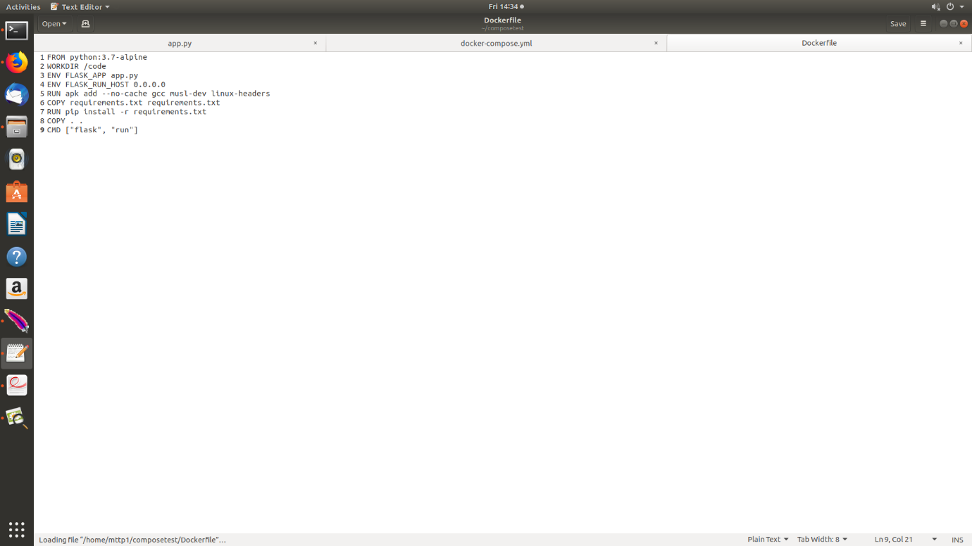
Figure 3. Dockerfile

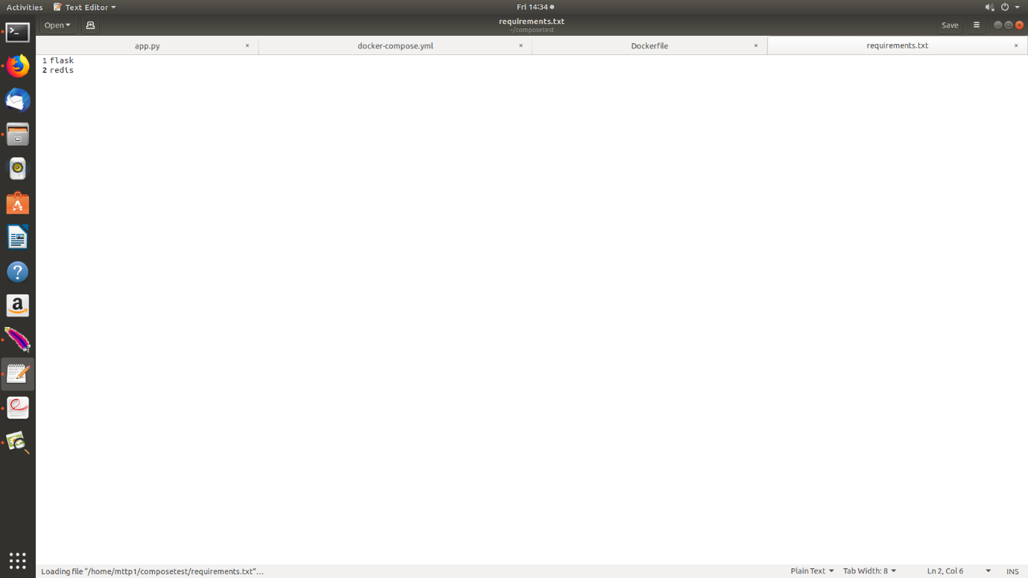
Figure 4. requirements

3) Test cases
- Check if number 1 is not a prime number.
- Check if number 2 is a prime number.
- Check if all the prime numbers are stored.
- Check if the list of stored prime number can be loaded.

4) Apache Jmeter Stress Test
Both scenarios will use 50 threads and their durations are 60 second for each.
I. Scenario 1
In the first scenario, the Apache JMeter app constantly invokes the isPrime method to check if the number 2,147,483,647 is a prime number or not. There are 2453 samples in this test. The throughput is 2,414,529 per minute. Figure 6 illustrates the green line of throughput starts at a very low point and then decreases a little bit. Throughout the whole process, the line is quite straight which indicates the changes are not much. The average throughput recorded is 40.2 per second. For the median response time, the purple line is not stable. It could mean that there are large requests running. Figure 7 shows that the maximum requests are 2096 and the minimum request is 1.

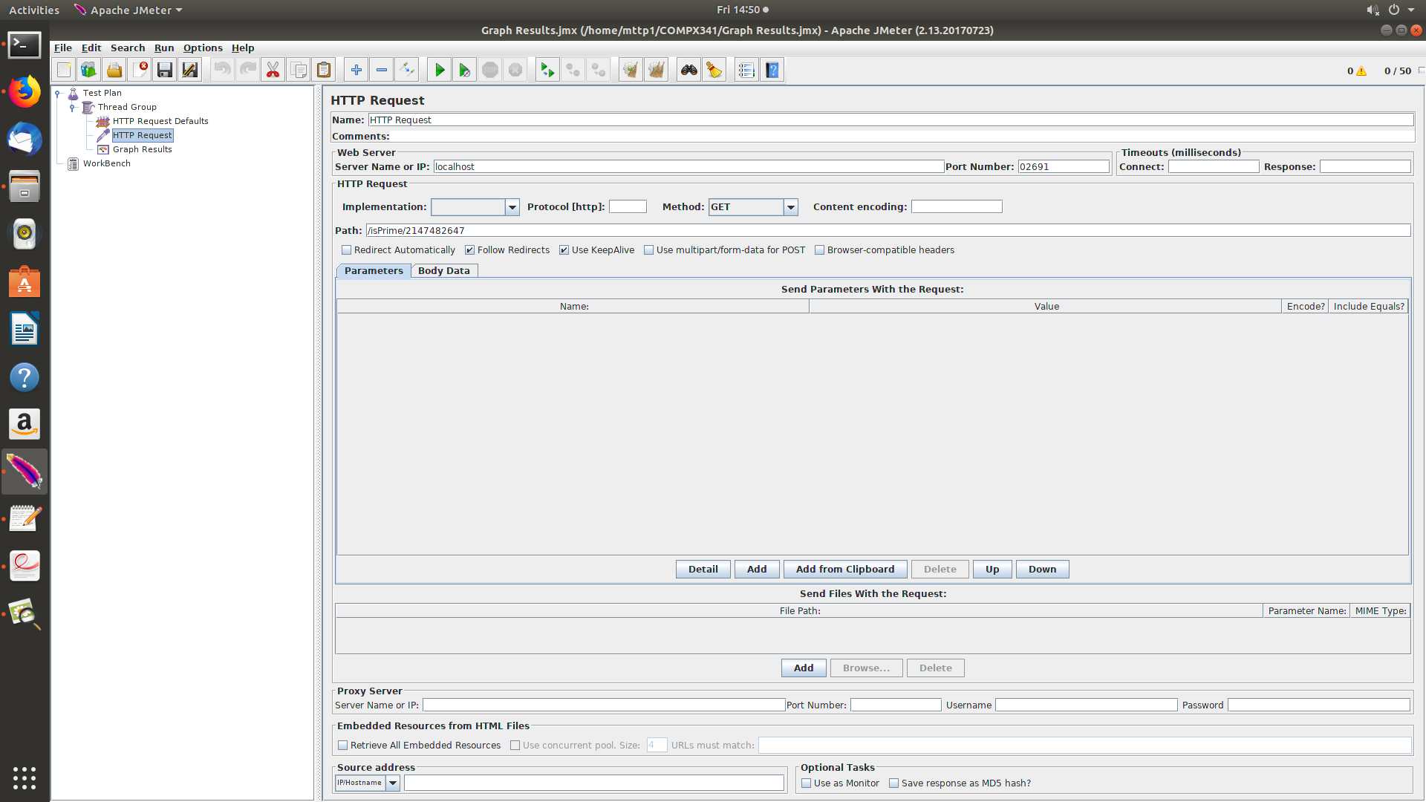
Figure 5. HTTP Request for Scenario 1
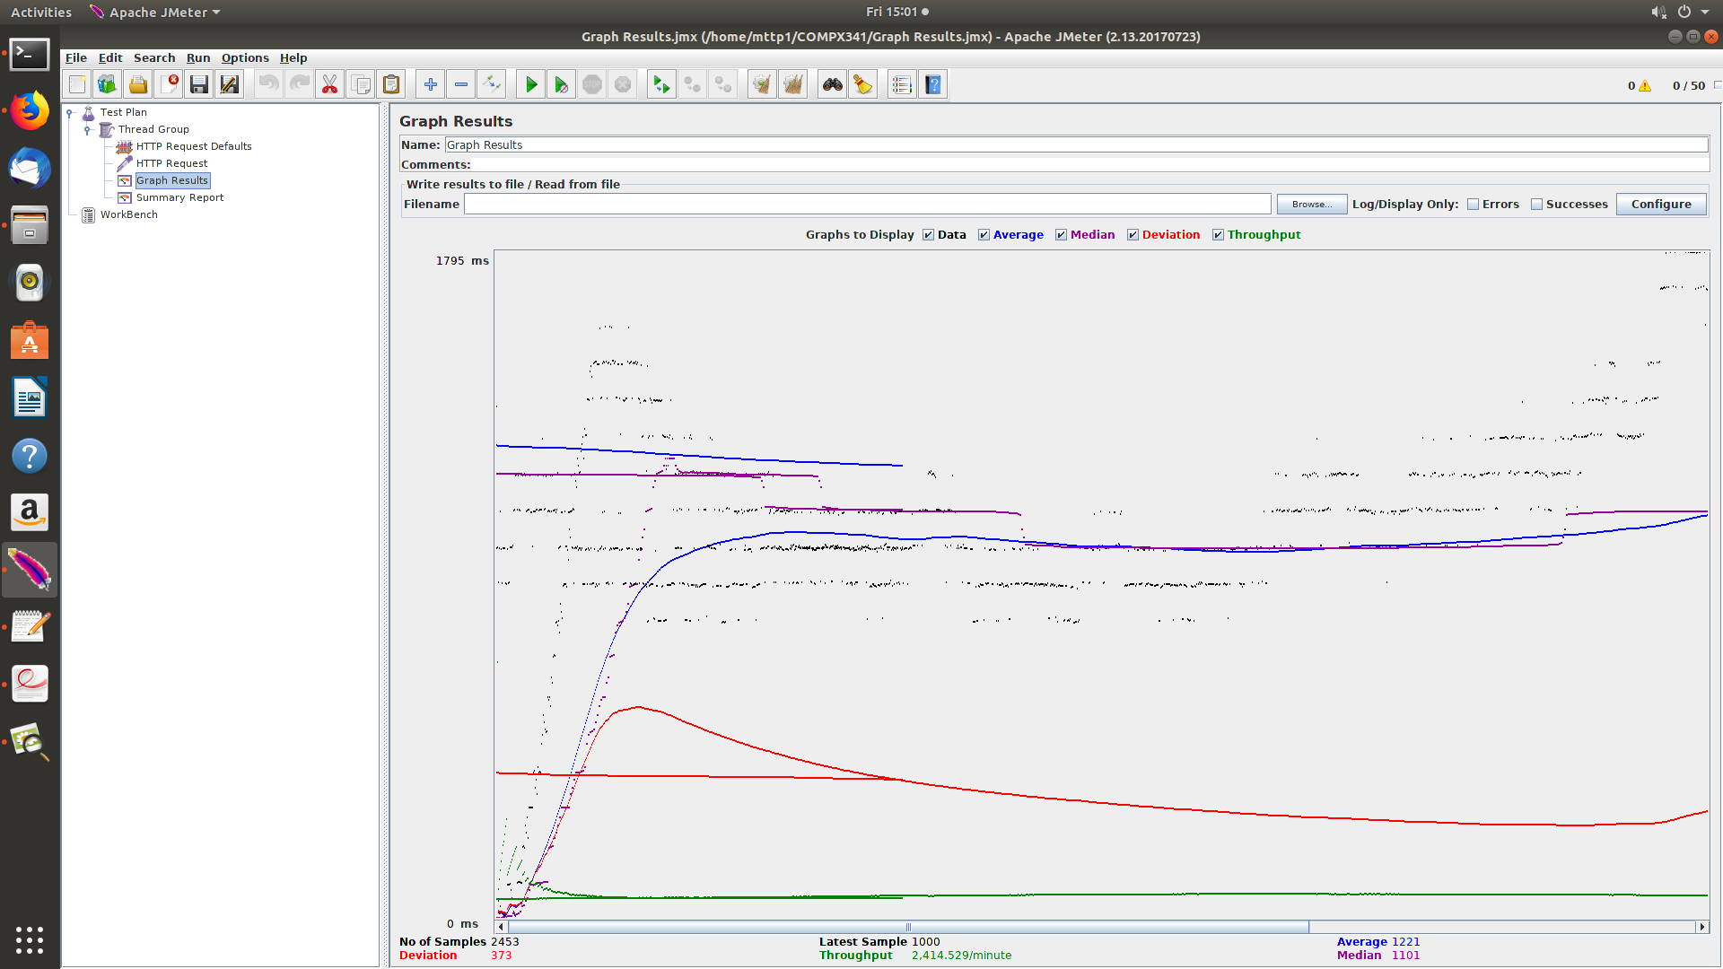
Figure 6. Graph results for Scenario 1
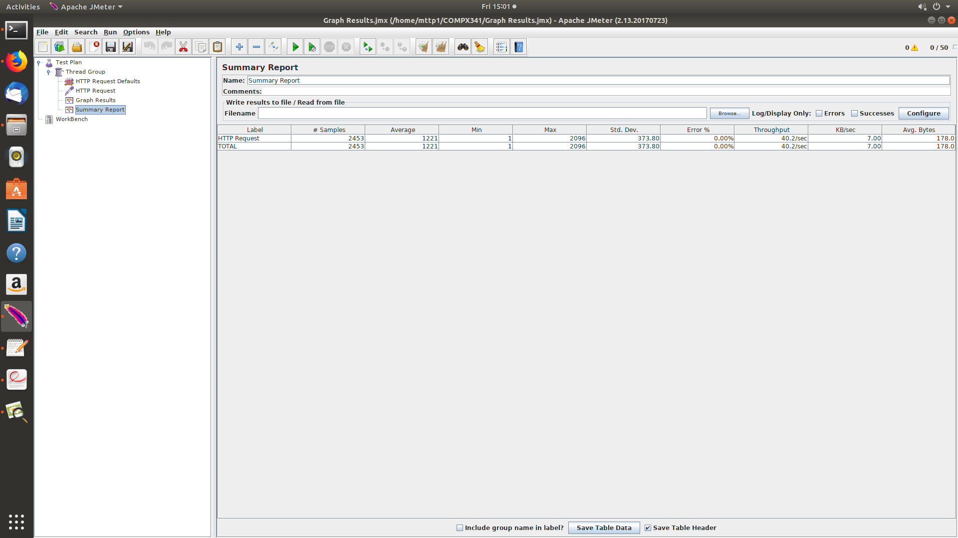
Figure 7. Summary report for Scenario 1
II. Scenario 2
In the second scenario, the application runs isPrime API from number 1 to number 100 and then invokes the primesStored. In order to fulfill this requirement, the counter in Figure 8 must be used. There are 2314 samples run in this test with the maximum number of requests is 2199. From Figure 9, The median response time in this scenario is also unstable. The purple line starts higher than the 1694/2 ms, then it increases toward 1694 ms and then gradually decreases. The throughput is 2,265.592/minute and the average throughput is 37.8/s. The summary report in Figure 10 indicates that the error in this scenario is 49.35%.
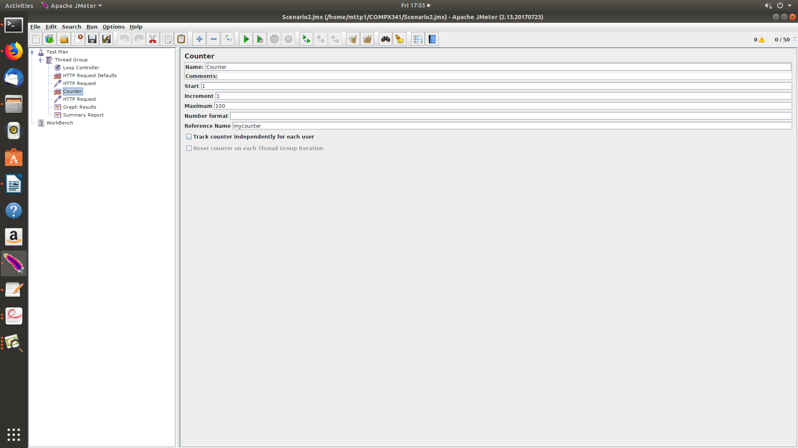
Figure 8. Counter
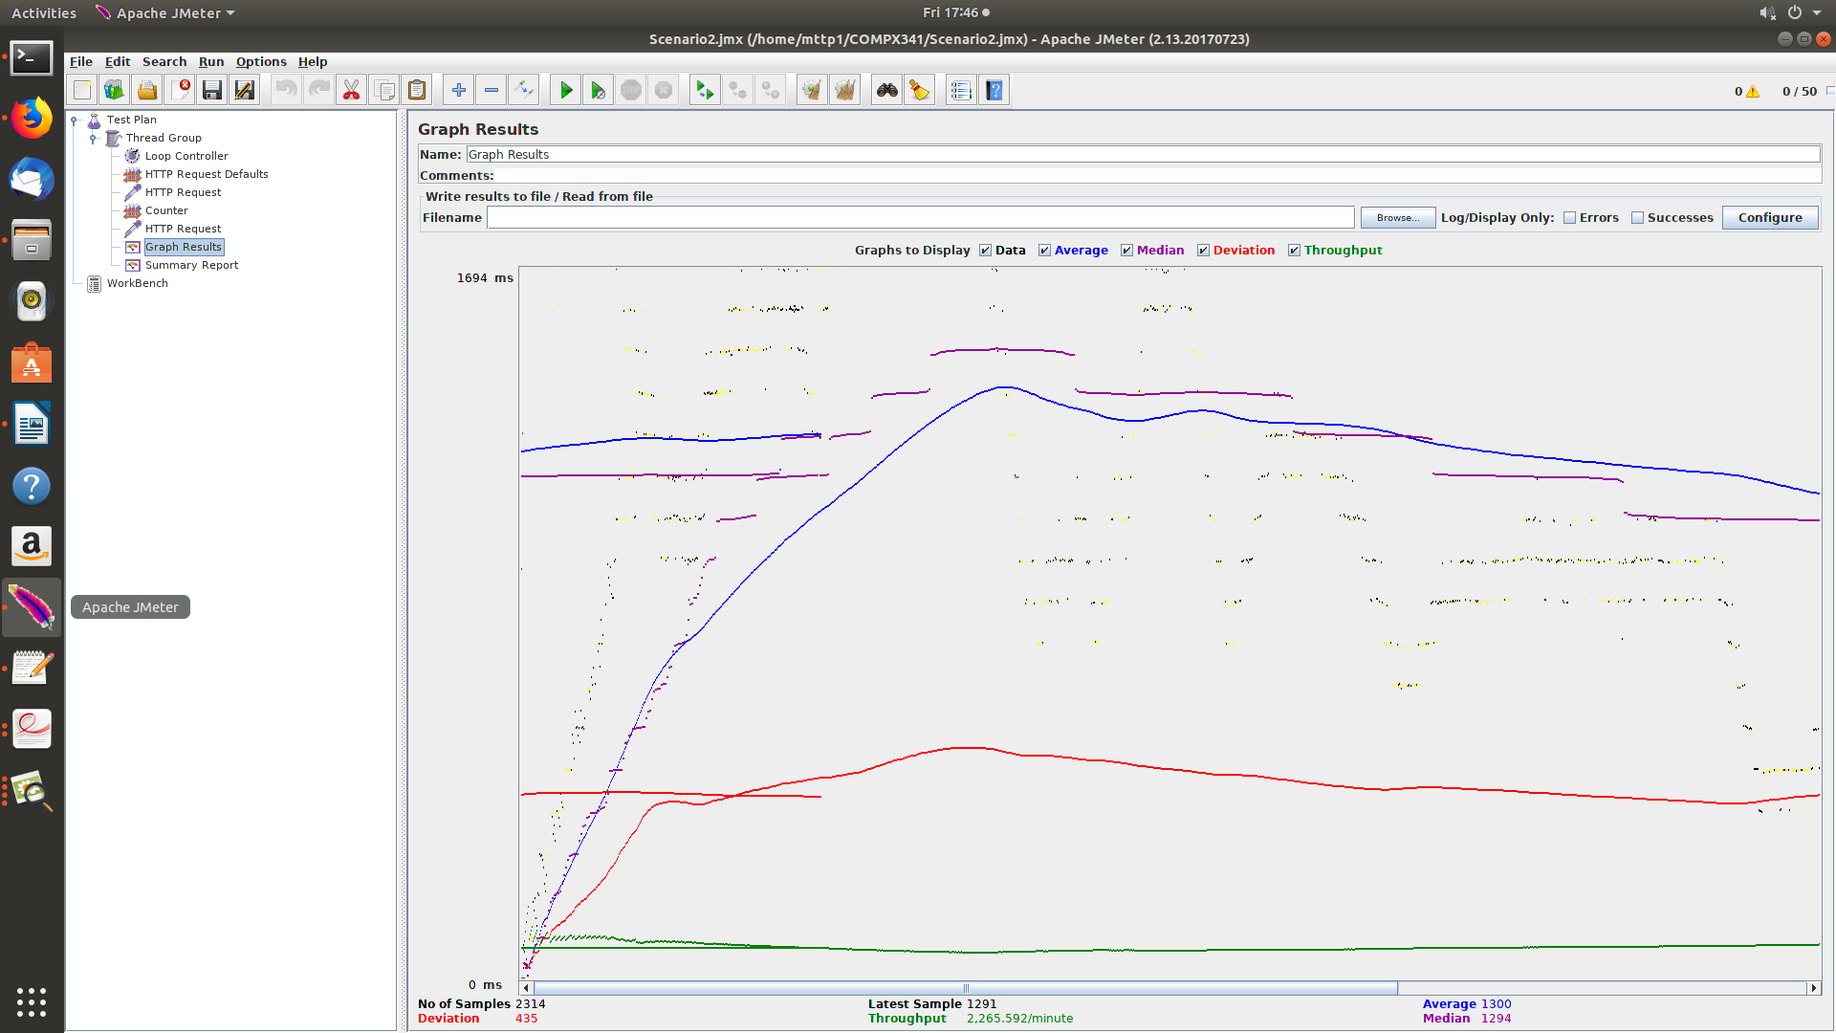
Figure 9. Graph results for Scenario 2
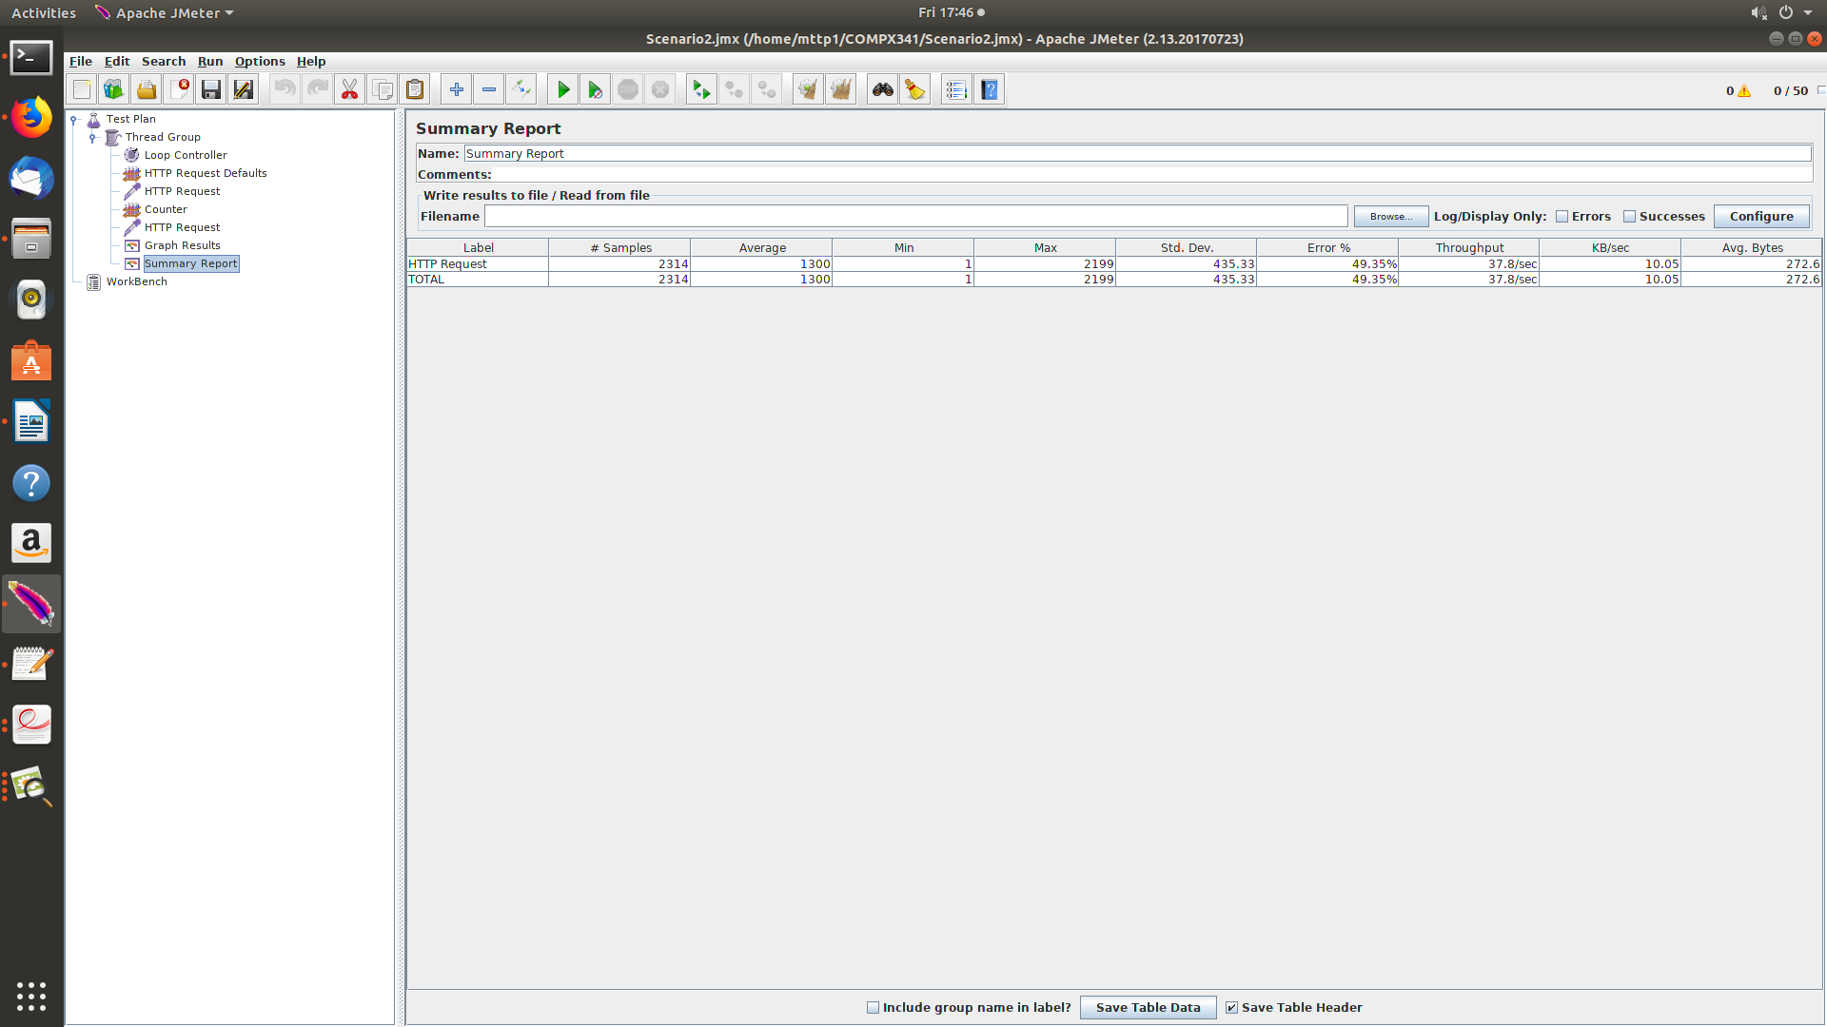
Figure 10. Summary report for Scenario 2

Link to Github: https://github.com/lysaphan/Stress-Testing-Containerized-Microservices

