**SOUTH PHILIPPINE ADVENTIST COLLEGE, INC**

Camanchiles, Matanao, Davao del Sur

P.O. Box 3749, 8002 Digos City

**Bachelor of Science in Computer Science**

**Strategic Planning and Budget System Prototype**

A Project in Practicum

# GETTING STARTED

## **Prerequisites**

1. XAMPP *(the version used by the developers is v3.3.0)*– It is a free and open-source cross-platform web server solution stack package developed by Apache Friends. Go to <https://www.apachefriends.org/download.html> and download what is compatible for your operating system.
2. SSD-MyRepo-master Zip File – Download the zip file either from <https://github.com/lyshasilva/SSD-MyRepo>.

## **Steps**

1. After downloading and installing XAMPP, locate the `xampp` file folder in your directory. It is typically found in the C: drive.

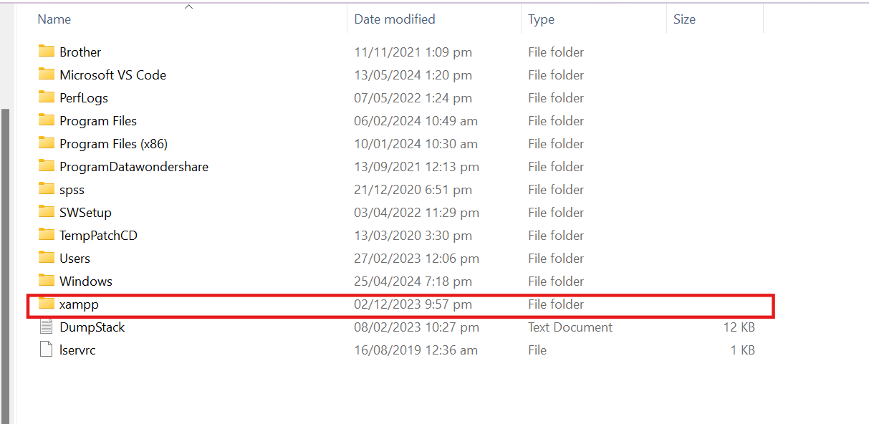

1. Go to the `xampp/htdocs` directory and create a new folder with your preferred name *(suggestion: ‘ssd’)*.

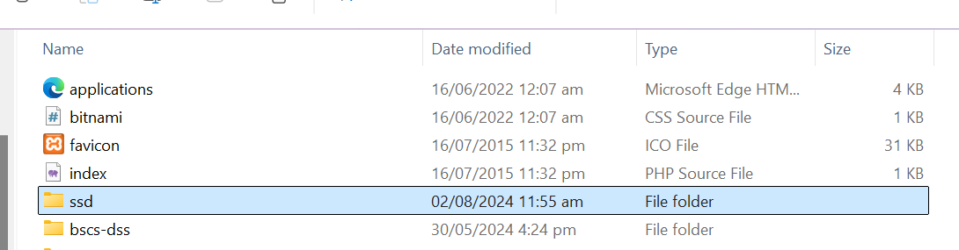

1. Go back to Downloads, extract ` SSD-MyRepo-master.zip` file and there you will find the code files.

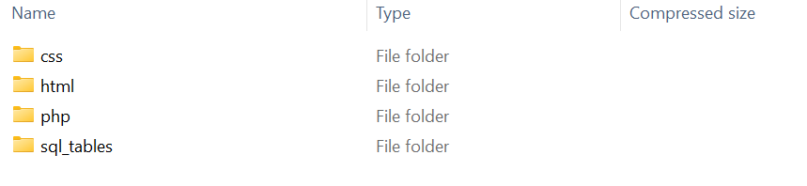

1. Move the code files to your newly created folder.

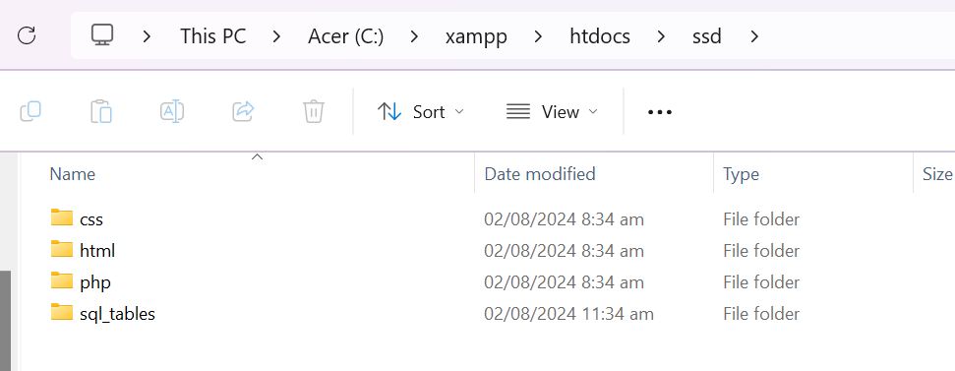

1. Open XAMPP Control Panel then start Apache and MySQL.

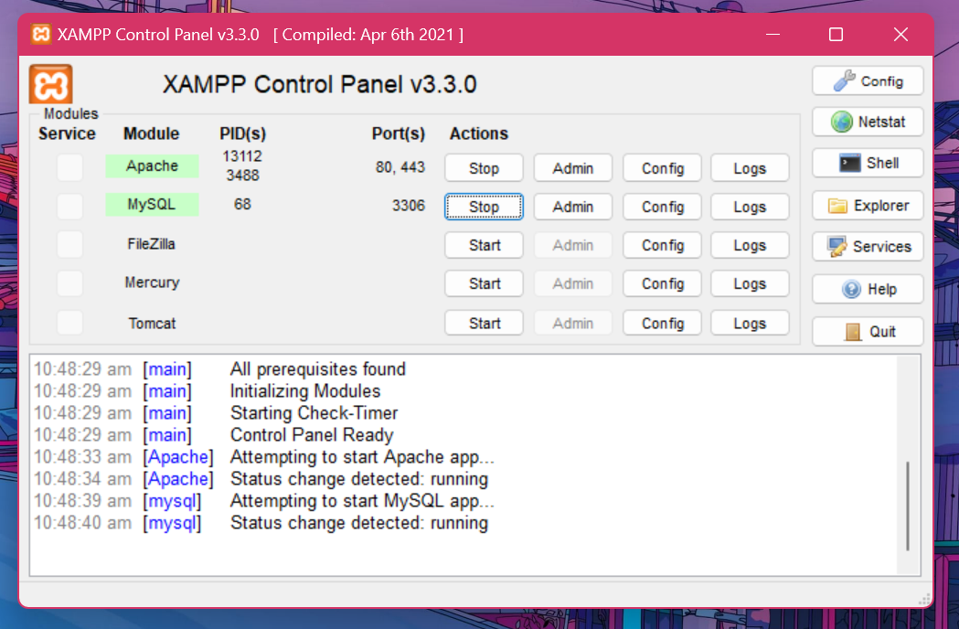

1. Click “Admin” of MySQL in the Control Panel or type <http://localhost/phpmyadmin/> in any browser.
2. Create a database named `ssdsystem`.

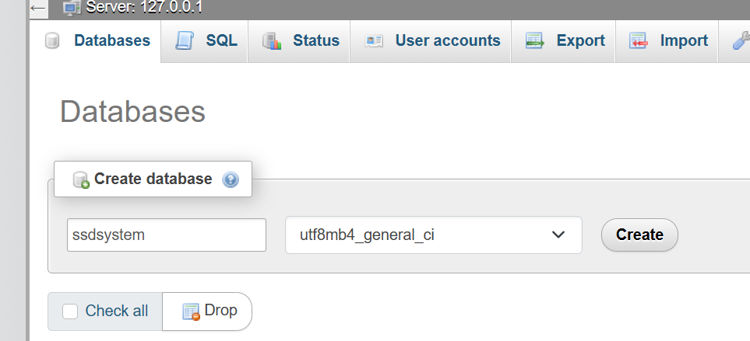

1. Import the ssdsystem.sql file found in the sql_tables folder within the extracted zip file. Be sure to click the “Import” button located at the bottom of the Import page.

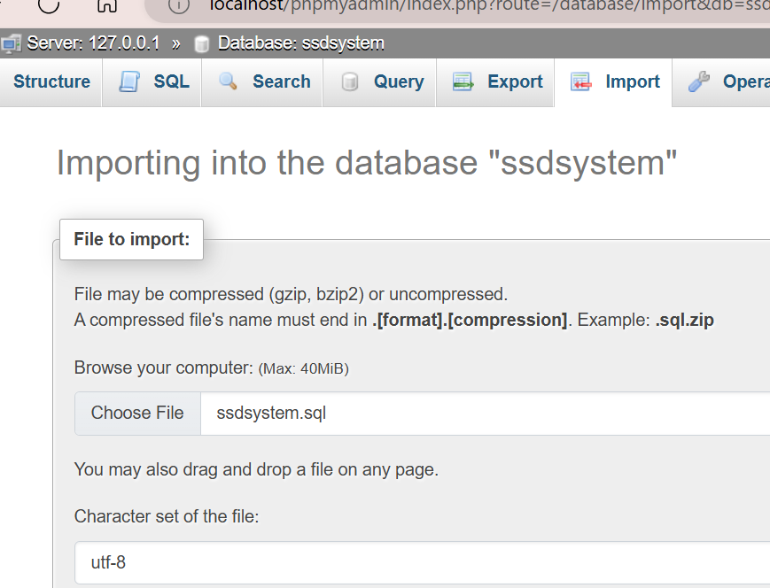

1. Finally, after successfully importing the .sql file, go to http://localhost/ssd/html/LogInPage.html and the browser will direct you to the log in page (replace ‘ssd’ with your created folder name).

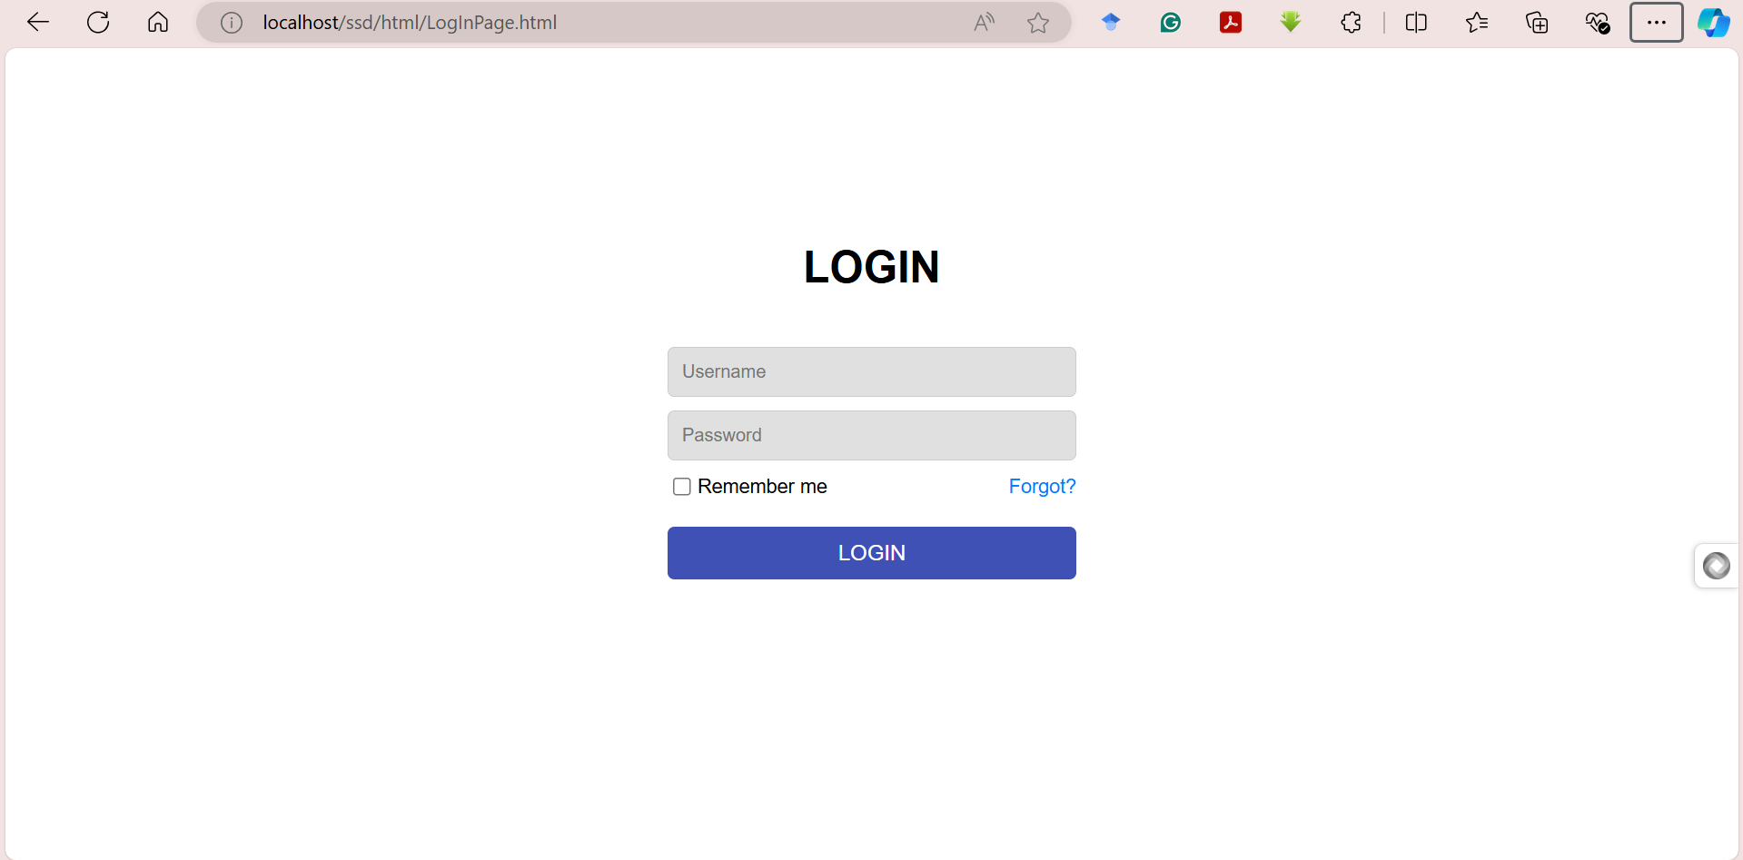

USER ACCESS AND DATA OVERVIEW

**Login Credentials**

The table below contains the login credentials currently available. Note that users will only see entries created under their department or (in some pages) their user account.

|  |  |  |
| --- | --- | --- |
| **Username** | **Password** | **Department** |
| lyshasilva | pass1234 | Sabbath School |
| prinzj | pass5678 | Sabbath School |
| mahalahj | pass3 | Sabbath School |
| amielopena | pass1 | IT |
| leonivereloy | pass2 | IT |

**Essential Data Information of Every Account**

This section provides an overview of the data related to goals and action plans for each user account. It details what to expect when accessing the system with a specific user account.

|  |  |  |  |  |
| --- | --- | --- | --- | --- |
| **Username** | **With Previous Goal** | **With Current Goal** | **With Previous AP** | **With Current AP** |
| lyshasilva | 1 | 1 | 1 | 1 |
| prinzj | 1 | 1 | 0 | 1 |
| mahalahj | 1 | 1 | 0 | 0 |
| amielopena | 1 | 0 | 1 | 0 |
| leonivereloy | 1 | 0 | 0 | 0 |

**Interface Features and Database Interaction Overview**

**Login Page**

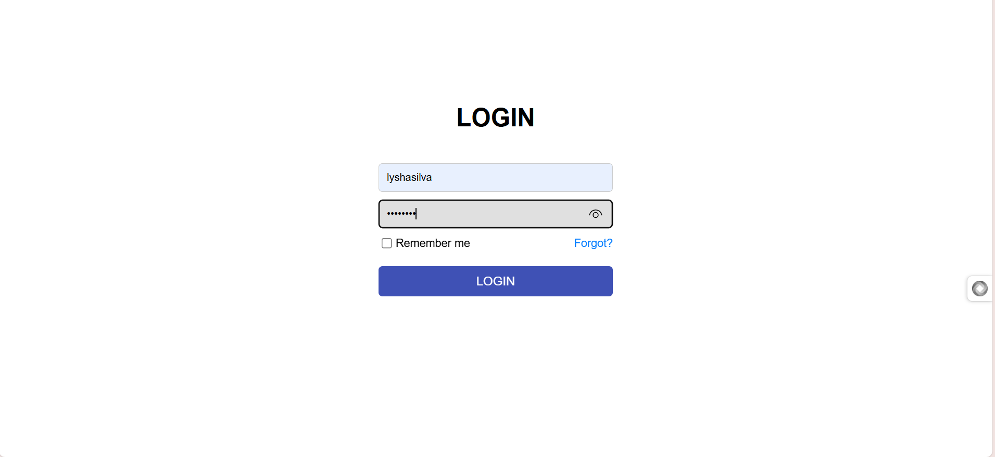

* + The **'Remember Me'** and **'Forgot Password'** features are not yet functional.
  + When incorrect credentials are entered, a JavaScript alert with an error message generated by PHP will be displayed.
  + Correct login credentials will establish a user session and redirect the user to the landing page.

**Landing Page**

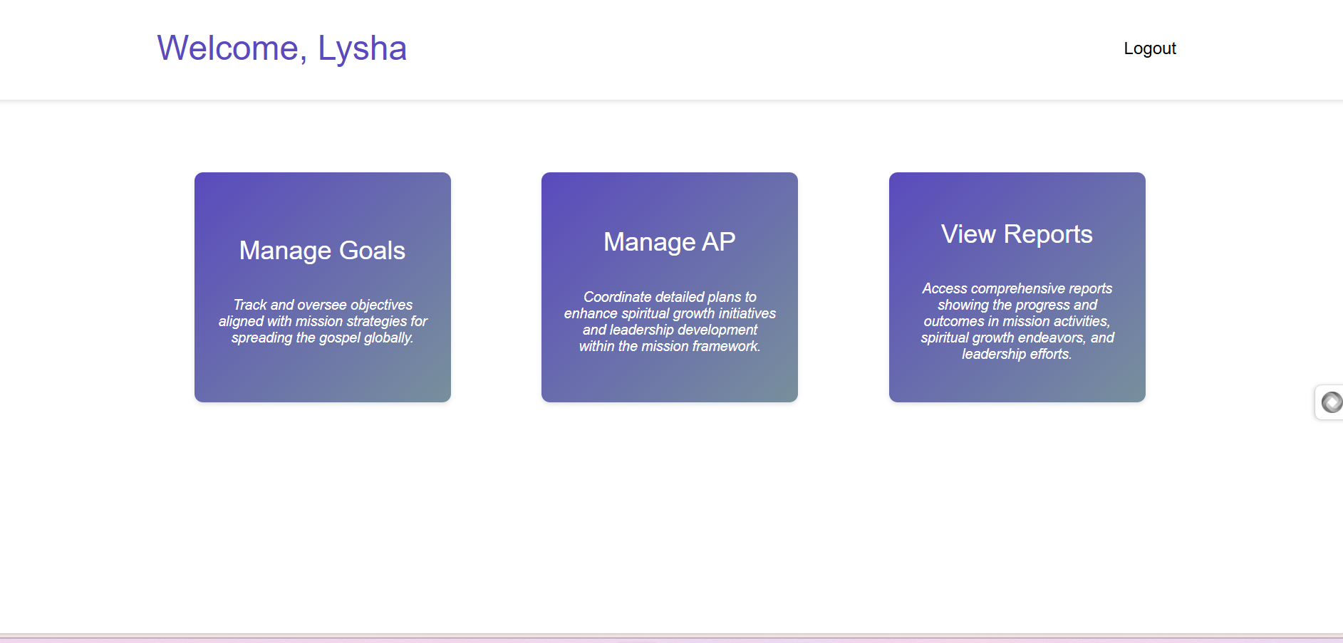

* The greeting message dynamically displays the user's first name.

**Manage Goals Page**

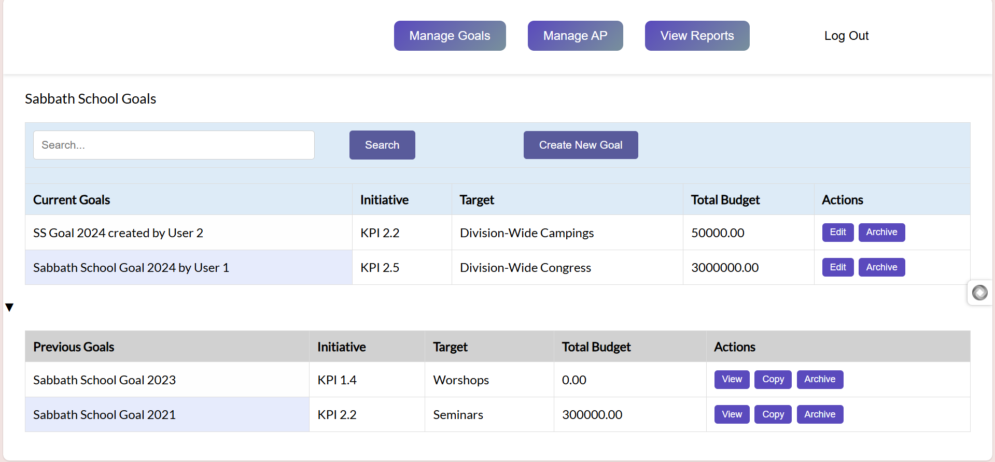

* **‘Manage Goals’, ‘Manage AP’,** and **‘View Reports’** will redirect the user to their respective pages
* **Logout**