综合实验报告
姓名 |  | 学号
专业 | 计算机科学与技术 | 班级
指导教师 | 赵备 | 课程名称 | 计算机组成原理课程设计（甲）
实验序号 | 10 | 实验名称 | CPU综合实验
实验时间 | 2024.06.20 | 实验地点 | 1教225

成绩表
考核项目 | 满分 | 得分
一、实验方案设计 | 30分
二、FPGA程序设计 | 20分
三、测试程序 | 10分
四、实验结果分析 | 20分
五、思考与探索 | 10分
格式 | 10分
合计 | 100分

一、实验方案设计
- 实验目的与要求（5分）
（1）掌握RISC-V 转移指令的数据通路设计；
（2）掌握掌握指令流和数据流的控制方法；
（3）学习依据新增指令，修改多周期CPU系统结构的方法
（4）具备连接各模块构建整机的能力
（5）实现转移类指令beq、jal、jalr的功能
- CPU的目标指令集（5分）
运算类指令（R型和I型）、传送指令（U 型lui指令）、访存指令（I型和S型）和转移类指令beq、jal、jalr；
- CPU的模块构成与连接（15分）
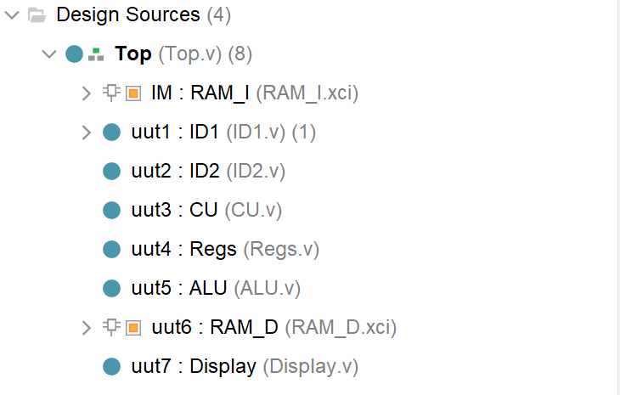
（1）Top.v：顶层CPU模块，集成了所有CPU部件，包括PC寄存器，PC0寄存器，PC专用运算器ADD，指令存储器IM，指令寄存器IR，一级译码器ID1，二级译码器ID2，译码及控制单元CU，寄存器堆Regs，A寄存器，B寄存器，运算器ALU，F寄存器，FR寄存器，标志位产生电路FlagU，数据存储器DM，MDR寄存器，数码管显示模块Display.v。
（2）RAM_I 指令存储器，存储指令。与PC寄存器和IR指令寄存器相连。
（3）ID1.v：指令一级译码模块， 对当前指令进行解析，分辨出是哪一条指令，并识别出操作数及其 寻址方式，然后发送控制信号。与IR、immU、ID2和Regs相连。
（4）immU.v：立即数拼接与扩展器，对32位指令码译码，识别出指 令格式，然后拼接组合立即数字段 imm，并扩展产生32位的立即数。与ID1和ID2相连。
（5）ID2.v：二级译码模块，根据opcode、funct3和funct7 三个字段，识别出具体的指令。与ID1、immU、CU相连。
（6）CU.v：控制单元模块, 抽象出CU模块入输出信号，将ID2模块的输出信号 作为输入，然后再根据状态机的不同状态，输出控制信号。连接Regs、ALU和DM。
（7）Regs.v：寄存器堆，存放32个寄存器，可以进行读写功能。和ID1、CU相连。
（8）ALU.v：运算器模块，接收输入A,B进行算术和逻辑运算。和CU相连。
（9）RAM_D：数据存储器，存储主存中的数据，可以进行读写功能。和CU相连。
（10）Display.v：数码管显示模块，显示PC、IR、F等数据。
- 板级验证方案（5分）
输入输出信号 | 输入输出设备
input clk | 点动开关R4
input rst_n | 点动开关AA4
input clk_nt | 点动开关H4
input [3:0] sw1 | 拨码开关T3,U3,T4,V3
input [2:0] sw2 | 拨码开关V4,W4,Y4
output reg [6:0] Led | LED灯R1,P2,P1,N2,M1,M2,L1
output [2:0] which | 8个数码管3-8译码器的DS0-DS2管脚N22,M21,M22
output [7:0] seg | 8段二极管的a-g-dp
output reg EN | 数码管的使能信号端

二、FPGA程序设计
（20分）
- 实验程序源代码
（1）Top.v：顶层模块，包括PC寄存器，PC0寄存器，PC专用运算器ADD，指令存储器IM，指令寄存器IR，一级译码器ID1，二级译码器ID2，译码及控制单元CU，寄存器堆Regs，A寄存器，B寄存器，运算器ALU，F寄存器，FR寄存器，标志位产生电路FlagU，数据存储器DM，MDR寄存器，数码管显示模块Display.v。
module Top(clk,rst_n, clk_nt,sw1,sw2,Led,which,seg,EN);
//显示字段
input clk,rst_n, clk_nt;
input [3:0] sw1;//LED选择rs1,rs2,rd,opcode,funct3,funct7
input [2:0] sw2;//数码管选择PC、IR、W_Data、MDR
output reg [6:0] Led;
output [2:0] which;
output [7:0] seg;
output reg EN=1;
reg [31:0] Lcd;
//取指令
reg [31:0] PC=32'h0000_0000,PC0=32'h0000_0000;
wire [31:0] Inst_Code;
reg [31:0] IR;
//译码
wire [4:0]rs1,rs2,rd,funct3,funct7;
wire [6:0]opcode;
wire [31:0]imm32;
wire IS_R,IS_IMM,IS_LUI,IS_LW,IS_SW,IS_BEQ,IS_JAL,IS_JALR;
//控制信号
wire PC_write,PC0_write,IR_write,Reg_write,Mem_write,rs2_imm_s;
reg PC_write_R,PC0_write_R,IR_write_R,rs2_imm_s_R;
//运算器
wire [31:0] R_Data_A,R_Data_B;
reg [31:0] A,B,F;
wire [31:0] ALU_A,ALU_B,ALU_F;
wire [3:0] ALU_OP,ALU_OP_R;
wire ZF,SF,CF,OF;
reg [3:0] FR;
wire [31:0]M_R_Data;
reg [31:0] MDR,W_Data;
//多路选择
wire [1:0] w_data_s,PC_s;
reg [1:0] w_data_s_R,PC_s_R;
always@(*)
begin
PC_write_R<=PC_write;
PC0_write_R<=PC0_write;
IR_write_R<=IR_write;
w_data_s_R<=w_data_s;
PC_s_R<=PC_s;
rs2_imm_s_R<=rs2_imm_s;
end
//PC
always@(posedge rst_n or negedge clk)
begin
//rst_n=1时清零
if(rst_n) begin
PC <= 32'h0000_0000;
PC0 <= 32'h0000_0000;
end
else
begin
if(PC0_write_R)
PC0<=PC;
if(PC_write_R)
case(PC_s_R)
2'b00:PC <= PC + 4;//顺序
2'b01:PC <= PC0 + imm32;//beq/jal
2'b10:PC <= F;//jalr
default:PC<=32'bz;
endcase
end
end
//IR
RAM_I IM(
.clka(clk), // input clka
.wea(0), // input [0 : 0] wea
.addra(PC[7:2]), // input [5 : 0] addra
.dina(32'hFFFF_FFFF), // input [31 : 0] dina
.douta(Inst_Code) // output [31 : 0] douta
);
always @(posedge rst_n or negedge clk)
begin
//rst_n上升沿来临，IR清零
if(rst_n) IR <= 32'h0000_0000;
else
if(IR_write_R) IR <= Inst_Code;
end
ID1 uut1(IR,rs1,rs2,rd,opcode,funct3,funct7,imm32);
ID2 uut2(opcode,funct3,funct7,
IS_R,IS_IMM,IS_LUI,IS_LW,IS_SW,IS_BEQ,IS_JAL,IS_JALR,
ALU_OP);
CU uut3(~rst_n,clk,
IS_R,IS_IMM,IS_LUI,IS_LW,IS_SW,IS_BEQ,IS_JAL,IS_JALR,ALU_OP,ZF,
PC_write,PC0_write,IR_write,Reg_write,Mem_write,
rs2_imm_s,w_data_s,PC_s,ALU_OP_R);
Regs uut4(~rst_n,Reg_write,~clk,rd,W_Data,rs1,rs2,R_Data_A,R_Data_B);
always@(*)
begin
A<=R_Data_A;
B<=R_Data_B;
end
assign ALU_A = A;
assign ALU_B = rs2_imm_s_R ? imm32 : B;
ALU uut5(ALU_A,ALU_B,ALU_OP_R,ALU_F,ZF,SF,CF,OF);
always@(*)
begin
F<=ALU_F;
FR[3]<=ZF;
FR[2]<=SF;
FR[1]<=CF;
FR[0]<=OF;
case(w_data_s_R)
2'b00:W_Data<=F;
2'b01:W_Data<=imm32;
2'b10:W_Data<=MDR;
2'b11:W_Data<=PC;
endcase
end
RAM_D uut6(clk,Mem_write,F[7:2],B,M_R_Data);
always@(negedge clk)
begin
MDR<=M_R_Data;
end
always@(*)
begin
case(sw1)
4'b0000:Led <= { 2'b0 , rs1 };
4'b0001:Led <= { 2'b0 , rs2 };
4'b0010:Led <= { 2'b0 , rd };
4'b0011:Led <= opcode;
4'b0100:Led <= { 4'b0 , funct3 };
4'b0101:Led <= funct7 ;
4'b0110:Led <= PC_s_R ;
4'b0111:Led <= PC_write_R ;
4'b1000:Led <= rs2_imm_s_R ;
4'b1001:Led <= w_data_s_R ;
4'b1010:Led <= IS_IMM ;
4'b1011:Led <= Reg_write ;
4'b1100:Led <= ZF ;
4'b1101:Led <= ALU_OP_R ;
default :Led<=7'b1111111;
endcase
case(sw2)
3'b000:Lcd <= PC;
3'b001:Lcd <= IR;
3'b010:Lcd <= W_Data;
3'b011:Lcd <= MDR;
3'b100:Lcd <= F;
3'b101:Lcd <= ALU_A;
3'b110:Lcd <= imm32;
3'b111:Lcd <= ALU_B;
endcase
end
Display uut7(clk_nt,Lcd,which,seg);
endmodule

（2）ID1.v：指令一级译码模块
module ID1(inst,rs1,rs2,rd,opcode,funct3,funct7,imm32);
input [31:0]inst;
output [5:0]rs1,rs2,rd;
output reg [6:0]opcode;
output [5:0]funct3,funct7;
output [31:0]imm32;
reg [2:0] inst_Type;
always @(*)
begin
opcode = inst[6:0];
case(opcode)
7'b0110011:inst_Type = 3'b000; // R型指令格式编码
7'b0010011:inst_Type = 3'b001; // I型指令格式编码
7'b0110111:inst_Type = 3'b010; // U型指令格式编码
7'b0000011:inst_Type = 3'b011; // LW型指令格式编码
7'b0100011:inst_Type = 3'b100; // SW型指令格式编码
7'b1100011:inst_Type = 3'b101; // B型指令格式编码
7'b1101111:inst_Type = 3'b110; // JAL型指令格式编码
7'b1100111:inst_Type = 3'b111; // JALR型指令格式编码
endcase
end
ImmU uut(inst,inst_Type,imm32);
assign rs1=inst[19:15];
assign rs2=inst[24:20];
assign rd=inst[11:7];
assign funct3=inst[14:12];
assign funct7=inst[31:25];
endmodule

（3）immU.v：立即数模块
module ImmU(
input [31:0]inst,
input [2:0] inst_Type,
output reg[31:0]imm32
);
always@(*)
begin
case(inst_Type)
//3'b000:imm32 <= { 27'b0 , inst[24:20]};
3'b001:begin
if((inst[14:12] == 3'b001) | (inst[14:12] == 3'b101))
//移位 无符号
imm32 <= { 27'b0 , inst[24:20]};
else//其他 SE32
imm32 <= {{20{inst[31]}} , inst[31:20]};
end
3'b010:imm32 <= {inst[31:12], 12'b0};

3'b011:imm32 <= {{20{inst[31]}} , inst[31:20]};
3'b100:imm32 <= {{20{inst[31]}}, inst[31:25], inst[11:7]};

3'b101:imm32 <= {{20{inst[31]}}, inst[7], inst[30:25], inst[11:8], 1'b0};
3'b110:imm32 <= {{12{inst[31]}}, inst[19:12], inst[20], inst[30:21], 1'b0};
3'b111:imm32 <= {{20{inst[31]}} , inst[31:20]};
endcase
end
endmodule

（4）ID2.v：二级译码模块
module ID2(opcode,funct3,funct7,IS_R,IS_IMM,IS_LUI,IS_LW,IS_SW,IS_BEQ,IS_JAL,IS_JALR,ALU_OP);
input [6:0]opcode;
input [5:0]funct3;
input [5:0]funct7;
output reg IS_R,IS_IMM,IS_LUI;
output reg IS_LW,IS_SW;
output reg IS_BEQ,IS_JAL,IS_JALR;
output reg [3:0] ALU_OP;
always@(*)
begin
IS_R <= (opcode==7'b0110011)?1'b1:1'b0;
IS_IMM <= (opcode==7'b0010011)?1'b1:1'b0;
IS_LUI <= (opcode==7'b0110111)?1'b1:1'b0;

IS_LW <= (opcode==7'b0000011)?1'b1:1'b0;
IS_SW <= (opcode==7'b0100011)?1'b1:1'b0;

IS_BEQ <= (opcode==7'b1100011)?1'b1:1'b0;
IS_JAL <= (opcode==7'b1101111)?1'b1:1'b0;
IS_JALR <= (opcode==7'b1100111)?1'b1:1'b0;

if(opcode==7'b0110011)//IS_R=1
ALU_OP = {funct7[5],funct3};
if(opcode==7'b0010011)//IS_IMM=1
ALU_OP = (funct3==3'b101) ? {funct7[5],funct3}:{1'b0,funct3};
end

endmodule

（5）CU.v：控制信号模块
module CU(
input rst_n,
input clk,
input IS_R,
input IS_IMM,
input IS_LUI,
input IS_LW,
input IS_SW,
input IS_BEQ,
input IS_JAL,
input IS_JALR,
input [3:0] ALU_OP,
input ZF,
output reg PC_write,
output reg PC0_write,
output reg IR_write,
output reg Reg_write,
output reg Mem_write,
output reg rs2_imm_s,
output reg [1:0] w_data_s,
output reg [1:0] PC_s,
output reg [3:0] ALU_OP_o
);
reg [3:0] ST,Next_ST;
`define Idle 4'b0000
`define S1 4'b0001
`define S2 4'b0010
`define S3 4'b0011
`define S4 4'b0100
`define S5 4'b0101
`define S6 4'b0110
`define S7 4'b0111
`define S8 4'b1000
`define S9 4'b1001
`define S10 4'b1010
`define S11 4'b1011
`define S12 4'b1100
`define S13 4'b1101
`define S14 4'b1110
// 第一段：状态转移，在clk的边沿进行状态转移，是同步时序逻辑电路
always @(negedge rst_n or posedge clk)
begin
if (!rst_n) ST <= `Idle; // 初始状态
else ST <= Next_ST; // clk的上跳沿，进行状态转移
end
// 第二段：次态函数，对次态的阻塞式赋值，是组合逻辑函数
always @(*)
begin
Next_ST = `Idle;
case (ST) // 根据状态转移图进行次态赋值
`Idle: Next_ST = `S1;
`S1: begin
if (IS_LUI) Next_ST = `S6;
else begin
if(IS_JAL) Next_ST = `S11;
else Next_ST = `S2;
end
end
`S2: begin
if (IS_R) Next_ST = `S3;
else begin
if(IS_BEQ) Next_ST = `S13;
else
begin
if(IS_IMM) Next_ST = `S5 ;
else Next_ST = `S7;
end
end
end
`S3: Next_ST = `S4;
`S5: Next_ST = `S4;
`S4: Next_ST = `S1;
`S6: Next_ST = `S1;

`S7: begin
if(IS_LW) Next_ST = `S8;
else
begin
if(IS_SW) Next_ST = `S10;
else Next_ST = `S12;
end
end
`S8: Next_ST = `S9;
`S9: Next_ST = `S1;
`S10: Next_ST = `S1;
`S11: Next_ST = `S1;
`S12: Next_ST = `S1;

`S13: Next_ST = `S14;
`S14: Next_ST = `S1;
default: Next_ST = `S1;
endcase
end
// 第三段：输出函数，在clk的上跳沿，根据下一状态进行控制信号的非阻塞式赋值
always @(negedge rst_n or posedge clk)
begin
if (!rst_n) // 全部信号初始化为0
begin
PC_write<=1'b0; PC0_write<=1'b0; IR_write<=1'b0;
Reg_write<=1'b0; Mem_write<=1'b0; ALU_OP_o<=4'b0000;
rs2_imm_s<=1'b0;w_data_s<=2'b00;PC_s<=2'b00;
end
else
begin
// 每个状态下输出的控制信号
case(Next_ST)
`S1:begin //取指令，PC自增
PC_write<=1'b1; PC0_write<=1'b1; IR_write<=1'b1;
Reg_write<=1'b0; Mem_write<=1'b0;
PC_s<=2'b00;
end
`S2:begin //R/I/lw/sw/jalr/beq
PC_write<=1'b0; PC0_write<=1'b0; IR_write<=1'b0;
Reg_write<=1'b0; Mem_write<=1'b0;
end
`S3:begin //R
PC_write<=1'b0; PC0_write<=1'b0; IR_write<=1'b0;
Reg_write<=1'b0; Mem_write<=1'b0; ALU_OP_o<=ALU_OP;
rs2_imm_s<=1'b0;
end
`S4:begin //R
PC_write<=1'b0; PC0_write<=1'b0; IR_write<=1'b0;
Reg_write<=1'b1; Mem_write<=1'b0;
w_data_s<=2'b00;
end
`S5:begin //I
PC_write<=1'b0; PC0_write<=1'b0; IR_write<=1'b0;
Reg_write<=1'b0; Mem_write<=1'b0; ALU_OP_o<=ALU_OP;
rs2_imm_s<=1'b1;
end
`S6:begin //lui
PC_write<=1'b0; PC0_write<=1'b0; IR_write<=1'b0;
Reg_write<=1'b1; Mem_write<=1'b0;
w_data_s<=2'b01;
end
`S7:begin //lw/sw/jalr
PC_write<=1'b0; PC0_write<=1'b0; IR_write<=1'b0;
Reg_write<=1'b0; Mem_write<=1'b0; ALU_OP_o<=4'b0000;
rs2_imm_s<=1'b1;
end
`S8:begin //lw
PC_write<=1'b0; PC0_write<=1'b0; IR_write<=1'b0;
Reg_write<=1'b0; Mem_write<=1'b0;
end
`S9:begin //lw
PC_write<=1'b0; PC0_write<=1'b0; IR_write<=1'b0;
Reg_write<=1'b1; Mem_write<=1'b0;
w_data_s<=2'b10;
end
`S10:begin //sw
PC_write<=1'b0; PC0_write<=1'b0; IR_write<=1'b0;
Reg_write<=1'b0; Mem_write<=1'b1;
end
`S11:begin //jal
PC_write<=1'b1; PC0_write<=1'b0; IR_write<=1'b0;
Reg_write<=1'b1; Mem_write<=1'b0;
w_data_s<=2'b11;PC_s<=2'b01;
end
`S12:begin //jalr
PC_write<=1'b1; PC0_write<=1'b0; IR_write<=1'b0;
Reg_write<=1'b1; Mem_write<=1'b0;
w_data_s<=2'b11;PC_s<=2'b10;
end
`S13:begin //beq
PC_write<=1'b0; PC0_write<=1'b0; IR_write<=1'b0;
Reg_write<=1'b0; Mem_write<=1'b0;ALU_OP_o<=4'b1000;
rs2_imm_s<=1'b0;
end
`S14:begin //beq
PC_write<=ZF; PC0_write<=1'b0; IR_write<=1'b0;
Reg_write<=1'b0; Mem_write<=1'b0;
PC_s<=2'b01;
end
endcase
end
end
endmodule
（6）Regs.v：寄存器堆
module Regs(rst_n,Reg_Write,clk_WB,W_Addr,W_Data,R_Addr_A,R_Addr_B,R_Data_A,R_Data_B);
input rst_n,clk_WB;
input Reg_Write;
input [4:0]R_Addr_A;
input [4:0]R_Addr_B;
input [4:0]W_Addr;
input [31:0]W_Data;
output [31:0]R_Data_A;
output [31:0]R_Data_B;
reg [31:0] REG_Files[0:31];
integer i;
always@(posedge clk_WB or negedge rst_n)
begin
if(!rst_n)
begin
for(i = 1; i <32; i = i + 1) begin
REG_Files[i] <= 32'h0000_0001;
end
REG_Files[0]<=32'h0000_0000;
REG_Files[1]<=32'h0000_0003;
end
else
if(Reg_Write)
begin
if(W_Addr!=5'b00000)
REG_Files[W_Addr]<=W_Data;
end
end
assign R_Data_A=REG_Files[R_Addr_A];
assign R_Data_B=REG_Files[R_Addr_B];
endmodule
（7）ALU.v：运算器模块
module ALU(A,B,ALU_OP,F,ZF,SF,CF,OF);
input [3:0] ALU_OP;
input [32:1] A,B;
output reg [32:1] F;
output reg ZF,SF,CF,OF;
reg C;
// 移位数 限制在0到31之间 srl，5位足以表示32
wire [5:1] shift_amount = B[5:1];
always@(*)
begin
C=0;
CF=0;
OF=0;
ZF=0;
SF=0;
case(ALU_OP)
4'b0000:begin {C,F}=A+B;OF = A[32]^B[32]^F[32]^C;CF = C;end //加法 add
4'b0001:begin F=A<<B; end //左移 sll
4'b0010:begin F=$signed(A)<$signed(B); end //有符号数比较 slt
4'b0011:begin F=A<B; end //无符号数比较 sltu
4'b0100:begin F=A^B; end//异或 xor
4'b0101:begin F = A >> shift_amount; end //srl 逻辑右移
4'b0110:begin F=A|B; end//按位或 or
4'b0111:begin F=A&B; end//按位与 and
4'b1000:begin {C,F}=A-B;OF = A[32]^B[32]^F[32]^C;CF = ~C; end//减法 sub
4'b1101:begin F=($signed(A))>>>shift_amount;end// 算术右移 sra 有符号位
endcase
ZF = F==0;
SF = F[32];
end
endmodule
（8）Display.v：数码管显示模块
module Display(clk,data,which,seg);
input clk; //时钟
input [32:1] data; //数据
output reg [2:0] which=0; //片选信号
output reg[7:0] seg; //片选数据
reg [14:0] count = 0;
reg [3:0] digit;
always@(posedge clk)count<=count+1'b1;
always@(negedge clk)if(&count)which<=which+1'b1;
always @*
begin
case(which)
0:digit<=data[32:29];
1:digit<=data[28:25];
2:digit<=data[24:21];
3:digit<=data[20:17];
4:digit<=data[16:13];
5:digit<=data[12:9];
6:digit<=data[8:5];
7:digit<=data[4:1];
endcase
end
always@*
begin
case(digit)
//_为了分隔比特方便阅读
4'h0:seg<=8'b0000_0011;
4'h1:seg<=8'b1001_1111;
4'h2:seg<=8'b0010_0101;
4'h3:seg<=8'b0000_1101;
4'h4:seg<=8'b1001_1001;
4'h5:seg<=8'b0100_1001;
4'h6:seg<=8'b0100_0001;
4'h7:seg<=8'b0001_1111;
4'h8:seg<=8'b0000_0001;
4'h9:seg<=8'b0000_1001;
4'hA:seg<=8'b0001_0001;
4'hB:seg<=8'b1100_0001;
4'hC:seg<=8'b0110_0011;
4'hD:seg<=8'b1000_0101;
4'hE:seg<=8'b0110_0001;
4'hF:seg<=8'b0111_0001;
endcase
end
endmodule
- FPGA管脚约束代码
（1）管脚约束文件constraint1.xdc代码
set_property IOSTANDARD LVCMOS18 [get_ports clk]
set_property PACKAGE_PIN R4 [get_ports clk]
set_property PACKAGE_PIN R1 [get_ports {Led[6]}]
set_property PACKAGE_PIN P2 [get_ports {Led[5]}]
set_property PACKAGE_PIN P1 [get_ports {Led[4]}]
set_property PACKAGE_PIN N2 [get_ports {Led[3]}]
set_property IOSTANDARD LVCMOS18 [get_ports {Led[6]}]
set_property IOSTANDARD LVCMOS18 [get_ports {Led[5]}]
set_property IOSTANDARD LVCMOS18 [get_ports {Led[4]}]
set_property IOSTANDARD LVCMOS18 [get_ports {Led[3]}]
set_property IOSTANDARD LVCMOS18 [get_ports {Led[2]}]
set_property IOSTANDARD LVCMOS18 [get_ports {Led[1]}]
set_property IOSTANDARD LVCMOS18 [get_ports {Led[0]}]
set_property PACKAGE_PIN M1 [get_ports {Led[2]}]
set_property PACKAGE_PIN M2 [get_ports {Led[1]}]
set_property PACKAGE_PIN L1 [get_ports {Led[0]}]
set_property IOSTANDARD LVCMOS18 [get_ports {seg[7]}]
set_property IOSTANDARD LVCMOS18 [get_ports {seg[6]}]
set_property IOSTANDARD LVCMOS18 [get_ports {seg[5]}]
set_property IOSTANDARD LVCMOS18 [get_ports {seg[4]}]
set_property IOSTANDARD LVCMOS18 [get_ports {seg[3]}]
set_property IOSTANDARD LVCMOS18 [get_ports {seg[2]}]
set_property IOSTANDARD LVCMOS18 [get_ports {seg[1]}]
set_property IOSTANDARD LVCMOS18 [get_ports {seg[0]}]
set_property PACKAGE_PIN H19 [get_ports {seg[7]}]
set_property PACKAGE_PIN G20 [get_ports {seg[6]}]
set_property PACKAGE_PIN J22 [get_ports {seg[5]}]
set_property PACKAGE_PIN K22 [get_ports {seg[4]}]
set_property PACKAGE_PIN K21 [get_ports {seg[3]}]
set_property PACKAGE_PIN H20 [get_ports {seg[2]}]
set_property PACKAGE_PIN H22 [get_ports {seg[1]}]
set_property PACKAGE_PIN J21 [get_ports {seg[0]}]
set_property IOSTANDARD LVCMOS18 [get_ports {sw1[3]}]
set_property IOSTANDARD LVCMOS18 [get_ports {sw1[2]}]
set_property IOSTANDARD LVCMOS18 [get_ports {sw1[1]}]
set_property IOSTANDARD LVCMOS18 [get_ports {sw1[0]}]
set_property PACKAGE_PIN T3 [get_ports {sw1[3]}]
set_property PACKAGE_PIN U3 [get_ports {sw1[2]}]
set_property PACKAGE_PIN T4 [get_ports {sw1[1]}]
set_property PACKAGE_PIN V3 [get_ports {sw1[0]}]
set_property IOSTANDARD LVCMOS18 [get_ports {sw2[2]}]
set_property IOSTANDARD LVCMOS18 [get_ports {sw2[1]}]
set_property IOSTANDARD LVCMOS18 [get_ports {sw2[0]}]
set_property PACKAGE_PIN V4 [get_ports {sw2[2]}]
set_property PACKAGE_PIN W4 [get_ports {sw2[1]}]
set_property PACKAGE_PIN Y4 [get_ports {sw2[0]}]
set_property IOSTANDARD LVCMOS18 [get_ports {which[2]}]
set_property IOSTANDARD LVCMOS18 [get_ports {which[1]}]
set_property IOSTANDARD LVCMOS18 [get_ports {which[0]}]
set_property PACKAGE_PIN M22 [get_ports {which[2]}]
set_property PACKAGE_PIN M21 [get_ports {which[1]}]
set_property PACKAGE_PIN N22 [get_ports {which[0]}]
set_property PACKAGE_PIN H4 [get_ports clk_nt]
set_property IOSTANDARD LVCMOS18 [get_ports clk_nt]
set_property IOSTANDARD LVCMOS18 [get_ports EN]
set_property IOSTANDARD LVCMOS18 [get_ports rst_n]
set_property PACKAGE_PIN L21 [get_ports EN]
set_property PACKAGE_PIN AA4 [get_ports rst_n]
set_property PULLDOWN true [get_ports {Led[6]}]
set_property PULLDOWN true [get_ports {Led[5]}]
set_property PULLDOWN true [get_ports {Led[4]}]
set_property PULLDOWN true [get_ports {Led[3]}]
set_property PULLDOWN true [get_ports {Led[2]}]
set_property PULLDOWN true [get_ports {Led[1]}]
set_property PULLDOWN true [get_ports {Led[0]}]
set_property PULLDOWN true [get_ports {sw1[3]}]
set_property PULLDOWN true [get_ports {sw1[2]}]
set_property PULLDOWN true [get_ports {sw1[1]}]
set_property PULLDOWN true [get_ports {sw1[0]}]
set_property PULLDOWN true [get_ports {sw2[2]}]
set_property PULLDOWN true [get_ports {sw2[1]}]
set_property PULLDOWN true [get_ports {sw2[0]}]
set_property BITSTREAM.GENERAL.COMPRESS TRUE [current_design]
set_property CLOCK_DEDICATED_ROUTE FALSE [get_nets rst_n]
set_property CLOCK_DEDICATED_ROUTE FALSE [get_nets clk]

（2）各信号对应的具体设备
输入输出信号 | 输入输出设备
input clk | 点动开关R4
input rst_n | 点动开关AA4
input clk_nt | 点动开关H4
input [3:0] sw1 | 拨码开关T3,U3,T4,V3
input [2:0] sw2 | 拨码开关V4,W4,Y4
output reg [6:0] Led | LED灯R1,P2,P1,N2,M1,M2,L1
output [2:0] which | 8个数码管3-8译码器的DS0-DS2管脚N22,M21,M22
output [7:0] seg | 8段二极管的a-g-dp
output reg EN | 数码管的使能信号端

三、测试程序
（10分）
1、CPU测试程序
main:
addi a0, zero, 0x10; #a0=0000_0010H，数据区域（数组）首址
ori a1, zero, 3; #a1=0000_0003H，累加的数据个数
xori a2, zero, 0x30; #a2=0000_0030H，累加和存放的单元
jal BankSum #子程序调用
lw s0, 0(a2) #读出累加和
BankSum:
add t0, a0, zero; #t0=数据区域首址
or t1, a1, zero; #t1=计数器，初始为累加的数据个数
and t2, zero, zero; #t2=累加和，初始清零
L: lw t3, 0(t0); #t3=取出数据
add t2, t2, t3 #累加
addi t0, t0, 4; #移动数据区指针
addi t1, t1, -1; #计数器-1
beq t1, zero, exit; #计数值=0，累加完成，退出循环
jal L #计数值≠0，继续累加，跳转至循环体首部
exit: sw t2, 0(a2); #累加和，存到指定单元
jalr ra #子程序返回
2、存储器内容
（1）指令存储器内容（test.coe）
memory_initialization_radix=16;
memory_initialization_vector=01000513 00306593 03004613 008000EF 00062403 000502B3 0005E333 000073B3 0002AE03 01C383B3 00428293 FFF30313 00030463 FEDFF06F 00762023 00008067;
（2）数据存储器内容（data.coe）
memory_initialization_radix=16;
memory_initialization_vector=00000001 00000001 00000001 00000001 00000001 00000001 00000001 00000001 00000001 00000001 00000001 00000001 00000001 00000001 00000001 00000001 00000001 00000001 00000001 00000001 00000001 00000001 00000001 00000001 00000001 00000001 00000001 00000001 00000001 00000001 00000001 00000001 00000001 00000001 00000001 00000001 00000001 00000001 00000001 00000001 00000001 00000001 00000001 00000001 00000001 00000001 00000001 00000001 00000001 00000001 00000001 00000001 00000001 00000001;

四、实验结果分析
- 仿真代码
module test;
reg clk,rst_n;
wire [31:0] PC,IR,ALU_A,ALU_B,imm32,F,W_Data,MDR;
Top uut(
.clk(clk),
.rst_n(rst_n),
.PC(PC),
.IR(IR),
.ALU_A(ALU_A),
.ALU_B(ALU_B),
.imm32(imm32),
.F(F),
.W_Data(W_Data),
.MDR(MDR)
);
always
#20 clk=~clk;
initial begin
rst_n=1;
clk=0;
#10;
rst_n=0;
#2000;
end
endmodule
- 仿真波形及结果分析
（1）仿真波形
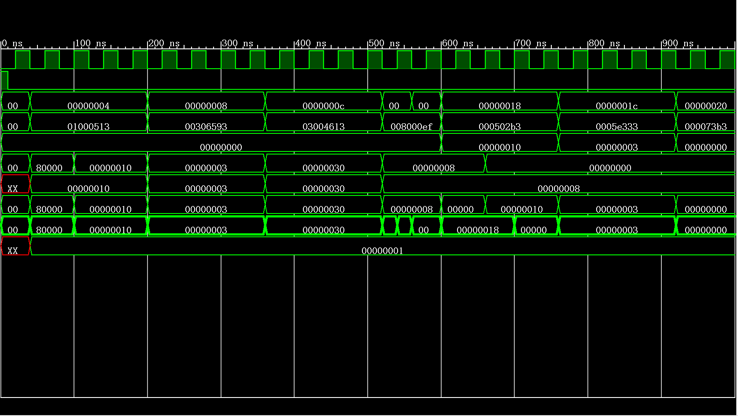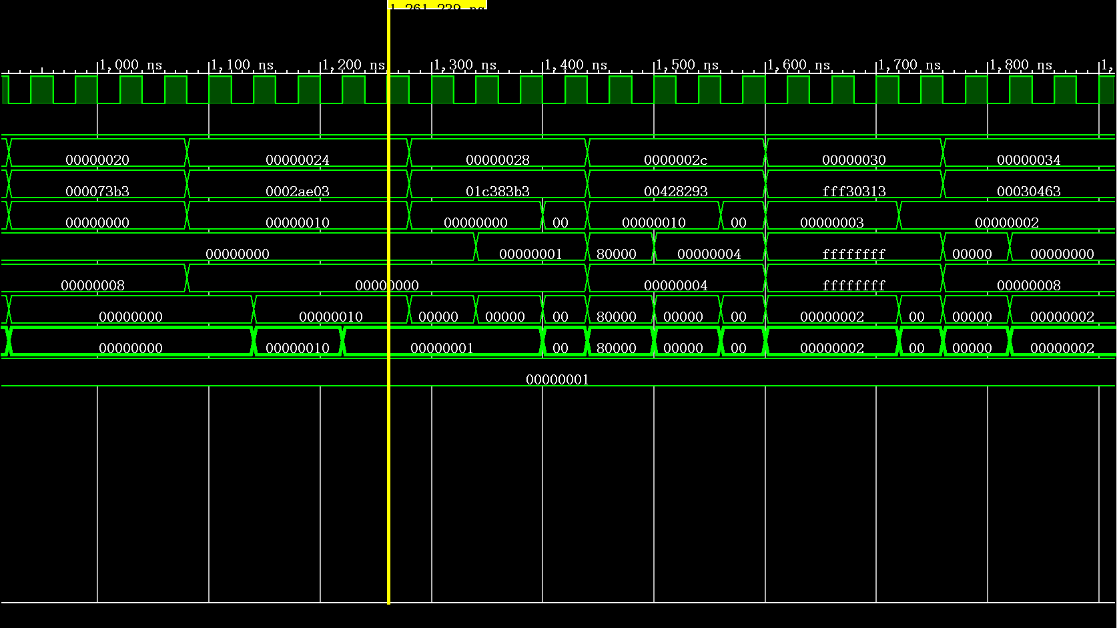
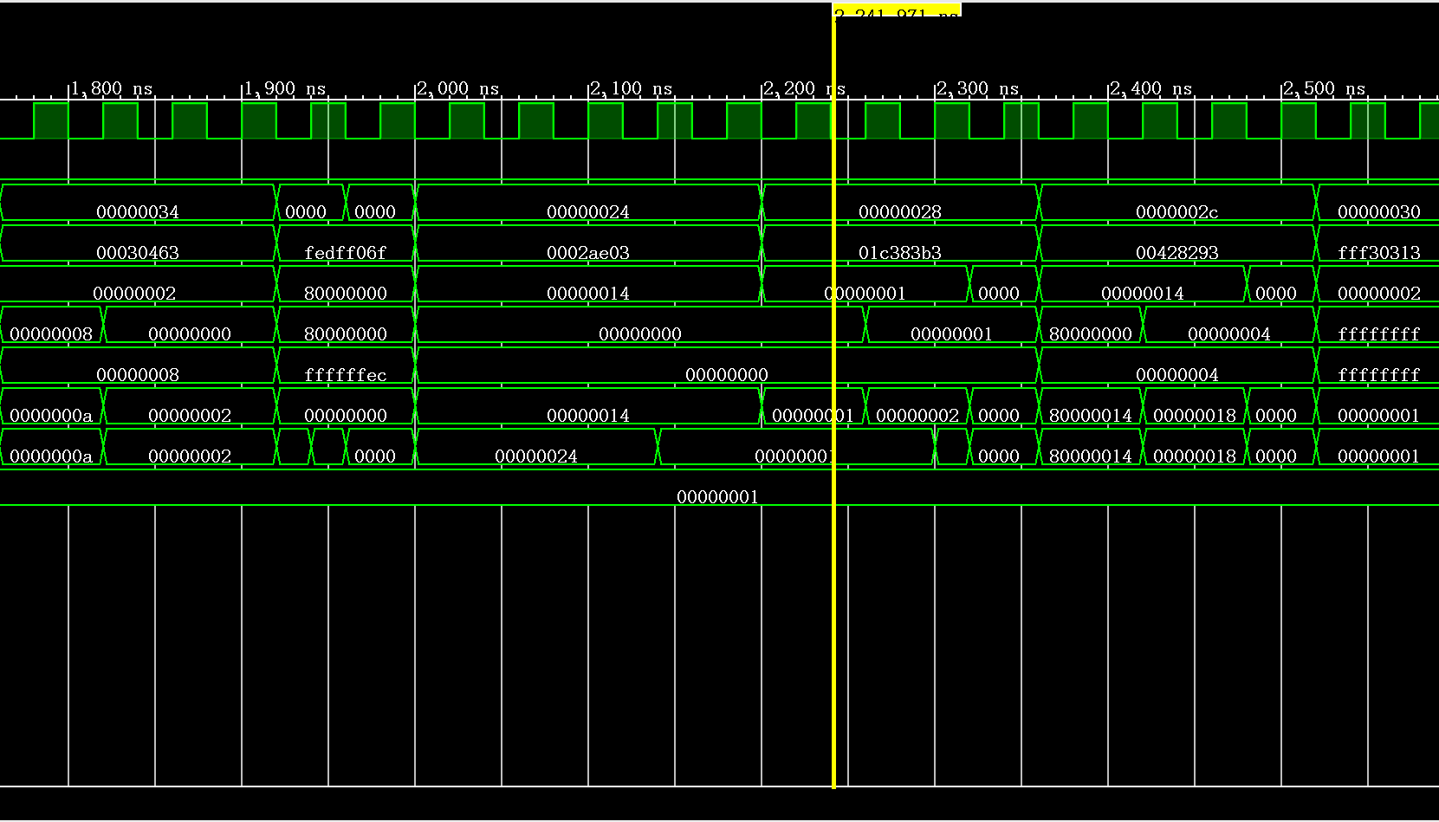
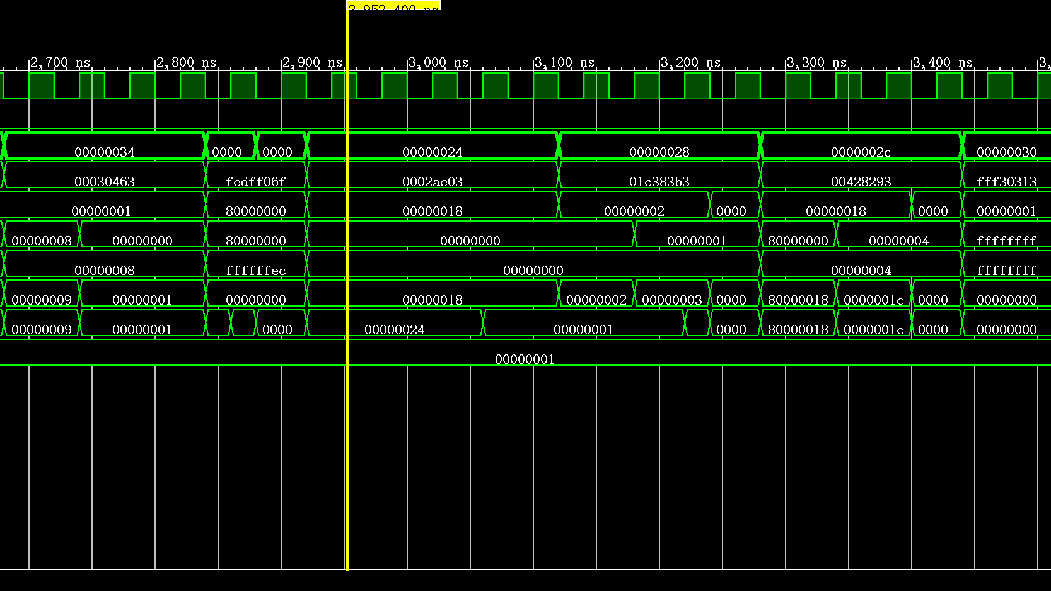
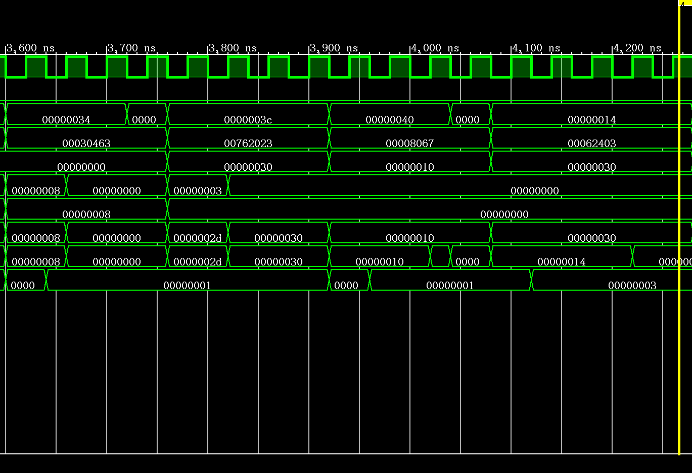
（2）结果分析
初始时刻CPU处于Idle状态，当第一个机器周期M0到来， CPU根据PC=0x00000000从指令存储器IM取出指令0x01000513到指令寄存器IR，PC自增4，同时进行一级译码和二级译码，接着在第二个机器周期M1，读寄存器Reg[0]=0—>ALU_A，在第三个机器周期M2，执行运算ALU_A=0+imm32=0x10—>F，在第四个机器周期M3，写寄存器F=0x10—>Reg[10]。然后继续根据PC值取指令，循环往复，直到程序运行结束。
- 板级实验操作说明
（1）按rst_n按键AA4，将PC和IR清零，接下来将从0号单元开始执行指令；
（2）按动clk时钟键R4，每按一下，指令就执行一步，切换开关sw2为‘000’和’001’，分别观察PC和IR的值，判断PC是否能够正确的+4或者跳转；拨动开关sw1，观察各部件值，判断其他指令执行结果是否正确。
- 板级实验结果记录
实验10实验结果记录表
序号 | PC | IR | 汇编指令 | 执行结果 | 下条指令地址
1 | 00000000 | 01000513 | addi x10 x0 16 | x10=00000010 | 00000004
2 | 00000004 | 00306593 | ori x11 x0 3 | x11=00000003 | 00000008
3 | 00000008 | 03004613 | xori x12 x0 48 | x12=00000030 | 0000000c
4 | 0000000c | 008000ef | jal x1 8 | x1=00000010,  PC=00000014 | 00000014
5 | 00000014 | 000502b3 | add x5 x10 x0 | x5=00000010 | 00000018
6 | 00000018 | 0005e333 | or x6 x11 x0 | x6=00000003 | 0000001c
7 | 0000001c | 000073b3 | and x7 x0 x0 | x7=00000000 | 00000020
8 | 00000020 | 0002ae03 | lw x28 0(x5) | x28=00000001 | 00000024
9 | 00000024 | 01c383b3 | add x7 x7 x28 | x7=00000001 | 00000028
10 | 00000028 | 00428293 | addi x5 x5 4 | x5=00000014 | 0000002c
11 | 0000002c | fff30313 | addi x6 x6 -1 | x6=00000002 | 00000030
12 | 00000030 | 0030463 | beq x6 x0 8 | ZF=0 | 00000034
13 | 00000034 | fedff0ef | jal x0 -20 | PC=00000020 | 00000020
14 | 00000020 | 0002ae03 | lw x28 0(x5) | x28=00000001 | 00000024
15 | 00000024 | 01c383b3 | add x7 x7 x28 | x7=00000002 | 00000028
16 | 00000028 | 00428293 | addi x5 x5 4 | x5=00000018 | 0000002c
17 | 0000002c | fff30313 | addi x6 x6 -1 | x6=00000001 | 00000030
18 | 00000030 | 0030463 | beq x6 x0 8 | ZF=0 | 00000034
19 | 00000034 | fedff0ef | jal x0 -20 | PC=00000020 | 00000020
20 | 00000020 | 0002ae03 | lw x28 0(x5) | x28=00000001 | 00000024
21 | 00000024 | 01c383b3 | add x7 x7 x28 | x7=00000003 | 00000028
22 | 00000028 | 00428293 | addi x5 x5 4 | x5=0000001c | 0000002c
23 | 0000002c | fff30313 | addi x6 x6 -1 | x6=00000000 | 00000030
24 | 00000030 | 0030463 | beq x6 x0 8 | ZF=1  PC=00000038 | 00000038
25 | 00000038 | 00762023 | sw x7 0(x12) | Mem(00000030)=00000003 | 0000003c
26 | 0000003c | 00008067 | jalr x0 x1 0 | PC=00000010 | 00000010
27 | 00000010 | 00062403 | lw x8 0(x12) | x8=00000003 | exit

- 实验结果分析与结论
本实验的测试程序功能为从主存的连续地址取出数据并进行循环累加三次，最终将运算结果存入主存中。经检验，实验的测试程序结果都正确，意味着本实验设计的多周期CPU能够完成从取指令、分析指令到执行指令的全部流程，并且能够实现运算类指令、传送指令、访存指令和转移类指令的功能。

五、思考与探索
（10分）
- 问题与解决方案：
问题一：在把汇编语言翻译成机器语言的过程中报错
解决方案：vscode汇编器的汇编语言没有分号，把分号全部去掉即可翻译成功。

问题二：使用define语句进行指令类型宏定义时出错。
解决方案：需要在define前面加上‘`’字符才符合语法。
- 思考题：
1. 你的CPU能否正确执行新增的三条转移指令？以你的测试程序为例，举例说明。
能够正确执行新增的三条转移指令。
jal指令首先将PC+4保存在x1寄存器中，然后跳转到了PC+8=00000014的地址。
在第一次循环，beq指令首先执行Reg[6]-Reg[0]=3，得到ZF=0，此时不执行跳转，PC转向下一条地址。
在第三次循环， Reg[6]-Reg[0]=0，得到ZF=1，此时PC跳转到00000038地址。
jalr指令首先要将PC+4=00000040写入x0寄存器，但因为x0无法进行写，因此只执行了Reg[1]—>PC，PC跳转到00000010的地址。
4 | 0000000c | 008000ef | jal x1 8 | x1=00000010,  PC=00000014 | 00000014
5 | 00000014 | 000502b3 | add x5 x10 x0 | x5=00000010 | 00000018
12 | 00000030 | 0030463 | beq x6 x0 8 | ZF=0 | 00000034
24 | 00000030 | 0030463 | beq x6 x0 8 | ZF=1  PC=00000038 | 00000038
25 | 00000038 | 00762023 | sw x7 0(x12) | Mem(00000030)=00000003 | 0000003c
26 | 0000003c | 00008067 | jalr x0 x1 0 | PC=00000010 | 00000010
27 | 00000010 | 00062403 | lw x8 0(x12) | x8=00000003 | exit

六、实验心得体会、意见建议
1.实验心得体会
通过本次实验，我对RISC-V架构中的各种指令的数据通路设计有了更深入的理解，并掌握了如何通过新增指令修改多周期CPU系统结构的方法。在实验中，我实现了运算类指令、传送指令、访存指令和转移指令等多种类型指令，并成功连接各模块构建了整机，验证了CPU的整体功能。
在实验过程中，我体会到硬件设计与软件编程的显著差异。硬件设计不仅需要考虑功能实现，还需要注意模块之间的接口和信号传递的时序问题。通过Verilog编写各个模块，特别是在设计和调试控制单元和ALU时，我深刻理解了指令流和数据流的控制方法。这次实验相比上学期的简单数字电路设计，不仅巩固了我对计算机体系结构和数字电路设计的知识，还提高了我的逻辑思维和问题解决能力。
2.意见建议
（1）实验指导书改进：实验指导书可以增加更详细的模块设计说明和具体的实现步骤，特别是对于复杂的控制逻辑部分，可以提供更多的示例和图示，帮助学生更好地理解和实现。
（2）增加实验报告要求：实验报告可以增加一些开放性问题，如让学生思考并设计更多的指令集或改进现有设计的性能，通过这些问题，培养学生的创新能力和独立思考能力。

