Lab 5 – Support Vector Machine

Problem 1 – Linear SVM and the Optimal Separating Hyperplane
Data:
Class 1 (label +1): (1, 1), (1, 2), (2, 1)
Class 2 (label -1): (0, 0), (1, 0), (0, 1)
Approach:
The points are plotted and a hard-margin linear SVM (scikit-learn's SVC with a linear kernel and a very large C) is fit to the six points to find the maximum-margin separating hyperplane.
import numpy as np
import matplotlib.pyplot as plt
from sklearn.svm import SVC
# Data from problem 1
class1 = np.array([[1, 1], [1, 2], [2, 1]]) # label +1
class2 = np.array([[0, 0], [1, 0], [0, 1]]) # label -1
X = np.vstack([class1, class2])
y = np.array([1, 1, 1, -1, -1, -1])
clf = SVC(kernel='linear', C=1e6)
clf.fit(X, y)
w = clf.coef_[0]
b = clf.intercept_[0]
margin = 1 / np.linalg.norm(w)
print("w =", w)
print("b =", b)
print("Decision boundary: {:.4f}*x1 + {:.4f}*x2 + {:.4f} = 0".format(w[0], w[1], b))
print("Margin (half-width, 1/||w||) =", margin)
print("Full margin (2/||w||) =", 2 * margin)
print("Support vectors:\n", clf.support_vectors_)
# Plot
fig, ax = plt.subplots(figsize=(6, 6))
ax.scatter(class1[:, 0], class1[:, 1], c='blue', marker='o', s=100, label='Class 1 (+1)')
ax.scatter(class2[:, 0], class2[:, 1], c='red', marker='s', s=100, label='Class 2 (-1)')
ax.scatter(clf.support_vectors_[:, 0], clf.support_vectors_[:, 1], s=250,
facecolors='none', edgecolors='black', linewidths=2, label='Support vectors')
xx = np.linspace(-1, 3, 200)
yy = -(w[0] * xx + b) / w[1]
margin_up = yy + margin * np.sqrt(1 + (w[0] / w[1]) ** 2)
margin_down = yy - margin * np.sqrt(1 + (w[0] / w[1]) ** 2)
ax.plot(xx, yy, 'k-', label='Separating hyperplane')
ax.plot(xx, margin_up, 'k--', linewidth=1)
ax.plot(xx, margin_down, 'k--', linewidth=1)
for pt in X:
ax.annotate(f"({pt[0]},{pt[1]})", (pt[0], pt[1]), textcoords="offset points", xytext=(8, 8))
ax.set_xlim(-1, 3)
ax.set_ylim(-1, 3)
ax.set_xlabel('x1')
ax.set_ylabel('x2')
ax.set_title('Problem 1: SVM Optimal Separating Hyperplane')
ax.legend(loc='upper right', fontsize=8)
ax.grid(True, linestyle=':')
ax.set_aspect('equal')
plt.tight_layout()
plt.savefig('p1_svm.png', dpi=150)
print("saved p1_svm.png")
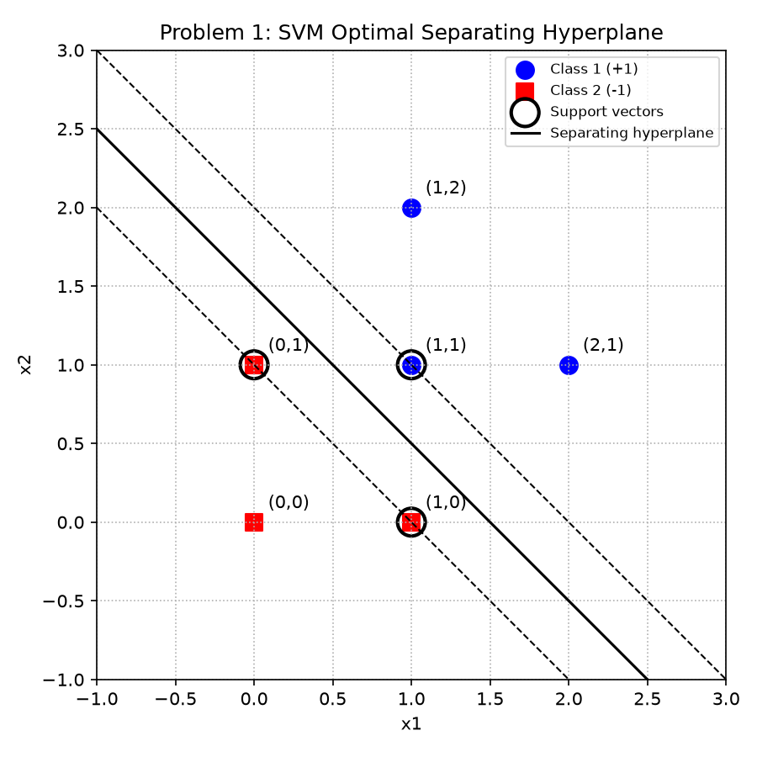
Figure 1. Optimal separating hyperplane for Problem 1. Circled points are the support vectors.
Results:
Decision boundary: 2·x1 + 2·x2 – 3 = 0 (equivalently x1 + x2 = 1.5)
Support vectors: (1, 0), (0, 1), (1, 1) — these are the points closest to the boundary and are the only points that determine the hyperplane; every other point could move without changing the solution as long as it stays outside the margin.
Margin: the distance from the hyperplane to each class is 1/||w|| = 0.354, so the full margin width (distance between the two dashed boundary lines) is 2/||w|| = 0.707 (= 1/√2).

Problem 2 – Perceptron vs. SVM
The classic Perceptron learning rule (Rosenblatt) is run on the same data from Problem 1, starting from zero weights and repeatedly cycling through the points in order until no point is misclassified.
import numpy as np
import matplotlib.pyplot as plt
from sklearn.svm import SVC
class1 = np.array([[1, 1], [1, 2], [2, 1]])
class2 = np.array([[0, 0], [1, 0], [0, 1]])
X = np.vstack([class1, class2])
y = np.array([1, 1, 1, -1, -1, -1])
# SVM (from problem 1)
svm = SVC(kernel='linear', C=1e6).fit(X, y)
w_svm = svm.coef_[0]
b_svm = svm.intercept_[0]
m_svm = 1 / np.linalg.norm(w_svm)
# Classic Perceptron learning rule (Rosenblatt), zero-initialized weights,
# single pass repeated over the data in order until no mistakes remain.
def perceptron(X, y, eta=1.0, max_epochs=100):
w = np.zeros(X.shape[1])
b = 0.0
for epoch in range(max_epochs):
errors = 0
for xi, yi in zip(X, y):
if yi * (np.dot(w, xi) + b) <= 0:
w += eta * yi * xi
b += eta * yi
errors += 1
if errors == 0:
return w, b, epoch + 1
return w, b, max_epochs
w_p, b_p, n_epochs = perceptron(X, y)
m_p = min(abs(w_p[0] * x[0] + w_p[1] * x[1] + b_p) for x in X) / np.linalg.norm(w_p)
print("Perceptron converged after", n_epochs, "epochs")
print("w_perceptron =", w_p, "b_perceptron =", b_p)
print("Perceptron margin (dist. to closest point) =", m_p)
print("SVM margin =", m_svm)
fig, ax = plt.subplots(figsize=(6, 6))
ax.scatter(class1[:, 0], class1[:, 1], c='blue', marker='o', s=100, label='Class 1 (+1)')
ax.scatter(class2[:, 0], class2[:, 1], c='red', marker='s', s=100, label='Class 2 (-1)')
xx = np.linspace(-1, 3, 200)
yy_svm = -(w_svm[0] * xx + b_svm) / w_svm[1]
yy_p = -(w_p[0] * xx + b_p) / w_p[1]
ax.plot(xx, yy_svm, 'k-', linewidth=2, label='SVM boundary')
ax.plot(xx, yy_p, 'g--', linewidth=2, label='Perceptron boundary')
ax.set_xlim(-1, 3)
ax.set_ylim(-1, 3)
ax.set_xlabel('x1')
ax.set_ylabel('x2')
ax.set_title('Problem 2: Perceptron vs. SVM')
ax.legend(loc='upper right', fontsize=8)
ax.grid(True, linestyle=':')
ax.set_aspect('equal')
plt.tight_layout()
plt.savefig('p2_perceptron.png', dpi=150)
print("saved p2_perceptron.png")
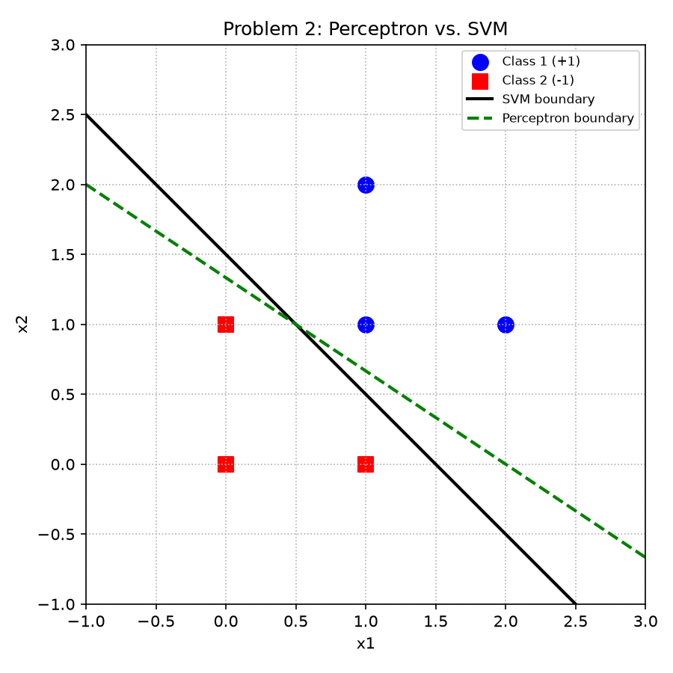
Figure 2. Perceptron decision boundary (green, dashed) vs. SVM decision boundary (black, solid).
Results:
Perceptron converged after 9 epochs to w = (2, 3), b = -4 (boundary: 2·x1 + 3·x2 – 4 = 0), giving a margin (distance to the closest point) of 0.277.
SVM found w = (2, 2), b = -3 (boundary: x1 + x2 = 1.5), giving the larger margin of 0.354.
Discussion:
Both lines correctly separate the six points, but they are different lines with different margins. The Perceptron algorithm only guarantees convergence to SOME hyperplane that has zero training error — it stops as soon as it stops making mistakes, so the final boundary depends on the order the points are visited and the initial weights. In this run it leans toward class 2's point (0, 1), giving it less breathing room (margin 0.277) than the other points.
SVM instead solves an explicit optimization problem (maximize the margin, i.e. minimize ||w|| subject to every point being correctly classified with margin ≥ 1) so it always returns the unique hyperplane that is as far as possible from the nearest points of both classes (margin 0.354, the largest possible for this data). This is why SVM tends to generalize better: the Perceptron solution is "good enough" but arbitrary, while the SVM solution is optimal and reproducible.

Problem 3 – Nonlinear Transformation
Data:
Positive labels: (2, 2), (2, -2), (-2, -2), (-2, 2)
Negative labels: (1, 1), (1, -1), (-1, -1), (-1, 1)
These two sets of points both surround the origin, so no straight line can separate them in the original space — the negative points form a smaller square nested inside the positive points.
Transformation function used:
Φ1(x1, x2) = (4 - x2 + |x1 - x2|, 4 - x1 + |x1 - x2|) if √(x1²+x2²) > 2
Φ1(x1, x2) = (x1, x2) otherwise
import numpy as np
import matplotlib.pyplot as plt
from sklearn.svm import SVC
# Data from problem 3
pos = np.array([[2, 2], [2, -2], [-2, -2], [-2, 2]]) # positive labels
neg = np.array([[1, 1], [1, -1], [-1, -1], [-1, 1]]) # negative labels
X = np.vstack([pos, neg])
y = np.array([1, 1, 1, 1, -1, -1, -1, -1])
def phi1(x1, x2):
r = np.sqrt(x1 ** 2 + x2 ** 2)
if r > 2:
d = abs(x1 - x2)
return np.array([4 - x2 + d, 4 - x1 + d])
else:
return np.array([x1, x2])
X_t = np.array([phi1(x1, x2) for x1, x2 in X])
print("Original points -> Transformed points")
for orig, t, label in zip(X, X_t, y):
print(f" {tuple(orig)} (label {label:+d}) -> {tuple(t)}")
# Original (nonlinear) data plot
fig, axes = plt.subplots(1, 2, figsize=(12, 6))
ax = axes[0]
ax.scatter(pos[:, 0], pos[:, 1], c='blue', marker='o', s=100, label='Positive (+1)')
ax.scatter(neg[:, 0], neg[:, 1], c='red', marker='s', s=100, label='Negative (-1)')
circle = plt.Circle((0, 0), 2, color='gray', fill=False, linestyle=':')
ax.add_patch(circle)
for pt in X:
ax.annotate(f"({pt[0]},{pt[1]})", (pt[0], pt[1]), textcoords="offset points", xytext=(6, 6), fontsize=8)
ax.set_xlim(-3.5, 3.5)
ax.set_ylim(-3.5, 3.5)
ax.set_title('Original data (not linearly separable)')
ax.set_xlabel('x1')
ax.set_ylabel('x2')
ax.legend(fontsize=8)
ax.grid(True, linestyle=':')
ax.set_aspect('equal')
# Transformed data + linear classifier
clf = SVC(kernel='linear', C=1e6).fit(X_t, y)
w = clf.coef_[0]
b = clf.intercept_[0]
margin = 1 / np.linalg.norm(w)
print("\nTransformed-space SVM:")
print("w =", w, "b =", b, "margin =", margin)
print("Support vectors (transformed space):\n", clf.support_vectors_)
ax = axes[1]
pos_t = X_t[y == 1]
neg_t = X_t[y == -1]
ax.scatter(pos_t[:, 0], pos_t[:, 1], c='blue', marker='o', s=100, label='Positive (+1)')
ax.scatter(neg_t[:, 0], neg_t[:, 1], c='red', marker='s', s=100, label='Negative (-1)')
for pt in X_t:
ax.annotate(f"({pt[0]:.0f},{pt[1]:.0f})", (pt[0], pt[1]), textcoords="offset points", xytext=(6, 6), fontsize=8)
xx = np.linspace(X_t[:, 0].min() - 1, X_t[:, 0].max() + 1, 200)
yy = -(w[0] * xx + b) / w[1]
ax.plot(xx, yy, 'k-', label='Separating line')
ax.set_title(r'Transformed data $\Phi_1(x_1,x_2)$ (linearly separable)')
ax.set_xlabel('z1')
ax.set_ylabel('z2')
ax.legend(fontsize=8)
ax.grid(True, linestyle=':')
ax.set_aspect('equal')
plt.tight_layout()
plt.savefig('p3_transform.png', dpi=150)
print("saved p3_transform.png")
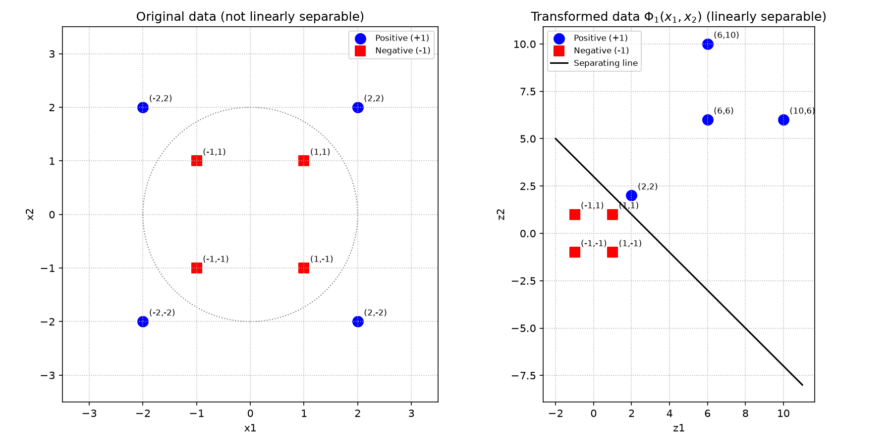
Figure 3. Left: original data (not linearly separable). Right: data after applying Φ1 (linearly separable).
Results:
Because every positive point has √(x1²+x2²) > 2 and every negative point has √(x1²+x2²) < 2, the transformation leaves the negative points unchanged ((1,1), (1,-1), (-1,-1), (-1,1)) while pushing all four positive points out to (2,2), (10,6), (6,6), (6,10). A straight line, x1 + x2 = 3 (w = (1,1), b = -3), now cleanly separates the two classes with margin 0.707. This illustrates the core idea behind the kernel trick: a nonlinear mapping into a different (sometimes higher-dimensional) feature space can turn a nonlinearly separable problem into a linearly separable one.

Problem 4 – Kernel Trick on Concentric Circles
Setup:
Ten points are generated on an outer circle of radius 3 and ten points on an inner circle of radius 1 (evenly spaced by angle). The outer circle is labeled +1 and the inner circle -1. No straight line can separate two concentric circles, so a linear SVM cannot be used directly on the raw (x1, x2) data.

4a. Polynomial kernel trick (explicit feature map)
The polynomial kernel K(x, z) = (x · z)² corresponds to the explicit feature map
φ(x1, x2) = (x1², √2·x1·x2, x2²)
which lifts each 2-D point into 3 dimensions. This mapping is computed directly with NumPy, and the dot product in the new 3-D space is verified to equal (x · z)² computed in the original 2-D space, confirming the kernel trick.
import numpy as np
import matplotlib.pyplot as plt
from mpl_toolkits.mplot3d import Axes3D # noqa: F401
from sklearn.svm import SVC
rng = np.linspace(0, 2 * np.pi, 10, endpoint=False)
R_outer, R_inner = 3.0, 1.0
outer = np.column_stack([R_outer * np.cos(rng), R_outer * np.sin(rng)])
inner = np.column_stack([R_inner * np.cos(rng), R_inner * np.sin(rng)])
X = np.vstack([outer, inner])
y = np.array([1] * len(outer) + [-1] * len(inner)) # outer = +1, inner = -1
# ---- 2D plot: not linearly separable ----
fig = plt.figure(figsize=(14, 6))
ax1 = fig.add_subplot(1, 2, 1)
ax1.scatter(outer[:, 0], outer[:, 1], c='blue', marker='o', s=80, label='Outer circle (+1)')
ax1.scatter(inner[:, 0], inner[:, 1], c='red', marker='s', s=80, label='Inner circle (-1)')
ax1.set_title('Original 2D data (not linearly separable)')
ax1.set_xlabel('x1')
ax1.set_ylabel('x2')
ax1.legend(fontsize=8)
ax1.grid(True, linestyle=':')
ax1.set_aspect('equal')
# ---- Polynomial kernel trick: explicit degree-2 feature map ----
# K(x, z) = (x . z)^2 corresponds to phi(x1, x2) = (x1^2, sqrt(2) x1 x2, x2^2)
def phi(X):
x1, x2 = X[:, 0], X[:, 1]
return np.column_stack([x1 ** 2, np.sqrt(2) * x1 * x2, x2 ** 2])
X_3d = phi(X)
# sanity check: dot product in 3D feature space equals (x.z)^2 in 2D
i, j = 0, 5
lhs = np.dot(X_3d[i], X_3d[j])
rhs = np.dot(X[i], X[j]) ** 2
print(f"Kernel check: phi(x).phi(z) = {lhs:.4f}, (x.z)^2 = {rhs:.4f}")
ax2 = fig.add_subplot(1, 2, 2, projection='3d')
outer_3d = X_3d[y == 1]
inner_3d = X_3d[y == -1]
ax2.scatter(outer_3d[:, 0], outer_3d[:, 1], outer_3d[:, 2], c='blue', marker='o', s=60, label='Outer circle (+1)')
ax2.scatter(inner_3d[:, 0], inner_3d[:, 1], inner_3d[:, 2], c='red', marker='s', s=60, label='Inner circle (-1)')
ax2.set_title(r'Kernel-transformed data: $\phi(x_1,x_2)=(x_1^2,\sqrt{2}x_1x_2,x_2^2)$')
ax2.set_xlabel('z1 = x1^2')
ax2.set_ylabel('z2 = sqrt(2) x1 x2')
ax2.set_zlabel('z3 = x2^2')
ax2.legend(fontsize=8)
plt.tight_layout()
plt.savefig('p4_circles_kernel.png', dpi=150)
print("saved p4_circles_kernel.png")
# ---- Optional (4b): run SVM with a polynomial kernel directly on the data ----
clf = SVC(kernel='poly', degree=2, coef0=0, gamma=1)
clf.fit(X, y)
preds = clf.predict(X)
print("\nSVM with polynomial kernel (degree=2) on original 2D data:")
print("Predictions:", preds)
print("True labels:", y)
print("Accuracy:", (preds == y).mean())
print("Number of support vectors:", len(clf.support_vectors_))
# Visualize the decision boundary in 2D
fig2, ax = plt.subplots(figsize=(6, 6))
xx, yy = np.meshgrid(np.linspace(-4, 4, 300), np.linspace(-4, 4, 300))
Z = clf.decision_function(np.column_stack([xx.ravel(), yy.ravel()])).reshape(xx.shape)
ax.contourf(xx, yy, Z, levels=[-1e9, 0, 1e9], colors=['#ffcccc', '#cce5ff'], alpha=0.6)
ax.contour(xx, yy, Z, levels=[0], colors='k', linewidths=2)
ax.scatter(outer[:, 0], outer[:, 1], c='blue', marker='o', s=80, label='Outer circle (+1)')
ax.scatter(inner[:, 0], inner[:, 1], c='red', marker='s', s=80, label='Inner circle (-1)')
ax.set_title('Problem 4b: SVM decision boundary (polynomial kernel)')
ax.set_xlabel('x1')
ax.set_ylabel('x2')
ax.legend(fontsize=8)
ax.set_aspect('equal')
plt.tight_layout()
plt.savefig('p4b_svm_boundary.png', dpi=150)
print("saved p4b_svm_boundary.png")
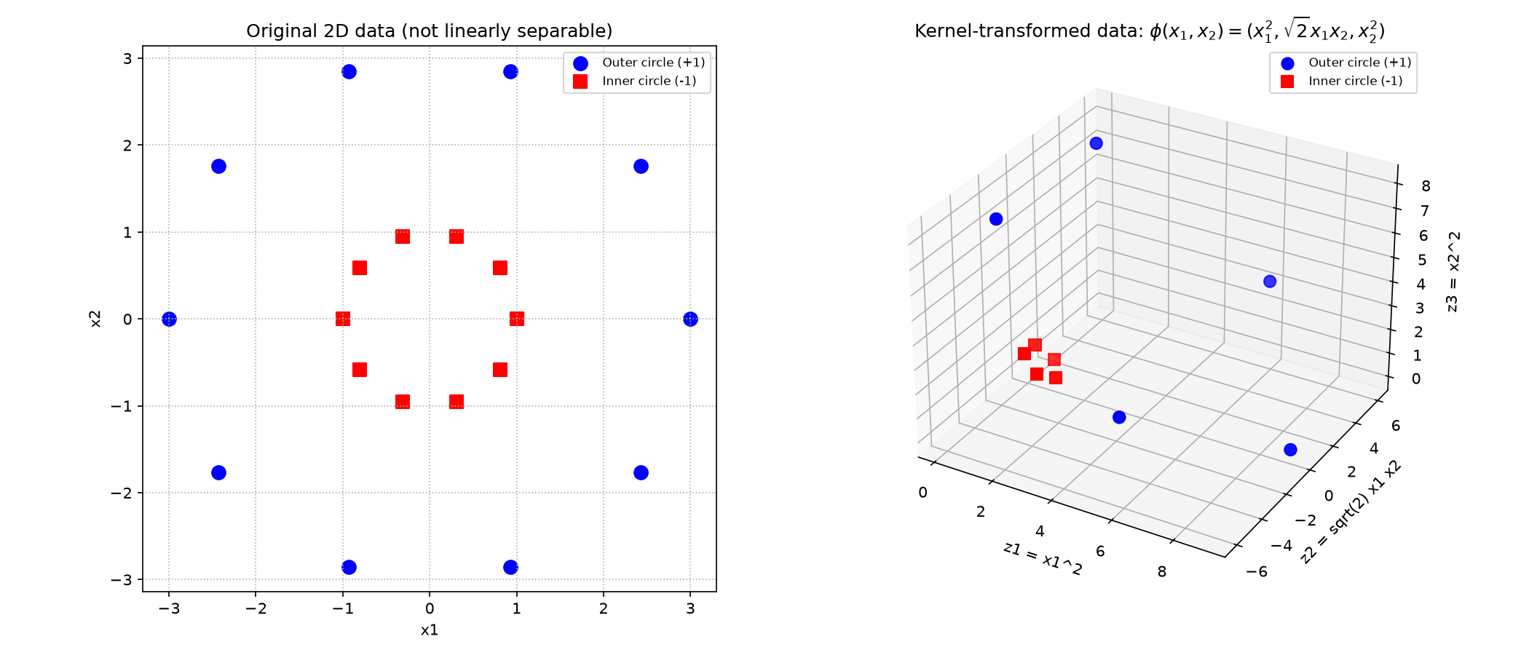
Figure 4. Left: original concentric-circle data. Right: data lifted into 3-D via φ(x1, x2) = (x1², √2 x1 x2, x2²) — the two circles now sit on different "sheets" and become linearly separable by a plane.
Once lifted into 3-D, the two circles become separable by a flat plane instead of a circle, exactly as the kernel trick predicts: a nonlinear boundary in low dimensions can become linear in a higher-dimensional feature space, without ever explicitly needing to work in that space when using the kernel function K.

4b. Running SVM with a polynomial kernel (optional)
Rather than building the 3-D features by hand, scikit-learn's SVC can be fit directly on the original 2-D data using kernel='poly' (degree 2), which uses the kernel trick internally.
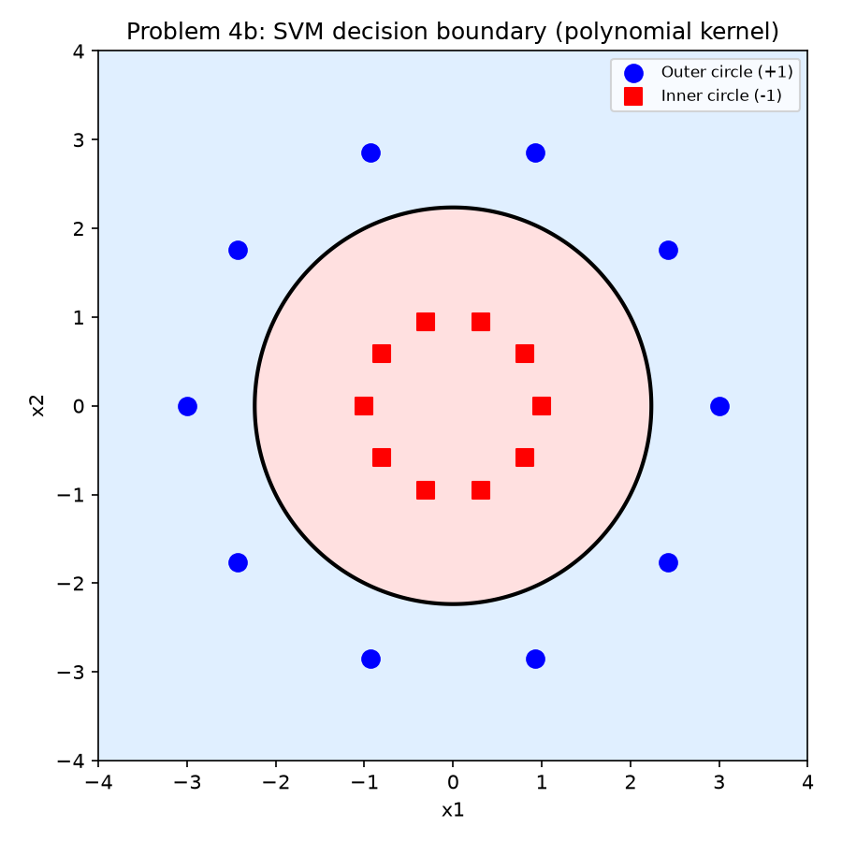
Figure 5. SVM decision boundary using a degree-2 polynomial kernel: a circle that perfectly separates the inner and outer classes.
Results:
The polynomial-kernel SVM achieves 100% training accuracy using 8 support vectors, and its decision boundary (shown above) is itself a circle that lies between the two classes. This is the same result as the explicit 3-D mapping in part (a): the kernel implicitly computes distances/dot-products as if the data had been lifted to 3-D, without ever forming the 3-D vectors explicitly.

