Development Team Project: Design Proposal for a University Student-Services Chatbot
Module: Intelligent Agents (IA_PCOM7E)
Student Name: Lyth Hishmeh
Student ID: 34119
Word Count: Approximately 1,000 words (excluding figure captions and references)
1. Introduction and requirements
This report proposes the design of a chatbot that lets a student at a university ask, in their own words, for three things: their current timetable, a downloadable transcript of their marks to date, and the PDF briefs of any assignments whose deadlines have not yet passed. The brief also asks that the chatbot can hold a simple conversation, with a greeting and a sign-off, and that one or more agents work together to deliver the service. I completed this project individually rather than as part of a consultancy team, so the design decisions below are my own. The Python prototype accompanies this report.
Three of the four requirements are data-access tasks with access-control consequences: a student must retrieve their own records easily and nobody else's at all. The fourth, conversation, is where the uncertainty lies, because students phrase the same request in many ways. The design therefore separates the part that must be reliable (records, documents, ownership) from the part that is allowed to be approximate (understanding what was asked), and lets them communicate through a small, explicit protocol.
2. Why an agent-based design
Wooldridge (2009) characterises an agent as a system that is autonomous, reactive, proactive and socially able, and argues that the agent abstraction pays off when a problem decomposes into distinct competences that need to coordinate. That is the shape of this problem. Timetable retrieval, transcript generation and assignment delivery are independent competences with different data and failure modes; the conversation that ties them together is a fourth. Building each as an agent and having them cooperate through messages rather than shared code makes each one testable on its own and replaceable without touching the others.
I want to be careful with terminology. The specialists are reactive in Brooks's (1991) sense of mapping inputs directly to actions without a world model, while the coordinating agent follows the practical-reasoning loop of Bratman, Israel and Pollack (1988): it forms a belief about what the student wants, commits to a short plan, and executes it by delegating. I call this a deliberative control loop with reactive specialists rather than a belief-desire-intention architecture, because the plans are fixed sequences and intentions are not reconsidered mid-plan.
3. Architecture
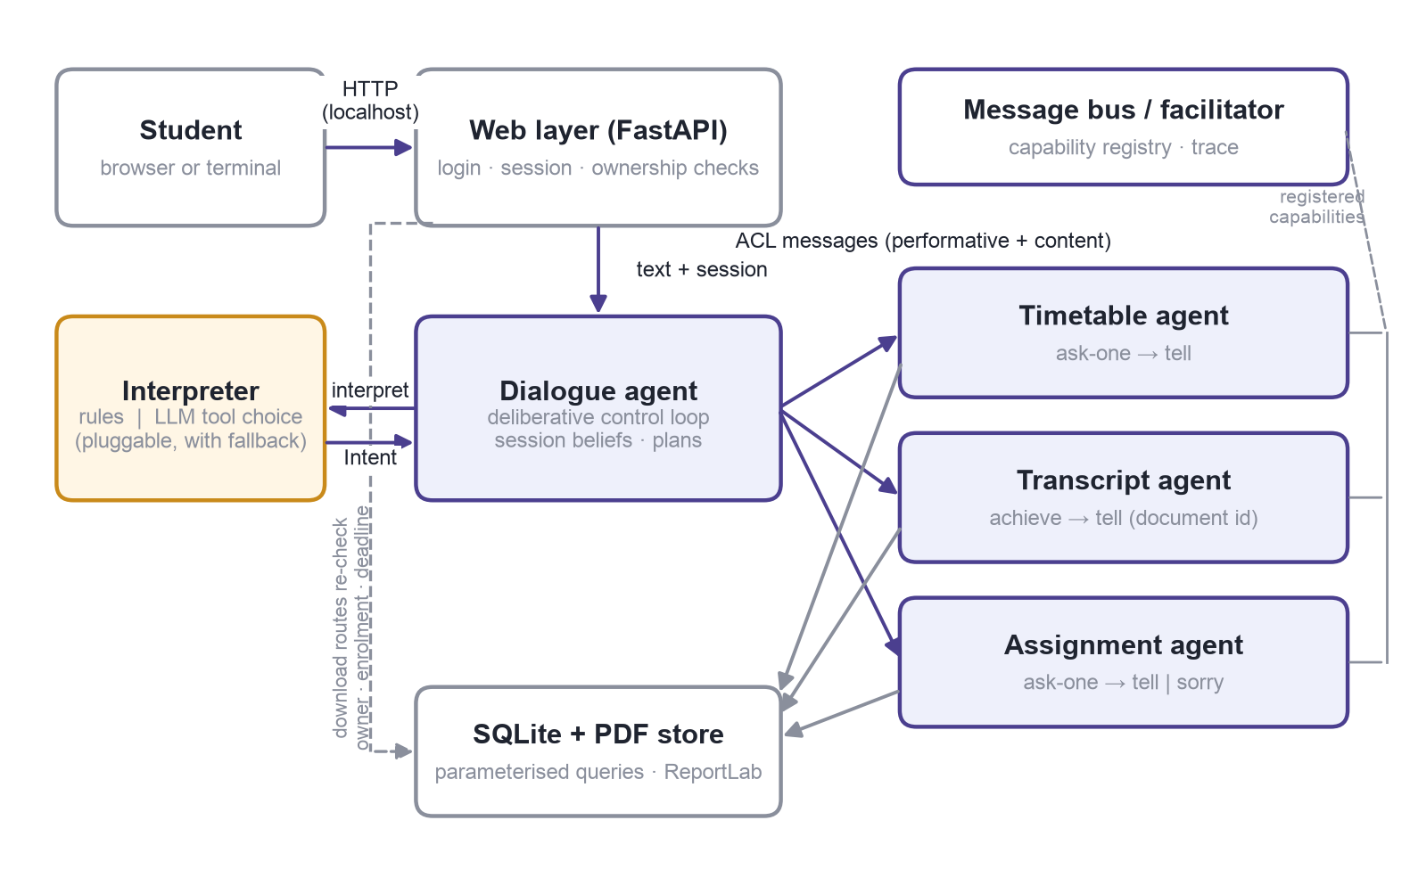
Figure 1. Architecture of the proposed system. The dialogue agent coordinates three specialist agents over a message bus; the interpreter is a replaceable component with a rule-based fallback.
Figure 1 shows the design. A FastAPI web layer handles sign-in and holds a server-side session bound to one student. Each message the student types is passed, with that session, to the dialogue agent. The dialogue agent asks an interpreter to turn the text into one of ten intents (greeting, farewell, thanks, help, timetable, transcript, list assignments, download one assignment, clarify, unsupported), then carries out a plan for that intent. Plans that need records send a message to the appropriate specialist: the timetable agent, the transcript agent or the assignment agent. Specialists answer with facts or a reason they could not help, never with text for the student; presentation is the dialogue agent's job.
The agents exchange messages through an in-process bus that plays the role of a KQML facilitator (Finin et al., 1994): agents register the capabilities they offer, and a sender addresses a capability rather than an object. The message format borrows KQML's separation of performative from content, which in turn rests on Searle's (1969) account of speech acts: ask-one and tell are different acts even when they mention the same facts. I use five performatives: ask-one, achieve, tell, sorry and error. Keeping sorry distinct from an empty tell matters: an empty list is a fact, a failed read is a failure, and the student should never see one dressed up as the other. This is KQML-inspired rather than a KQML implementation.
The dialogue agent keeps a few beliefs per session: the last list of assignments shown, whether a clarification is pending, and a bounded window of recent turns, which make follow-ups such as "download the second one" meaningful. State lives inside the authenticated session and is cleared with it.
4. Understanding the student
Two interchangeable interpreters produce the same intent object. The first is a rule-based keyword matcher: transparent, fast, free, and also the fallback. The second asks a large language model to choose one of the ten intents, implemented as tool use against the Anthropic Messages API (Anthropic, 2026). This is the only place a language model appears, and its decision surface is deliberately narrow: it can say which capability to invoke, and for small talk what to reply, but it cannot read records, name a student or build a link. Rüdel and Leidner (2023) describe this kind of hybrid as a way to keep developer control over what a chatbot does while gaining conversational flexibility, and it sidesteps hallucination (Huang et al., 2023), since no fact the model generates ever reaches the student. Every tool call is validated locally against a strict schema, so an argument such as another student's identifier is rejected whatever the model proposes. If the model is unavailable, times out or returns anything other than exactly one tool call, the rule interpreter answers instead. Prompt injection (Greshake et al., 2023) is treated as something to test rather than something a prompt sentence solves: whatever is typed, the dispatcher can only execute the three record operations for the signed-in student.
5. Data, documents and security
Records live in SQLite, which keeps the prototype runnable from a single folder. Every query is parameterised and every record query is filtered by the session's student identifier, following the OWASP (2021) guidance on injection. Passwords are hashed and sessions are random, expiring tokens carried in an HttpOnly cookie. Transcripts are generated on demand with ReportLab, so each is a snapshot, and are registered against their owner; the download route looks a document up by identifier and owner and returns the same not-found response for a missing and an unauthorised file. Assignment briefs are served through a route that re-checks enrolment and deadline at the moment of download. "Active" means the deadline has not passed, so an assignment due at exactly the current instant is still active; all instants are stored in UTC and compared as timezone-aware values, which matters across the British clock change.
6. Implementation and testing plan
The prototype is built in stages: data and the specialist agents first, then the dialogue agent and web layer with the rule interpreter, then the language-model interpreter behind the same interface, then evaluation. Testing uses pytest for the protocol, each agent, both interpreters (with a fake client, so the suite needs no network) and the HTTP access controls, plus flake8, pylint and bandit. A fixed set of twenty-four scenarios compares the two interpreters on paraphrases, ambiguity, out-of-scope requests and attacks. The main limitation is scope: synthetic data, two demo accounts, and no integration with a real record system or single sign-on. The agent boundaries are where those would plug in.
References
Anthropic (2026) Define tools. Claude Developer Platform documentation. Available from: https://platform.claude.com/docs/en/agents-and-tools/tool-use/define-tools [Accessed 9 October 2026].
Bratman, M.E., Israel, D.J. and Pollack, M.E. (1988) Plans and resource-bounded practical reasoning. Computational Intelligence 4(3): 349-355. DOI: https://doi.org/10.1111/j.1467-8640.1988.tb00284.x [Accessed 6 October 2026].
Brooks, R.A. (1991) Intelligence without representation. Artificial Intelligence 47(1-3): 139-159. DOI: https://doi.org/10.1016/0004-3702(91)90053-M [Accessed 6 October 2026].
Finin, T., Fritzson, R., McKay, D. and McEntire, R. (1994) KQML as an agent communication language. Proceedings of the Third International Conference on Information and Knowledge Management (CIKM '94): 456-463. DOI: https://doi.org/10.1145/191246.191322 [Accessed 7 October 2026].
Greshake, K., Abdelnabi, S., Mishra, S., Endres, C., Holz, T. and Fritz, M. (2023) Not what you've signed up for: Compromising real-world LLM-integrated applications with indirect prompt injection. Proceedings of the 16th ACM Workshop on Artificial Intelligence and Security (AISec '23): 79-90. DOI: https://doi.org/10.1145/3605764.3623985 [Accessed 8 October 2026].
Huang, L. et al. (2023) A survey on hallucination in large language models: Principles, taxonomy, challenges, and open questions. arXiv.org. Available from: https://arxiv.org/abs/2311.05232 [Accessed 8 October 2026].
OWASP (2021) SQL injection prevention cheat sheet. Available from: https://cheatsheetseries.owasp.org/cheatsheets/SQL_Injection_Prevention_Cheat_Sheet.html [Accessed 9 October 2026].
Rüdel, T. and Leidner, J.L. (2023) Control in hybrid chatbots. arXiv.org. Available from: https://arxiv.org/abs/2311.11701 [Accessed 7 October 2026].
Searle, J.R. (1969) Speech Acts: An Essay in the Philosophy of Language. Cambridge: Cambridge University Press.
Wooldridge, M. (2009) An Introduction to MultiAgent Systems. 2nd edn. Chichester: John Wiley & Sons.

