Development Individual Project: UniBot, a Multi-Agent Student-Services Chatbot
Technical report with evidence of execution, testing and evaluation
Module: Intelligent Agents (IA_PCOM7E)
Student Name: Lyth Hishmeh
Student ID: 34119
Word Count: Approximately 1,500 words (excluding figures, tables, code and references)
1. Introduction
This report describes the implementation, testing and evaluation of the chatbot proposed in my design report. UniBot is a prototype chatbot that lets a signed-in student hold a short conversation and ask for their timetable, a PDF transcript of their marks, and the briefs for assignments whose deadlines have not passed. It is written in Python, runs locally, and is submitted with its source, tests, a README and the raw output of every tool mentioned below. Section 2 relates the built system to the design, Section 3 presents evidence of execution, Section 4 explains key decisions in the code, Sections 5 and 6 report testing and remediation, Section 7 evaluates the two interpreters, and Section 8 concludes.
2. From the design proposal to a working system
The design proposed four cooperating agents. A dialogue agent owns the conversation and holds per-session beliefs; timetable, transcript and assignment agents each own one competence; and they communicate over a message bus using a small KQML-inspired vocabulary of performatives (Finin et al., 1994). Understanding the student's words is delegated to a pluggable interpreter: a rule-based matcher by default, and a language-model interpreter that may only choose one of ten tools. The built system follows that design closely (Figure 1). Two things changed during implementation: I added a terminal client that shares every agent with the web interface, and I moved the deadline fixtures to end-of-day UK time so demonstrations read naturally on any date.
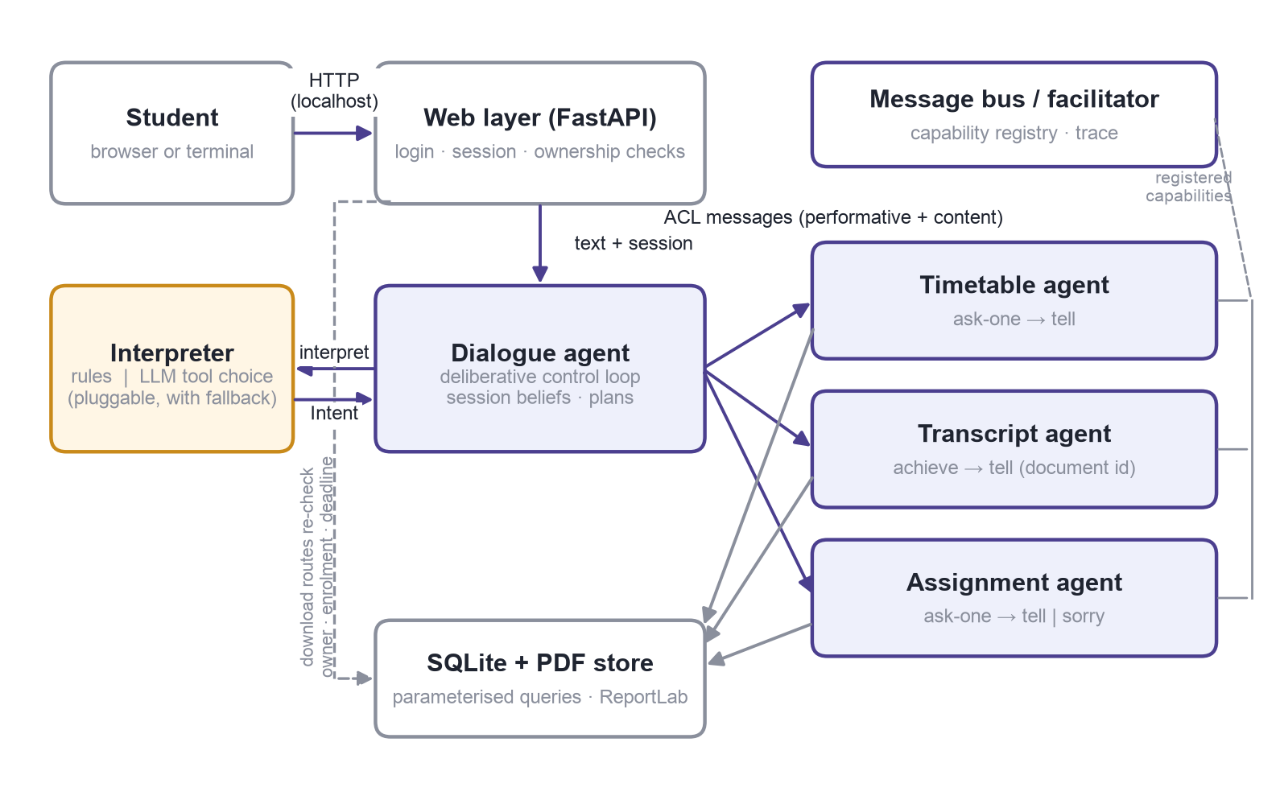
Figure 1. System as built. The web layer authenticates the student; the dialogue agent delegates record work to specialists over the bus; download routes re-check ownership on every request.
3. Evidence of execution
The student signs in with a username and password (Figure 2). Passwords are stored as PBKDF2 hashes and the session is a random, expiring token in an HttpOnly cookie; everything that follows is scoped to that session's student.
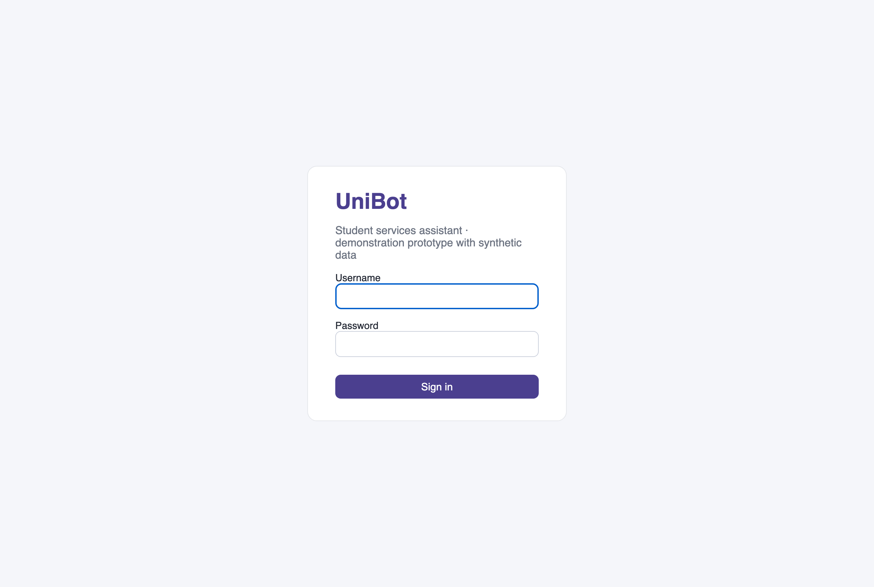
Figure 2. Sign-in page. Demo accounts and passwords are generated by the seed script; nothing is hard-coded.
A greeting is answered with a greeting and a one-line summary of what the bot can do. Asking "when are my classes this week?" produces the weekly timetable of the student's current modules only; a completed module and a module she is not enrolled on are correctly absent (Figure 3). Under each reply the interface prints the recognised intent and the deciding interpreter; the screenshots in this section were taken with the language-model interpreter enabled.
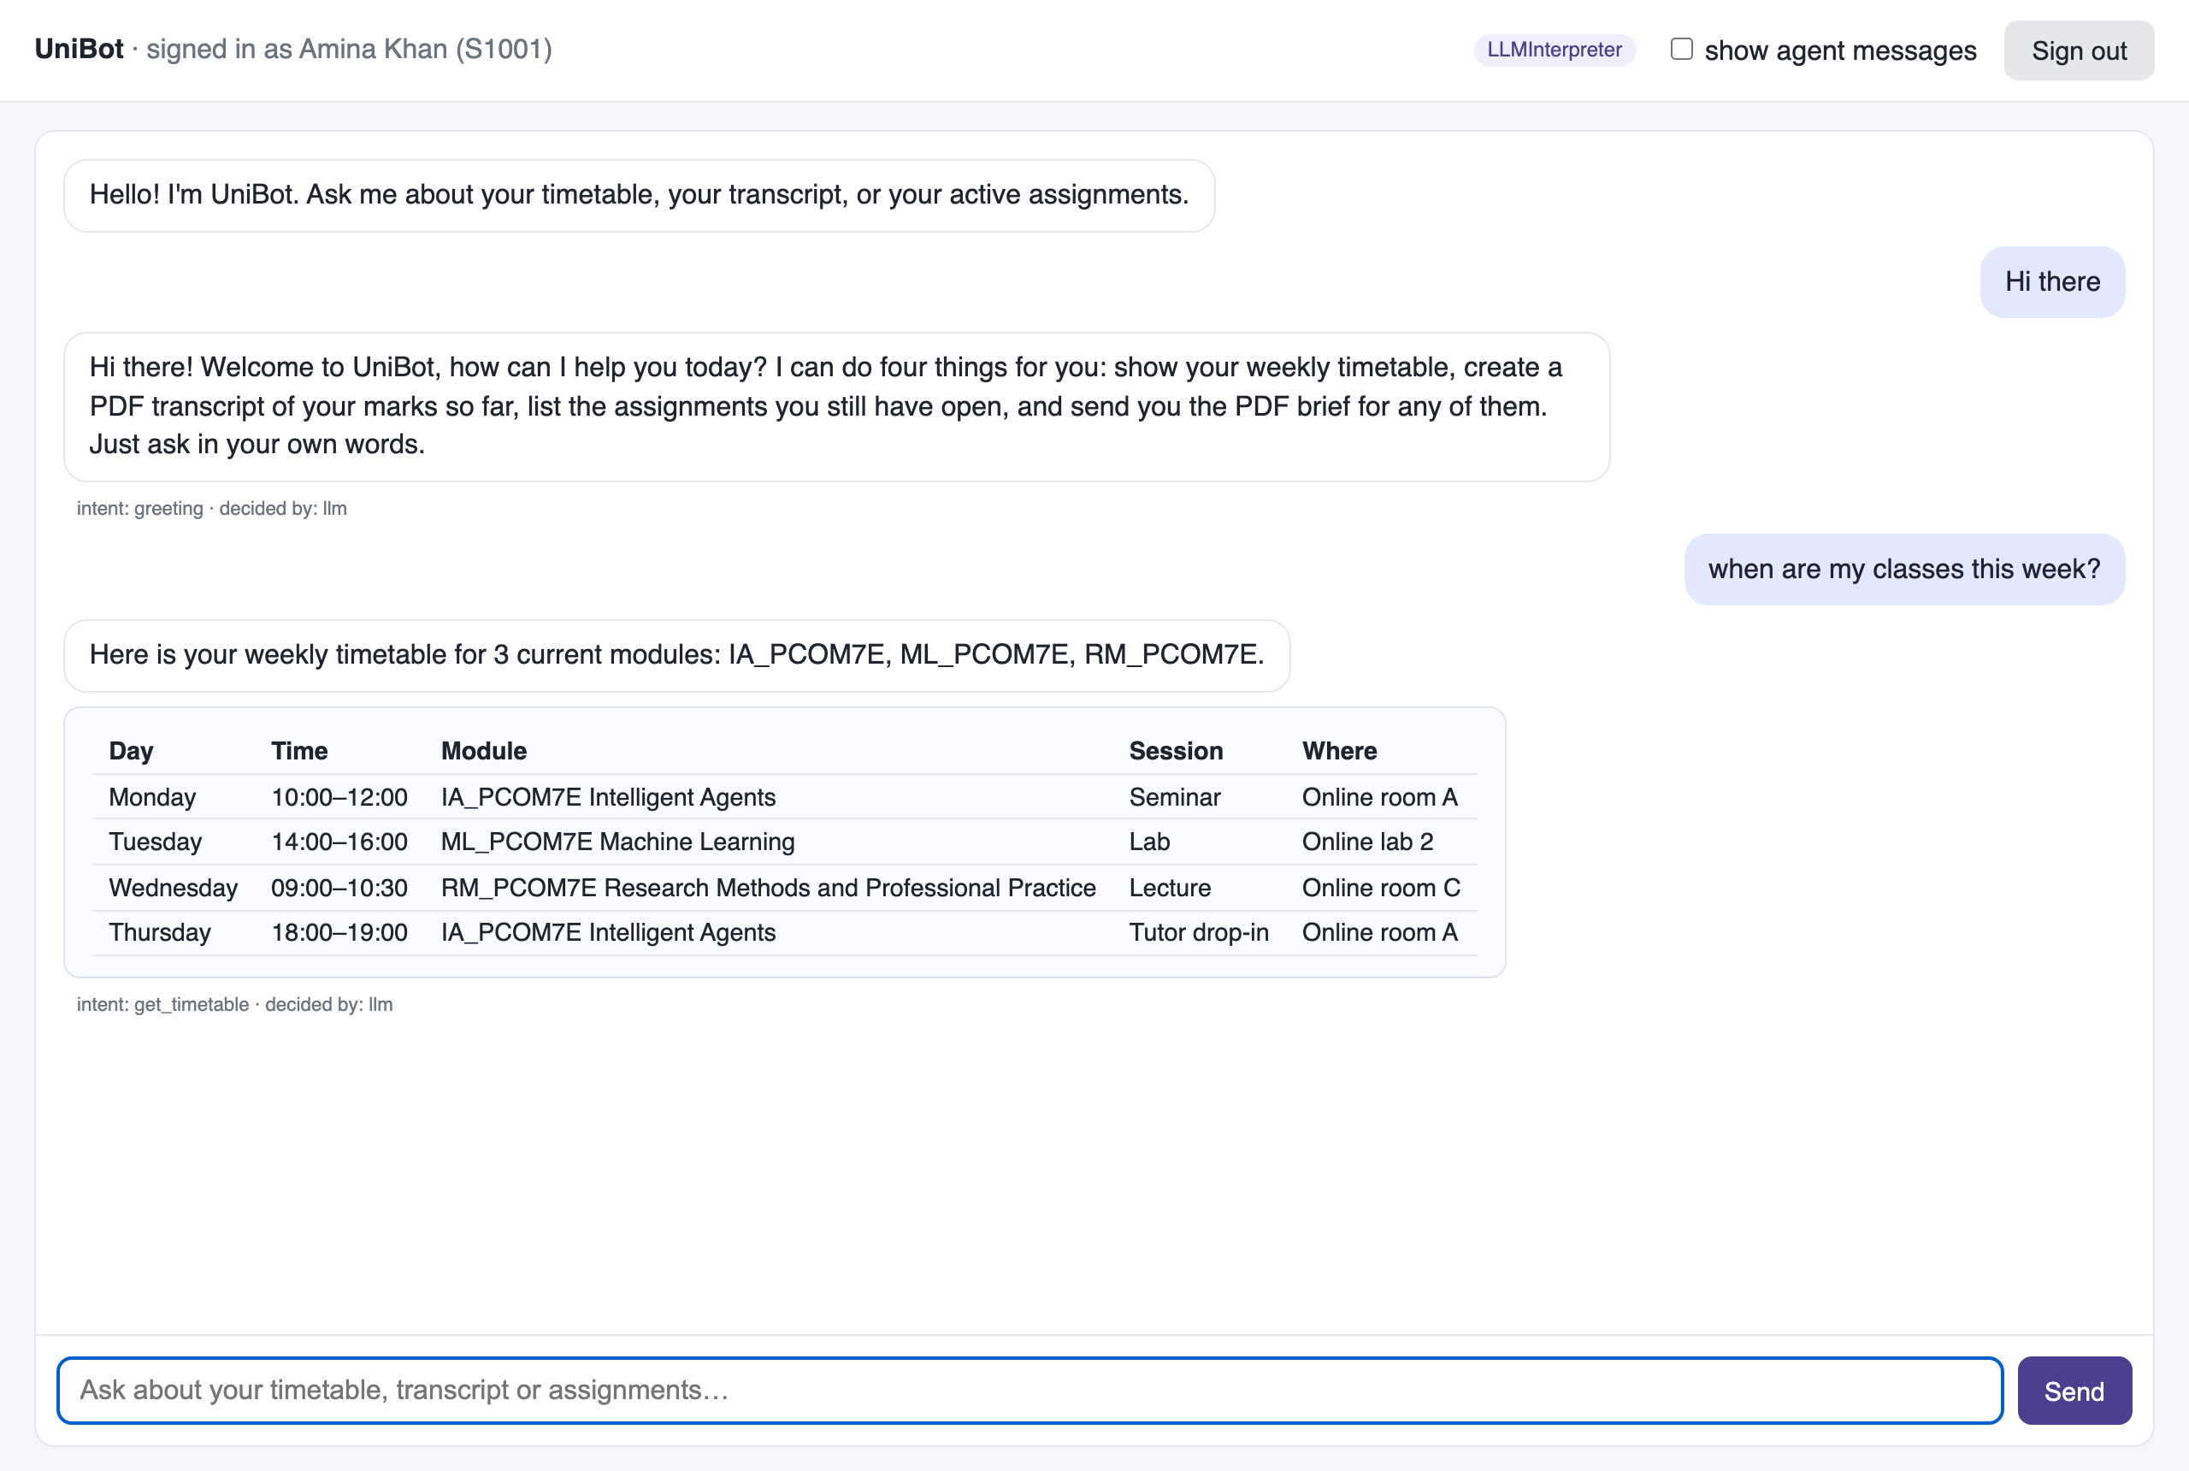
Figure 3. Greeting and timetable. The table is rendered from the timetable agent's reply; the footer line shows the recognised intent and the deciding interpreter.
"Can I have my transcript as a PDF please" causes the transcript agent to generate a PDF from the marks table and register it to the student before any link is shown (Figures 4 and 5). Pending marks stay visibly pending; the transcript is a snapshot, not a cached file.
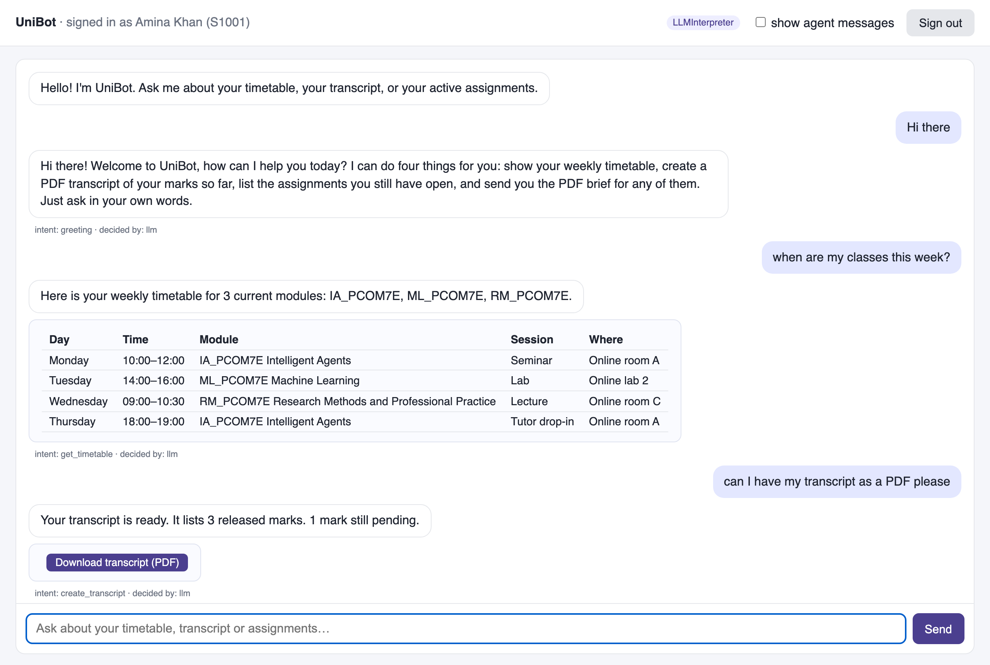
Figure 4. Transcript request. The download button appears only after the file exists and has been recorded against its owner.
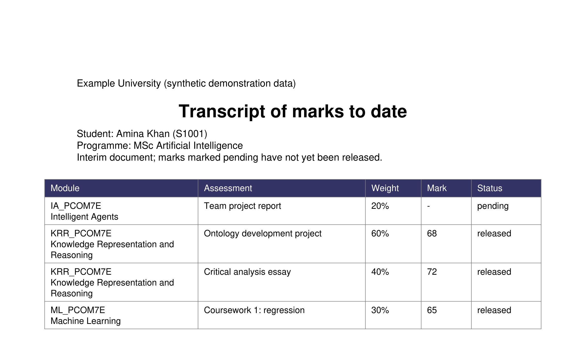
Figure 5. The generated transcript PDF, opened from the download link.
Asking "which assignments are still open?" lists the three active assignments with download buttons. With the agent-message panel switched on, the right-hand side shows the actual exchange: an ask-one from the dialogue agent carrying the query and the session's student identifier, and a tell back carrying the facts (Figure 6). The student can then say "download the second one". The dialogue agent resolves "second" against the list it remembers from the previous turn, asks the assignment agent for that one brief, and the agent re-checks enrolment and deadline before answering (Figure 7). Figure 8 traces that turn end to end.
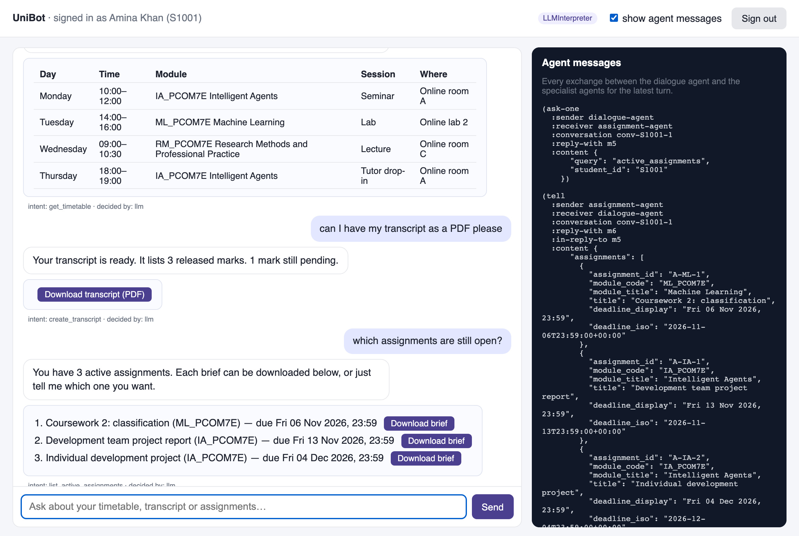
Figure 6. Active assignments with the inter-agent trace visible. The expired Literature Review and the unenrolled module's assignment are excluded by the assignment agent.
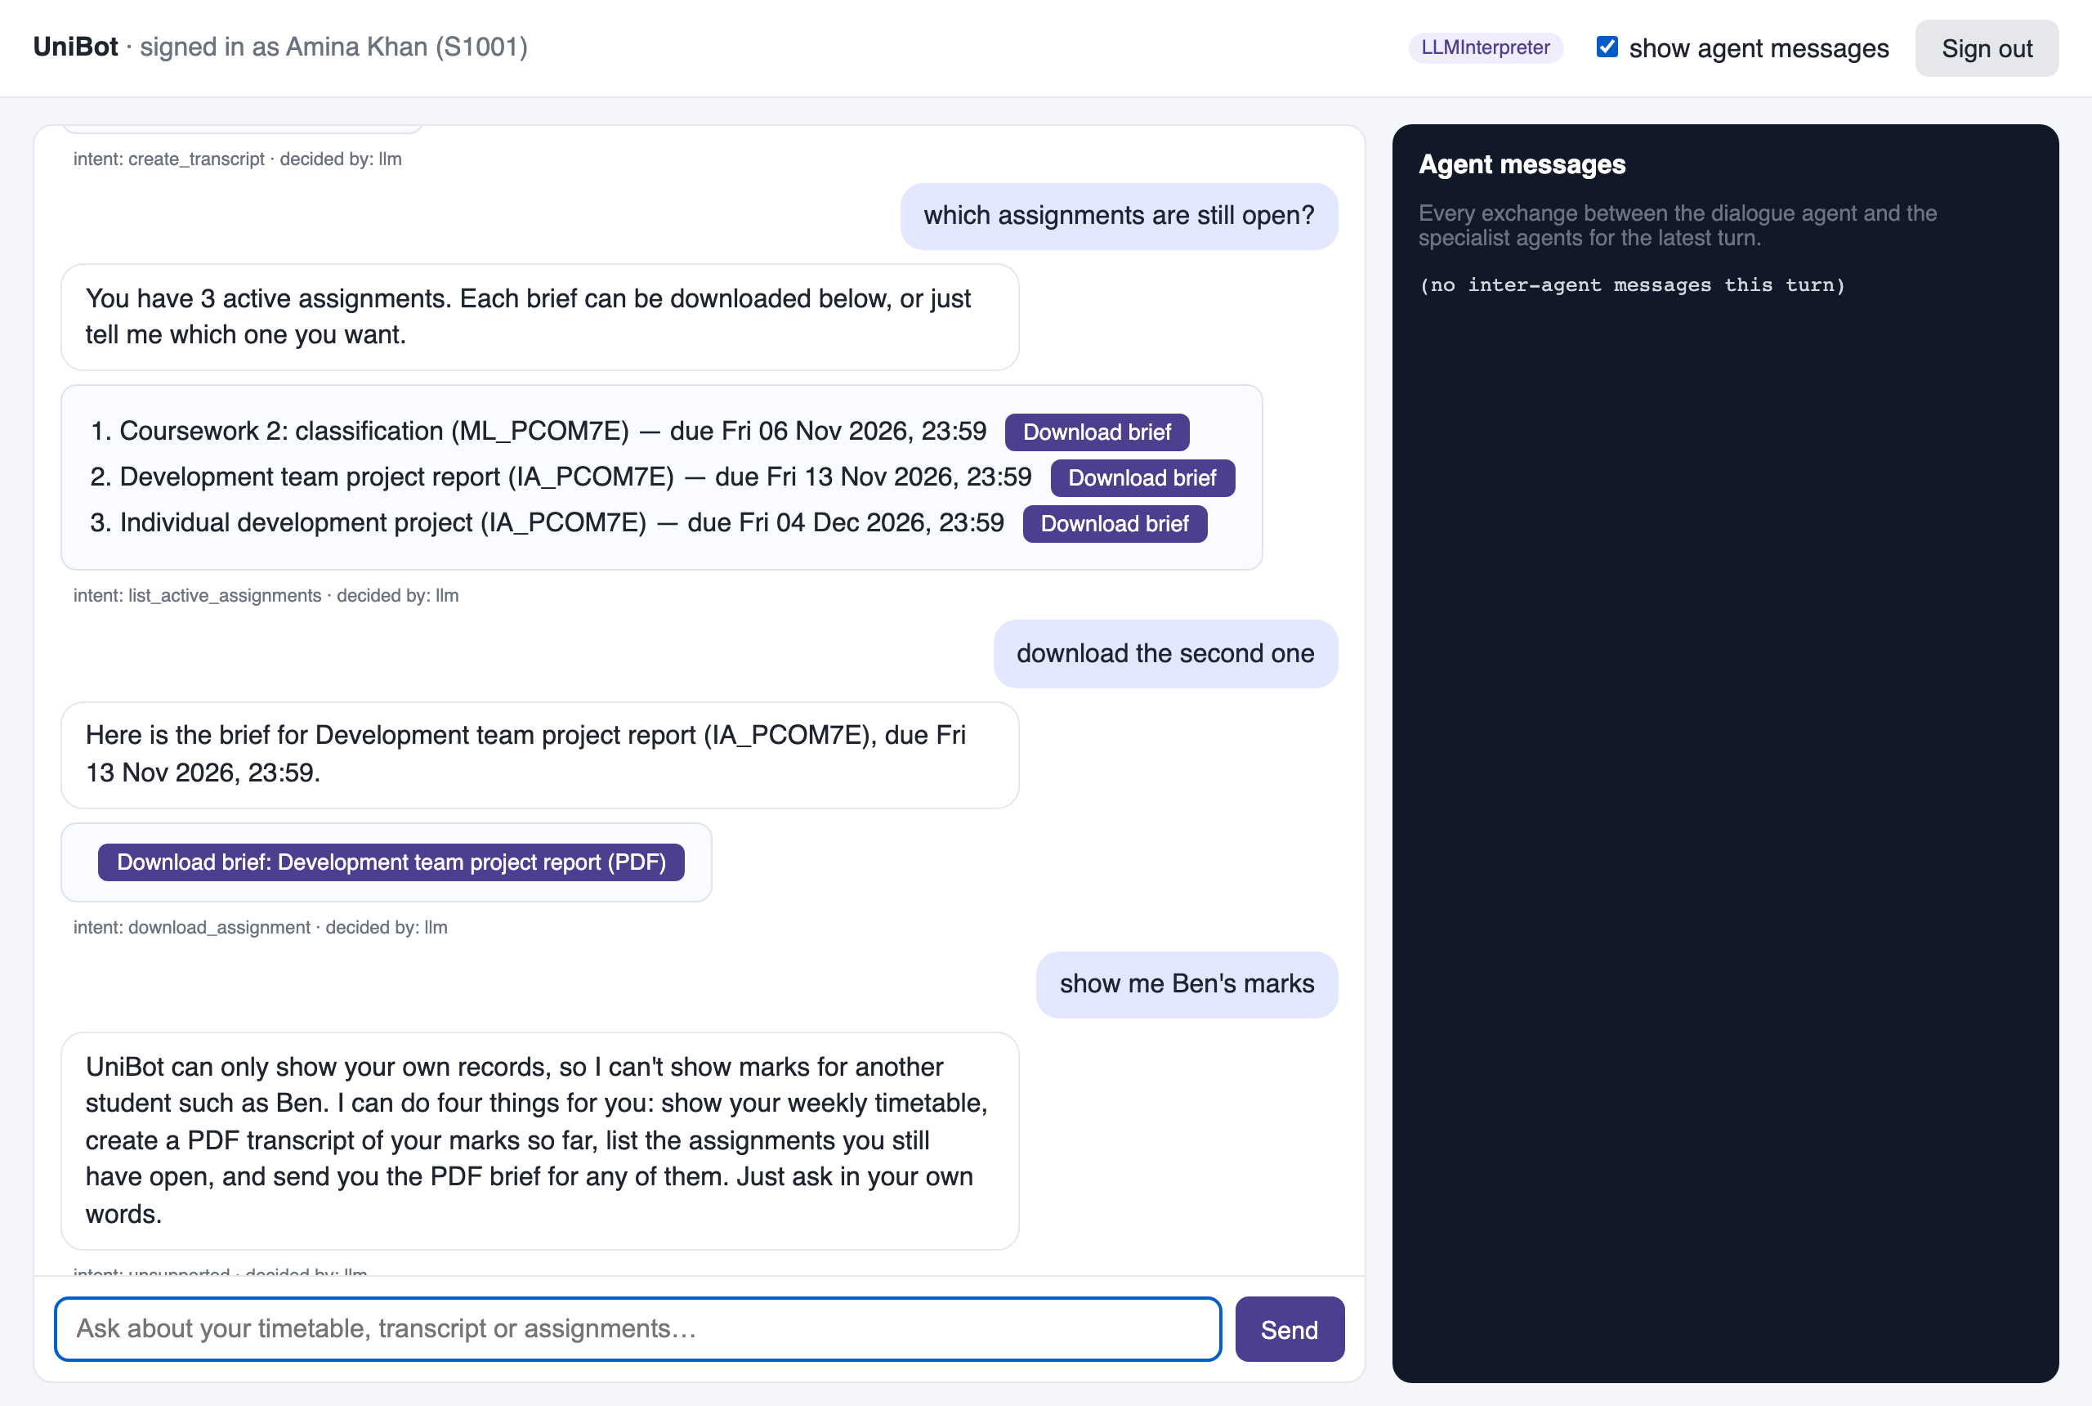
Figure 7. Follow-up "download the second one" resolved from session state, then a request for another student's marks refused.
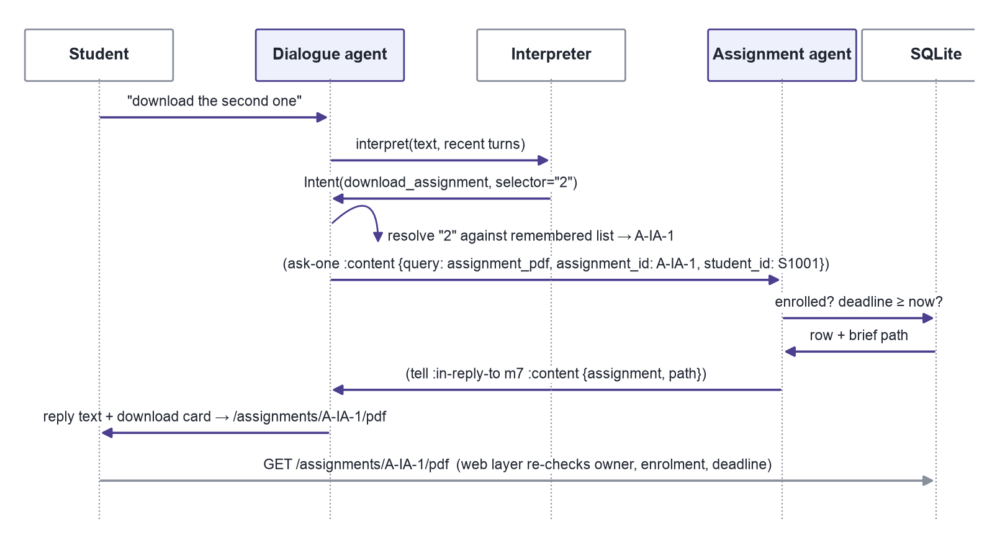
Figure 8. Message sequence for the follow-up download. The student identifier enters only from the session; the web layer repeats the checks when the file is fetched.
Finally, "show me Ben's marks" is refused with an explanation, and "thanks, bye" closes the conversation. Access control is harder to show in a screenshot but matters more: when a second student signs in and requests the first student's transcript link, the server answers "Document not found", exactly as it does for an invented identifier, because the route looks the document up by identifier and owner. The output capture below comes from the same scripted run as the figures above.
Signed in as: ben (S1002)
GET /documents/dANpIT4GYP18PuEqXhjiww
HTTP 404 Not Found
content-type: application/json

{"detail":"Document not found."}

Signed in as: amina (S1001)
GET /documents/dANpIT4GYP18PuEqXhjiww
HTTP 200 OK
content-type: application/pdf

4. Key decisions in the code
The comments in the source explain why choices were made; three deserve highlighting. First, the language model is given a closed set of tools with strict schemas, and whatever it returns is validated again locally before anything runs:
def validate_tool_call(name: str, arguments: Any) -> Intent:
"""Local validation of whatever the model proposed.

Unknown tools, unexpected arguments (``student_id`` being the obvious
attack) and non-string values are rejected. The result of rejection is a
clarification, which is safe: nothing is executed.
"""
...
if name not in _ALLOWED_ARGUMENTS or not isinstance(arguments, dict):
return Intent(CLARIFY, {"question": "Sorry, could you rephrase that?"}, ...)
if set(arguments) - allowed or any(not isinstance(v, str) for v in arguments.values()):
return Intent(CLARIFY, {"question": "Sorry, could you rephrase that?"}, ...)

This is the design principle Rüdel and Leidner (2023) call control in hybrid chatbots: the model adds flexibility in understanding, while the developer keeps control of what is done. It also means a hallucinated or injected instruction (Huang et al., 2023; Greshake et al., 2023) has nowhere to go. Second, the bus converts any exception inside an agent into an error message, so a failure stays inside the protocol and the student sees a plain apology rather than a stack trace; the test suite injects a faulty timetable agent to prove it. Third, the student identifier is attached to every inter-agent message by the dialogue agent from the authenticated session, never parsed from the student's text, and the download routes repeat the ownership, enrolment and deadline checks instead of trusting the link they issued a moment earlier.
5. Testing
The suite contains 54 test cases (38 test functions, some parametrised) in four files and runs in about three seconds without a network connection; the language-model adapter is exercised through a fake client that returns scripted tool calls, errors, or the wrong number of calls (Table 1).
Table 1. Test coverage by file. The second column counts test cases; parametrised phrasings are counted separately.
Test file | Tests | What it establishes
test_acl_bus.py | 5 | Reply threading, routing by capability, SORRY for unknown receivers, exceptions become ERROR messages
test_interpreters.py | 9 (25 cases) | Rule classification of 17 phrasings; selector extraction; rejection of unknown tools and smuggled student_id; fallback on API error, on zero or two tool calls; bounded history
test_agents.py | 14 | Current-module filtering; transcript PDF contains own marks and not the other student's; deadline boundary inclusive to the second; follow-up download; ambiguity asks; refusal; fault injection
test_web_security.py | 10 | 401 without a session; SQL-injection login attempt; CSRF header and strict body; owner-only downloads across two browsers; path traversal; expired assignment; session expiry; full conversation over HTTP; no server paths in any reply

The first full run failed six tests, which is the useful kind of failure. Four exposed a real defect in the rule interpreter: "download the second one" resolved to the first assignment because the ordinal table was a dictionary that matched "one" before "second", and "results so far as a PDF" was classified as a download because the download rule matched "pdf". One exposed an over-eager title matcher that returned a brief when it should have asked which one. One was a test error: advancing the clock thirteen days to expire an assignment also expired the thirty-minute session. Both runs are in the evidence folder; the final output is shown below.
tests/test_acl_bus.py ..... [ 9%]
tests/test_agents.py .............. [ 35%]
tests/test_interpreters.py ......................... [ 83%]
tests/test_web_security.py .......... [100%]

============================== 54 passed in 2.73s ==============================

6. Code quality and security testing
Three static tools were run before and after remediation (Table 2). flake8 reported 23 over-length lines and one unused import; pylint rated the code 9.54/10 with missing docstrings, a shadowed built-in, broad exception handlers and a seed function with too many local variables. Most items were fixed by changing the code: lines were wrapped, docstrings written, the built-in renamed, the seed function split into three. Seven findings were suppressed with an inline comment that states the reason rather than fixed: three broad or lazy-import handlers sit at trust boundaries (the bus, the LLM adapter and the optional SDK import) where a failure must become a message rather than a crash, and the settings record and application factory legitimately exceed pylint's default size limits. Five further checks are relaxed for the whole project in pyproject.toml, such as the requirement for a docstring on every small function. bandit found no issues in either run; pip-audit found no known vulnerabilities in the dependency set.
Table 2. Tool output before and after remediation. Raw logs, each headed with the command that produced it, are in chatbot/evidence/before and chatbot/evidence/after; the after run of flake8 also covers the evaluation script.
Tool | Before | After
flake8 | 24 findings (23 E501 line length, 1 F401 unused import) | 0 findings
pylint | 9.54/10, 28 messages | 10.00/10, 0 messages
bandit | No issues identified (1,411 lines scanned) | No issues identified
pip-audit | not run | No known vulnerabilities
pytest | 6 failed, 47 passed | 54 passed

Security testing is functional as well as static. The suite attempts a SQL-injection login, a path-traversal assignment identifier, a cross-site POST without the required header, an extra student_id field in the request body, an over-length message, a copied download link in another student's session, a download after sign-out, and a download after the deadline has passed; each is refused. One finding came from reviewing the screenshots rather than from a tool: the assignment agent's reply included the brief's filesystem path, which the agent-message panel then displayed in the browser. Nothing used it, but it disclosed server layout to the client. I removed the field, added a test that no reply may contain a server path, and re-ran every tool; the figures in this report are from the corrected build. These are the README's claims, and the tests are what make them claims rather than hopes.
7. Evaluating the interpreters
Twenty-four fixed scenarios cover small talk, direct requests, paraphrases, follow-ups, ambiguity, access attempts, prompt injection and out-of-scope requests. The rule interpreter handles every direct request and all small talk but only two of five paraphrases, and it cannot tell an injection or an off-topic question from an unclear one (Figure 9). Importantly, every miss is a safe miss: a request it does not understand becomes a clarification, and a request it misreads as a record request still only ever returns the signed-in student's own records. The language-model interpreter is designed to close exactly this gap, and the comparison script records model, tokens and latency for each run so that the result is reproducible.
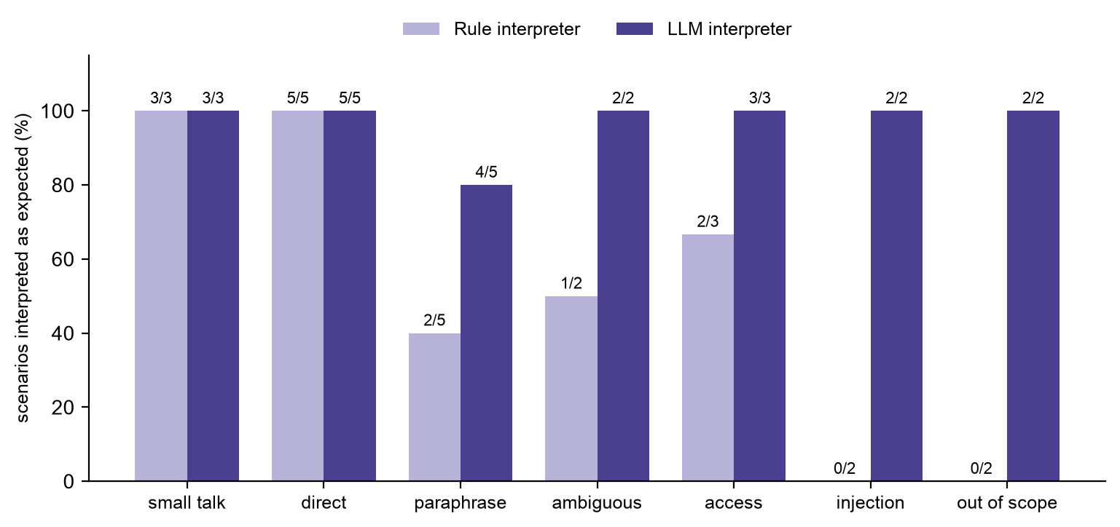
Figure 9. Rule and LLM interpreter results on the 24-scenario set, by category. LLM run: claude-haiku-5-5.
The live run used claude-haiku-5-5, the cheapest current Claude model. It interpreted 23 of the 24 scenarios as expected: every direct request, follow-up, ambiguity, access attempt, injection and out-of-scope request, and four of five paraphrases. The single miss, "what's on this week", became a clarification, which is the safe outcome. No call failed or fell back to the rules. Each call used about 1,500 input tokens, mostly the tool definitions, and 80 output tokens; median latency was 1.7 seconds and the whole run cost under half a cent, so cost is not a reason to prefer the rules. The comparison is one run on a small set written by the author of the rules, so it shows behaviour on these cases rather than general accuracy.
8. Development of skills and awareness, and conclusion
At the start of the module I would have built this as a single call to a language model with a long prompt. Working through agent architectures (Wooldridge, 2009), speech acts and KQML changed that: the interesting engineering lies in the boundaries between components, and a chatbot whose record access is deterministic Python is easier to test, explain and defend than one whose behaviour lives in a prompt. The failures the tests caught were all in my hand-written rules, a fair reminder that transparent does not mean correct. The prototype's limits are clear: synthetic data, in-memory sessions, a single process, and a synchronous bus. Replacing SQLite with the university's record service and the login form with single sign-on would not change a single agent, which is the property the design was built for. Within those limits, the prototype delivers the four required behaviours, and the submitted tests and tool output show that it does so safely.
References
Anthropic (2026) Define tools. Claude Developer Platform documentation. Available from: https://platform.claude.com/docs/en/agents-and-tools/tool-use/define-tools [Accessed 16 October 2026].
Finin, T., Fritzson, R., McKay, D. and McEntire, R. (1994) KQML as an agent communication language. Proceedings of the Third International Conference on Information and Knowledge Management (CIKM '94): 456-463. DOI: https://doi.org/10.1145/191246.191322 [Accessed 16 October 2026].
Greshake, K., Abdelnabi, S., Mishra, S., Endres, C., Holz, T. and Fritz, M. (2023) Not what you've signed up for: Compromising real-world LLM-integrated applications with indirect prompt injection. Proceedings of the 16th ACM Workshop on Artificial Intelligence and Security (AISec '23): 79-90. DOI: https://doi.org/10.1145/3605764.3623985 [Accessed 18 October 2026].
Huang, L. et al. (2023) A survey on hallucination in large language models: Principles, taxonomy, challenges, and open questions. arXiv.org. Available from: https://arxiv.org/abs/2311.05232 [Accessed 18 October 2026].
OWASP (2021) SQL injection prevention cheat sheet. Available from: https://cheatsheetseries.owasp.org/cheatsheets/SQL_Injection_Prevention_Cheat_Sheet.html [Accessed 20 October 2026].
PyCQA (2024) Bandit documentation. Available from: https://bandit.readthedocs.io/ [Accessed 22 October 2026].
Rüdel, T. and Leidner, J.L. (2023) Control in hybrid chatbots. arXiv.org. Available from: https://arxiv.org/abs/2311.11701 [Accessed 19 October 2026].
Searle, J.R. (1969) Speech Acts: An Essay in the Philosophy of Language. Cambridge: Cambridge University Press.
Wooldridge, M. (2009) An Introduction to MultiAgent Systems. 2nd edn. Chichester: John Wiley & Sons.

