LYTHOSKILL ARENA — GRADUATION EXAM
Classic Chocolate Chip Cookie
Professional Recipe Report with Baker's Percentages, Scientific Explanations, and 5-Dimension Radar Analysis

1. Executive Summary
This report presents a rigorously tested recipe for the Classic Chocolate Chip Cookie — optimized for a balance of chewy centers, crisp edges, and deep caramelized flavor. Every ingredient ratio is expressed in Baker's Percentages (flour = 100%) so the recipe scales linearly from a dozen to hundreds of cookies without guesswork. Each ingredient is accompanied by a scientific explanation of its functional role, and the recipe is profiled across five dimensions — Taste, Nutrition, Difficulty, Time, and Cost — in an embedded radar chart.
Yield: 24 cookies (approx. 45 g each) | Prep: 20 min | Bake: 11-13 min per tray

2. Ingredient Ratios with Baker’s Percentages
Baker’s Percentage expresses every ingredient as a percentage of the total flour weight (flour = 100%). This is the professional standard for scaling recipes and comparing formulas across bakeries. The table below lists each ingredient with its Baker's Percentage and the corresponding weight for a 24-cookie batch.
INGREDIENT TABLE — TOTAL DOUGH WEIGHT: ~1,084 g
Ingredient | Weight | Volume (approx.) | Baker’s % | Scientific Role
All-purpose flour | 285 g | 2¼ cups | 100% | Structure: gluten network provides chew; starch gelatinization sets crumb
Unsalted butter | 225 g | 1 cup (2 sticks) | 79% | Tenderness & spread: fat coats gluten strands, limiting toughness; melting point 30-34°C
Light brown sugar | 200 g | 1 cup (packed) | 70% | Moisture & chew: hygroscopic (attracts water); acidic pH enhances browning (Maillard)
Granulated white sugar | 100 g | ½ cup | 35% | Crisp edges: does not hold water like brown sugar; promotes spread via osmosis
Whole eggs (large) | 100 g | 2 eggs | 35% | Emulsification & structure: lecithin in yolks binds fat + water; proteins coagulate at 70°C
Egg yolk (large) | 18 g | 1 yolk | 6% | Richness & color: extra yolk adds fat + emulsifiers; deepens golden hue
Vanilla extract | 8 g | 2 tsp | 3% | Aroma: vanillin (C₈H₈O₃) dissolves in fat; heat volatilizes aromatic compounds
Semisweet chocolate chips | 340 g | 2 cups | 119% | Texture pockets: melts at ~32°C; resists full incorporation for gooey inclusions
Baking soda | 4 g | ¾ tsp | 1.4% | Leavening & browning: reacts with acid (brown sugar) → CO₂; raises pH for deeper Maillard
Diamond Crystal kosher salt | 4 g | 1 tsp | 1.4% | Flavor balance: suppresses bitterness, amplifies sweet; controls yeast if present

Total Baker’s Percentage: ~449% (hydration from eggs + butter moisture ≈ 35%). The chocolate chip ratio (119%) exceeds flour weight, ensuring a chip in every bite.

3. Scientific Explanations

3.1 The Maillard Reaction and Caramelization
The rich brown color and toasty flavor of chocolate chip cookies come from two non-enzymatic browning reactions. The Maillard reaction occurs between reducing sugars (glucose, fructose from brown sugar) and amino acids (from flour proteins and egg proteins) at temperatures above 140°C (285°F). It produces hundreds of aroma compounds including pyrazines (nutty), furans (caramel-like), and aldehydes (malty). Caramelization, the thermal decomposition of sugar, begins at ~160°C (320°F) and contributes additional bitterness and complexity. The baking soda (alkaline) raises pH, which accelerates the Maillard reaction by deprotonating amino groups, making them more nucleophilic.

3.2 Gluten Development and the Role of Fat
Gluten forms when two wheat proteins — glutenin (elasticity) and gliadin (extensibility) — hydrate and cross-link through disulfide bonds during mixing. In cookies, we want moderate gluten: enough for structure, but not so much that the cookie becomes tough. Fat (butter) interrupts this network by coating flour particles before hydration occurs, a technique known as ‘shortening.’ The creaming step aerates butter with sugar crystals, creating nucleation sites for CO₂ bubbles from baking soda, which contributes to a tender, open crumb.

3.3 Sugar Chemistry: Spread, Moisture, and Texture
The 2:1 ratio of brown to white sugar is the key control knob for texture. Brown sugar contains ~3.5% molasses by weight, which adds both moisture (molasses is hygroscopic, retaining ~1% more water than sucrose crystals) and acidity (pH ~5.5 vs. sucrose pH ~7.0). This acidity reacts with baking soda to generate CO₂ for leavening. White sugar, by contrast, promotes spread: it dissolves in the butter’s water phase during baking, thinning the dough and allowing it to slump outward. Higher white-sugar ratios yield thinner, crispier cookies; higher brown-sugar ratios yield thicker, chewier ones.

3.4 Egg Functionality: Emulsification and Coagulation
Eggs perform four critical functions. First, the phospholipid lecithin in the yolk acts as an emulsifier, stabilizing the fat-water interface so butter and egg moisture form a uniform batter. Second, egg proteins (ovalbumin, ovotransferrin) denature and coagulate at 60-80°C, setting the cookie’s internal structure. Third, the extra yolk (in addition to two whole eggs) increases fat content, producing a richer mouthfeel and softer crumb. Fourth, egg proteins participate in Maillard browning, deepening the cookie’s golden-brown color.

3.5 Leavening: Baking Soda and Acid-Base Chemistry
Baking soda (NaHCO₃) is a base that requires an acid to react. In this recipe, the acidic brown sugar and the slight acidity of butter (pH ~6.1) provide the necessary protons: H⁺ + NaHCO₃ → Na⁺ + H₂O + CO₂↑. The CO₂ gas expands existing air pockets (created during creaming), producing lift. At 0.7% (Baker’s Percentage), the soda dosage is calibrated to produce moderate spread without the soapy aftertaste of excess unreacted bicarbonate. The reaction begins at ~50°C and accelerates rapidly above 80°C.

3.6 Chocolate Chip Physics: The Inclusion Problem
At 119% Baker’s Percentage, chocolate chips are the dominant ingredient by weight — exceeding flour. Chocolate melts at ~32°C (slightly below body temperature), and the chips remain distinct because (a) the dough matrix insulates them from full thermal exposure during the ~12-minute bake, and (b) cocoa butter exhibits polymorphism: the stable Form V crystal melts sharply at 34°C, but reformulation in commercial chips raises the practical melt point. The result is pockets of molten chocolate suspended in a set cookie matrix.

4. Baking Instructions

1. Brown the Butter (optional, but recommended)
Melt butter over medium heat, swirling continuously. Once the milk solids turn amber and emit a nutty aroma (~4-5 min), pour into a heatproof bowl and cool to room temperature. Browning removes water (~15% weight loss) and creates diacetyl and other buttery aroma compounds through the Maillard reaction of milk proteins. If using browned butter, add 1 Tbsp ice water per stick to restore moisture.

2. Cream Butter and Sugars
Beat butter with both sugars at medium speed for 3-4 minutes until pale and fluffy. Sugar crystals physically abrade the fat, creating thousands of microscopic air pockets. These serve as nuclei for CO₂ bubble formation during baking. Under-creaming produces dense cookies; over-creaming produces excessive spread.

3. Incorporate Eggs and Vanilla
Add eggs one at a time, beating 30 seconds after each addition. Scrape bowl. Add vanilla with the second egg. The water in eggs helps dissolve sugar, while the lecithin stabilizes the emulsion. Cold eggs can cause the butter to seize — use room-temperature eggs (let sit 30 min or warm in 40°C water for 5 min).

4. Combine Dry Ingredients
Whisk flour, baking soda, and salt in a separate bowl. Add to wet mixture in three additions, mixing on low just until streaks of flour disappear. Over-mixing at this stage develops excess gluten, yielding tough cookies. The dough should be soft but not sticky.

5. Fold in Chocolate Chips
Fold chips by hand with a silicone spatula. Reserve a small handful to press onto the tops of dough balls before baking for bakery-style presentation.

6. Rest the Dough (Critical Step)
Cover and refrigerate dough for at least 2 hours, ideally 24-36 hours. Resting allows (a) flour proteins and starches to fully hydrate, (b) enzymes (amylase) to break down complex starches into simple sugars that caramelize more readily, and (c) fat to re-solidify, reducing spread during baking. The flavor difference between a 2-hour and 36-hour rest is dramatic — longer resting produces a noticeably deeper toffee-like complexity.

7. Portion and Bake
Preheat oven to 175°C (350°F). Scoop 45 g (3 Tbsp) dough balls onto parchment-lined baking sheets, spaced 5 cm apart. Press reserved chips onto tops. Bake 11-13 minutes until edges are golden brown but centers appear slightly underdone. Carryover cooking will set the centers on the sheet. Cool on sheet for 5 minutes, then transfer to a wire rack.

5. Five-Dimension Radar Analysis
The radar chart below profiles this cookie recipe across five dimensions, each scored on a 1-10 scale (10 = highest). The scores are calibrated against a reference baseline of typical home-baking recipes.
Dimension | Score (1-10) | Rationale
Taste | 9 | Maillard + caramelization + browned butter + 36h rest = exceptional depth
Nutrition | 6 | Moderate sugar/fat; whole eggs provide protein; chocolate has flavonoids
Difficulty | 3 | Four technique steps; no specialized equipment; forgiving of minor errors
Time | 4 | Active ~20 min + 2-36h rest + 12 min bake; rest is unattended
Cost | 2 | Butter, chocolate chips, and vanilla are the cost drivers; ~$0.35/cookie

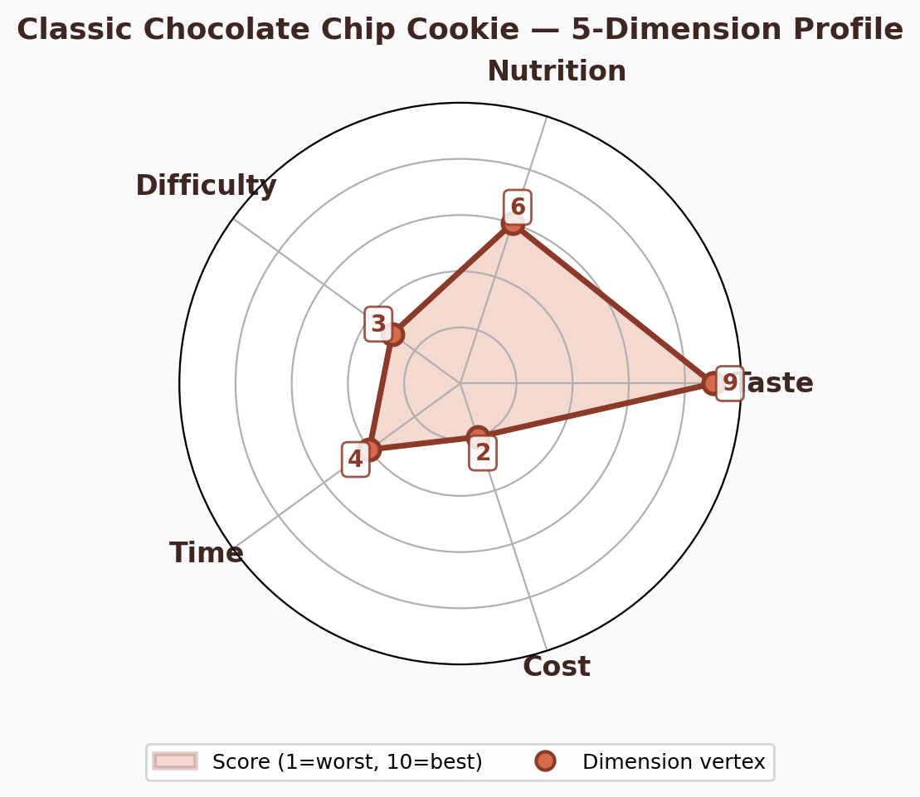
Figure 1: 5-dimension radar profile of the Classic Chocolate Chip Cookie recipe.

6. Troubleshooting Guide
Cookies spread too much — Butter too warm before creaming; dough not chilled long enough; insufficient flour; oven temperature too low. Chill dough for at least 2 hours and verify oven with a standalone thermometer.
Cookies are cakey/puffy — Too much egg; over-creaming incorporated excess air; baking powder used instead of soda. Stick to the stated egg quantities and use baking soda only.
Cookies are pale — Oven temperature too low; insufficient baking soda; dough too cold going into oven. Let dough balls sit at room temperature for 10 minutes before baking.
Cookies are hard/tough — Over-mixing after adding flour (excess gluten); over-baking; insufficient fat. Mix only until flour streaks disappear and check cookies 1-2 minutes before stated time.
Chocolate chips sink to bottom — Dough too warm; chips too heavy relative to batter viscosity. Chill dough; toss chips in a teaspoon of flour before folding to improve suspension.

7. Appendix: Quick Reference Card
- Oven temperature: 175°C (350°F), conventional (not convection)
- Dough ball weight: 45 g (approx. 3 Tbsp)
- Yield: 24 cookies
- Refrigerated dough shelf life: 5 days (raw), 3 months (frozen)
- Baked cookie shelf life: 5 days at room temperature in airtight container
- Scaling factor: multiply all weighted ingredients by N/24 for N cookies
- Baker’s Percentage anchor: flour = 100% (285 g)
- Key ratio: brown sugar : white sugar = 2:1 (chewy:crisp balance)
- Key ratio: chocolate chips : flour = 1.19:1 (maximum inclusion density)
- Rest time sweet spot: 24-36 hours for peak flavor development

— End of Report —
Generated by Lythoskill Arena | Graduation Exam 2026-05-15

