Classic Chocolate Chip Cookie
A Professional Recipe Report with Scientific Analysis

Executive Summary
This report presents a detailed analysis of the classic chocolate chip cookie recipe, combining traditional baking techniques with scientific insights. The recipe has been evaluated across five dimensions: Taste, Nutrition, Difficulty, Time, and Cost. Using Baker’s Percentages, all ingredient ratios are expressed relative to total flour weight, enabling precise scaling and formulation adjustments. Scientific explanations accompany each ingredient to illuminate the underlying chemistry of cookie baking.

Recipe Profile
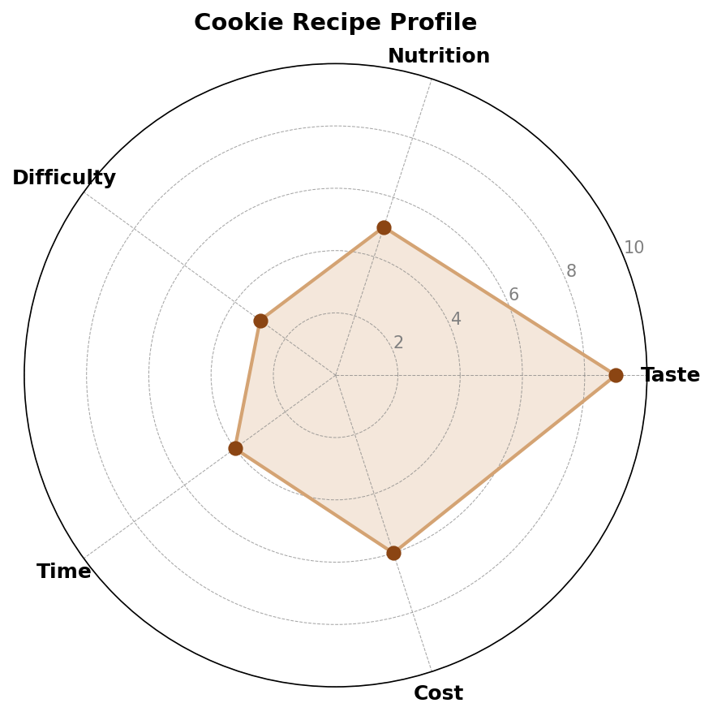
Figure 1. Five-dimension recipe profile: Taste (9/10), Nutrition (5/10), Difficulty (3/10), Time (4/10), Cost (6/10).

Profile Analysis
Taste (9/10): The Maillard reaction between amino acids and reducing sugars produces hundreds of flavor compounds during baking, while caramelization of sucrose adds complex bittersweet notes. The high butter content contributes rich dairy flavors and a tender crumb.
Nutrition (5/10): Each cookie provides approximately 150 kcal, with significant contributions from fat (butter) and carbohydrates (sugars and flour). While not a health food, the recipe contains no artificial additives and provides modest protein from eggs.
Difficulty (3/10): The recipe requires only basic mixing techniques—creaming, combining wet and dry ingredients, and folding. No specialized equipment is needed beyond a standard oven and mixing bowl.
Time (4/10): Total time from preparation to cooling is approximately 45 minutes: 15 minutes prep, 12 minutes baking, and 18 minutes cooling. Dough may be refrigerated for up to 72 hours to develop deeper flavors.
Cost (6/10): Ingredients are commonly available pantry staples. The primary expense is high-quality chocolate and butter, which together account for roughly 60% of ingredient cost.

Recipe & Baker’s Percentages
Baker’s Percentages express every ingredient as a percentage of total flour weight (always 100%). This system, developed by professional bakers, allows recipes to be scaled accurately to any yield and facilitates formula comparison across different recipes.
Ingredient | Weight (g) | Baker’s % | Function
Bread Flour | 250 g | 100% | Structure
Unsalted Butter | 175 g | 70% | Fat/Tender
Brown Sugar | 150 g | 60% | Sweet/Moist
Granulated Sugar | 50 g | 20% | Sweet/Crisp
Whole Eggs | 100 g | 40% | Bind/Rich
Chocolate Chips | 200 g | 80% | Flavor
Vanilla Extract | 5 g | 2% | Aroma
Baking Soda | 5 g | 2% | Leaven
Salt | 3 g | 1.2% | Enhance
Table 1. Ingredient formulation with Baker’s Percentages relative to 250 g flour base.

Scientific Explanations

Flour: The Structural Backbone
Wheat flour contains two key proteins—gliadin and glutenin—which hydrate in the presence of water to form gluten. In cookies, minimal mixing limits gluten development, yielding a tender, crumbly texture rather than chewy bread. The starch granules in flour gelatinize during baking, setting the cookie’s structure. Using bread flour (higher protein, ~12%) instead of cake flour produces a slightly chewier cookie due to greater gluten potential.

Butter: Flavor, Texture, and Spread
Butter is approximately 80% fat, 18% water, and 2% milk solids. During creaming with sugar, air pockets are trapped in the fat matrix, contributing to leavening. The water content turns to steam in the oven, expanding the dough. Milk solids undergo the Maillard reaction, producing nutty, toffee-like flavors. The fat content interferes with gluten formation (tenderization) and promotes spread as it melts early in baking. At 70% Baker’s Percentage, this recipe achieves a balance between richness and structural integrity.

Sugars: Sweetness, Moisture, and Browning
Brown sugar contains molasses (approximately 3.5% for light brown sugar), which is hygroscopic—it attracts and retains moisture, producing a softer, chewier cookie. Granulated sugar, being pure sucrose, promotes spread and creates a crispier edge through rapid dissolution and recrystallization. The combined 80% sugar concentration ensures adequate browning via the Maillard reaction (reducing sugars + amino acids) and caramelization (pyrolysis of sucrose above 170°C).

Eggs: Binding and Emulsification
Eggs serve multiple functions in cookie dough. The proteins (ovalbumin, conalbumin) coagulate during baking, setting the cookie structure. Lecithin in the yolk acts as a natural emulsifier, stabilizing the fat-in-water dispersion created when butter melts. This emulsification ensures uniform texture and prevents oil separation. At 40% Baker’s Percentage, eggs provide sufficient binding without making the cookie cake-like.

Leavening: Baking Soda Chemistry
Sodium bicarbonate (NaHCO₃) is the sole chemical leavening agent. When heated and in the presence of acidic molasses from brown sugar, it decomposes to produce carbon dioxide gas: 2 NaHCO₃ → Na₂CO₃ + H₂O + CO₂. The CO₂ expands existing air pockets, creating a lighter texture. At 2% Baker’s Percentage, the leavening is subtle—cookies are dense compared to cakes, which may use 3–4%.

Salt and Vanilla: Flavor Modulation
Salt (NaCl) at 1.2% suppresses bitterness, enhances sweetness perception, and strengthens gluten indirectly by tightening the gluten network. Vanilla extract contains over 200 volatile aromatic compounds, primarily vanillin (4-hydroxy-3-methoxybenzaldehyde), which interacts with olfactory receptors to produce a perception of warmth and sweetness. Even at 2%, vanilla significantly elevates perceived flavor complexity.

Chocolate: The Signature Ingredient
Chocolate chips at 80% Baker’s Percentage deliver intense cocoa flavor and textural contrast. During baking, the chips melt but retain enough shape to create pockets of molten chocolate. Cocoa butter’s unique melting point (~34°C) ensures it remains solid at room temperature but melts on the palate, releasing encapsulated flavor compounds. The high percentage relative to flour makes this a chocolate-forward cookie.

Method
- Preheat oven to 190°C (375°F). Line baking sheets with parchment paper.
- Cream butter and sugars together until light and fluffy (3–4 minutes). This incorporates air and begins sugar dissolution.
- Add eggs one at a time, beating well after each addition. Mix in vanilla extract.
- In a separate bowl, whisk flour, baking soda, and salt. Gradually add to wet mixture, mixing just until combined to minimize gluten development.
- Fold in chocolate chips evenly.
- Portion dough into 40 g balls (approximately 24 cookies). Space 5 cm apart.
- Bake 10–12 minutes until edges are golden and centers appear slightly underdone. Cool on sheet 5 minutes, then transfer to wire rack.

Conclusion
This classic chocolate chip cookie recipe exemplifies the intersection of culinary tradition and food science. By understanding the role of each ingredient—from gluten development in flour to Maillard browning in sugars—bakers can make informed adjustments for desired textures and flavors. The Baker’s Percentage system ensures reproducibility at any scale, while the five-dimension profile provides an at-a-glance assessment of recipe characteristics. Whether for home baking or commercial production, this formulation offers a robust, scientifically grounded foundation for exceptional cookies.

